Contents

1. QDABBN0001 5

2. QDABBN0002 7

3. QDABBS0001 9

4. QDABBS0002 11

5. QDABBS0003 13

6. QDABBS0004 15

7. QDABBS0005 17

8. QDABBS0006 19

9. QDABBS0007 21

10. QDABBS0008 23

11. QDABBS0009 25

12. QDABBS0010 27

13. QDACHC0001 29

14. QDACHC0002 31

15. QDACHC0003 33

16. QDACHC0004 35

17. QDACHC0005 37

18. QDACHC0006 39

19. QDACHC0007 41

20. QDACYP0001 43

21. QDACYP0002 45

22. QDACYP0003 47

23. QDACYP0004 49

24. QDACYP0005 51

25. QDACYP0006 53

26. QDACYP0007 55

27. QDACYP0008 57

28. QDACYP0009 59

29. QDACYP0010 61

30. QDACYP0011 63

31. QDACYP0012 65

32. QDACYP0013 67

33. QDACYP0014 69

34. QDACYP0015 71

35. QDACYP0016 73

36. QDACYP0017 75

37. QDACYP0018 77

38. QDACYP0019 79

39. QDACYP0020 81

40. QDACYP0021 83

41. QDACYP0022 85

42. QDACYP0023 87

43. QDACYP0024 89

44. QDADEU0001 91

45. QDAEIU0001 93

46. QDAEIU0002 95

47. QDAEIU0003 97

48. QDAEIU0004 99

49. QDAEIU0005 101

50. QDAEIU0006 103

51. QDAEIU0007 105

52. QDAEIU0008 107

53. QDAEIU0009 109

54. QDAEIU0010 111

55. QDAGUP0001 113

56. QDAGUP0002 115

57. QDAGUP0003 117

58. QDAGUP0004 119

59. QDAGUP0005 121

60. QDAGUP0006 123

61. QDAGUP0007 125

62. QDAGUP0008 127

63. QDAGUP0009 129

64. QDAGUP0010 131

65. QDAGUP0011 133

66. QDAGUP0012 135

67. QDAGUP0013 137

68. QDAGUP0014 139

69. QDAGUP0015 141

70. QDAGUP0016 143

71. QDAGUP0017 145

72. QDAGUP0018 147

73. QDAGUP0019 149

74. QDAGUP0021 151

75. QDAGUP0022 153

76. QDAGUP0023 155

77. QDAGUP0024 157

78. QDAGUP0026 159

79. QDAGUP0027 161

80. QDAGUP0028 163

81. QDAGUP0029 165

82. QDAGUP0030 167

83. QDAGUP0031 169

84. QDAMGD0001 171

85. QDAMGD0002 173

86. QDAMGD0003 175

87. QDAMGD0004 177

88. QDAMGD0005 179

89. QDAMGD0006 181

90. QDAMGD0007 183

91. QDAMGD0008 185

92. QDAMGD0009 187

93. QDAMGD0010 189

94. QDAMGD0011 191

95. QDAMGD0012 193

96. QDAMGD0013 195

97. QDAMGD0014 197

98. QDAMGD0015 199

99. QDAMGD0016 201

100. QDAMGD0017 203

101. QDAMGD0018 205

102. QDAMGD0019 207

103. QDAMGD0020 209

104. QDAMGD0021 211

105. QDAMGD0022 213

106. QDAMGD0023 215

107. QDAMGD0024 217

108. QDAMGD0025 219

109. QDAMGD0026 221

110. QDAMGD0027 223

111. QDAMGD0028 225

112. QDAMII0001 227

113. QDAMII0002 229

114. QDAMUL0001 231

115. QDAMUL0002 233

116. QDAMUL0003 235

117. QDASEQ0001 237

118. QDASEQ0002 239

119. QDASEQ0003 241

120. QDASEQ0004 243

121. QDASSD0001 245

122. QDASSD0002 247

123. QDASSD0003 249

124. QDASSD0004 251

125. QDASSD0005 253

126. QDASSD0006 255

127. QDASSD0007 257

128. QDASSD0008 259

129. QDASSD0009 261

130. QDASSD0010 263

131. QDASSD0011 265

132. QDASSD0012 267

133. QDASSD0013 269

134. QDASSD0014 271

135. QDASSD0015 273

# QDABBN0001

| Min. | 1st Qu. | Median | Mean | 3rd Qu. | Max. |
| --- | --- | --- | --- | --- | --- |
| 17.07712 | 35.57372 | 41.89867 | 42.50292 | 49.59316 | 65.97337 |

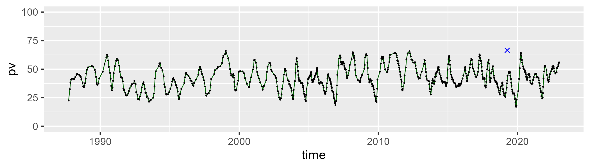

| Min. | 1st Qu. | Median | Mean | 3rd Qu. | Max. |
| --- | --- | --- | --- | --- | --- |
| 27.93394 | 43.0779 | 50.59962 | 49.85145 | 55.8313 | 74.48005 |

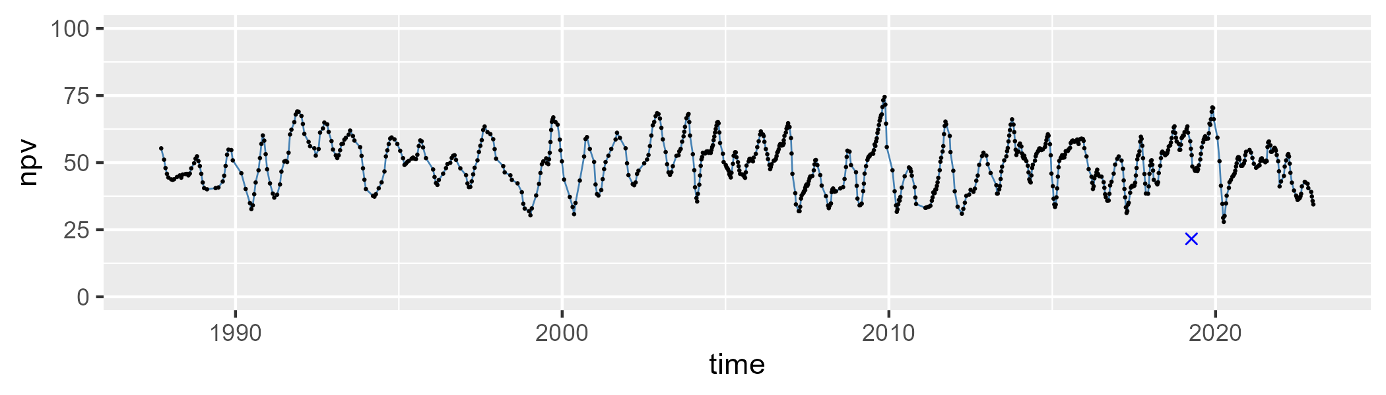

| Min. | 1st Qu. | Median | Mean | 3rd Qu. | Max. |
| --- | --- | --- | --- | --- | --- |
| 0 | 3.933679 | 5.707336 | 6.493914 | 8.472409 | 21.84495 |

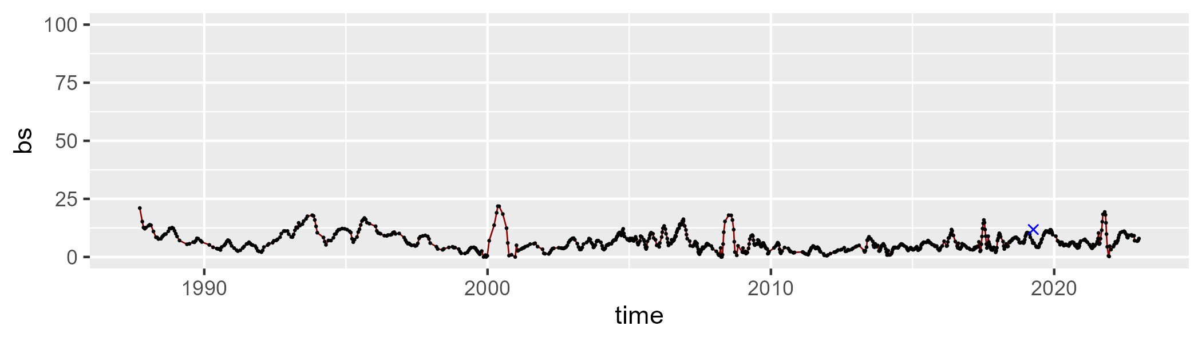

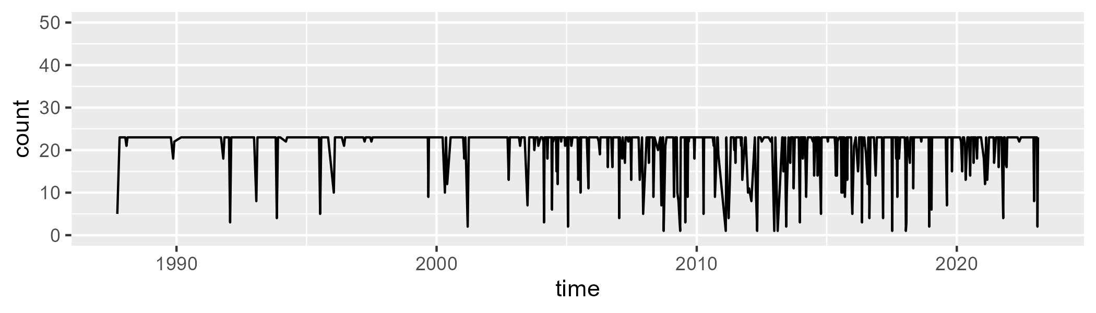

Min. : 1.00 1st Qu.:23.00 Median :23.00 Mean :21.11 3rd Qu.:23.00 Max. :23.00

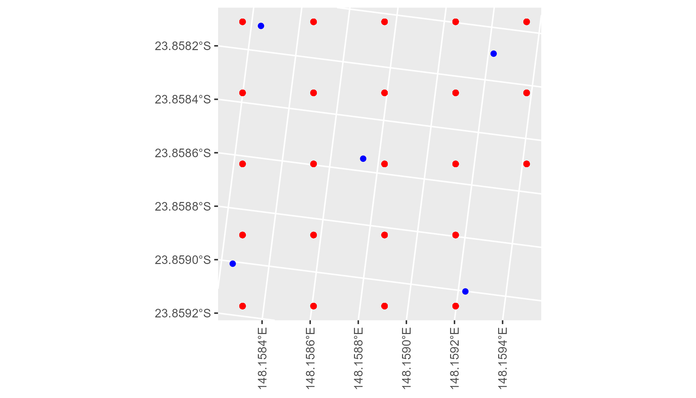

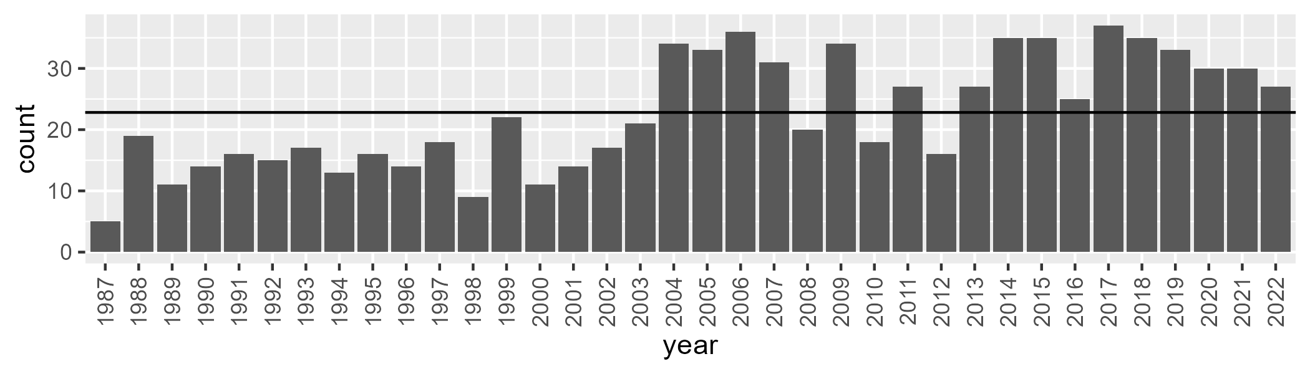

Number of samples: 815

# QDABBN0002

| Min. | 1st Qu. | Median | Mean | 3rd Qu. | Max. |
| --- | --- | --- | --- | --- | --- |
| 19.13032 | 34.30801 | 40.08556 | 40.19585 | 46.25958 | 64.28304 |

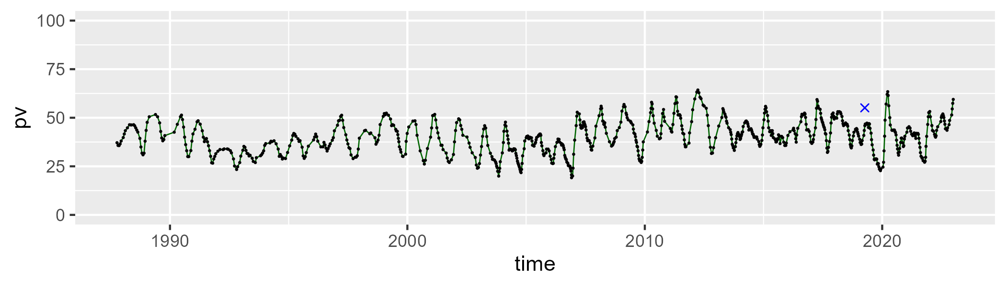

| Min. | 1st Qu. | Median | Mean | 3rd Qu. | Max. |
| --- | --- | --- | --- | --- | --- |
| 30.15968 | 46.86905 | 51.33104 | 51.26471 | 55.72185 | 69.26714 |

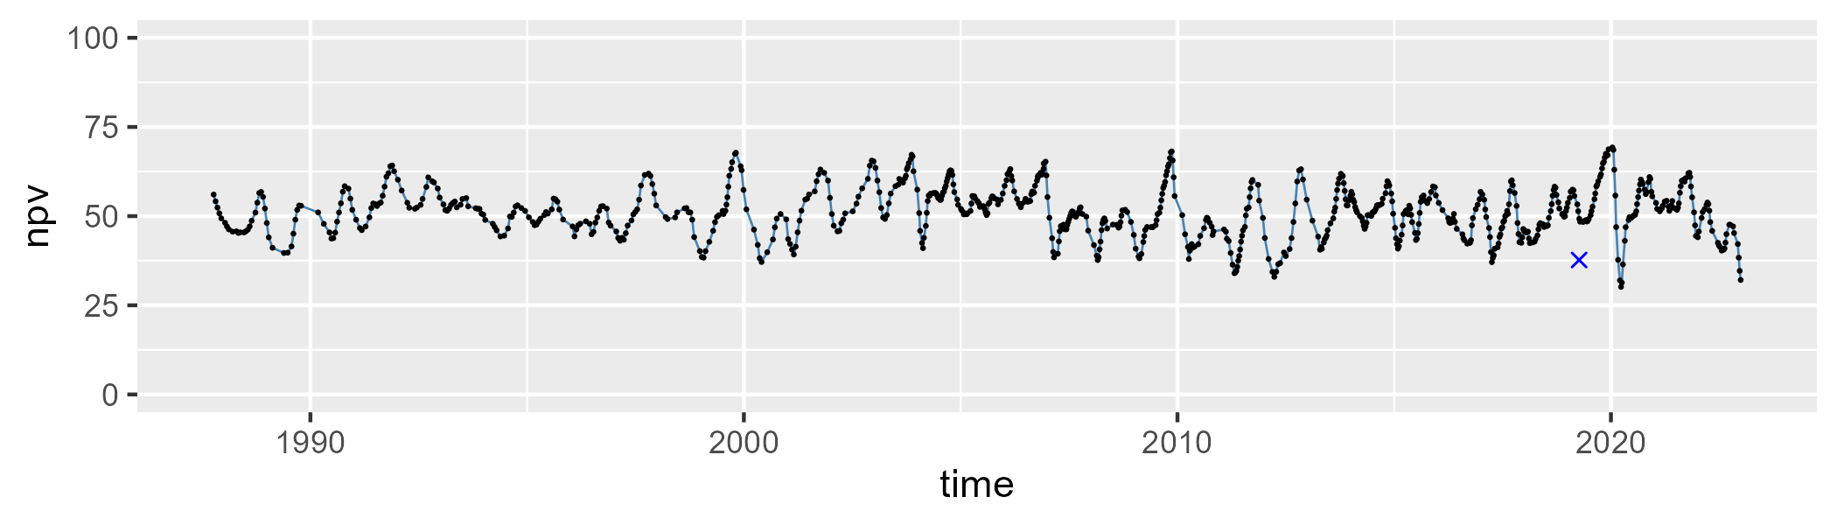

| Min. | 1st Qu. | Median | Mean | 3rd Qu. | Max. |
| --- | --- | --- | --- | --- | --- |
| 0 | 4.47311 | 6.610574 | 7.403756 | 9.747521 | 27.53244 |

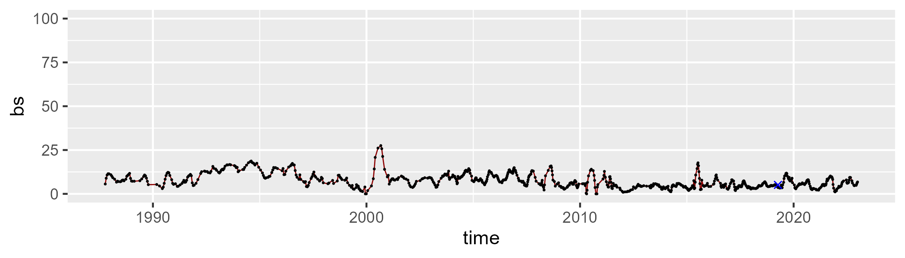

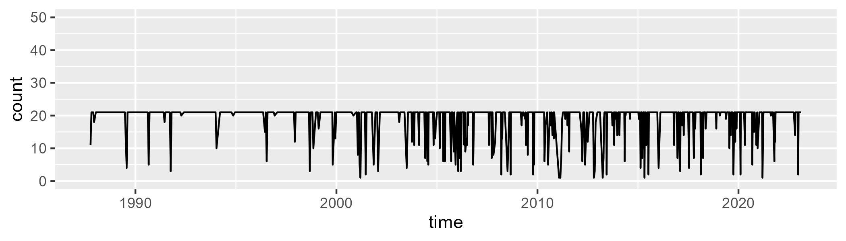

Min. : 1.0 1st Qu.:21.0 Median :21.0 Mean :19.1 3rd Qu.:21.0 Max. :21.0

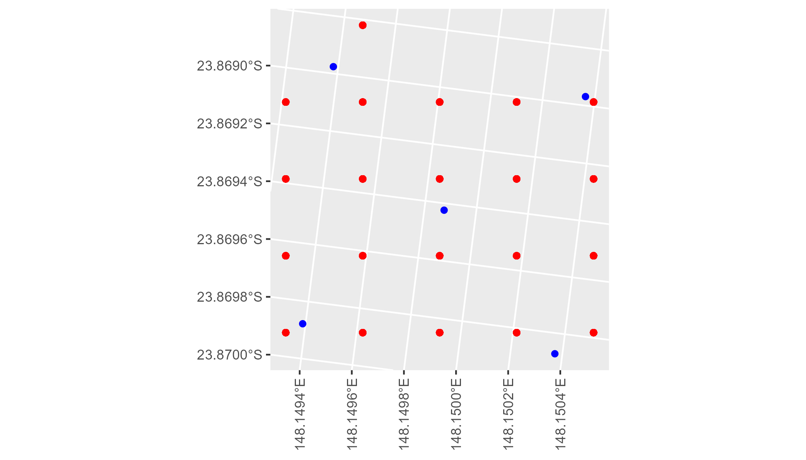

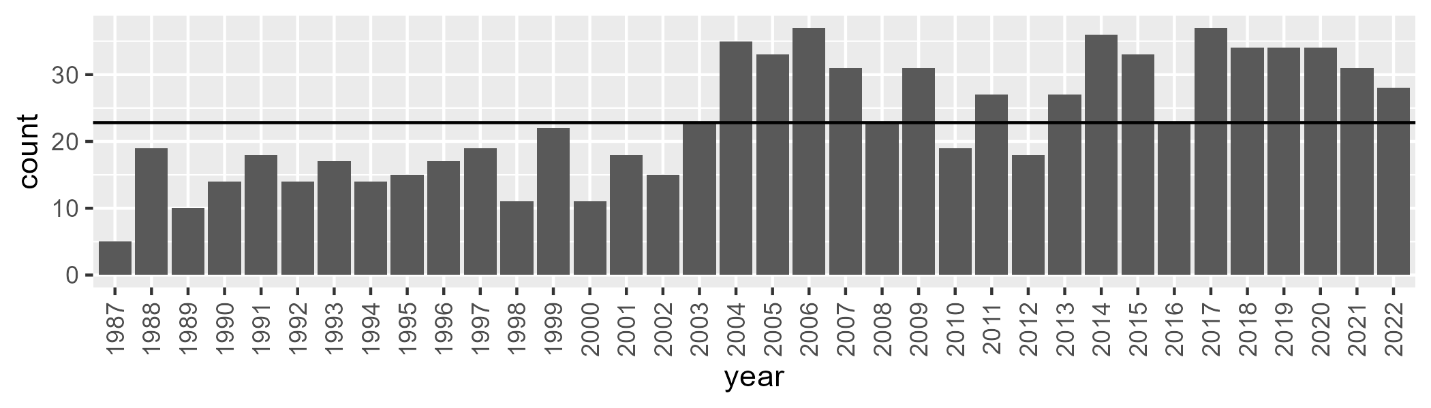

Number of samples: 833

# QDABBS0001

| Min. | 1st Qu. | Median | Mean | 3rd Qu. | Max. |
| --- | --- | --- | --- | --- | --- |
| 0 | 10.19277 | 25.16104 | 27.85072 | 42.97799 | 86.70776 |

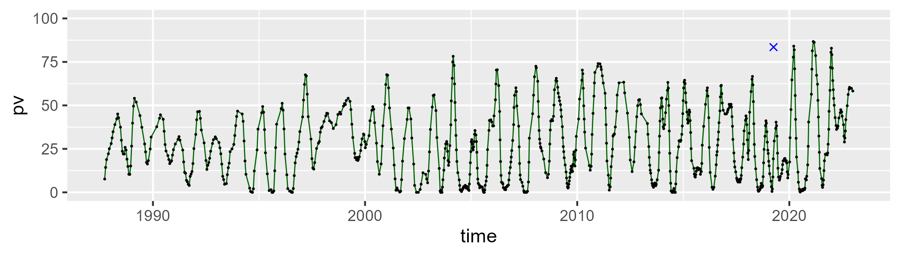

| Min. | 1st Qu. | Median | Mean | 3rd Qu. | Max. |
| --- | --- | --- | --- | --- | --- |
| 6.11411 | 42.94164 | 54.40823 | 56.01191 | 71.3478 | 91.74318 |

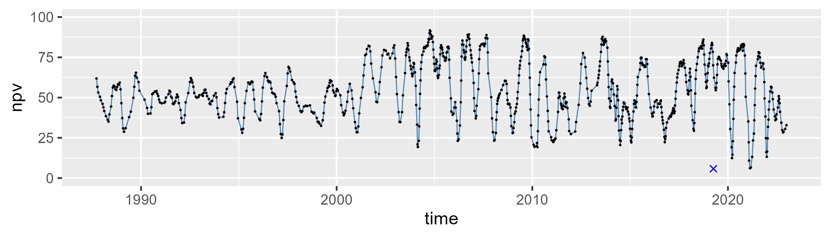

| Min. | 1st Qu. | Median | Mean | 3rd Qu. | Max. |
| --- | --- | --- | --- | --- | --- |
| 0 | 7.082281 | 13.07747 | 14.98361 | 19.28103 | 78.55145 |

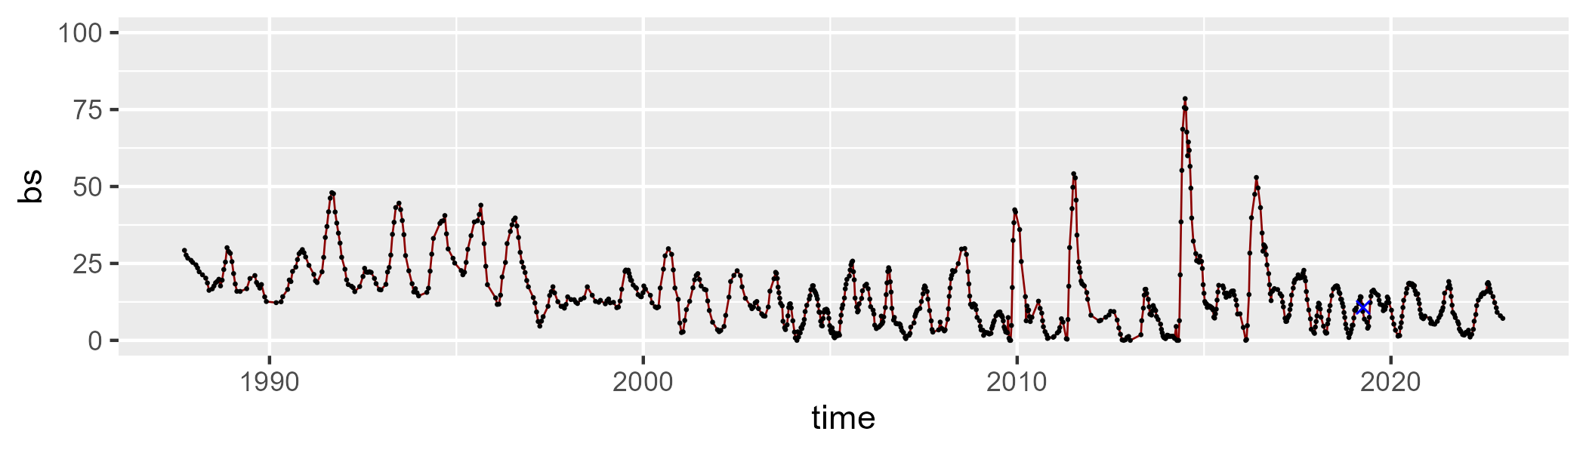

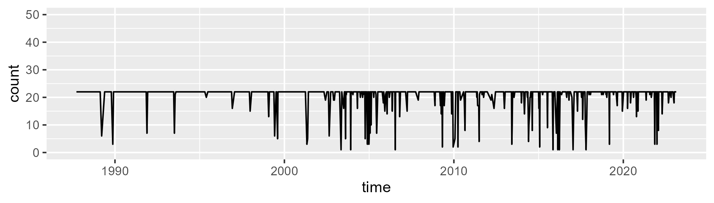

Min. : 1.0 1st Qu.:22.0 Median :22.0 Mean :20.7 3rd Qu.:22.0 Max. :22.0

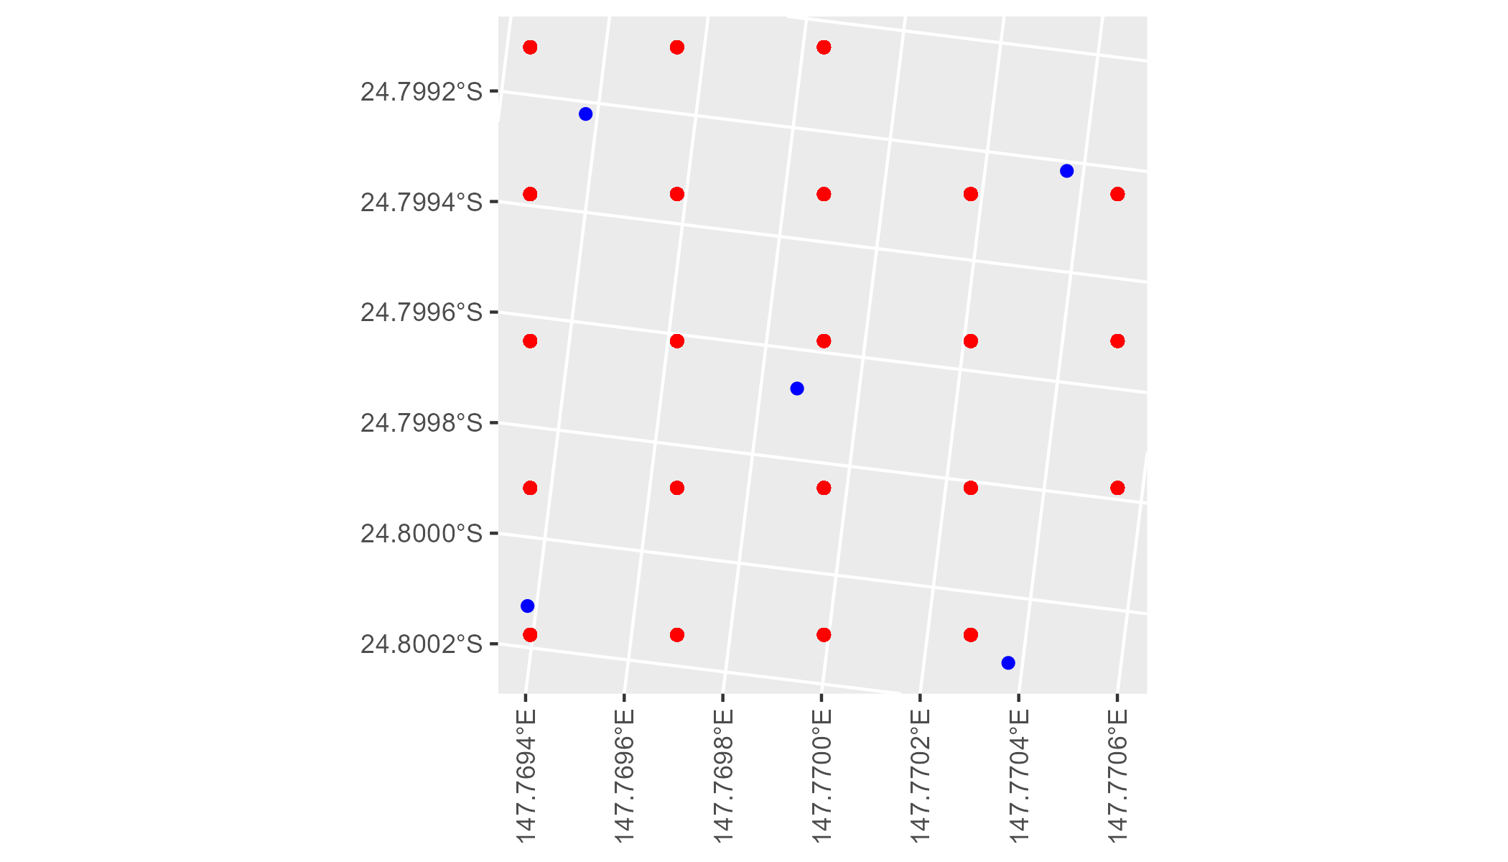

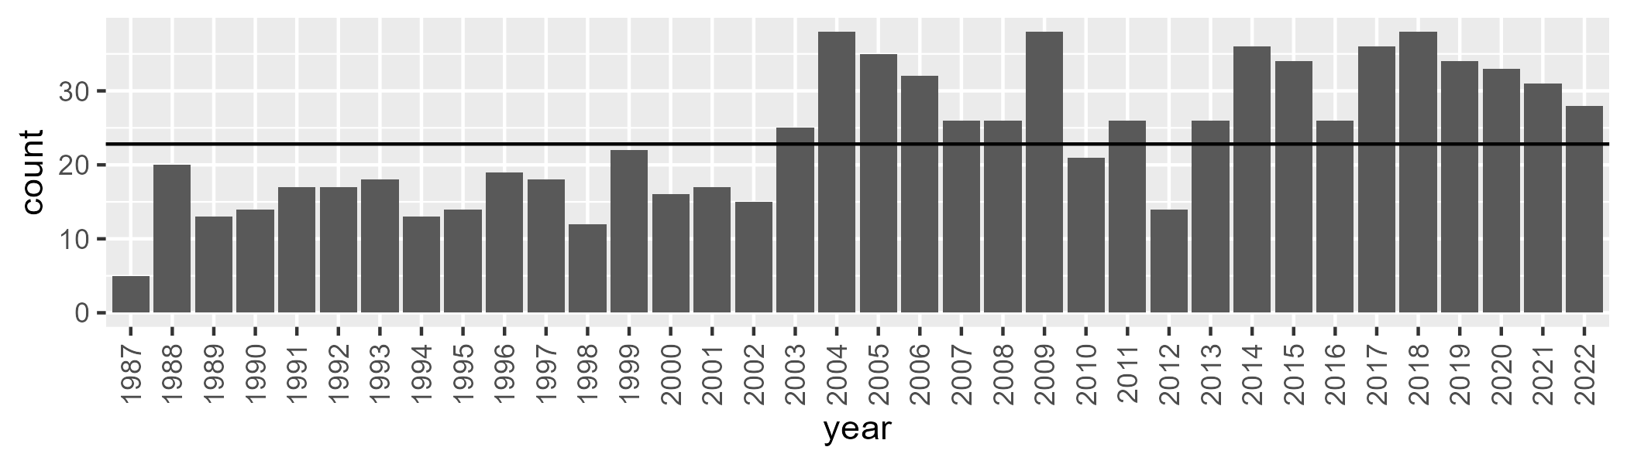

Number of samples: 853

# QDABBS0002

| Min. | 1st Qu. | Median | Mean | 3rd Qu. | Max. |
| --- | --- | --- | --- | --- | --- |
| 0 | 11.62747 | 23.41006 | 27.54603 | 39.93411 | 83.32568 |

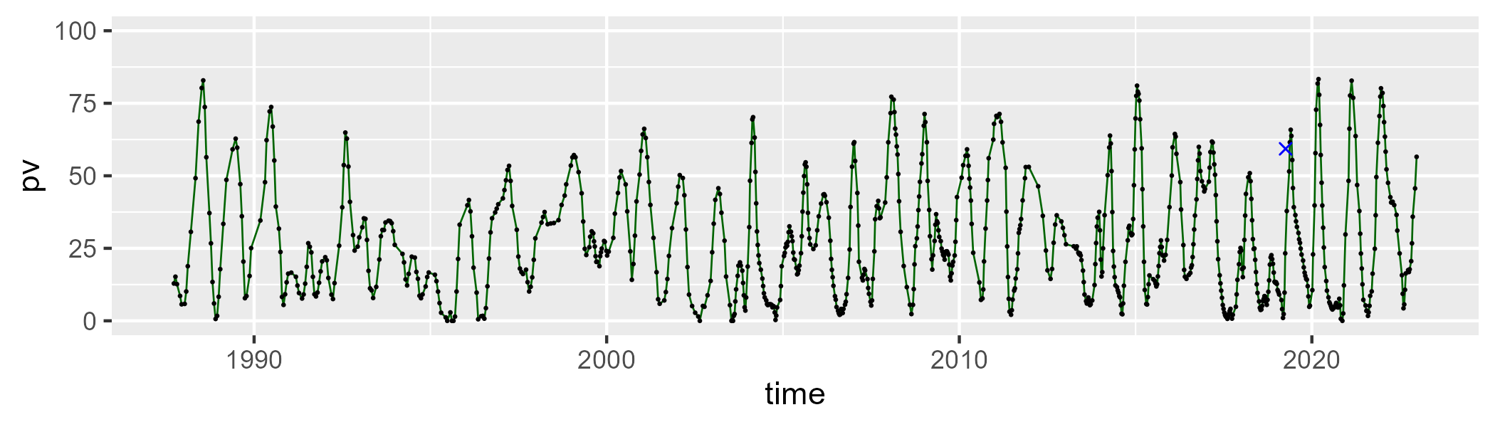

| Min. | 1st Qu. | Median | Mean | 3rd Qu. | Max. |
| --- | --- | --- | --- | --- | --- |
| 8.498635 | 36.52892 | 47.03855 | 47.94299 | 60.28974 | 90.52595 |

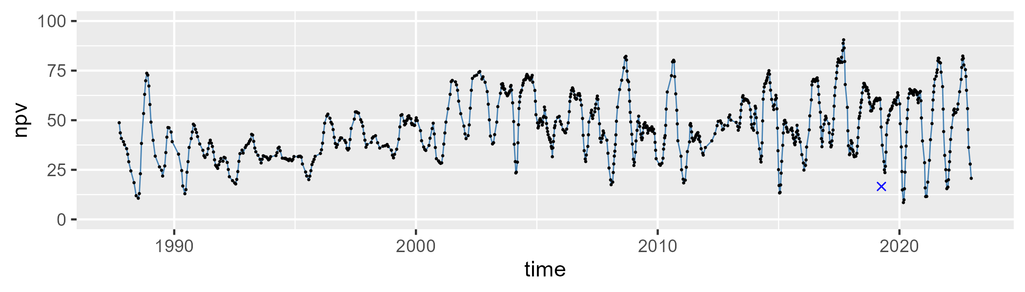

| Min. | 1st Qu. | Median | Mean | 3rd Qu. | Max. |
| --- | --- | --- | --- | --- | --- |
| 0 | 12.46078 | 21.84746 | 23.19612 | 30.65928 | 78.81629 |

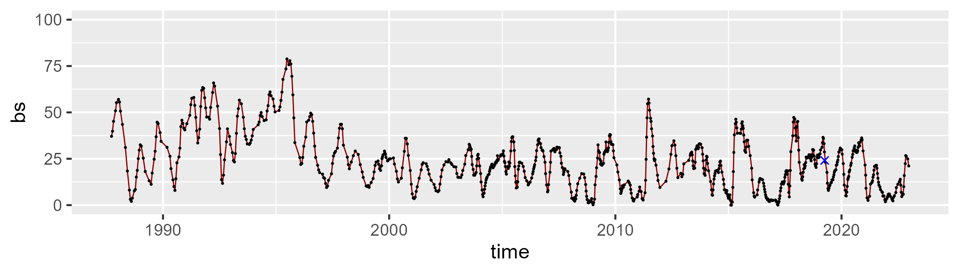

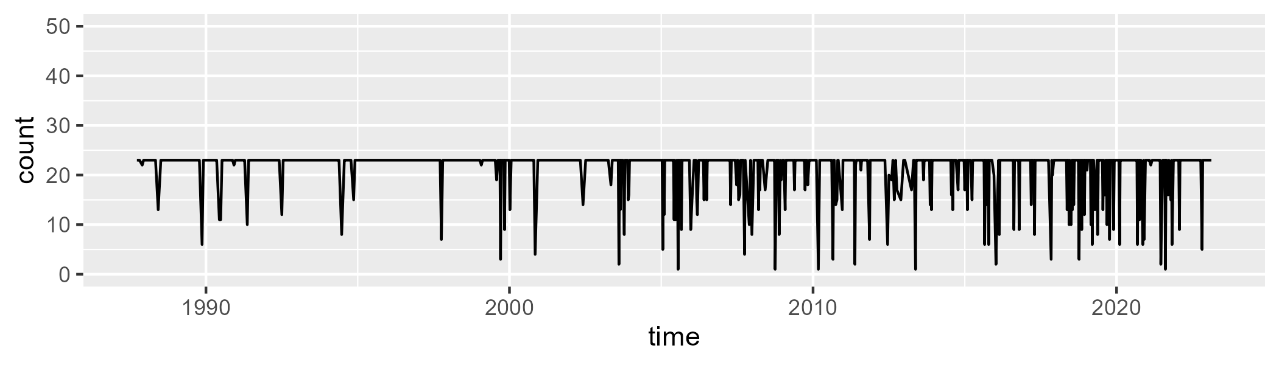

Min. : 1.00 1st Qu.:23.00 Median :23.00 Mean :21.37 3rd Qu.:23.00 Max. :23.00

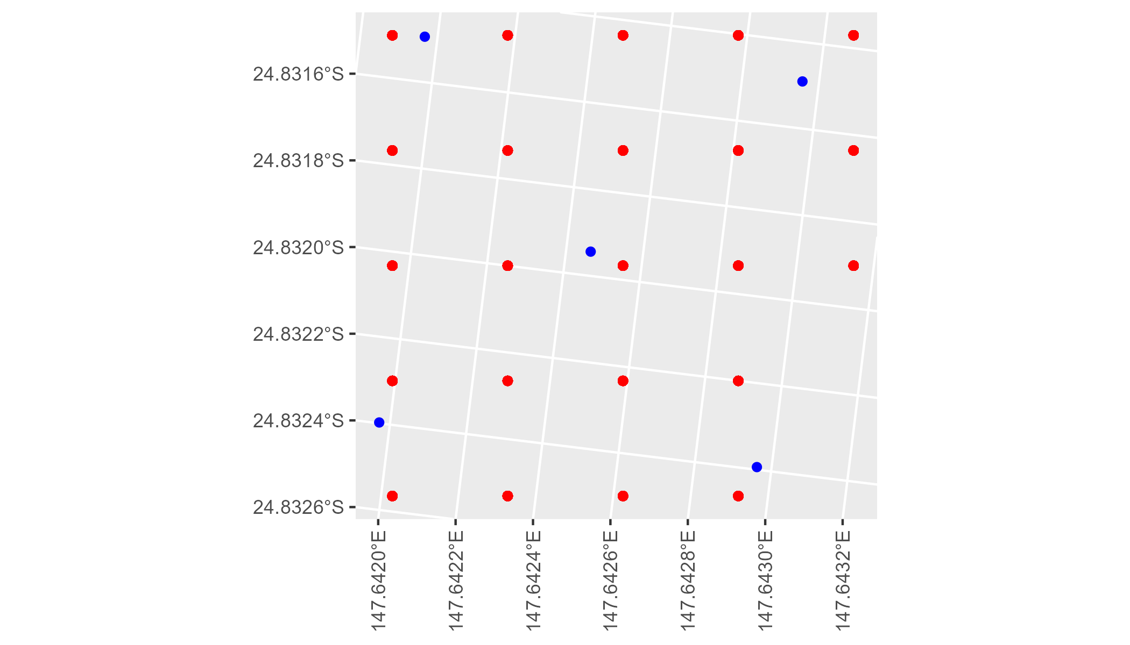

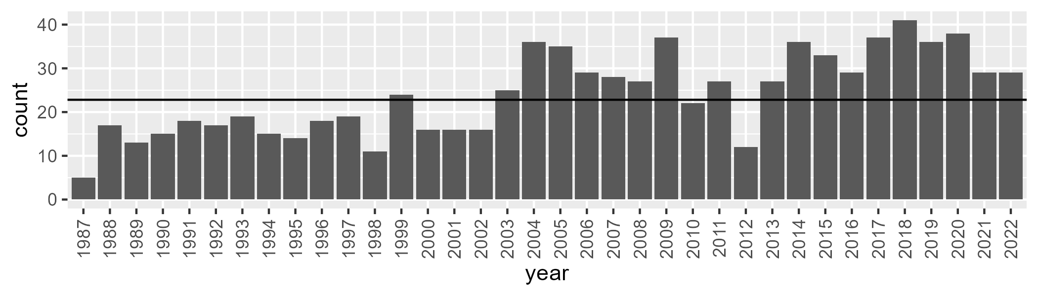

Number of samples: 866

# QDABBS0003

| Min. | 1st Qu. | Median | Mean | 3rd Qu. | Max. |
| --- | --- | --- | --- | --- | --- |
| 27.51006 | 43.1306 | 46.88066 | 47.32176 | 51.11931 | 66.28982 |

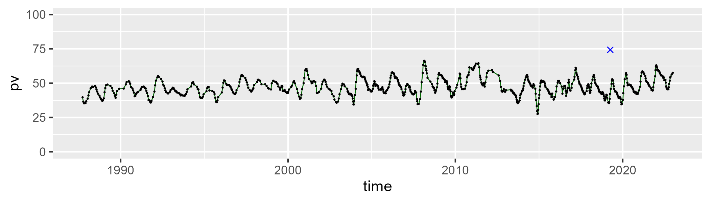

| Min. | 1st Qu. | Median | Mean | 3rd Qu. | Max. |
| --- | --- | --- | --- | --- | --- |
| 21.96964 | 39.78981 | 43.73777 | 43.31685 | 47.02433 | 56.57399 |

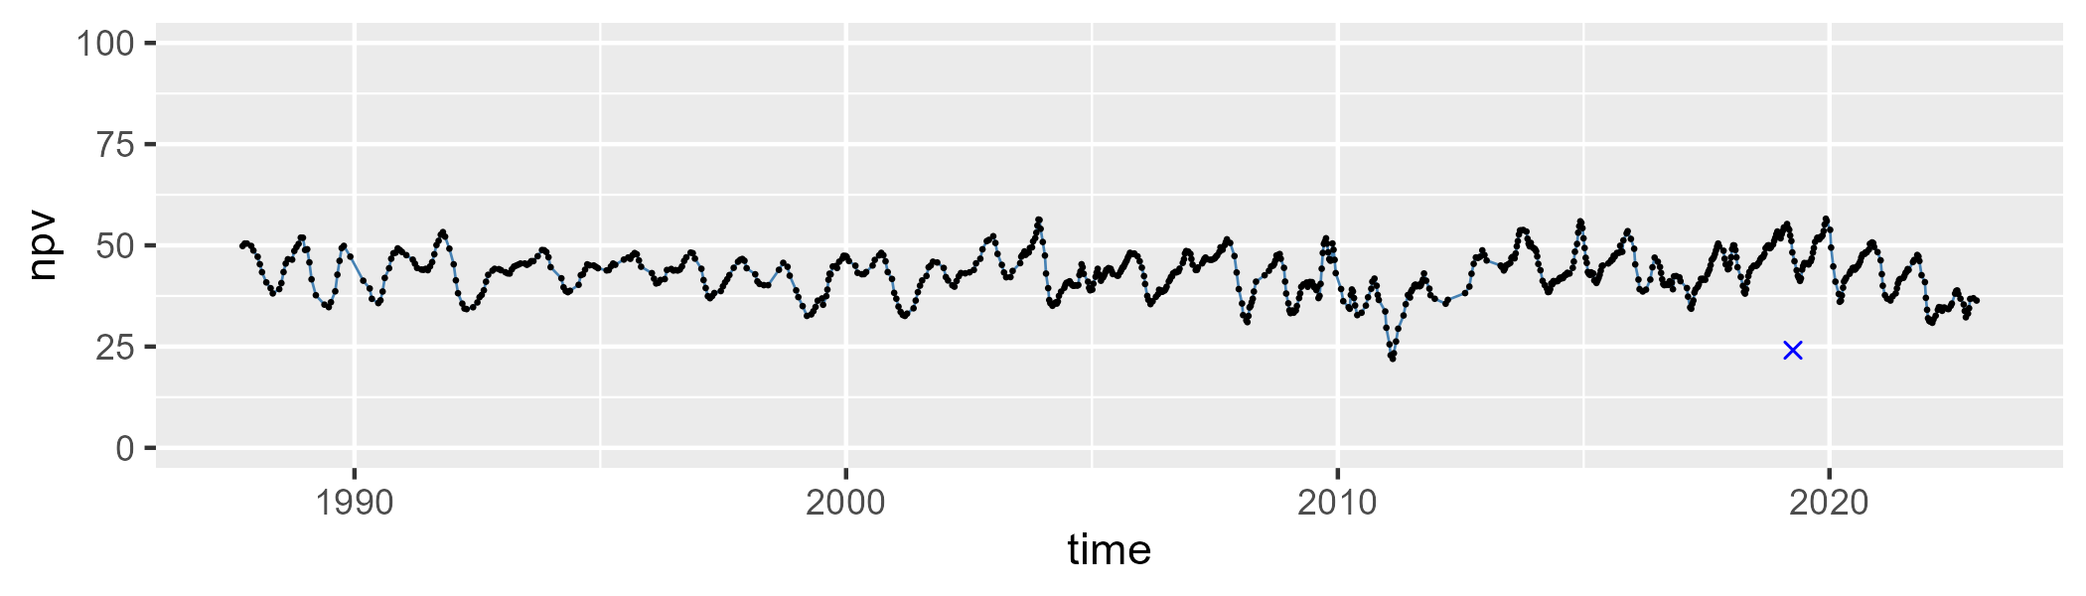

| Min. | 1st Qu. | Median | Mean | 3rd Qu. | Max. |
| --- | --- | --- | --- | --- | --- |
| 0 | 6.042629 | 7.657948 | 8.054853 | 9.611759 | 20.32479 |

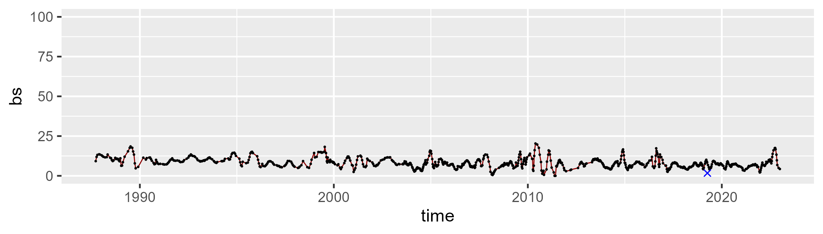

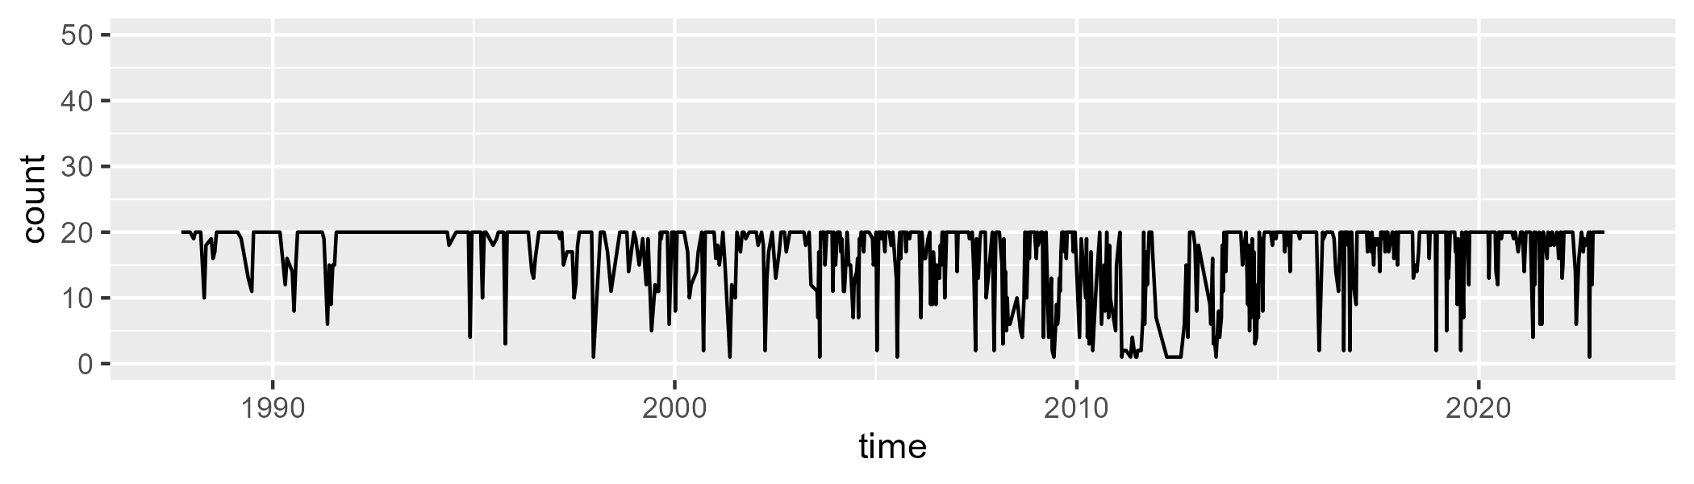

Min. : 1.00 1st Qu.:16.00 Median :20.00 Mean :16.86 3rd Qu.:20.00 Max. :20.00

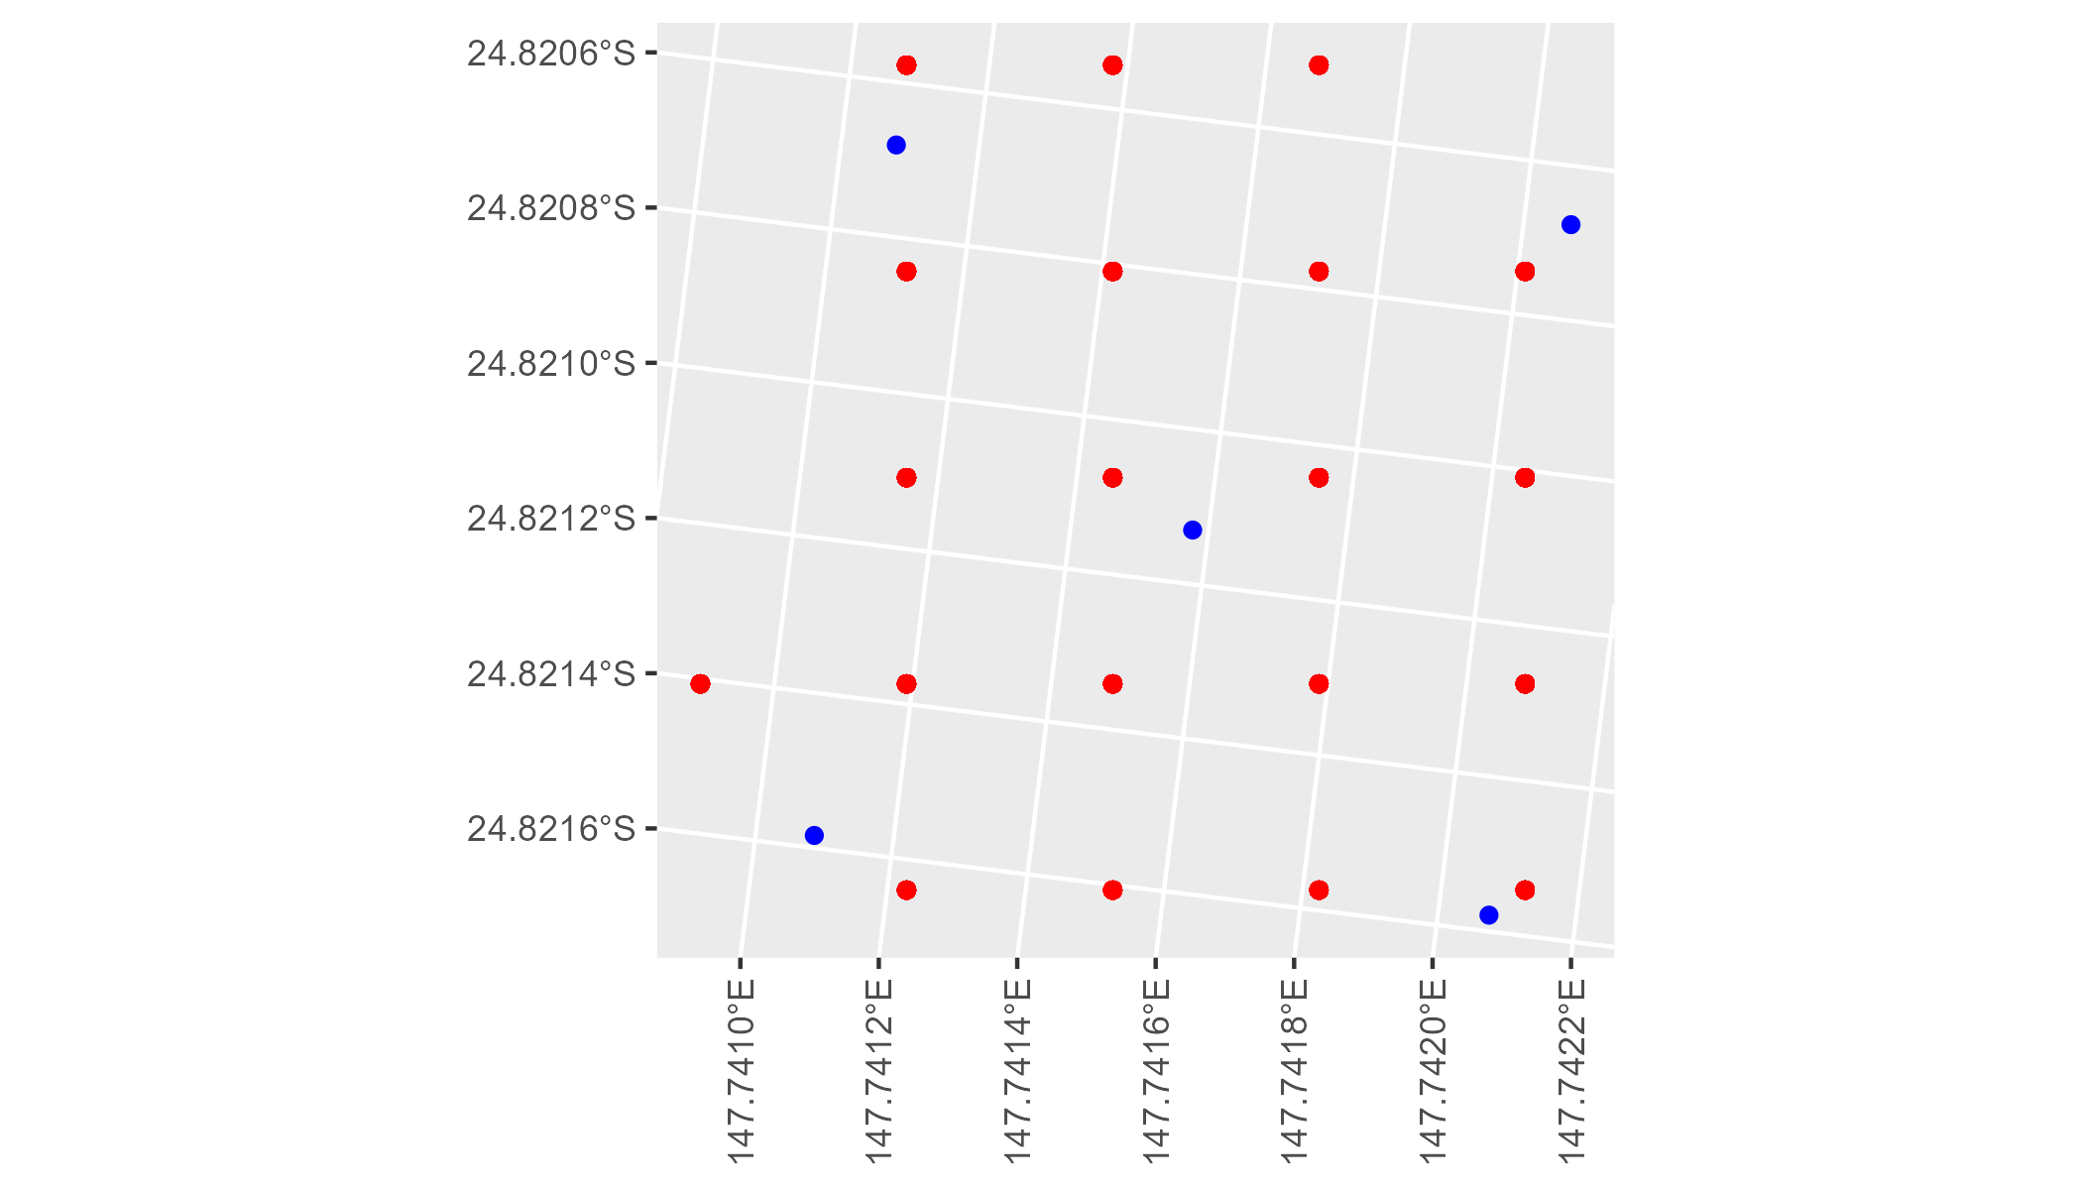

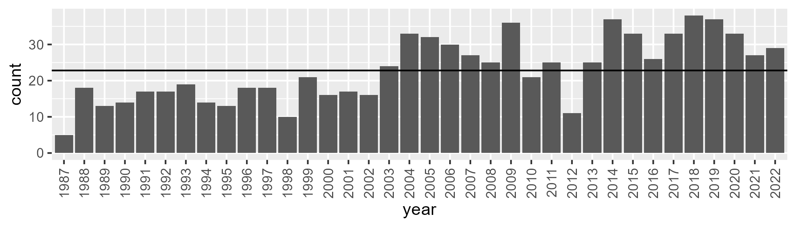

Number of samples: 828

# QDABBS0004

| Min. | 1st Qu. | Median | Mean | 3rd Qu. | Max. |
| --- | --- | --- | --- | --- | --- |
| 16.4449 | 31.12484 | 38.43578 | 40.04808 | 47.77027 | 75.56223 |

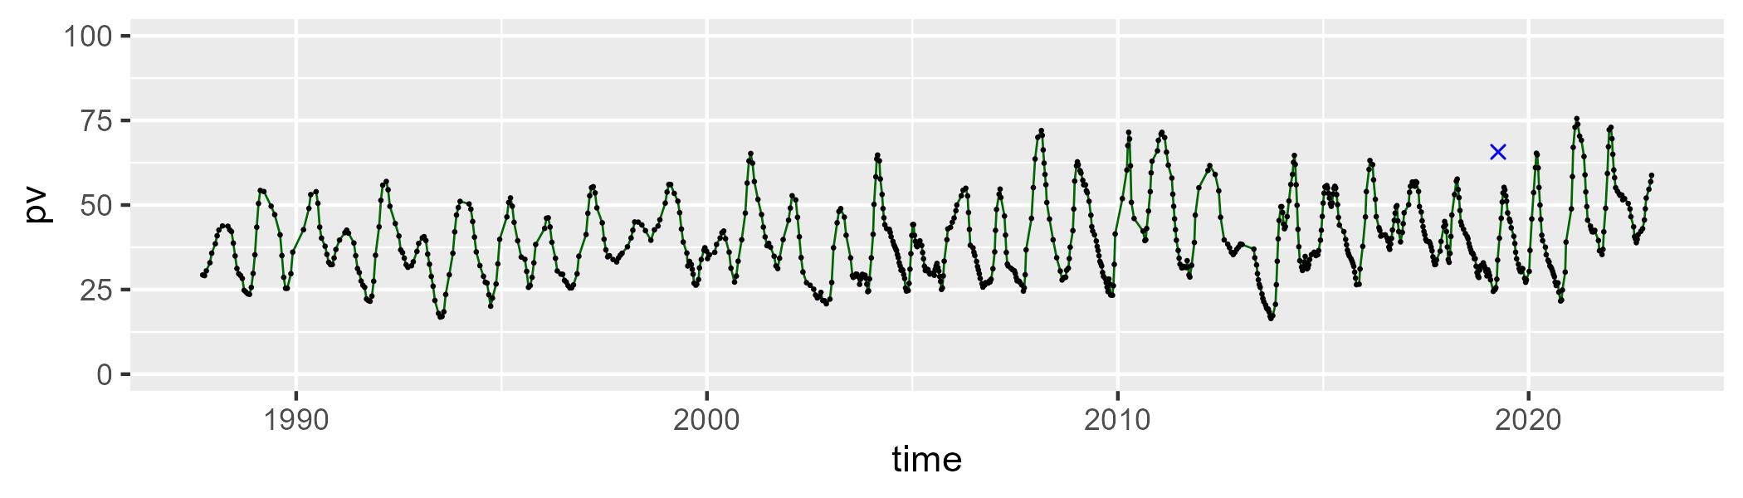

| Min. | 1st Qu. | Median | Mean | 3rd Qu. | Max. |
| --- | --- | --- | --- | --- | --- |
| 14.15234 | 42.47163 | 49.36937 | 48.41134 | 55.01848 | 74.01175 |

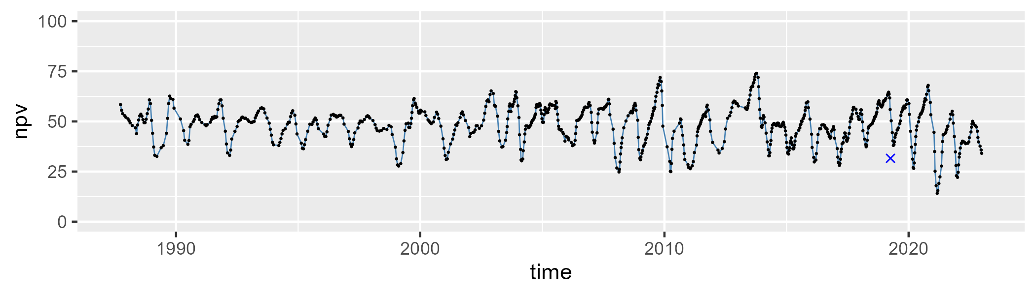

| Min. | 1st Qu. | Median | Mean | 3rd Qu. | Max. |
| --- | --- | --- | --- | --- | --- |
| 0 | 7.064658 | 9.7914 | 10.26615 | 12.89862 | 27.69933 |

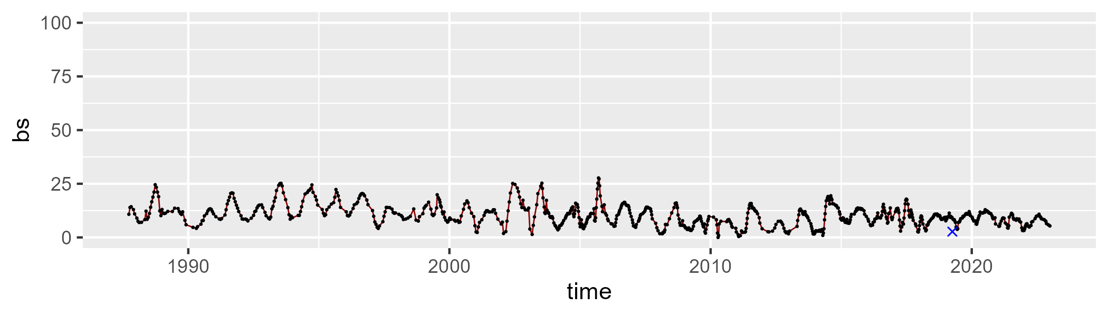

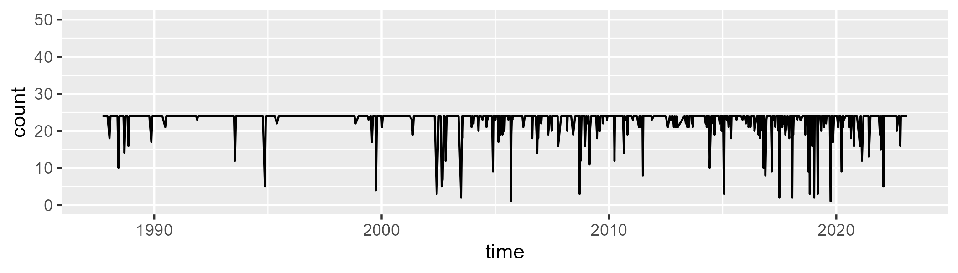

Min. : 1.0 1st Qu.:24.0 Median :24.0 Mean :22.8 3rd Qu.:24.0 Max. :24.0

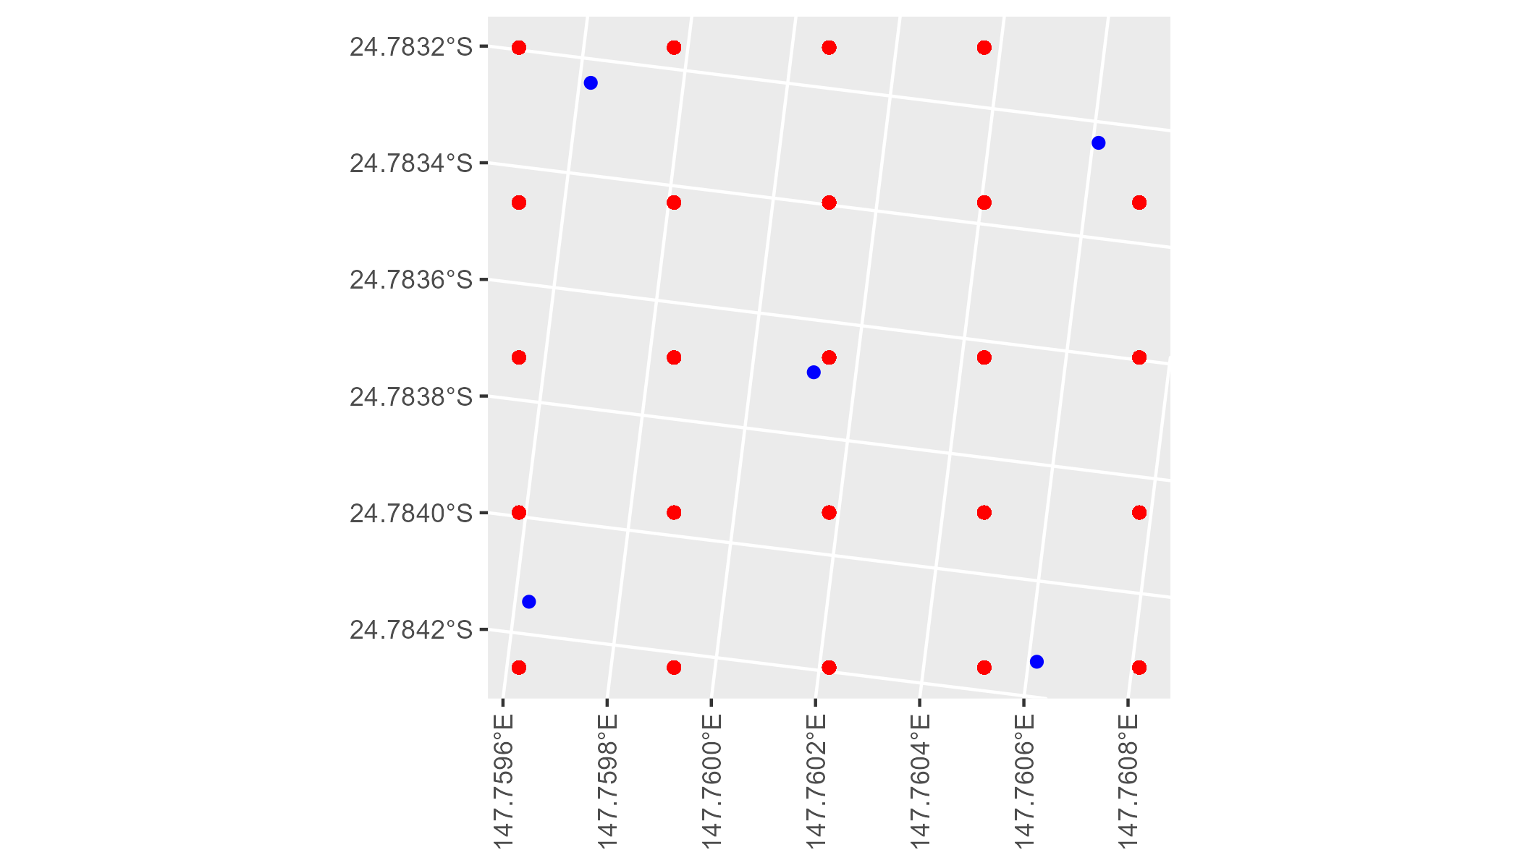

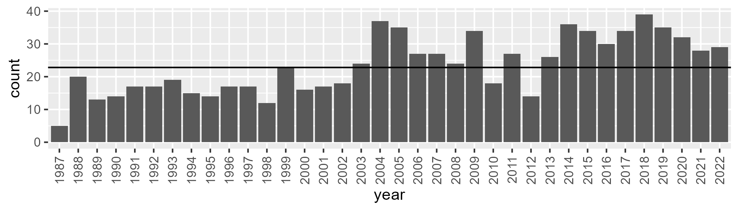

Number of samples: 844

# QDABBS0005

| Min. | 1st Qu. | Median | Mean | 3rd Qu. | Max. |
| --- | --- | --- | --- | --- | --- |
| 23.70993 | 39.042 | 45.22411 | 45.93337 | 52.51272 | 71.17436 |

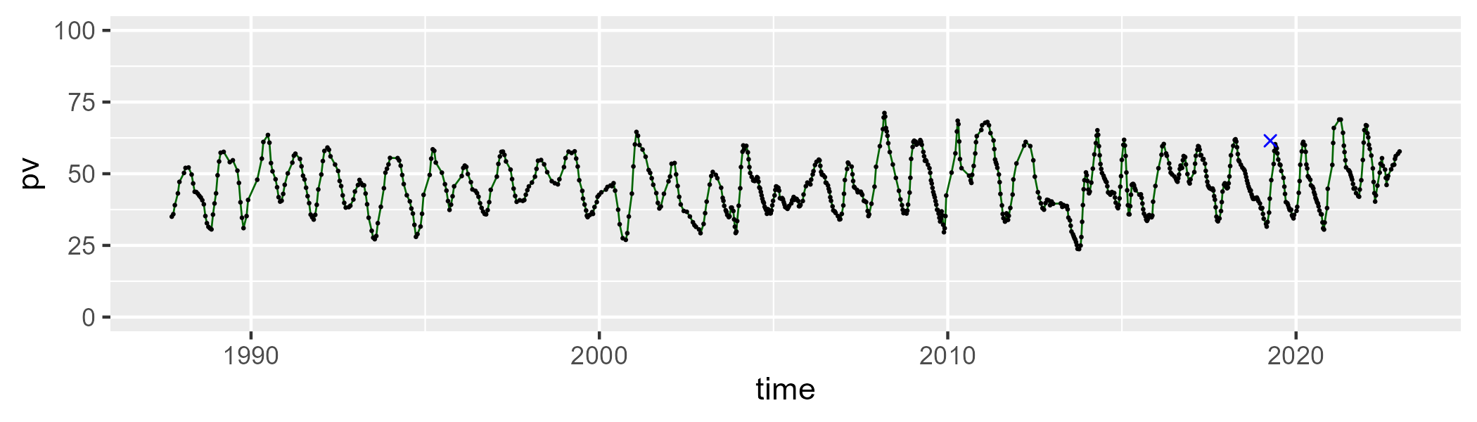

| Min. | 1st Qu. | Median | Mean | 3rd Qu. | Max. |
| --- | --- | --- | --- | --- | --- |
| 26.28471 | 40.76244 | 47.26991 | 46.58089 | 52.24933 | 69.45404 |

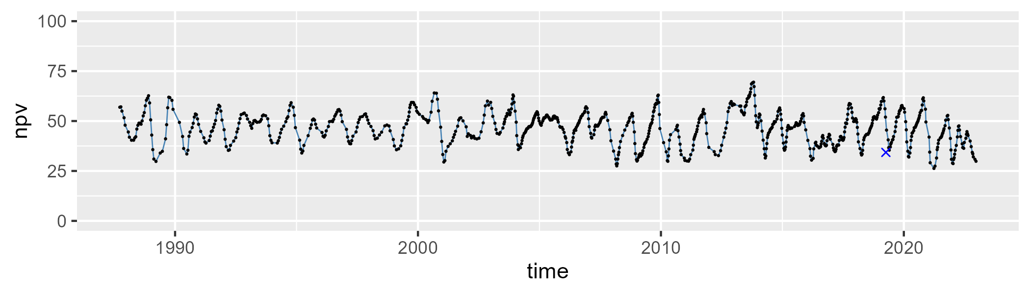

| Min. | 1st Qu. | Median | Mean | 3rd Qu. | Max. |
| --- | --- | --- | --- | --- | --- |
| 0 | 4.062575 | 5.937283 | 6.268574 | 7.870516 | 21.20036 |

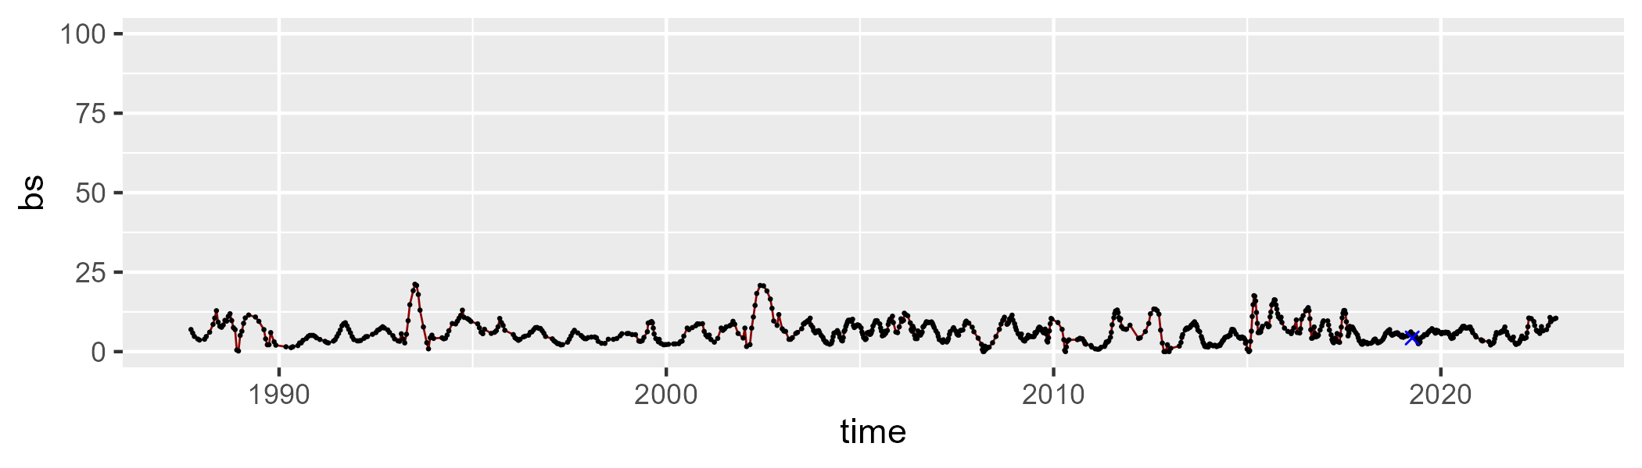

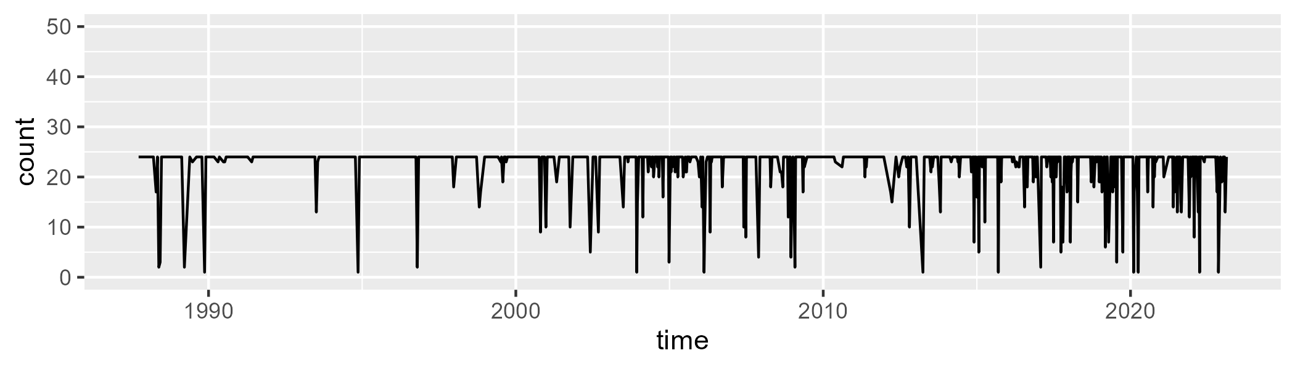

Min. : 1.00 1st Qu.:24.00 Median :24.00 Mean :22.44 3rd Qu.:24.00 Max. :24.00

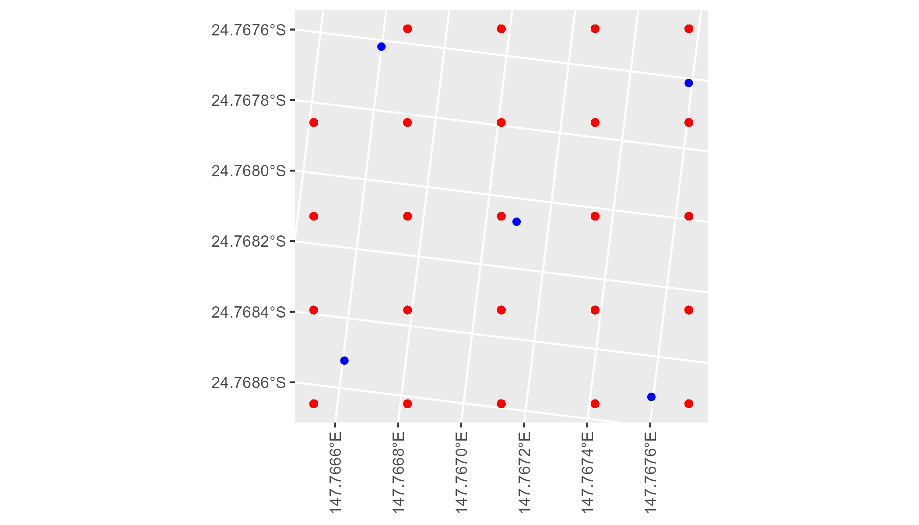

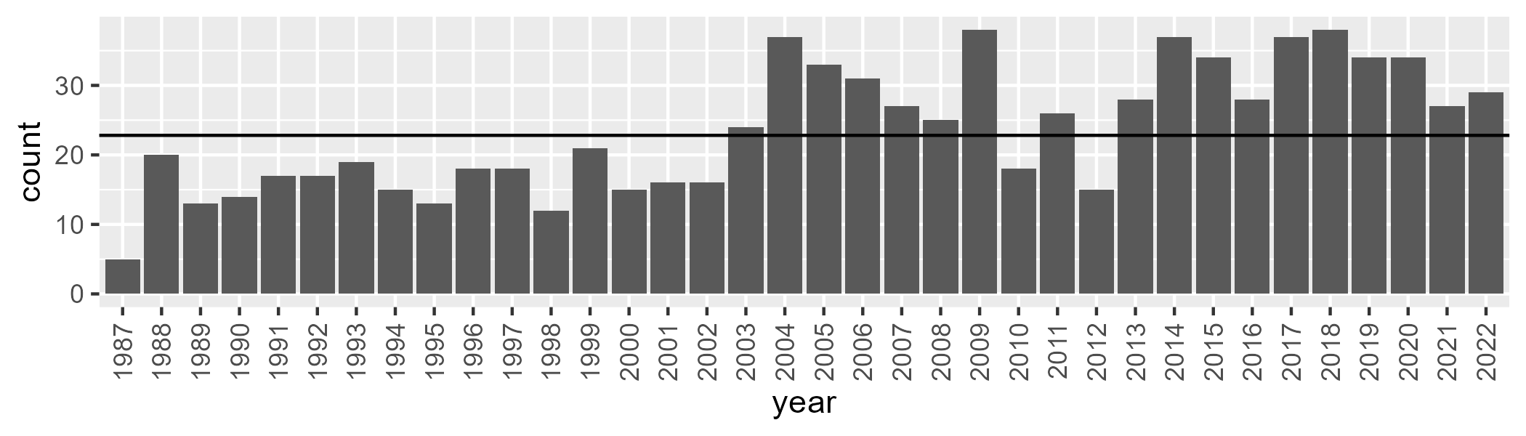

Number of samples: 849

# QDABBS0006

| Min. | 1st Qu. | Median | Mean | 3rd Qu. | Max. |
| --- | --- | --- | --- | --- | --- |
| 14.94456 | 26.61853 | 32.6212 | 33.72673 | 38.73728 | 65.18741 |

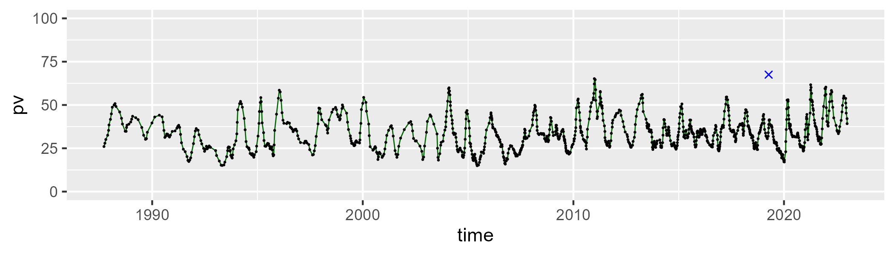

| Min. | 1st Qu. | Median | Mean | 3rd Qu. | Max. |
| --- | --- | --- | --- | --- | --- |
| 22.86597 | 43.1825 | 48.19306 | 47.72749 | 52.24454 | 68.94167 |

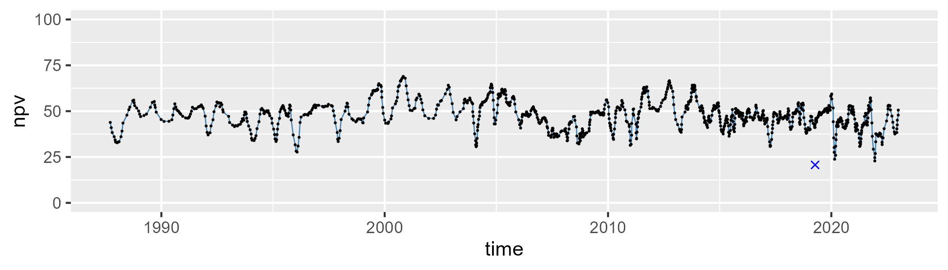

| Min. | 1st Qu. | Median | Mean | 3rd Qu. | Max. |
| --- | --- | --- | --- | --- | --- |
| 1.072629 | 11.46786 | 16.71479 | 17.26821 | 22.34063 | 42.06228 |

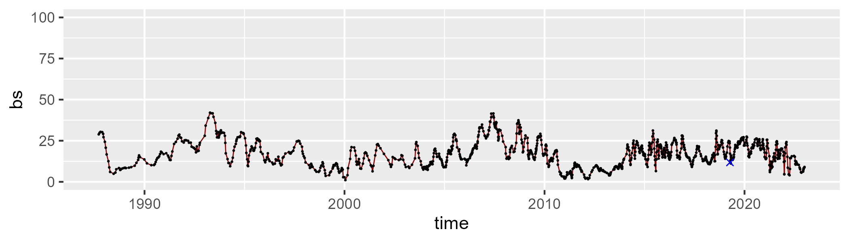

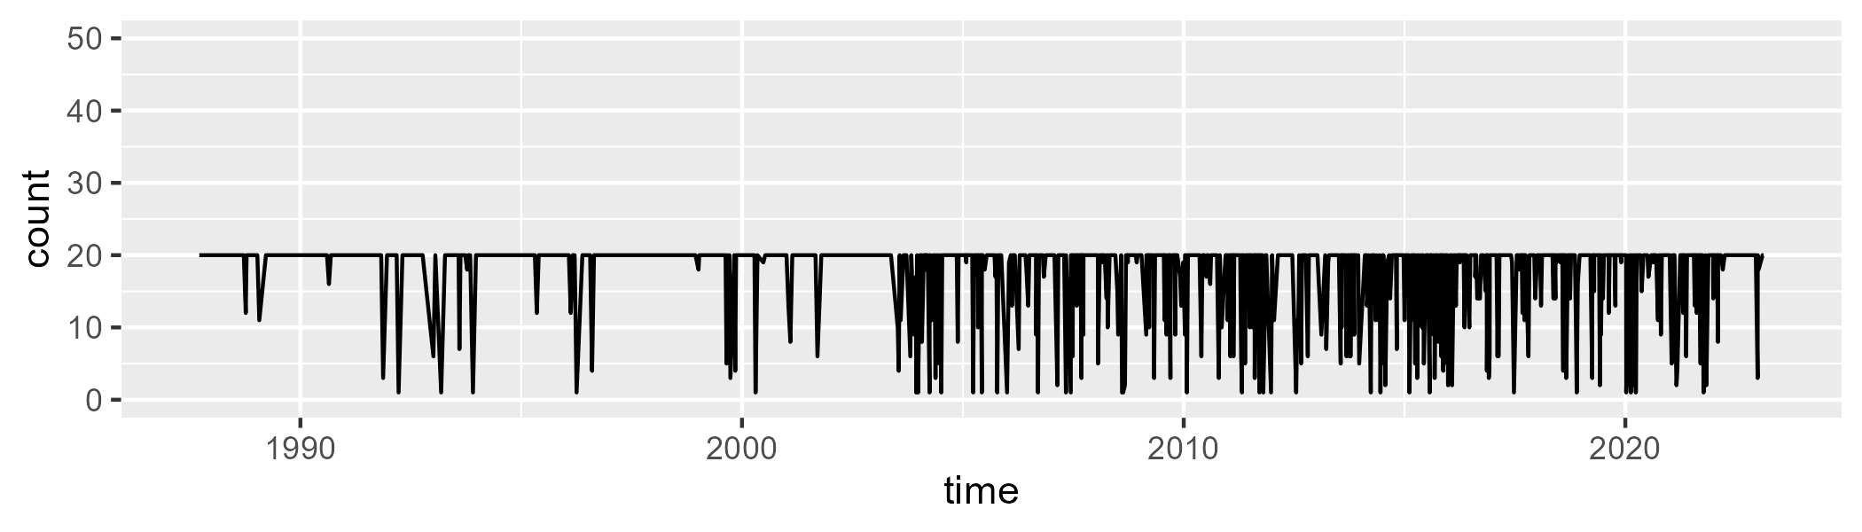

Min. : 1.00 1st Qu.:20.00 Median :20.00 Mean :17.82 3rd Qu.:20.00 Max. :20.00

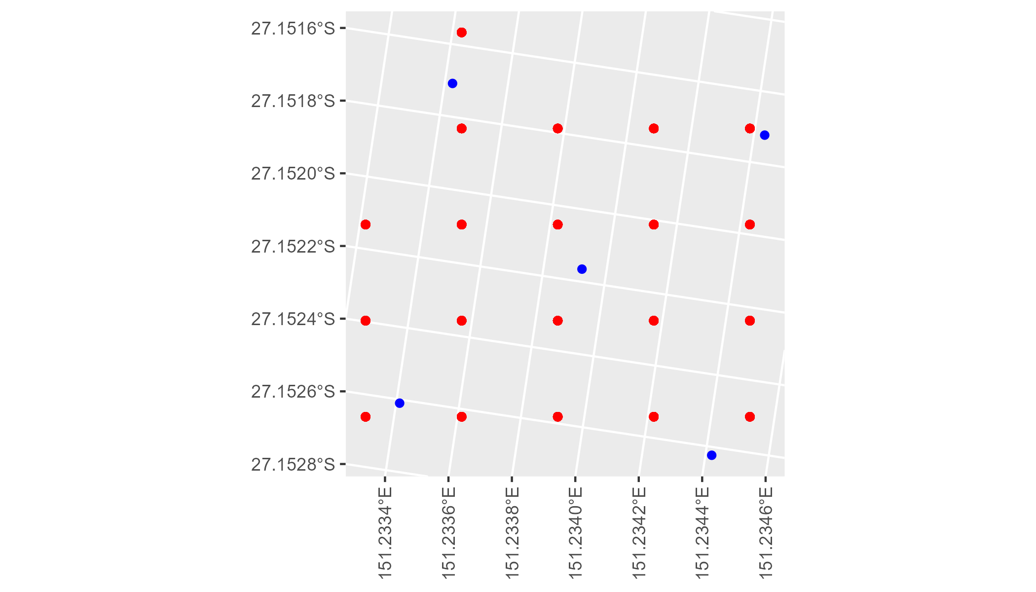

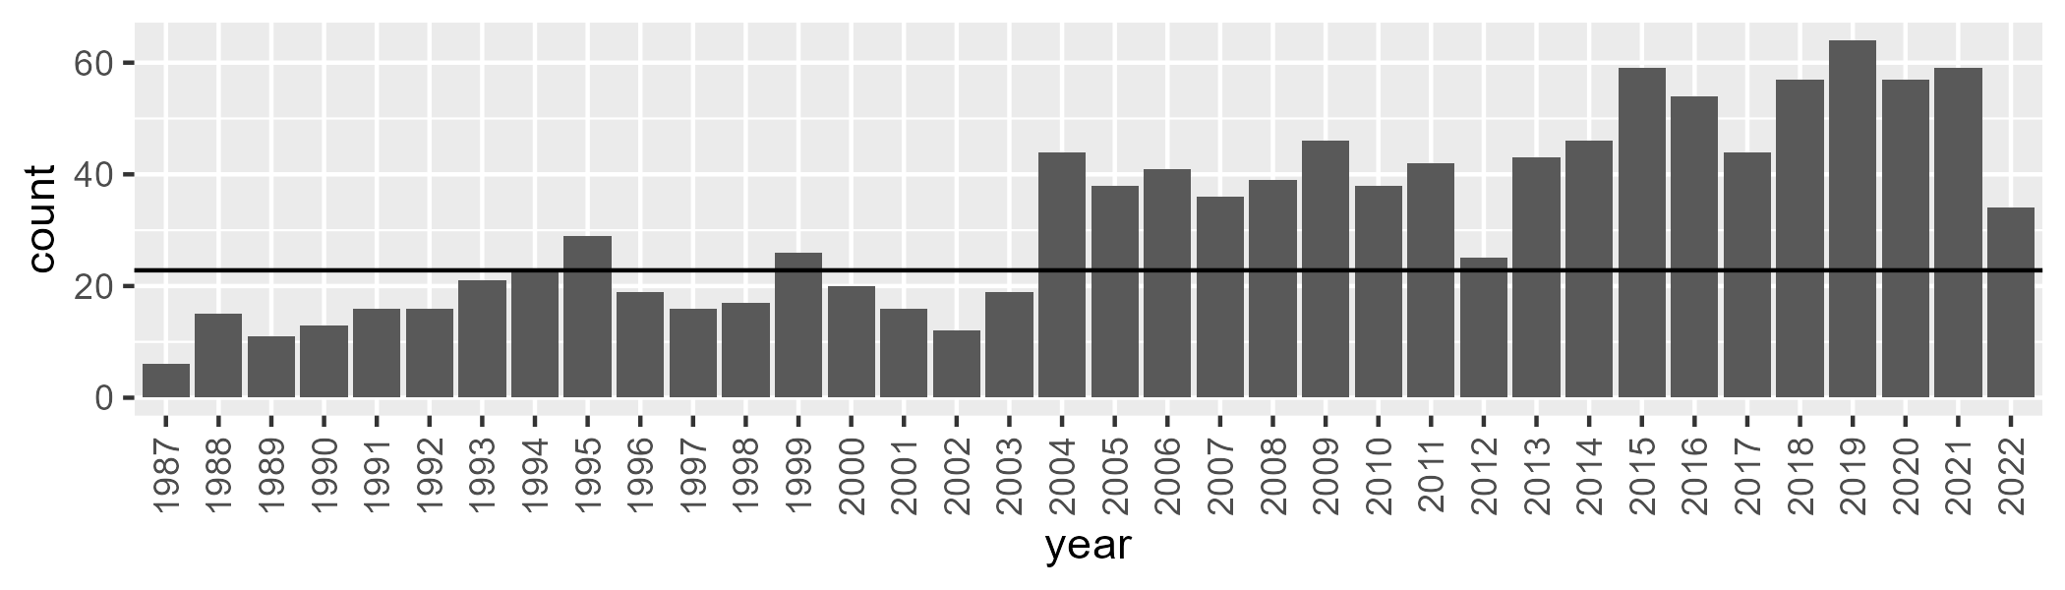

Number of samples: 1161

# QDABBS0007

| Min. | 1st Qu. | Median | Mean | 3rd Qu. | Max. |
| --- | --- | --- | --- | --- | --- |
| 13.41954 | 25.85621 | 33.9764 | 34.4894 | 41.48037 | 62.48092 |

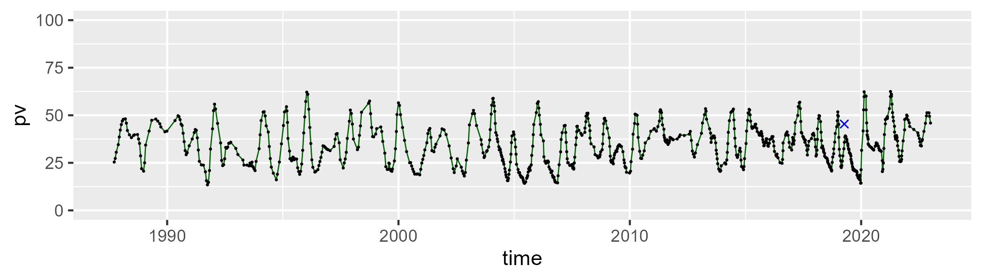

| Min. | 1st Qu. | Median | Mean | 3rd Qu. | Max. |
| --- | --- | --- | --- | --- | --- |
| 22.94564 | 41.90315 | 49.1519 | 48.49623 | 54.45625 | 74.72557 |

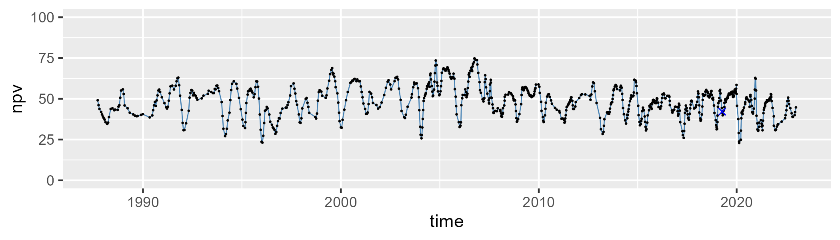

| Min. | 1st Qu. | Median | Mean | 3rd Qu. | Max. |
| --- | --- | --- | --- | --- | --- |
| 2.546133 | 12.18878 | 15.72915 | 15.75737 | 18.99619 | 42.82488 |

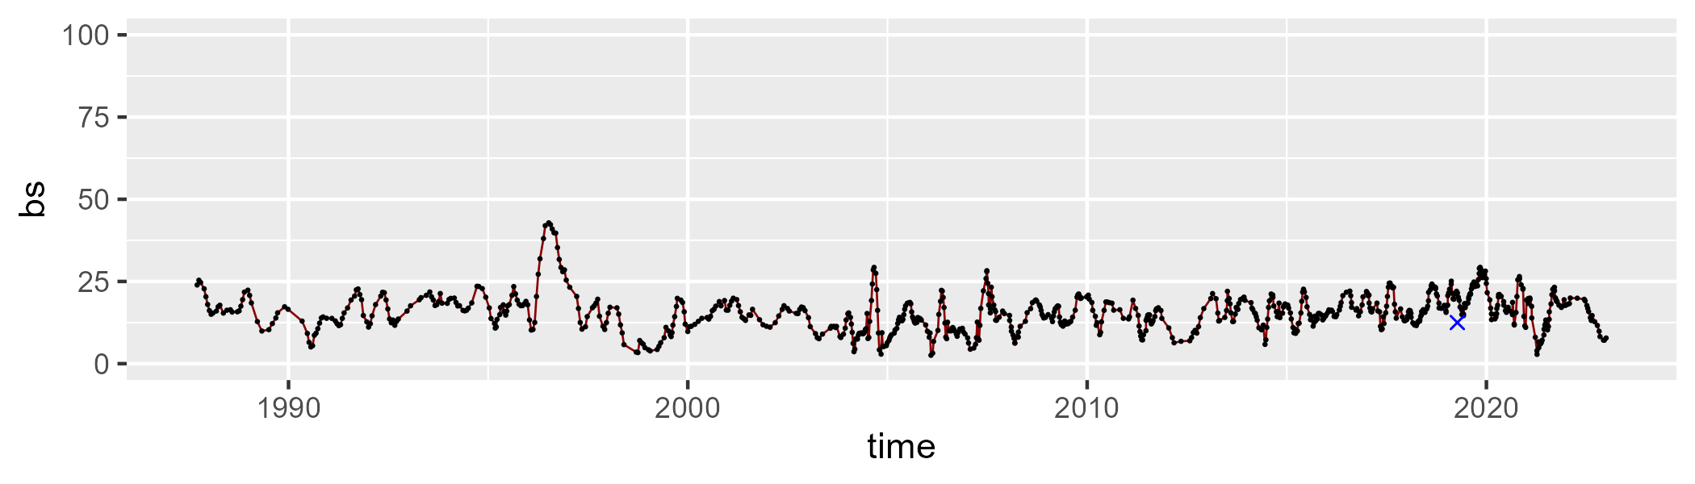

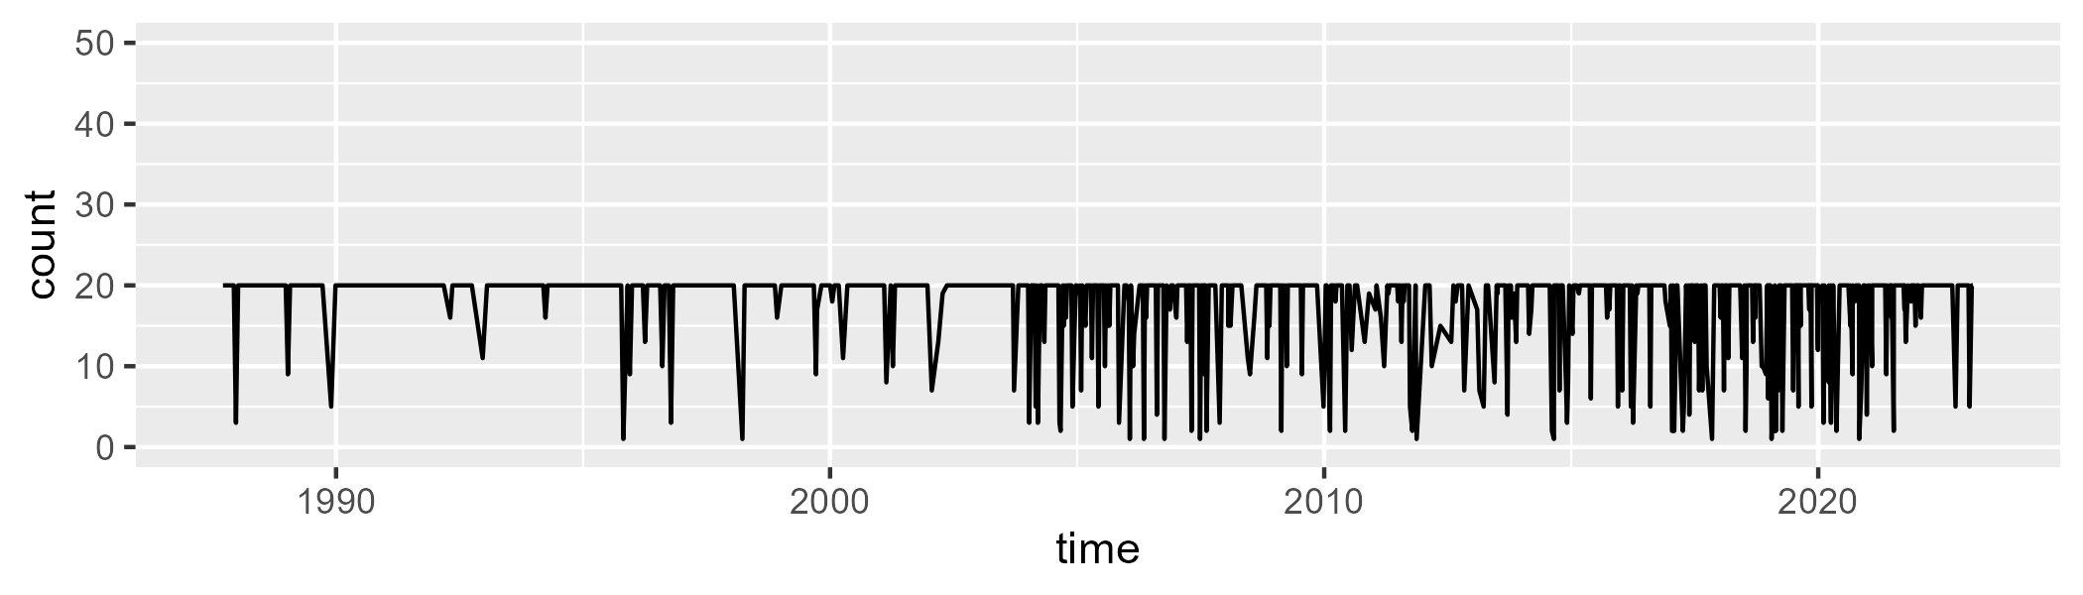

Min. : 1.00 1st Qu.:20.00 Median :20.00 Mean :17.71 3rd Qu.:20.00 Max. :20.00

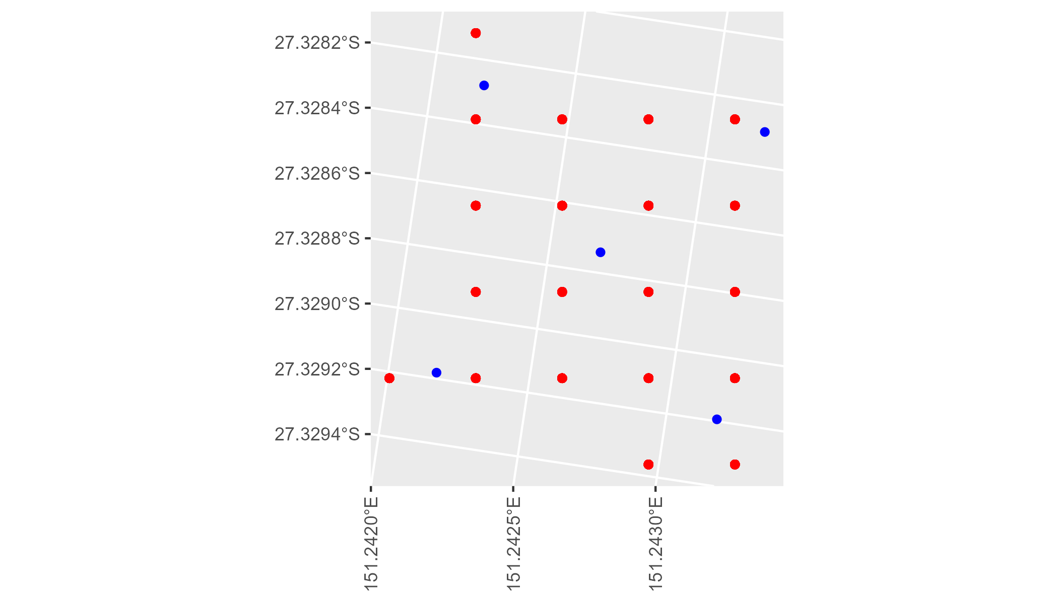

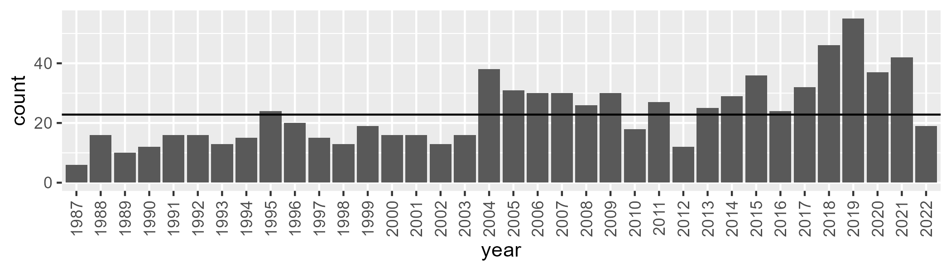

Number of samples: 843

# QDABBS0008

| Min. | 1st Qu. | Median | Mean | 3rd Qu. | Max. |
| --- | --- | --- | --- | --- | --- |
| 10.25813 | 25.45279 | 35.99999 | 36.81936 | 46.33321 | 77.95375 |

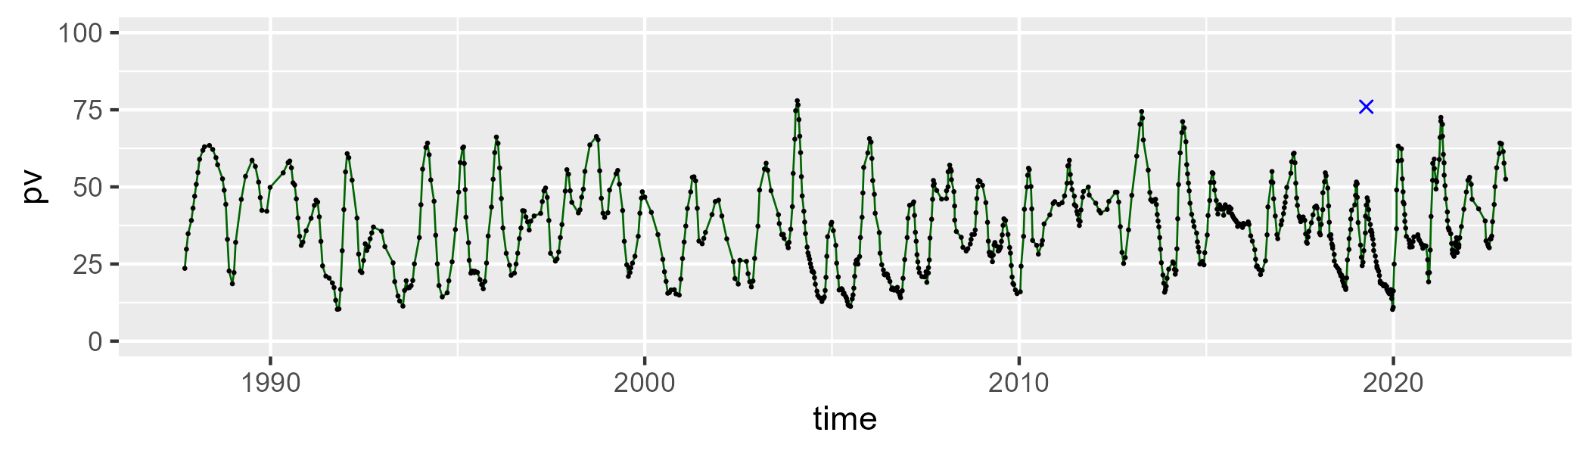

| Min. | 1st Qu. | Median | Mean | 3rd Qu. | Max. |
| --- | --- | --- | --- | --- | --- |
| 13.67918 | 37.7499 | 46.64313 | 46.58578 | 55.11725 | 77.82146 |

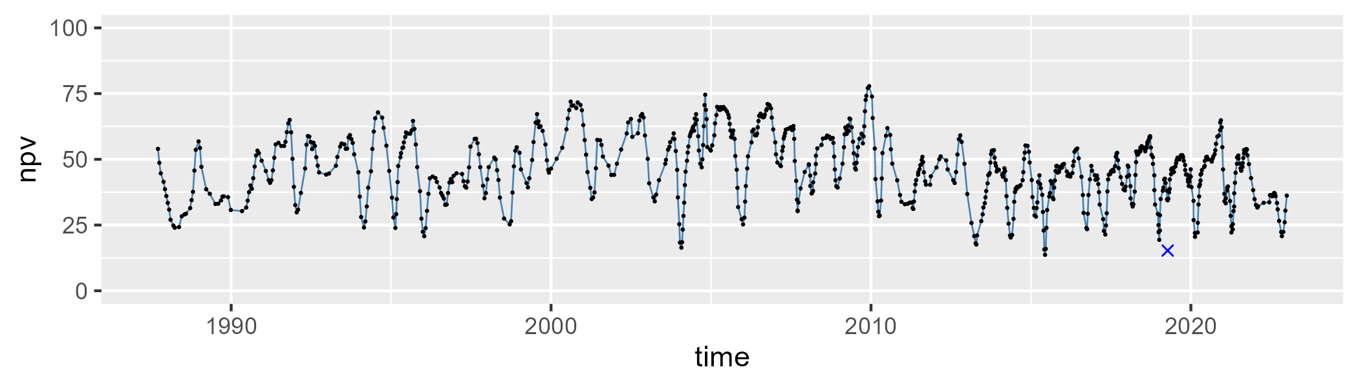

| Min. | 1st Qu. | Median | Mean | 3rd Qu. | Max. |
| --- | --- | --- | --- | --- | --- |
| 1.75891 | 9.901243 | 13.88741 | 15.31051 | 18.78126 | 44.84851 |

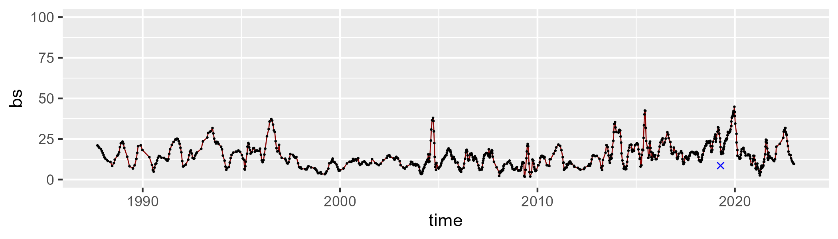

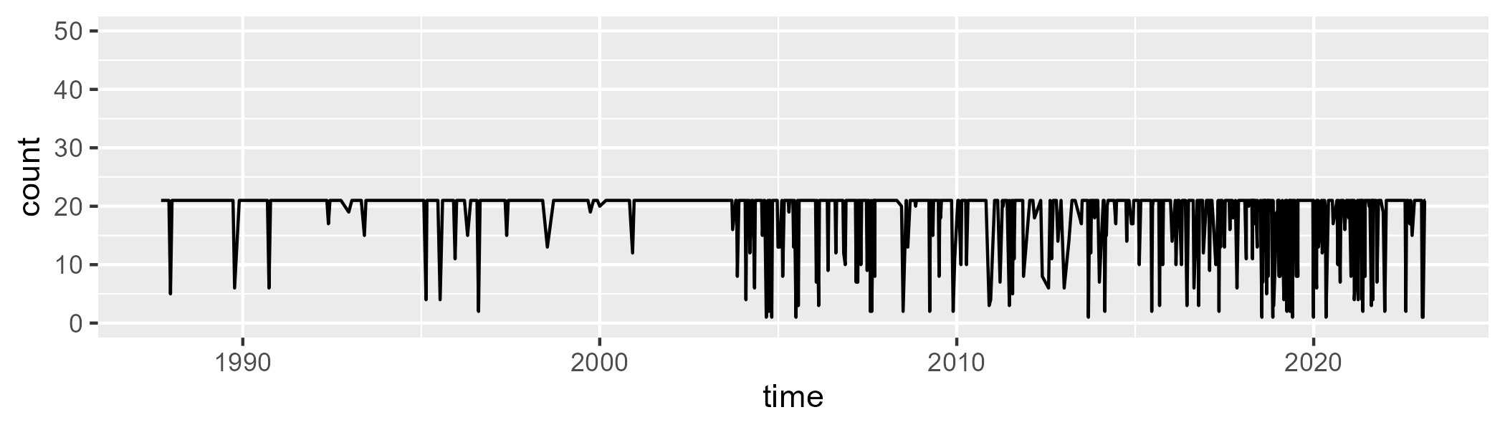

Min. : 1.00 1st Qu.:21.00 Median :21.00 Mean :18.75 3rd Qu.:21.00 Max. :21.00

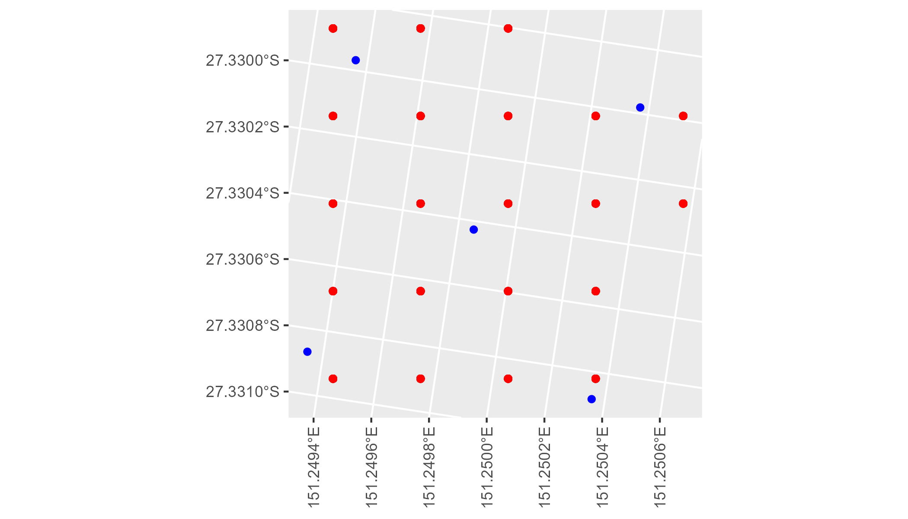

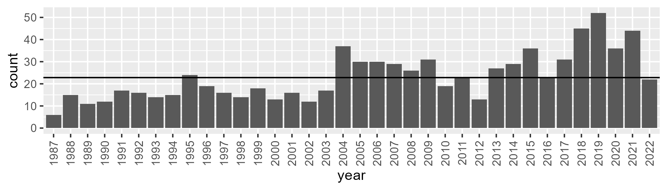

Number of samples: 838

# QDABBS0009

| Min. | 1st Qu. | Median | Mean | 3rd Qu. | Max. |
| --- | --- | --- | --- | --- | --- |
| 26.06613 | 36.81649 | 40.84553 | 41.08787 | 45.24766 | 55.97885 |

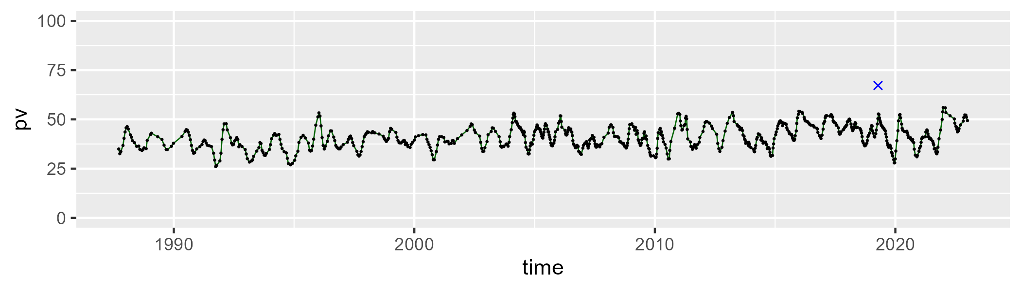

| Min. | 1st Qu. | Median | Mean | 3rd Qu. | Max. |
| --- | --- | --- | --- | --- | --- |
| 22.44841 | 39.12042 | 42.16693 | 41.96239 | 44.84759 | 59.21077 |

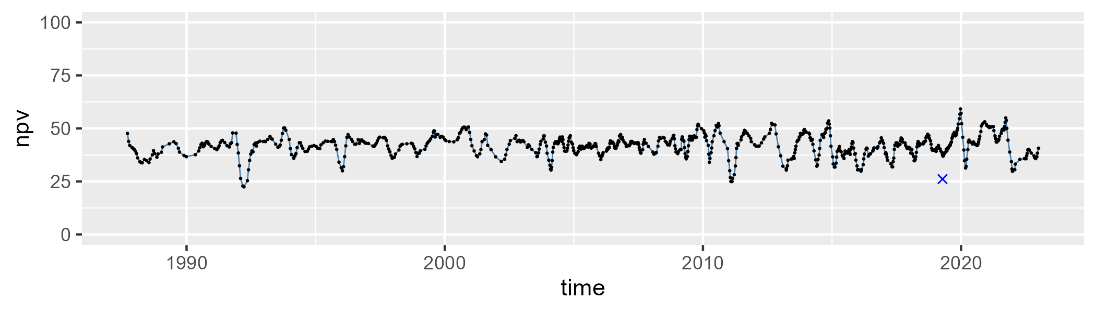

| Min. | 1st Qu. | Median | Mean | 3rd Qu. | Max. |
| --- | --- | --- | --- | --- | --- |
| 5.396813 | 12.38356 | 14.89375 | 15.6252 | 18.48087 | 32.65912 |

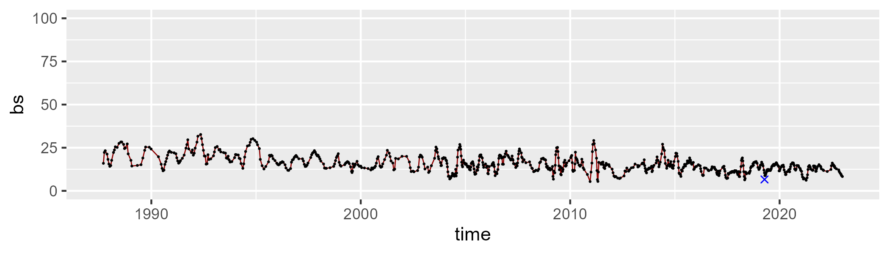

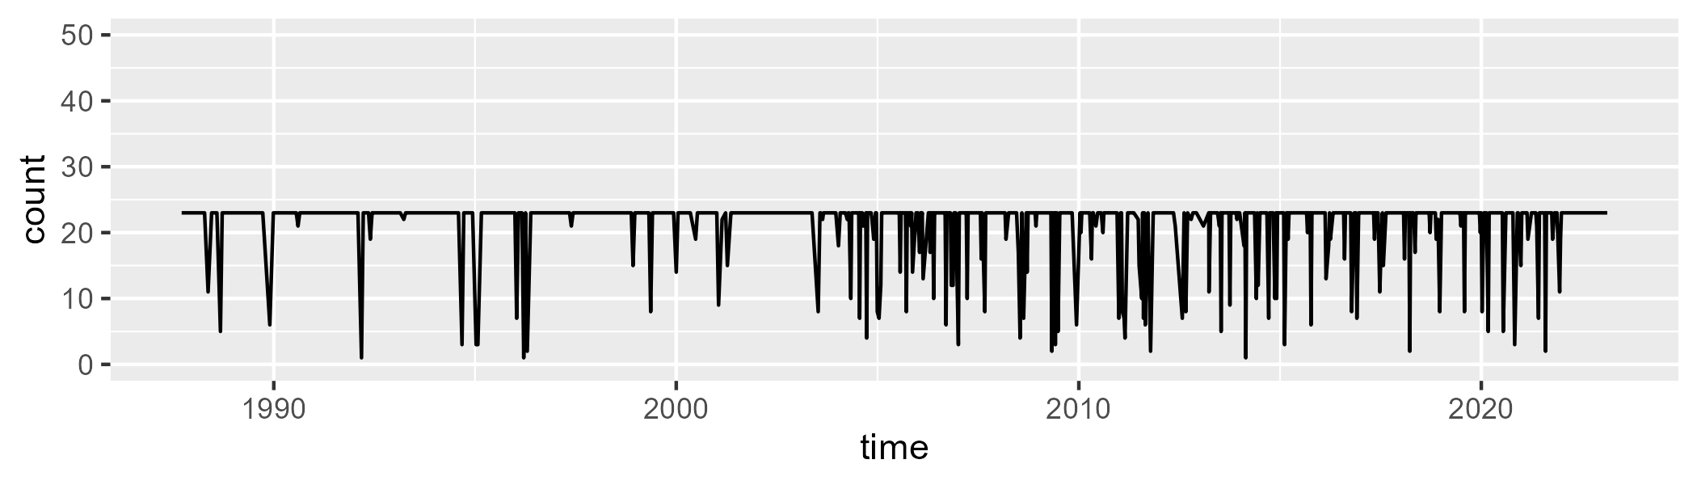

Min. : 1.00 1st Qu.:23.00 Median :23.00 Mean :21.31 3rd Qu.:23.00 Max. :23.00

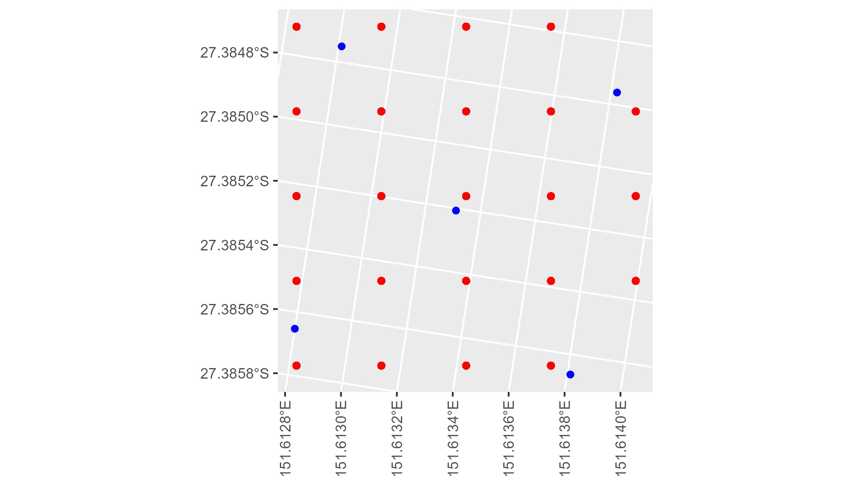

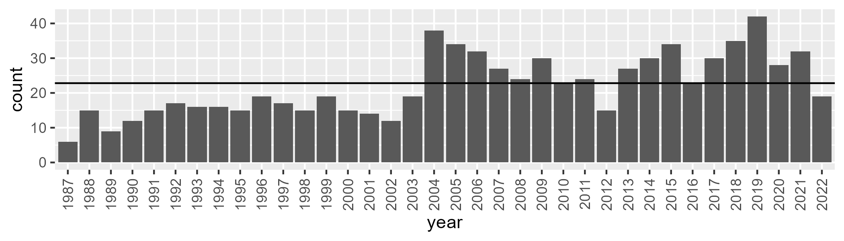

Number of samples: 798

# QDABBS0010

| Min. | 1st Qu. | Median | Mean | 3rd Qu. | Max. |
| --- | --- | --- | --- | --- | --- |
| 29.89323 | 43.85086 | 48.10469 | 48.14266 | 52.09851 | 65.28635 |

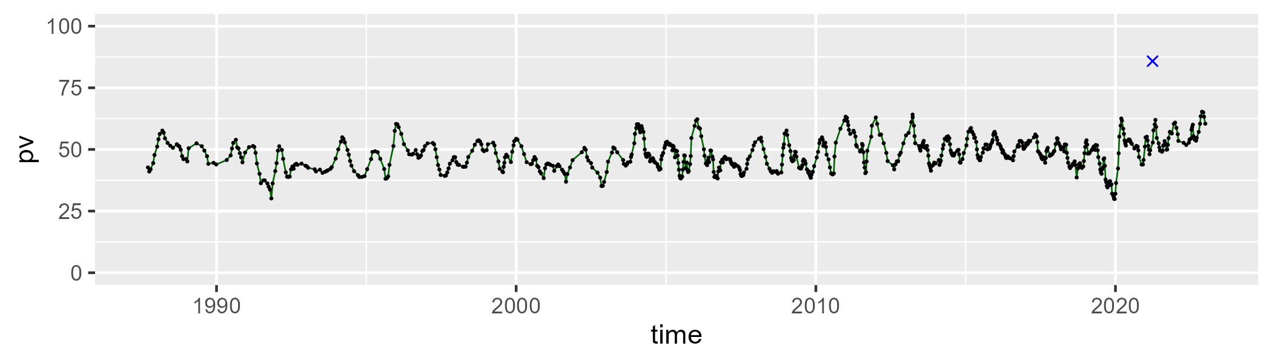

| Min. | 1st Qu. | Median | Mean | 3rd Qu. | Max. |
| --- | --- | --- | --- | --- | --- |
| 22.02553 | 35.80017 | 39.62154 | 39.67054 | 44.0194 | 61.49349 |

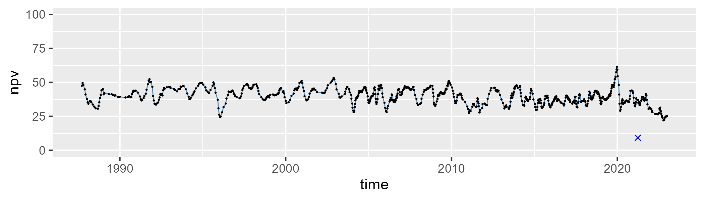

| Min. | 1st Qu. | Median | Mean | 3rd Qu. | Max. |
| --- | --- | --- | --- | --- | --- |
| 1.274164 | 8.231027 | 10.13717 | 10.82823 | 12.79556 | 30.16955 |

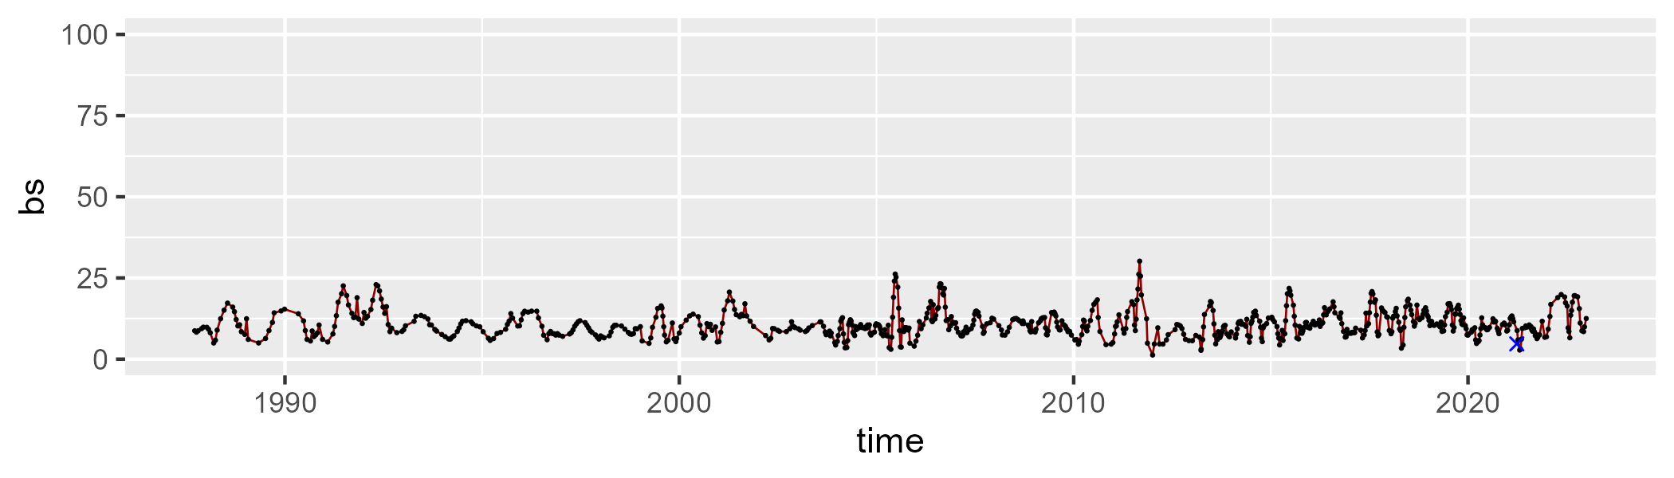

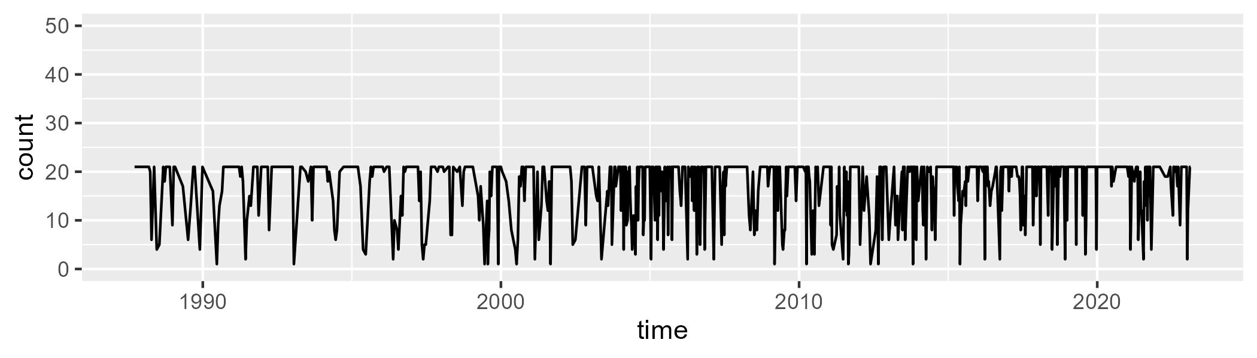

Min. : 1.00 1st Qu.:14.00 Median :21.00 Mean :17.13 3rd Qu.:21.00 Max. :21.00

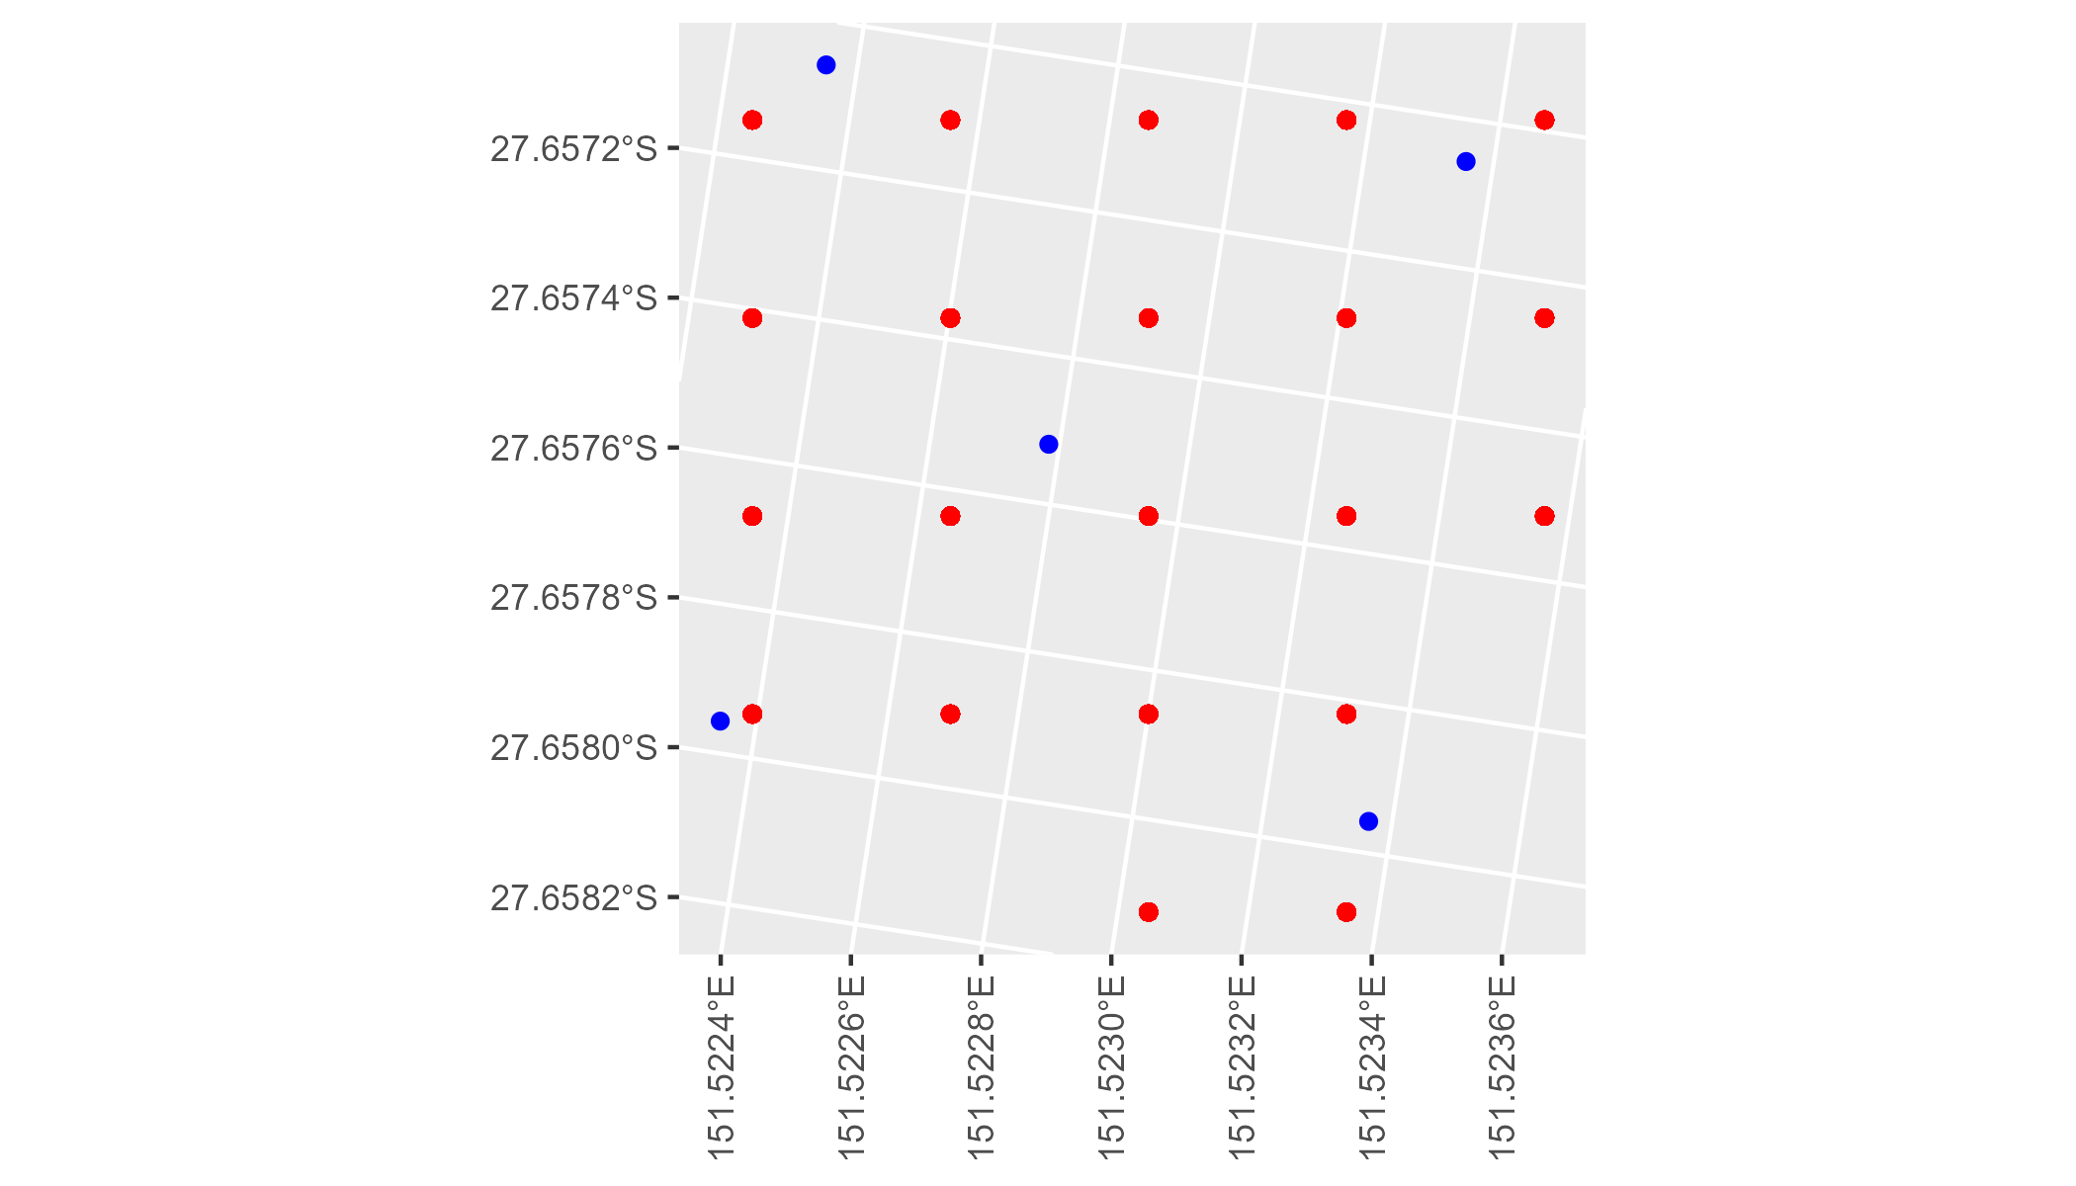

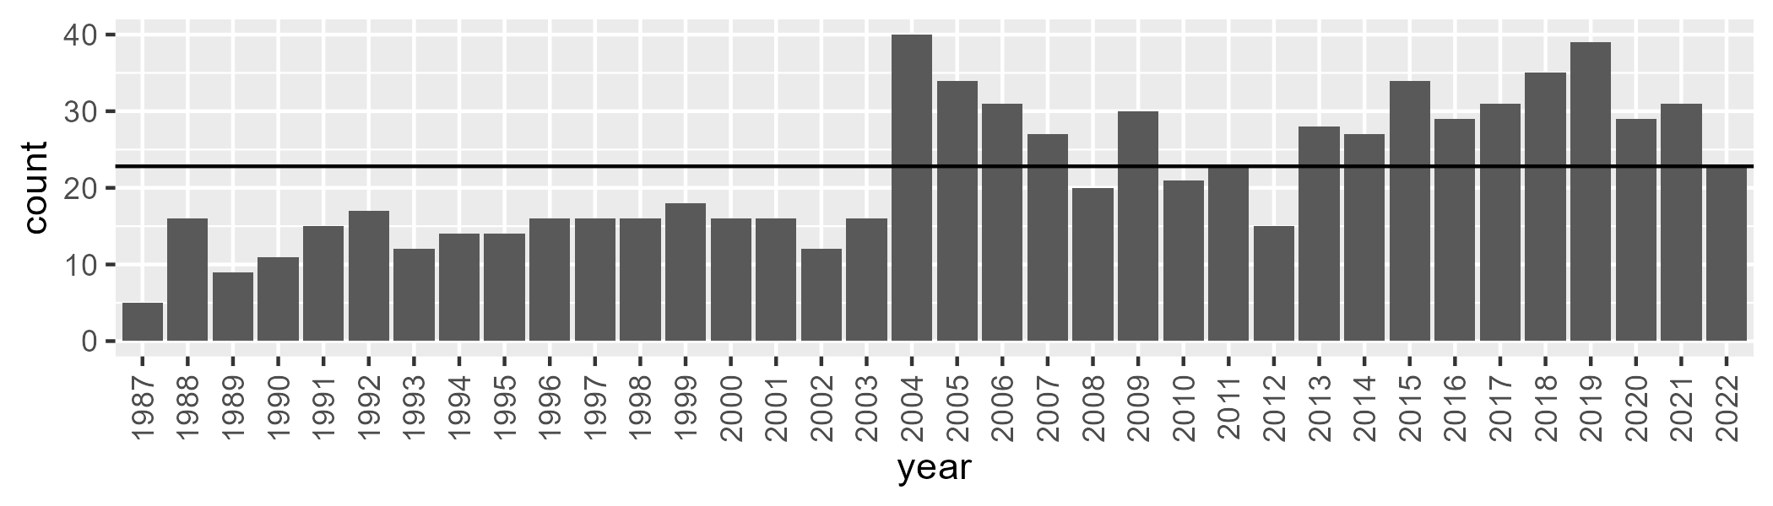

Number of samples: 786

# QDACHC0001

| Min. | 1st Qu. | Median | Mean | 3rd Qu. | Max. |
| --- | --- | --- | --- | --- | --- |
| 1.835036 | 6.800524 | 9.235839 | 10.48328 | 12.58766 | 31.247 |

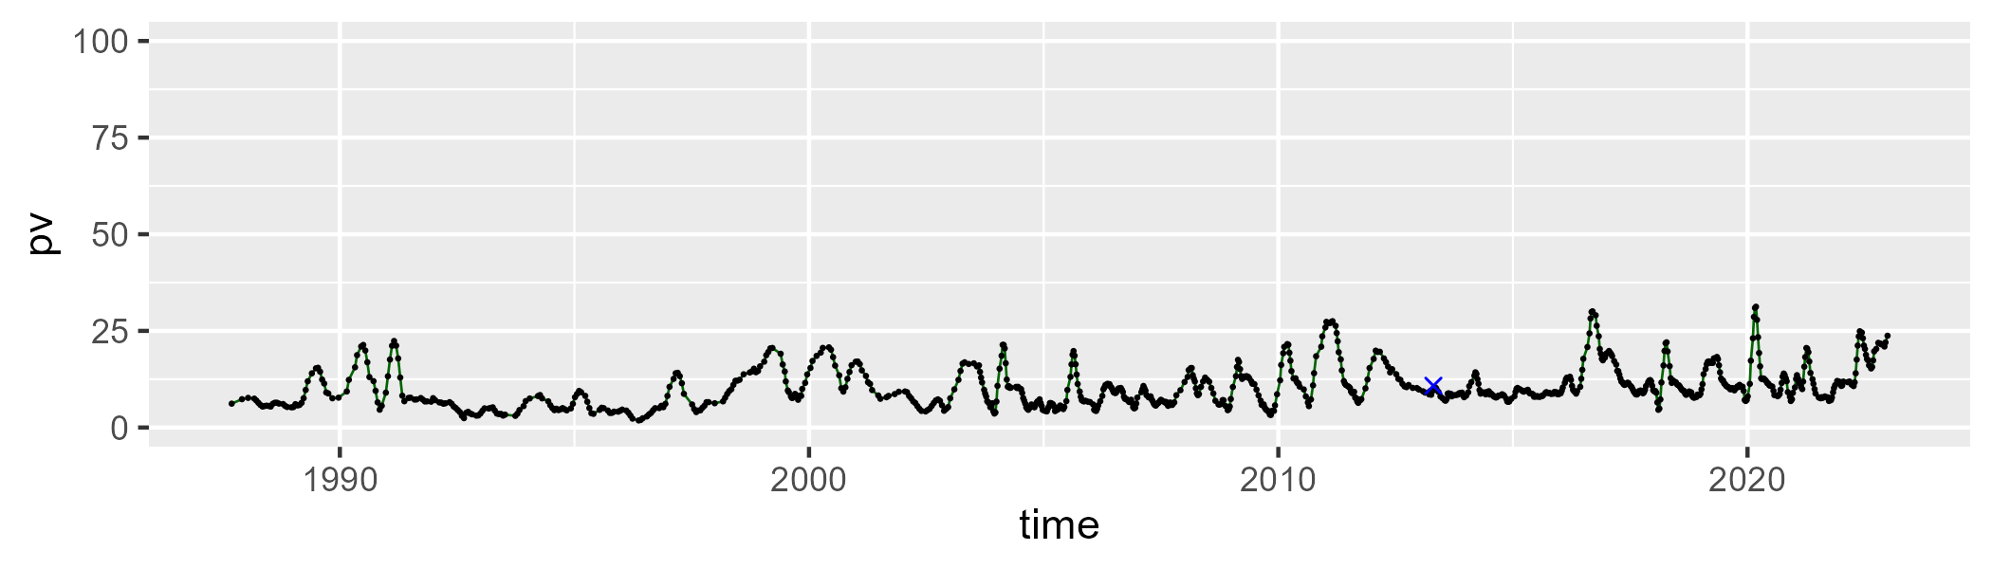

| Min. | 1st Qu. | Median | Mean | 3rd Qu. | Max. |
| --- | --- | --- | --- | --- | --- |
| 4.175626 | 23.71712 | 32.53063 | 31.88697 | 39.23237 | 61.8272 |

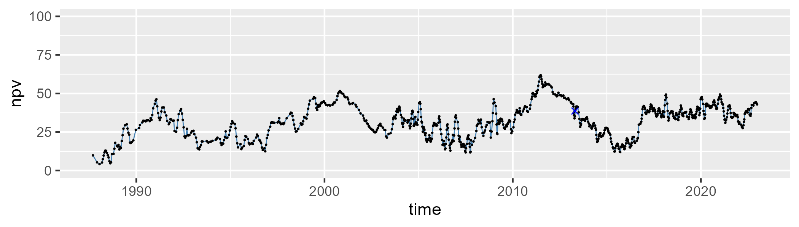

| Min. | 1st Qu. | Median | Mean | 3rd Qu. | Max. |
| --- | --- | --- | --- | --- | --- |
| 21.58605 | 46.6564 | 55.61157 | 56.12635 | 66.4044 | 87.37907 |

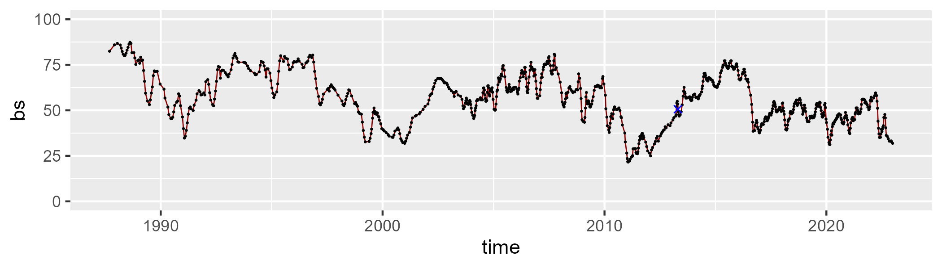

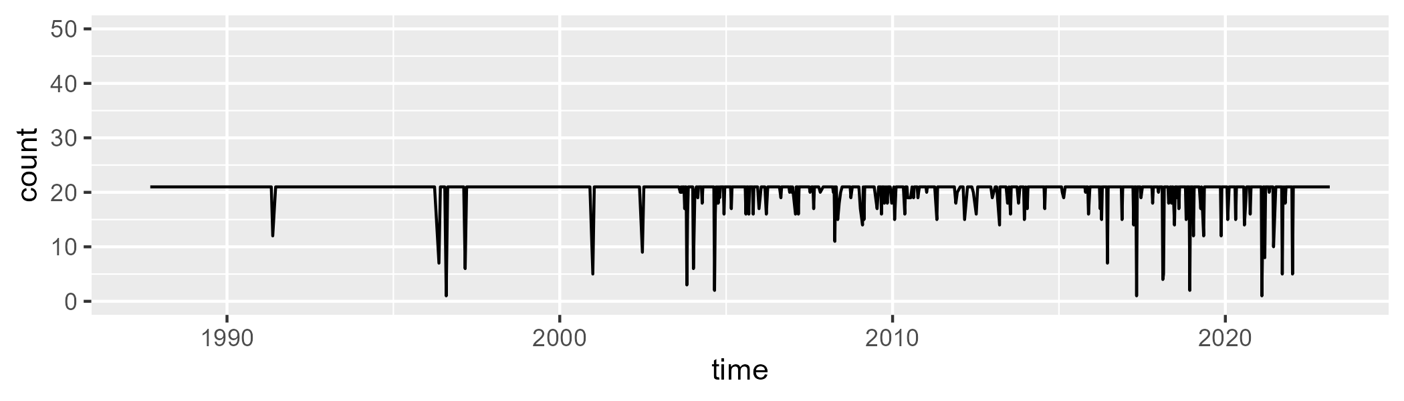

Min. : 1.00 1st Qu.:21.00 Median :21.00 Mean :20.33 3rd Qu.:21.00 Max. :21.00

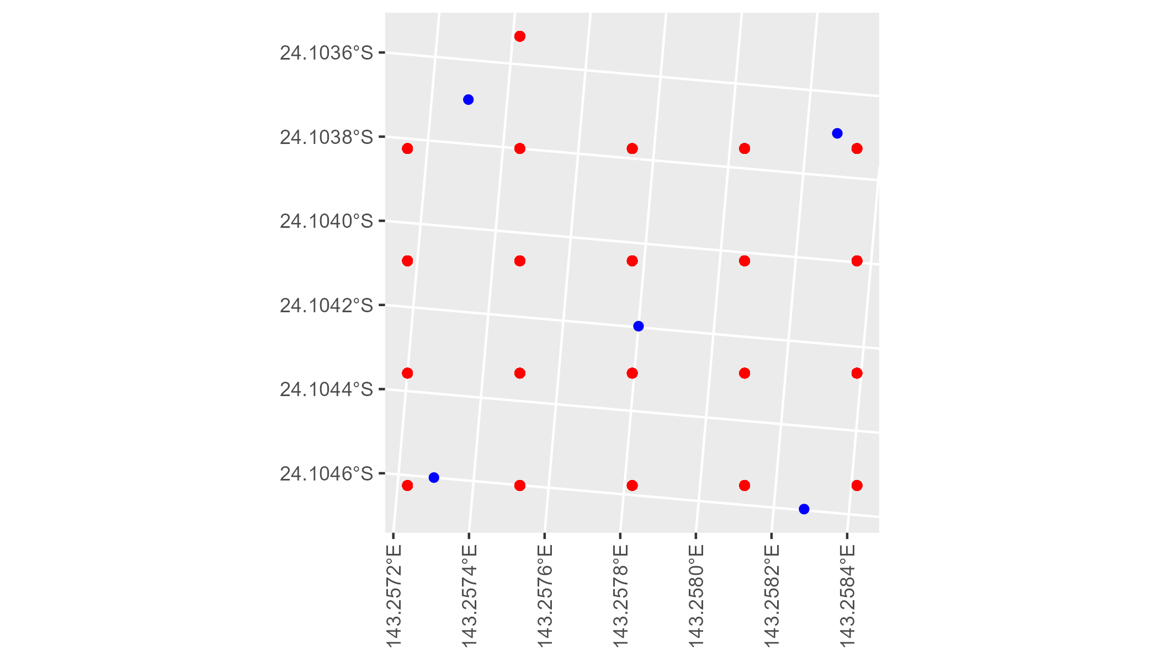

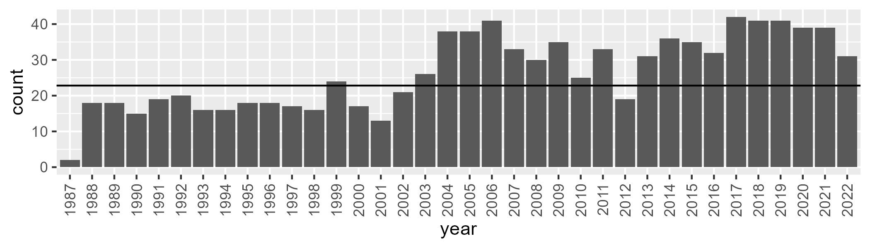

Number of samples: 953

# QDACHC0002

| Min. | 1st Qu. | Median | Mean | 3rd Qu. | Max. |
| --- | --- | --- | --- | --- | --- |
| 5.284182 | 10.04401 | 12.77526 | 13.95495 | 16.39221 | 32.30838 |

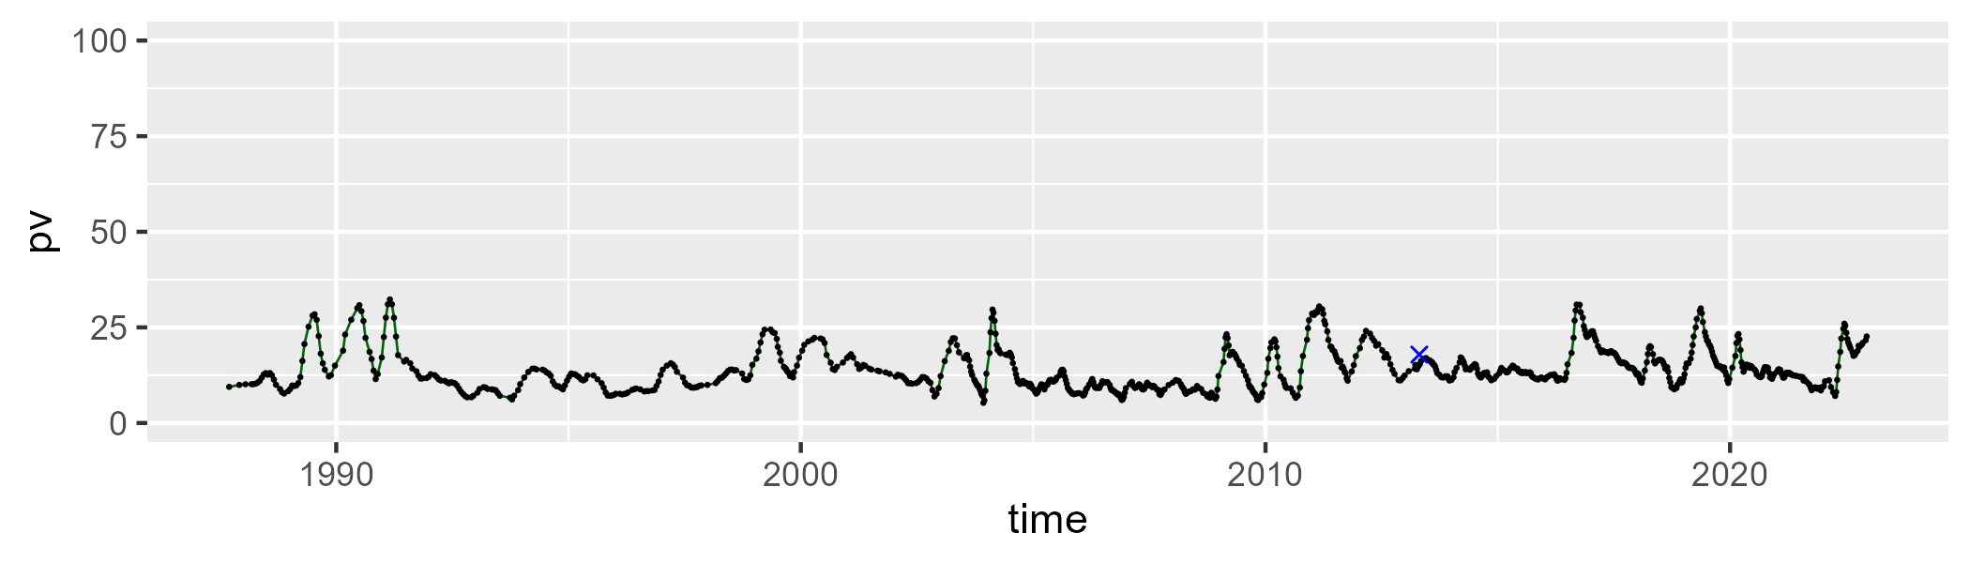

| Min. | 1st Qu. | Median | Mean | 3rd Qu. | Max. |
| --- | --- | --- | --- | --- | --- |
| 18.21166 | 29.5322 | 33.94099 | 33.85908 | 38.45593 | 57.63008 |

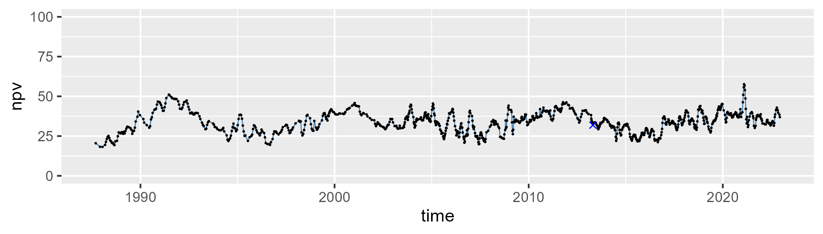

| Min. | 1st Qu. | Median | Mean | 3rd Qu. | Max. |
| --- | --- | --- | --- | --- | --- |
| 25.07619 | 44.81492 | 50.5984 | 50.73366 | 57.3841 | 70.69523 |

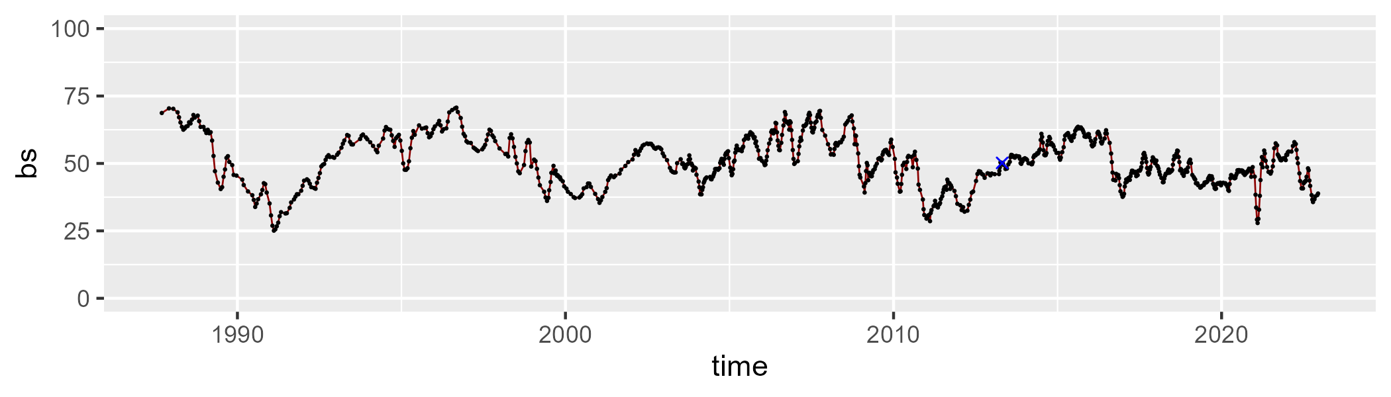

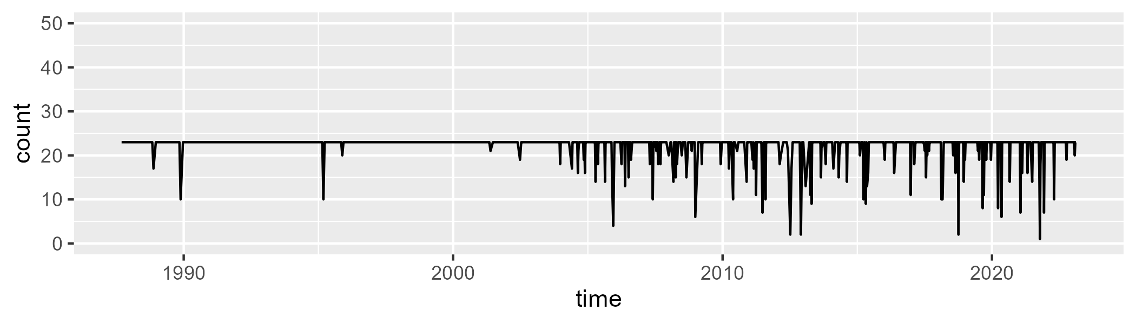

Min. : 1.00 1st Qu.:23.00 Median :23.00 Mean :22.13 3rd Qu.:23.00 Max. :23.00

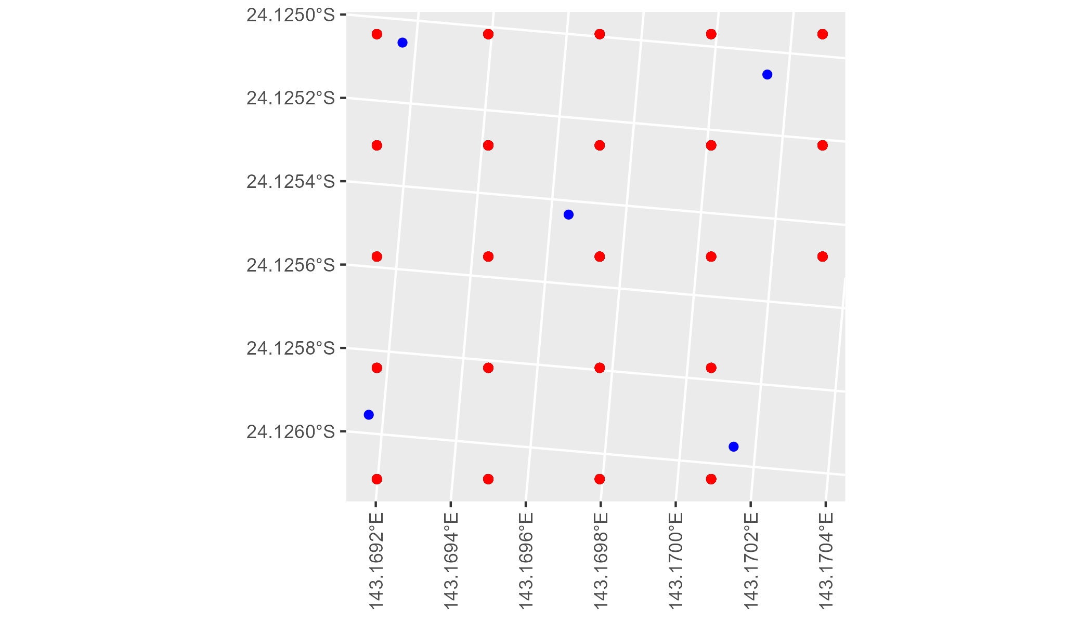

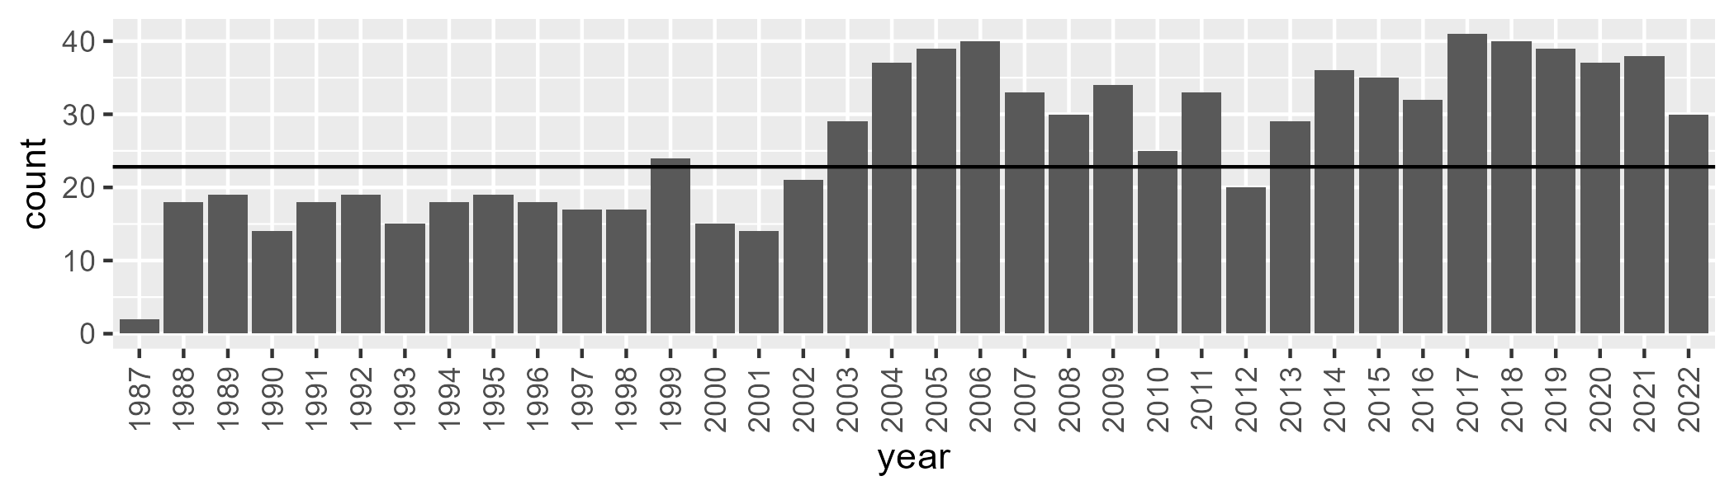

Number of samples: 945

# QDACHC0003

| Min. | 1st Qu. | Median | Mean | 3rd Qu. | Max. |
| --- | --- | --- | --- | --- | --- |
| 3.130562 | 11.61914 | 15.47648 | 17.42615 | 21.57274 | 47.00687 |

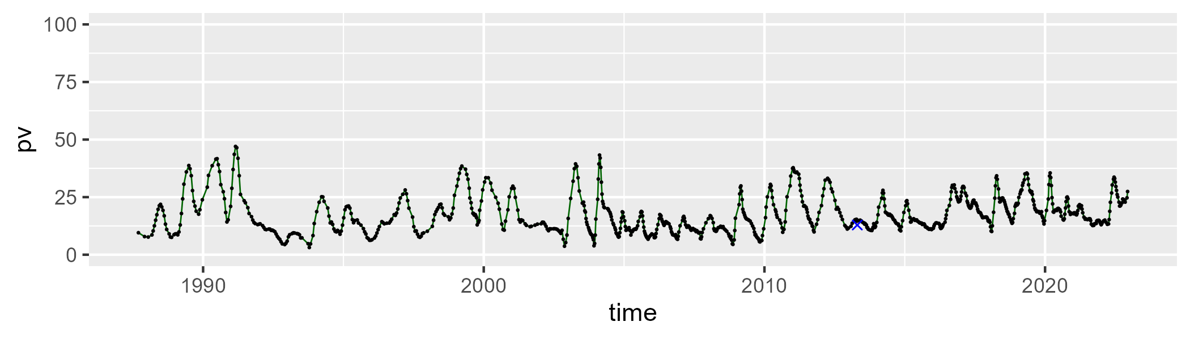

| Min. | 1st Qu. | Median | Mean | 3rd Qu. | Max. |
| --- | --- | --- | --- | --- | --- |
| 19.93378 | 31.56823 | 37.61442 | 38.91259 | 45.41023 | 67.63333 |

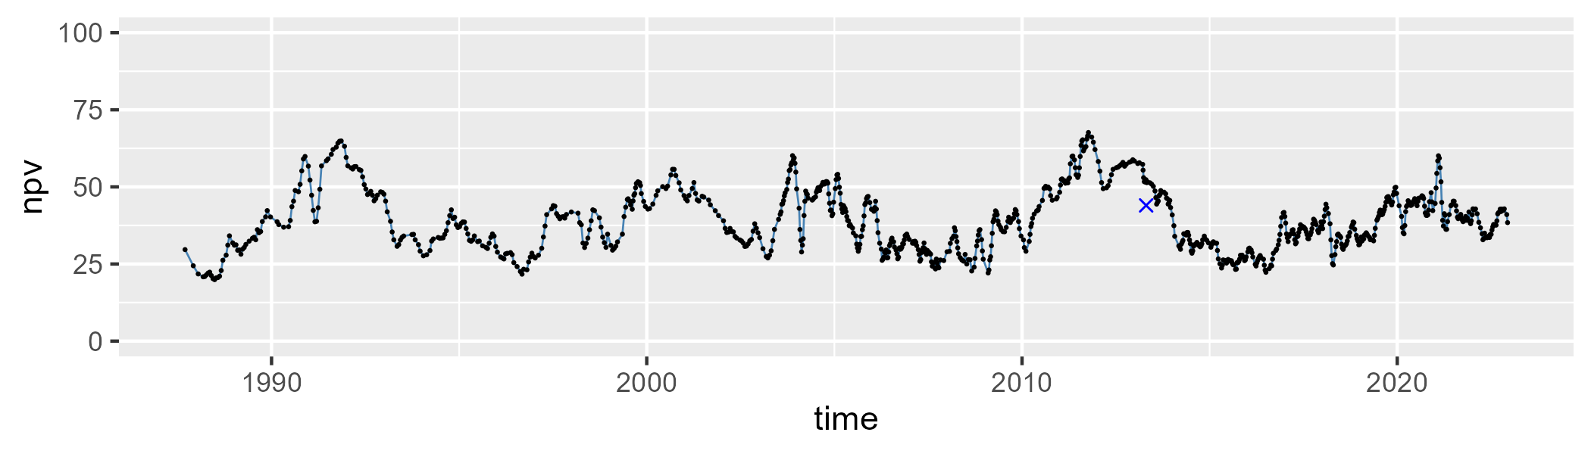

| Min. | 1st Qu. | Median | Mean | 3rd Qu. | Max. |
| --- | --- | --- | --- | --- | --- |
| 9.587801 | 33.83279 | 42.32745 | 42.2309 | 51.86599 | 69.13805 |

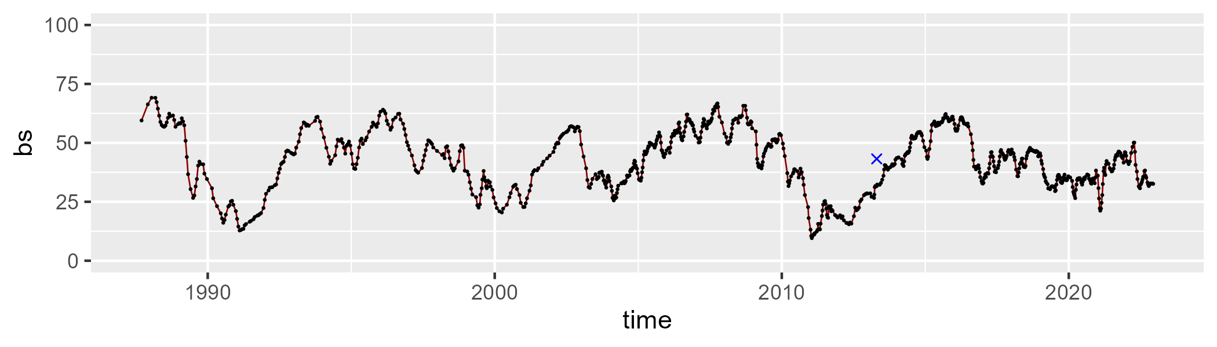

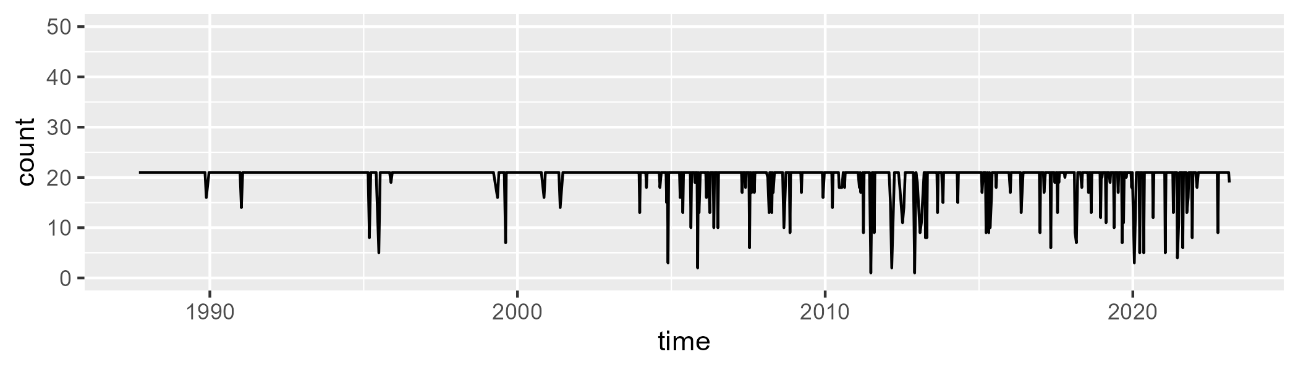

Min. : 1.00 1st Qu.:21.00 Median :21.00 Mean :20.08 3rd Qu.:21.00 Max. :21.00

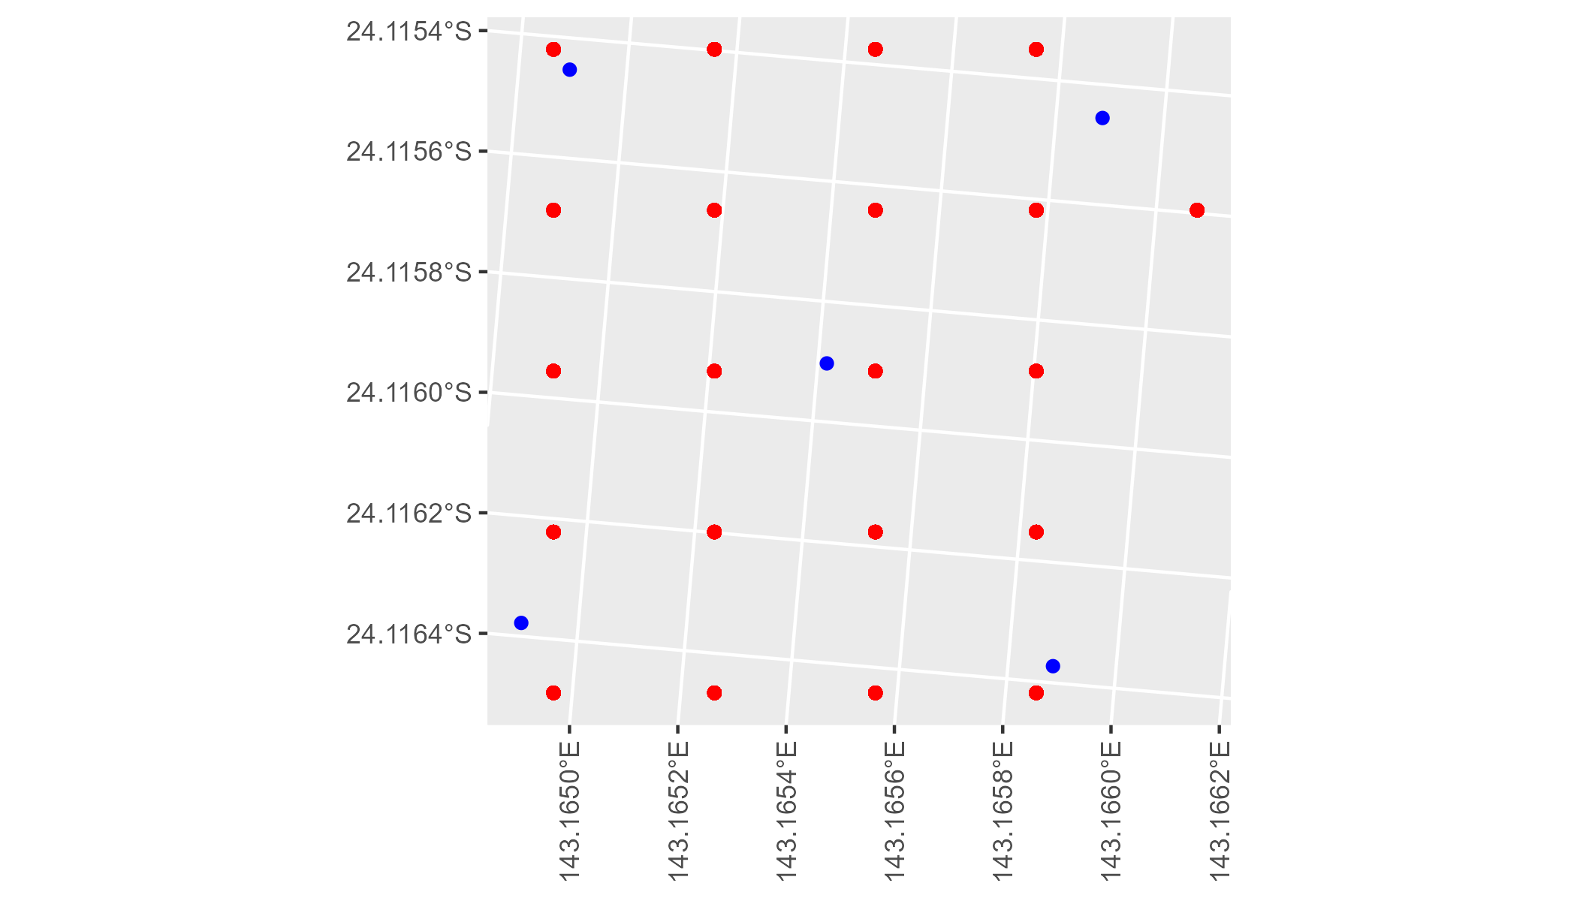

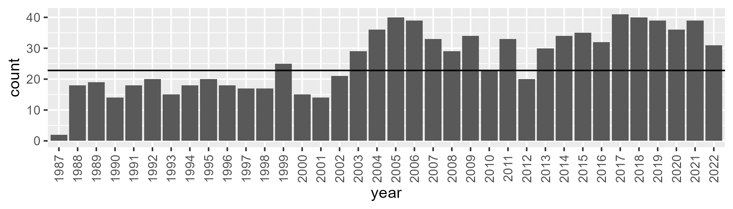

Number of samples: 944

# QDACHC0004

| Min. | 1st Qu. | Median | Mean | 3rd Qu. | Max. |
| --- | --- | --- | --- | --- | --- |
| 3.783931 | 9.819123 | 12.66277 | 15.20796 | 17.78299 | 57.3957 |

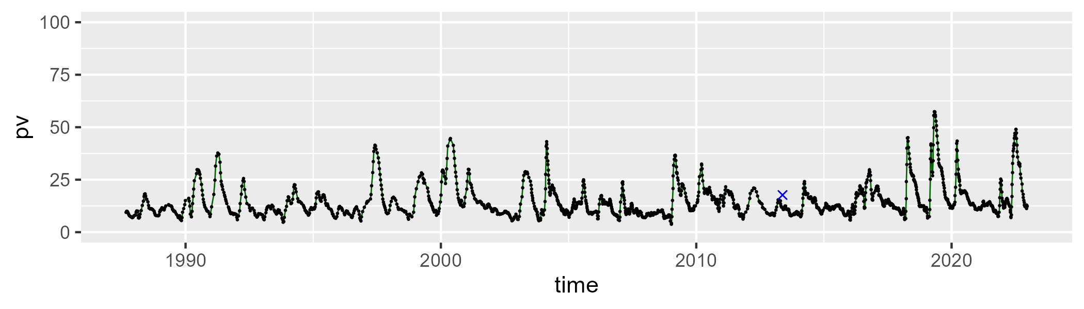

| Min. | 1st Qu. | Median | Mean | 3rd Qu. | Max. |
| --- | --- | --- | --- | --- | --- |
| 20.7515 | 40.14286 | 45.2532 | 45.27837 | 50.38116 | 77.94567 |

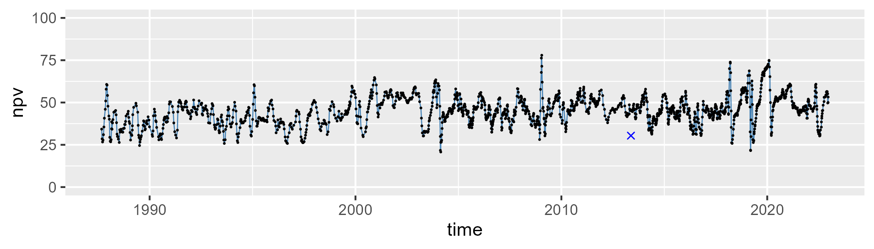

| Min. | 1st Qu. | Median | Mean | 3rd Qu. | Max. |
| --- | --- | --- | --- | --- | --- |
| 5.932916 | 32.58387 | 38.70381 | 38.17471 | 43.93311 | 63.62976 |

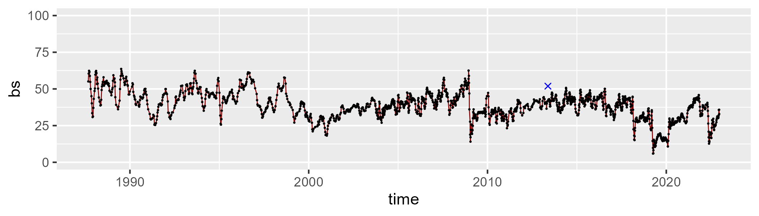

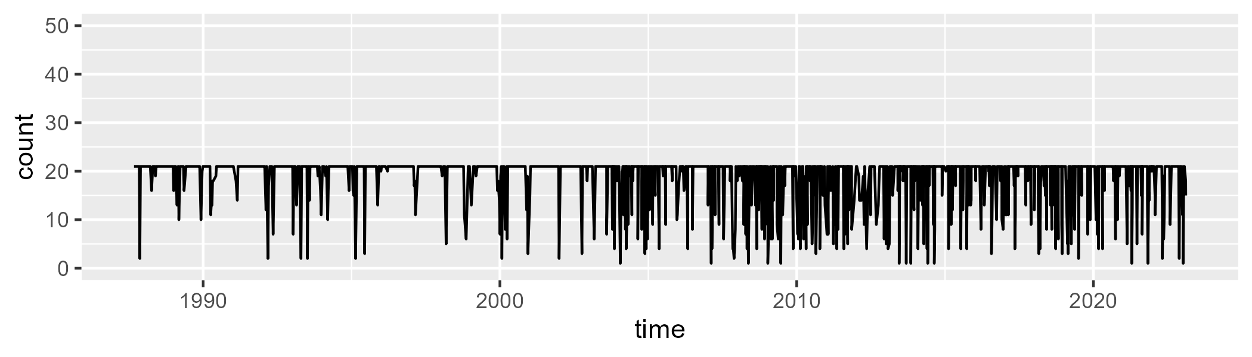

Min. : 1.00 1st Qu.:21.00 Median :21.00 Mean :19.01 3rd Qu.:21.00 Max. :21.00

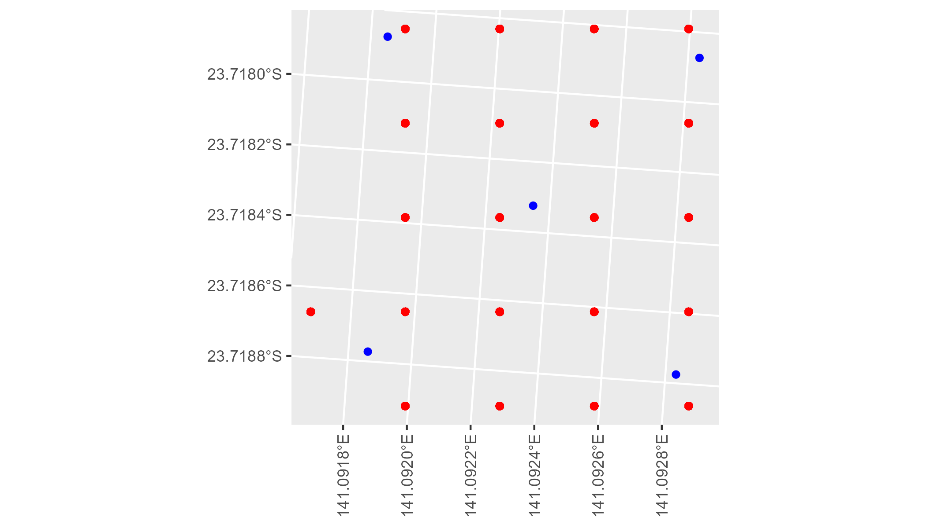

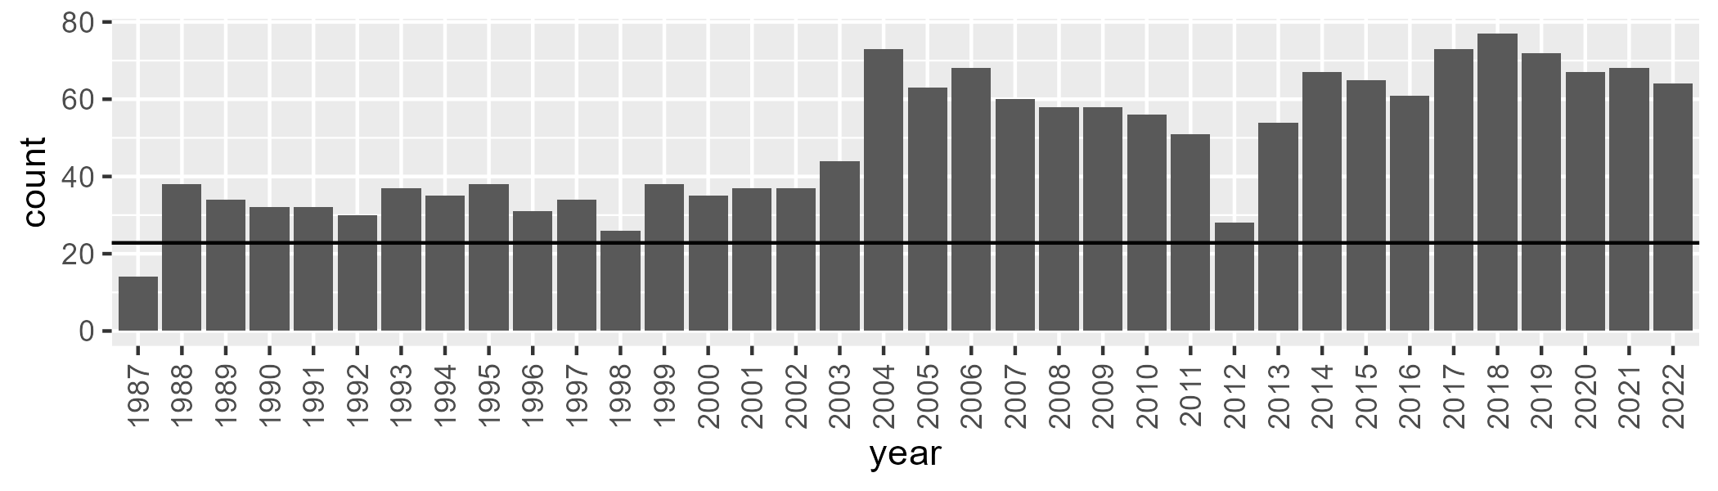

Number of samples: 1755

# QDACHC0005

| Min. | 1st Qu. | Median | Mean | 3rd Qu. | Max. |
| --- | --- | --- | --- | --- | --- |
| 0 | 5.254919 | 7.8267 | 11.03818 | 13.25677 | 65.03579 |

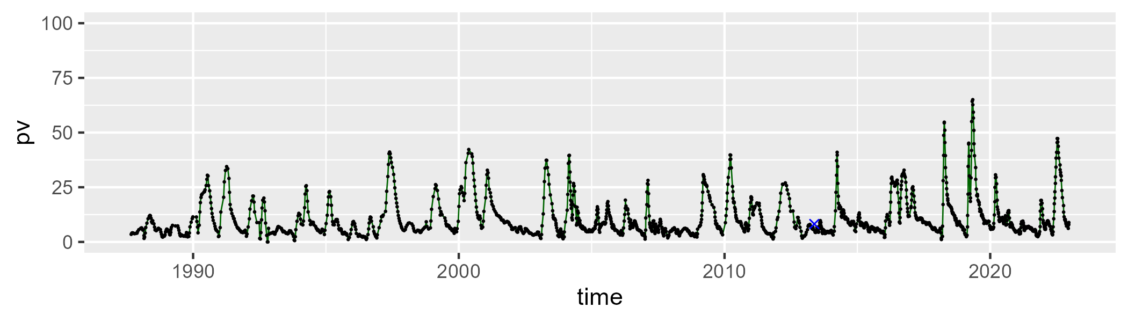

| Min. | 1st Qu. | Median | Mean | 3rd Qu. | Max. |
| --- | --- | --- | --- | --- | --- |
| 9.304245 | 39.02676 | 44.83638 | 44.86919 | 49.79249 | 80.58912 |

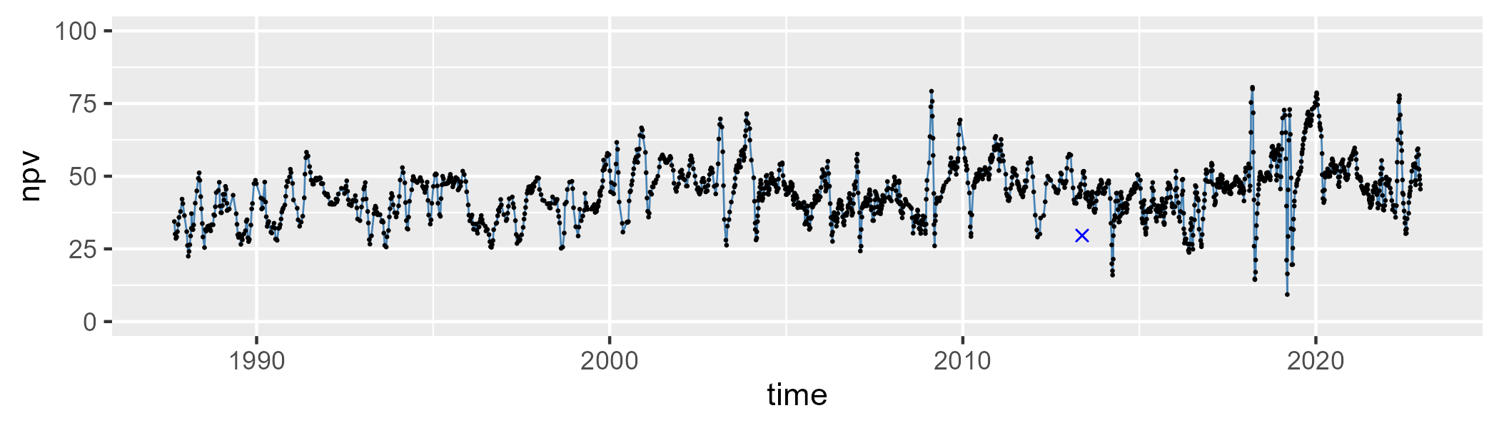

| Min. | 1st Qu. | Median | Mean | 3rd Qu. | Max. |
| --- | --- | --- | --- | --- | --- |
| 4.351731 | 35.92046 | 43.85505 | 42.77819 | 50.32524 | 70.12938 |

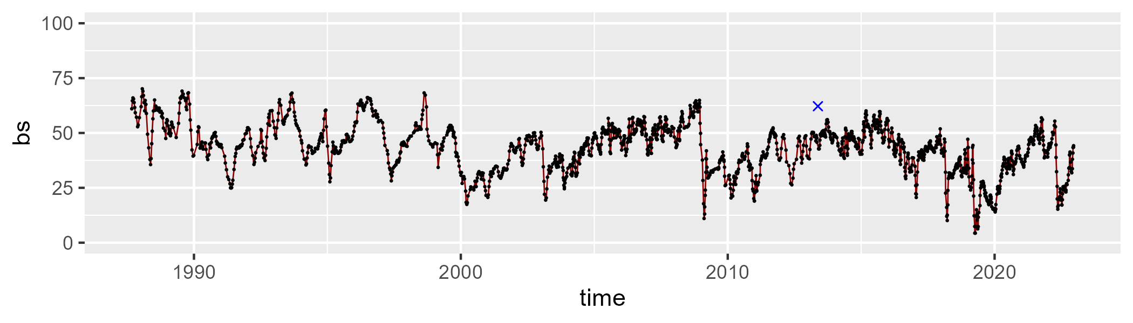

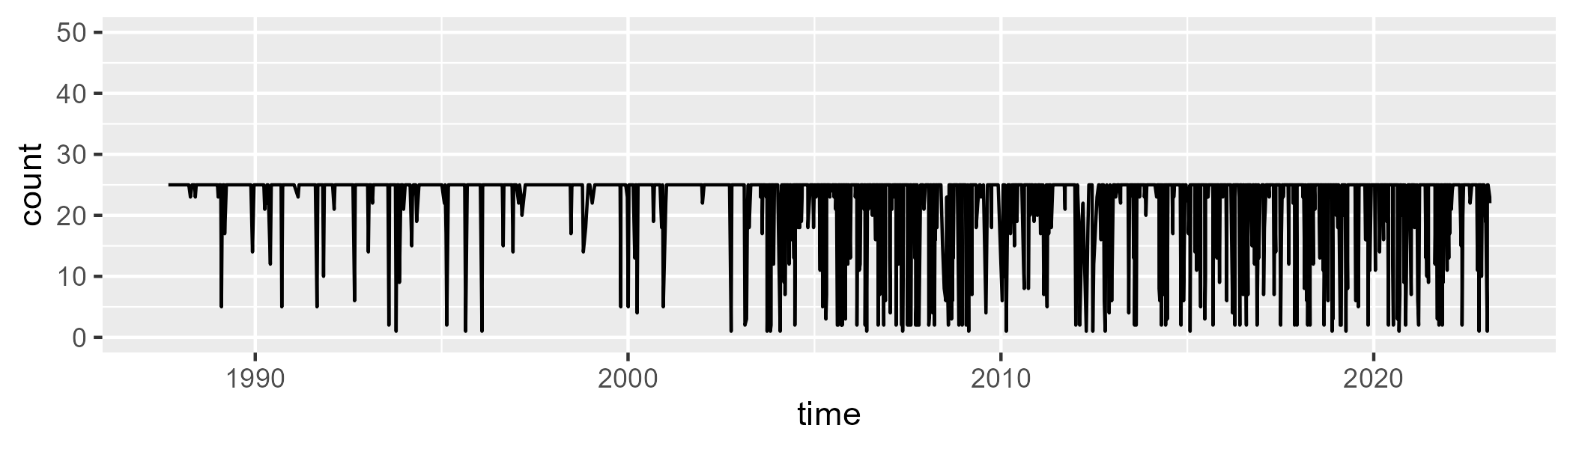

Min. : 1.00 1st Qu.:25.00 Median :25.00 Mean :22.38 3rd Qu.:25.00 Max. :25.00

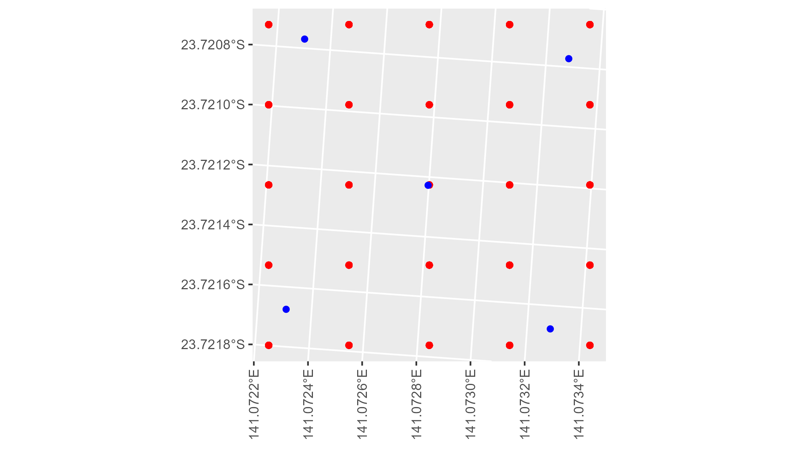

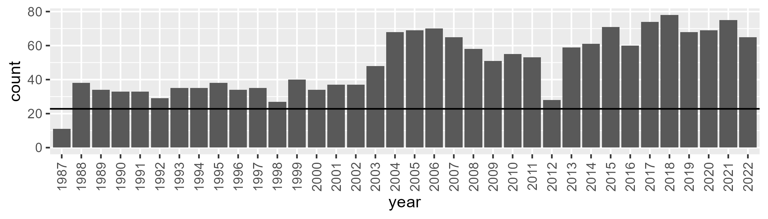

Number of samples: 1775

# QDACHC0006

| Min. | 1st Qu. | Median | Mean | 3rd Qu. | Max. |
| --- | --- | --- | --- | --- | --- |
| 0 | 2.700237 | 6.046759 | 11.48565 | 15.12376 | 66.17322 |

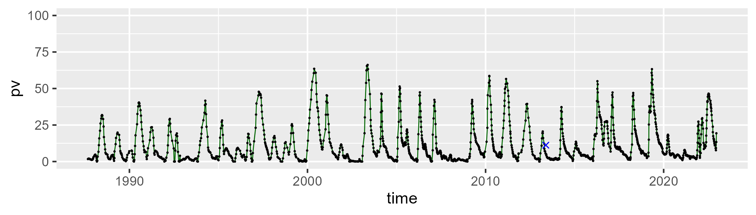

| Min. | 1st Qu. | Median | Mean | 3rd Qu. | Max. |
| --- | --- | --- | --- | --- | --- |
| 20.03981 | 53.52781 | 60.88404 | 60.09845 | 67.75102 | 89.73045 |

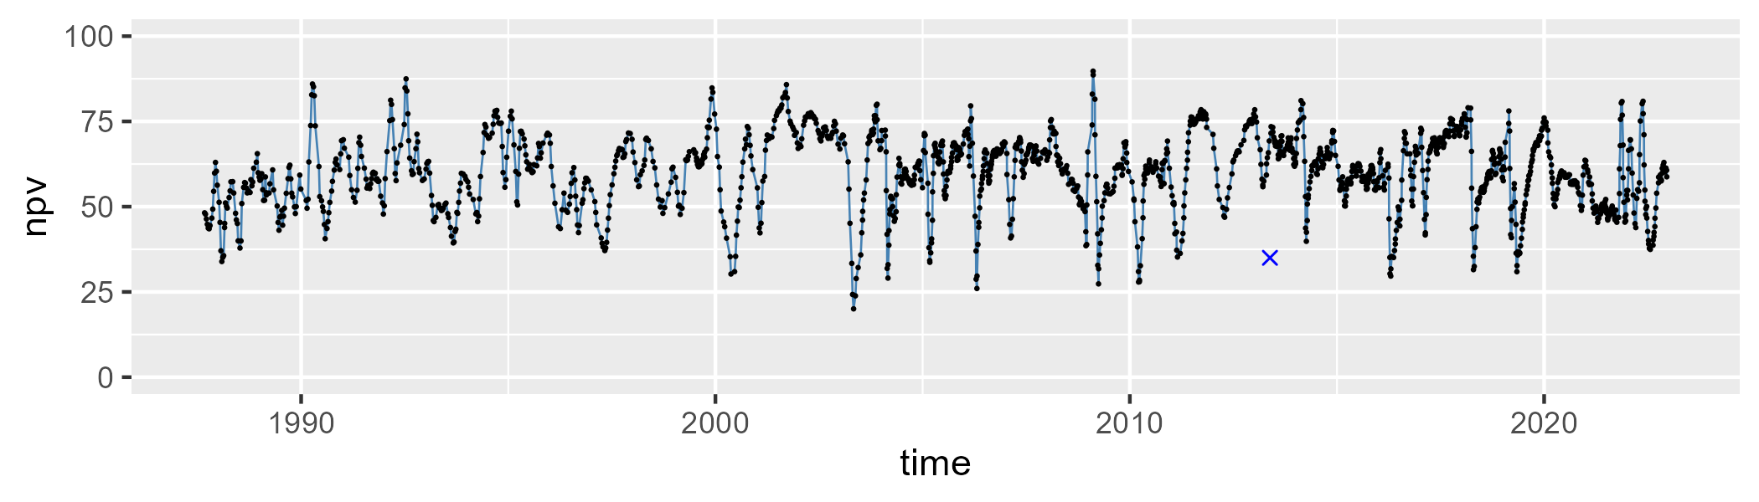

| Min. | 1st Qu. | Median | Mean | 3rd Qu. | Max. |
| --- | --- | --- | --- | --- | --- |
| 0 | 19.88449 | 26.88921 | 27.19298 | 33.93723 | 60.11217 |

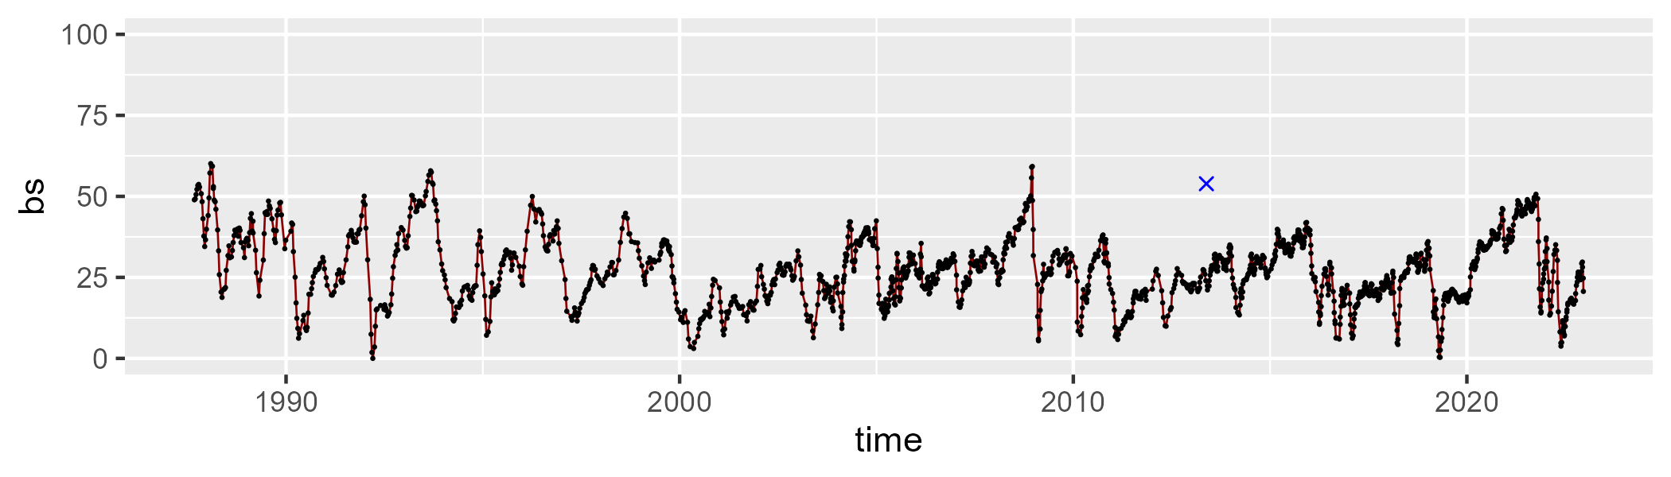

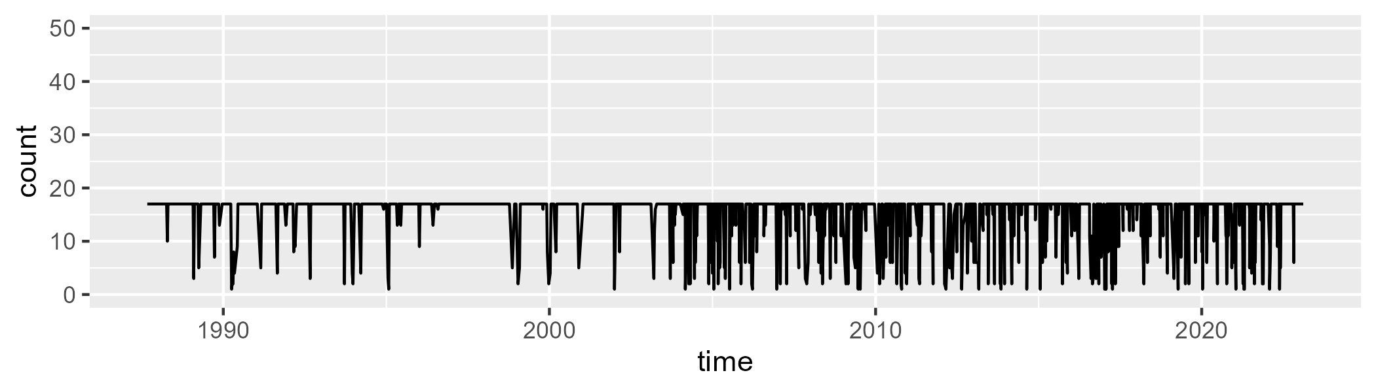

Min. : 1.00 1st Qu.:17.00 Median :17.00 Mean :15.32 3rd Qu.:17.00 Max. :17.00

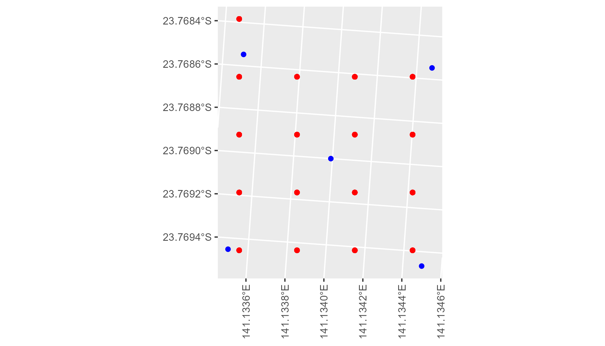

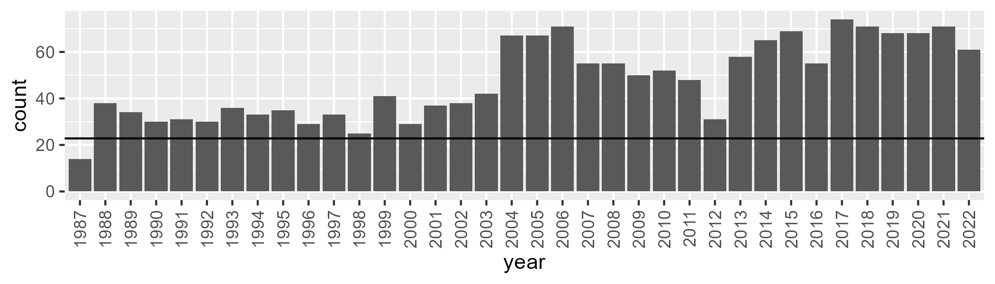

Number of samples: 1711

# QDACHC0007

| Min. | 1st Qu. | Median | Mean | 3rd Qu. | Max. |
| --- | --- | --- | --- | --- | --- |
| 0 | 3.727058 | 5.844826 | 7.606303 | 9.962046 | 38.90772 |

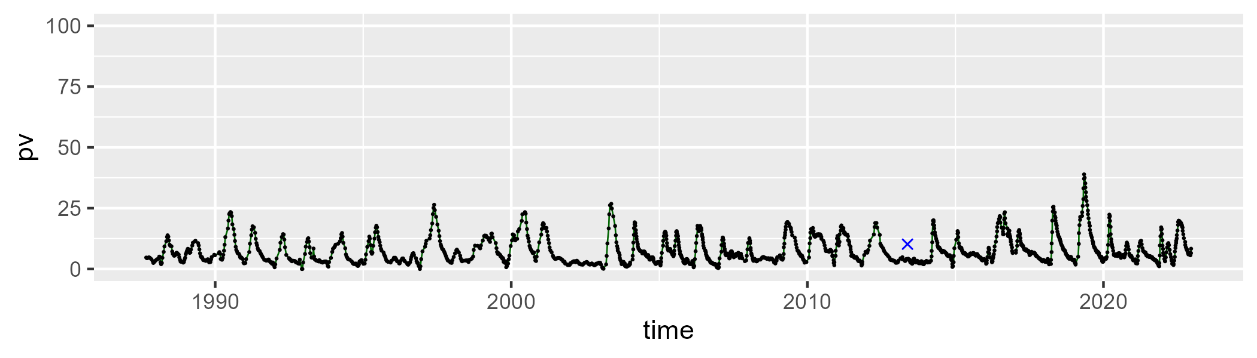

| Min. | 1st Qu. | Median | Mean | 3rd Qu. | Max. |
| --- | --- | --- | --- | --- | --- |
| 22.19191 | 41.00009 | 45.78936 | 46.82878 | 50.60756 | 93.49353 |

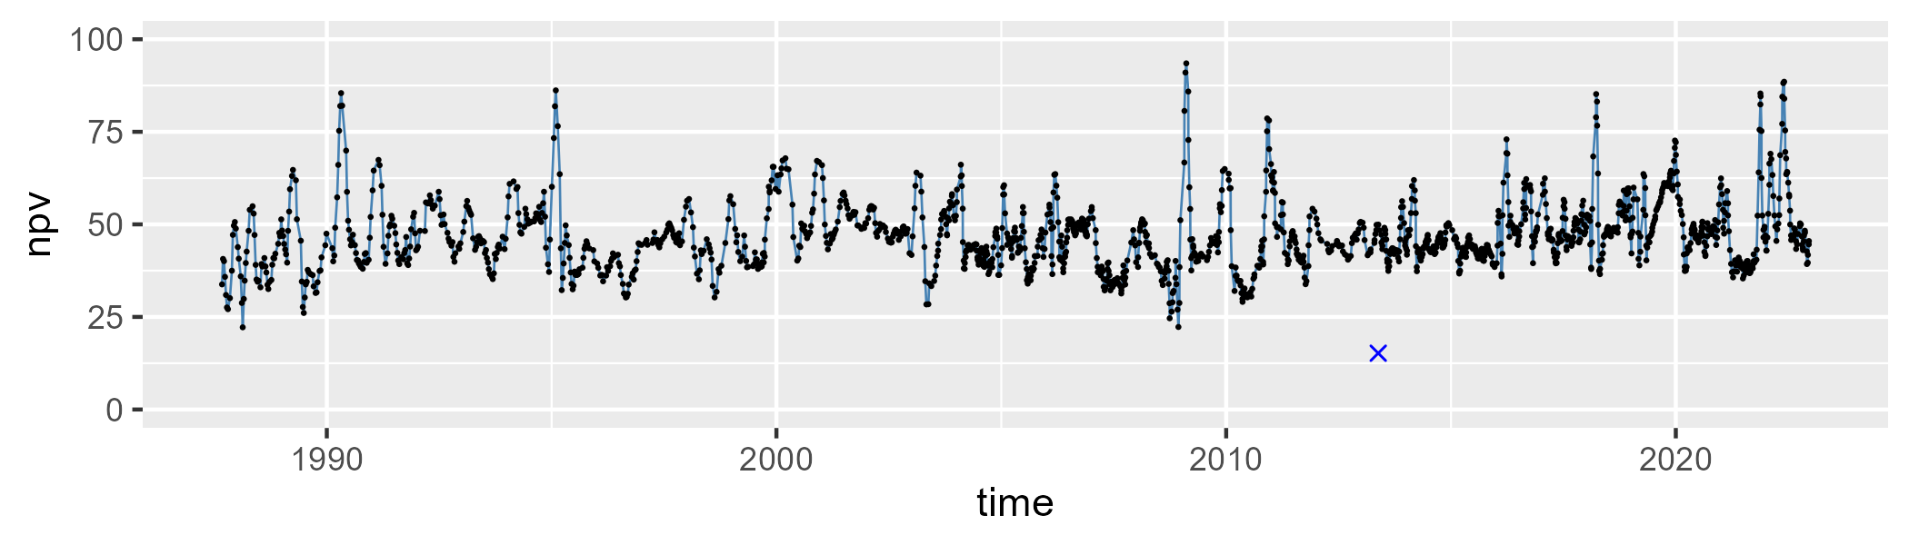

| Min. | 1st Qu. | Median | Mean | 3rd Qu. | Max. |
| --- | --- | --- | --- | --- | --- |
| 2.104573 | 38.96528 | 45.69585 | 44.25367 | 51.28453 | 73.23985 |

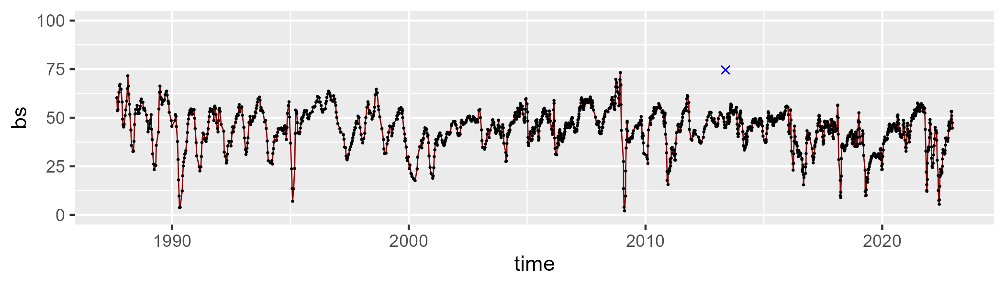

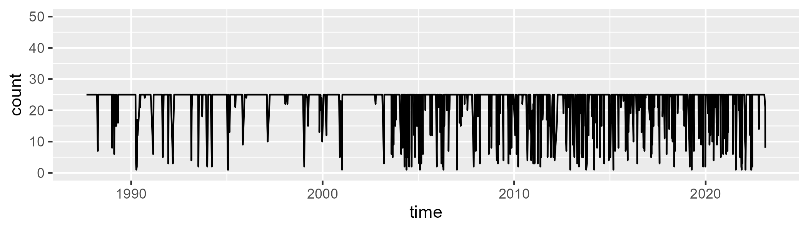

Min. : 1.0 1st Qu.:25.0 Median :25.0 Mean :22.5 3rd Qu.:25.0 Max. :25.0

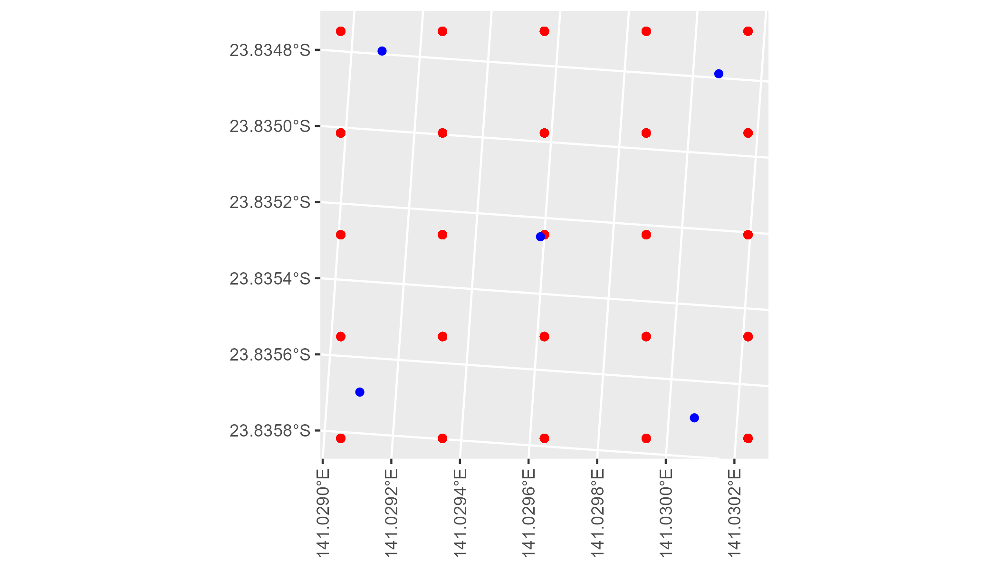

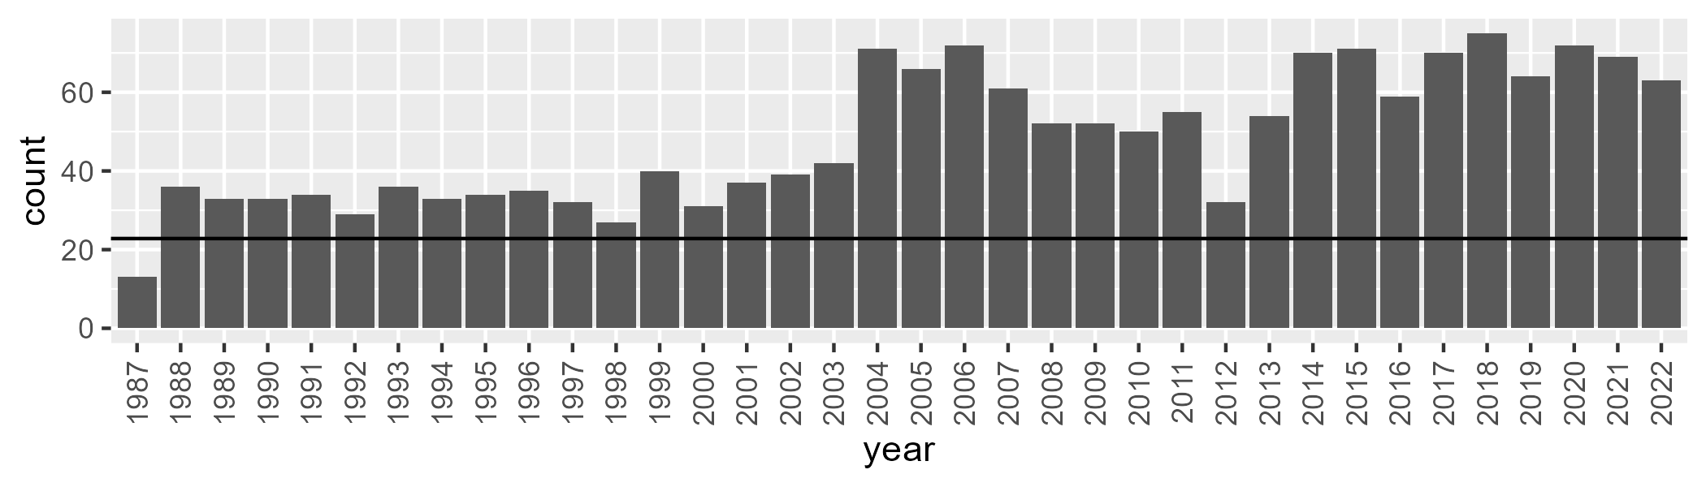

Number of samples: 1742

# QDACYP0001

| Min. | 1st Qu. | Median | Mean | 3rd Qu. | Max. |
| --- | --- | --- | --- | --- | --- |
| 33.61286 | 47.3593 | 50.42851 | 50.12145 | 53.50607 | 62.07826 |

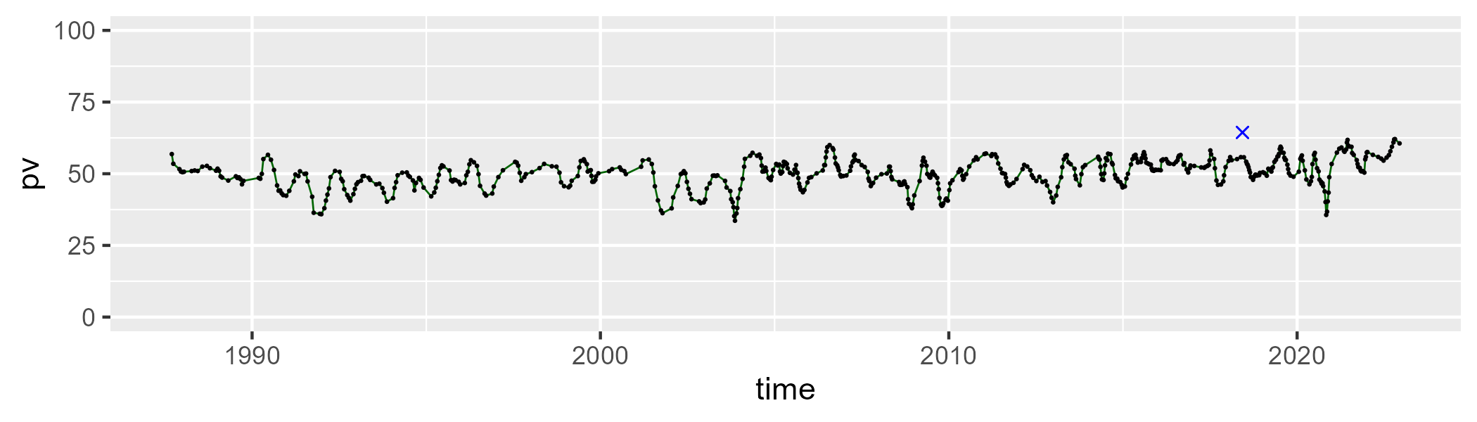

| Min. | 1st Qu. | Median | Mean | 3rd Qu. | Max. |
| --- | --- | --- | --- | --- | --- |
| 16.37708 | 33.43542 | 37.12845 | 37.73703 | 41.71152 | 60.78145 |

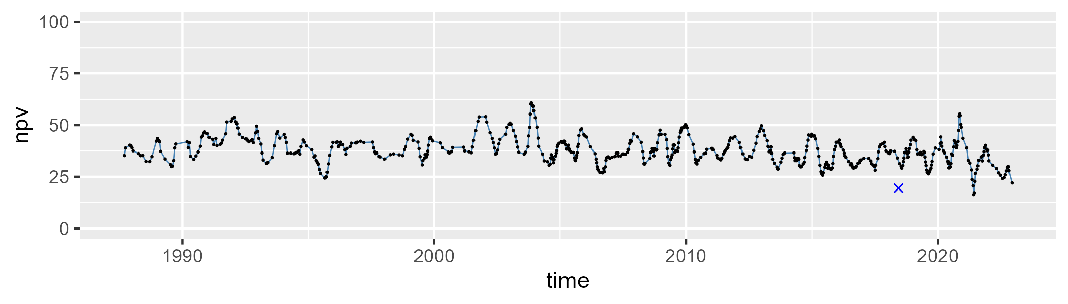

| Min. | 1st Qu. | Median | Mean | 3rd Qu. | Max. |
| --- | --- | --- | --- | --- | --- |
| 0 | 7.939126 | 11.02185 | 10.93377 | 13.75189 | 26.12777 |

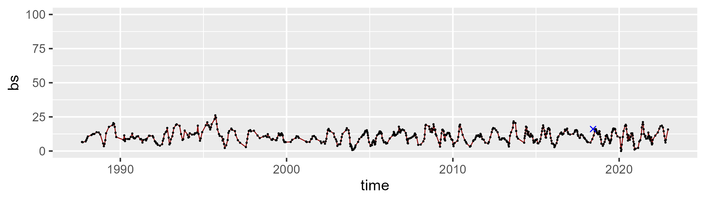

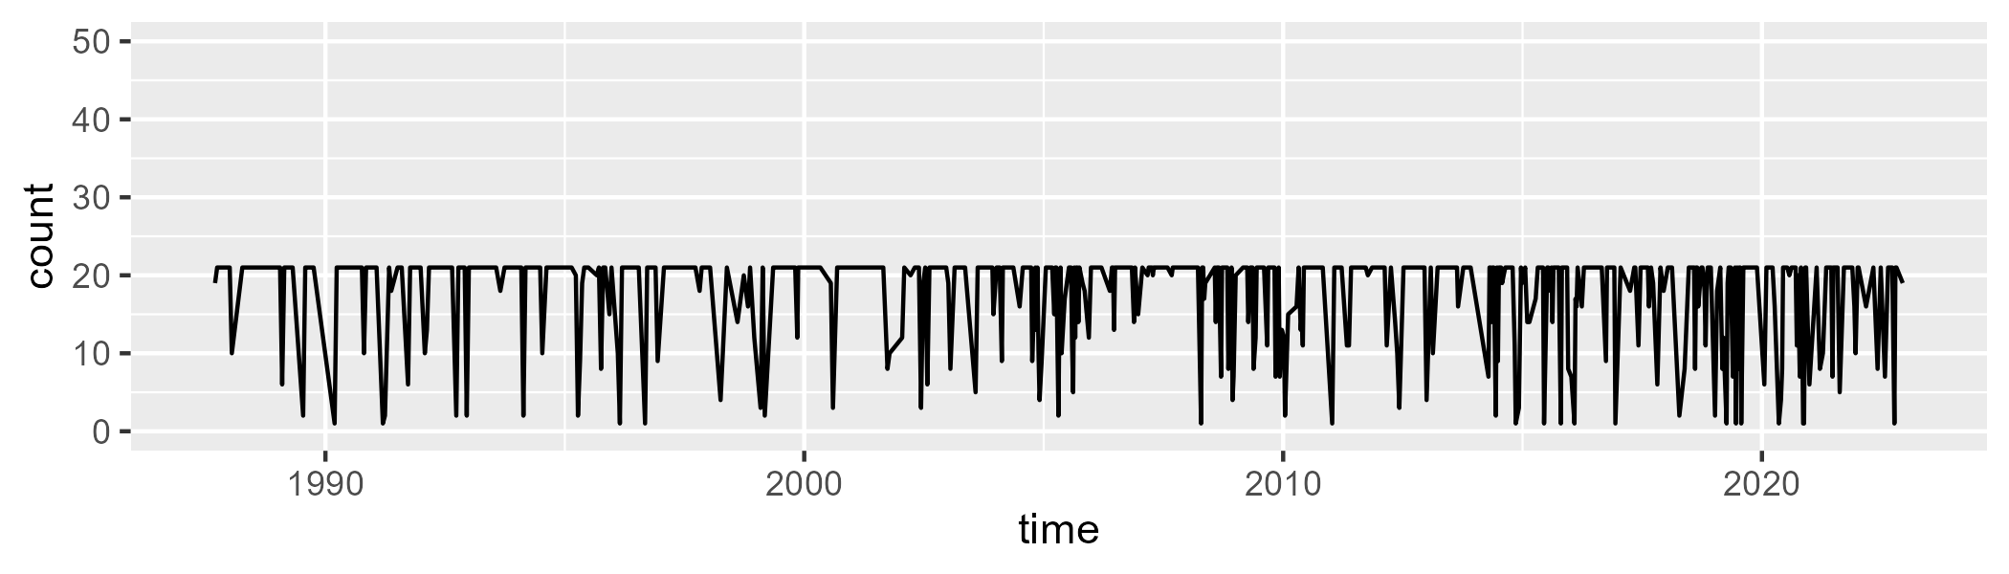

Min. : 1.00 1st Qu.:17.25 Median :21.00 Mean :17.79 3rd Qu.:21.00 Max. :21.00

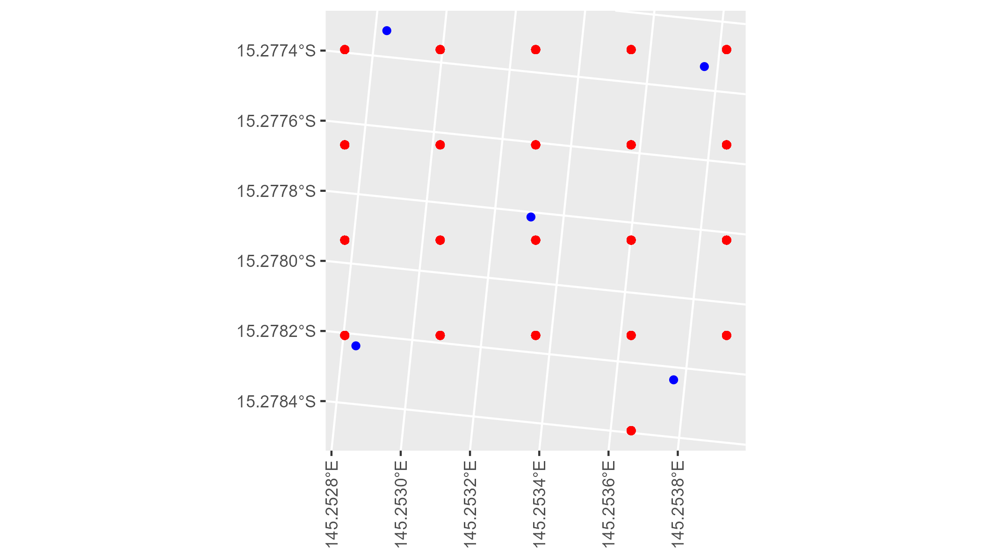

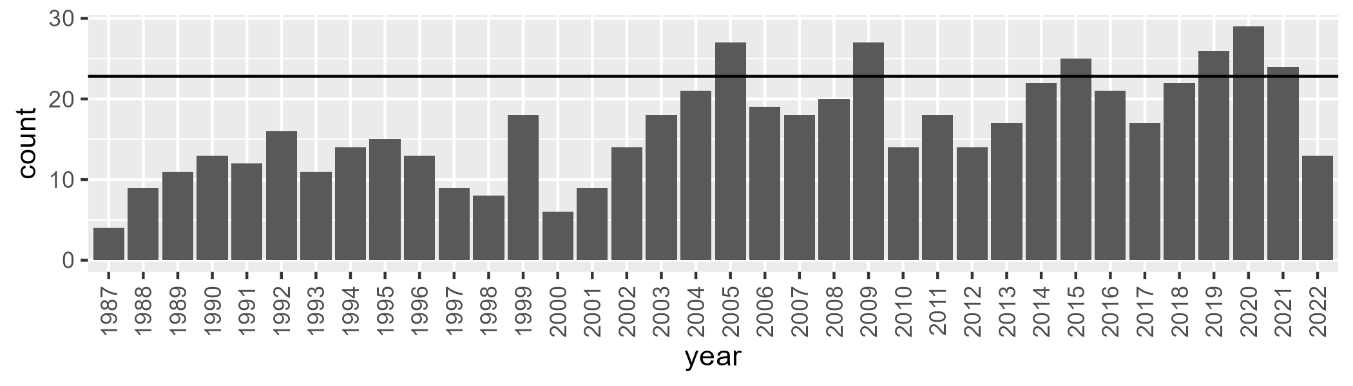

Number of samples: 594

# QDACYP0002

| Min. | 1st Qu. | Median | Mean | 3rd Qu. | Max. |
| --- | --- | --- | --- | --- | --- |
| 18.64988 | 41.03119 | 45.82708 | 45.82546 | 51.77705 | 59.96024 |

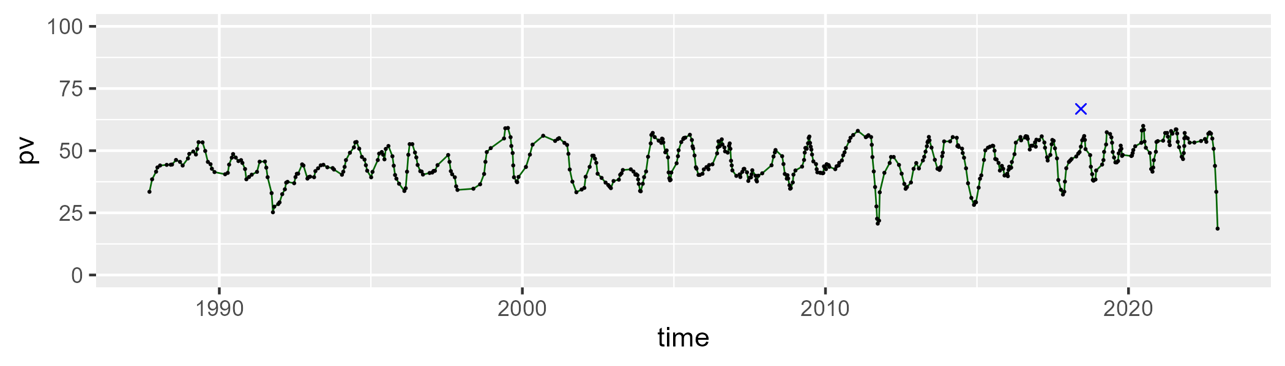

| Min. | 1st Qu. | Median | Mean | 3rd Qu. | Max. |
| --- | --- | --- | --- | --- | --- |
| 19.66106 | 38.0787 | 42.84924 | 42.96542 | 48.29208 | 61.28505 |

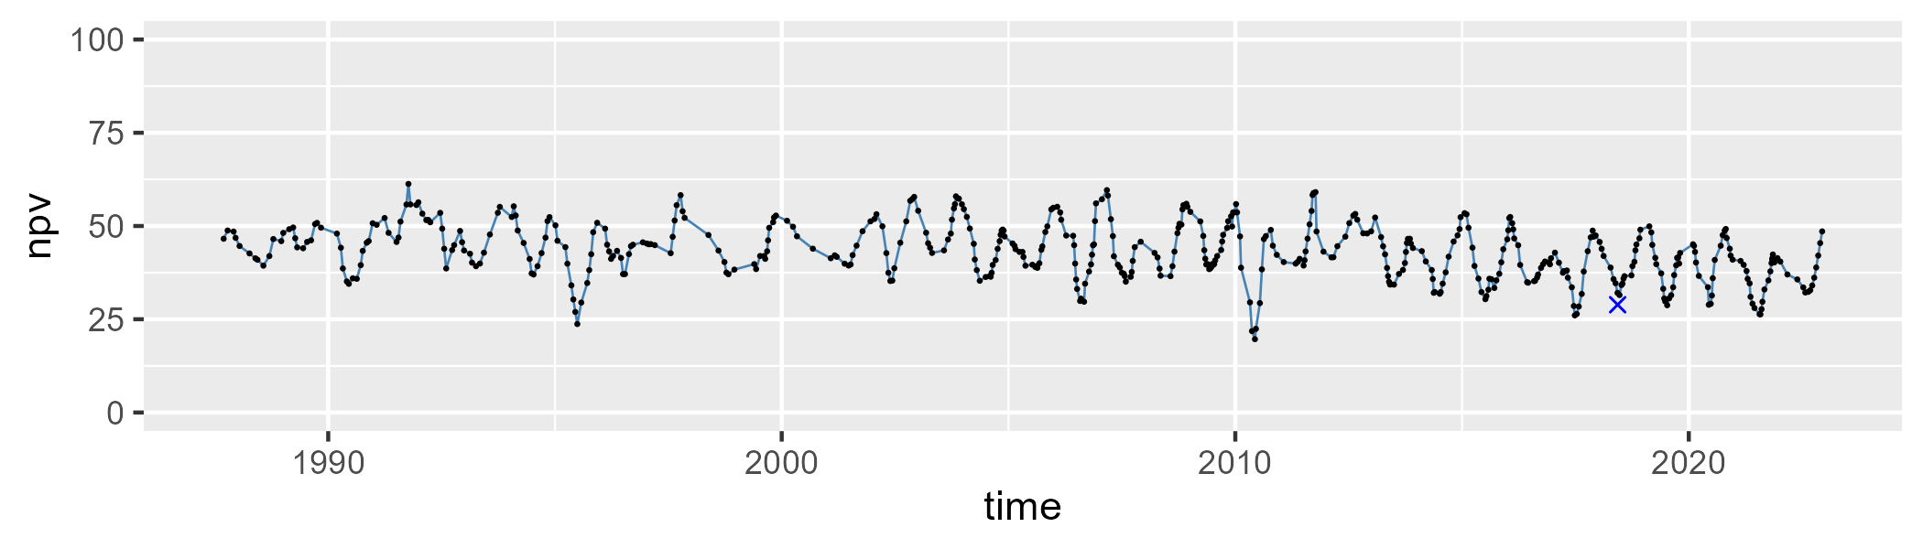

| Min. | 1st Qu. | Median | Mean | 3rd Qu. | Max. |
| --- | --- | --- | --- | --- | --- |
| 0 | 5.806611 | 9.208596 | 10.05867 | 14.02963 | 35.40355 |

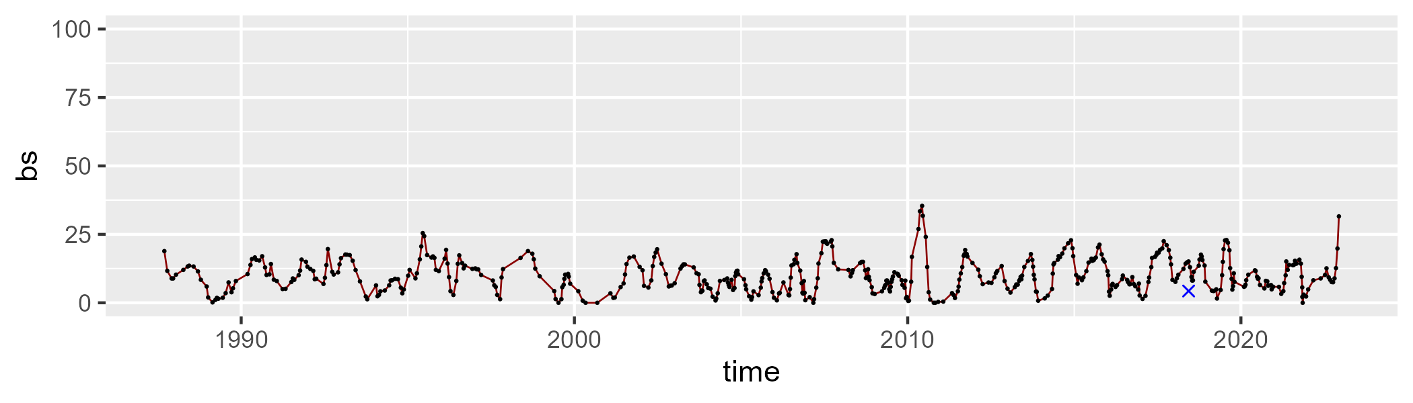

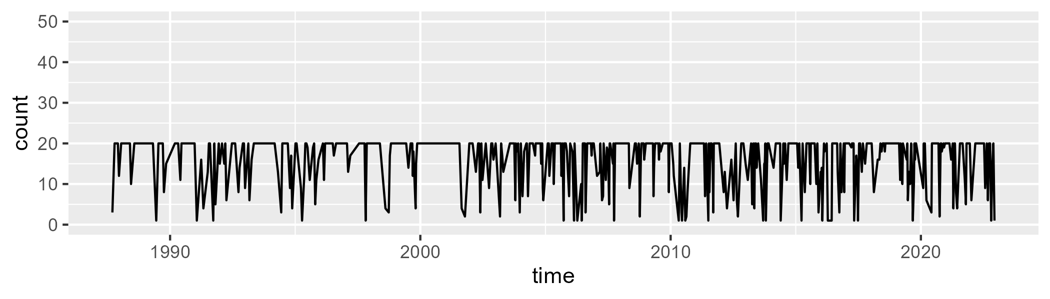

Min. : 1.00 1st Qu.:13.00 Median :20.00 Mean :15.96 3rd Qu.:20.00 Max. :20.00

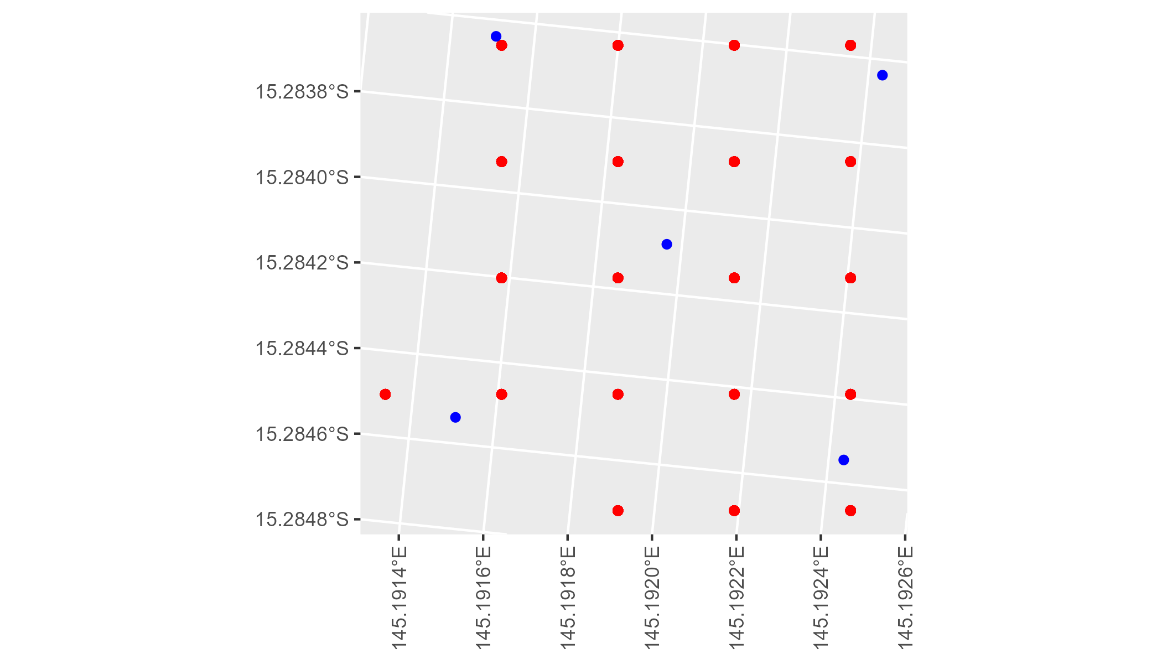

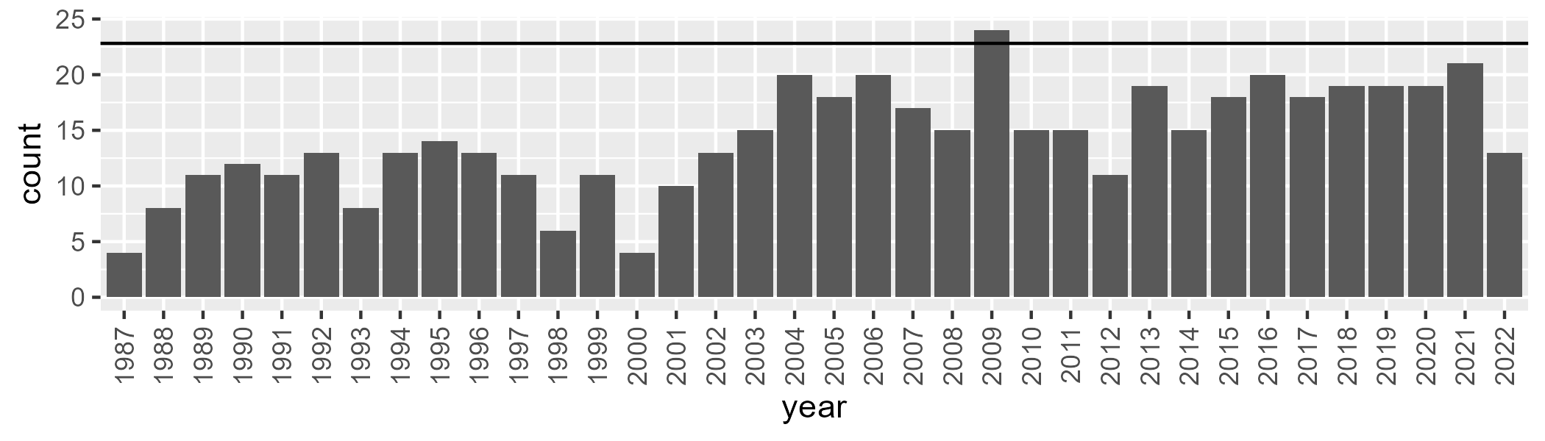

Number of samples: 513

# QDACYP0003

| Min. | 1st Qu. | Median | Mean | 3rd Qu. | Max. |
| --- | --- | --- | --- | --- | --- |
| 1.400457 | 43.77304 | 51.66794 | 48.96228 | 58.24262 | 68.62005 |

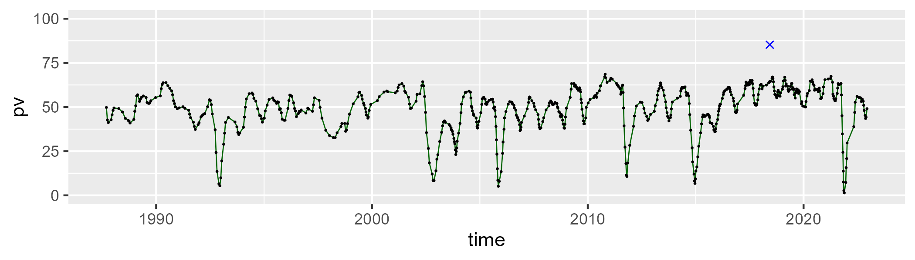

| Min. | 1st Qu. | Median | Mean | 3rd Qu. | Max. |
| --- | --- | --- | --- | --- | --- |
| 9.198494 | 26.59575 | 32.92679 | 32.87501 | 39.45932 | 58.12067 |

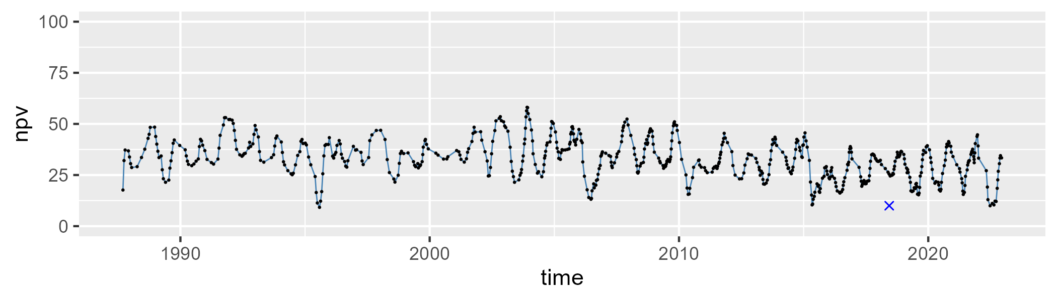

| Min. | 1st Qu. | Median | Mean | 3rd Qu. | Max. |
| --- | --- | --- | --- | --- | --- |
| 0 | 8.407859 | 14.23356 | 16.87967 | 22.39373 | 59.7364 |

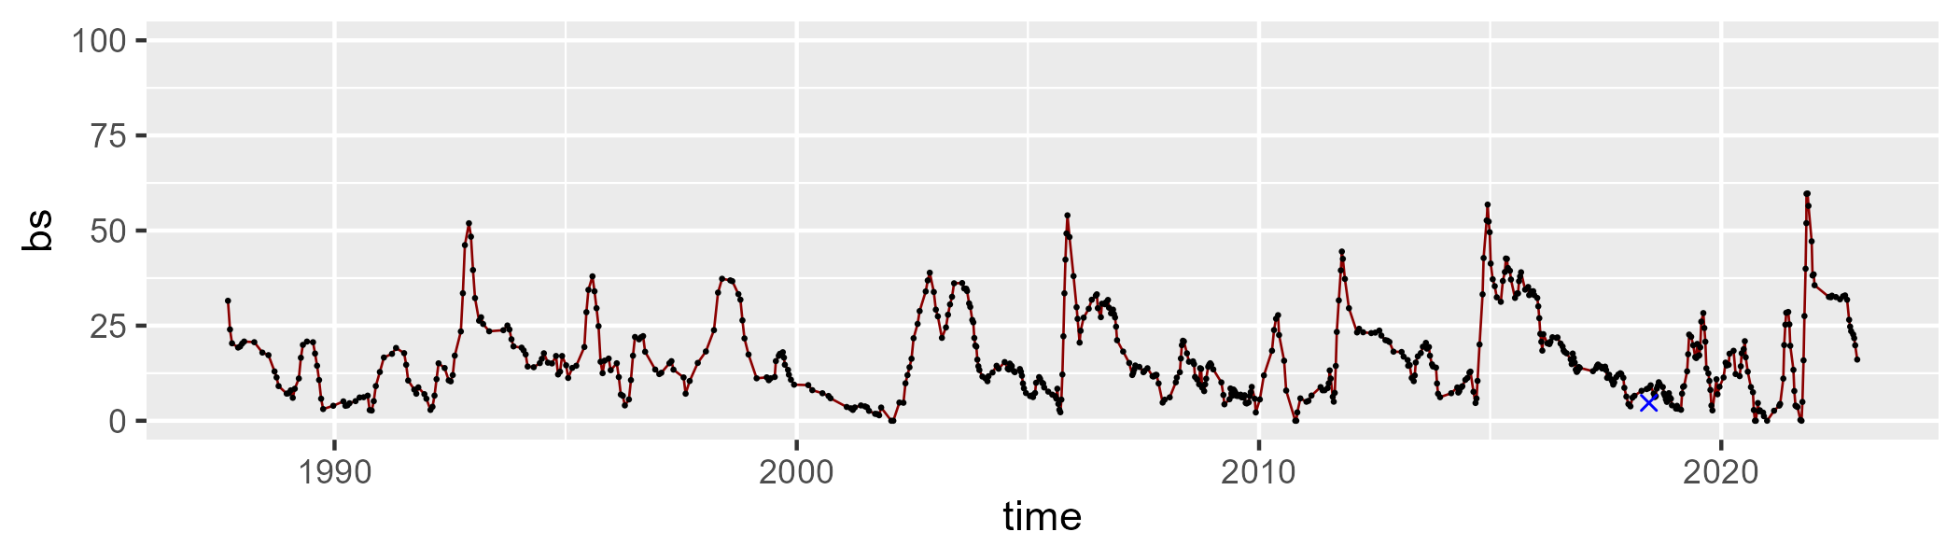

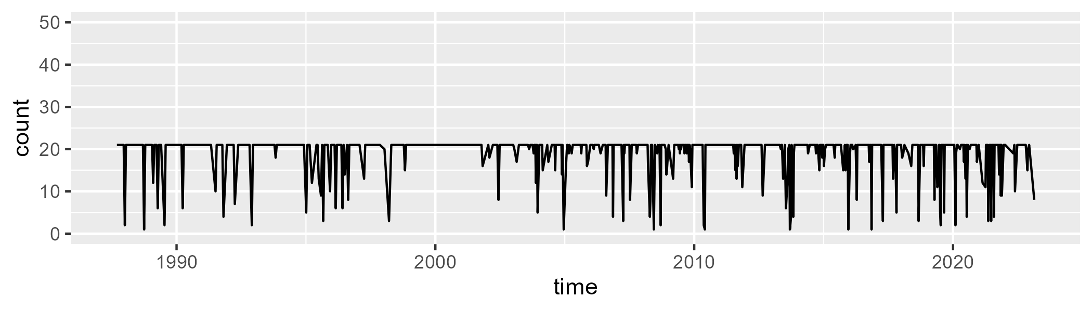

Min. : 1.00 1st Qu.:21.00 Median :21.00 Mean :19.03 3rd Qu.:21.00 Max. :21.00

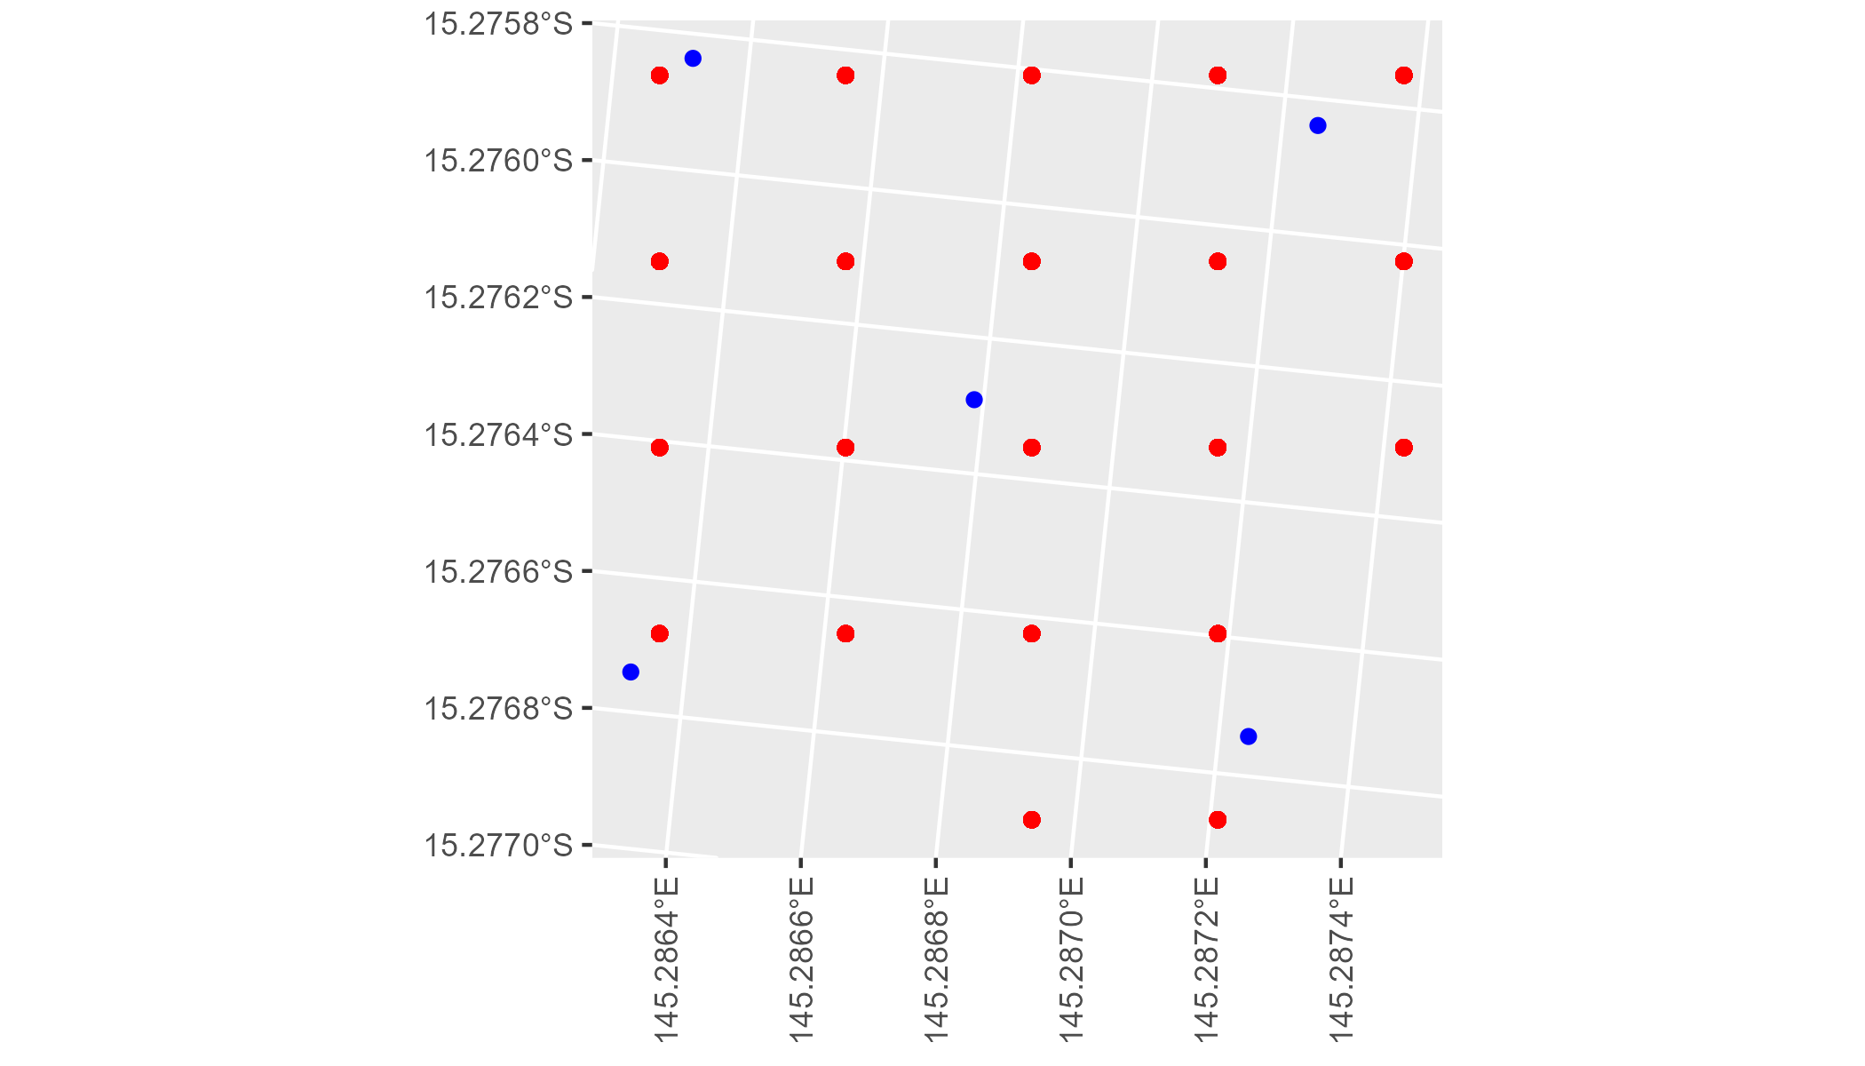

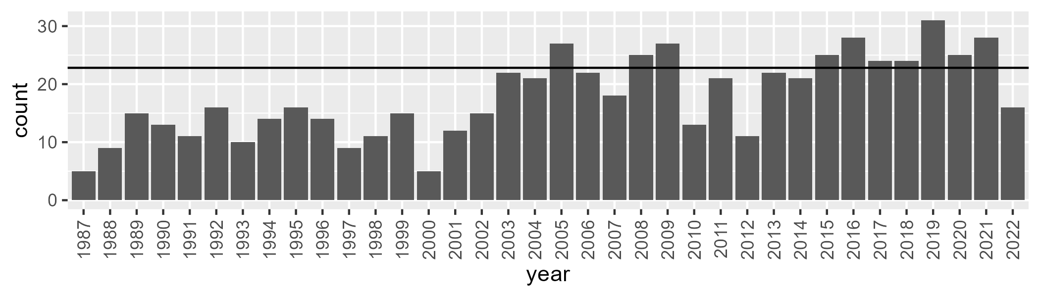

Number of samples: 641

# QDACYP0004

| Min. | 1st Qu. | Median | Mean | 3rd Qu. | Max. |
| --- | --- | --- | --- | --- | --- |
| 18.83147 | 37.46316 | 43.64397 | 44.639 | 51.10595 | 77.90026 |

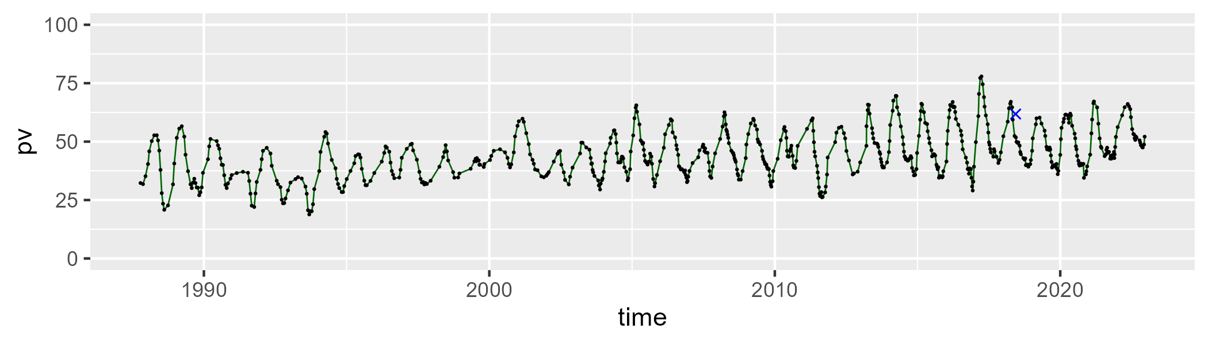

| Min. | 1st Qu. | Median | Mean | 3rd Qu. | Max. |
| --- | --- | --- | --- | --- | --- |
| 17.00896 | 41.30142 | 47.98201 | 46.43855 | 53.84117 | 69.03412 |

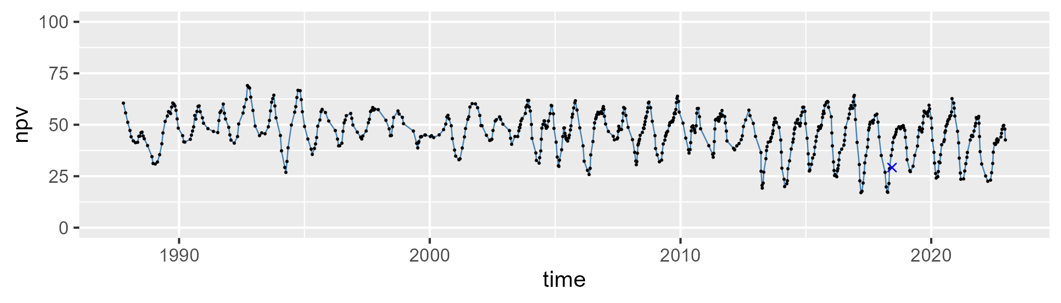

| Min. | 1st Qu. | Median | Mean | 3rd Qu. | Max. |
| --- | --- | --- | --- | --- | --- |
| 0 | 4.421758 | 6.293315 | 7.708102 | 10.36741 | 36.17472 |

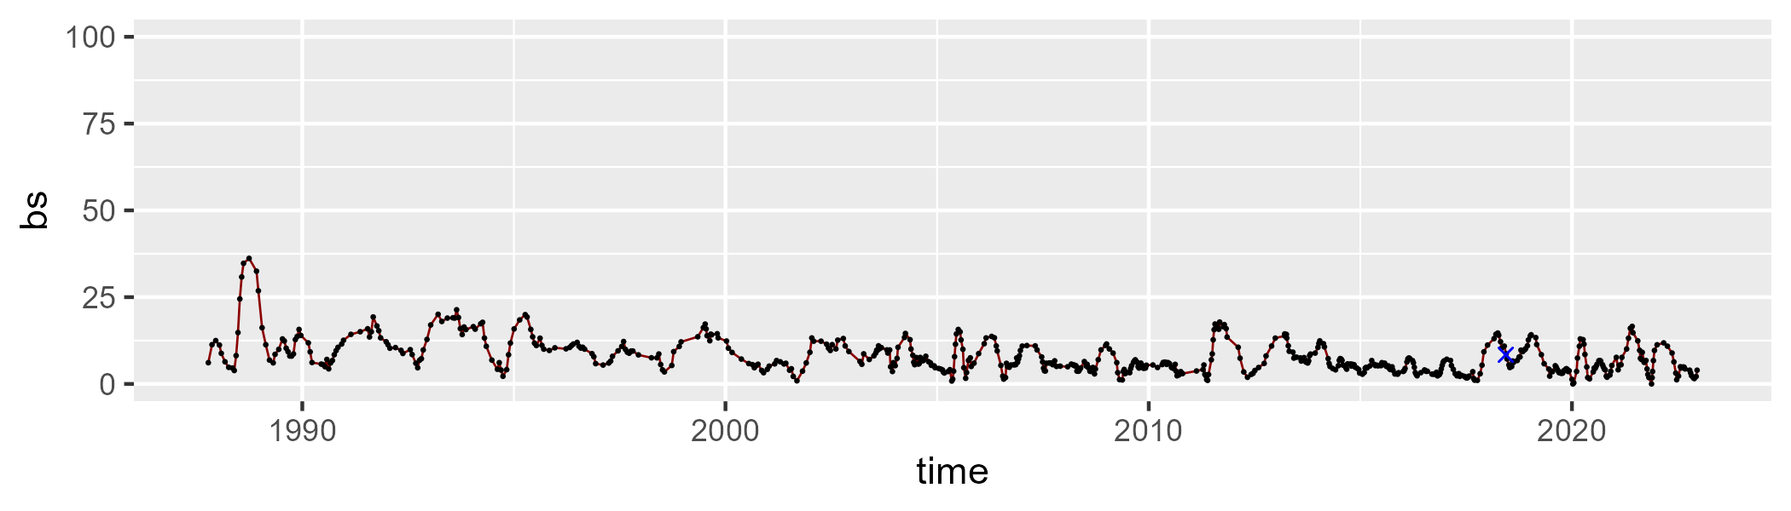

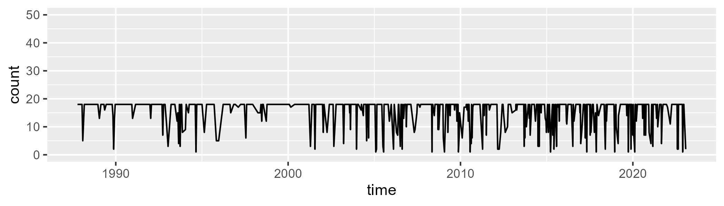

Min. : 1.00 1st Qu.:17.00 Median :18.00 Mean :15.64 3rd Qu.:18.00 Max. :18.00

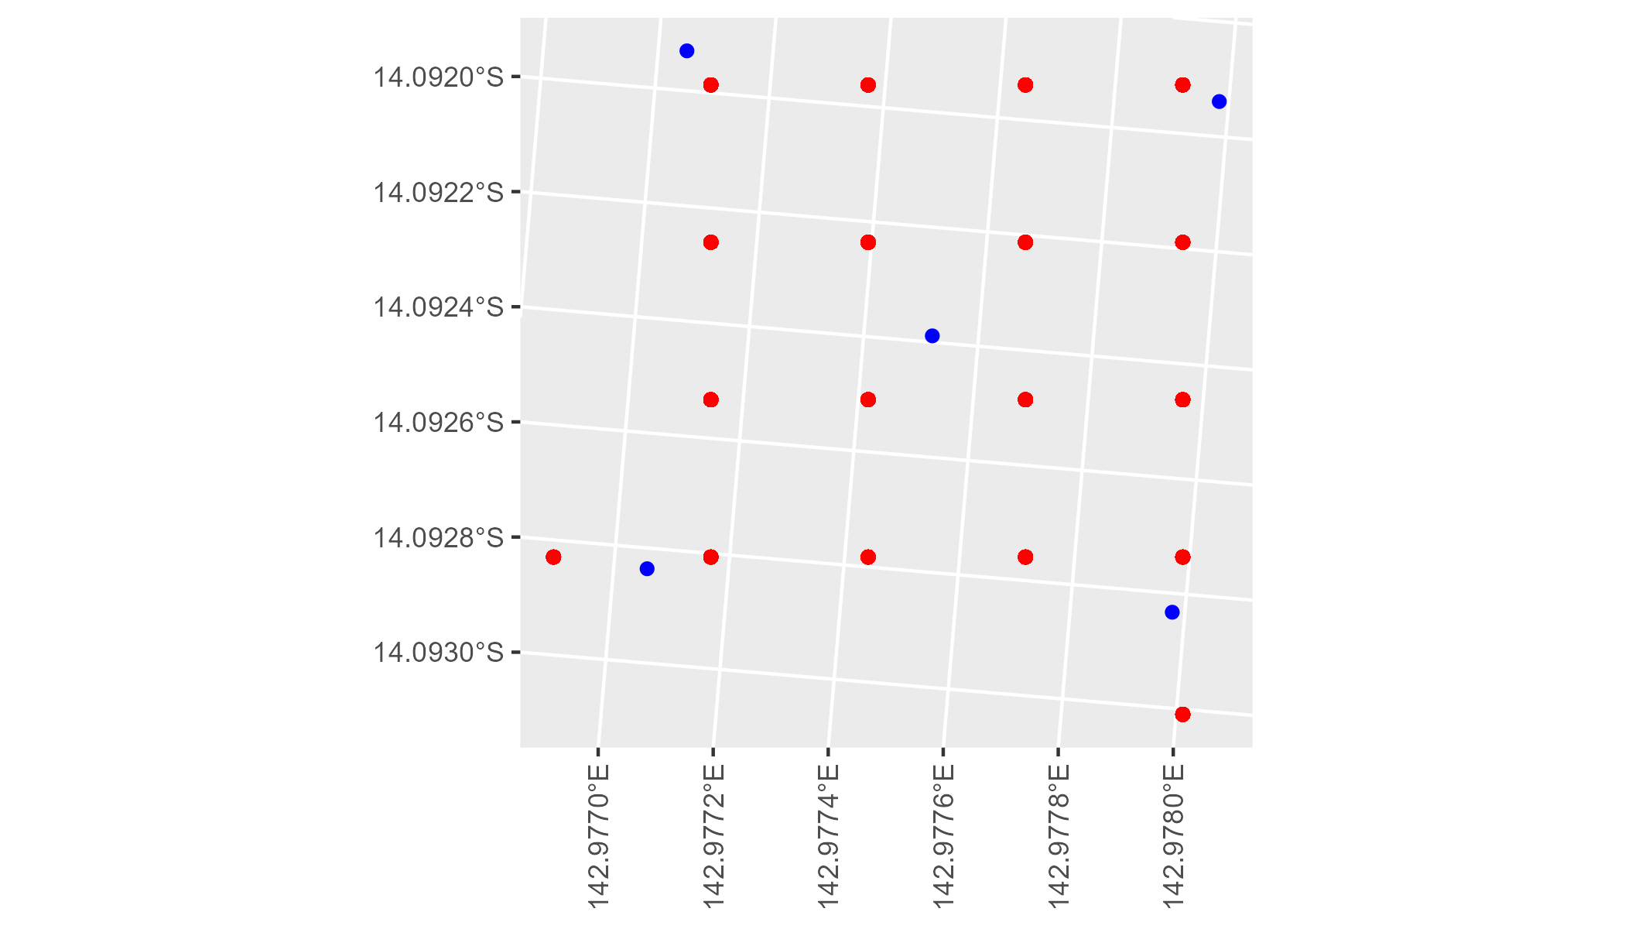

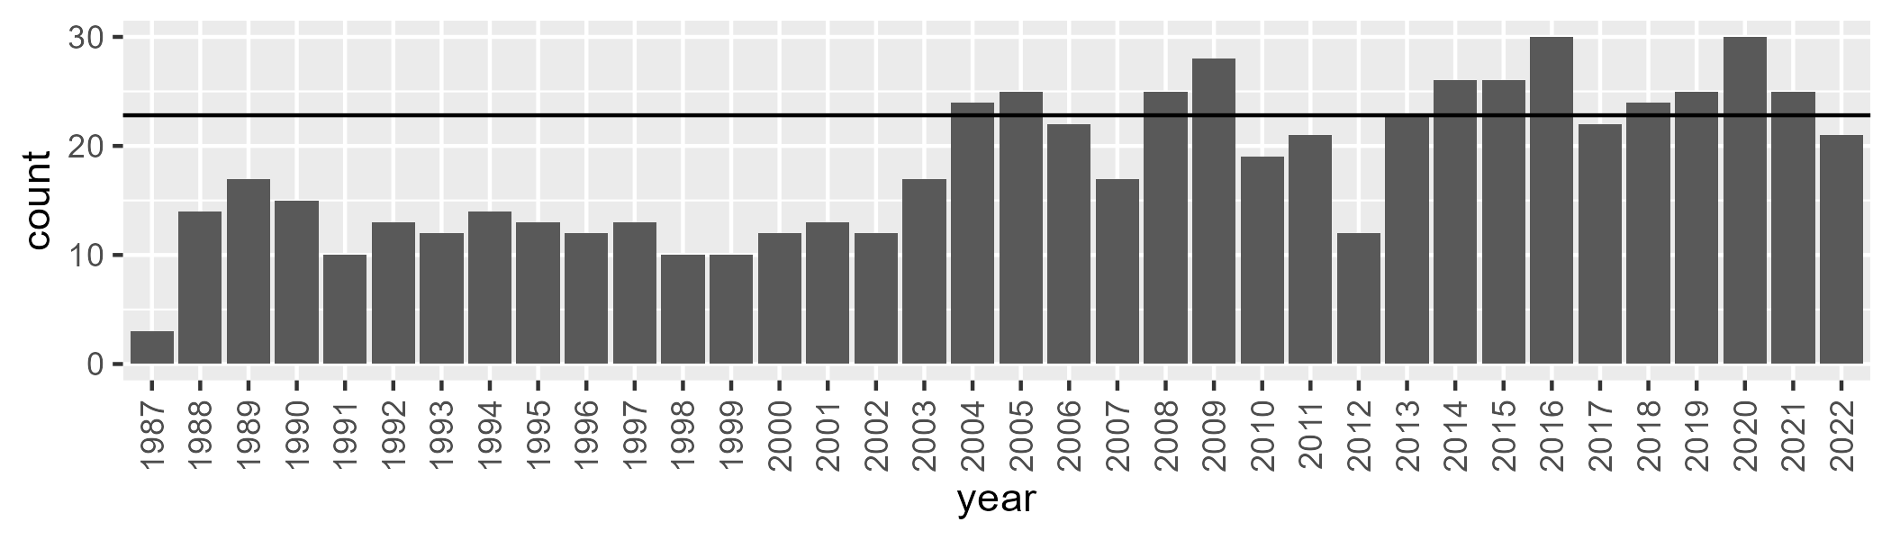

Number of samples: 655

# QDACYP0005

| Min. | 1st Qu. | Median | Mean | 3rd Qu. | Max. |
| --- | --- | --- | --- | --- | --- |
| 14.35773 | 36.98466 | 42.81069 | 43.29927 | 49.88254 | 67.94772 |

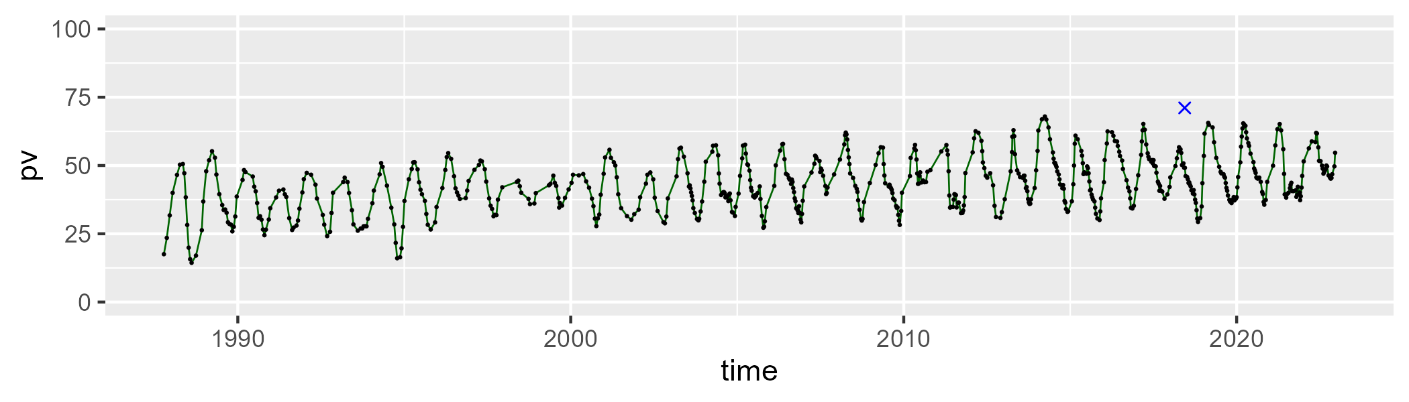

| Min. | 1st Qu. | Median | Mean | 3rd Qu. | Max. |
| --- | --- | --- | --- | --- | --- |
| 19.20717 | 40.94913 | 48.06121 | 46.98921 | 54.09561 | 65.54373 |

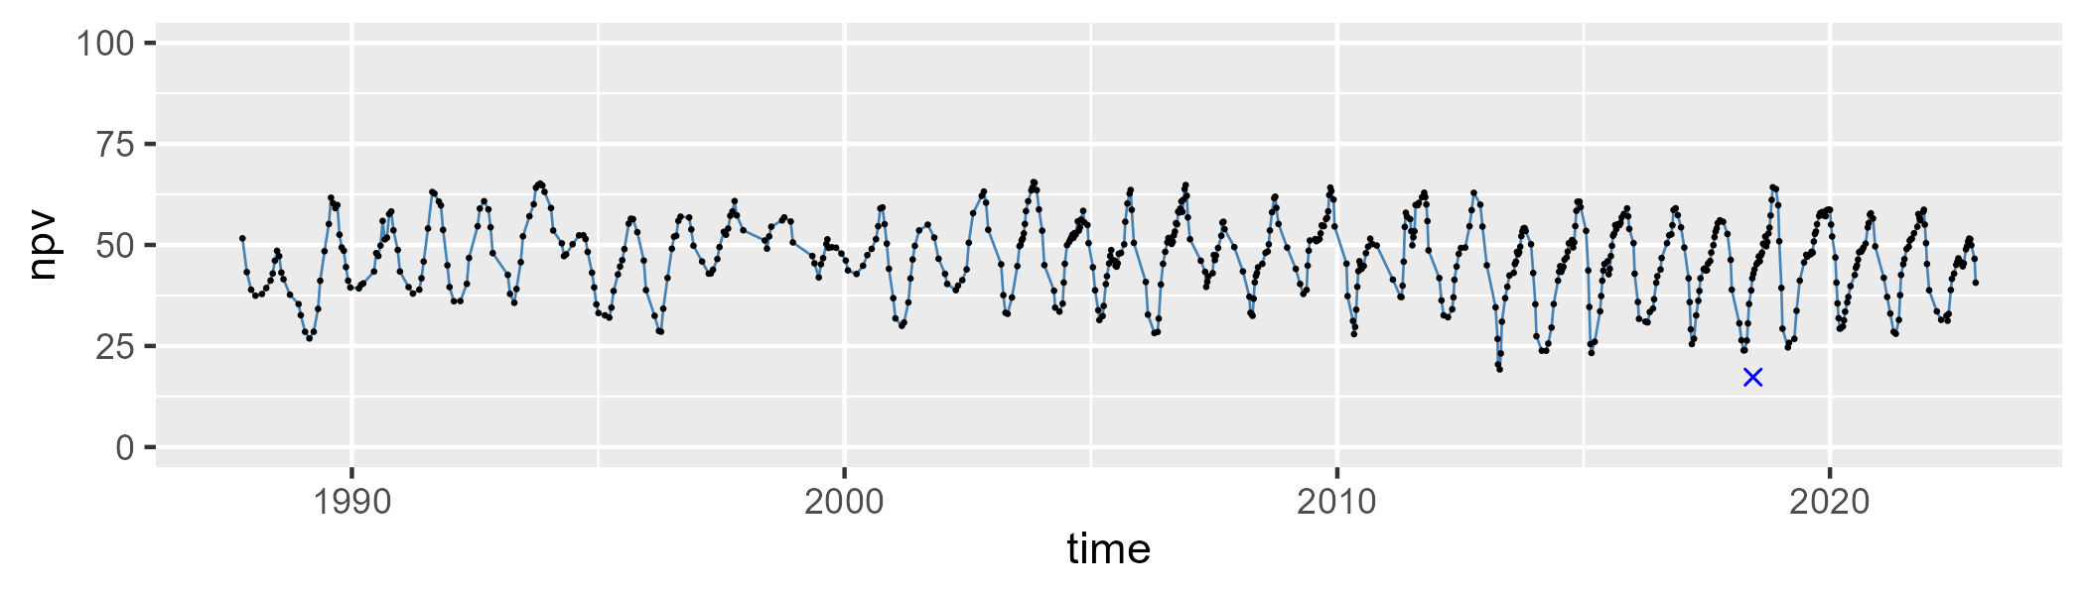

| Min. | 1st Qu. | Median | Mean | 3rd Qu. | Max. |
| --- | --- | --- | --- | --- | --- |
| 0.6577838 | 4.588513 | 6.787706 | 8.535646 | 10.29382 | 43.93872 |

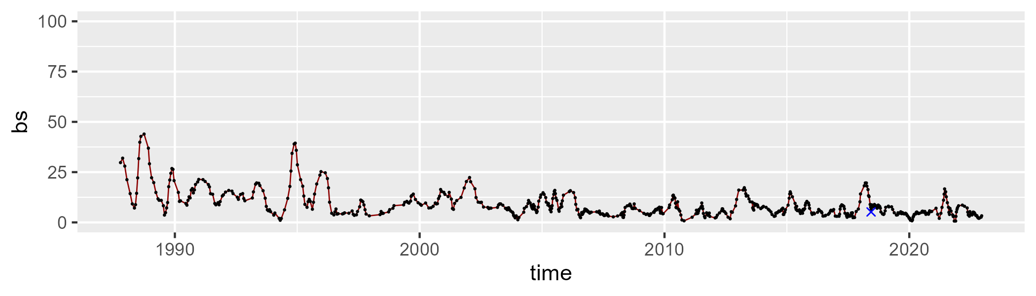

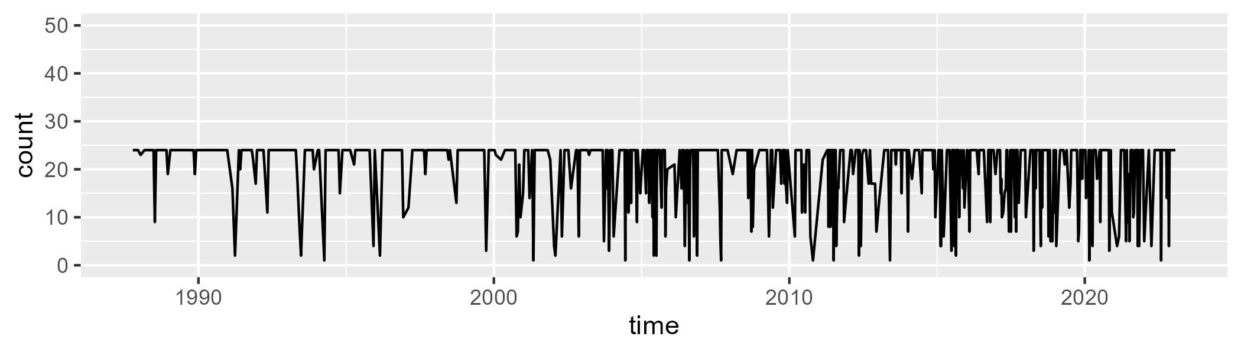

Min. : 1.0 1st Qu.:20.0 Median :24.0 Mean :20.4 3rd Qu.:24.0 Max. :24.0

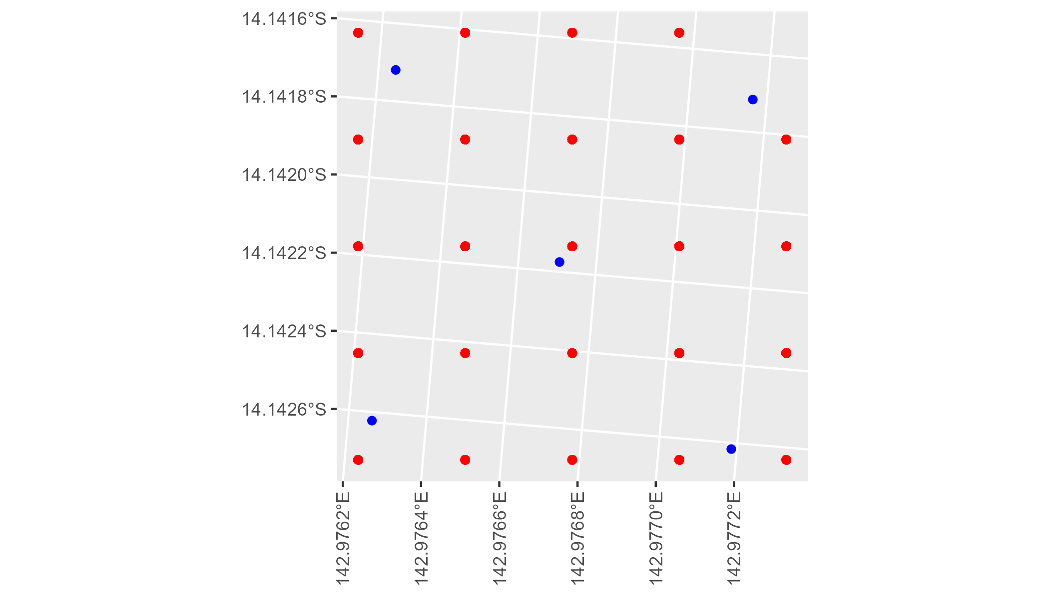

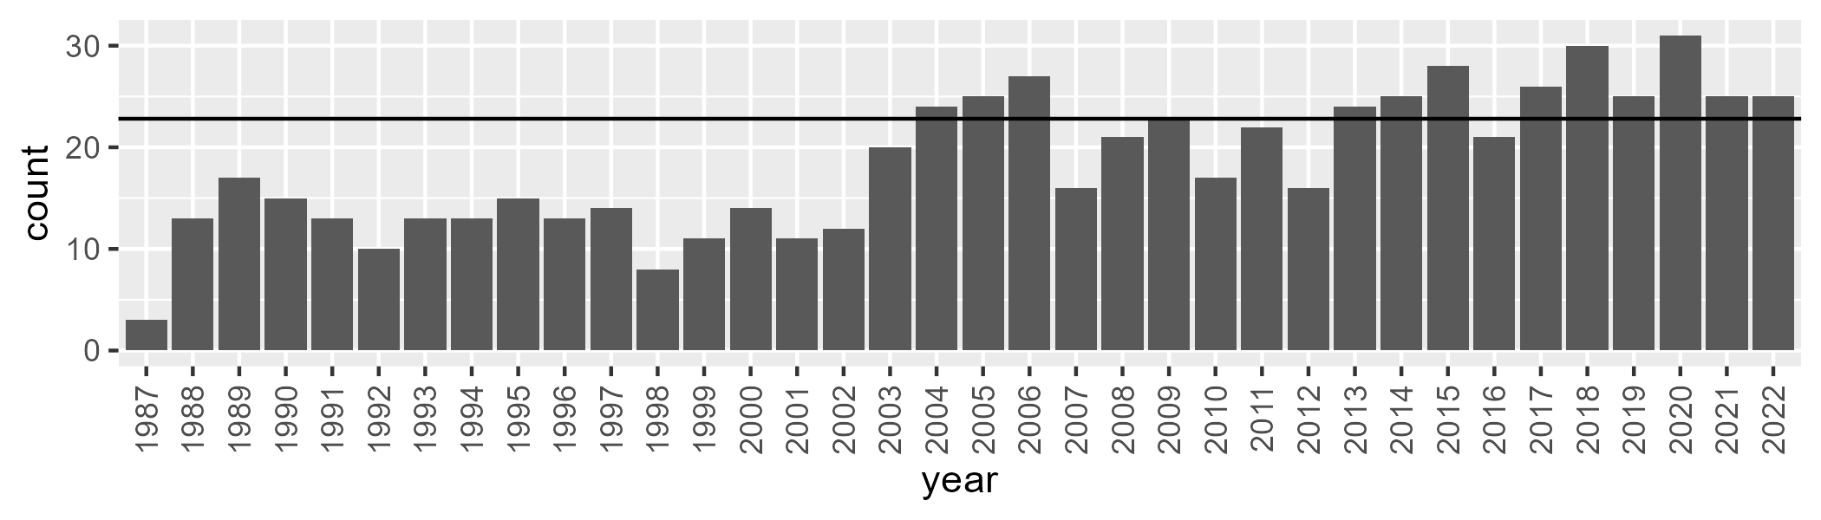

Number of samples: 666

# QDACYP0006

| Min. | 1st Qu. | Median | Mean | 3rd Qu. | Max. |
| --- | --- | --- | --- | --- | --- |
| 13.67309 | 33.31968 | 43.47203 | 45.38366 | 56.74864 | 78.85259 |

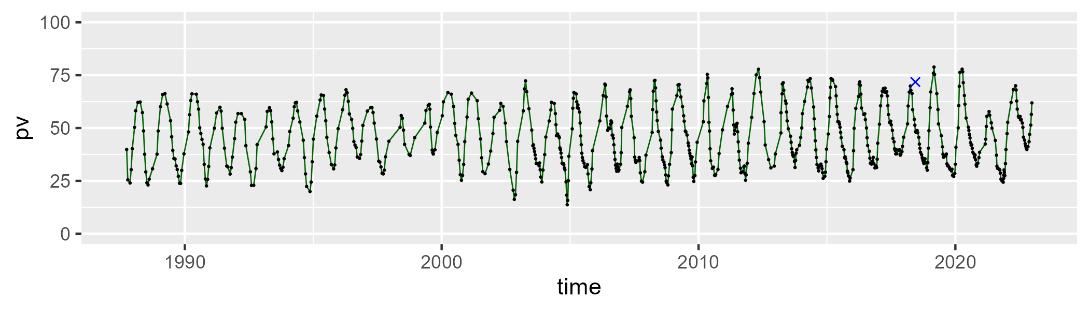

| Min. | 1st Qu. | Median | Mean | 3rd Qu. | Max. |
| --- | --- | --- | --- | --- | --- |
| 14.49734 | 35.17586 | 46.61162 | 44.81117 | 54.63814 | 71.93045 |

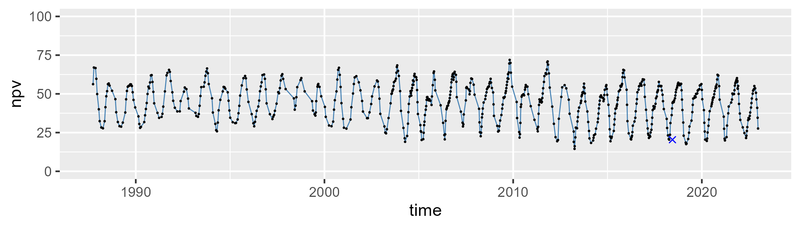

| Min. | 1st Qu. | Median | Mean | 3rd Qu. | Max. |
| --- | --- | --- | --- | --- | --- |
| 0 | 4.19094 | 7.308753 | 8.607681 | 11.73255 | 30.74338 |

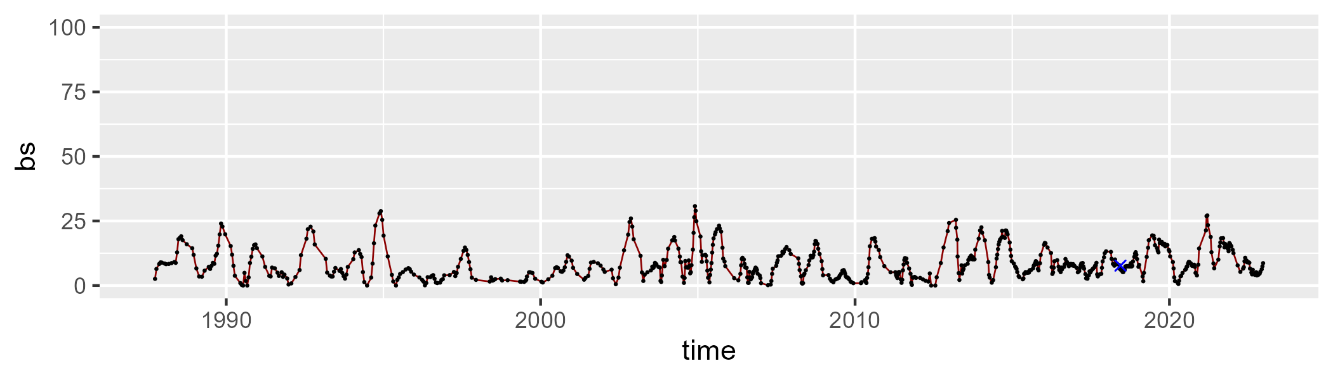

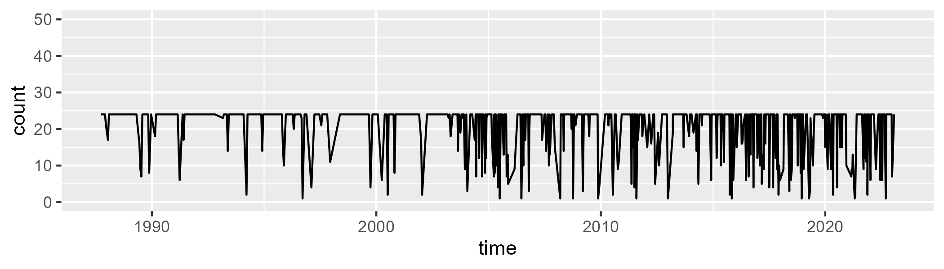

Min. : 1.00 1st Qu.:23.00 Median :24.00 Mean :20.82 3rd Qu.:24.00 Max. :24.00

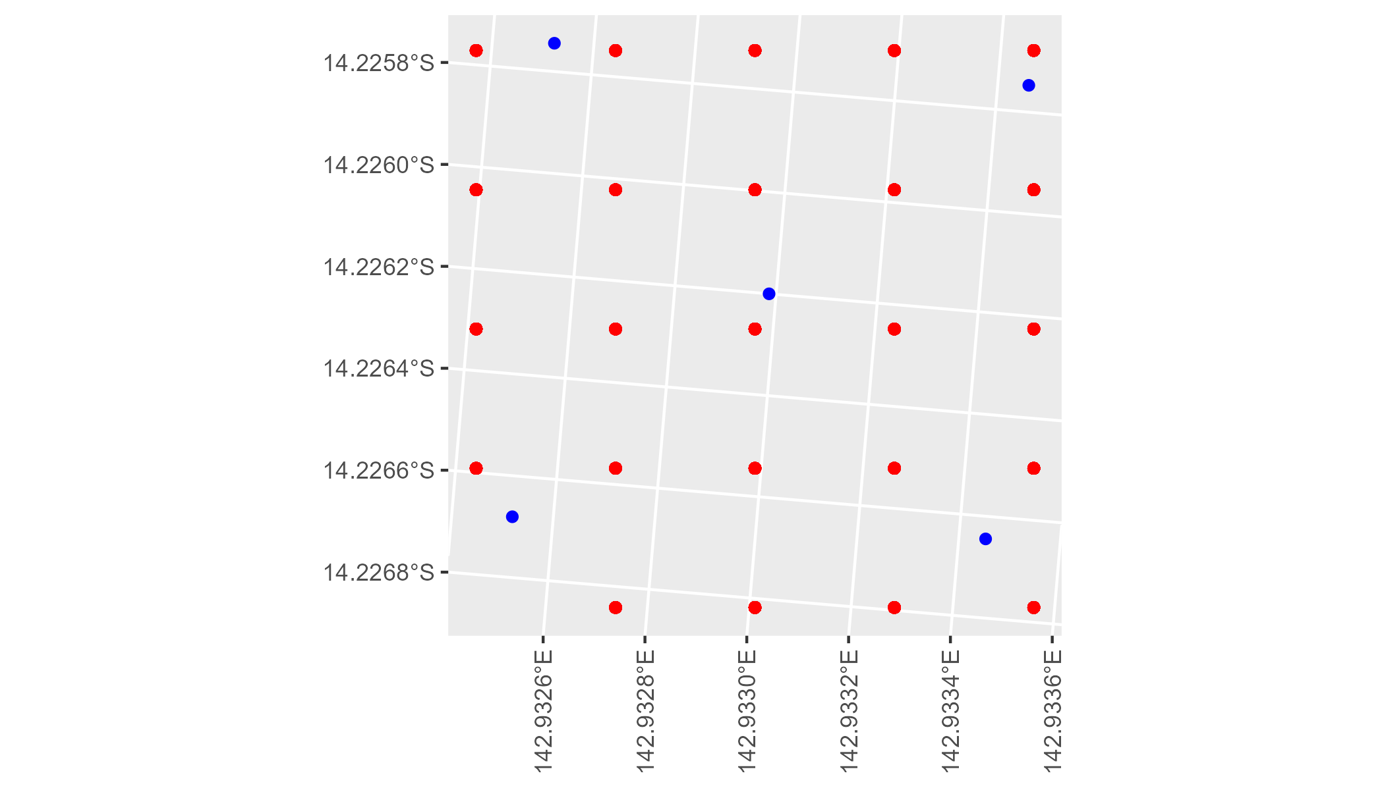

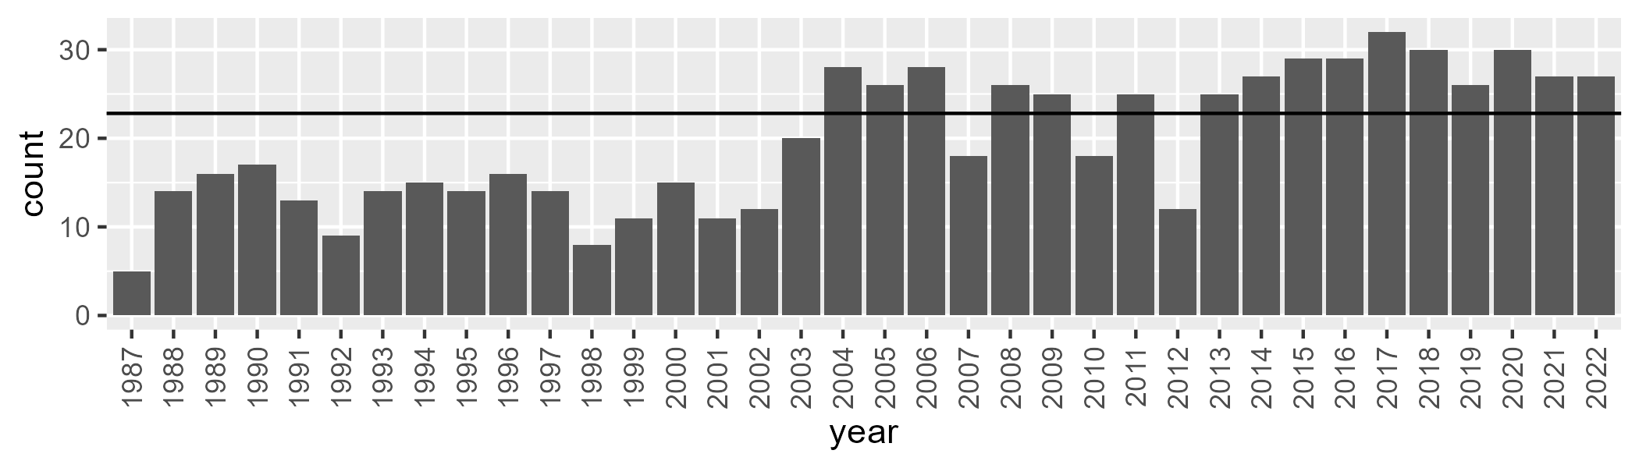

Number of samples: 712

# QDACYP0007

| Min. | 1st Qu. | Median | Mean | 3rd Qu. | Max. |
| --- | --- | --- | --- | --- | --- |
| 20.93362 | 42.08919 | 50.68339 | 50.51514 | 59.18118 | 79.95587 |

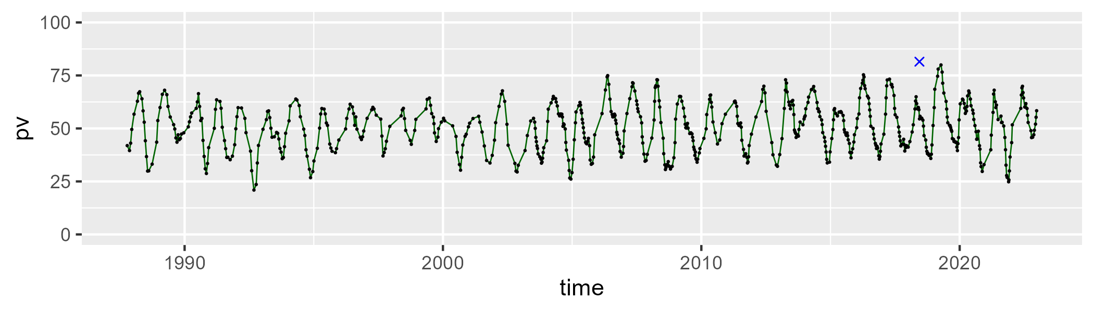

| Min. | 1st Qu. | Median | Mean | 3rd Qu. | Max. |
| --- | --- | --- | --- | --- | --- |
| 16.98295 | 33.9739 | 42.55899 | 42.02192 | 49.97984 | 67.65124 |

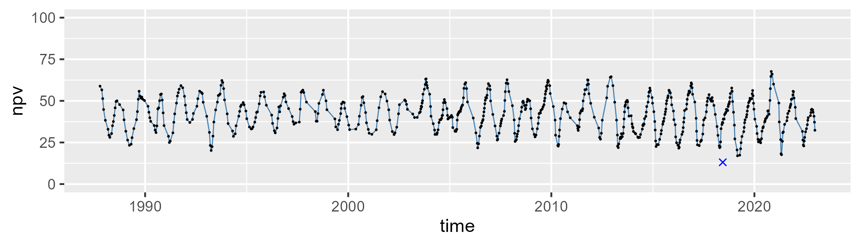

| Min. | 1st Qu. | Median | Mean | 3rd Qu. | Max. |
| --- | --- | --- | --- | --- | --- |
| 0 | 2.569686 | 4.61016 | 6.303875 | 8.299212 | 33.29363 |

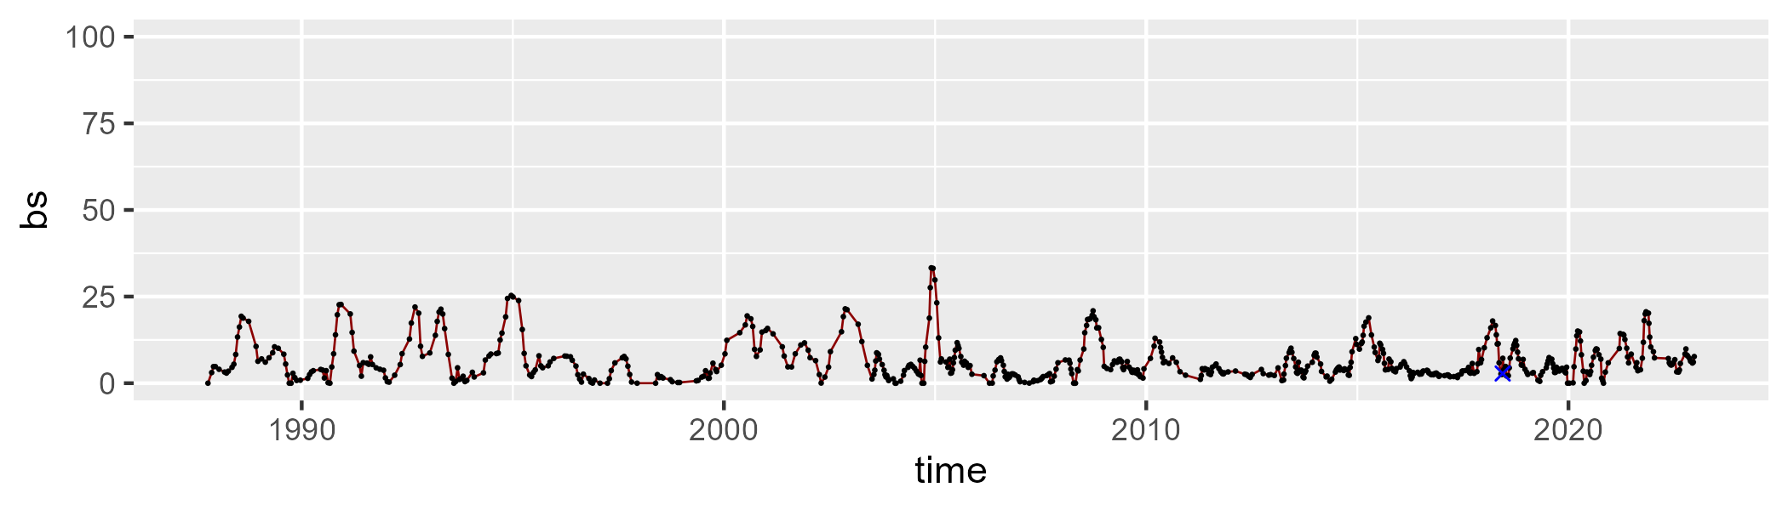

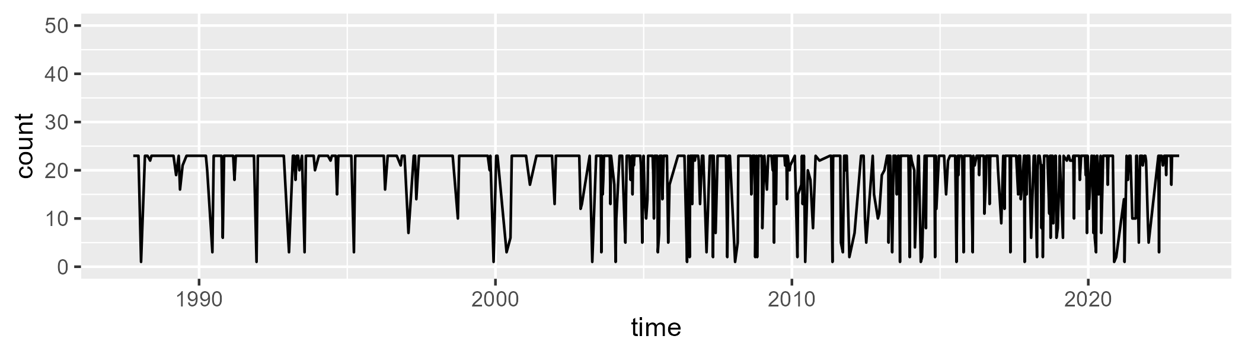

Min. : 1.00 1st Qu.:20.00 Median :23.00 Mean :19.73 3rd Qu.:23.00 Max. :23.00

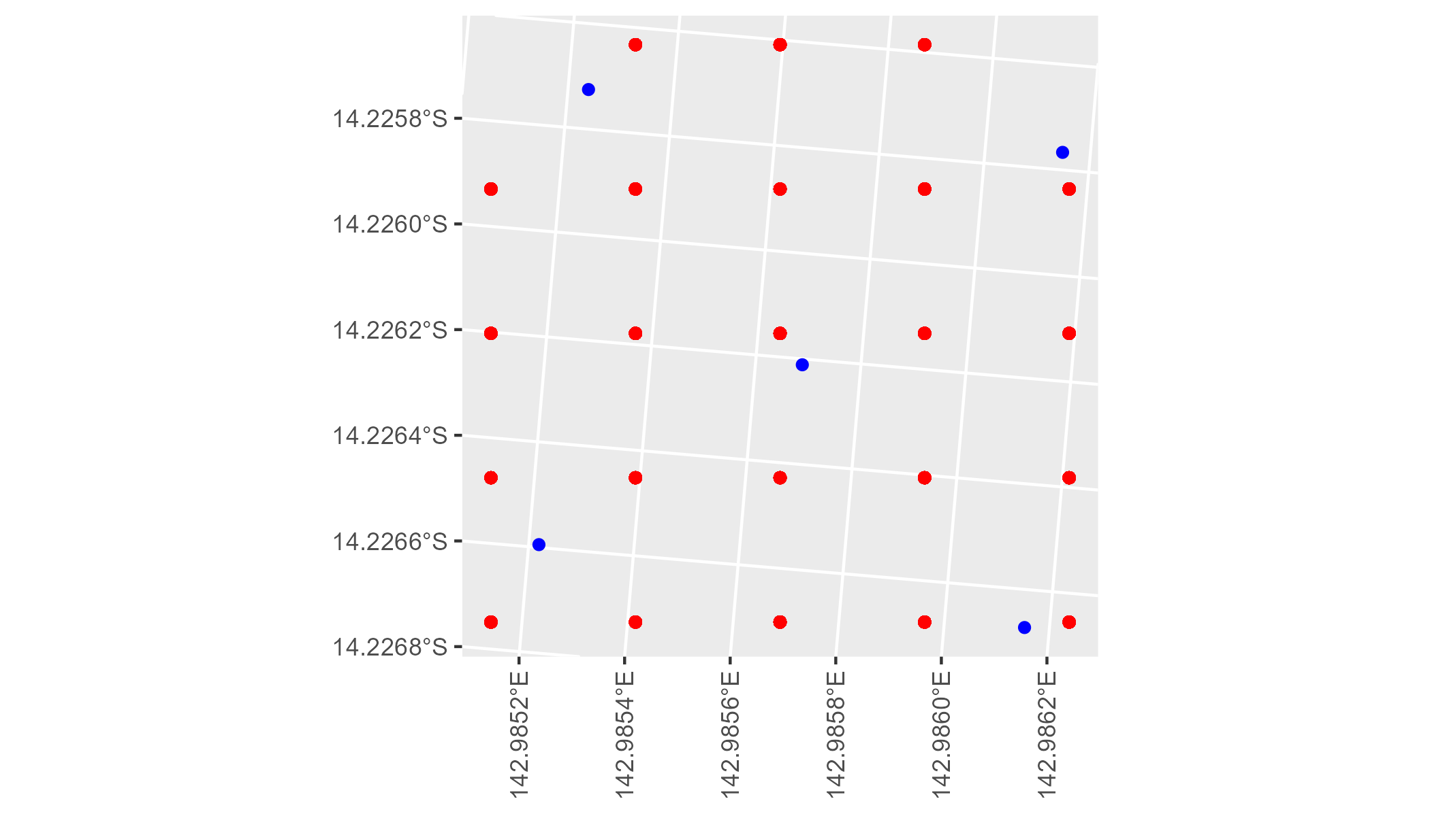

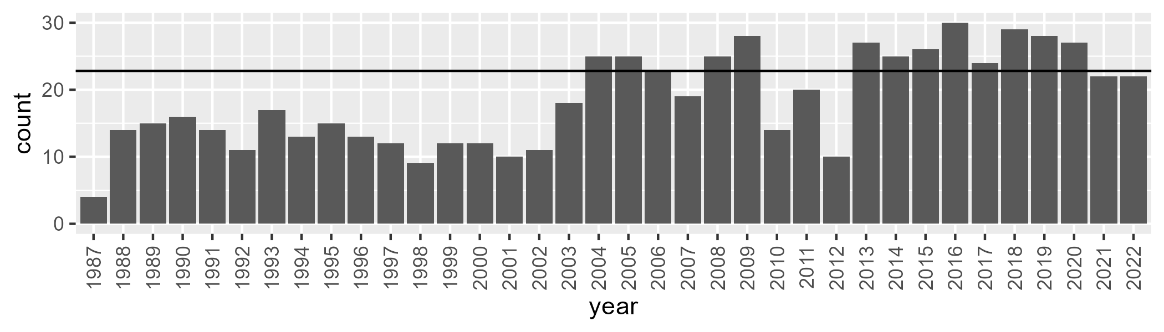

Number of samples: 665

# QDACYP0008

| Min. | 1st Qu. | Median | Mean | 3rd Qu. | Max. |
| --- | --- | --- | --- | --- | --- |
| 19.64843 | 41.27232 | 47.63227 | 46.67757 | 53.51045 | 65.04858 |

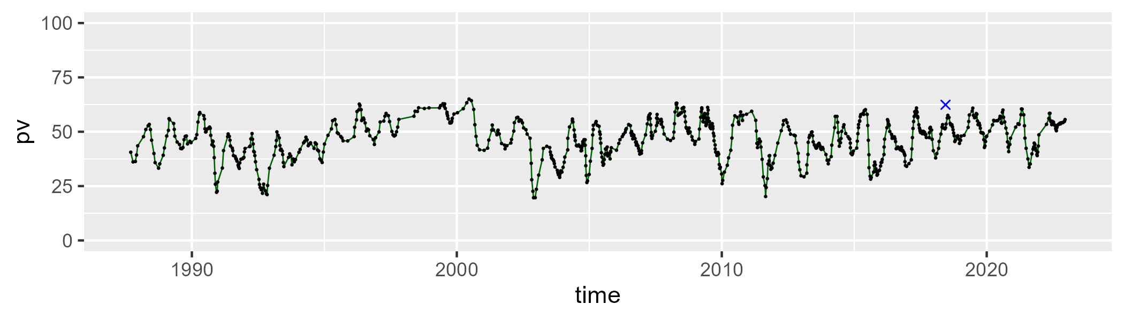

| Min. | 1st Qu. | Median | Mean | 3rd Qu. | Max. |
| --- | --- | --- | --- | --- | --- |
| 28.99714 | 39.78141 | 44.98478 | 45.28452 | 49.95934 | 69.59704 |

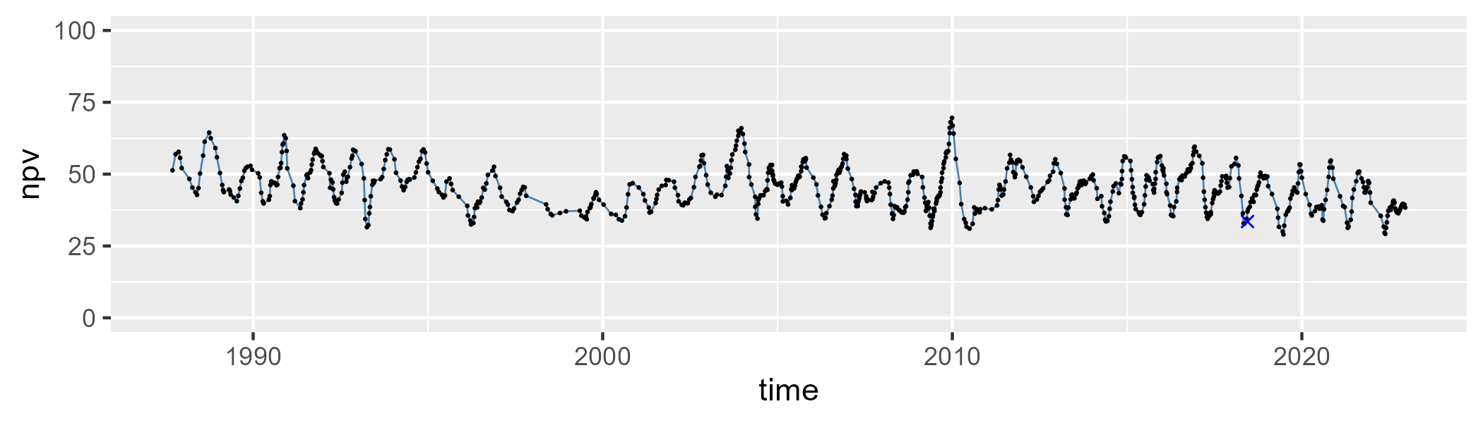

| Min. | 1st Qu. | Median | Mean | 3rd Qu. | Max. |
| --- | --- | --- | --- | --- | --- |
| 0 | 2.64493 | 5.394378 | 6.881285 | 9.628791 | 29.72618 |

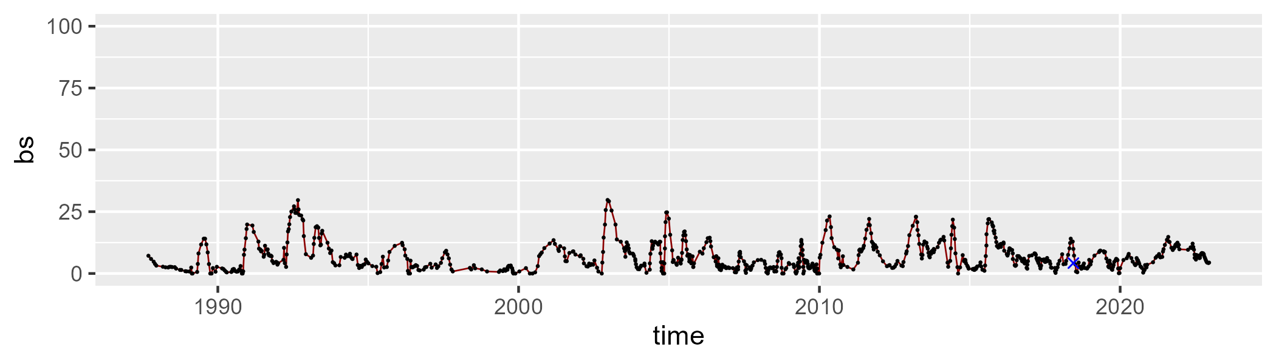

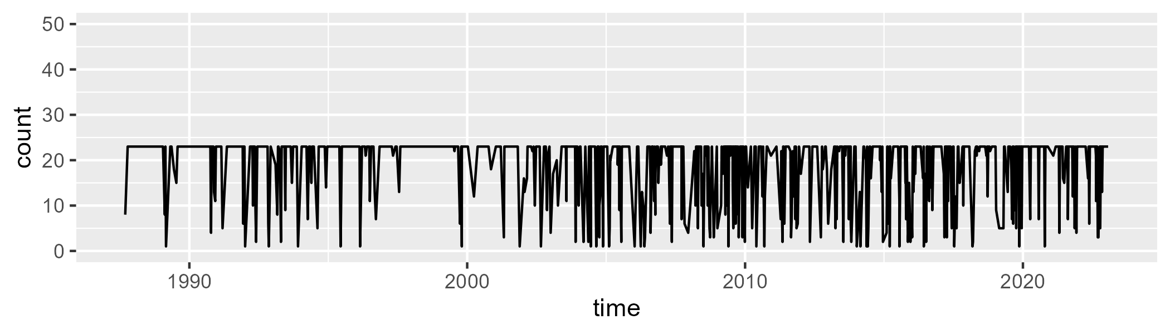

Min. : 1.00 1st Qu.:17.00 Median :23.00 Mean :18.86 3rd Qu.:23.00 Max. :23.00

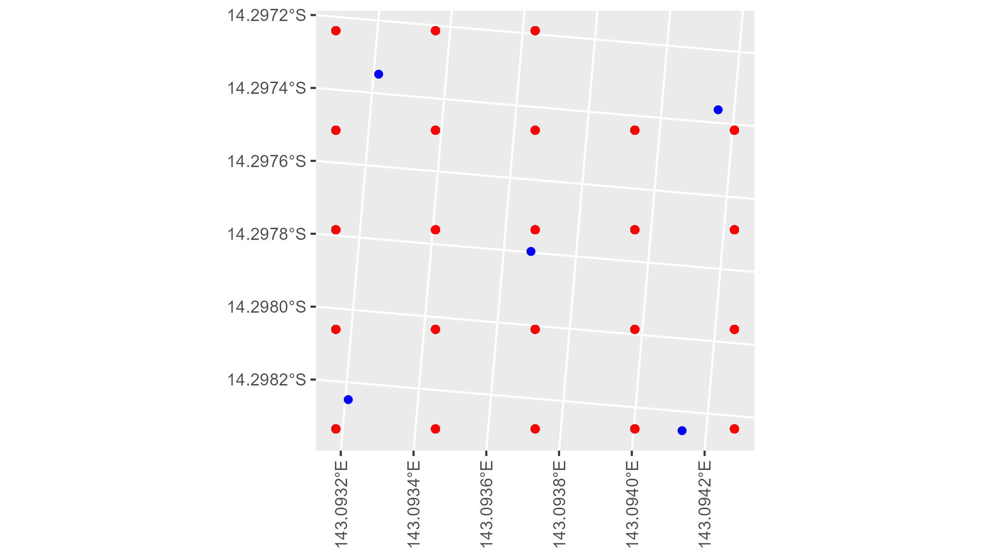

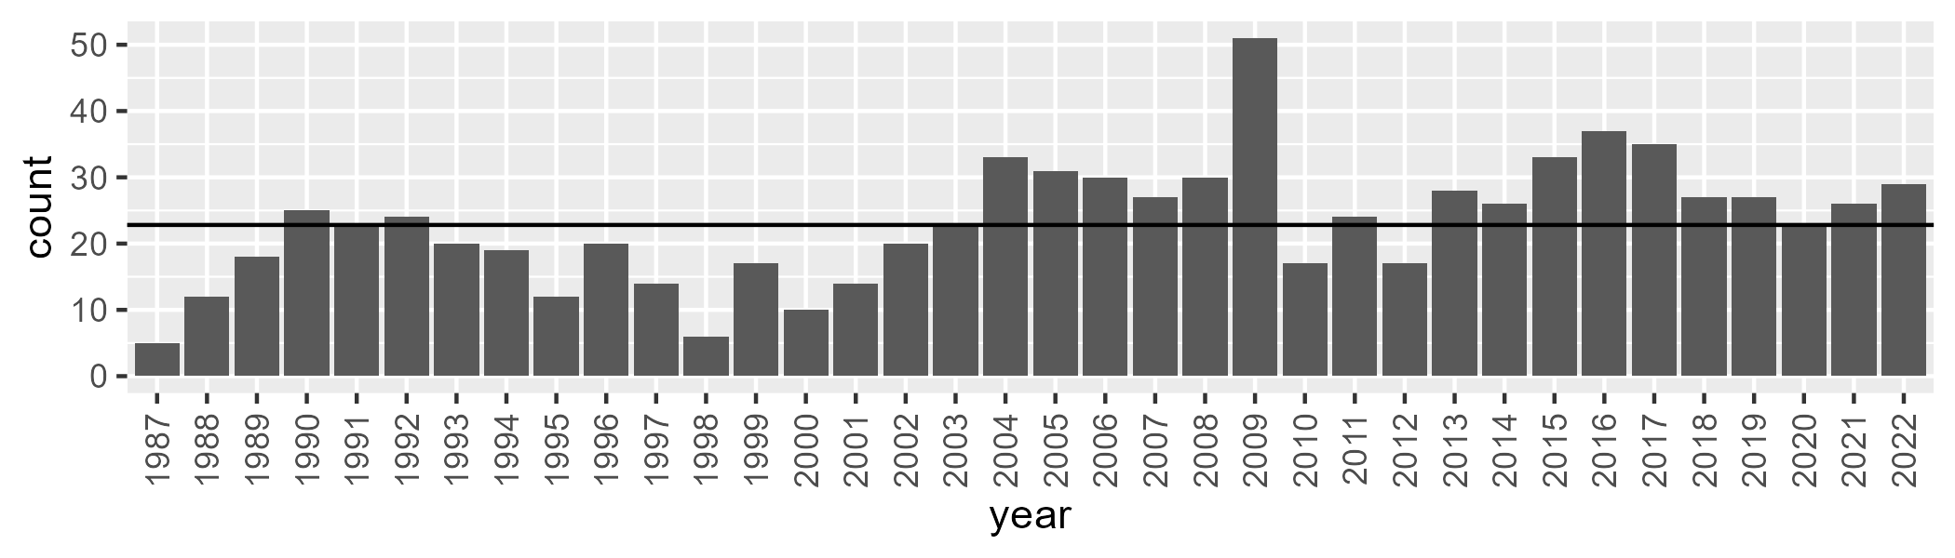

Number of samples: 833

# QDACYP0009

| Min. | 1st Qu. | Median | Mean | 3rd Qu. | Max. |
| --- | --- | --- | --- | --- | --- |
| 17.67933 | 31.19973 | 39.24149 | 40.60146 | 50.53281 | 68.42622 |

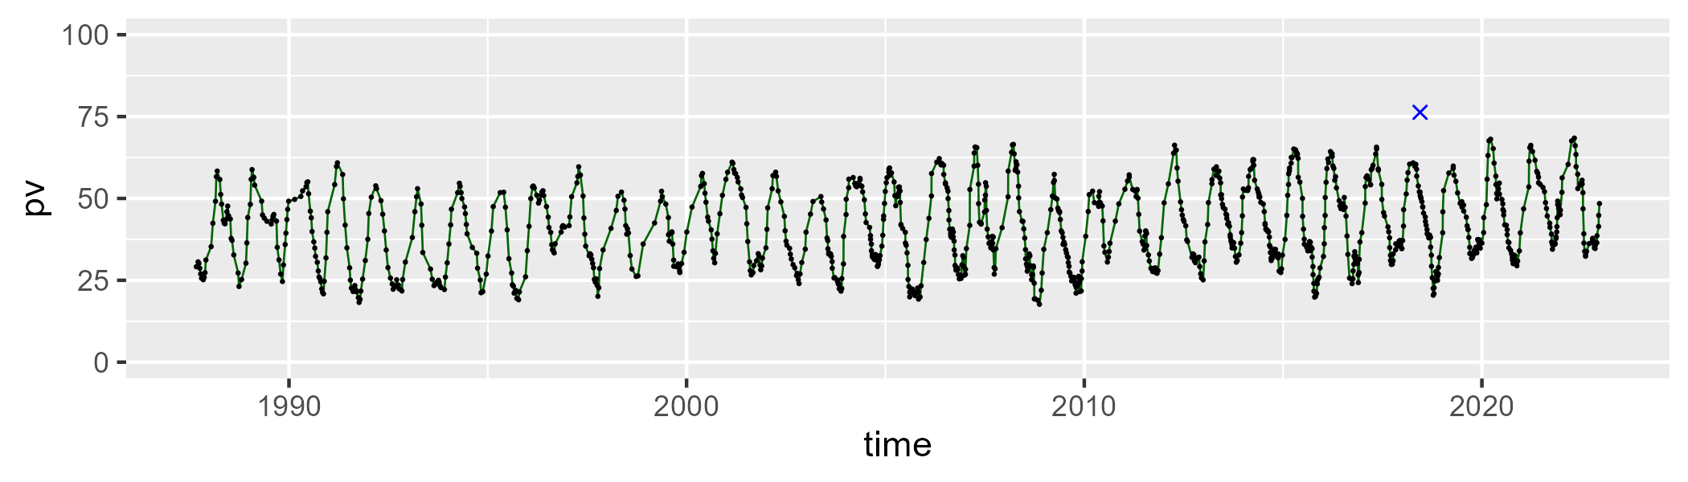

| Min. | 1st Qu. | Median | Mean | 3rd Qu. | Max. |
| --- | --- | --- | --- | --- | --- |
| 20.07562 | 39.65178 | 50.74263 | 49.22427 | 58.21286 | 74.30346 |

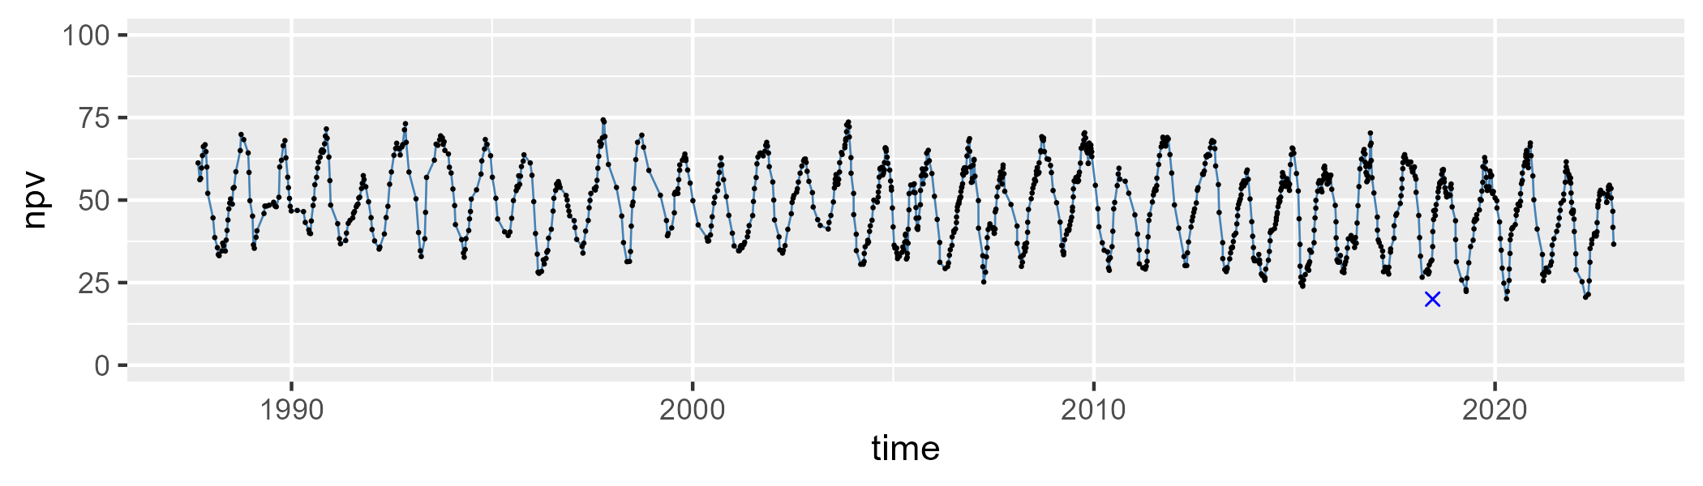

| Min. | 1st Qu. | Median | Mean | 3rd Qu. | Max. |
| --- | --- | --- | --- | --- | --- |
| 0 | 5.45427 | 8.342459 | 9.020122 | 11.25412 | 37.65472 |

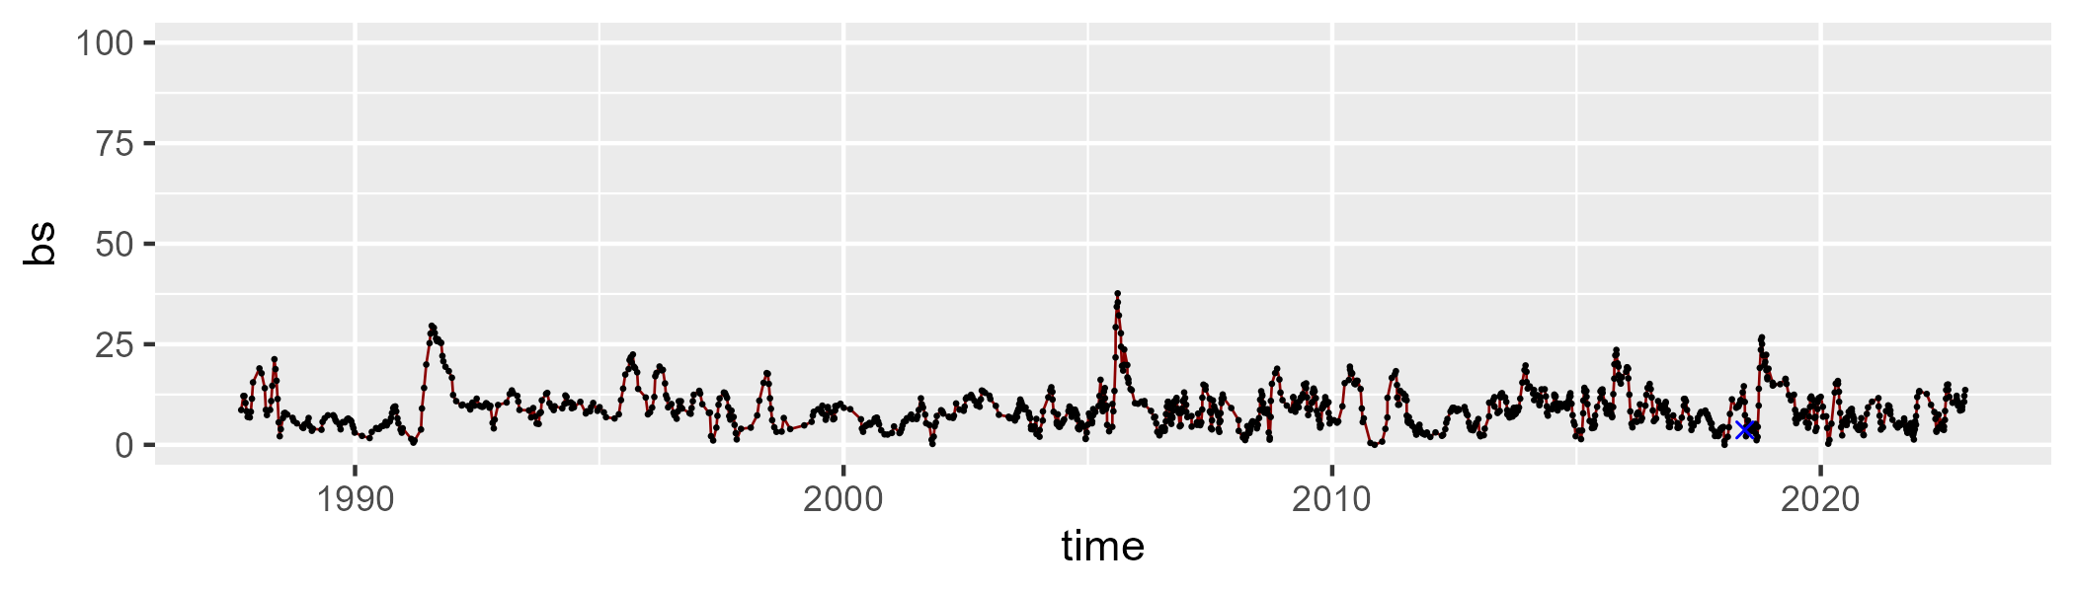

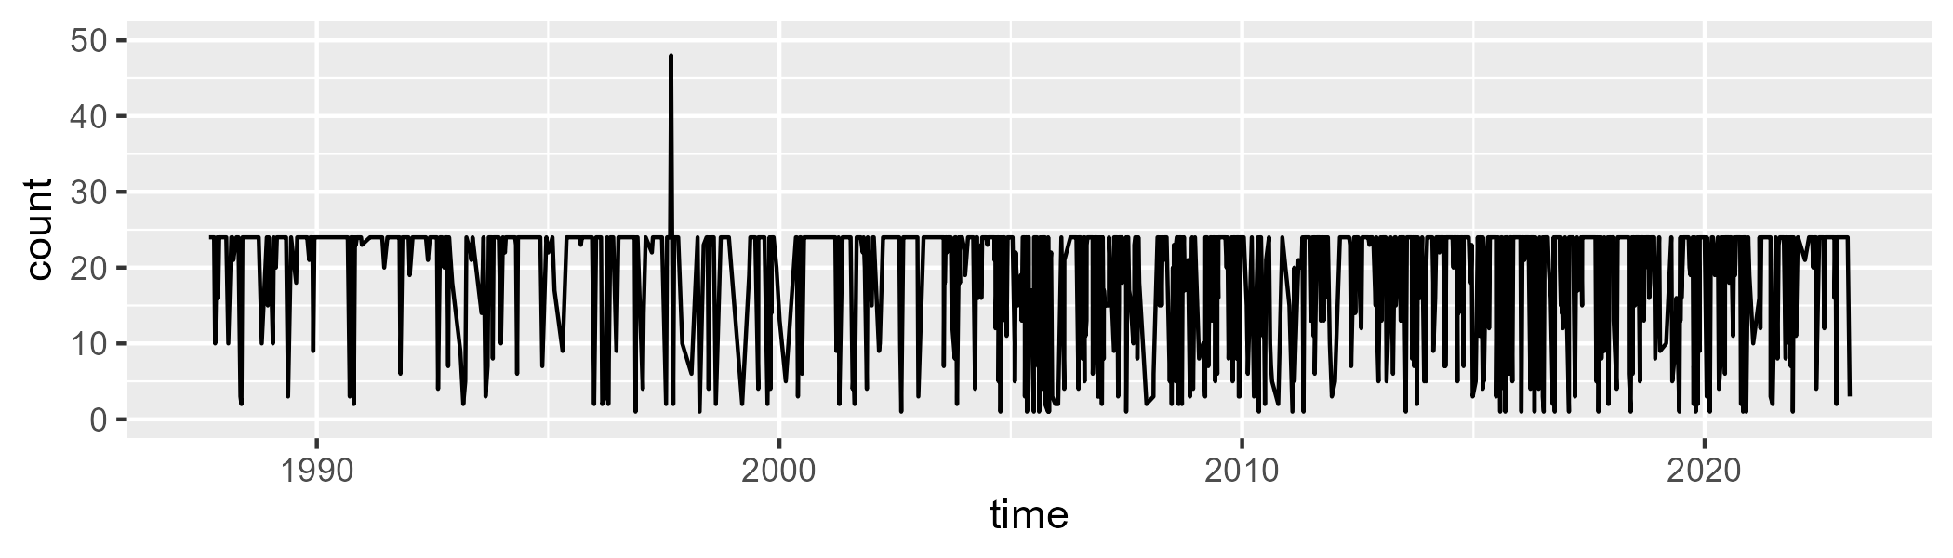

Min. : 1.00 1st Qu.:16.00 Median :24.00 Mean :19.35 3rd Qu.:24.00 Max. :48.00

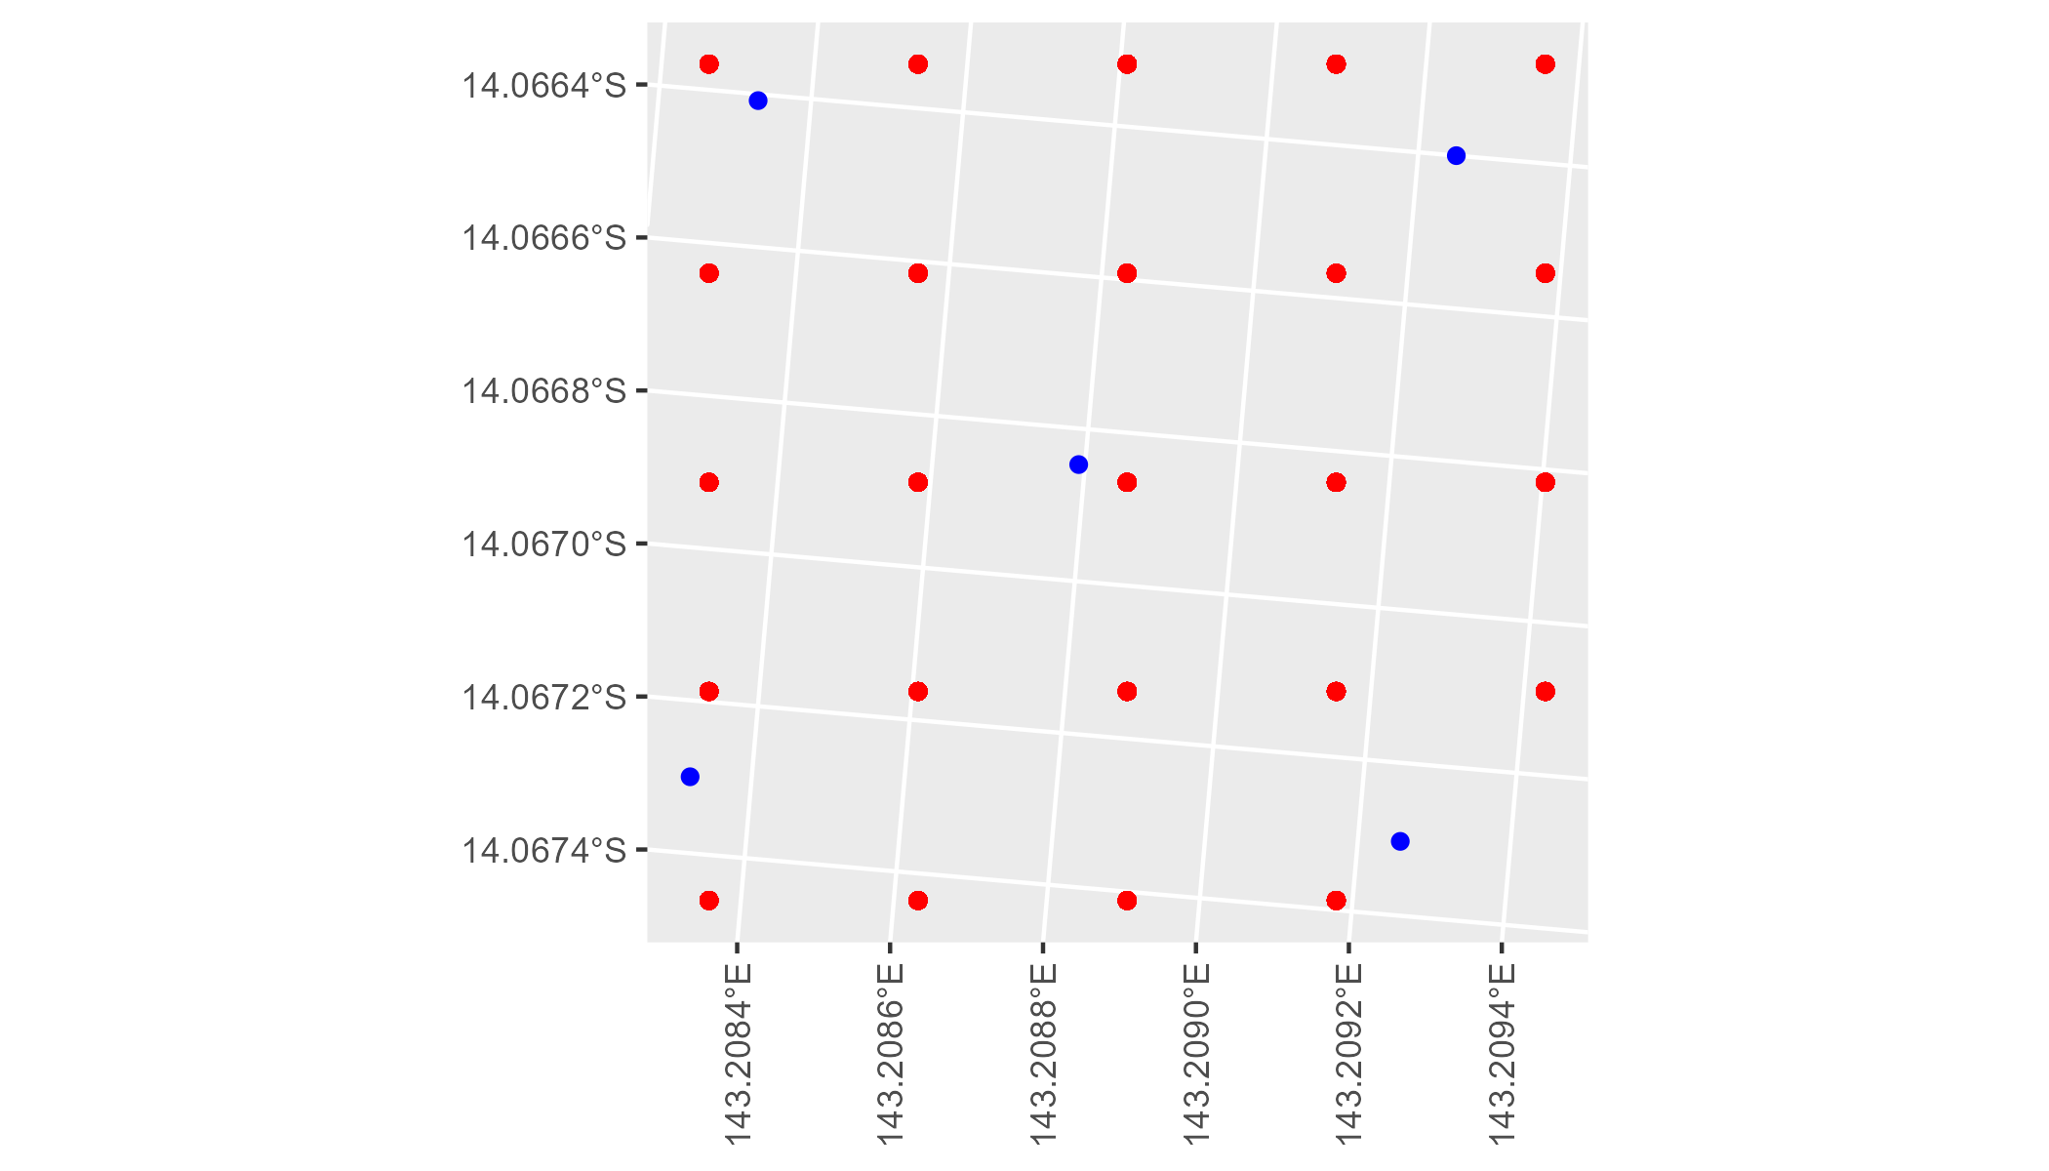

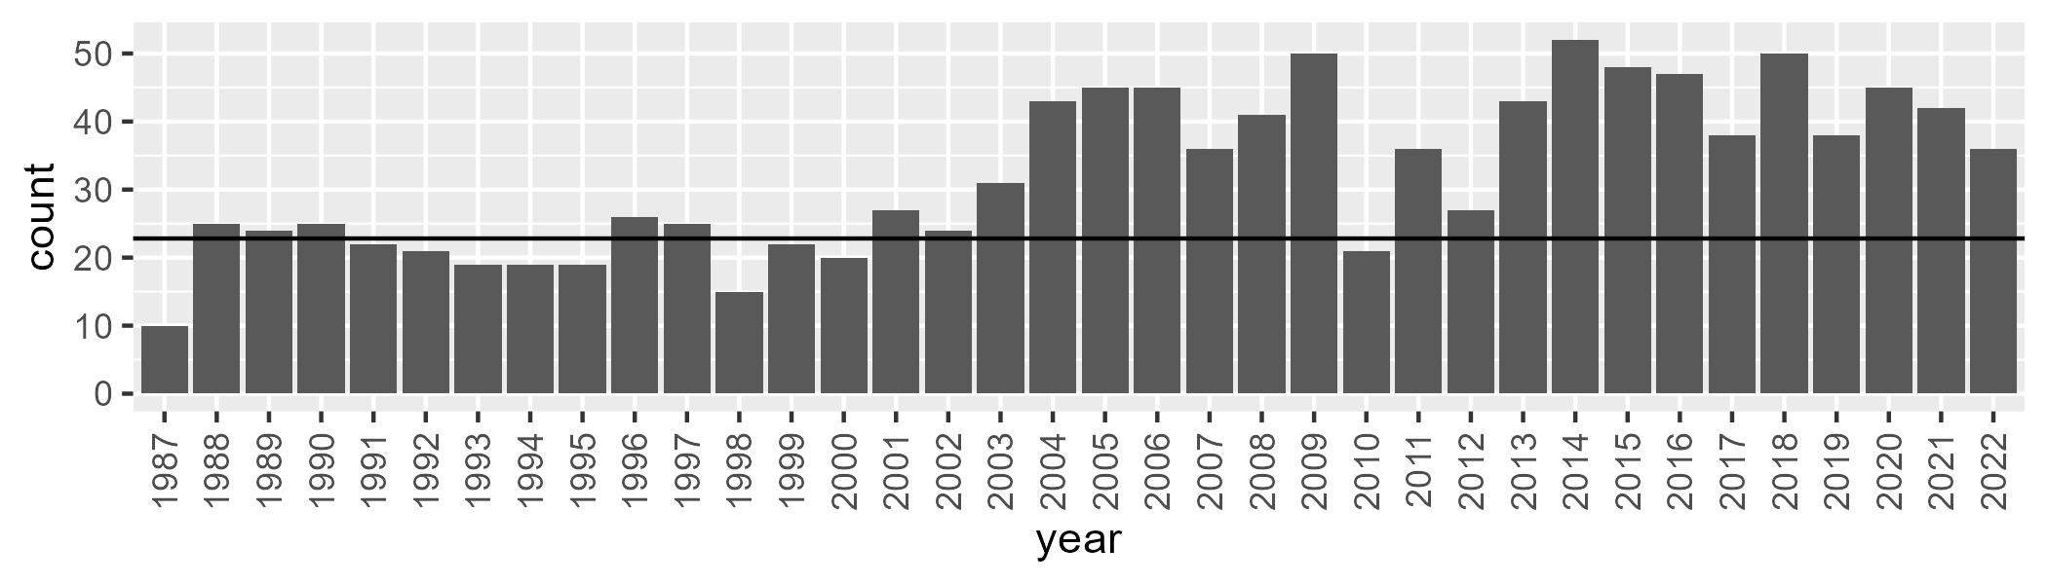

Number of samples: 1157

# QDACYP0010

| Min. | 1st Qu. | Median | Mean | 3rd Qu. | Max. |
| --- | --- | --- | --- | --- | --- |
| 2.56786 | 20.60497 | 33.30189 | 36.81556 | 52.00873 | 86.59888 |

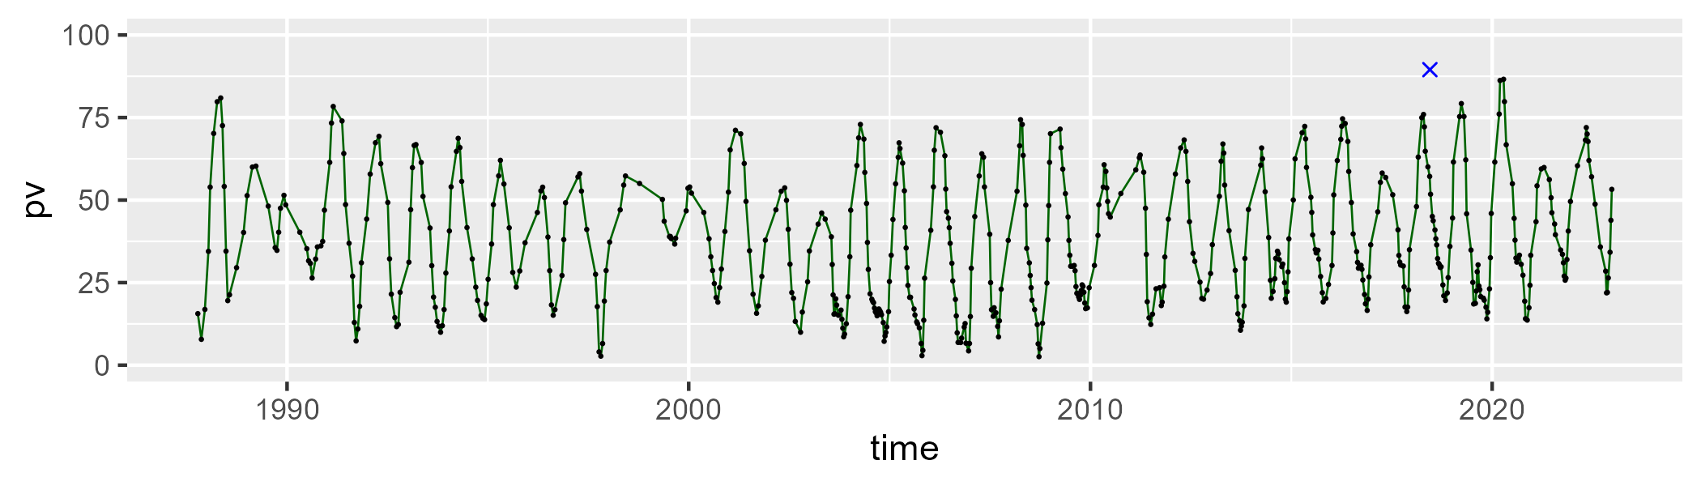

| Min. | 1st Qu. | Median | Mean | 3rd Qu. | Max. |
| --- | --- | --- | --- | --- | --- |
| 9.29518 | 38.84447 | 53.85567 | 53.07368 | 66.50539 | 92.73607 |

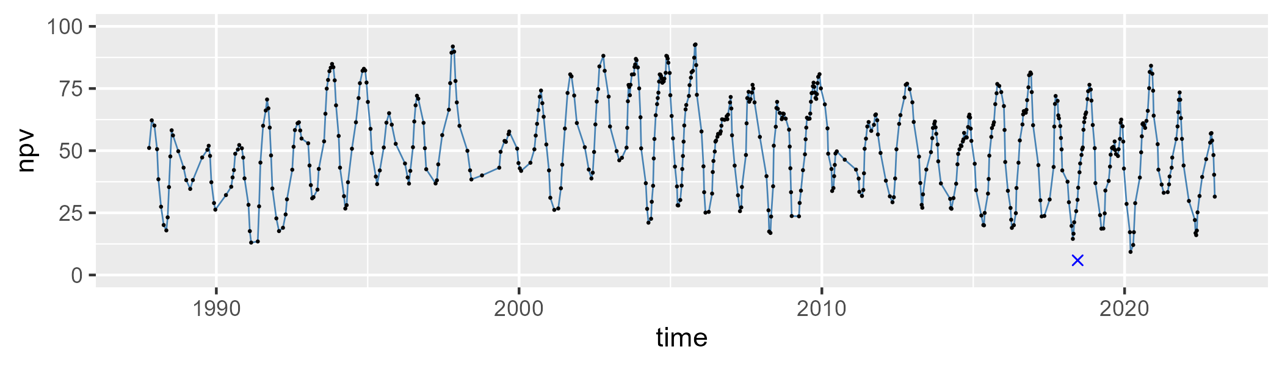

| Min. | 1st Qu. | Median | Mean | 3rd Qu. | Max. |
| --- | --- | --- | --- | --- | --- |
| 0 | 3.142457 | 6.166443 | 8.977012 | 12.55924 | 33.1026 |

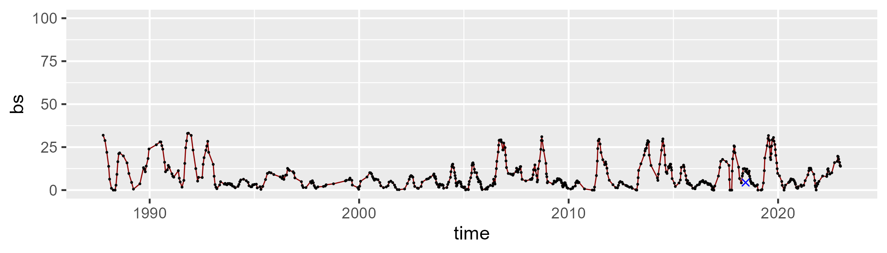

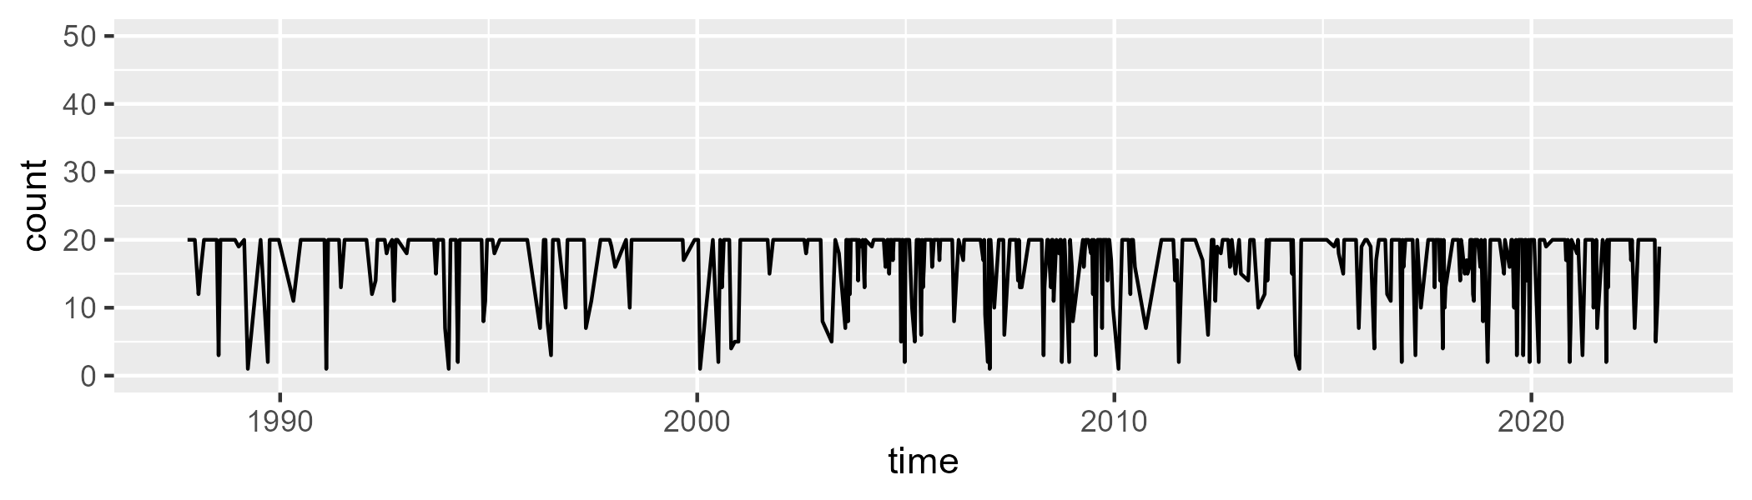

Min. : 1.00 1st Qu.:17.00 Median :20.00 Mean :17.36 3rd Qu.:20.00 Max. :20.00

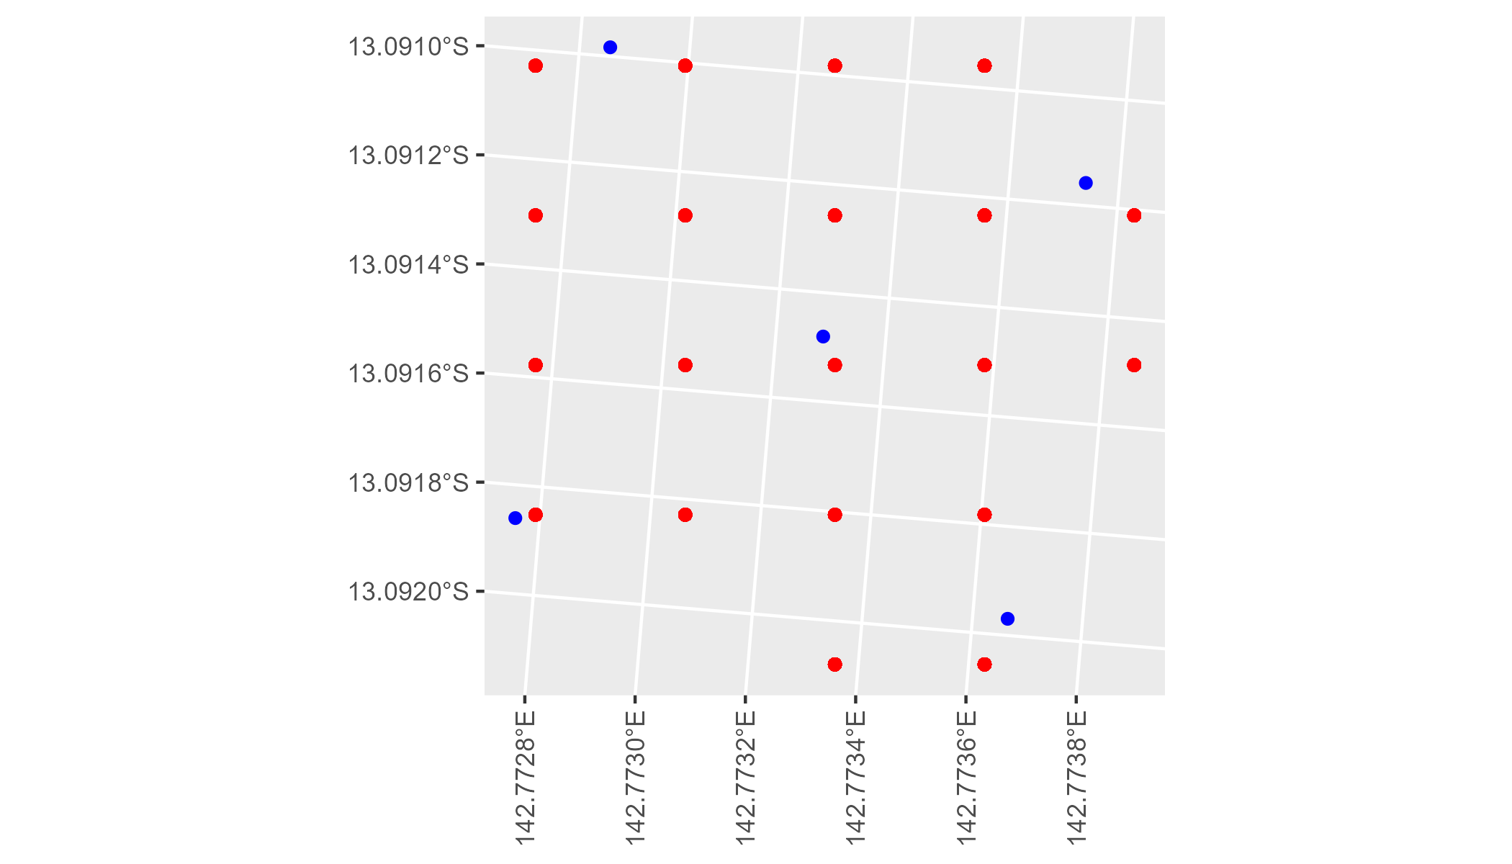

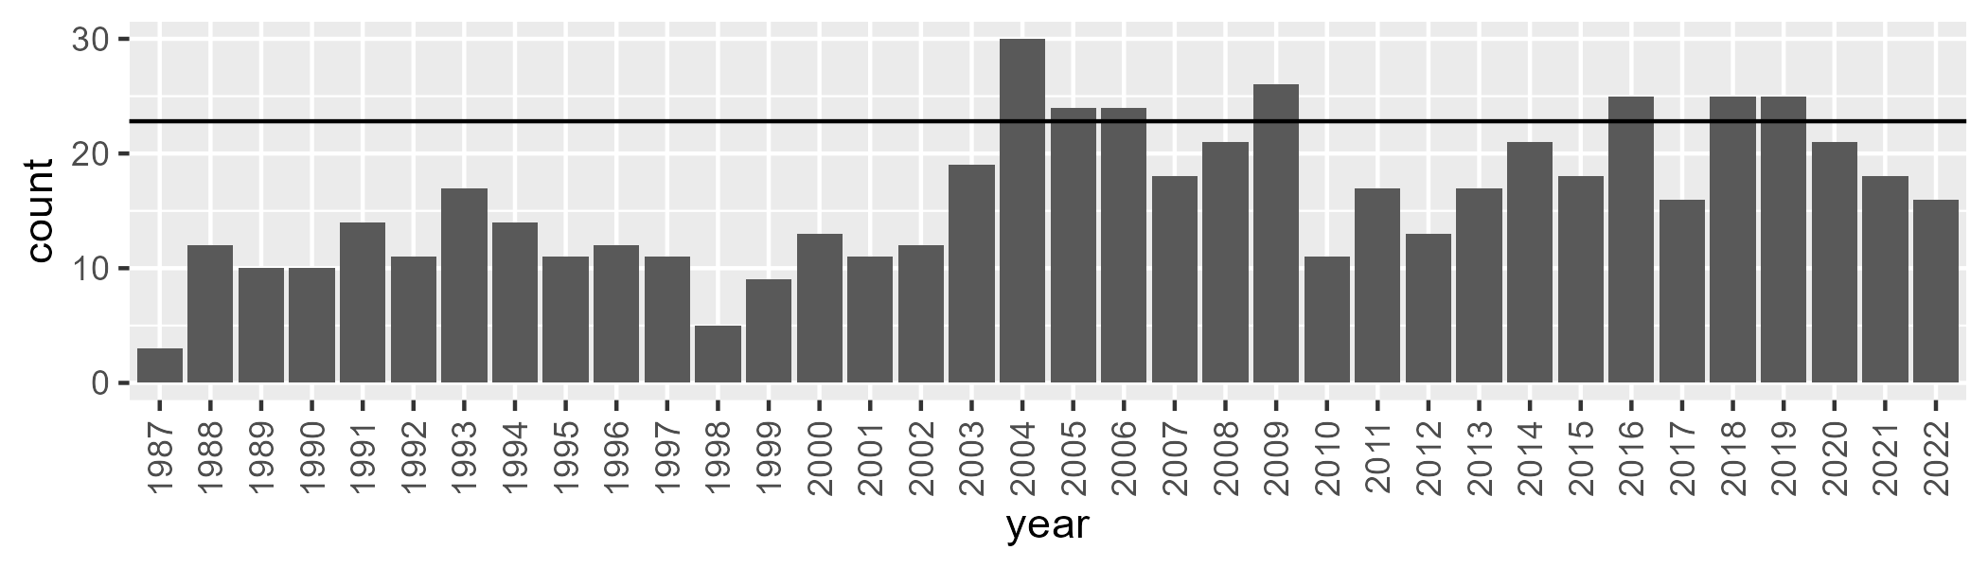

Number of samples: 580

# QDACYP0011

| Min. | 1st Qu. | Median | Mean | 3rd Qu. | Max. |
| --- | --- | --- | --- | --- | --- |
| 16.27177 | 32.73088 | 40.83276 | 41.90302 | 50.52245 | 81.4573 |

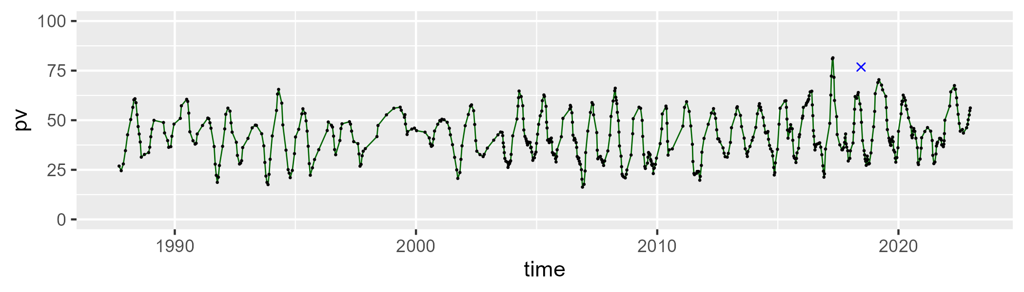

| Min. | 1st Qu. | Median | Mean | 3rd Qu. | Max. |
| --- | --- | --- | --- | --- | --- |
| 6.052819 | 40.70563 | 49.06264 | 48.47391 | 56.17663 | 75.74715 |

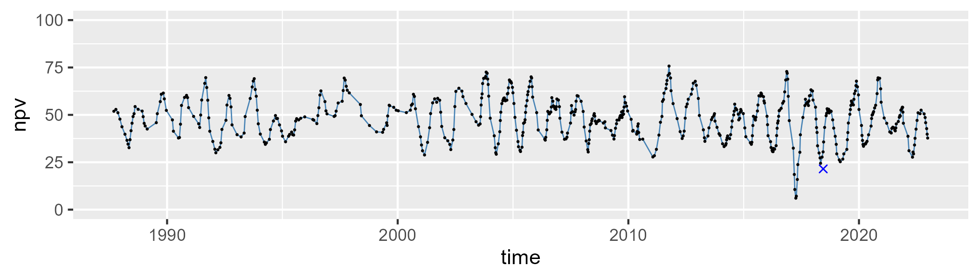

| Min. | 1st Qu. | Median | Mean | 3rd Qu. | Max. |
| --- | --- | --- | --- | --- | --- |
| 0 | 2.696852 | 6.543267 | 8.593878 | 13.18724 | 31.90583 |

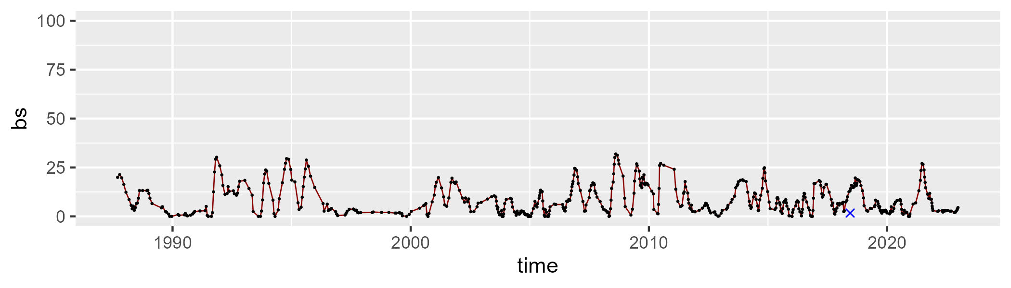

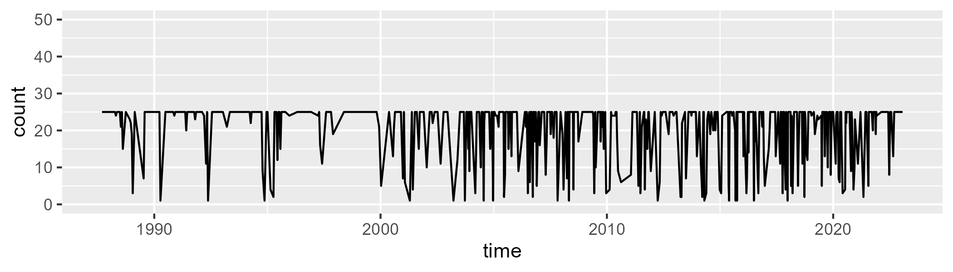

Min. : 1.00 1st Qu.:20.00 Median :25.00 Mean :20.77 3rd Qu.:25.00 Max. :25.00

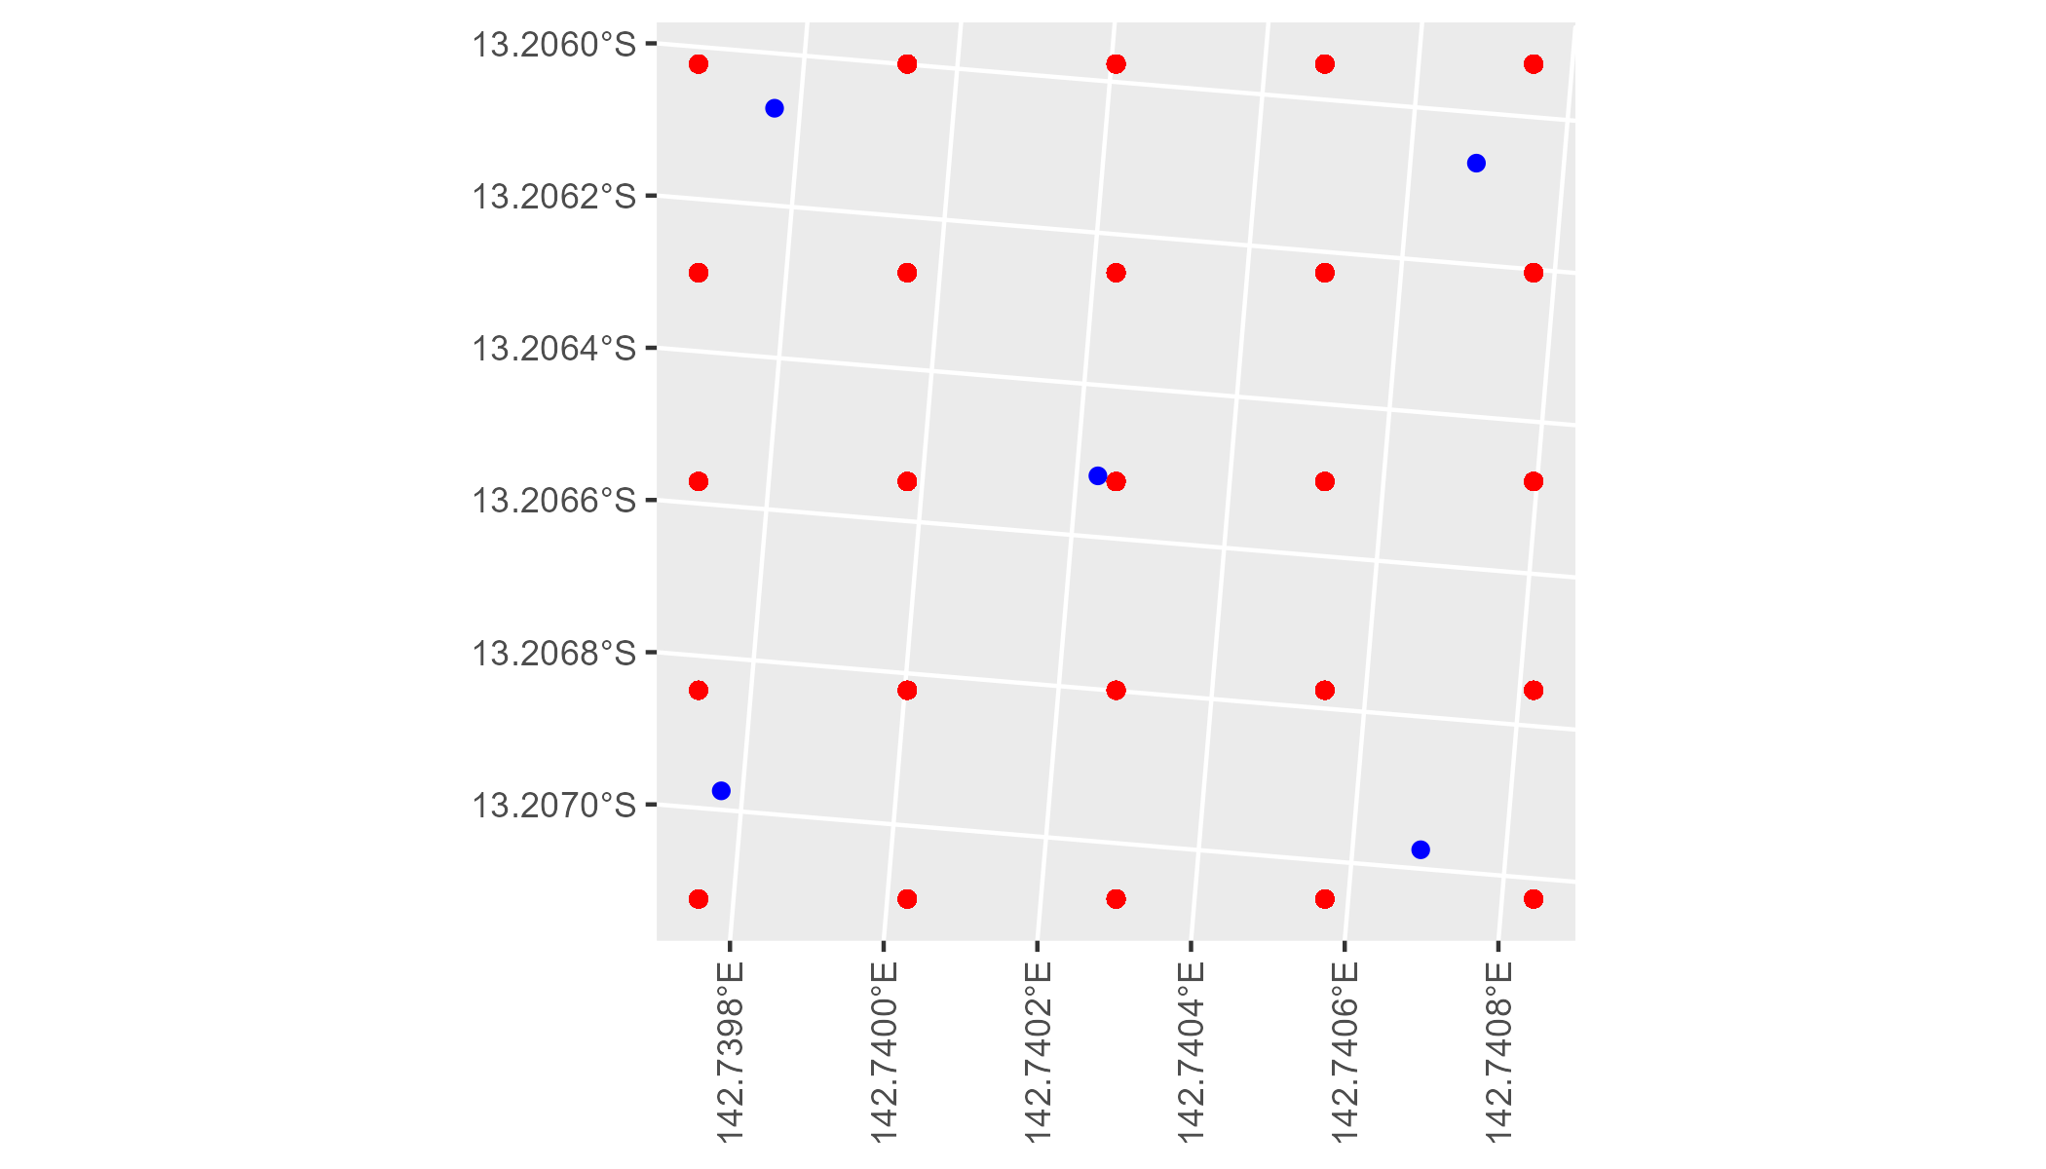

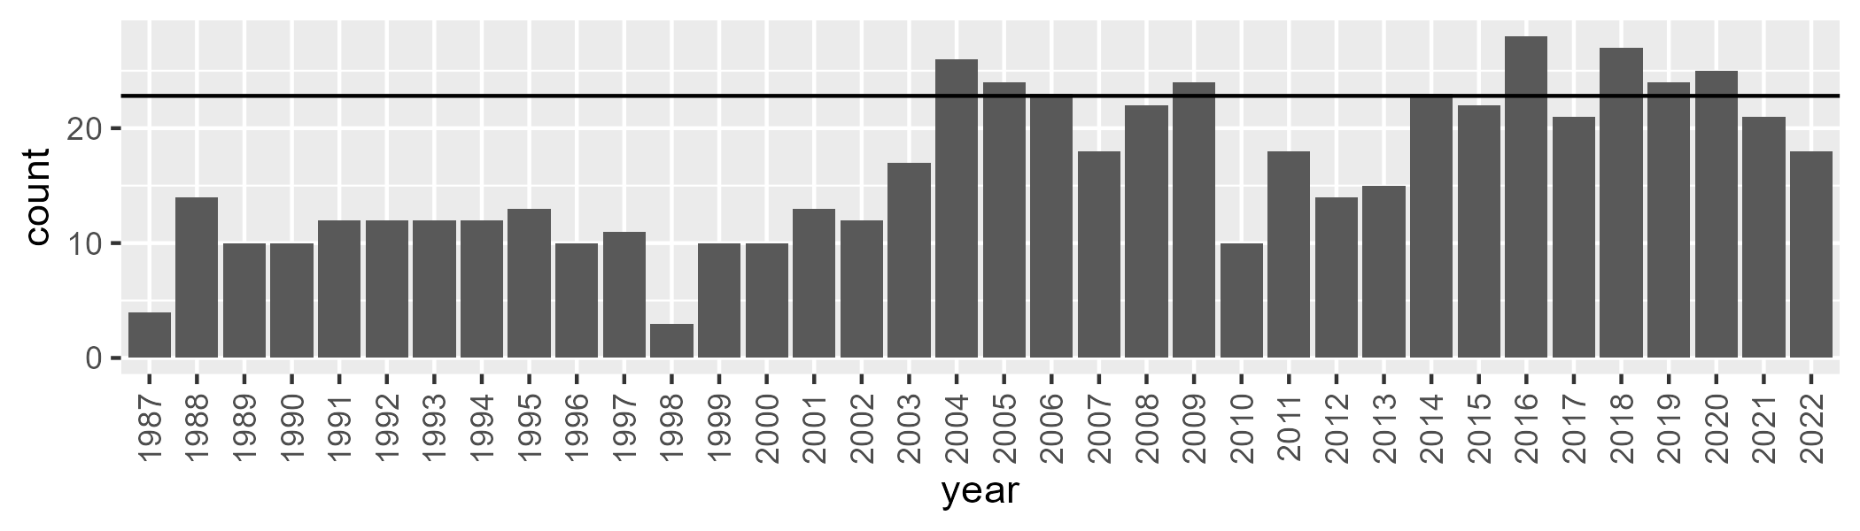

Number of samples: 588

# QDACYP0012

| Min. | 1st Qu. | Median | Mean | 3rd Qu. | Max. |
| --- | --- | --- | --- | --- | --- |
| 36.98416 | 56.81095 | 70.96667 | 69.06446 | 81.10082 | 95.78876 |

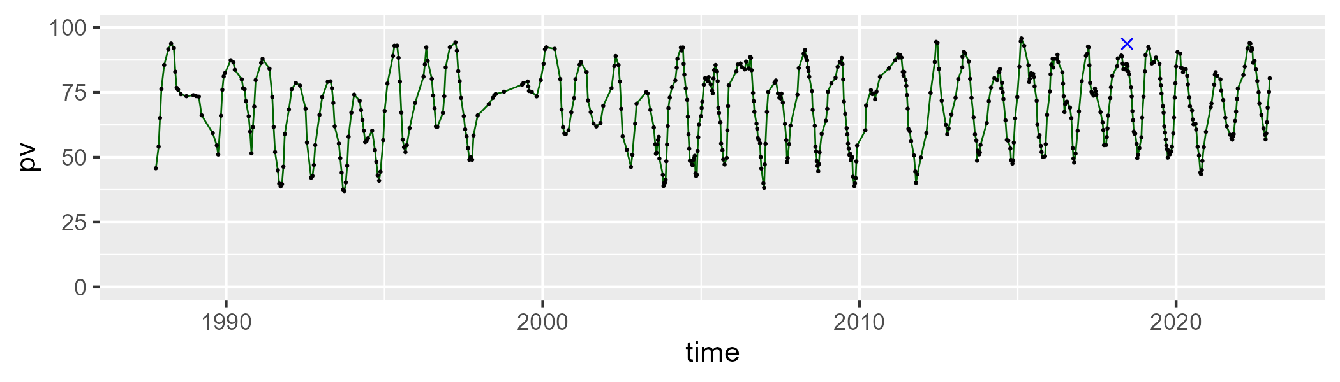

| Min. | 1st Qu. | Median | Mean | 3rd Qu. | Max. |
| --- | --- | --- | --- | --- | --- |
| 0 | 11.78686 | 22.86485 | 25.33337 | 38.26085 | 60.77895 |

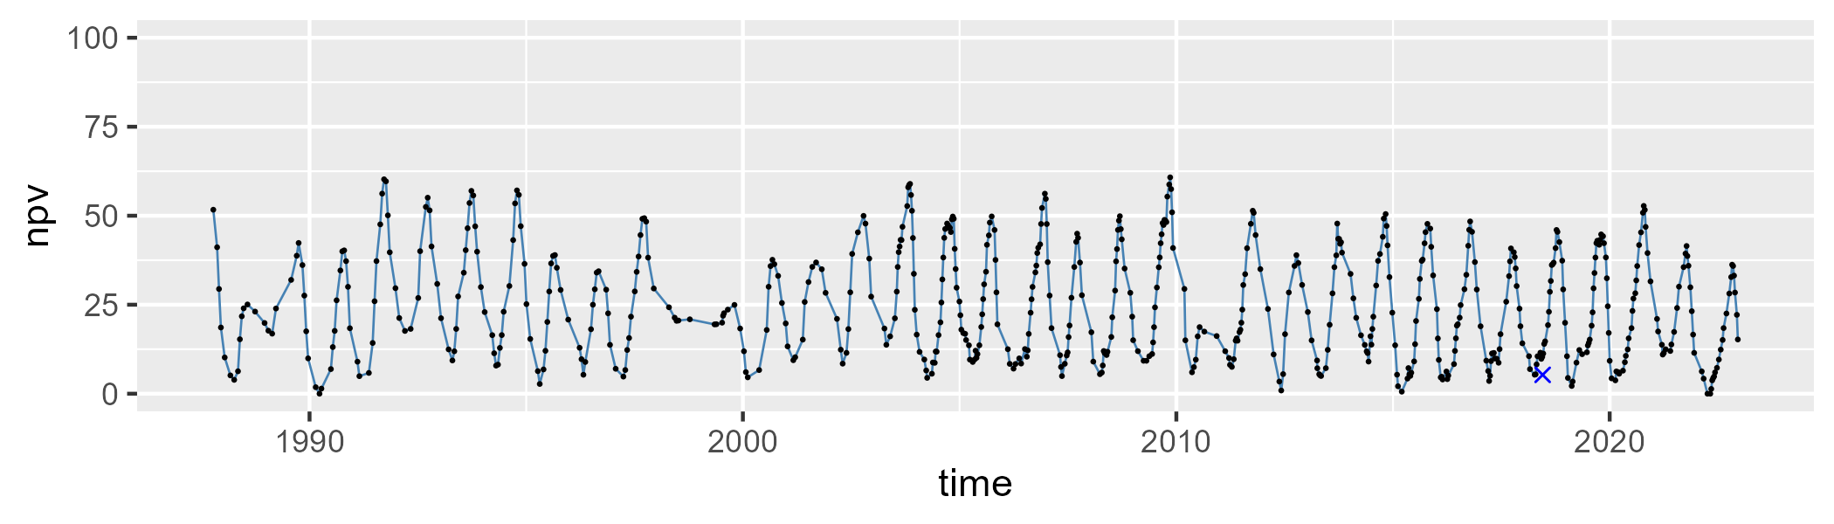

| Min. | 1st Qu. | Median | Mean | 3rd Qu. | Max. |
| --- | --- | --- | --- | --- | --- |
| 0 | 1.299252 | 3.18166 | 4.348067 | 6.353769 | 30.6643 |

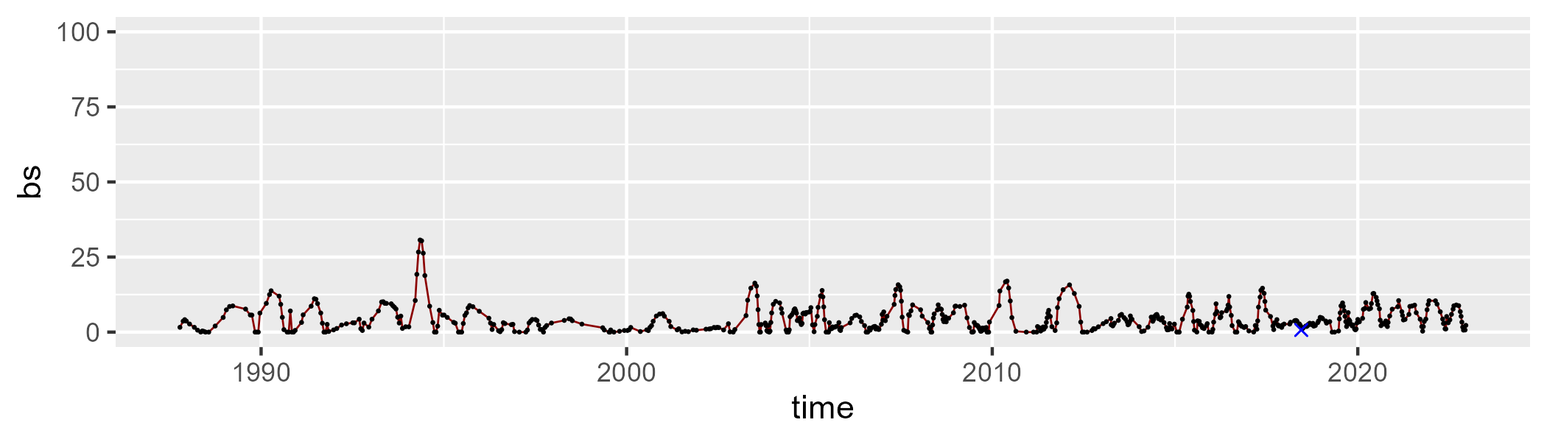

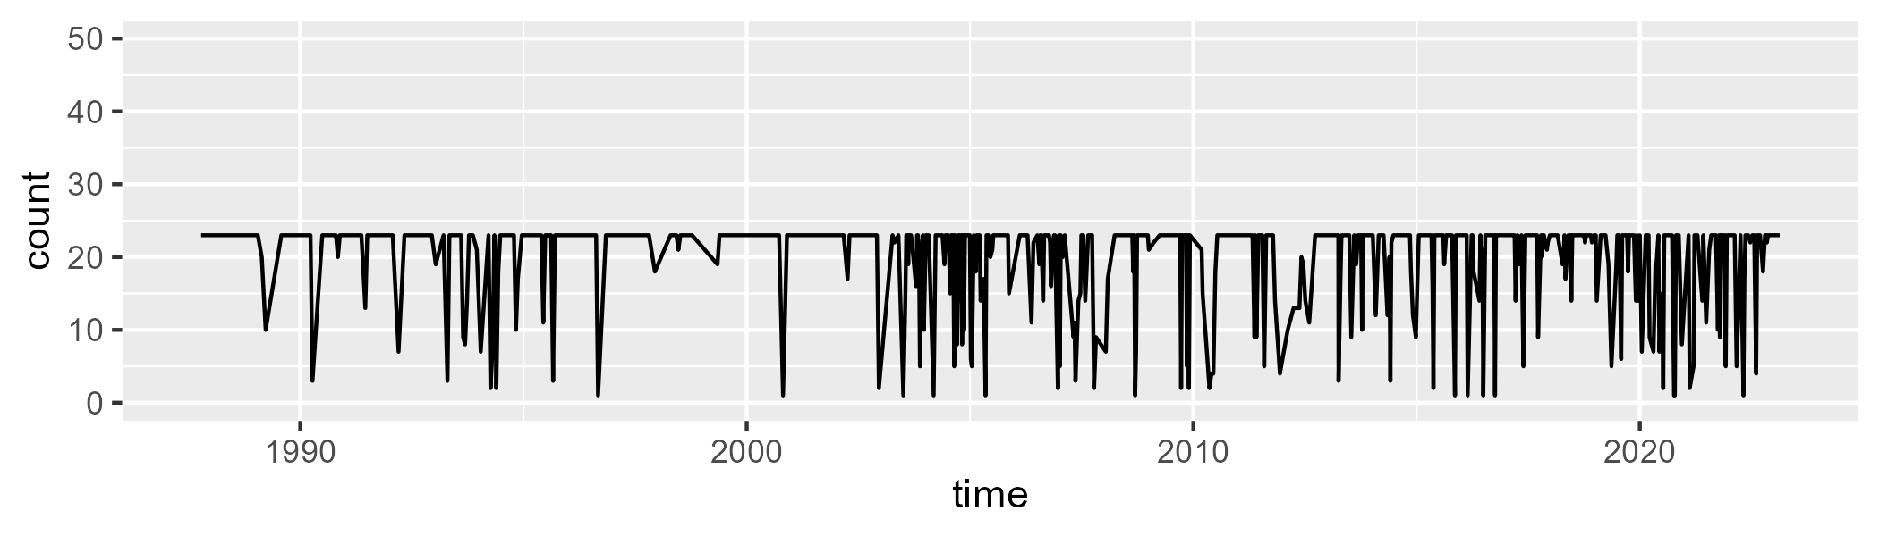

Min. : 1.00 1st Qu.:21.00 Median :23.00 Mean :19.91 3rd Qu.:23.00 Max. :23.00

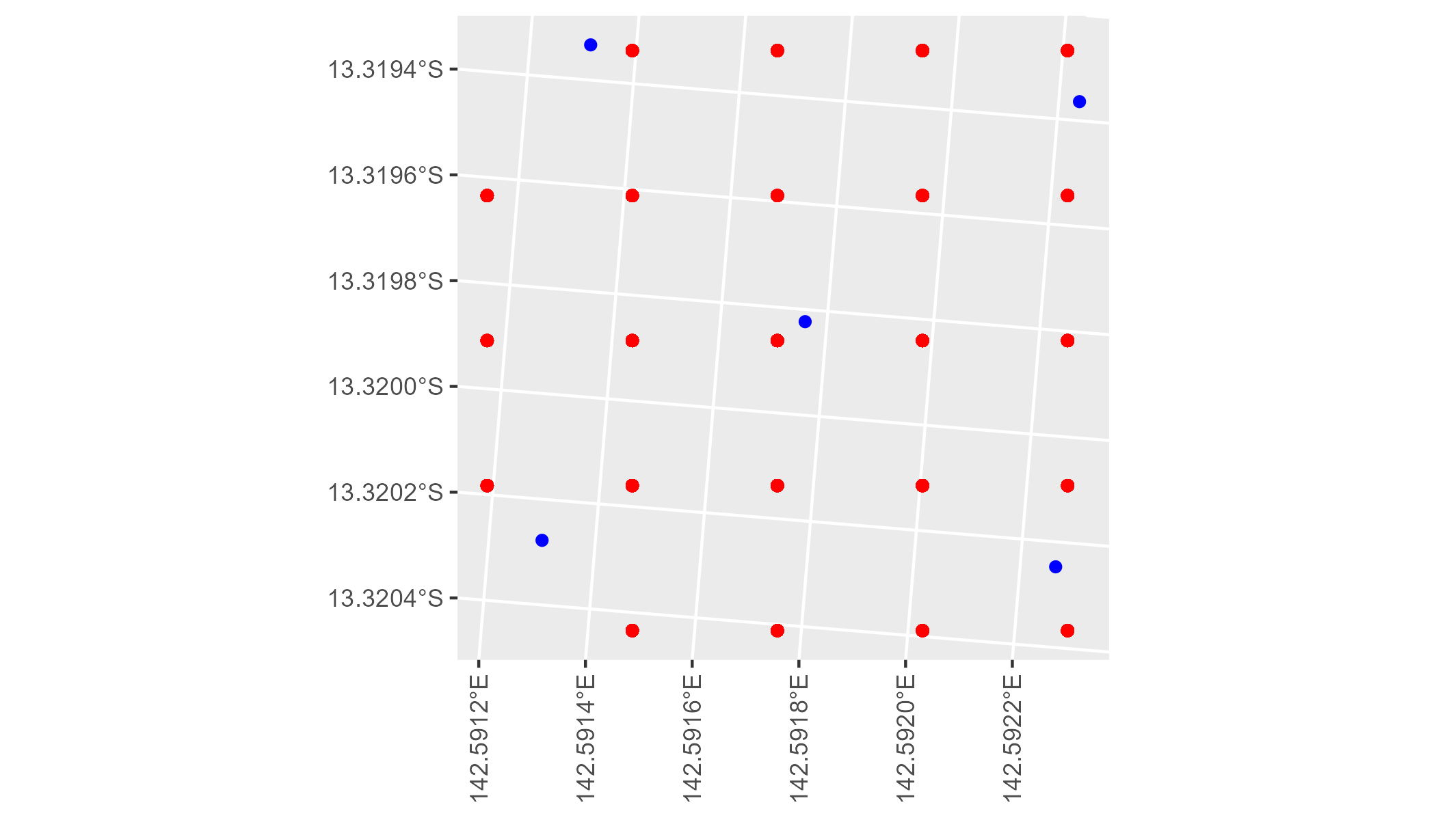

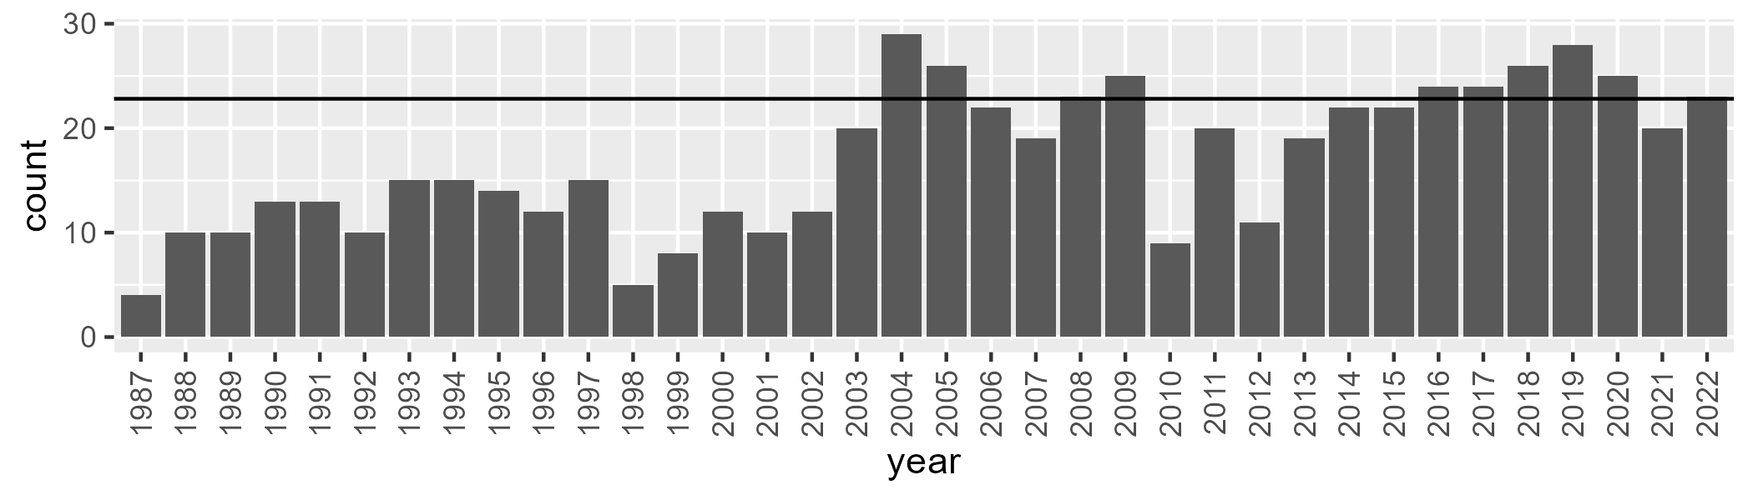

Number of samples: 615

# QDACYP0013

| Min. | 1st Qu. | Median | Mean | 3rd Qu. | Max. |
| --- | --- | --- | --- | --- | --- |
| 27.54794 | 42.66808 | 50.79656 | 52.20418 | 61.4241 | 79.36005 |

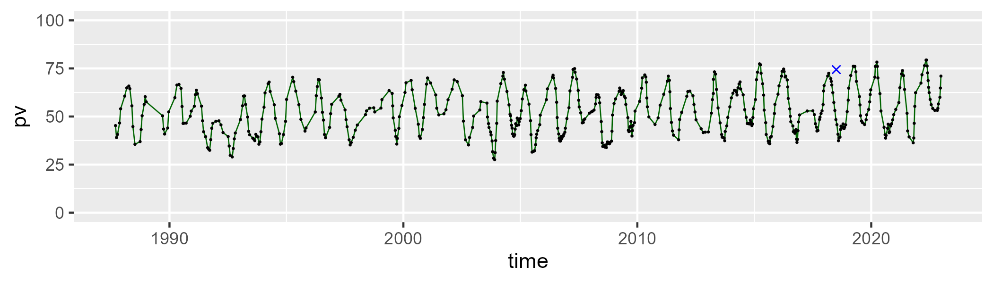

| Min. | 1st Qu. | Median | Mean | 3rd Qu. | Max. |
| --- | --- | --- | --- | --- | --- |
| 15.51571 | 30.86162 | 39.38824 | 38.10309 | 45.76777 | 59.84397 |

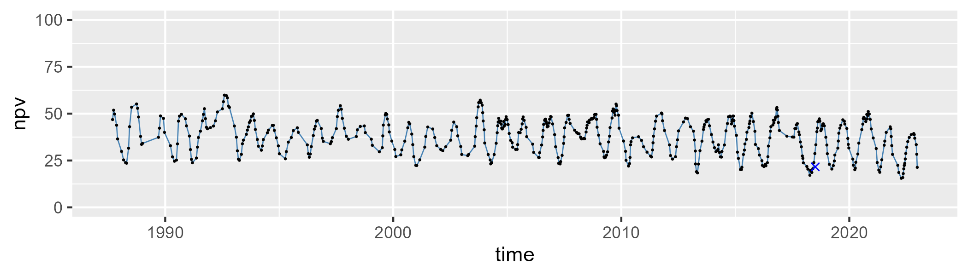

| Min. | 1st Qu. | Median | Mean | 3rd Qu. | Max. |
| --- | --- | --- | --- | --- | --- |
| 0 | 4.380945 | 7.370704 | 8.401958 | 11.38985 | 27.52938 |

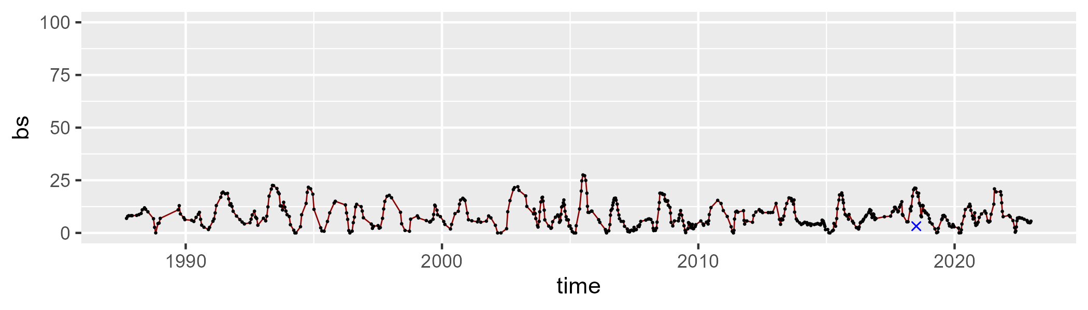

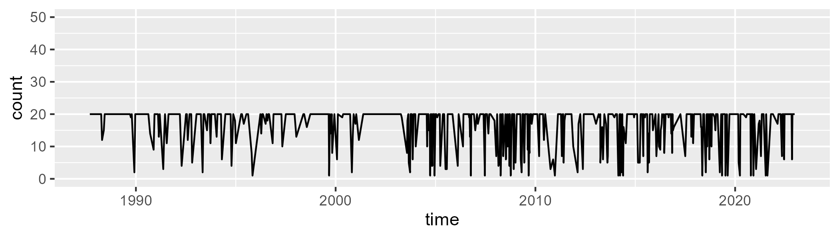

Min. : 1.00 1st Qu.:15.25 Median :20.00 Mean :16.57 3rd Qu.:20.00 Max. :20.00

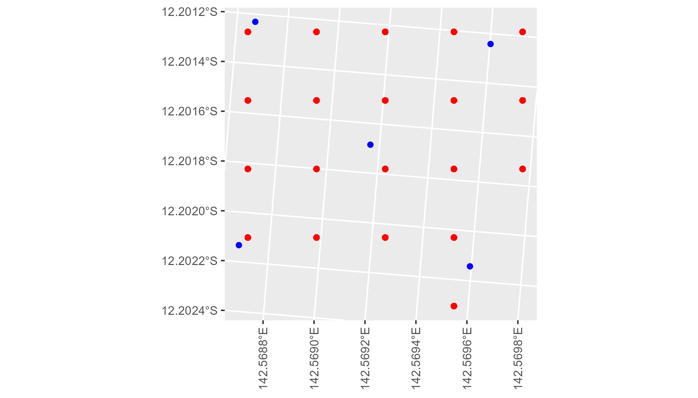

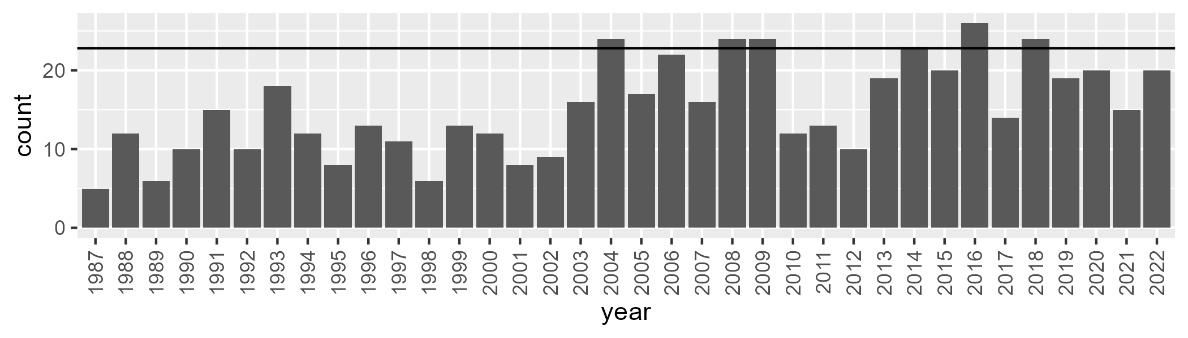

Number of samples: 546

# QDACYP0014

| Min. | 1st Qu. | Median | Mean | 3rd Qu. | Max. |
| --- | --- | --- | --- | --- | --- |
| 21.61061 | 41.38194 | 48.92889 | 49.15799 | 57.69019 | 73.09853 |

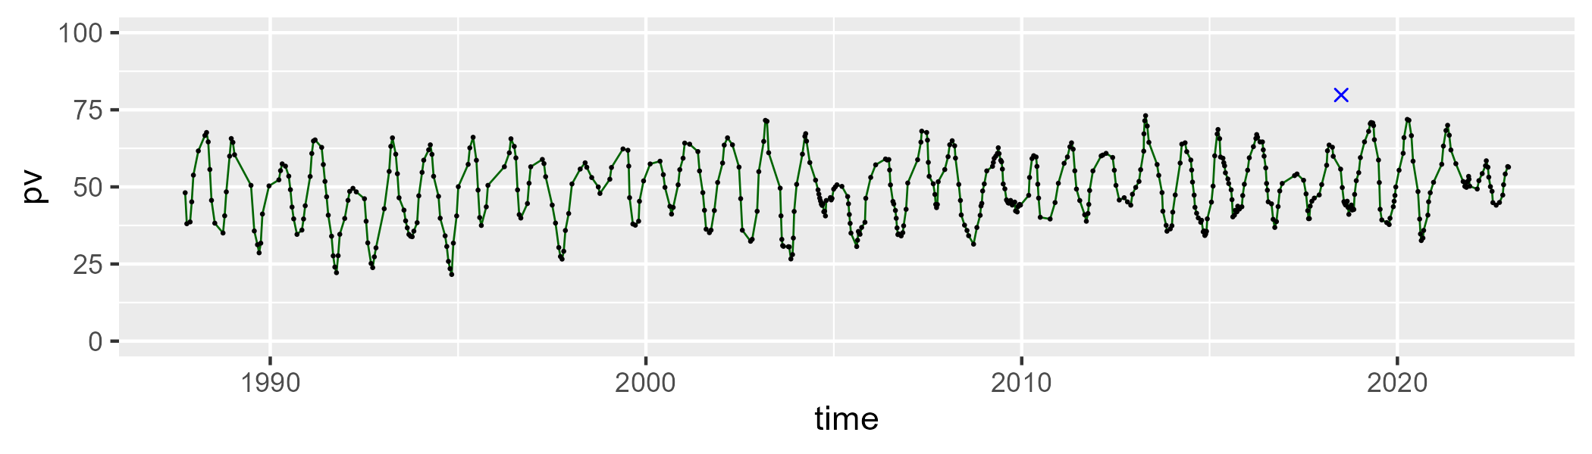

| Min. | 1st Qu. | Median | Mean | 3rd Qu. | Max. |
| --- | --- | --- | --- | --- | --- |
| 19.07215 | 35.32943 | 42.70941 | 41.96236 | 48.52378 | 58.32706 |

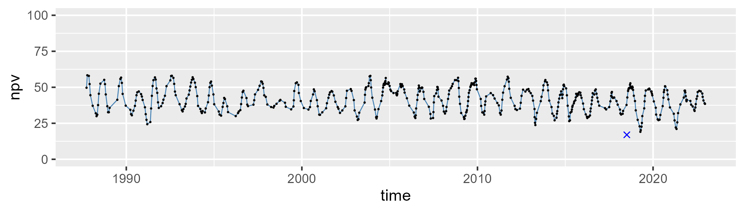

| Min. | 1st Qu. | Median | Mean | 3rd Qu. | Max. |
| --- | --- | --- | --- | --- | --- |
| 0 | 3.270009 | 6.539177 | 7.676972 | 11.19655 | 32.0269 |

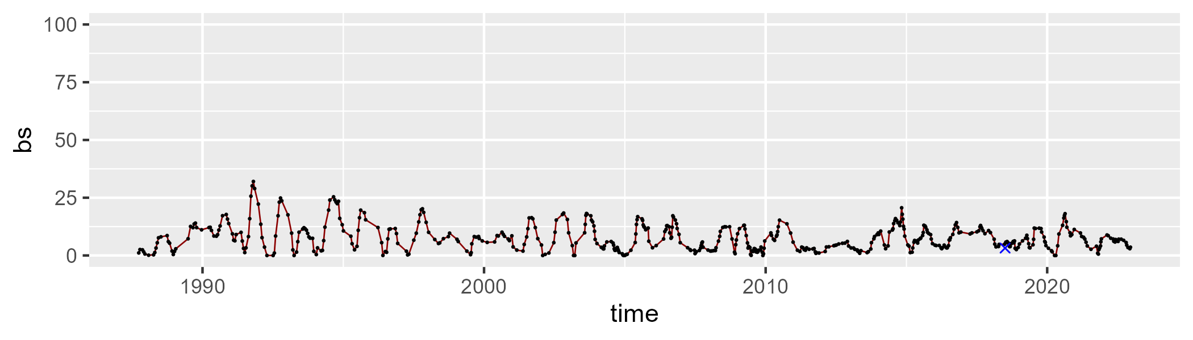

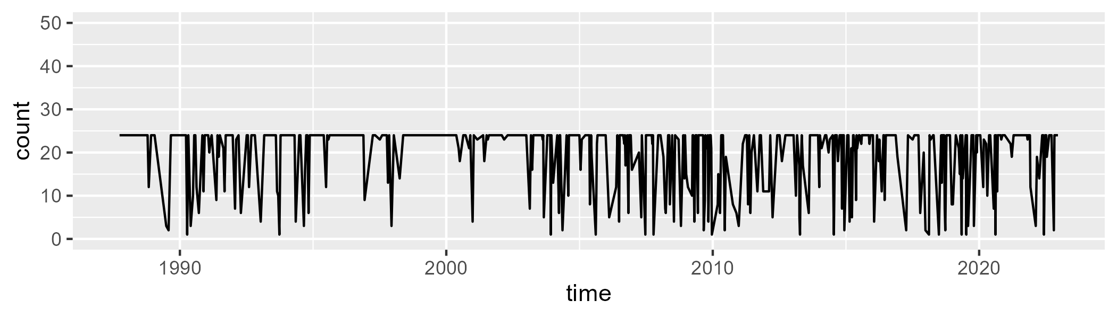

Min. : 1.00 1st Qu.:18.50 Median :24.00 Mean :19.77 3rd Qu.:24.00 Max. :24.00

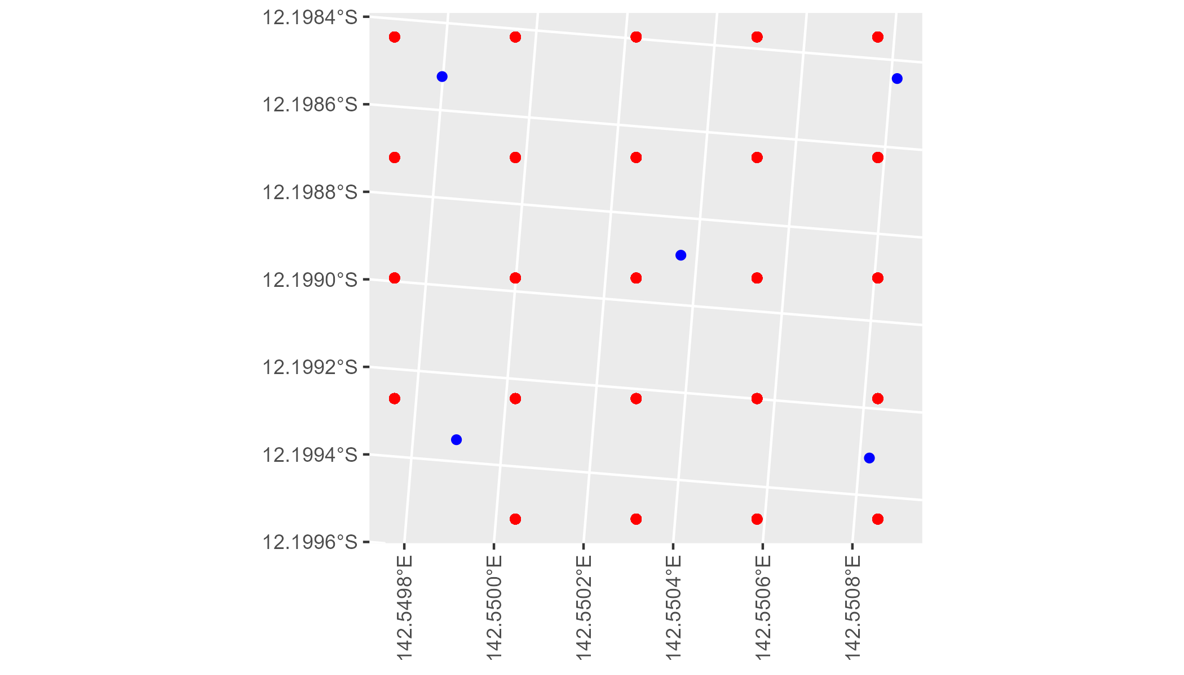

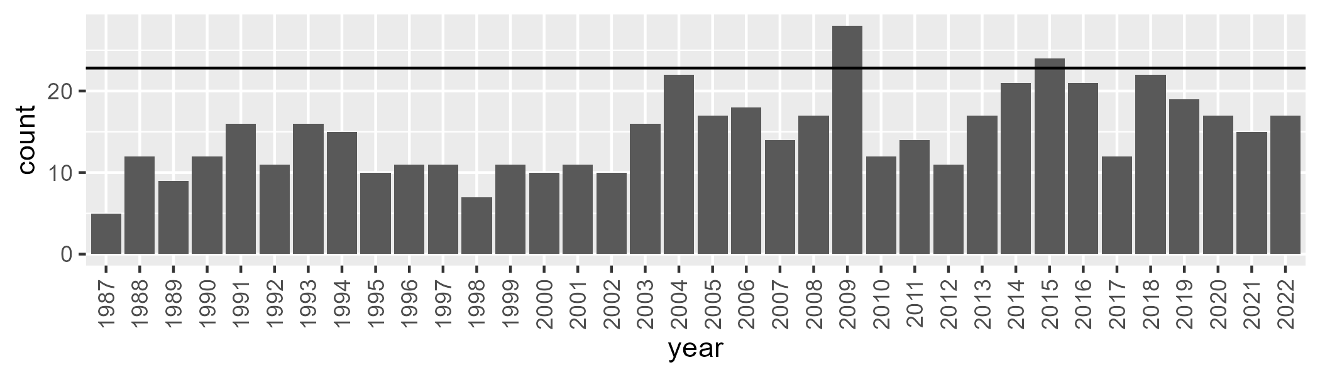

Number of samples: 531

# QDACYP0015

| Min. | 1st Qu. | Median | Mean | 3rd Qu. | Max. |
| --- | --- | --- | --- | --- | --- |
| 11.27322 | 27.44132 | 34.52565 | 36.57405 | 46.5948 | 68.43576 |

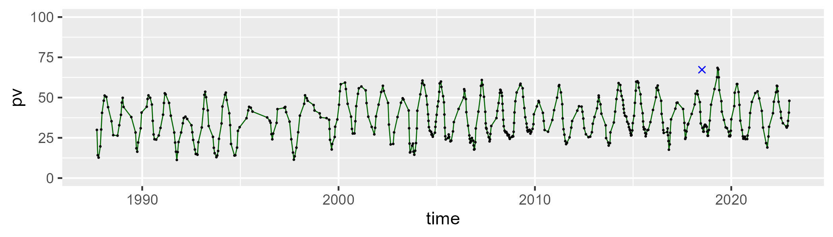

| Min. | 1st Qu. | Median | Mean | 3rd Qu. | Max. |
| --- | --- | --- | --- | --- | --- |
| 28.61225 | 43.72283 | 49.06915 | 49.41377 | 54.45327 | 71.23981 |

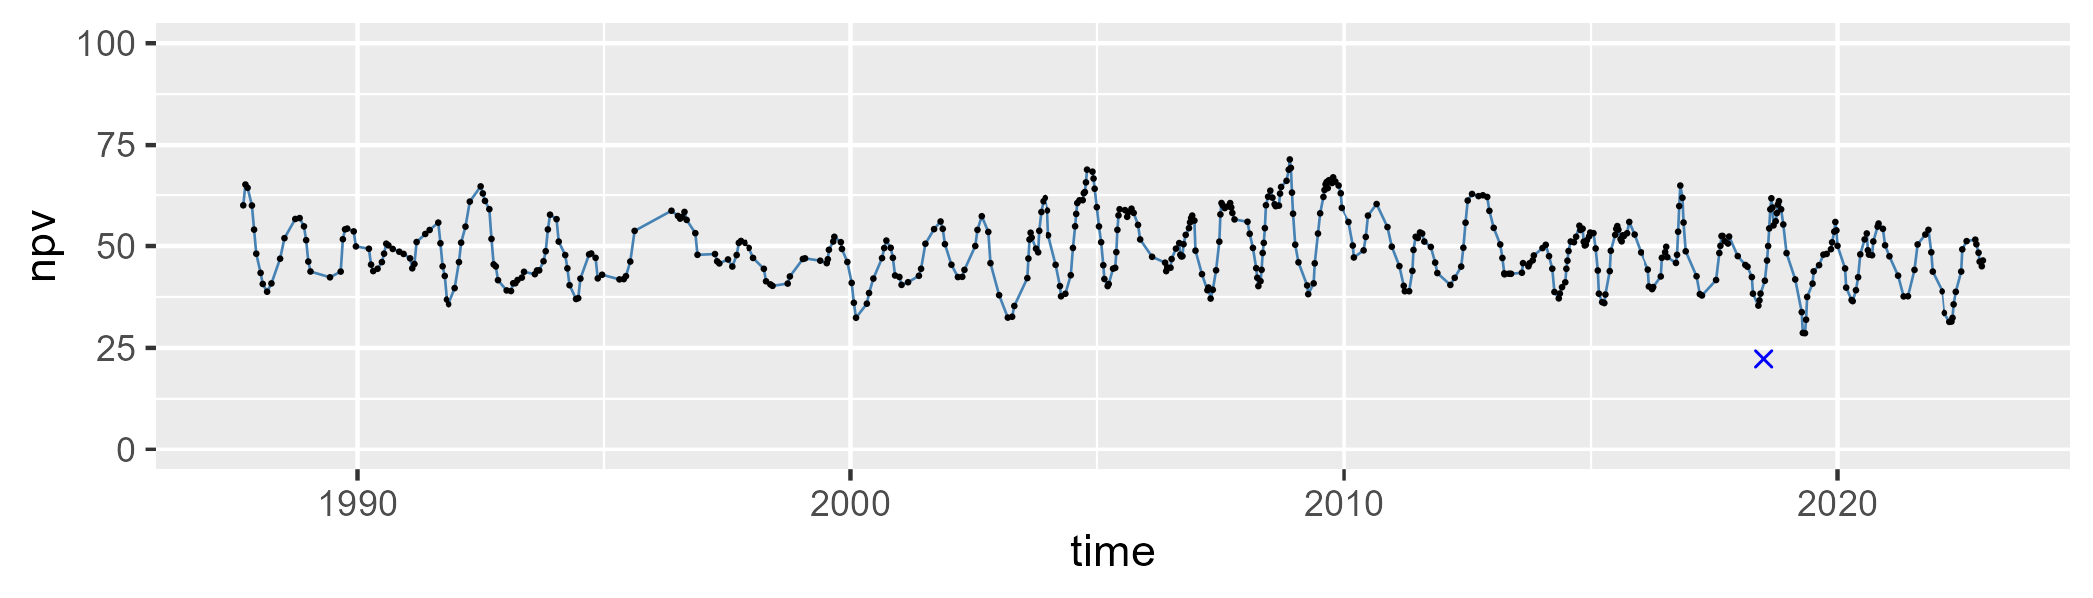

| Min. | 1st Qu. | Median | Mean | 3rd Qu. | Max. |
| --- | --- | --- | --- | --- | --- |
| 0 | 5.006636 | 11.49191 | 12.86067 | 18.9255 | 46.14959 |

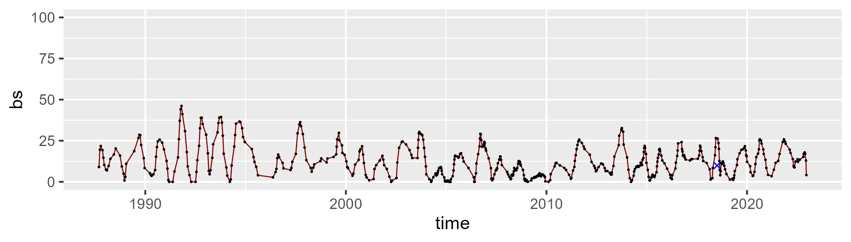

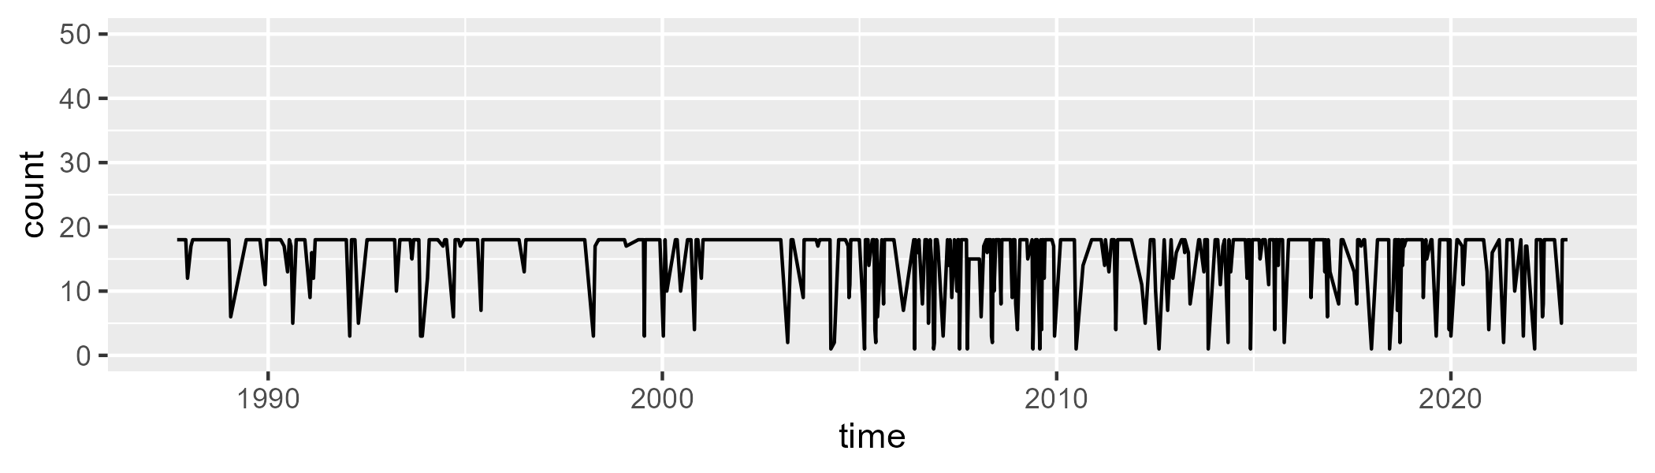

Min. : 1.00 1st Qu.:16.00 Median :18.00 Mean :15.39 3rd Qu.:18.00 Max. :18.00

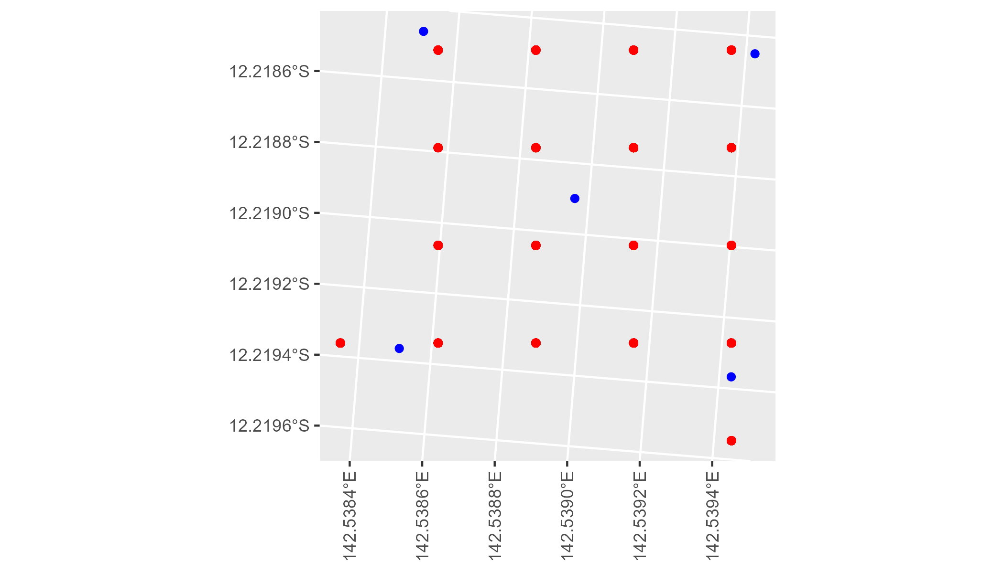

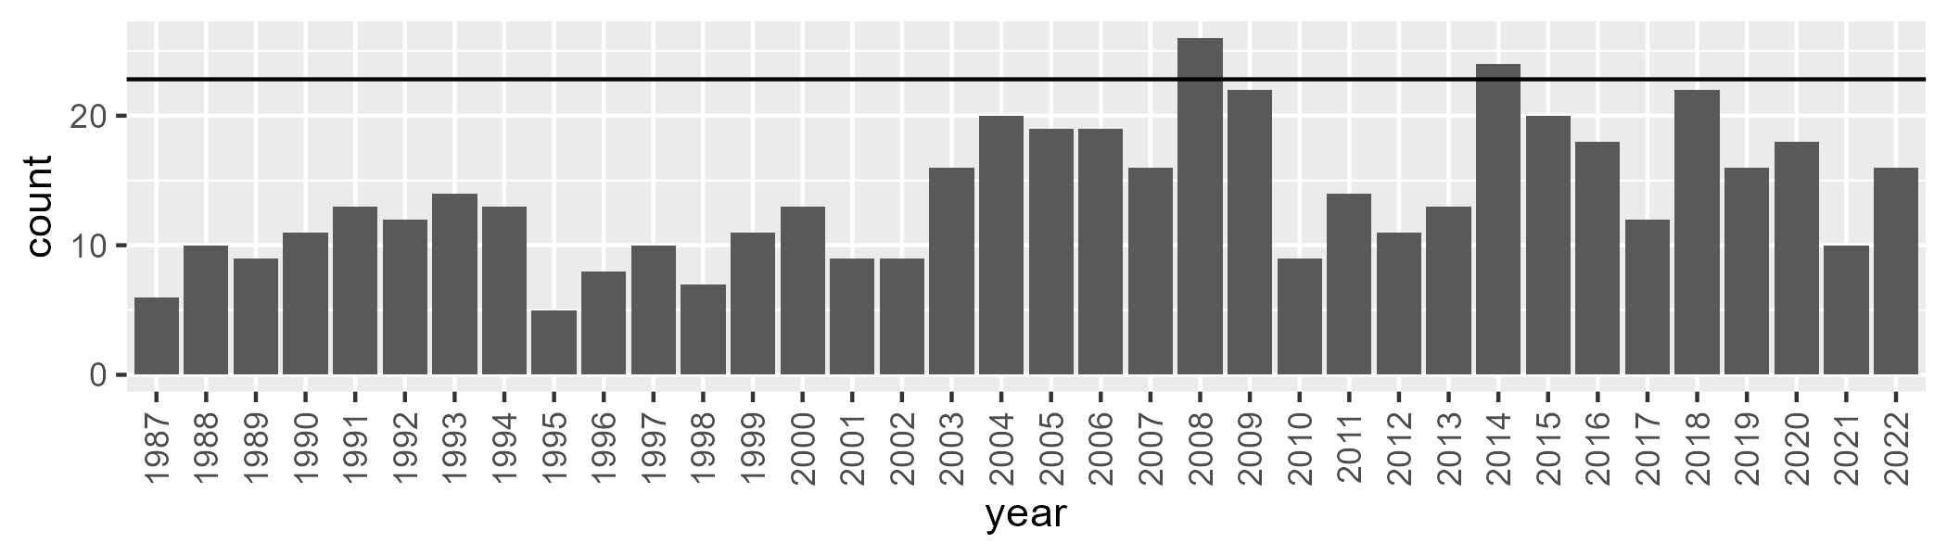

Number of samples: 501

# QDACYP0016

| Min. | 1st Qu. | Median | Mean | 3rd Qu. | Max. |
| --- | --- | --- | --- | --- | --- |
| 27.15799 | 44.60685 | 49.22675 | 49.2882 | 54.44831 | 65.43301 |

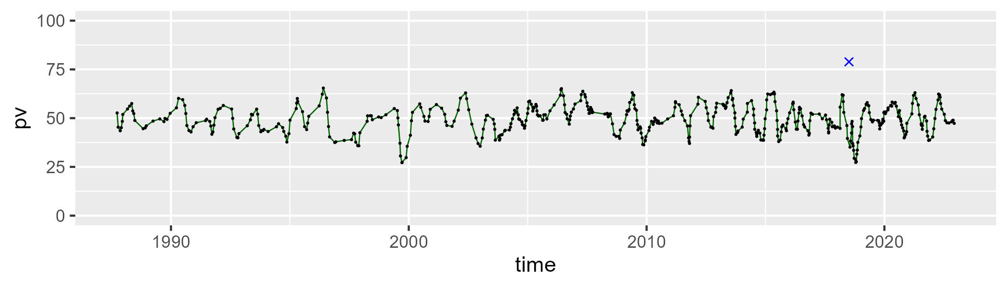

| Min. | 1st Qu. | Median | Mean | 3rd Qu. | Max. |
| --- | --- | --- | --- | --- | --- |
| 17.43231 | 36.50738 | 41.63685 | 41.73908 | 46.45748 | 61.82702 |

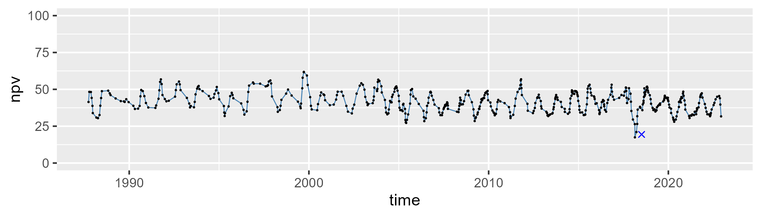

| Min. | 1st Qu. | Median | Mean | 3rd Qu. | Max. |
| --- | --- | --- | --- | --- | --- |
| 0 | 4.167846 | 7.227611 | 7.742925 | 10.29812 | 27.9244 |

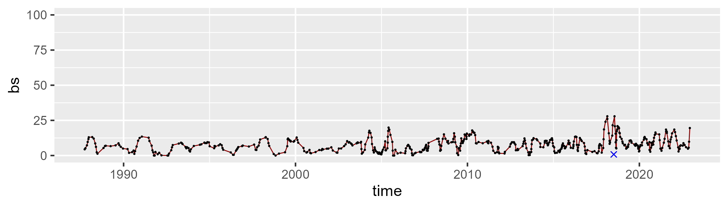

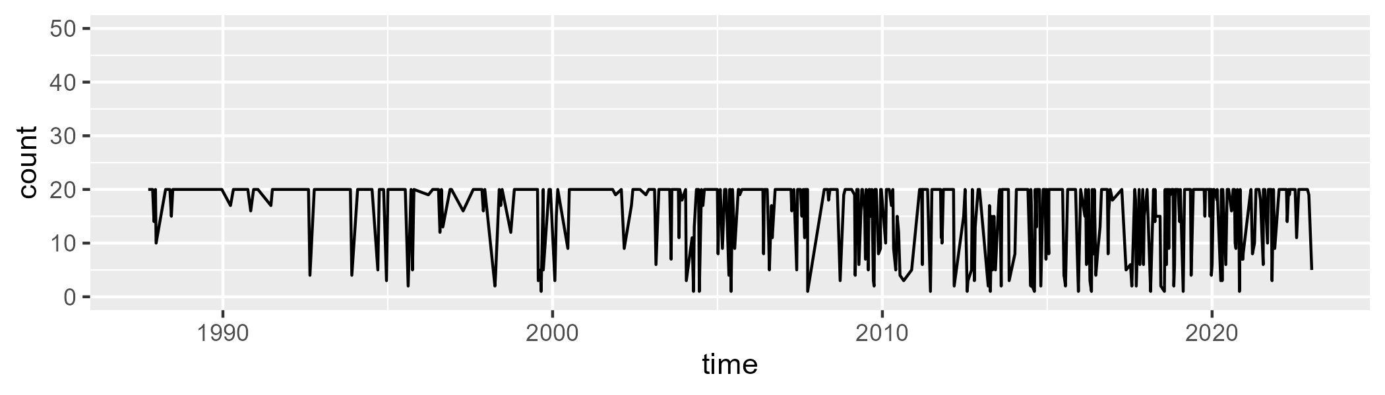

Min. : 1.00 1st Qu.:13.00 Median :20.00 Mean :15.98 3rd Qu.:20.00 Max. :20.00

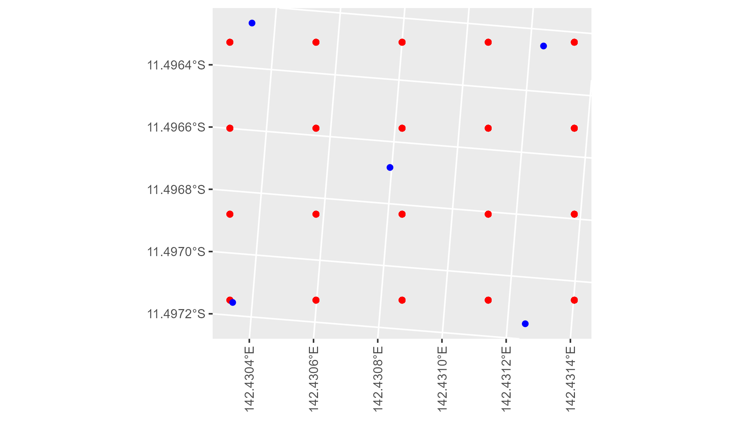

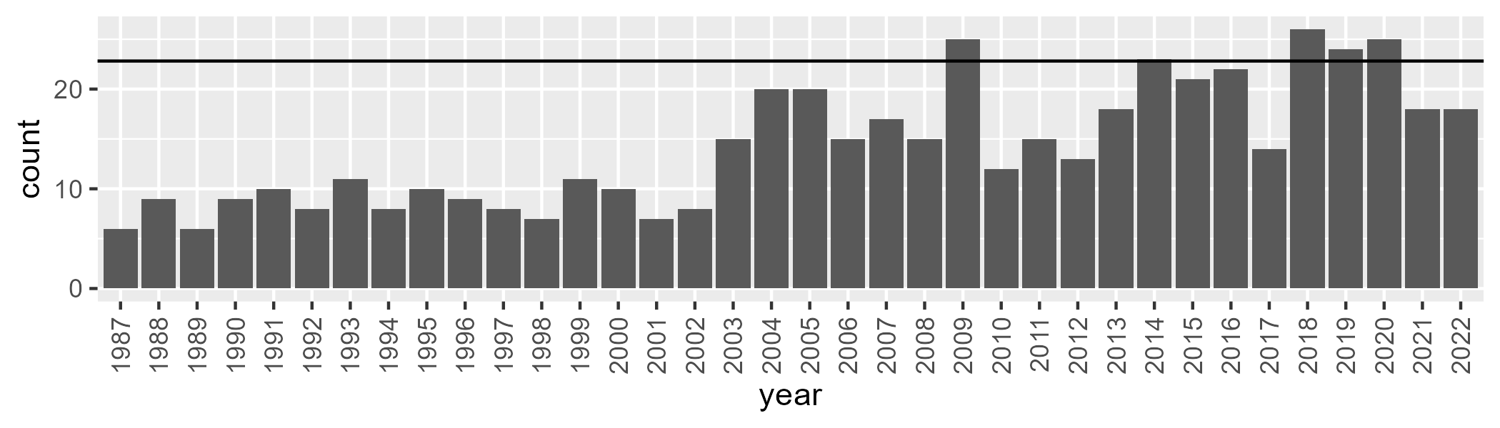

Number of samples: 513

# QDACYP0017

| Min. | 1st Qu. | Median | Mean | 3rd Qu. | Max. |
| --- | --- | --- | --- | --- | --- |
| 14.29612 | 52.42564 | 58.33955 | 57.58685 | 63.59306 | 82.06347 |

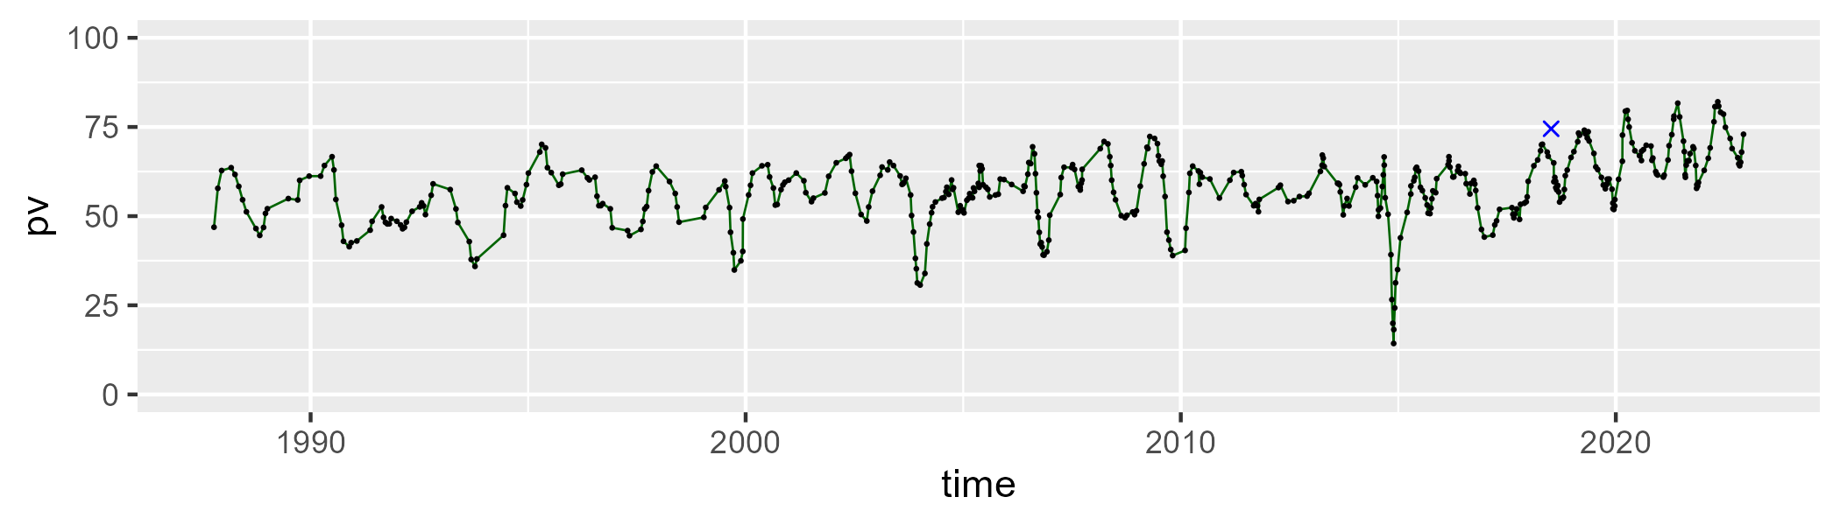

| Min. | 1st Qu. | Median | Mean | 3rd Qu. | Max. |
| --- | --- | --- | --- | --- | --- |
| 14.31168 | 28.0417 | 33.04273 | 32.96597 | 38.2335 | 55.51713 |

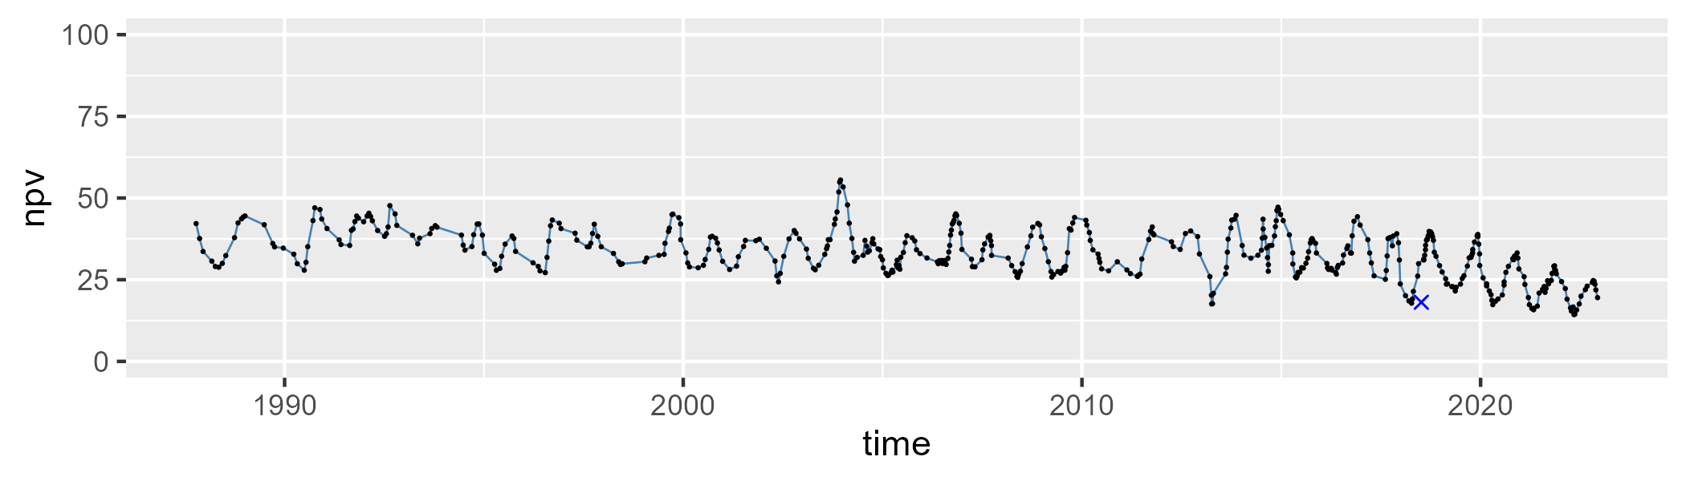

| Min. | 1st Qu. | Median | Mean | 3rd Qu. | Max. |
| --- | --- | --- | --- | --- | --- |
| 0 | 4.154165 | 7.229906 | 8.138541 | 11.41212 | 38.16701 |

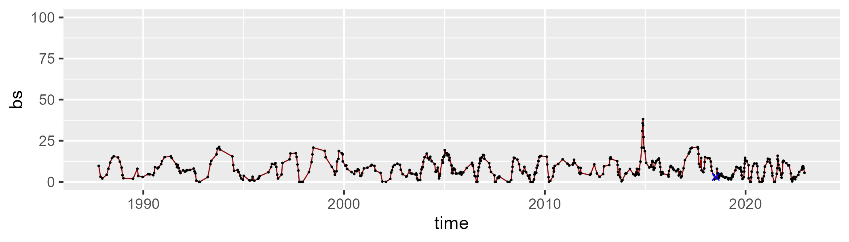

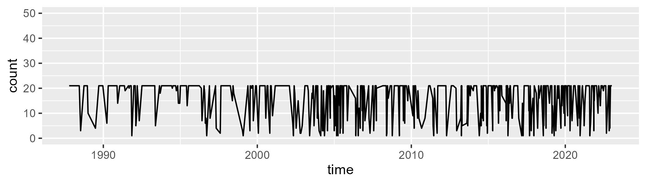

Min. : 1.00 1st Qu.: 9.00 Median :21.00 Mean :15.73 3rd Qu.:21.00 Max. :21.00

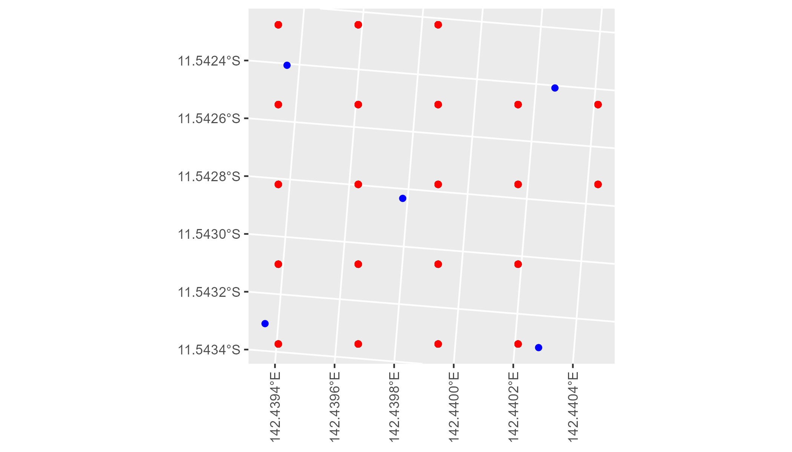

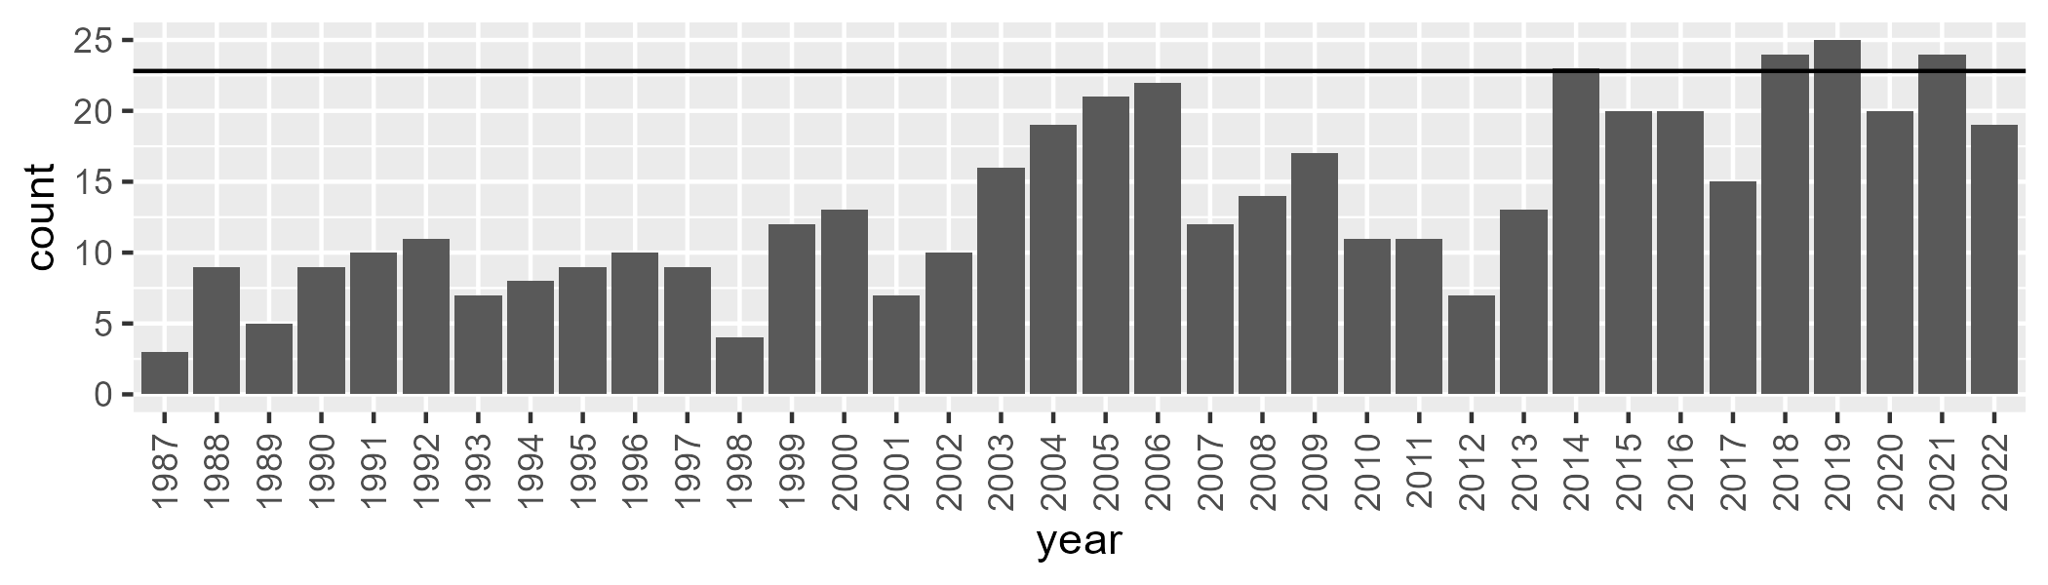

Number of samples: 489

# QDACYP0018

| Min. | 1st Qu. | Median | Mean | 3rd Qu. | Max. |
| --- | --- | --- | --- | --- | --- |
| 17.47717 | 45.93202 | 50.92364 | 50.88553 | 56.17514 | 74.70535 |

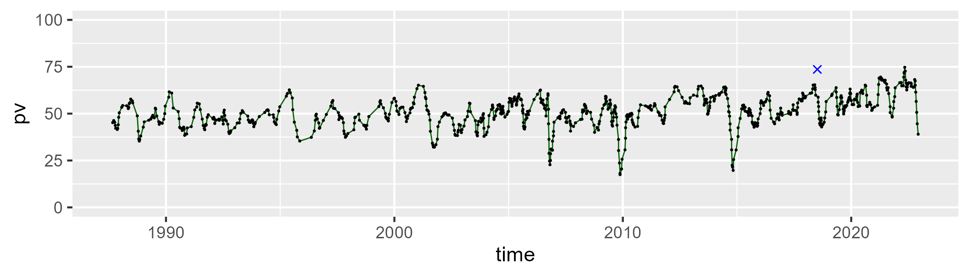

| Min. | 1st Qu. | Median | Mean | 3rd Qu. | Max. |
| --- | --- | --- | --- | --- | --- |
| 21.94258 | 35.4192 | 40.46303 | 40.12072 | 44.97611 | 60.80872 |

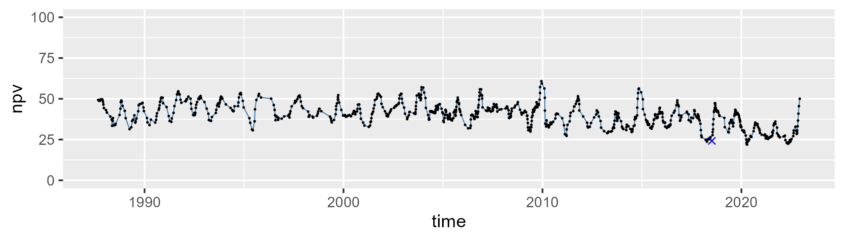

| Min. | 1st Qu. | Median | Mean | 3rd Qu. | Max. |
| --- | --- | --- | --- | --- | --- |
| 0 | 3.53105 | 6.983517 | 7.728492 | 11.13724 | 27.95378 |

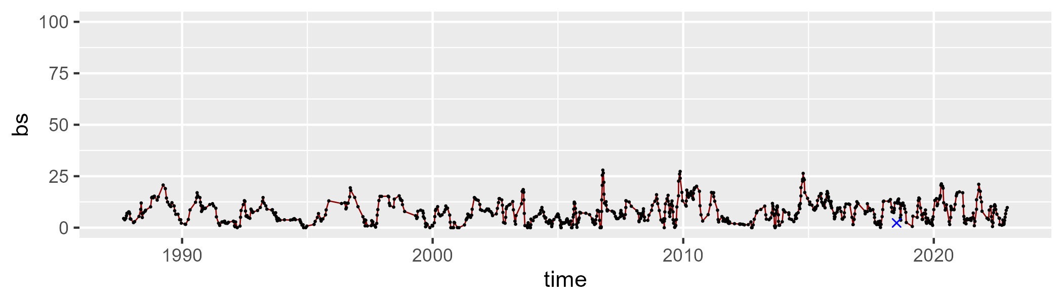

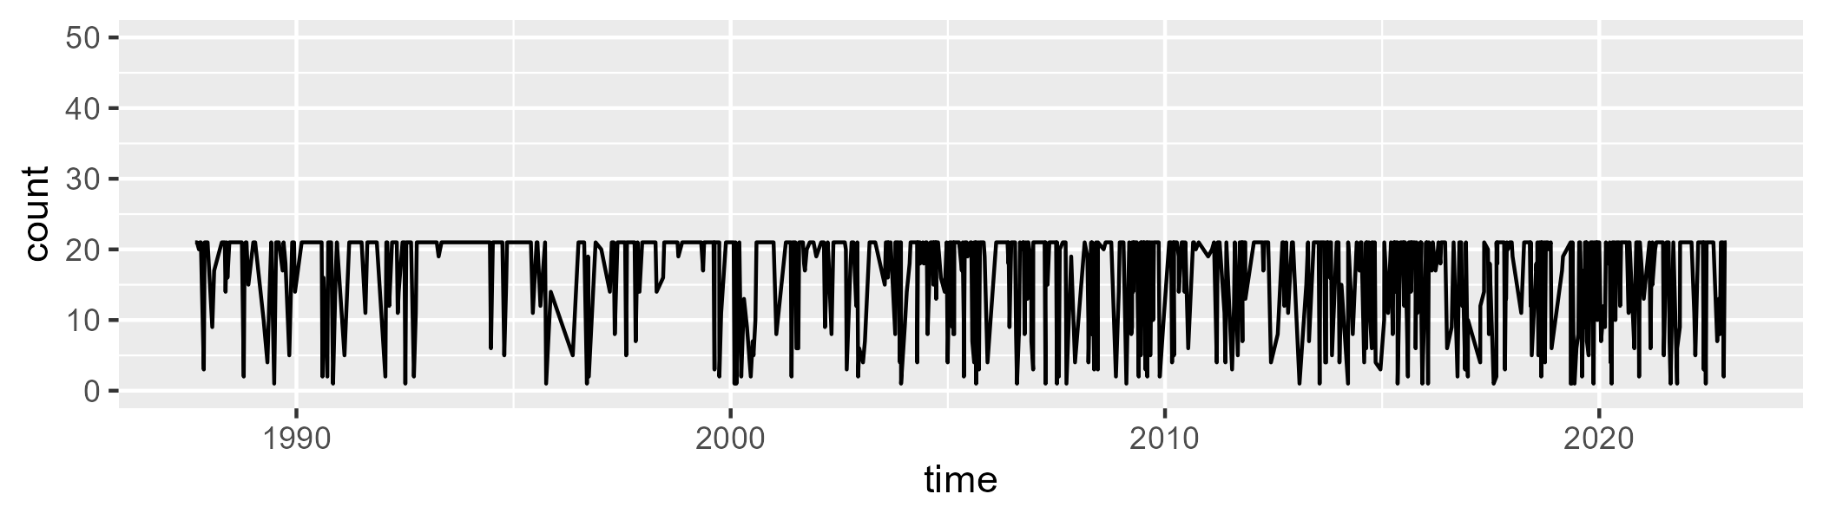

Min. : 1.00 1st Qu.:13.00 Median :21.00 Mean :16.52 3rd Qu.:21.00 Max. :21.00

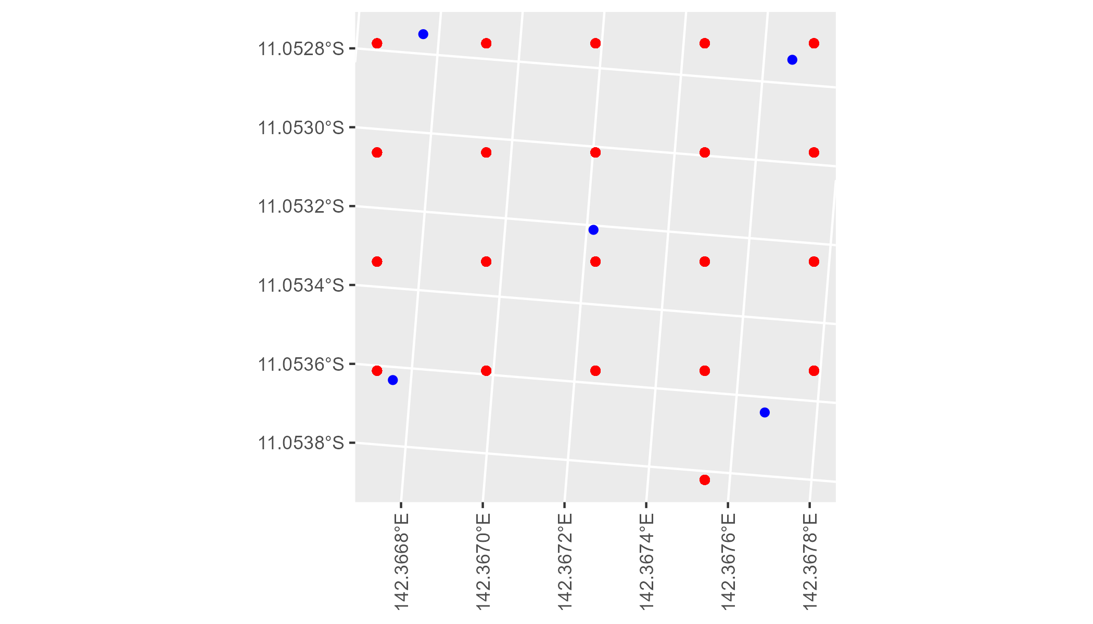

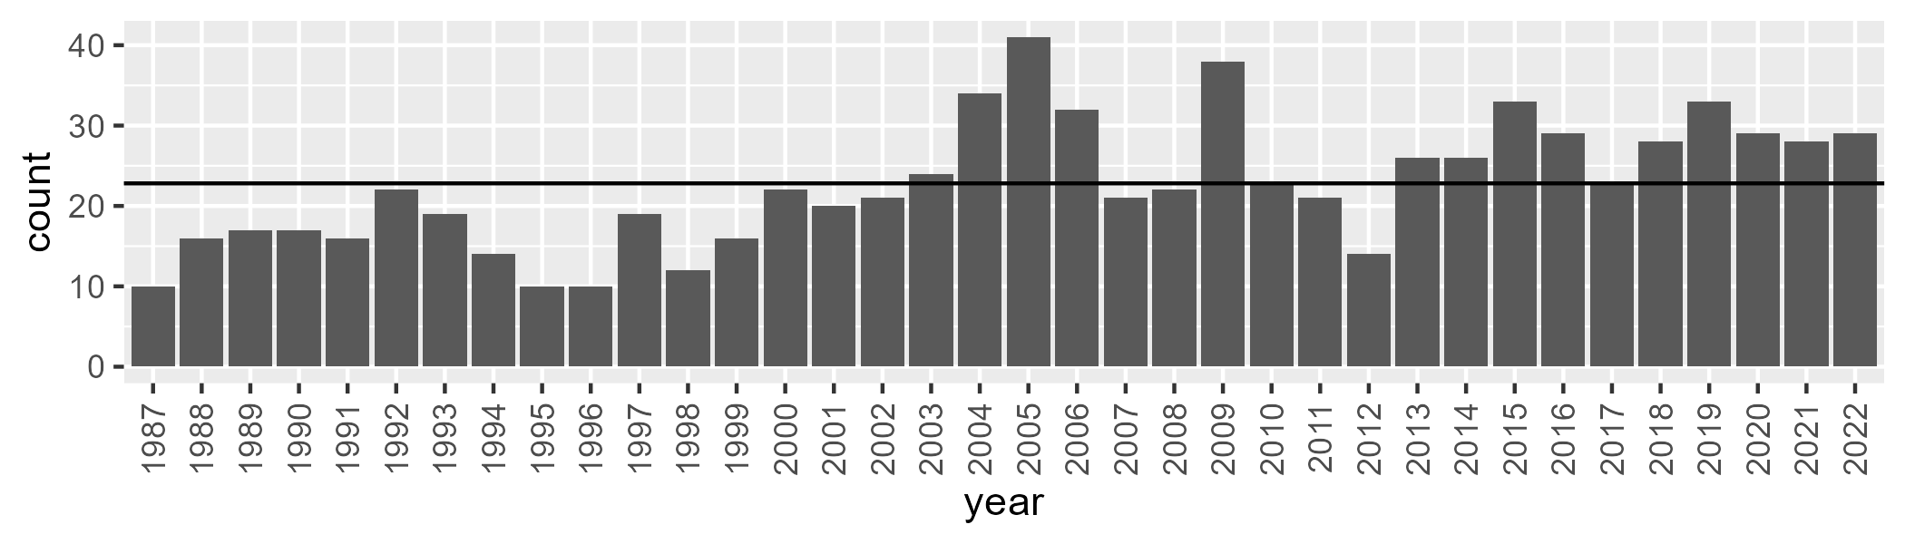

Number of samples: 815

# QDACYP0019

| Min. | 1st Qu. | Median | Mean | 3rd Qu. | Max. |
| --- | --- | --- | --- | --- | --- |
| 30.29198 | 41.50125 | 45.43399 | 45.17717 | 48.7415 | 56.31025 |

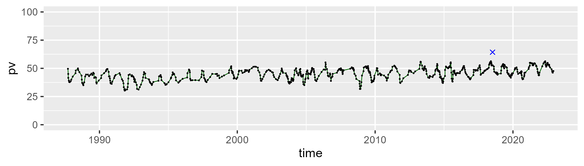

| Min. | 1st Qu. | Median | Mean | 3rd Qu. | Max. |
| --- | --- | --- | --- | --- | --- |
| 27.96774 | 42.70579 | 46.58008 | 46.66913 | 50.68137 | 67.08614 |

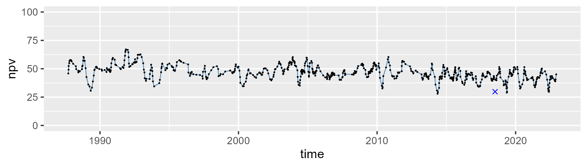

| Min. | 1st Qu. | Median | Mean | 3rd Qu. | Max. |
| --- | --- | --- | --- | --- | --- |
| 0 | 3.521665 | 5.852818 | 7.062306 | 9.840909 | 26.82982 |

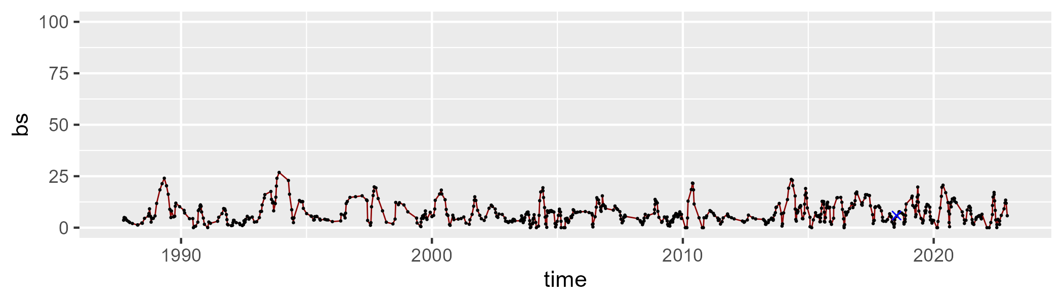

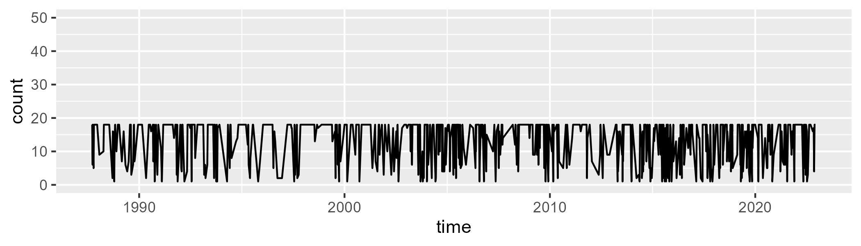

Min. : 1.00 1st Qu.: 6.00 Median :17.00 Mean :12.74 3rd Qu.:18.00 Max. :18.00

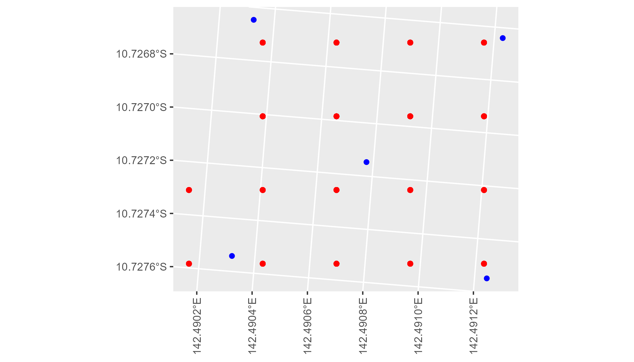

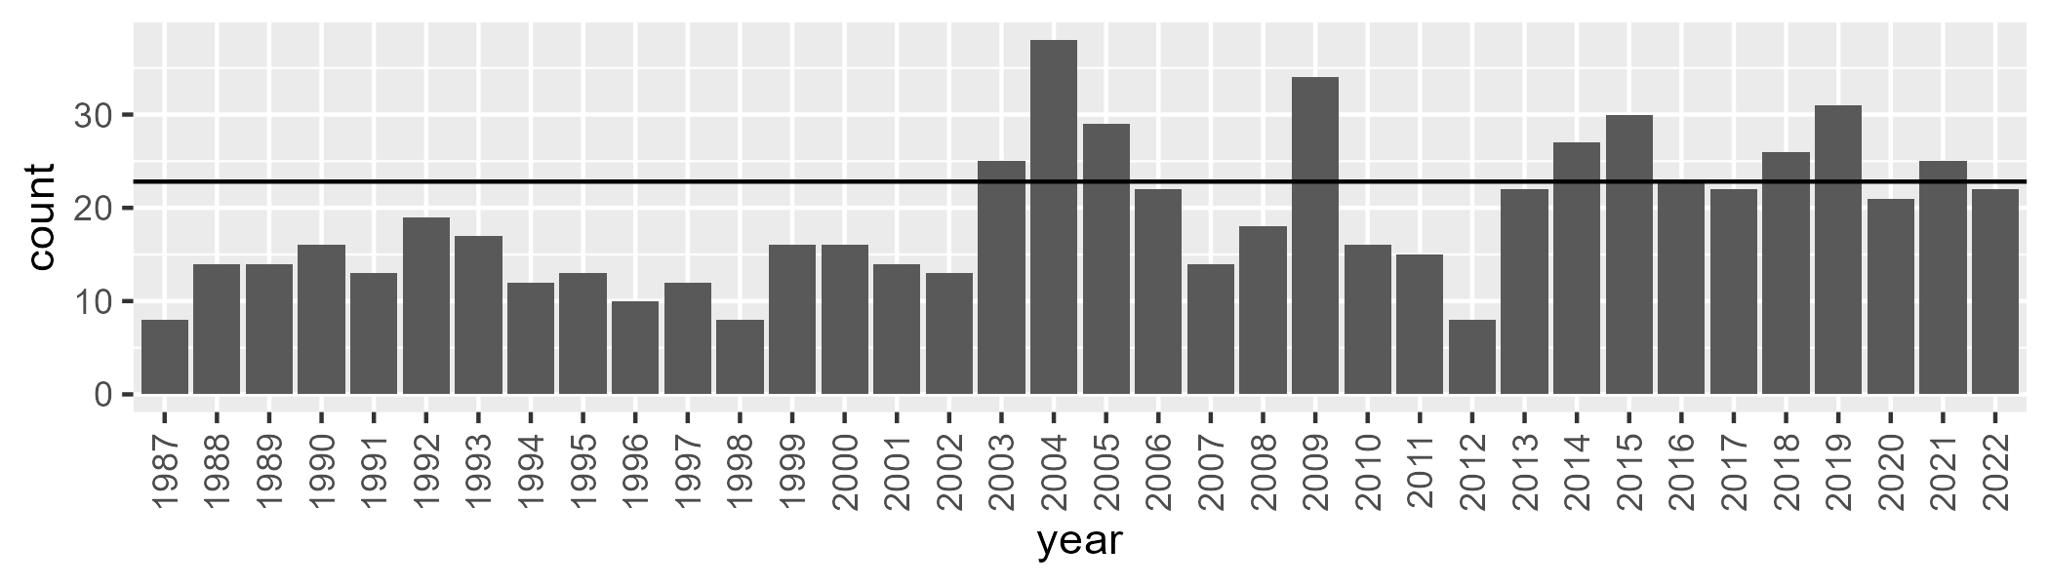

Number of samples: 683

# QDACYP0020

| Min. | 1st Qu. | Median | Mean | 3rd Qu. | Max. |
| --- | --- | --- | --- | --- | --- |
| 29.27165 | 46.2992 | 51.20727 | 50.22153 | 54.91941 | 63.2359 |

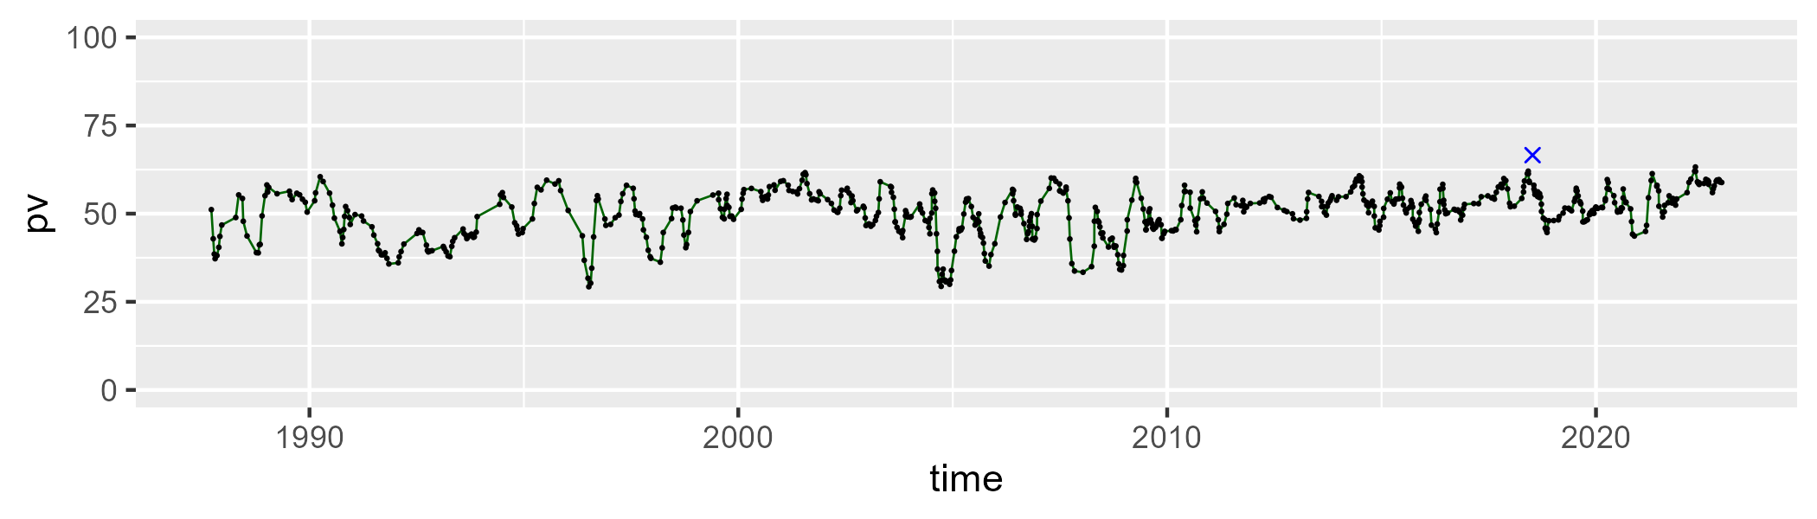

| Min. | 1st Qu. | Median | Mean | 3rd Qu. | Max. |
| --- | --- | --- | --- | --- | --- |
| 24.09993 | 38.55295 | 41.5157 | 42.17626 | 45.20511 | 59.13844 |

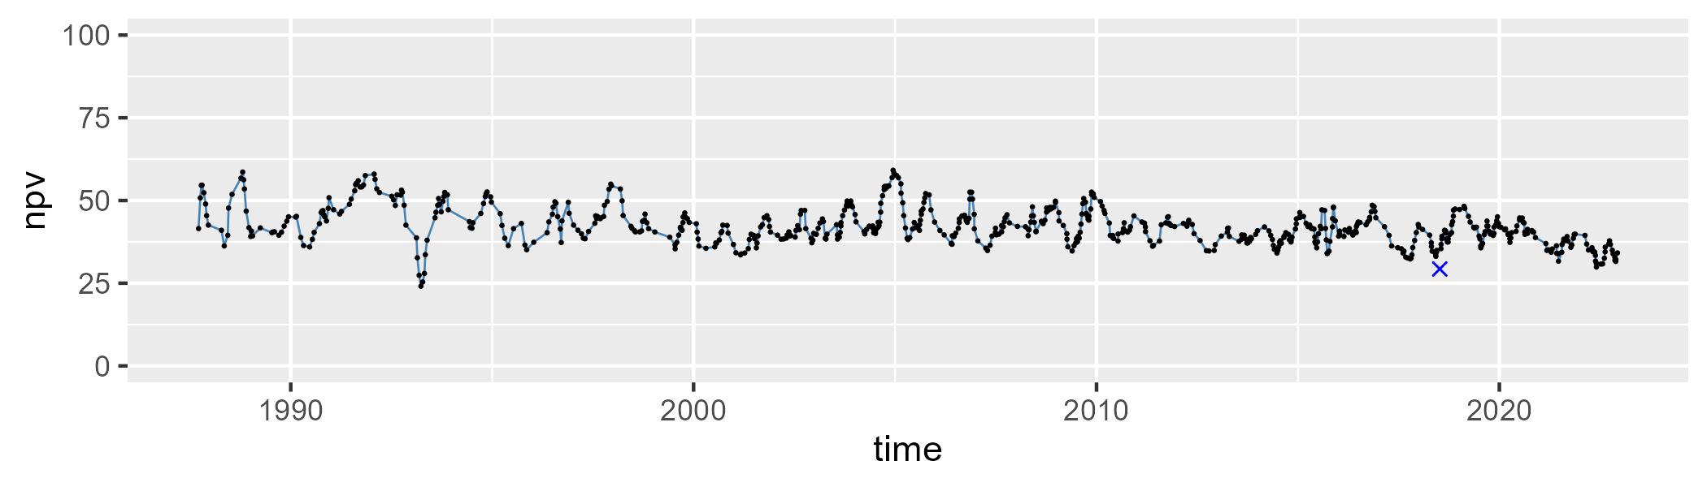

| Min. | 1st Qu. | Median | Mean | 3rd Qu. | Max. |
| --- | --- | --- | --- | --- | --- |
| 0 | 3.319363 | 5.568728 | 6.455015 | 8.585579 | 37.13058 |

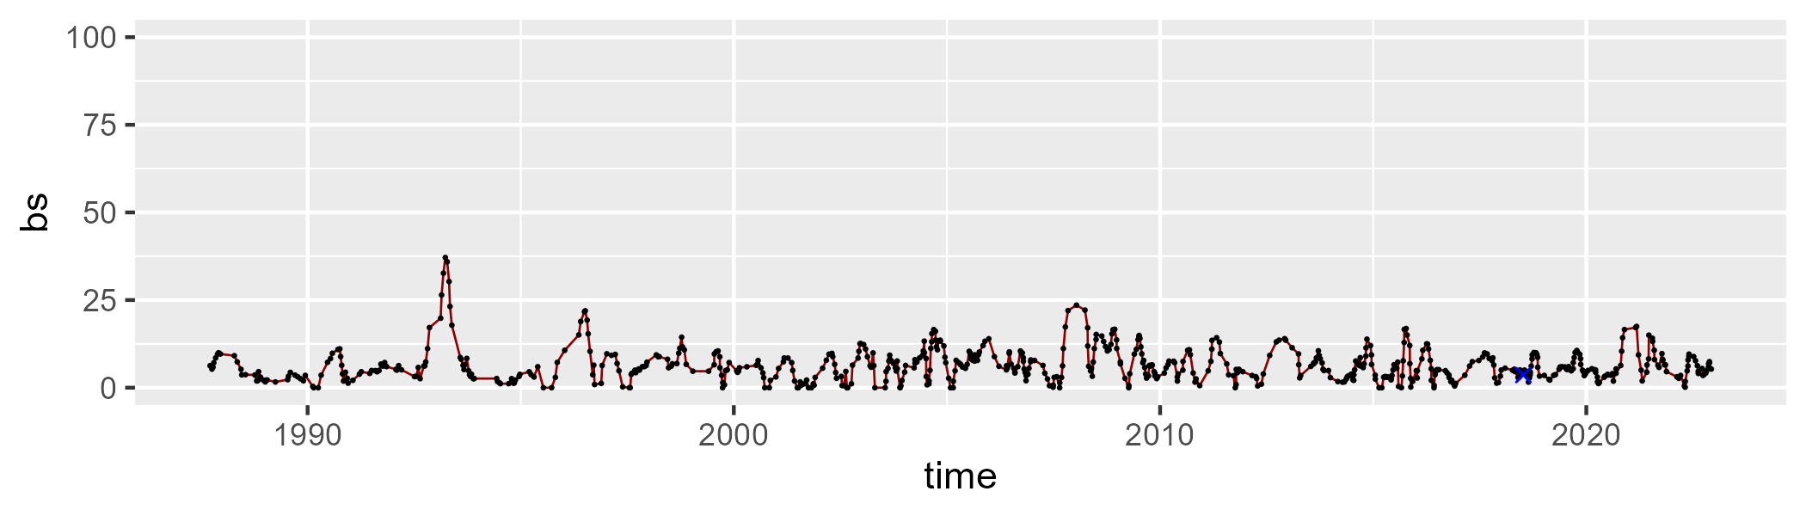

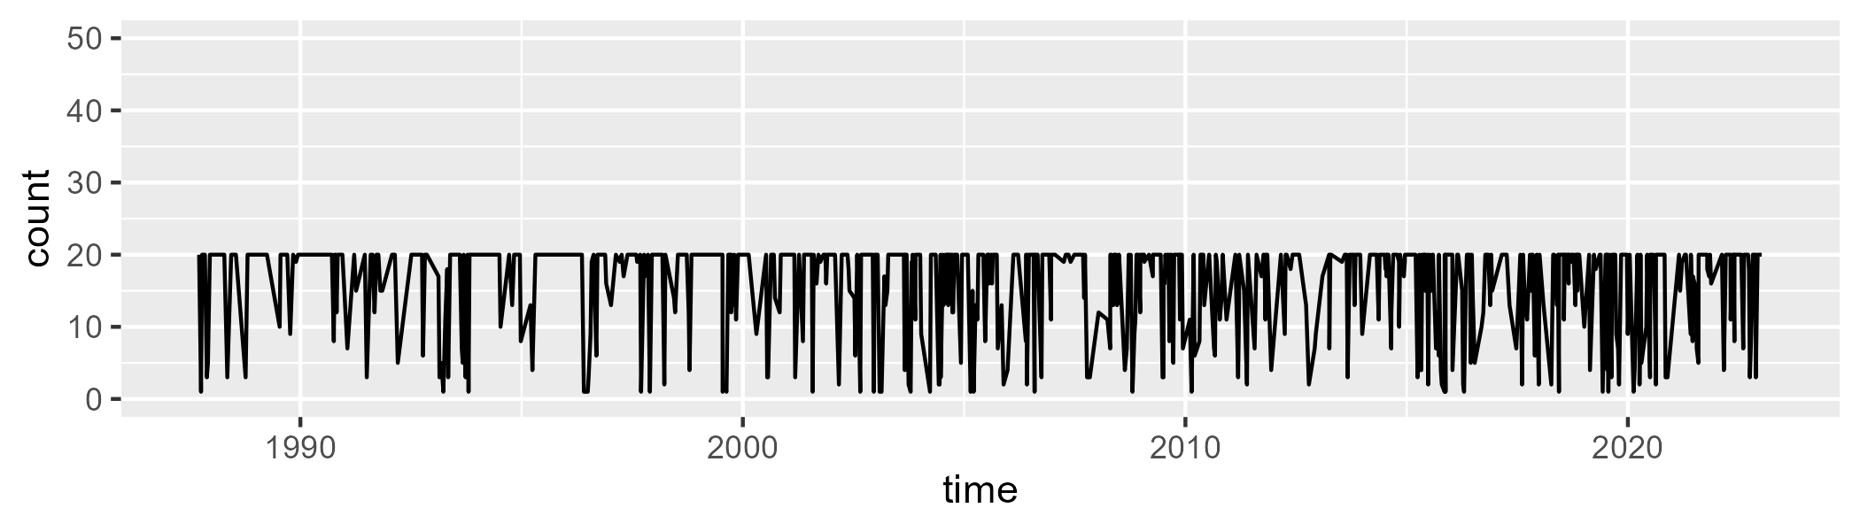

Min. : 1.00 1st Qu.:12.00 Median :20.00 Mean :15.72 3rd Qu.:20.00 Max. :20.00

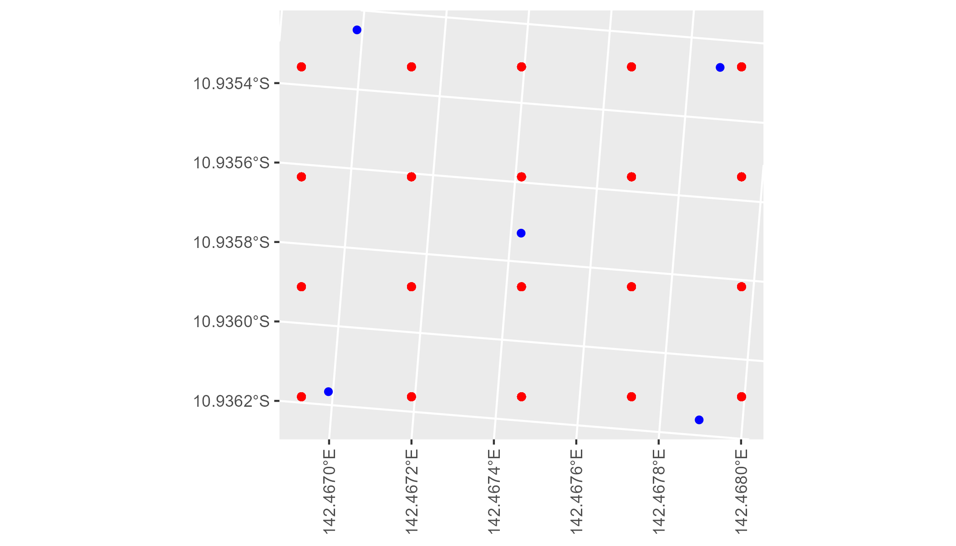

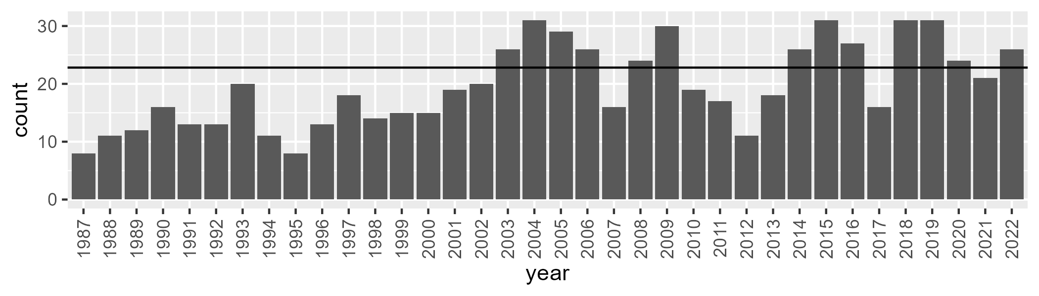

Number of samples: 706

# QDACYP0021

| Min. | 1st Qu. | Median | Mean | 3rd Qu. | Max. |
| --- | --- | --- | --- | --- | --- |
| 35.09625 | 57.97444 | 62.55872 | 62.04201 | 66.4725 | 79.05584 |

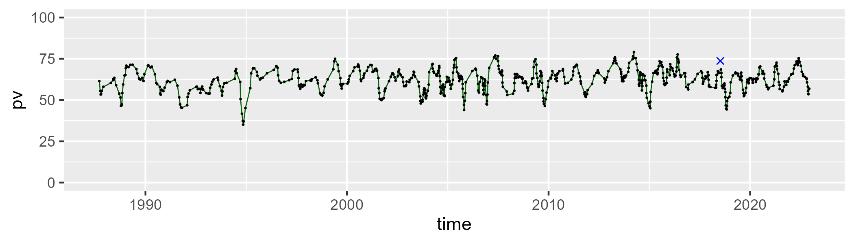

| Min. | 1st Qu. | Median | Mean | 3rd Qu. | Max. |
| --- | --- | --- | --- | --- | --- |
| 16.70581 | 24.62791 | 29.0432 | 29.25051 | 32.76259 | 50.96084 |

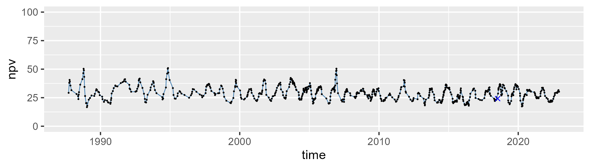

| Min. | 1st Qu. | Median | Mean | 3rd Qu. | Max. |
| --- | --- | --- | --- | --- | --- |
| 0 | 3.256079 | 6.523653 | 7.32482 | 10.75628 | 26.10589 |

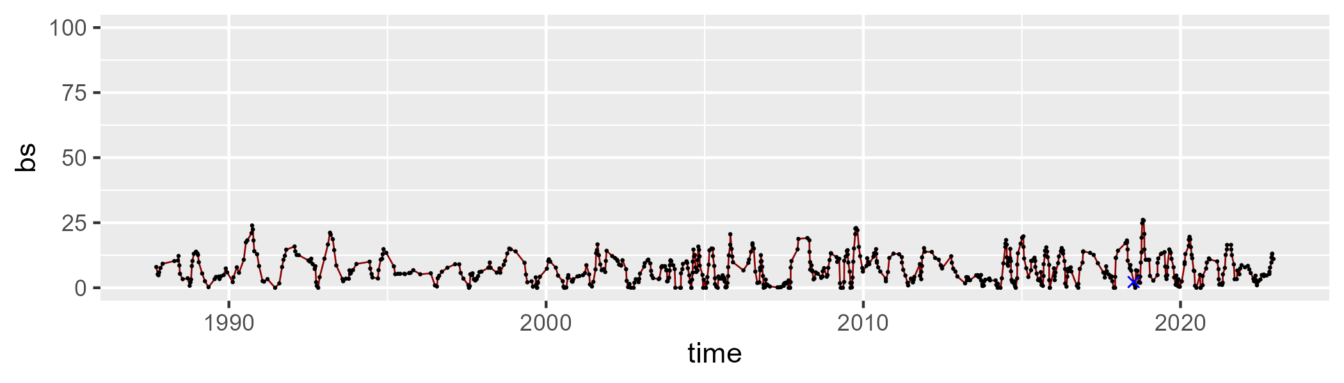

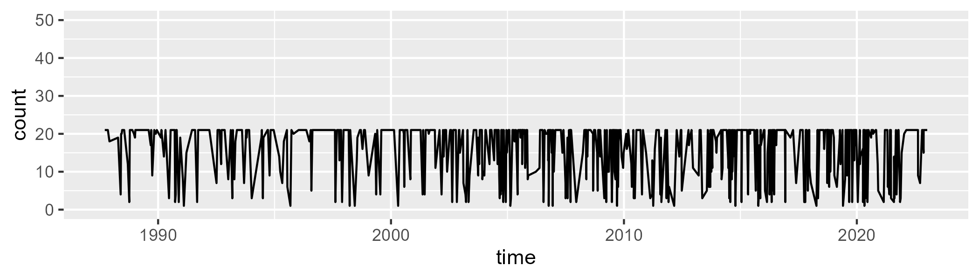

Min. : 1.00 1st Qu.:11.00 Median :21.00 Mean :16.25 3rd Qu.:21.00 Max. :21.00

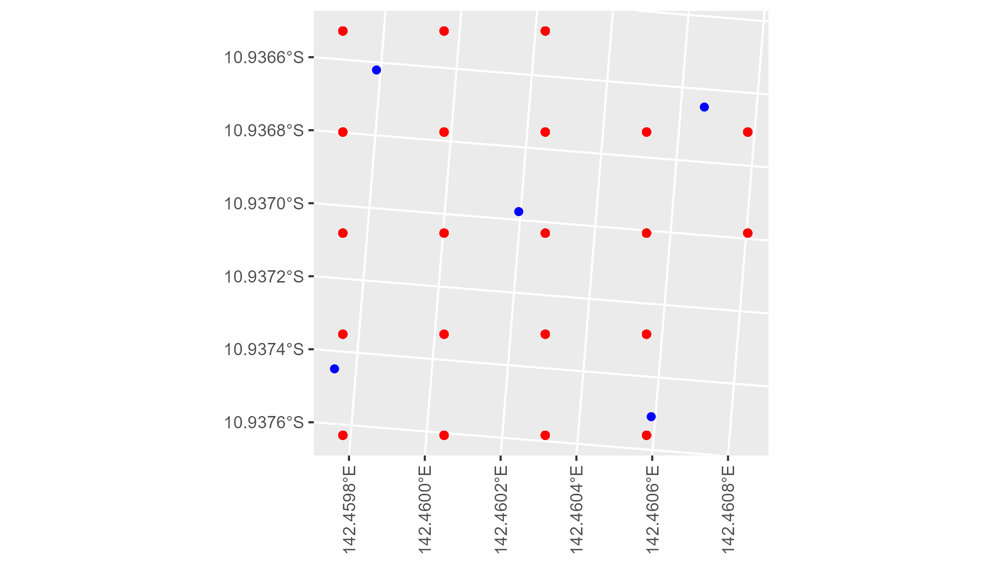

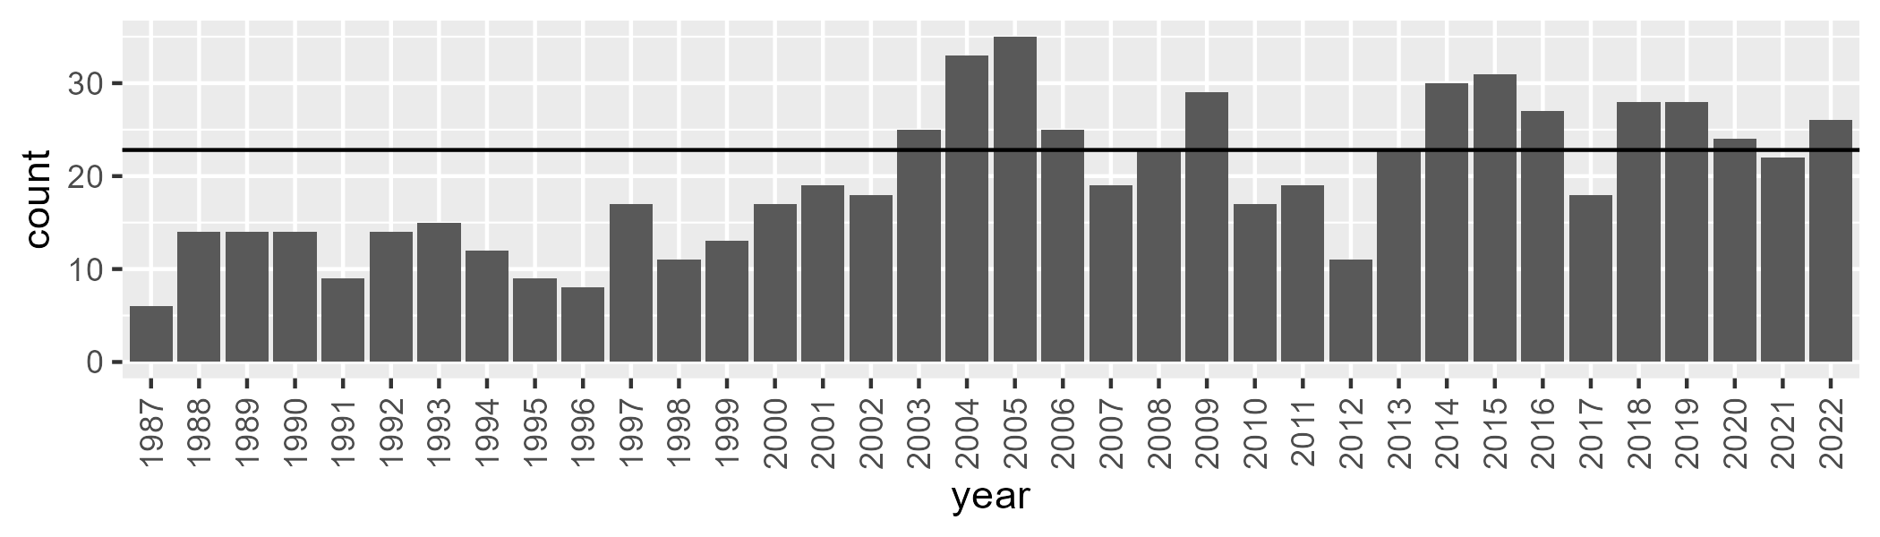

Number of samples: 703

# QDACYP0022

| Min. | 1st Qu. | Median | Mean | 3rd Qu. | Max. |
| --- | --- | --- | --- | --- | --- |
| 25.75486 | 40.57847 | 46.2315 | 45.51107 | 50.48506 | 61.24709 |

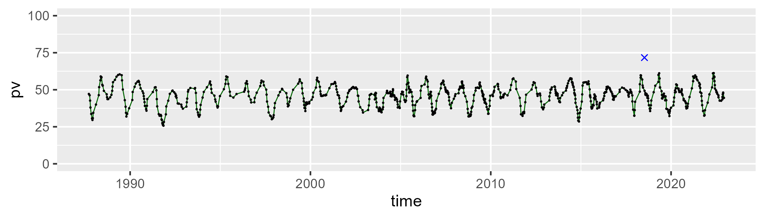

| Min. | 1st Qu. | Median | Mean | 3rd Qu. | Max. |
| --- | --- | --- | --- | --- | --- |
| 26.2107 | 37.53824 | 40.40037 | 40.60416 | 43.59626 | 53.31429 |

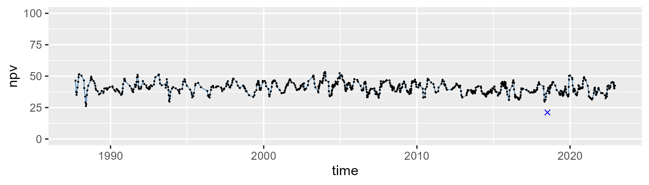

| Min. | 1st Qu. | Median | Mean | 3rd Qu. | Max. |
| --- | --- | --- | --- | --- | --- |
| 0 | 7.676603 | 11.47341 | 12.61995 | 15.9254 | 36.31167 |

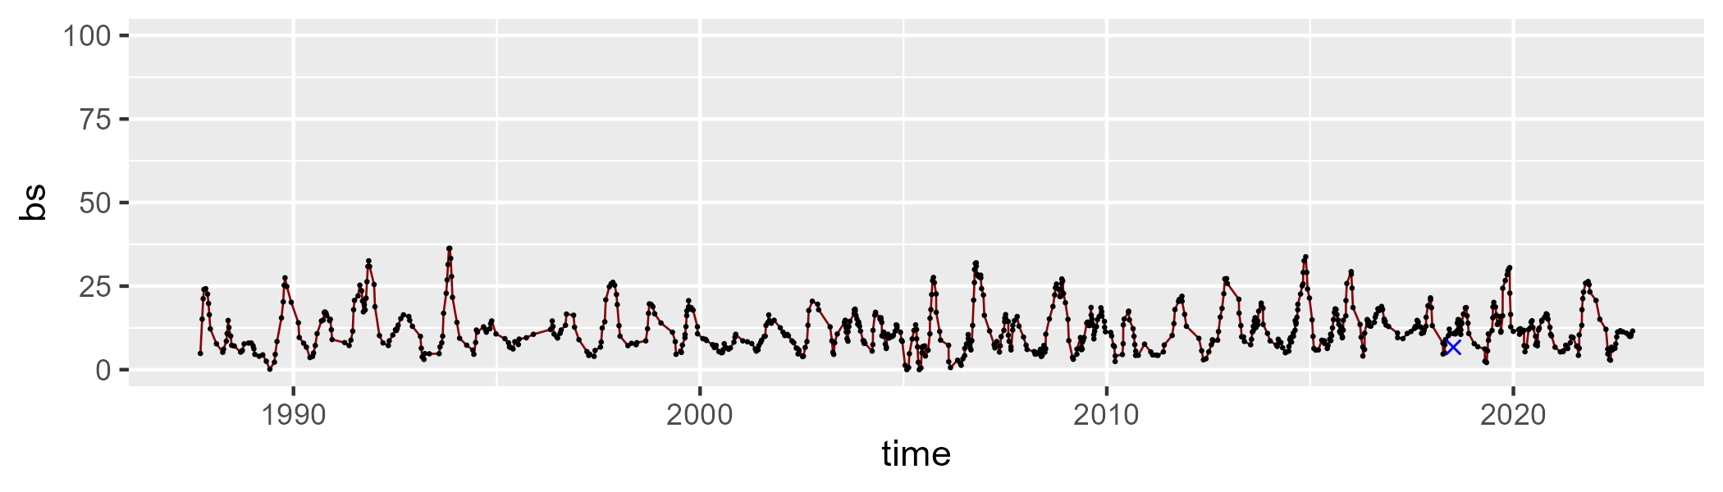

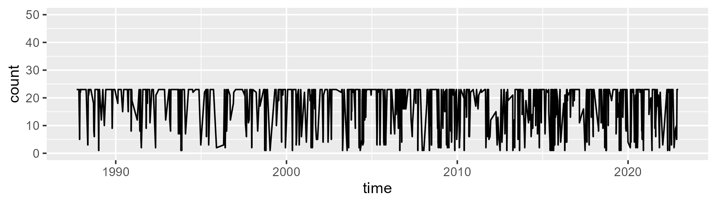

Min. : 1.00 1st Qu.:12.00 Median :23.00 Mean :17.66 3rd Qu.:23.00 Max. :23.00

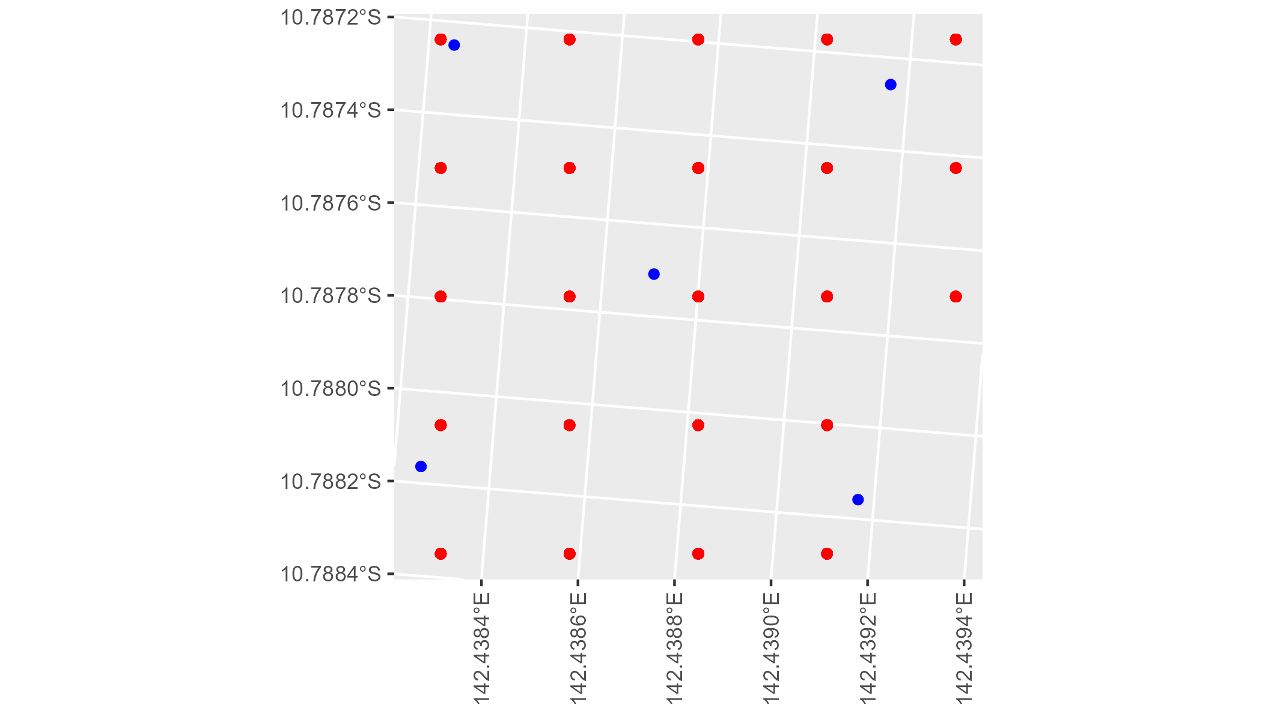

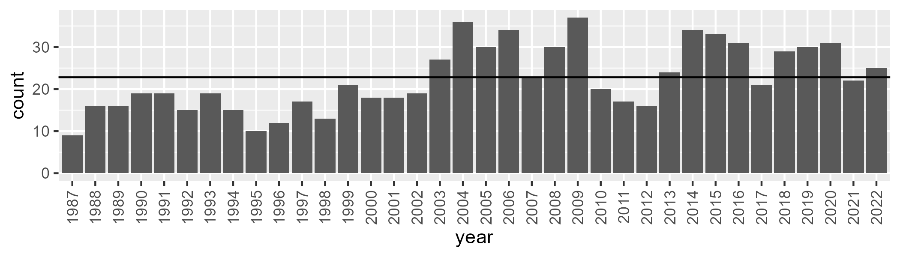

Number of samples: 806

# QDACYP0023

| Min. | 1st Qu. | Median | Mean | 3rd Qu. | Max. |
| --- | --- | --- | --- | --- | --- |
| 30.54398 | 48.44126 | 57.39643 | 56.76551 | 65.01723 | 84.54259 |

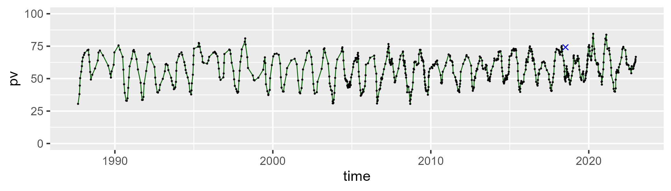

| Min. | 1st Qu. | Median | Mean | 3rd Qu. | Max. |
| --- | --- | --- | --- | --- | --- |
| 13.51194 | 26.17179 | 34.66613 | 35.1147 | 44.26439 | 59.57835 |

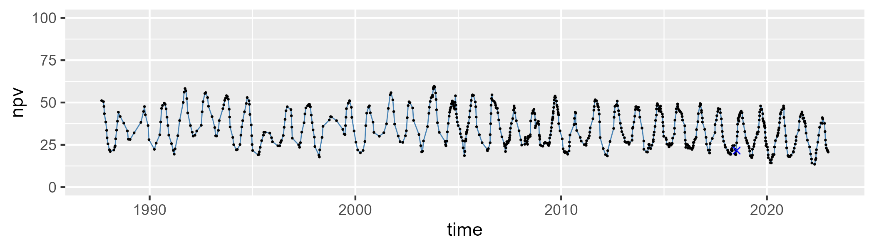

| Min. | 1st Qu. | Median | Mean | 3rd Qu. | Max. |
| --- | --- | --- | --- | --- | --- |
| 0 | 2.861358 | 5.656215 | 6.825874 | 9.665394 | 29.51347 |

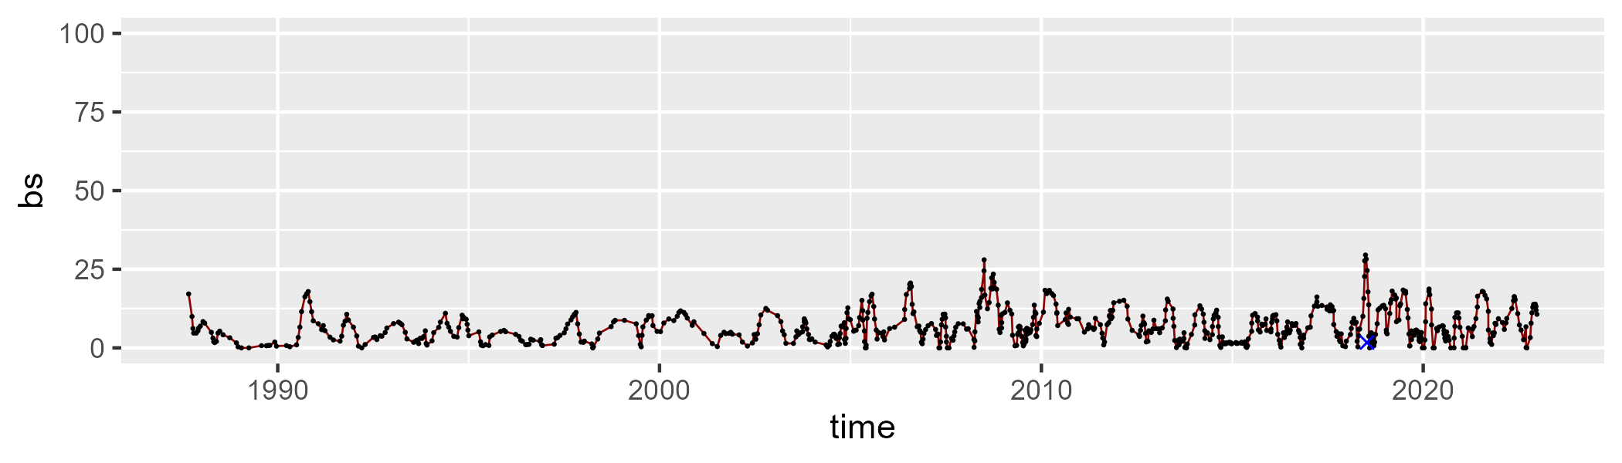

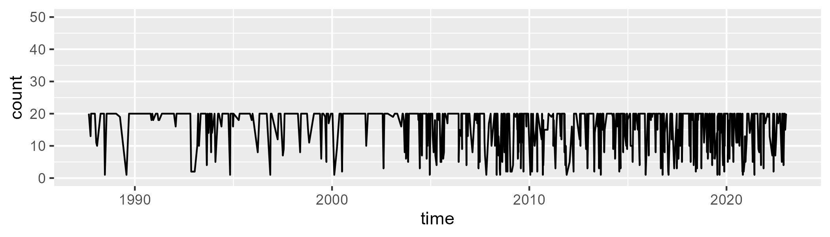

Min. : 1.00 1st Qu.:14.00 Median :20.00 Mean :16.27 3rd Qu.:20.00 Max. :20.00

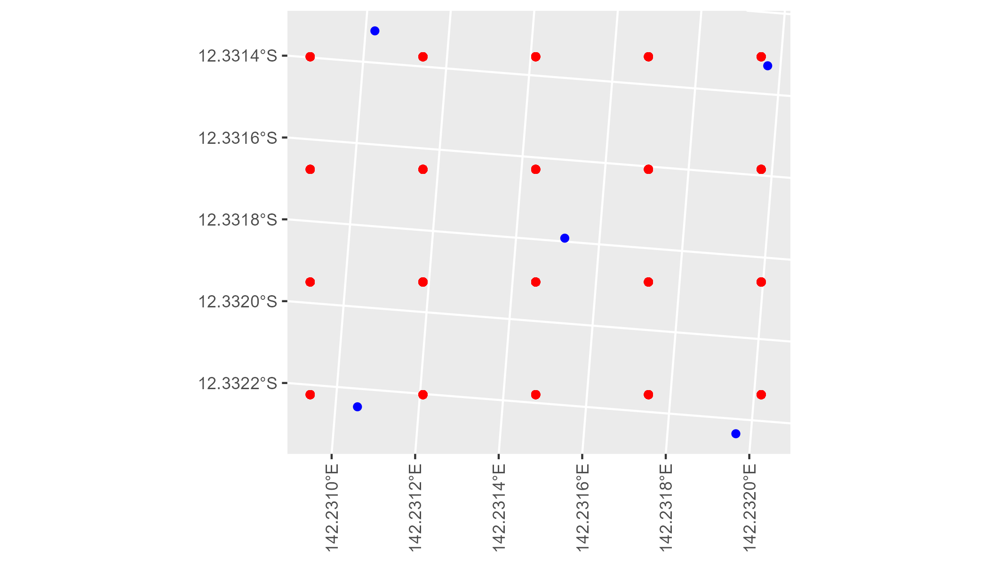

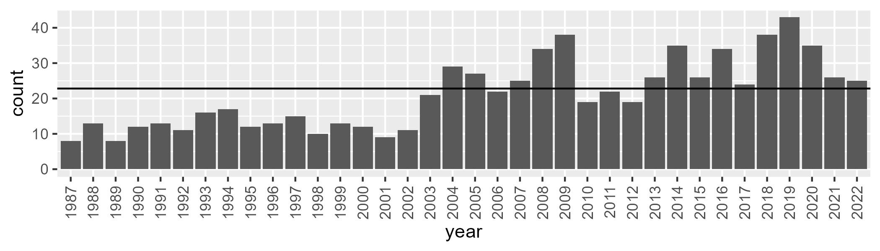

Number of samples: 761

# QDACYP0024

| Min. | 1st Qu. | Median | Mean | 3rd Qu. | Max. |
| --- | --- | --- | --- | --- | --- |
| 26.45956 | 52.34396 | 58.12102 | 58.02177 | 65.3708 | 80.31918 |

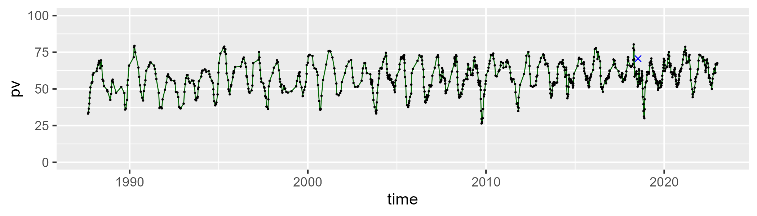

| Min. | 1st Qu. | Median | Mean | 3rd Qu. | Max. |
| --- | --- | --- | --- | --- | --- |
| 13.37094 | 26.00163 | 33.08739 | 33.3684 | 40.37564 | 62.5918 |

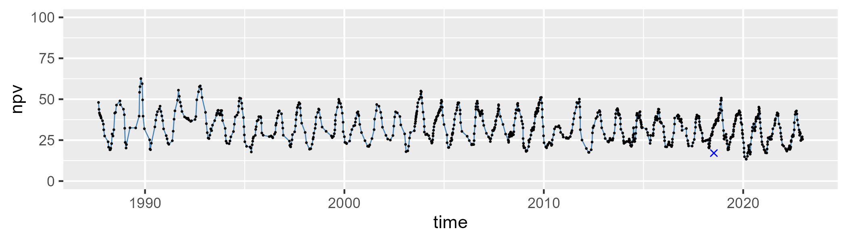

| Min. | 1st Qu. | Median | Mean | 3rd Qu. | Max. |
| --- | --- | --- | --- | --- | --- |
| 0 | 2.757603 | 6.070388 | 7.325631 | 10.85828 | 30.32267 |

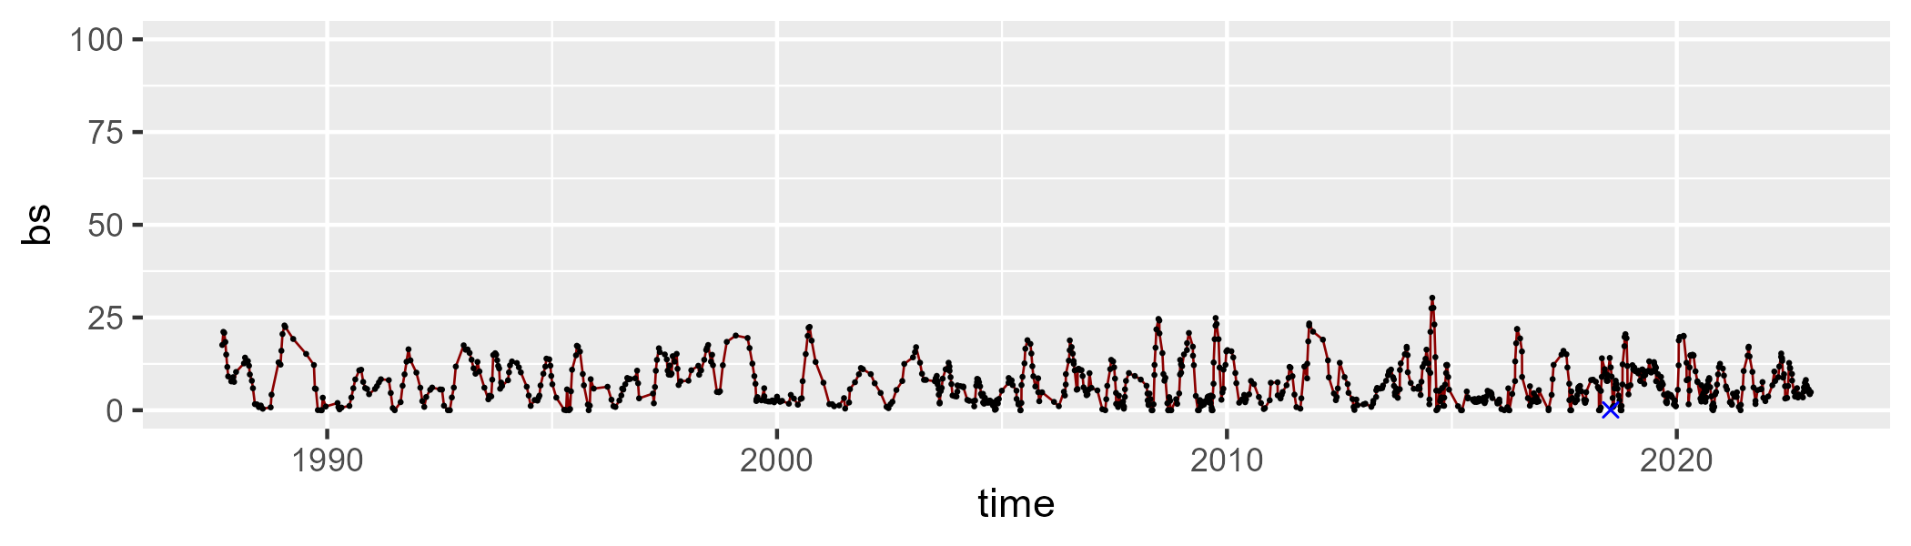

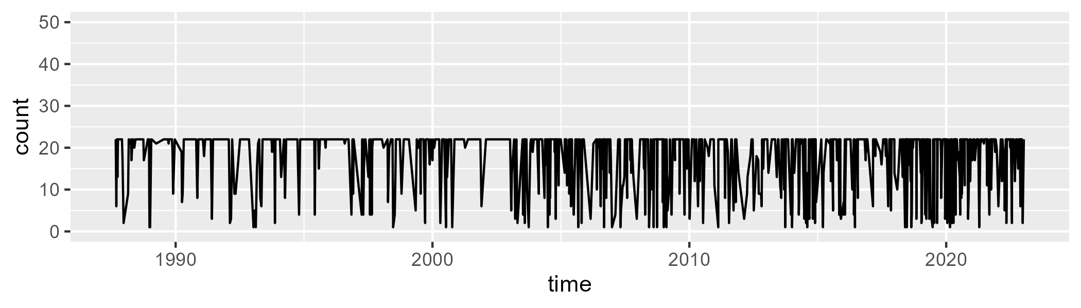

Min. : 1.00 1st Qu.:15.00 Median :22.00 Mean :17.79 3rd Qu.:22.00 Max. :22.00

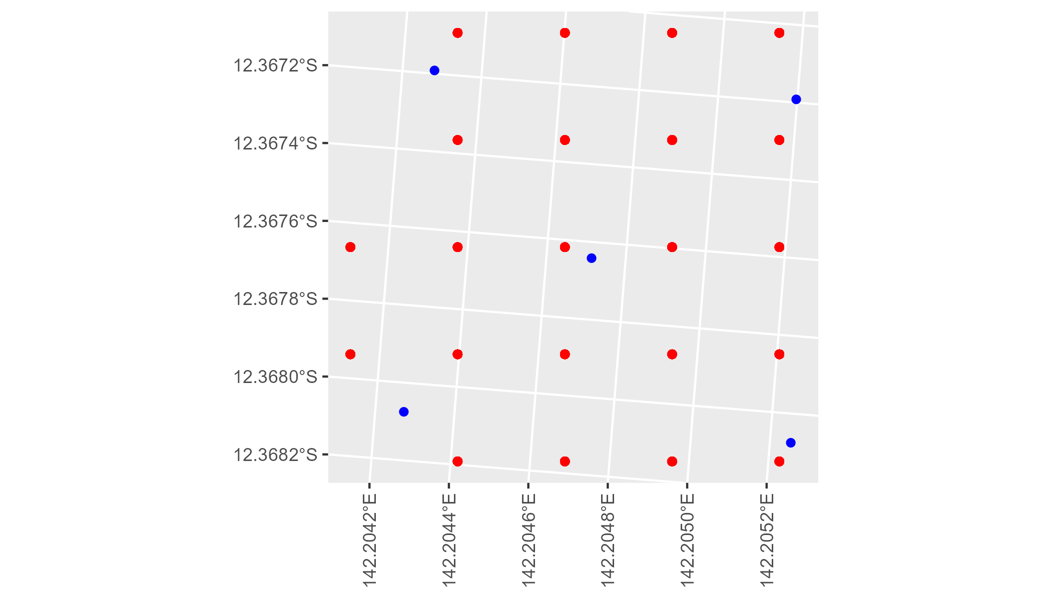

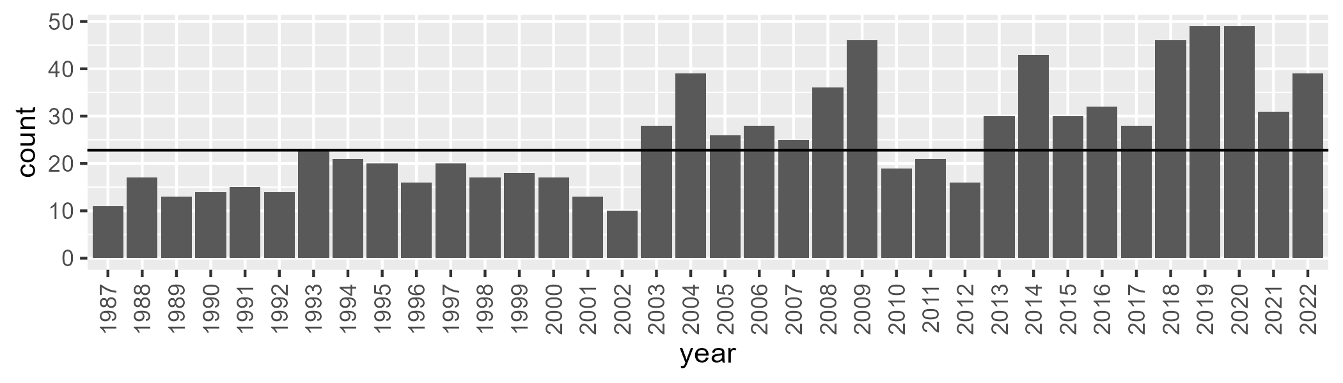

Number of samples: 920

# QDADEU0001

| Min. | 1st Qu. | Median | Mean | 3rd Qu. | Max. |
| --- | --- | --- | --- | --- | --- |
| 0.8800603 | 14.20408 | 22.45428 | 24.51917 | 32.92063 | 66.33175 |

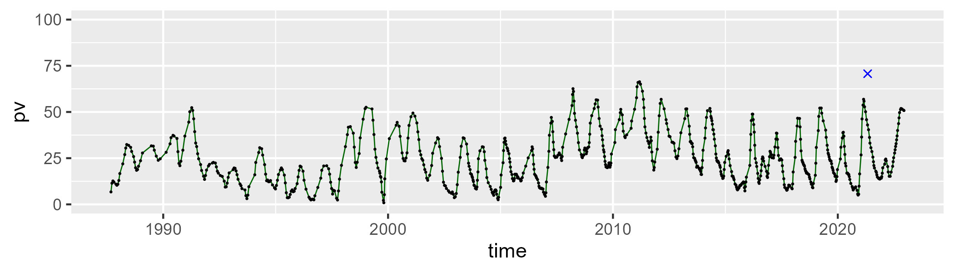

| Min. | 1st Qu. | Median | Mean | 3rd Qu. | Max. |
| --- | --- | --- | --- | --- | --- |
| 12.50182 | 45.33075 | 53.03815 | 52.38975 | 60.35363 | 84.95309 |

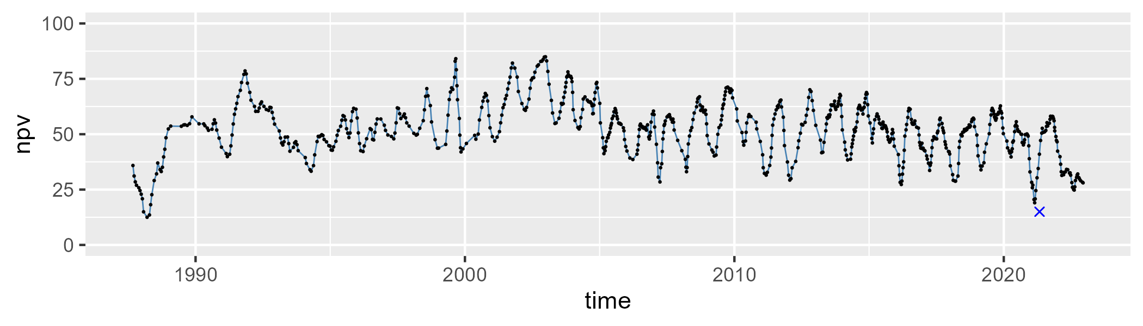

| Min. | 1st Qu. | Median | Mean | 3rd Qu. | Max. |
| --- | --- | --- | --- | --- | --- |
| 0 | 9.082519 | 21.07015 | 21.84007 | 31.38671 | 66.96009 |

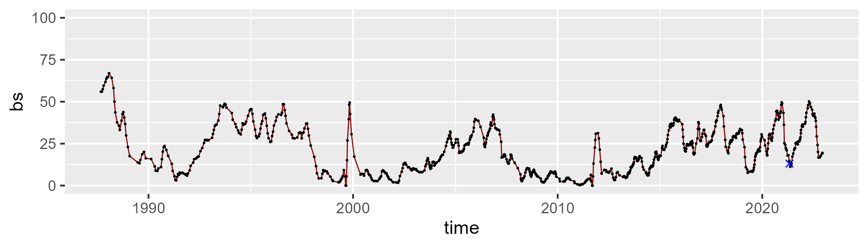

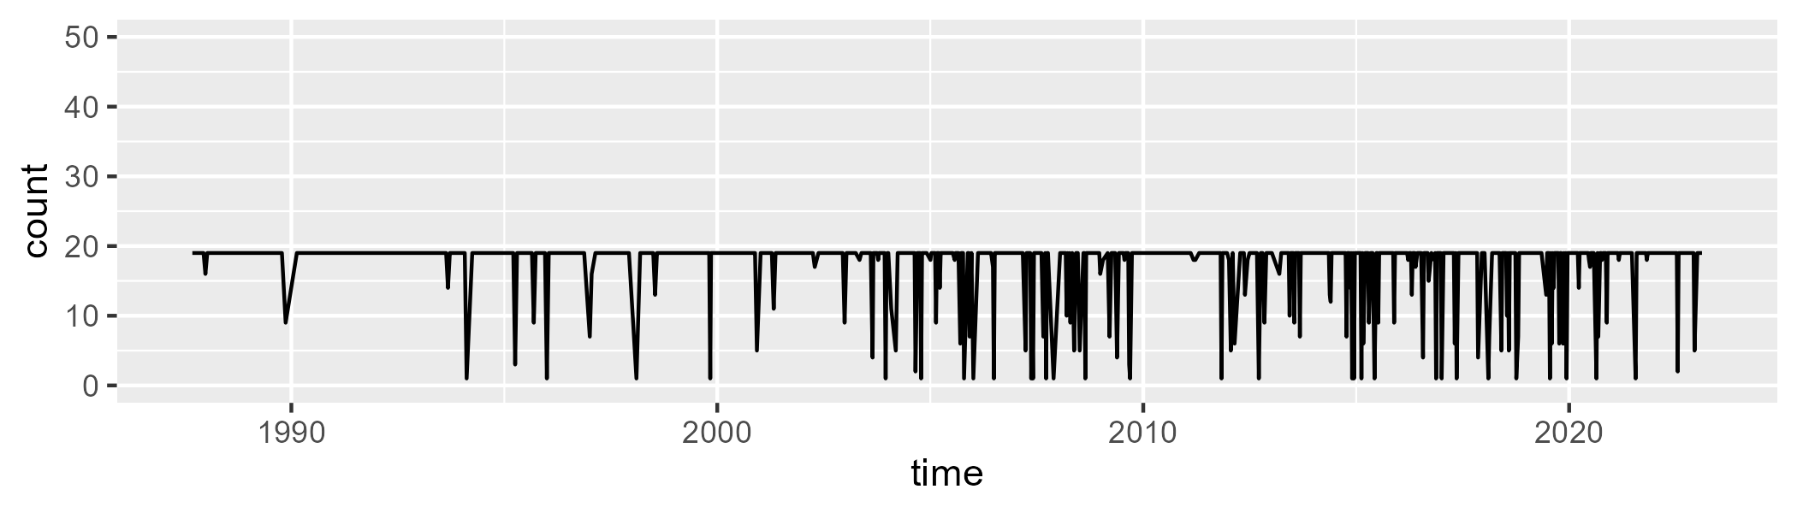

Min. : 1.00 1st Qu.:19.00 Median :19.00 Mean :17.38 3rd Qu.:19.00 Max. :19.00

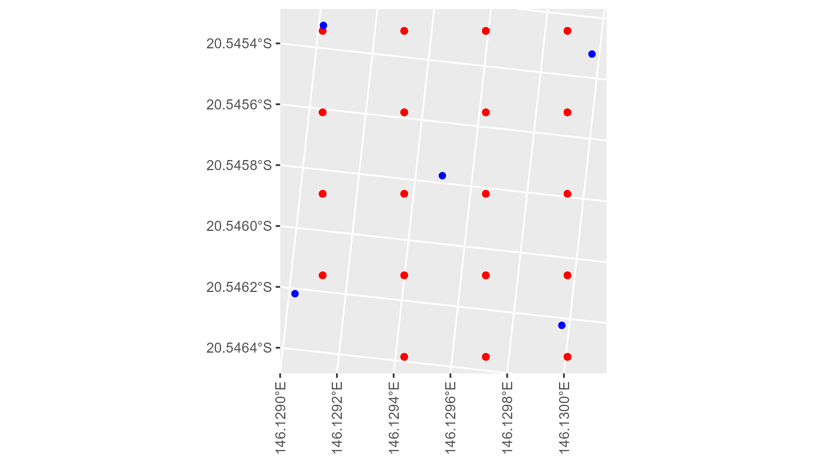

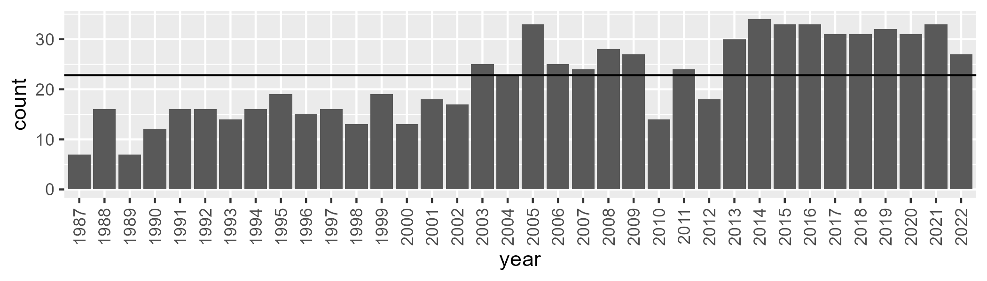

Number of samples: 790

# QDAEIU0001

| Min. | 1st Qu. | Median | Mean | 3rd Qu. | Max. |
| --- | --- | --- | --- | --- | --- |
| 0 | 11.84192 | 22.18167 | 26.71733 | 39.52875 | 82.10098 |

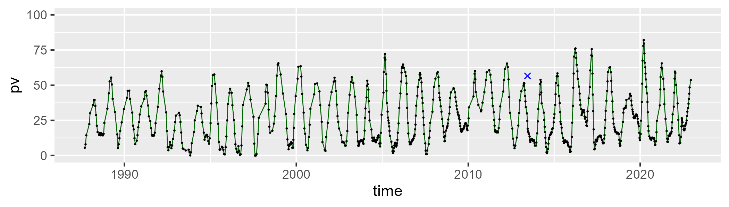

| Min. | 1st Qu. | Median | Mean | 3rd Qu. | Max. |
| --- | --- | --- | --- | --- | --- |
| 10.78744 | 44.65989 | 56.97813 | 55.65217 | 67.04839 | 87.76119 |

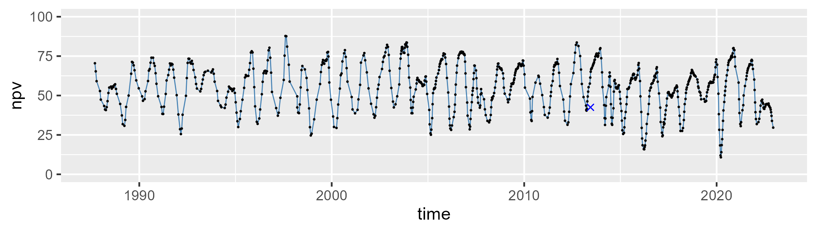

| Min. | 1st Qu. | Median | Mean | 3rd Qu. | Max. |
| --- | --- | --- | --- | --- | --- |
| 0 | 9.379091 | 14.00179 | 16.42603 | 22.0315 | 65.70338 |

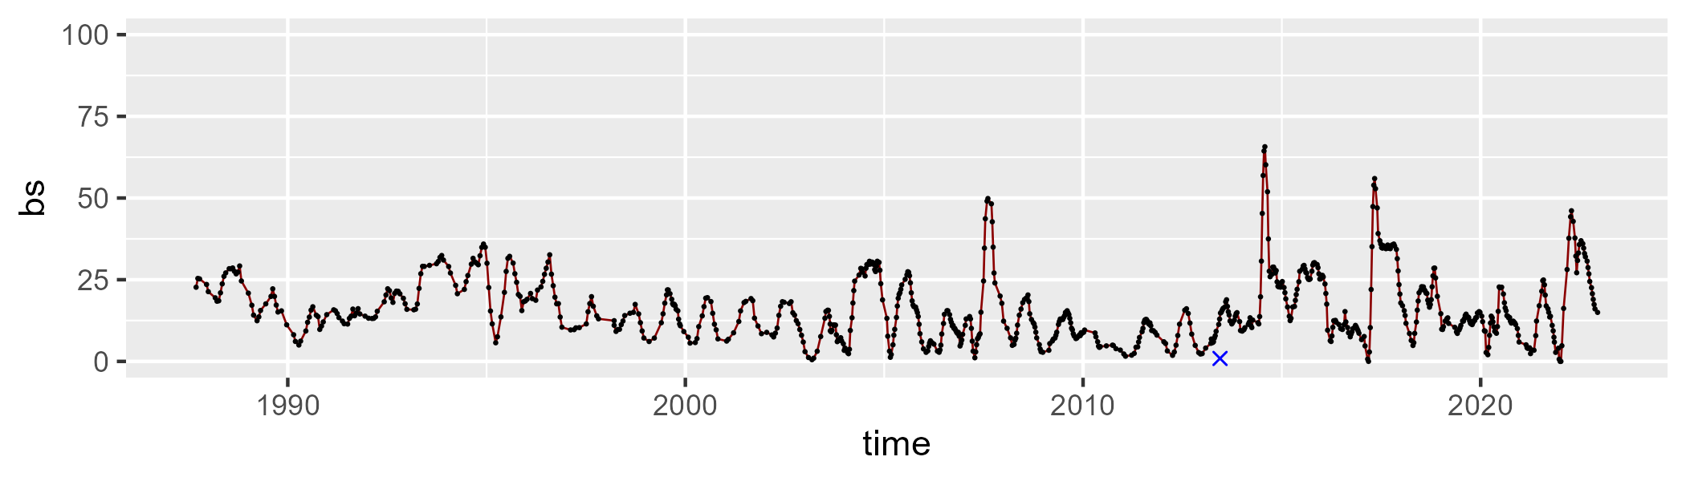

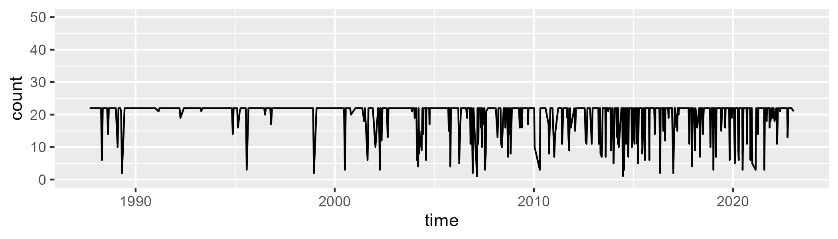

Min. : 1.00 1st Qu.:22.00 Median :22.00 Mean :20.14 3rd Qu.:22.00 Max. :22.00

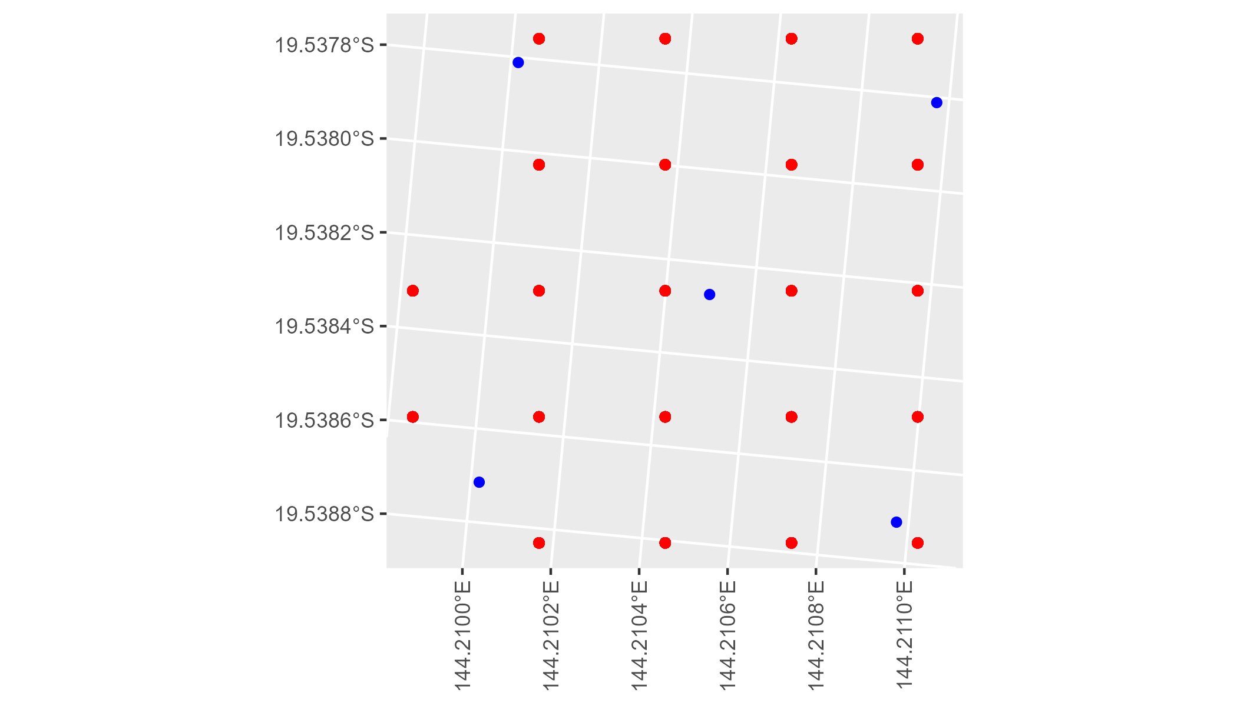

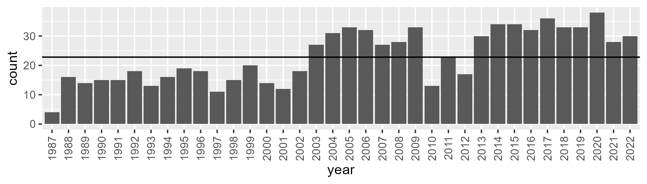

Number of samples: 830

# QDAEIU0002

| Min. | 1st Qu. | Median | Mean | 3rd Qu. | Max. |
| --- | --- | --- | --- | --- | --- |
| 4.496305 | 18.5877 | 26.01606 | 29.13772 | 38.71131 | 66.75855 |

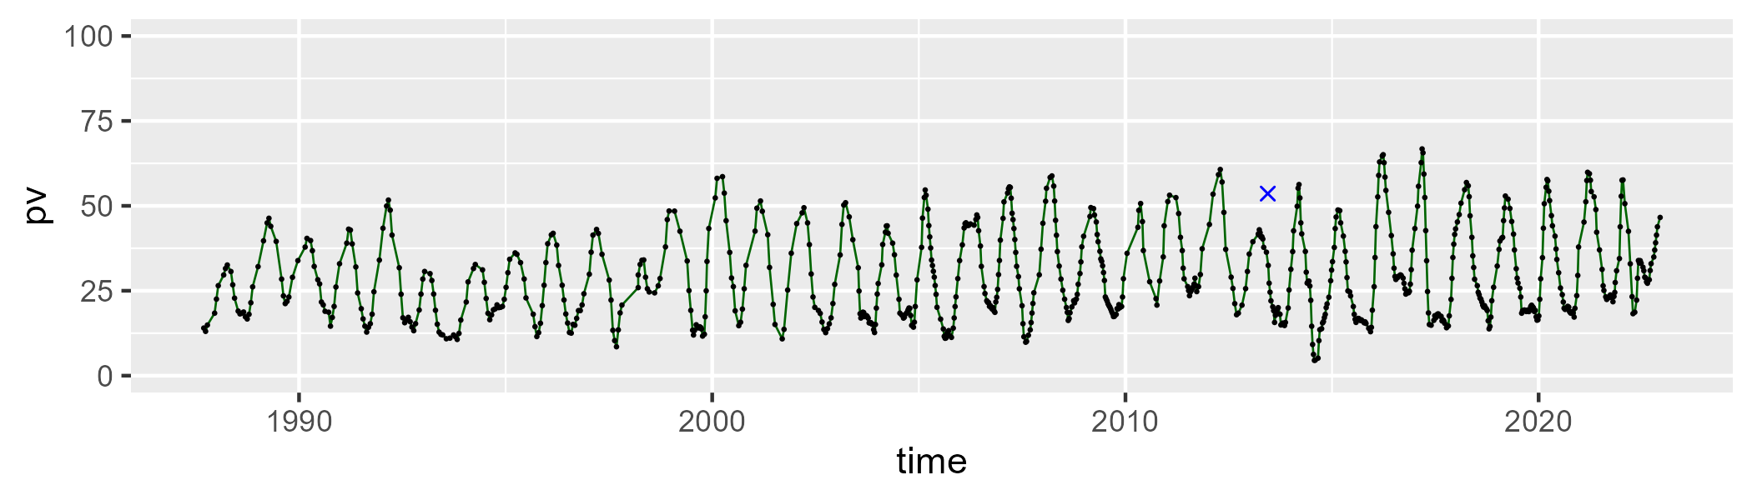

| Min. | 1st Qu. | Median | Mean | 3rd Qu. | Max. |
| --- | --- | --- | --- | --- | --- |
| 24.85796 | 47.64292 | 56.2576 | 55.96442 | 64.76376 | 80.72829 |

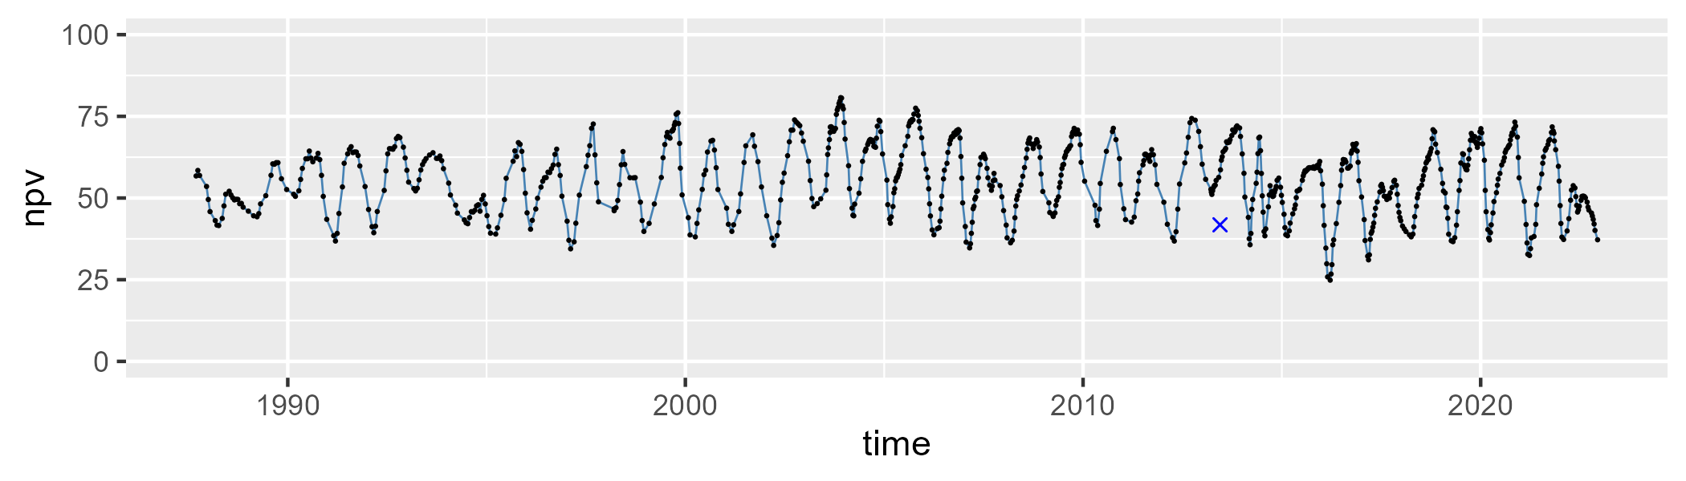

| Min. | 1st Qu. | Median | Mean | 3rd Qu. | Max. |
| --- | --- | --- | --- | --- | --- |
| 0 | 7.942869 | 12.27908 | 13.80532 | 17.89092 | 55.4983 |

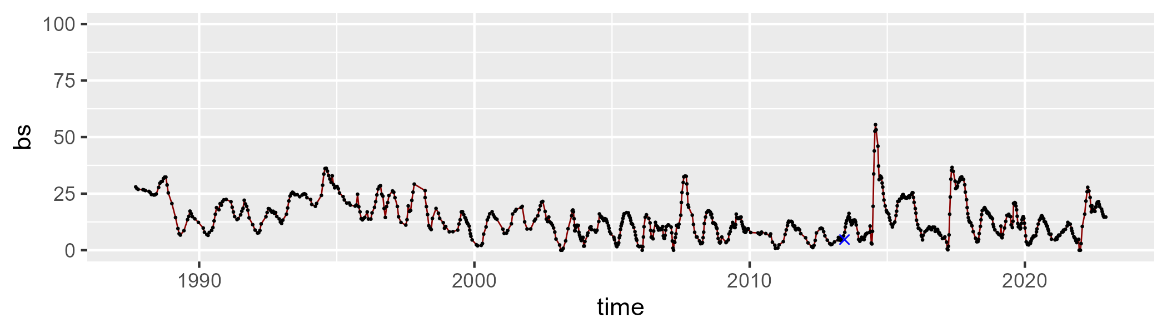

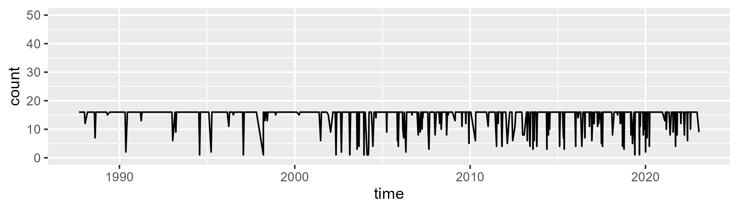

Min. : 1.00 1st Qu.:16.00 Median :16.00 Mean :14.79 3rd Qu.:16.00 Max. :16.00

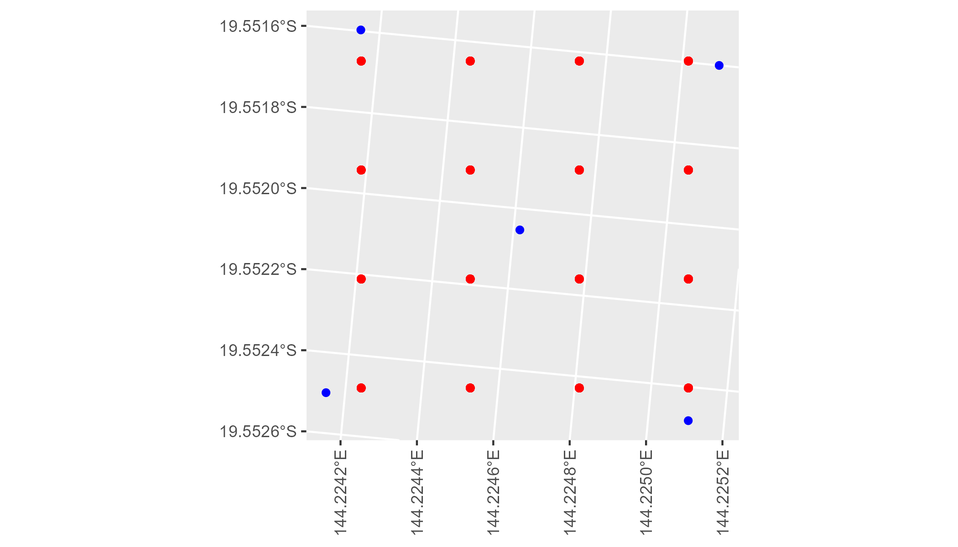

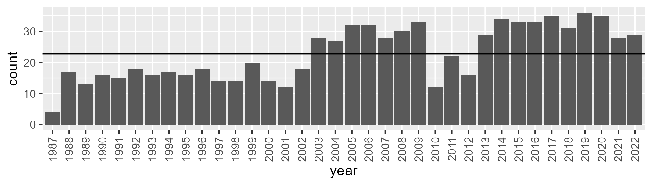

Number of samples: 825

# QDAEIU0003

| Min. | 1st Qu. | Median | Mean | 3rd Qu. | Max. |
| --- | --- | --- | --- | --- | --- |
| 5.681617 | 22.72175 | 30.00855 | 31.7833 | 41.26522 | 65.0741 |

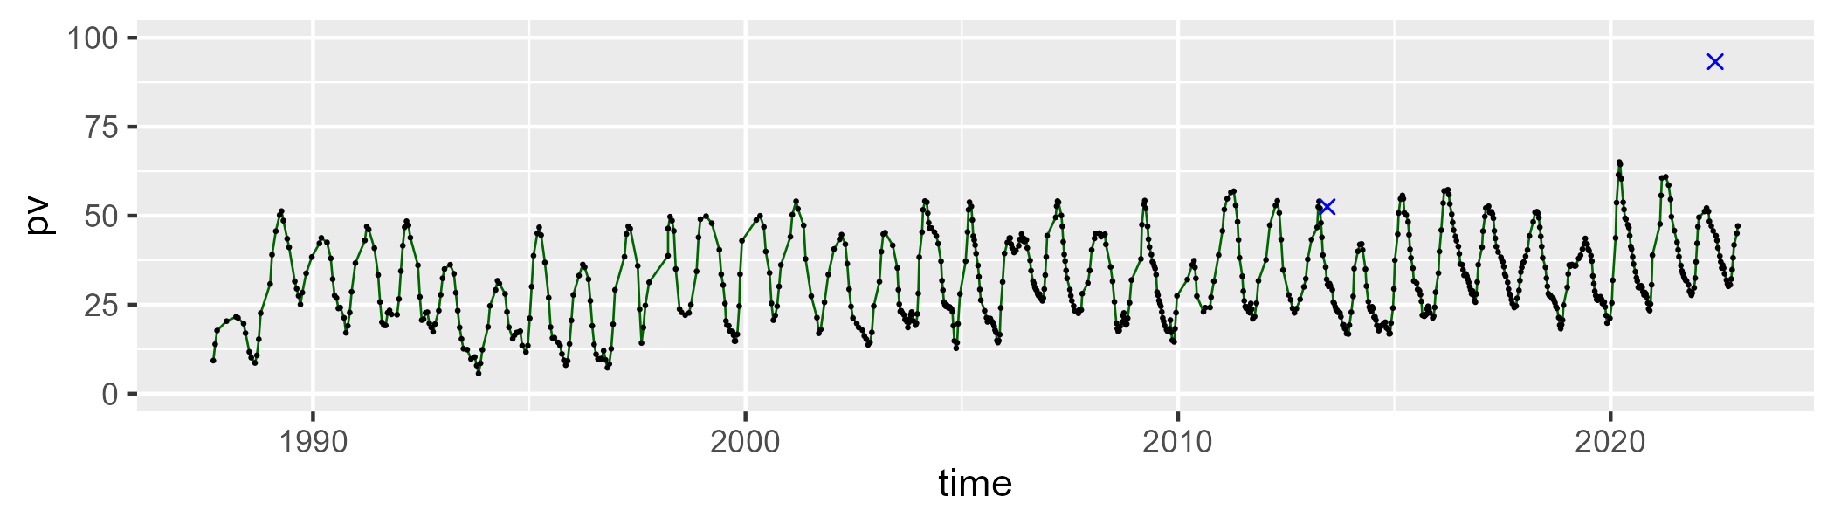

| Min. | 1st Qu. | Median | Mean | 3rd Qu. | Max. |
| --- | --- | --- | --- | --- | --- |
| 21.8504 | 50.8091 | 58.23415 | 57.59151 | 64.41593 | 80.01843 |

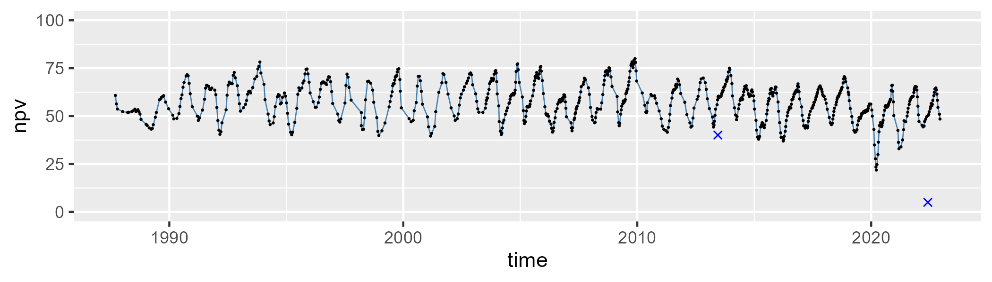

| Min. | 1st Qu. | Median | Mean | 3rd Qu. | Max. |
| --- | --- | --- | --- | --- | --- |
| 0 | 5.393254 | 9.016984 | 9.620131 | 12.69858 | 36.48742 |

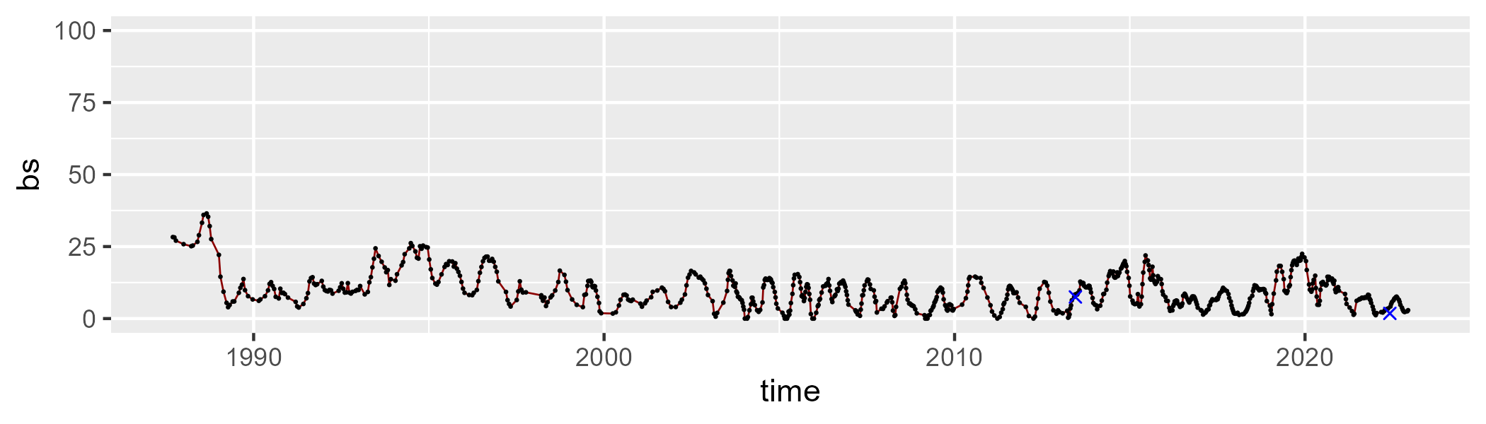

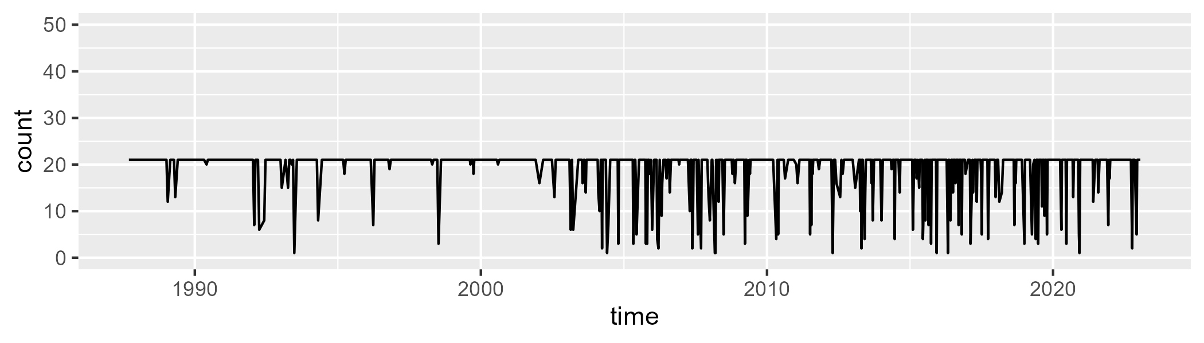

Min. : 1.00 1st Qu.:21.00 Median :21.00 Mean :19.19 3rd Qu.:21.00 Max. :21.00

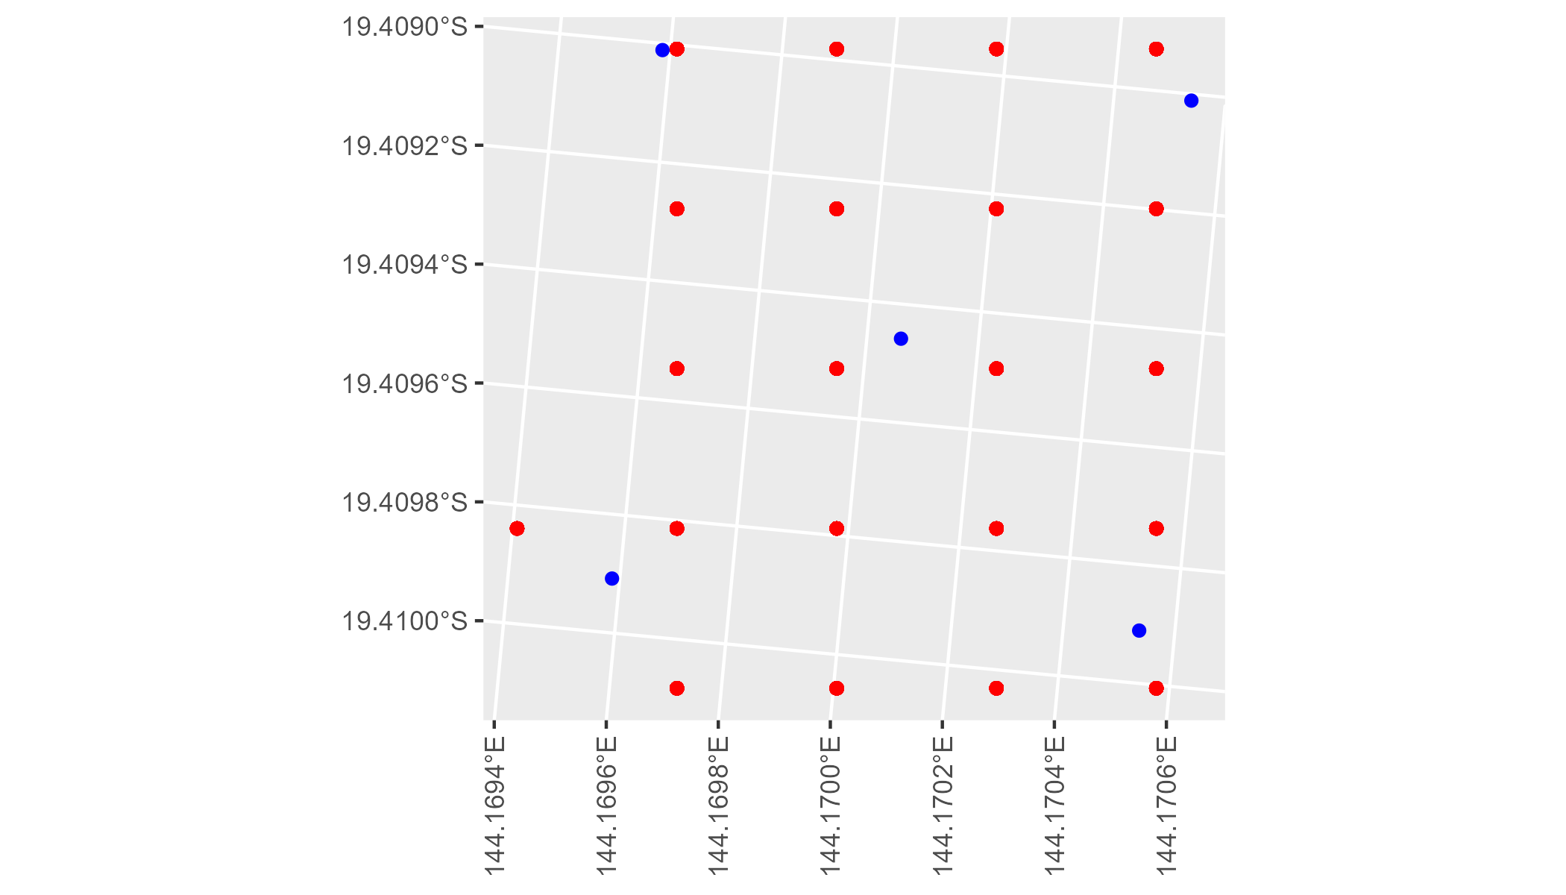

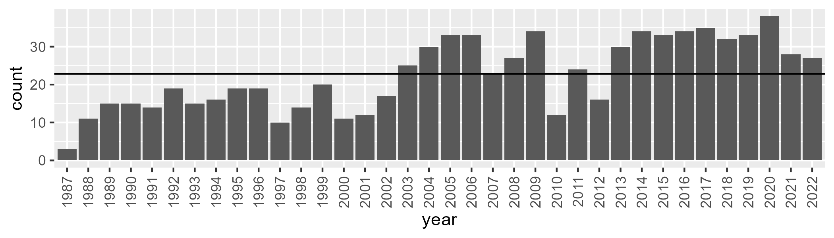

Number of samples: 811

# QDAEIU0004

| Min. | 1st Qu. | Median | Mean | 3rd Qu. | Max. |
| --- | --- | --- | --- | --- | --- |
| 7.265368 | 25.17738 | 31.32063 | 33.28633 | 41.10009 | 63.9258 |

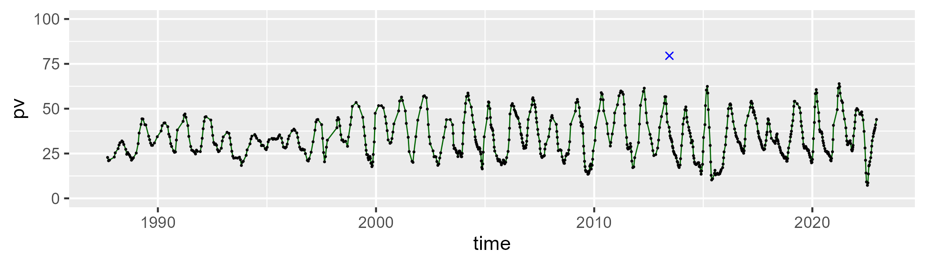

| Min. | 1st Qu. | Median | Mean | 3rd Qu. | Max. |
| --- | --- | --- | --- | --- | --- |
| 30.74233 | 48.93556 | 54.83918 | 54.37396 | 59.85982 | 76.70438 |

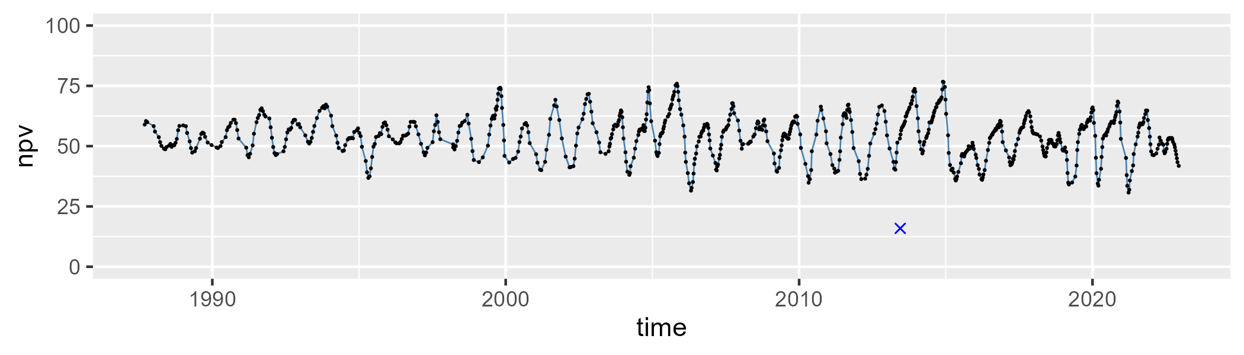

| Min. | 1st Qu. | Median | Mean | 3rd Qu. | Max. |
| --- | --- | --- | --- | --- | --- |
| 0 | 6.139309 | 10.28803 | 11.2857 | 14.04099 | 50.66643 |

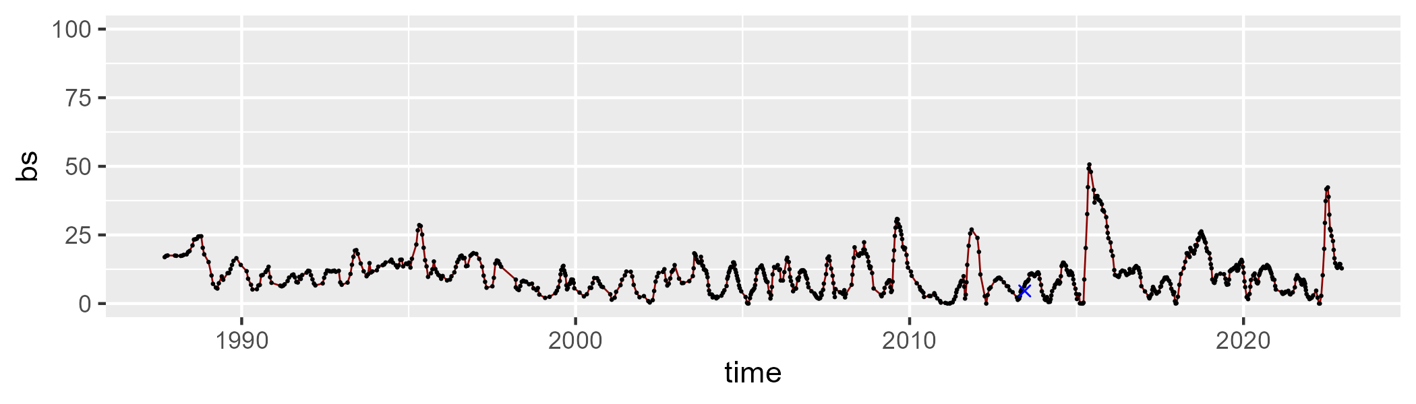

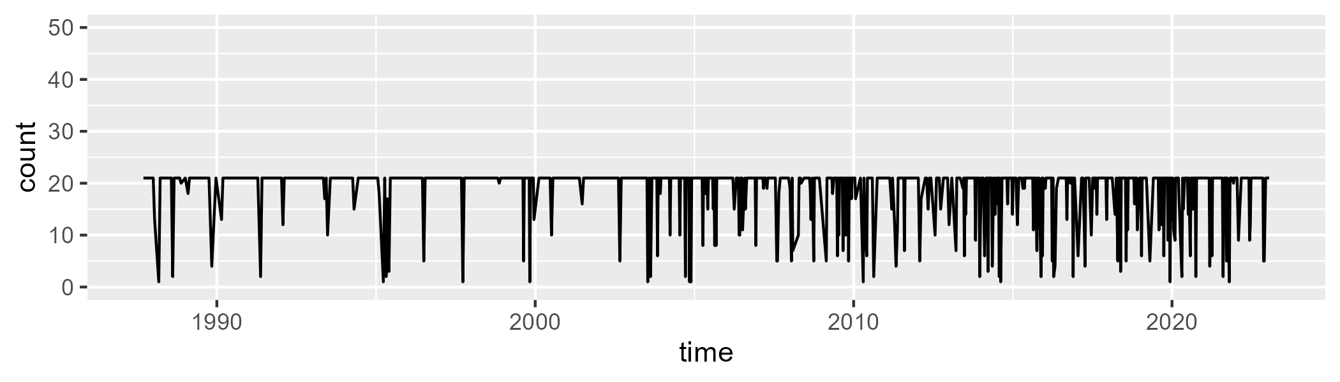

Min. : 1.0 1st Qu.:21.0 Median :21.0 Mean :18.8 3rd Qu.:21.0 Max. :21.0

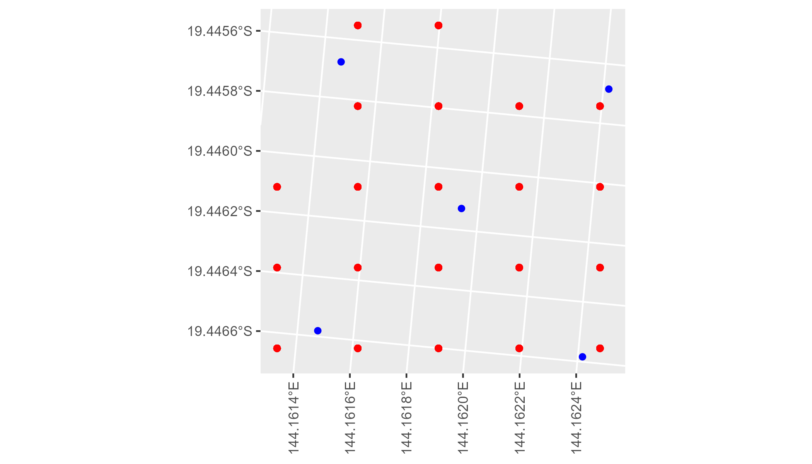

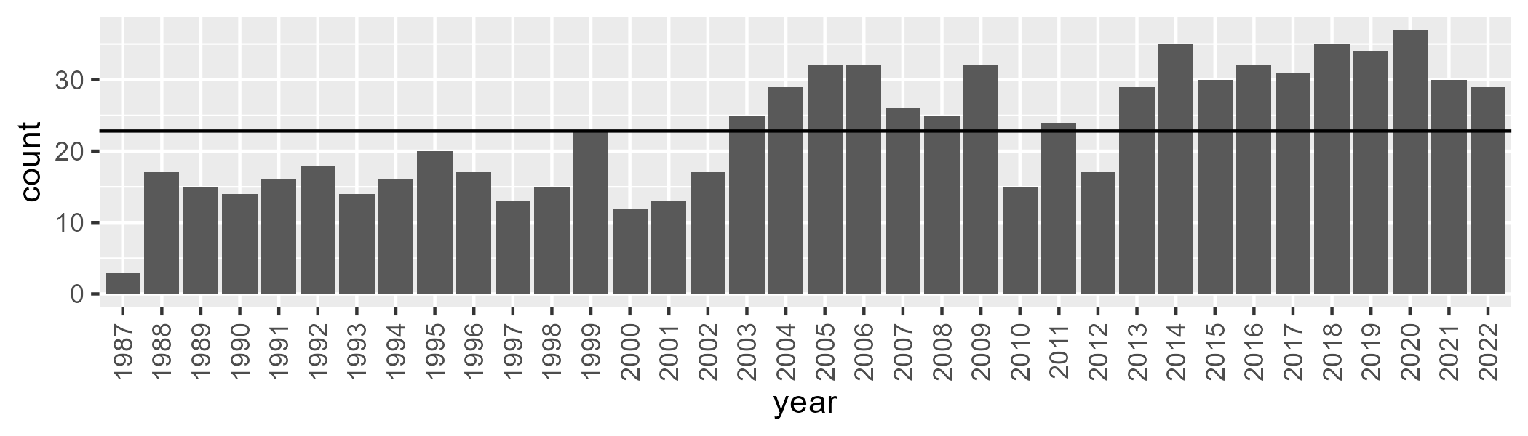

Number of samples: 822

# QDAEIU0005

| Min. | 1st Qu. | Median | Mean | 3rd Qu. | Max. |
| --- | --- | --- | --- | --- | --- |
| 0.8572048 | 17.68514 | 25.2197 | 28.41883 | 38.59852 | 65.68448 |

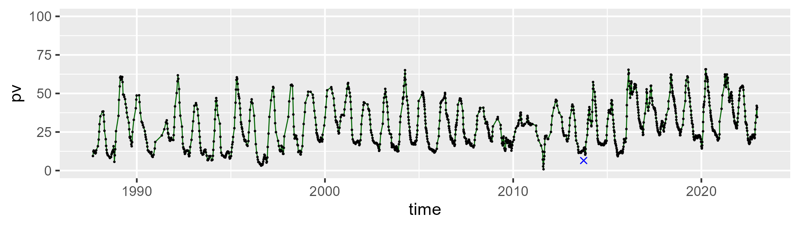

| Min. | 1st Qu. | Median | Mean | 3rd Qu. | Max. |
| --- | --- | --- | --- | --- | --- |
| 8.243894 | 44.57893 | 55.81126 | 51.89994 | 61.30203 | 75.84091 |

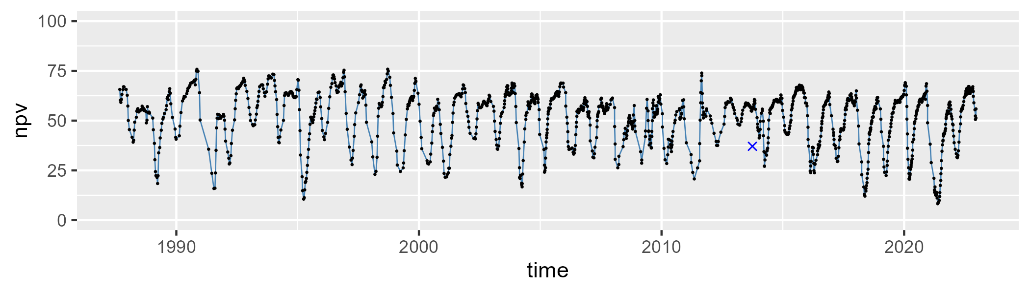

| Min. | 1st Qu. | Median | Mean | 3rd Qu. | Max. |
| --- | --- | --- | --- | --- | --- |
| 3.368469 | 13.28906 | 17.75021 | 18.42216 | 22.12834 | 58.77939 |

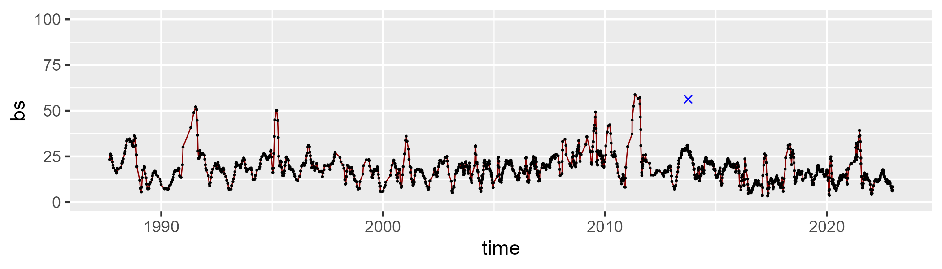

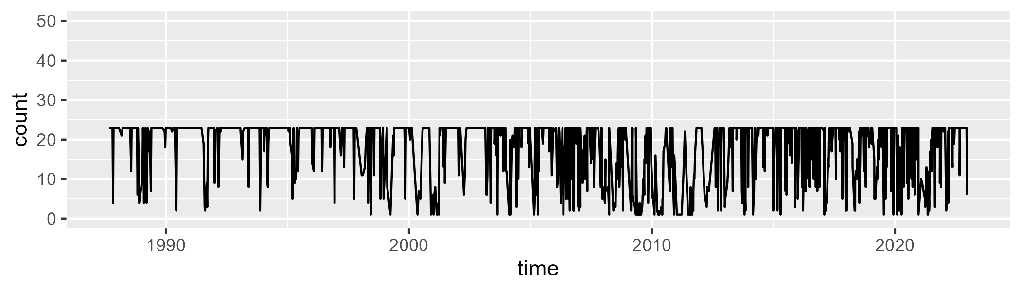

Min. : 1.00 1st Qu.:16.00 Median :23.00 Mean :18.71 3rd Qu.:23.00 Max. :23.00

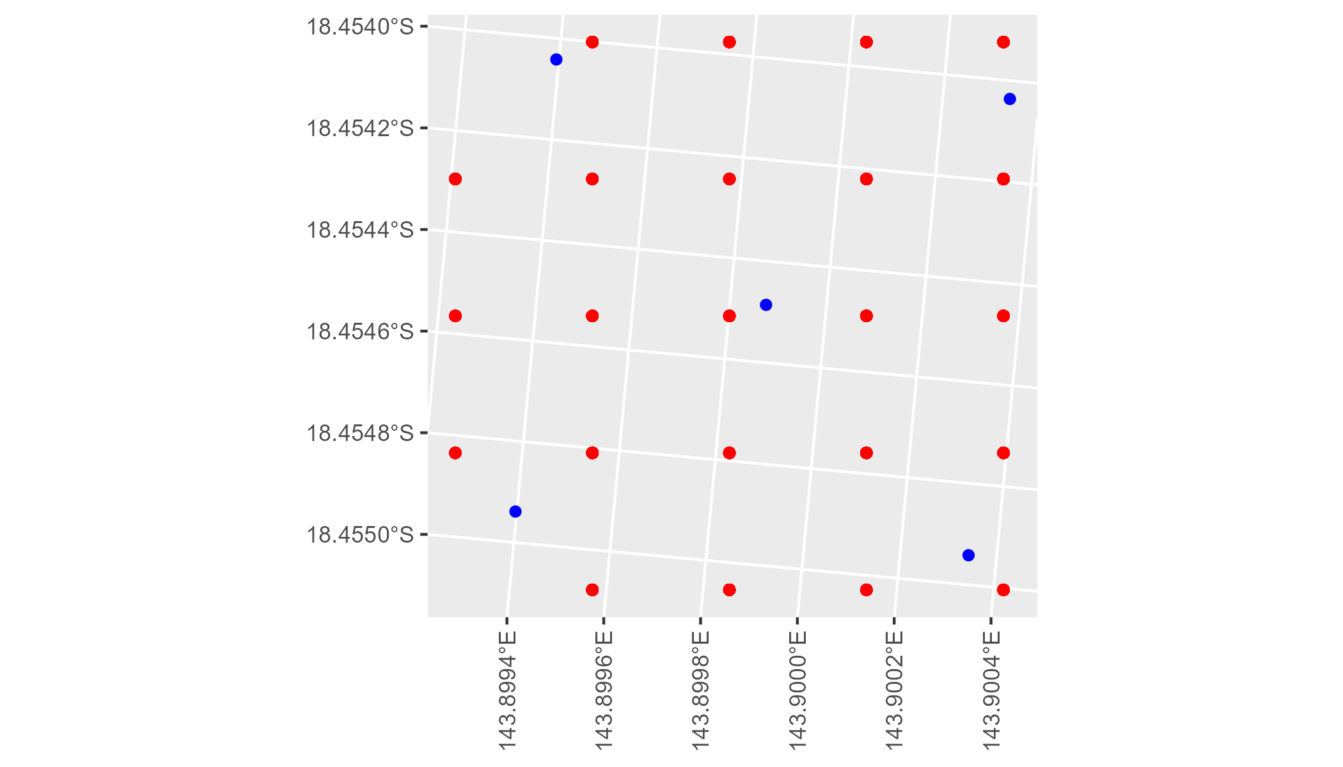

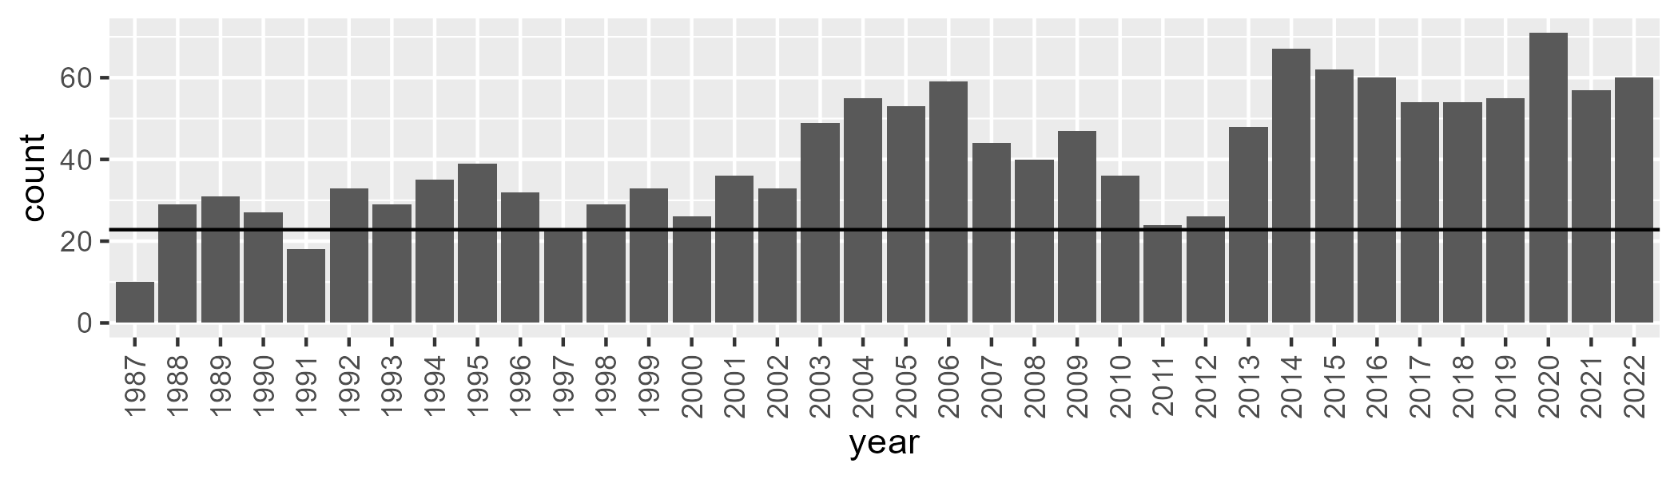

Number of samples: 1484

# QDAEIU0006

| Min. | 1st Qu. | Median | Mean | 3rd Qu. | Max. |
| --- | --- | --- | --- | --- | --- |
| 19.20508 | 47.74688 | 52.66635 | 52.46268 | 57.98147 | 68.79167 |

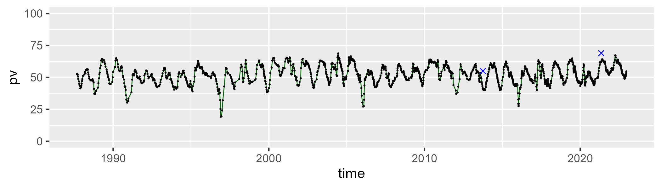

| Min. | 1st Qu. | Median | Mean | 3rd Qu. | Max. |
| --- | --- | --- | --- | --- | --- |
| 24.37353 | 36.15818 | 40.26672 | 40.39943 | 44.37423 | 58.93661 |

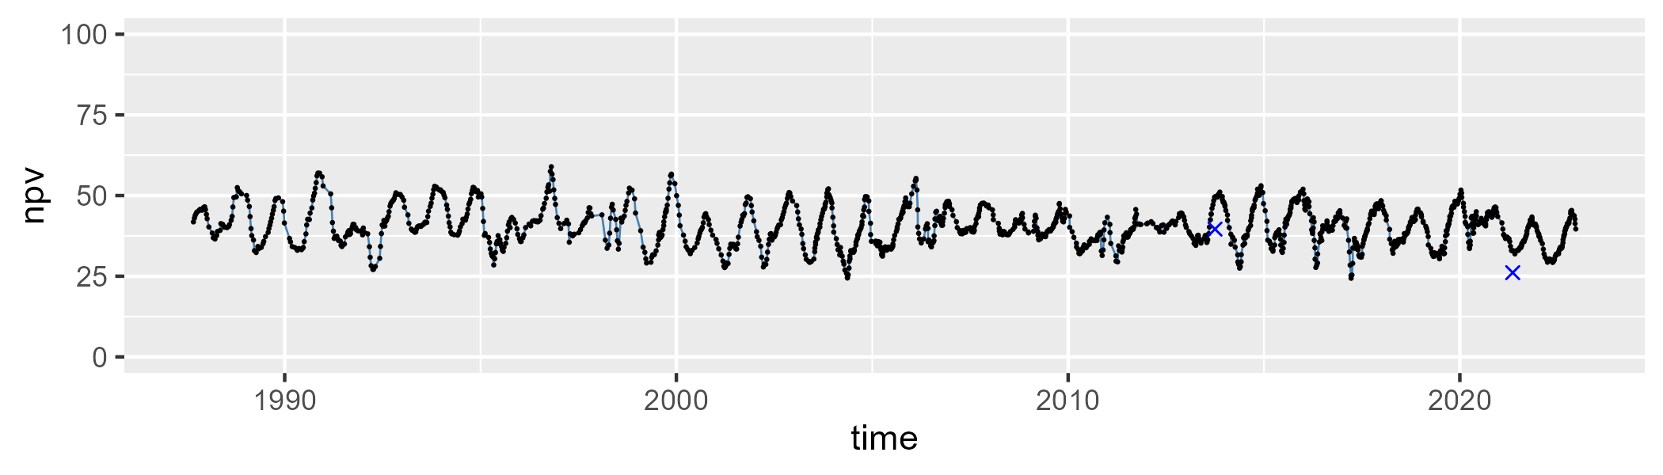

| Min. | 1st Qu. | Median | Mean | 3rd Qu. | Max. |
| --- | --- | --- | --- | --- | --- |
| 0 | 3.030188 | 4.852645 | 5.782747 | 7.50954 | 36.27268 |

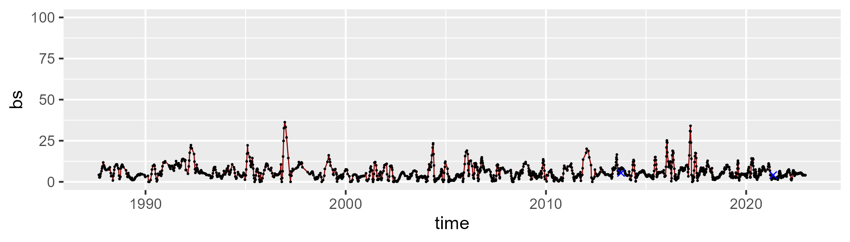

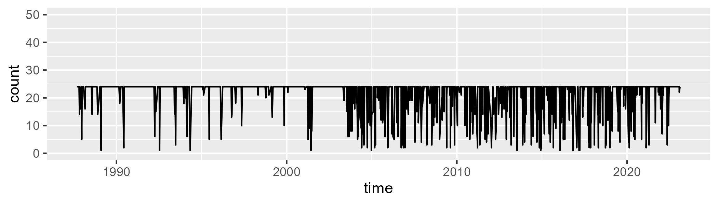

Min. : 1.00 1st Qu.:24.00 Median :24.00 Mean :21.54 3rd Qu.:24.00 Max. :24.00

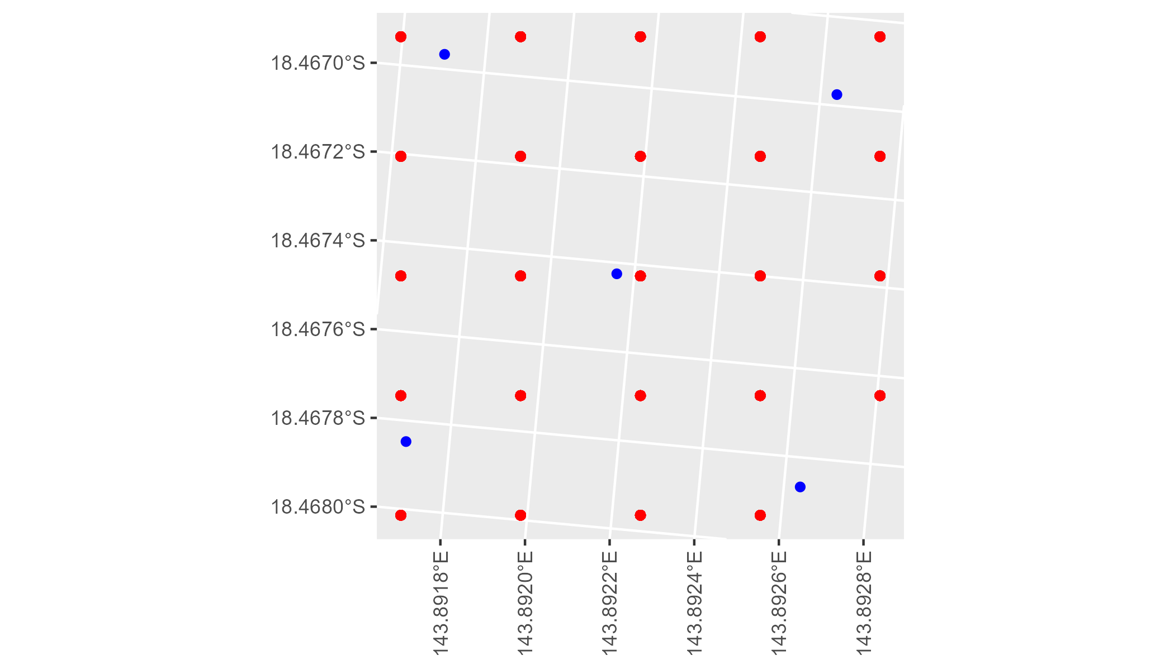

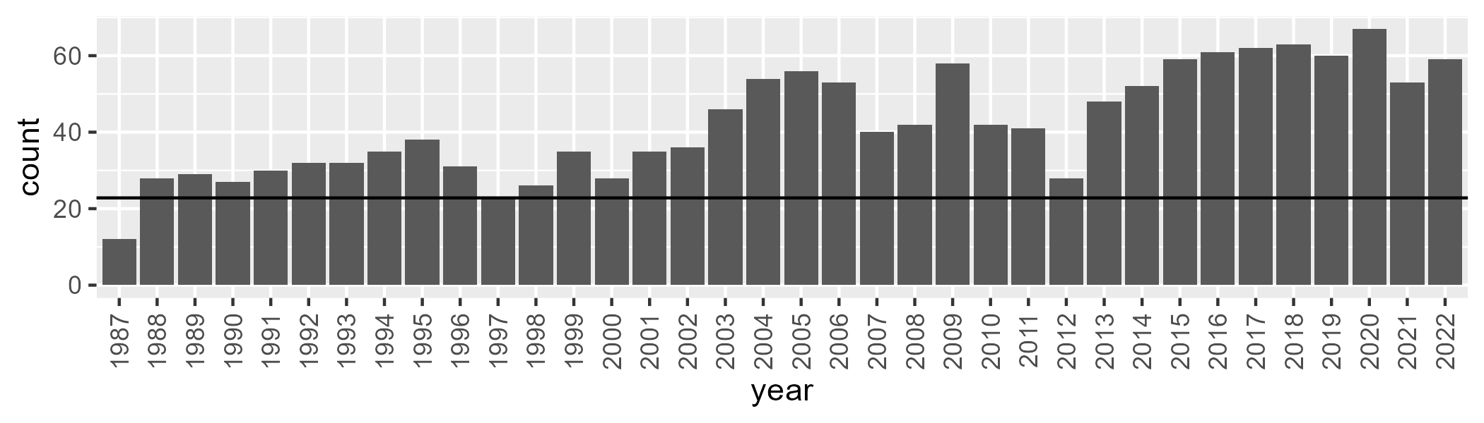

Number of samples: 1521

# QDAEIU0007

| Min. | 1st Qu. | Median | Mean | 3rd Qu. | Max. |
| --- | --- | --- | --- | --- | --- |
| 18.76913 | 49.58453 | 54.97165 | 54.64662 | 60.78747 | 71.0289 |

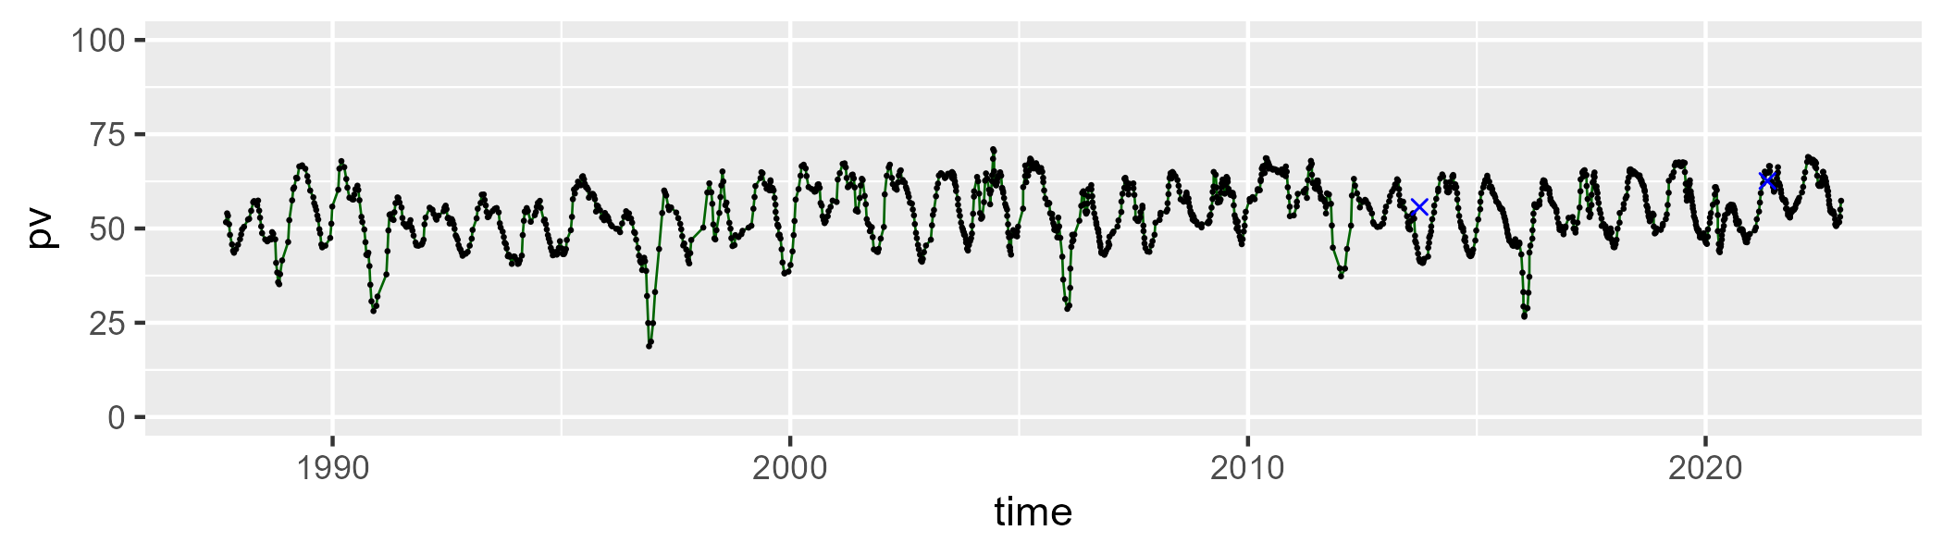

| Min. | 1st Qu. | Median | Mean | 3rd Qu. | Max. |
| --- | --- | --- | --- | --- | --- |
| 22.65127 | 33.97086 | 38.51922 | 38.92854 | 43.50084 | 59.22416 |

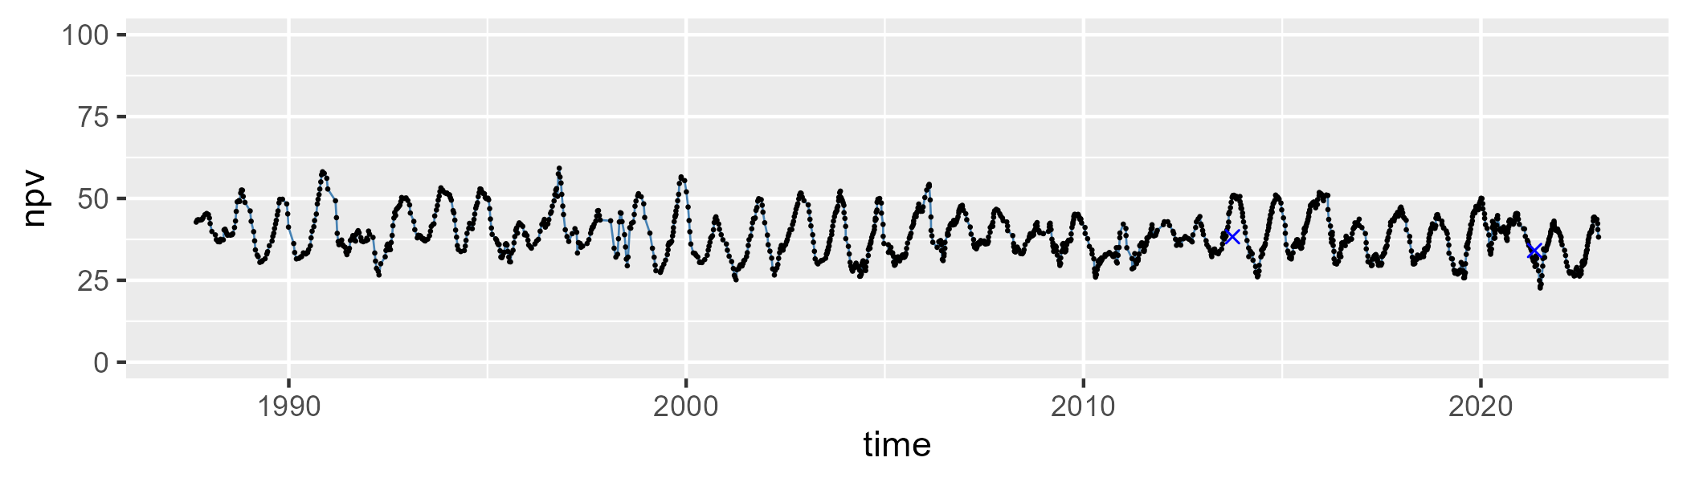

| Min. | 1st Qu. | Median | Mean | 3rd Qu. | Max. |
| --- | --- | --- | --- | --- | --- |
| 0 | 2.473976 | 4.080986 | 5.065102 | 6.777588 | 39.06217 |

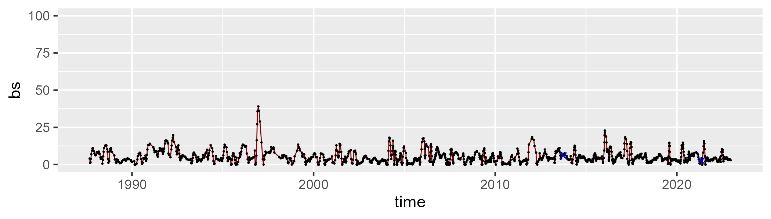

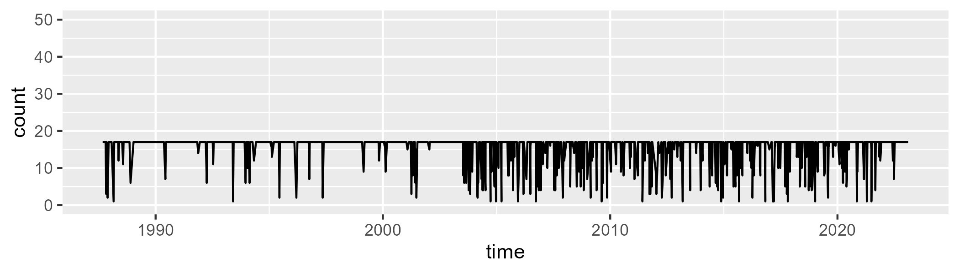

Min. : 1.00 1st Qu.:17.00 Median :17.00 Mean :15.62 3rd Qu.:17.00 Max. :17.00

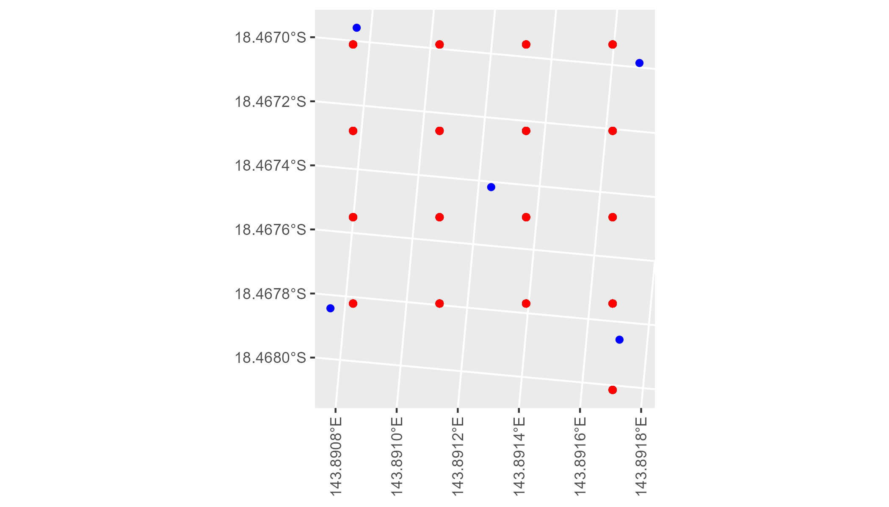

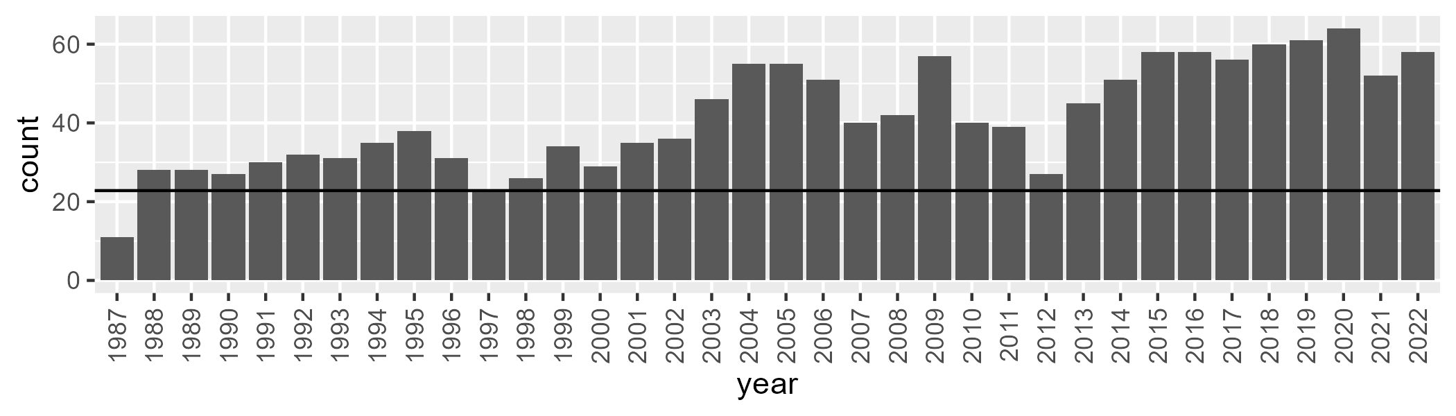

Number of samples: 1489

# QDAEIU0008

| Min. | 1st Qu. | Median | Mean | 3rd Qu. | Max. |
| --- | --- | --- | --- | --- | --- |
| 7.819061 | 19.62501 | 25.99571 | 26.98849 | 33.52304 | 60.17896 |

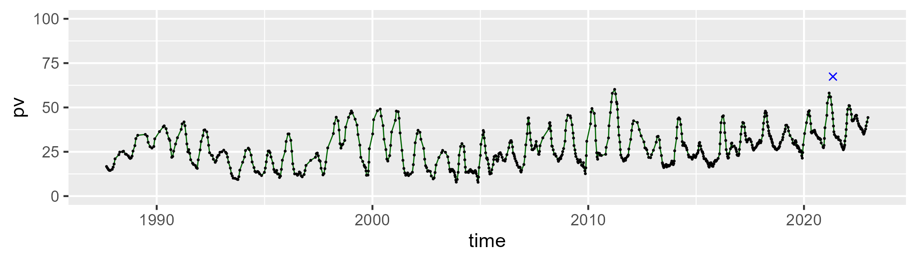

| Min. | 1st Qu. | Median | Mean | 3rd Qu. | Max. |
| --- | --- | --- | --- | --- | --- |
| 23.02596 | 41.38899 | 46.79101 | 47.21538 | 52.5208 | 78.7922 |

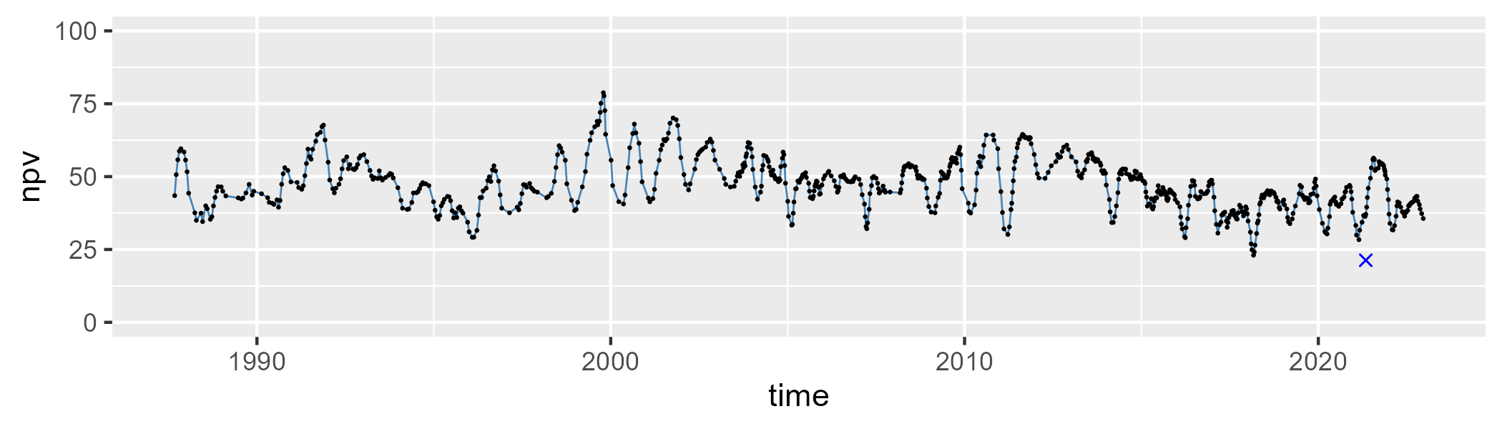

| Min. | 1st Qu. | Median | Mean | 3rd Qu. | Max. |
| --- | --- | --- | --- | --- | --- |
| 5.303972 | 18.18986 | 24.90159 | 24.48403 | 30.4589 | 50.00075 |

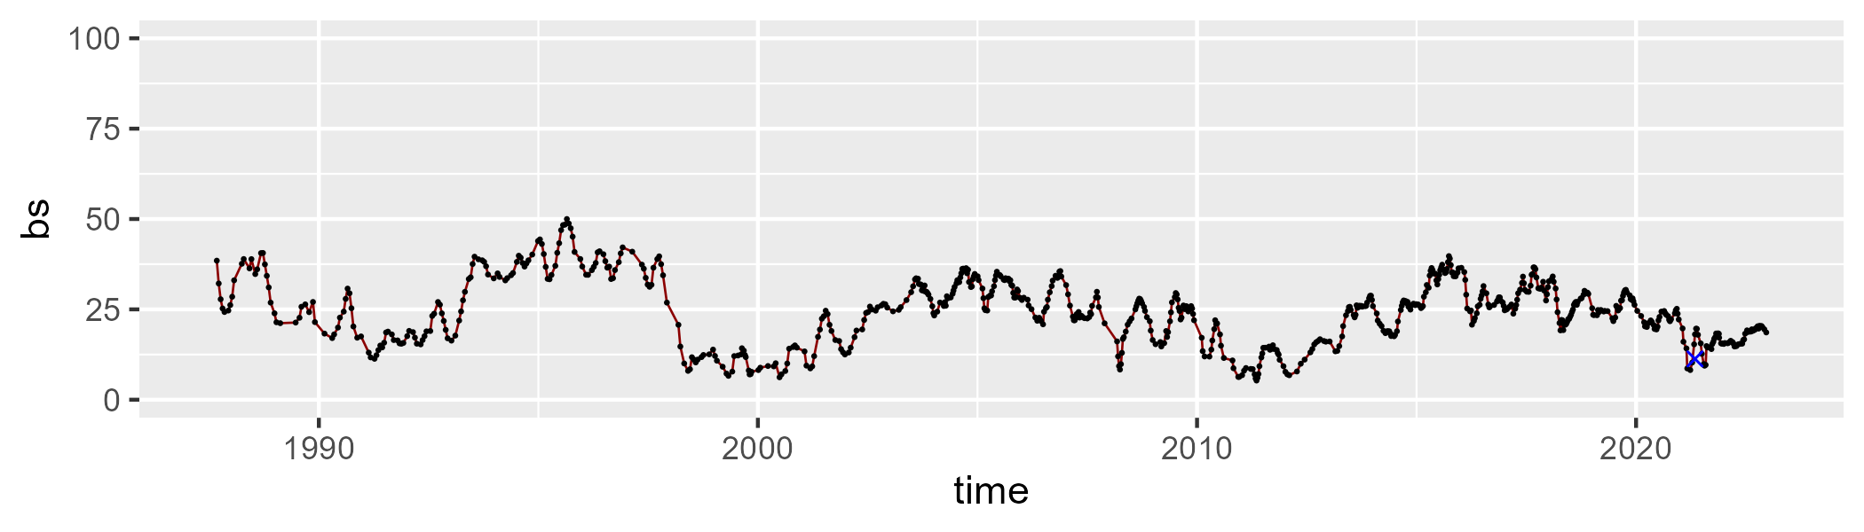

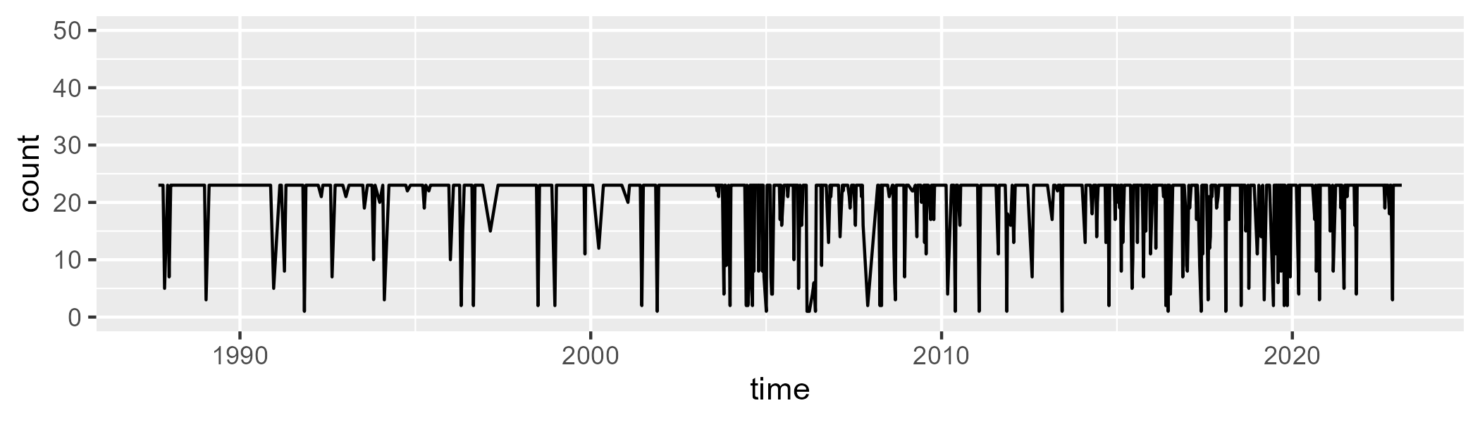

Min. : 1.0 1st Qu.:23.0 Median :23.0 Mean :20.4 3rd Qu.:23.0 Max. :23.0

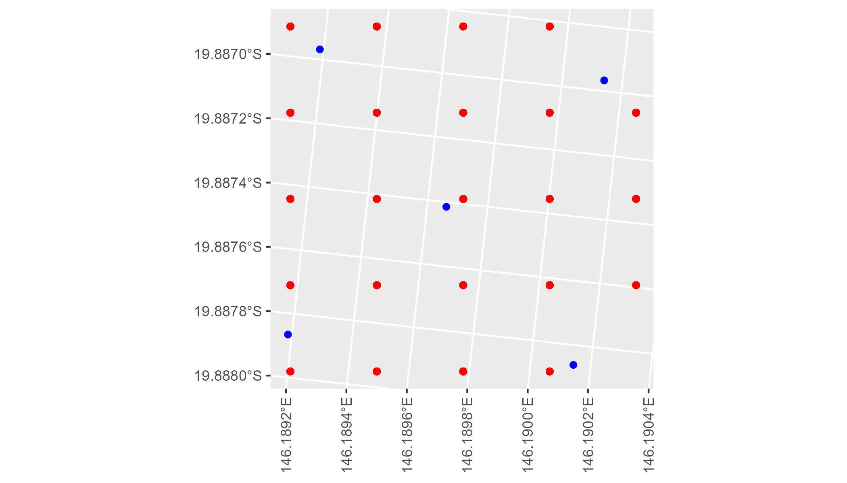

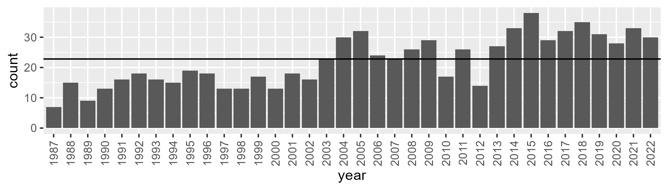

Number of samples: 796

# QDAEIU0009

| Min. | 1st Qu. | Median | Mean | 3rd Qu. | Max. |
| --- | --- | --- | --- | --- | --- |
| 0 | 14.03884 | 21.82865 | 25.5564 | 34.87672 | 71.29675 |

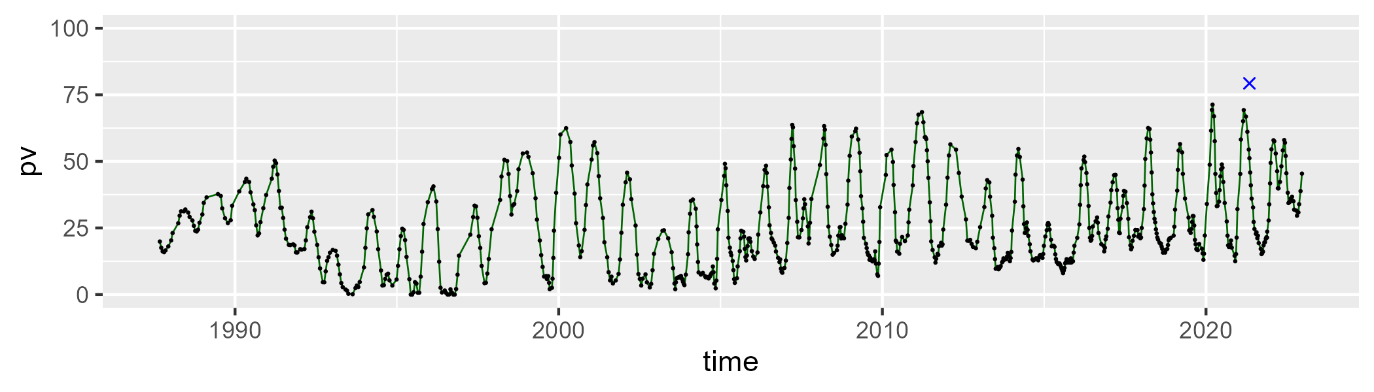

| Min. | 1st Qu. | Median | Mean | 3rd Qu. | Max. |
| --- | --- | --- | --- | --- | --- |
| 12.04244 | 43.69758 | 52.81033 | 52.21125 | 61.54036 | 83.43499 |

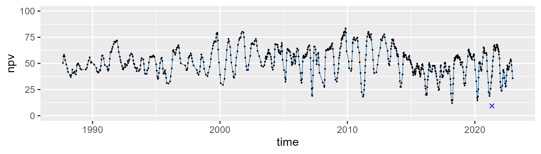

| Min. | 1st Qu. | Median | Mean | 3rd Qu. | Max. |
| --- | --- | --- | --- | --- | --- |
| 0 | 12.41747 | 20.06684 | 20.9736 | 28.54084 | 56.06188 |

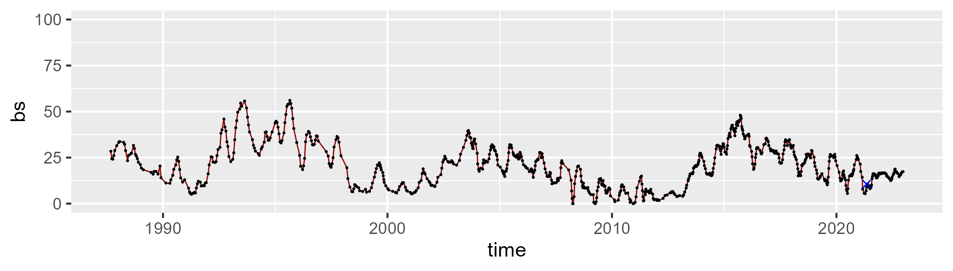

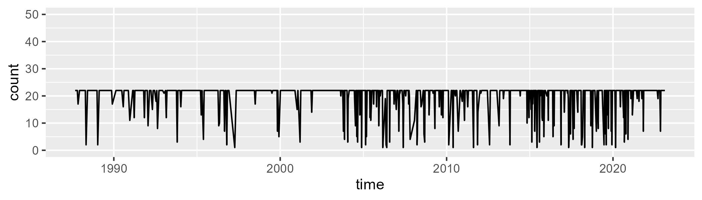

Min. : 1.00 1st Qu.:22.00 Median :22.00 Mean :19.67 3rd Qu.:22.00 Max. :22.00

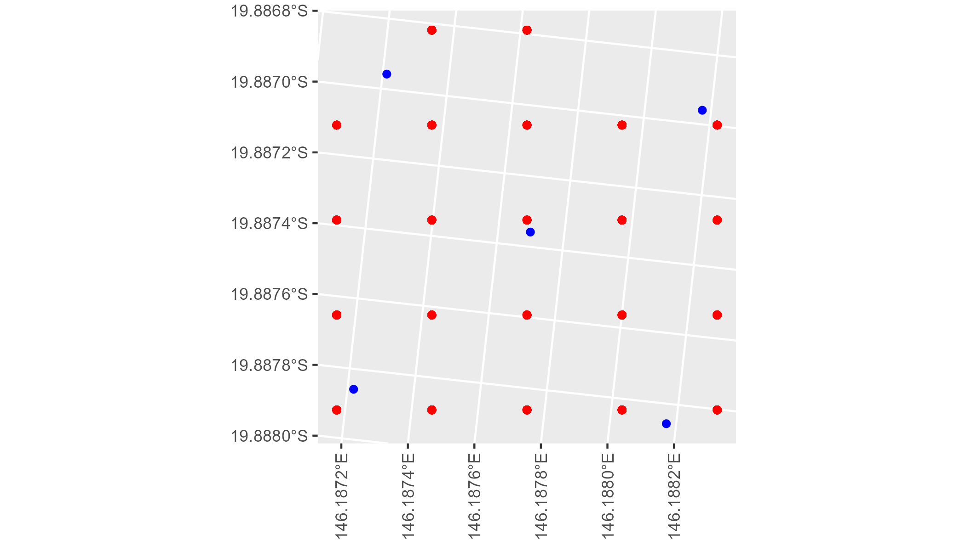

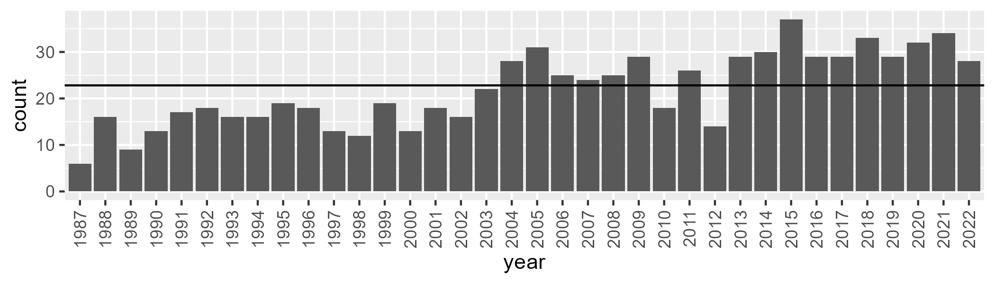

Number of samples: 791

# QDAEIU0010

| Min. | 1st Qu. | Median | Mean | 3rd Qu. | Max. |
| --- | --- | --- | --- | --- | --- |
| 11.1119 | 28.25716 | 33.73014 | 34.94203 | 41.33031 | 66.68061 |

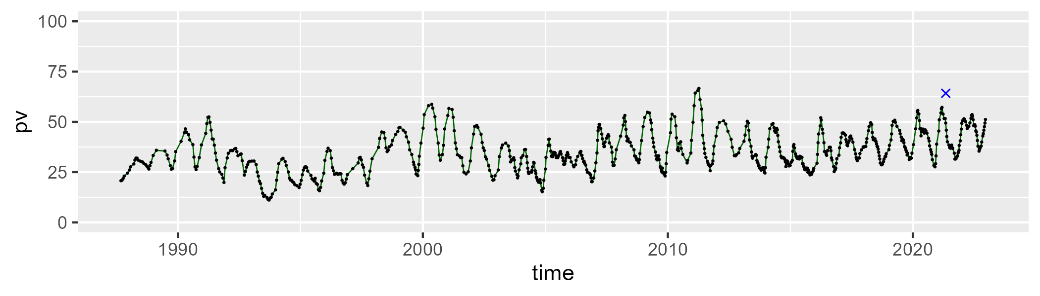

| Min. | 1st Qu. | Median | Mean | 3rd Qu. | Max. |
| --- | --- | --- | --- | --- | --- |
| 24.27236 | 42.92912 | 47.66577 | 48.01864 | 53.13706 | 69.82295 |

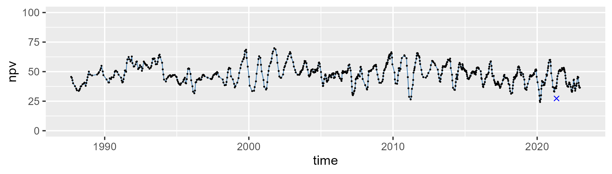

| Min. | 1st Qu. | Median | Mean | 3rd Qu. | Max. |
| --- | --- | --- | --- | --- | --- |
| 2.074405 | 10.30968 | 14.68527 | 15.79137 | 20.47951 | 39.11047 |

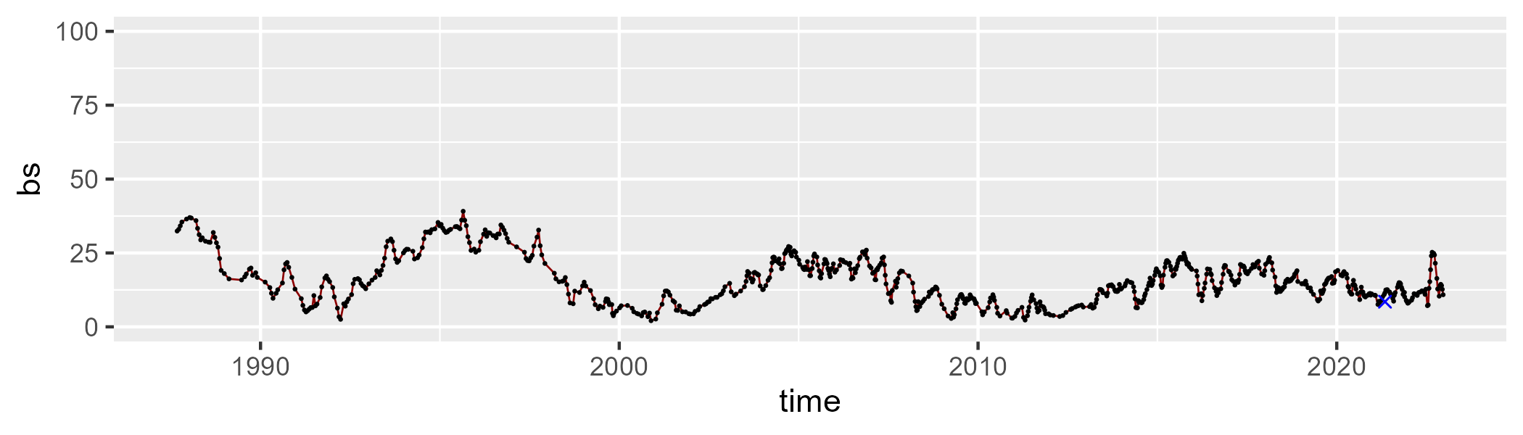

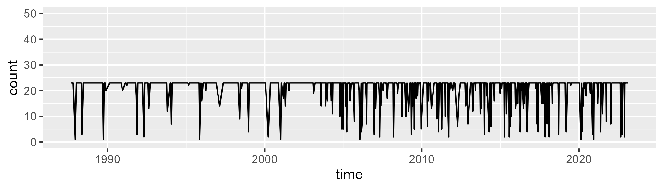

Min. : 1.00 1st Qu.:23.00 Median :23.00 Mean :20.85 3rd Qu.:23.00 Max. :23.00

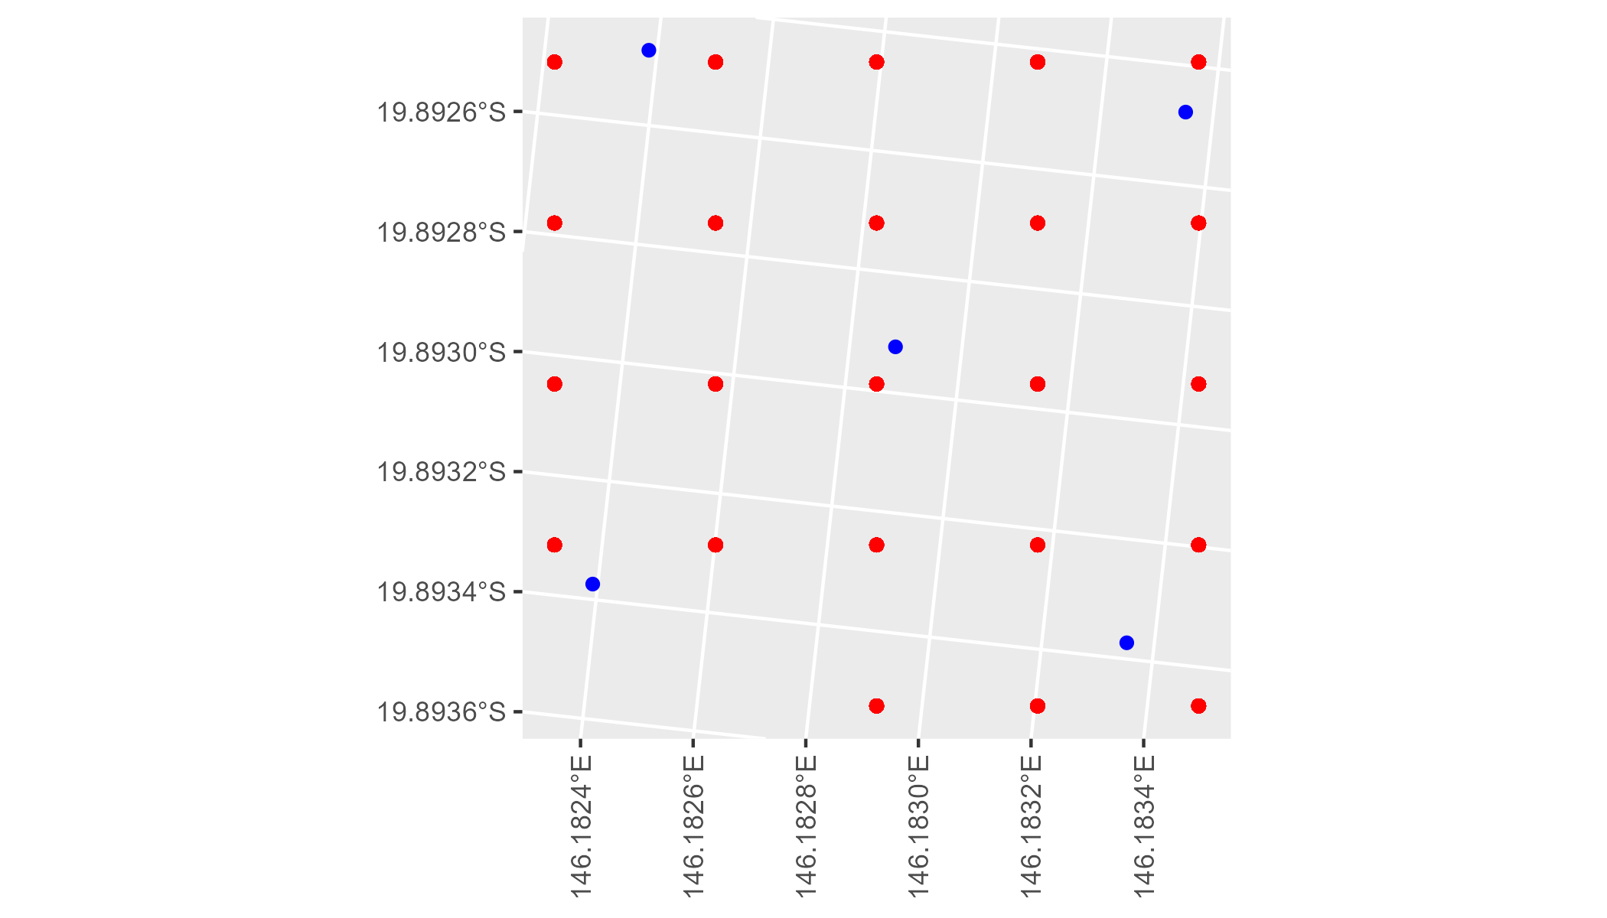

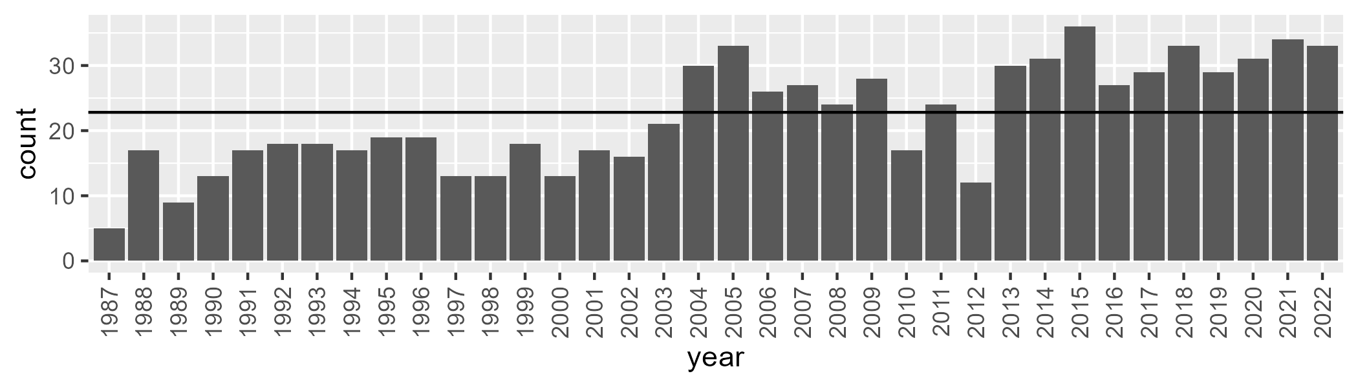

Number of samples: 797

# QDAGUP0001

| Min. | 1st Qu. | Median | Mean | 3rd Qu. | Max. |
| --- | --- | --- | --- | --- | --- |
| 3.89867 | 18.6748 | 25.05215 | 26.56714 | 33.71606 | 59.91501 |

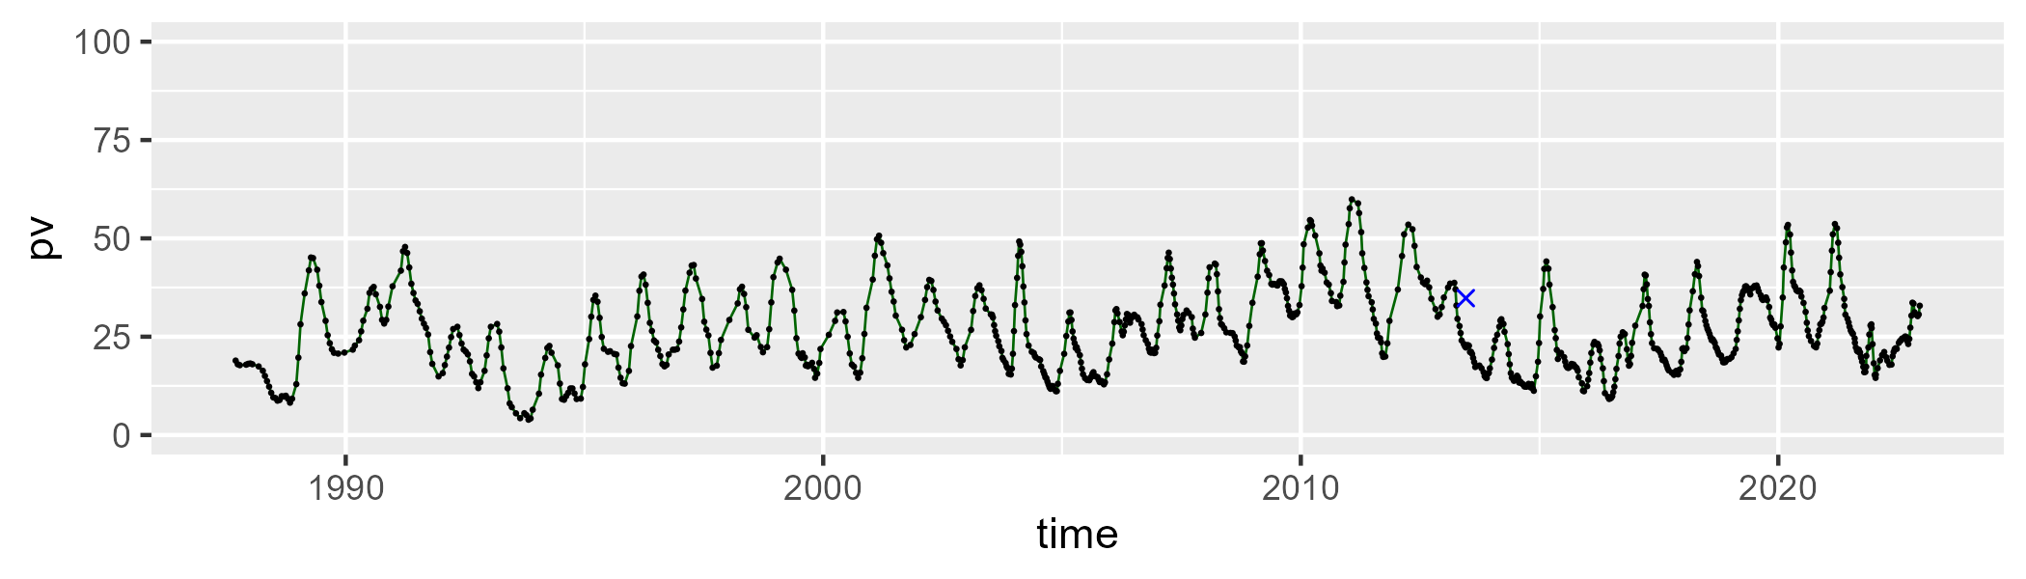

| Min. | 1st Qu. | Median | Mean | 3rd Qu. | Max. |
| --- | --- | --- | --- | --- | --- |
| 31.17812 | 42.53735 | 49.10013 | 49.72689 | 55.23956 | 74.54248 |

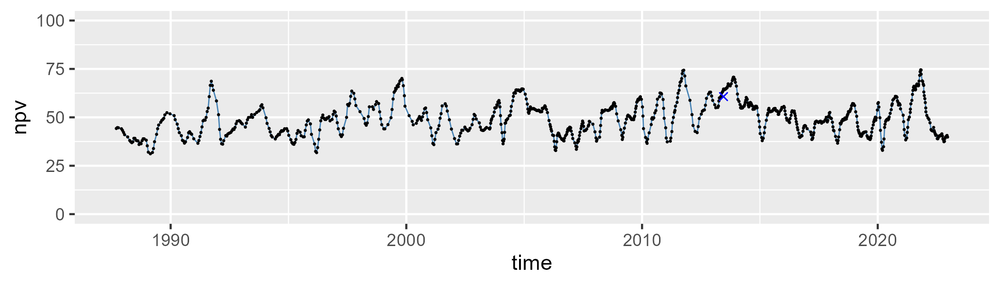

| Min. | 1st Qu. | Median | Mean | 3rd Qu. | Max. |
| --- | --- | --- | --- | --- | --- |
| 0.7553633 | 13.86999 | 22.63721 | 22.3842 | 29.69632 | 52.68752 |

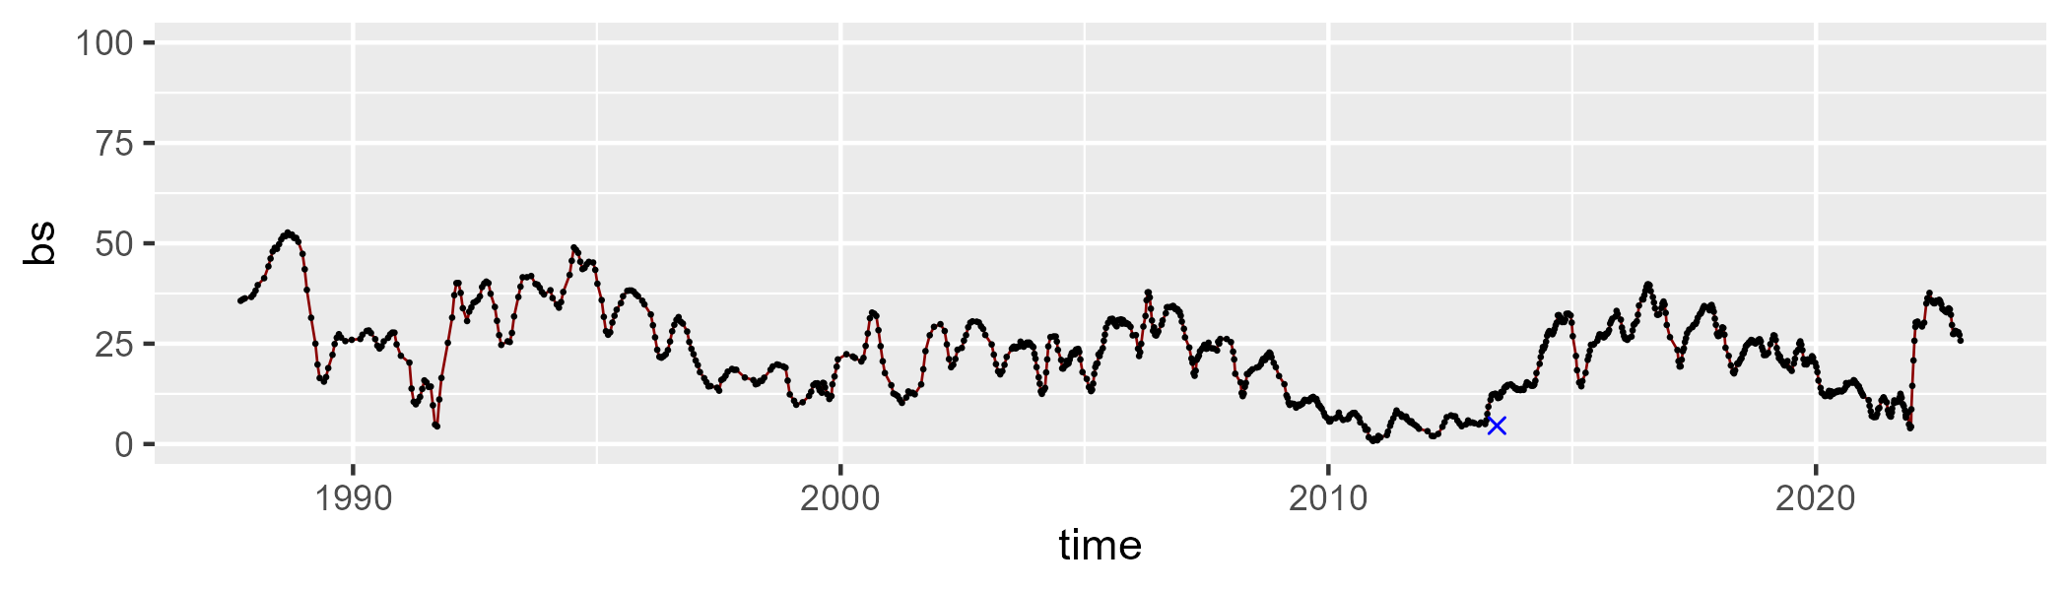

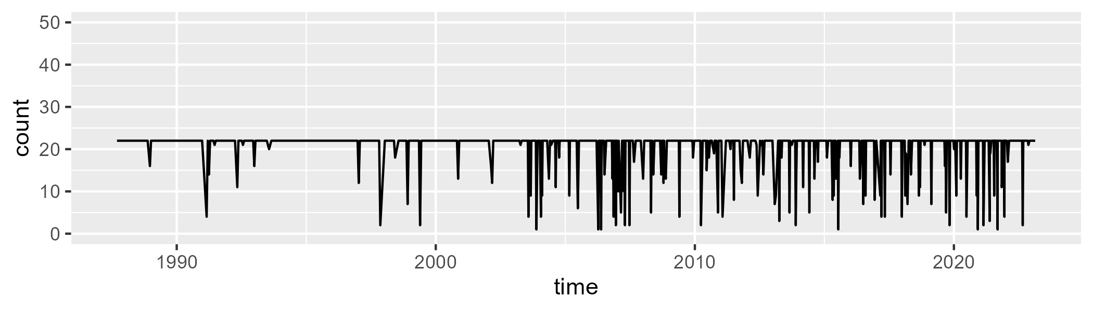

Min. : 1.00 1st Qu.:22.00 Median :22.00 Mean :20.47 3rd Qu.:22.00 Max. :22.00

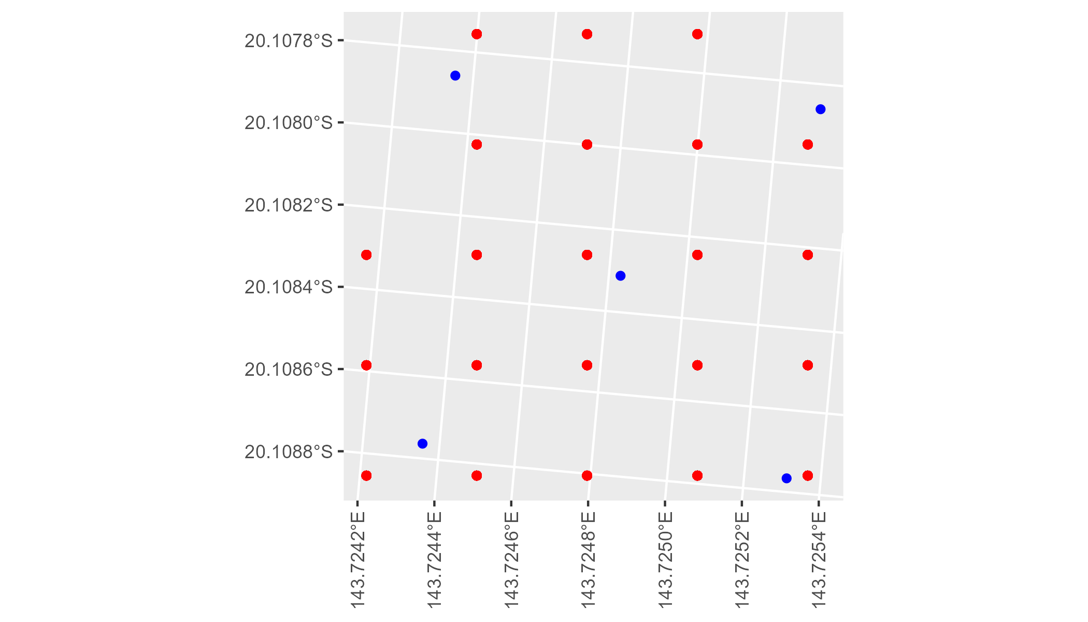

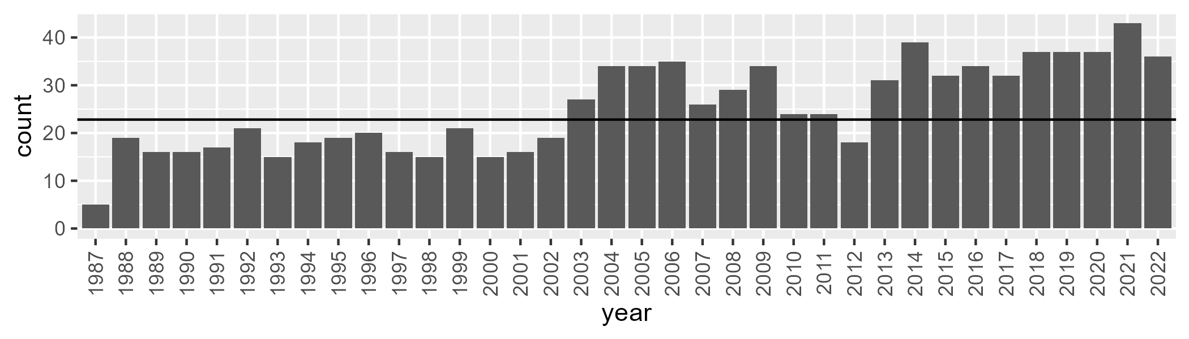

Number of samples: 911

# QDAGUP0002

| Min. | 1st Qu. | Median | Mean | 3rd Qu. | Max. |
| --- | --- | --- | --- | --- | --- |
| 6.223885 | 26.23107 | 32.60941 | 32.5363 | 38.74611 | 60.0499 |

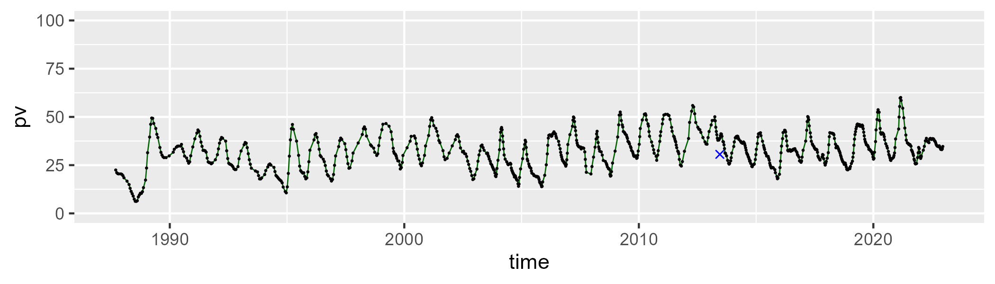

| Min. | 1st Qu. | Median | Mean | 3rd Qu. | Max. |
| --- | --- | --- | --- | --- | --- |
| 31.00615 | 44.22442 | 48.62009 | 49.02014 | 53.46462 | 69.10353 |

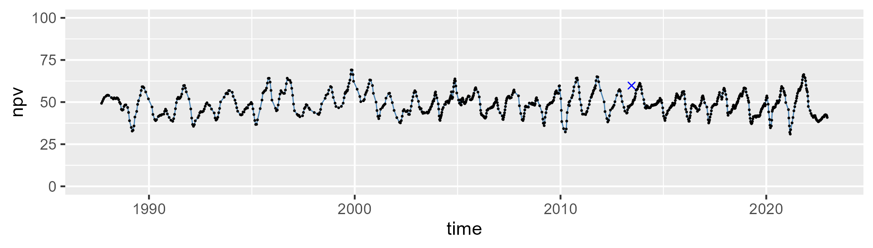

| Min. | 1st Qu. | Median | Mean | 3rd Qu. | Max. |
| --- | --- | --- | --- | --- | --- |
| 2.525834 | 11.29536 | 16.93969 | 17.15094 | 22.24293 | 44.31879 |

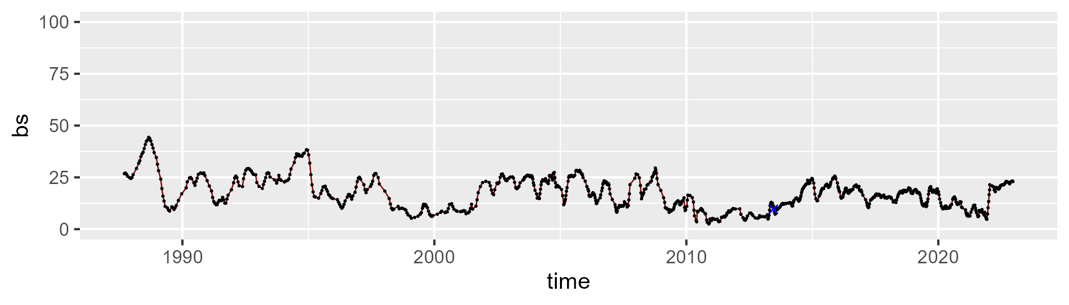

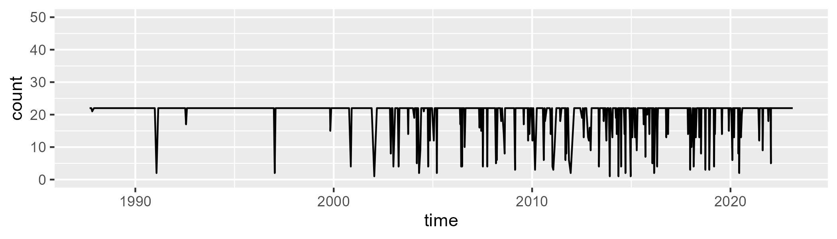

Min. : 1.00 1st Qu.:22.00 Median :22.00 Mean :20.55 3rd Qu.:22.00 Max. :22.00

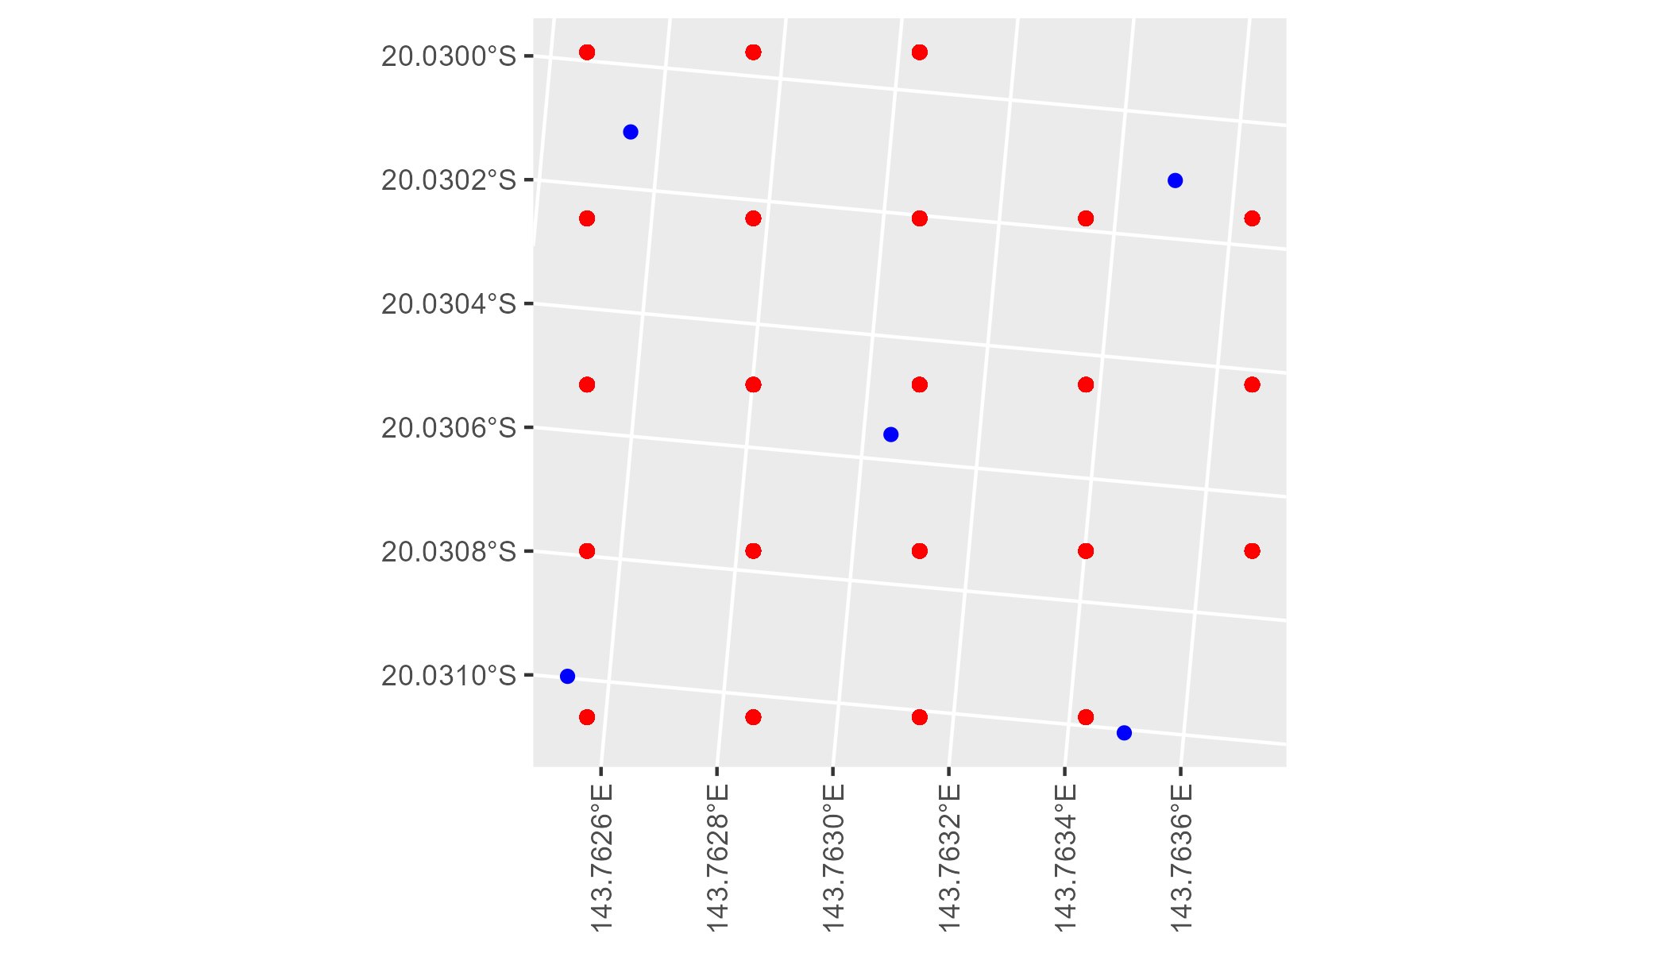

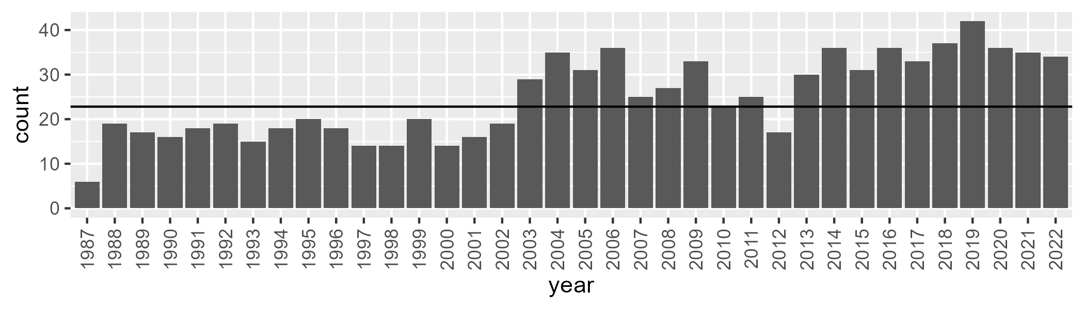

Number of samples: 894

# QDAGUP0003

| Min. | 1st Qu. | Median | Mean | 3rd Qu. | Max. |
| --- | --- | --- | --- | --- | --- |
| 4.867788 | 15.18296 | 18.82995 | 20.22013 | 24.08464 | 47.08261 |

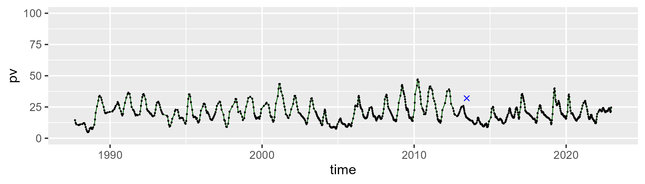

| Min. | 1st Qu. | Median | Mean | 3rd Qu. | Max. |
| --- | --- | --- | --- | --- | --- |
| 22.51802 | 35.91507 | 41.53682 | 42.55345 | 47.58576 | 67.449 |

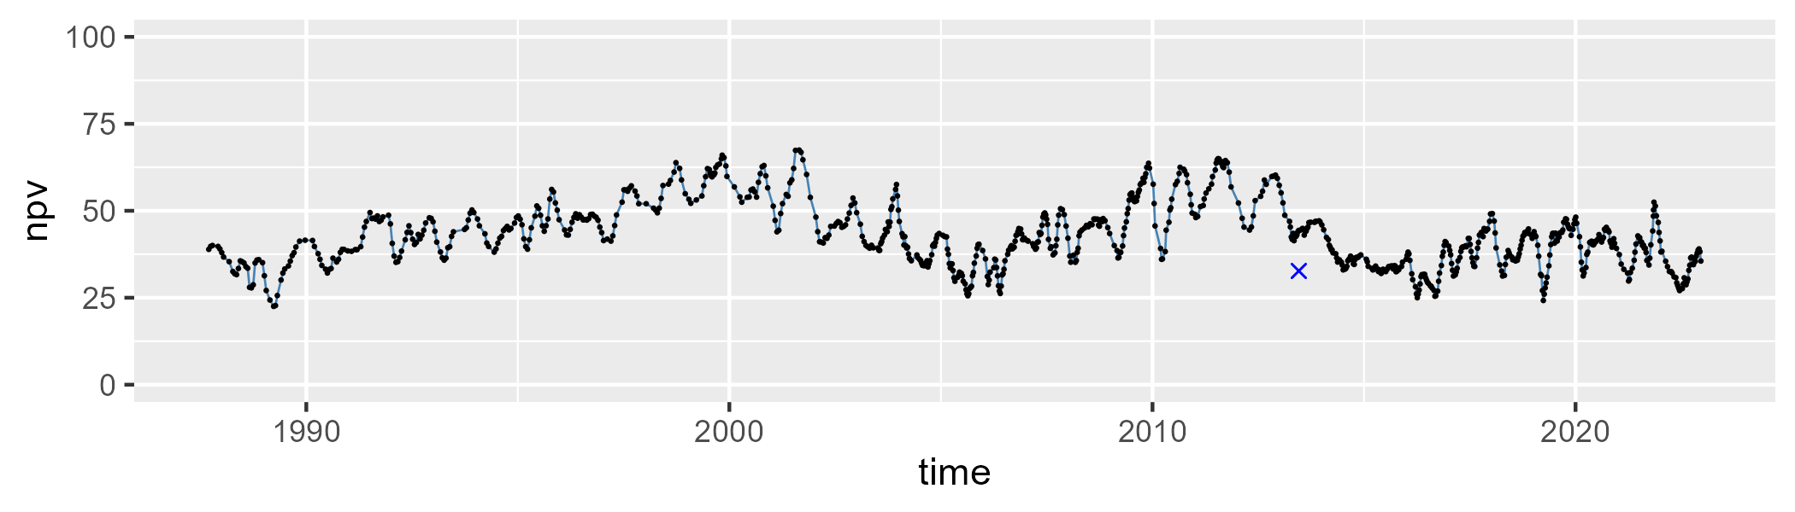

| Min. | 1st Qu. | Median | Mean | 3rd Qu. | Max. |
| --- | --- | --- | --- | --- | --- |
| 7.790722 | 28.77817 | 37.31614 | 35.82053 | 42.4172 | 63.2415 |

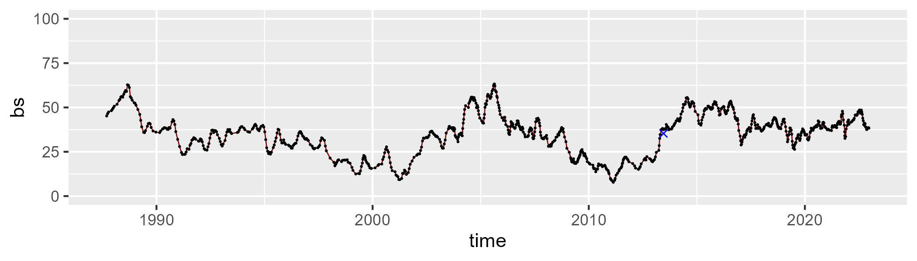

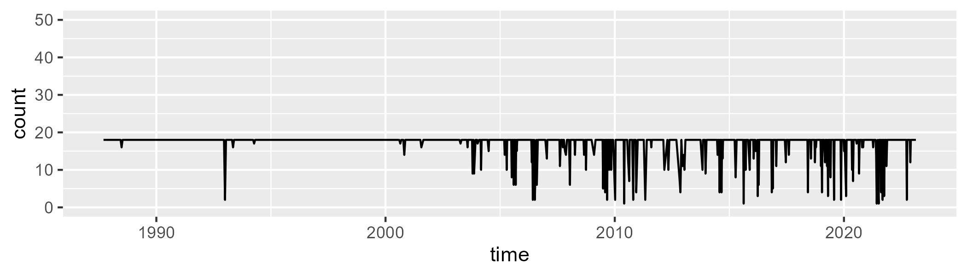

Min. : 1.00 1st Qu.:18.00 Median :18.00 Mean :16.98 3rd Qu.:18.00 Max. :18.00

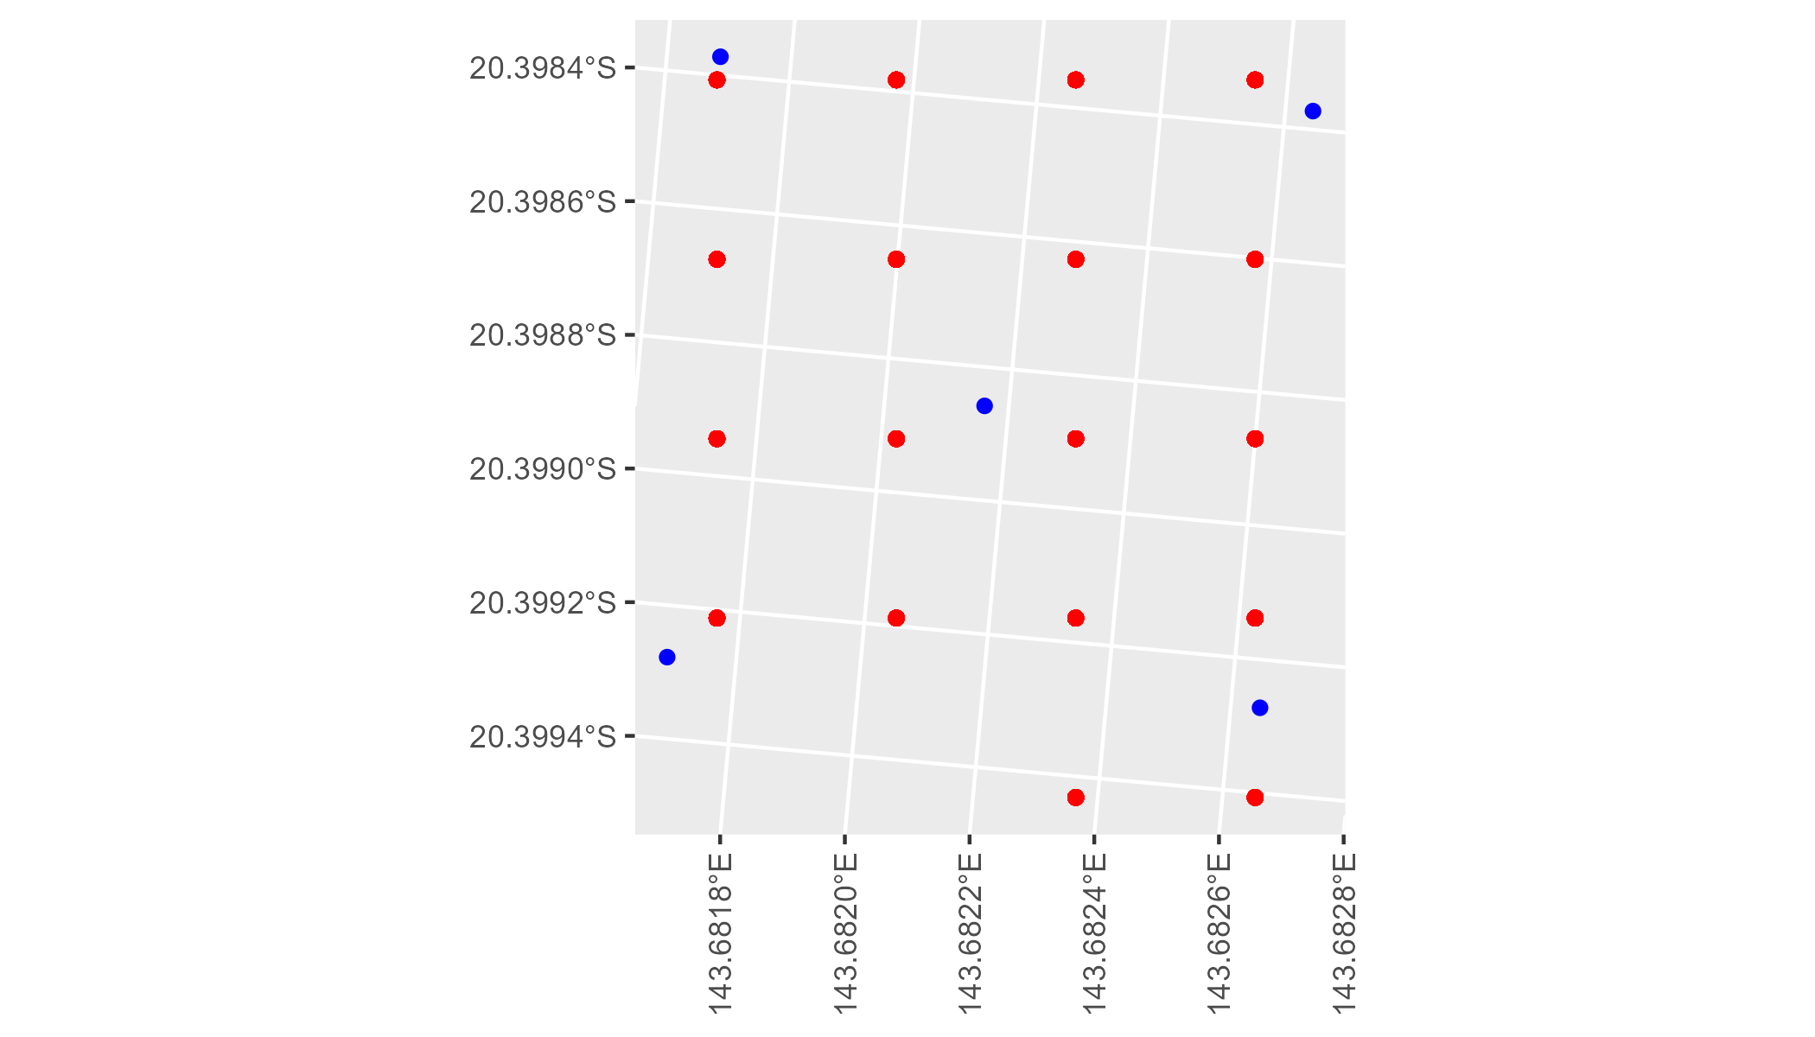

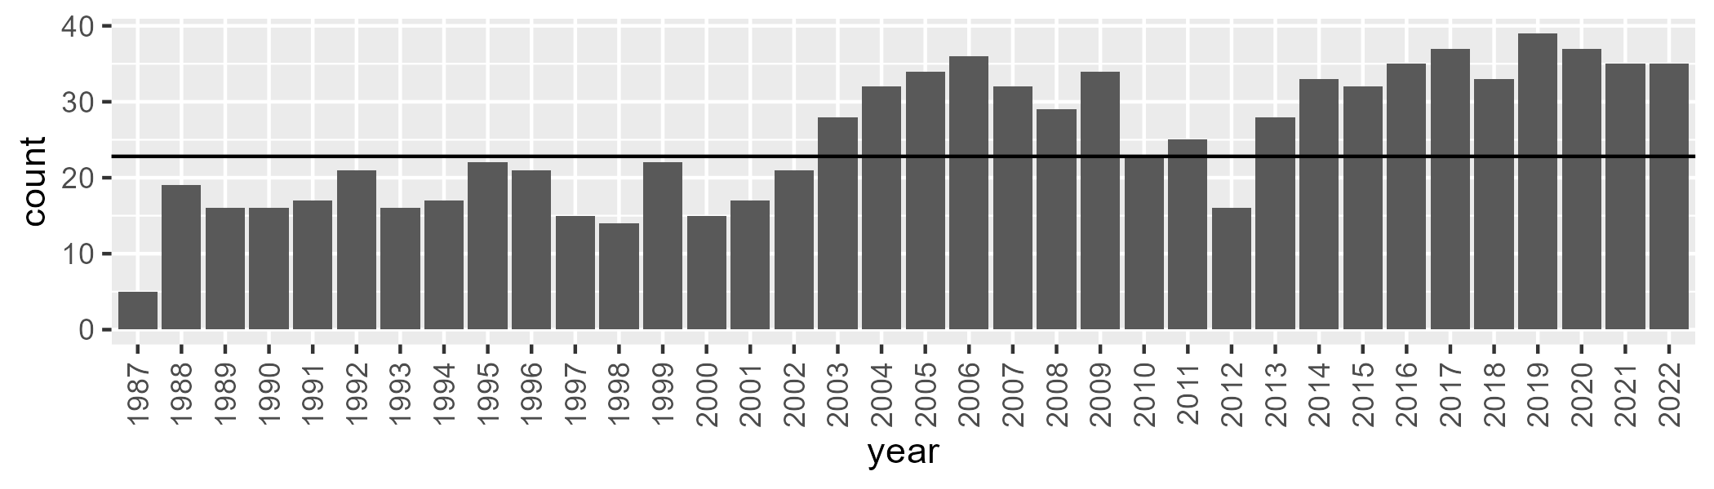

Number of samples: 907

# QDAGUP0004

| Min. | 1st Qu. | Median | Mean | 3rd Qu. | Max. |
| --- | --- | --- | --- | --- | --- |
| 9.619383 | 19.73368 | 25.68412 | 25.8733 | 31.41972 | 47.43836 |

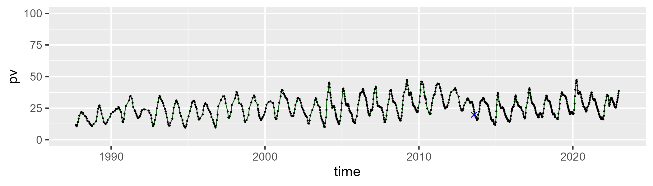

| Min. | 1st Qu. | Median | Mean | 3rd Qu. | Max. |
| --- | --- | --- | --- | --- | --- |
| 22.10742 | 40.62603 | 45.68675 | 45.12538 | 50.07363 | 61.39567 |

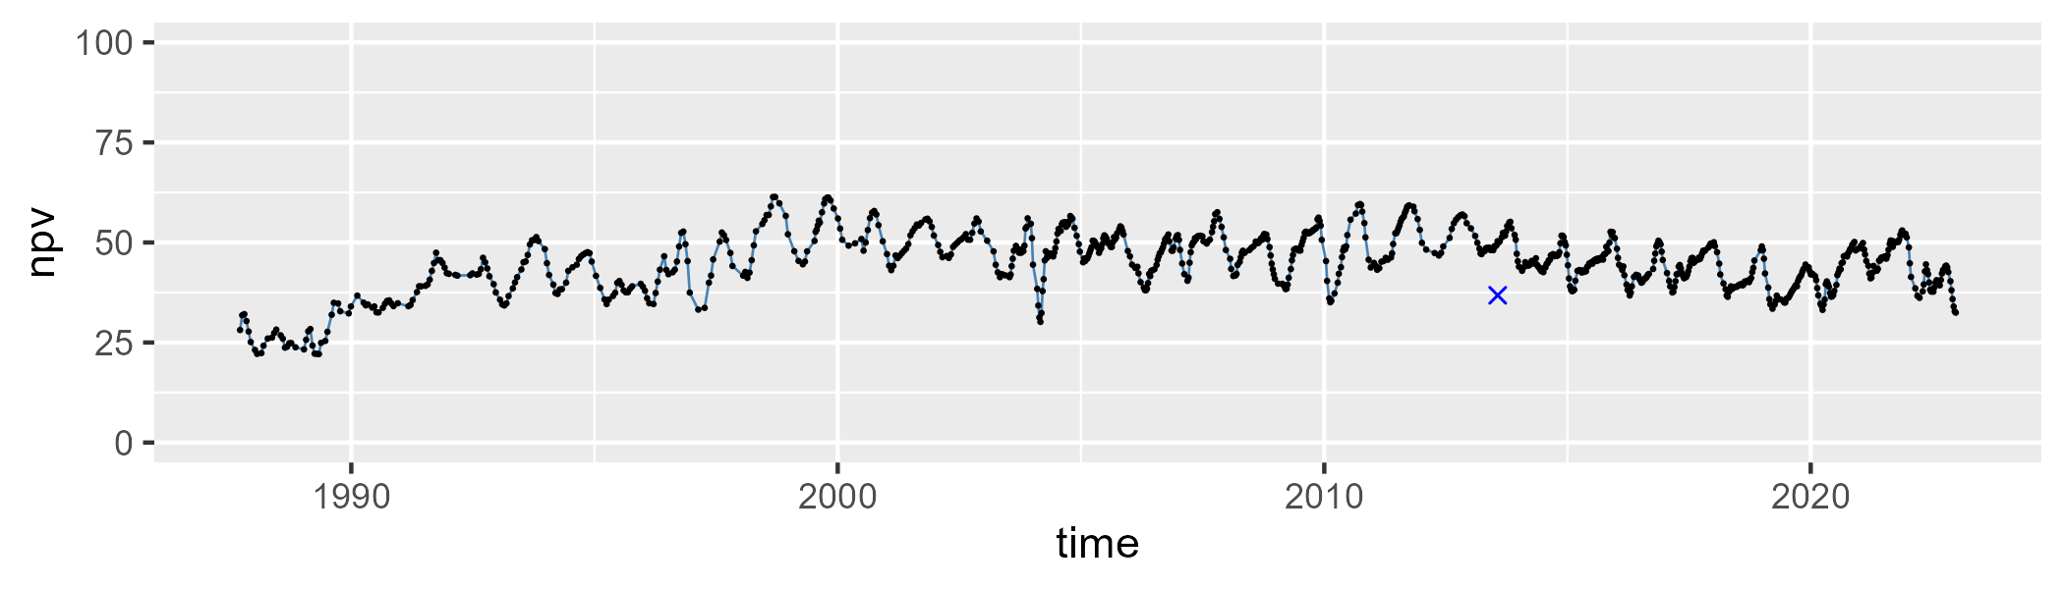

| Min. | 1st Qu. | Median | Mean | 3rd Qu. | Max. |
| --- | --- | --- | --- | --- | --- |
| 8.463752 | 21.34225 | 27.25474 | 27.65479 | 31.98081 | 62.90204 |

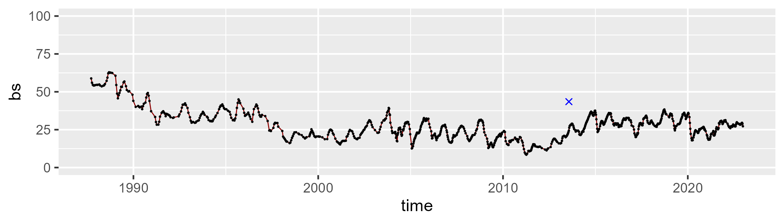

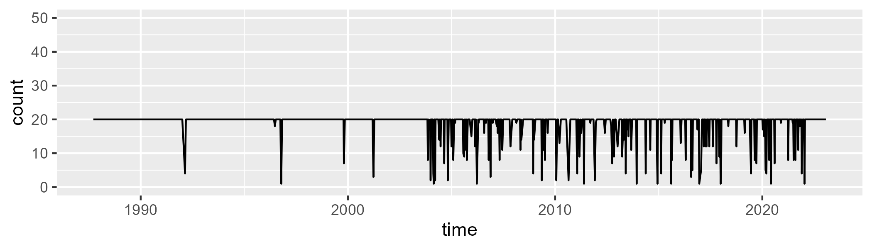

Min. : 1.00 1st Qu.:20.00 Median :20.00 Mean :18.71 3rd Qu.:20.00 Max. :20.00

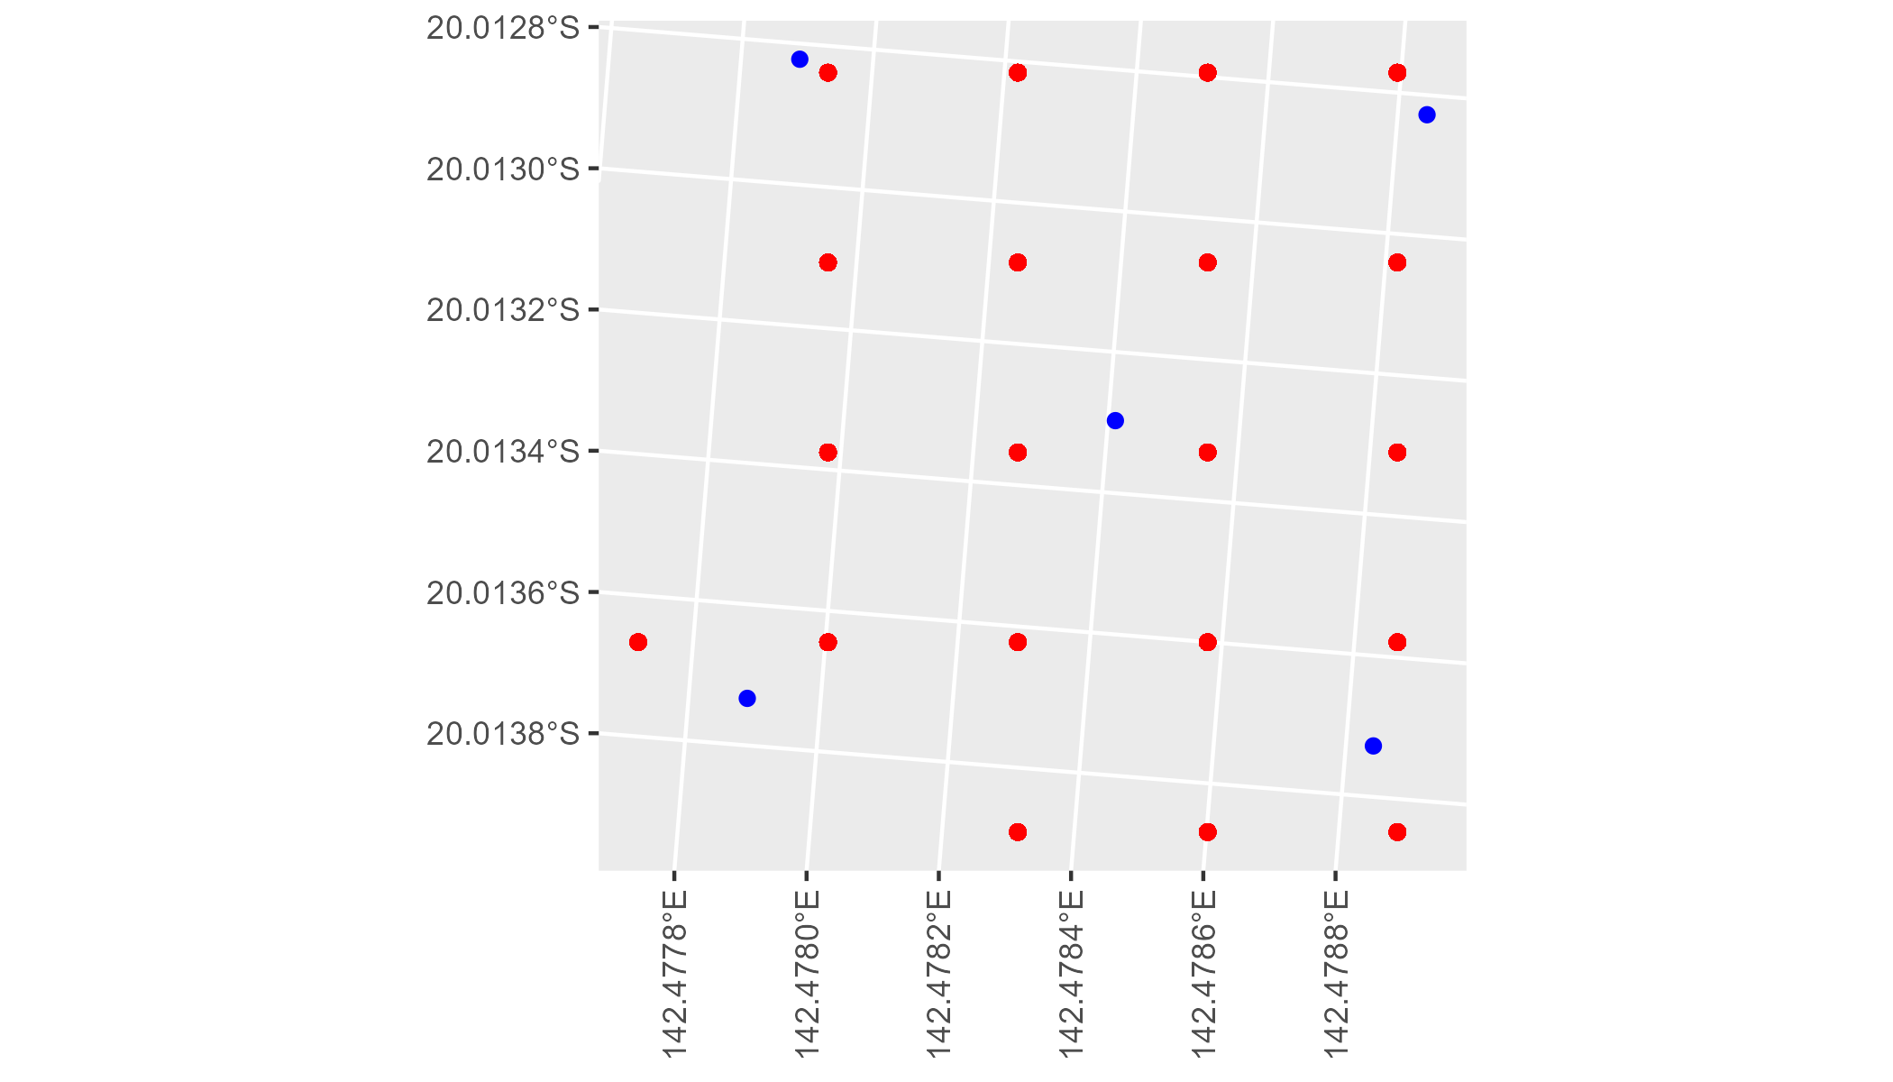

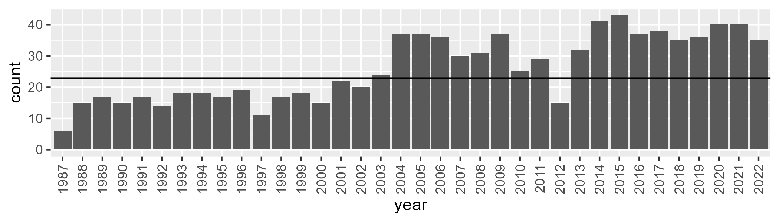

Number of samples: 937

# QDAGUP0005

| Min. | 1st Qu. | Median | Mean | 3rd Qu. | Max. |
| --- | --- | --- | --- | --- | --- |
| 14.20842 | 24.13448 | 28.75867 | 28.90959 | 33.51446 | 47.92703 |

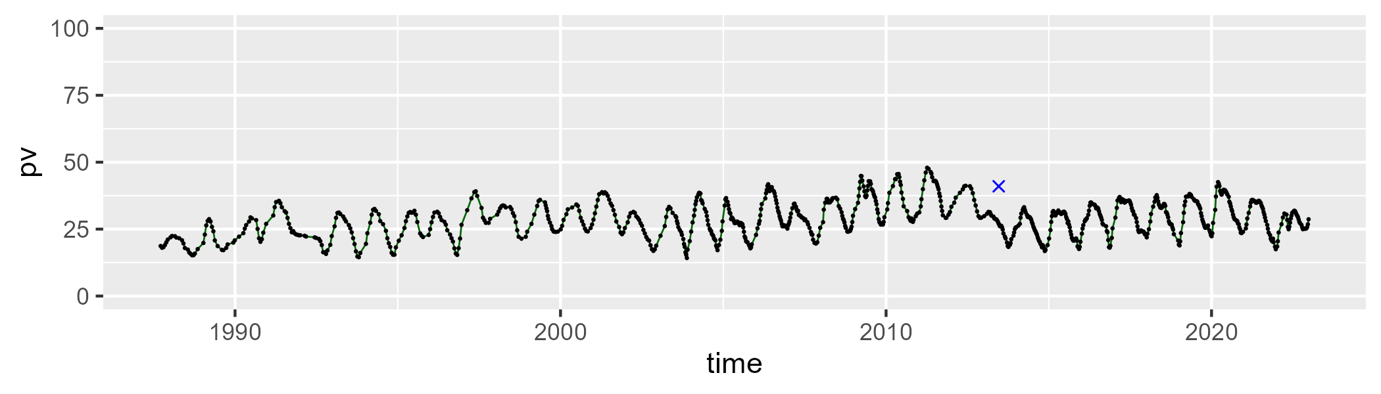

| Min. | 1st Qu. | Median | Mean | 3rd Qu. | Max. |
| --- | --- | --- | --- | --- | --- |
| 27.49485 | 43.67306 | 46.89798 | 46.7579 | 50.72516 | 59.07649 |

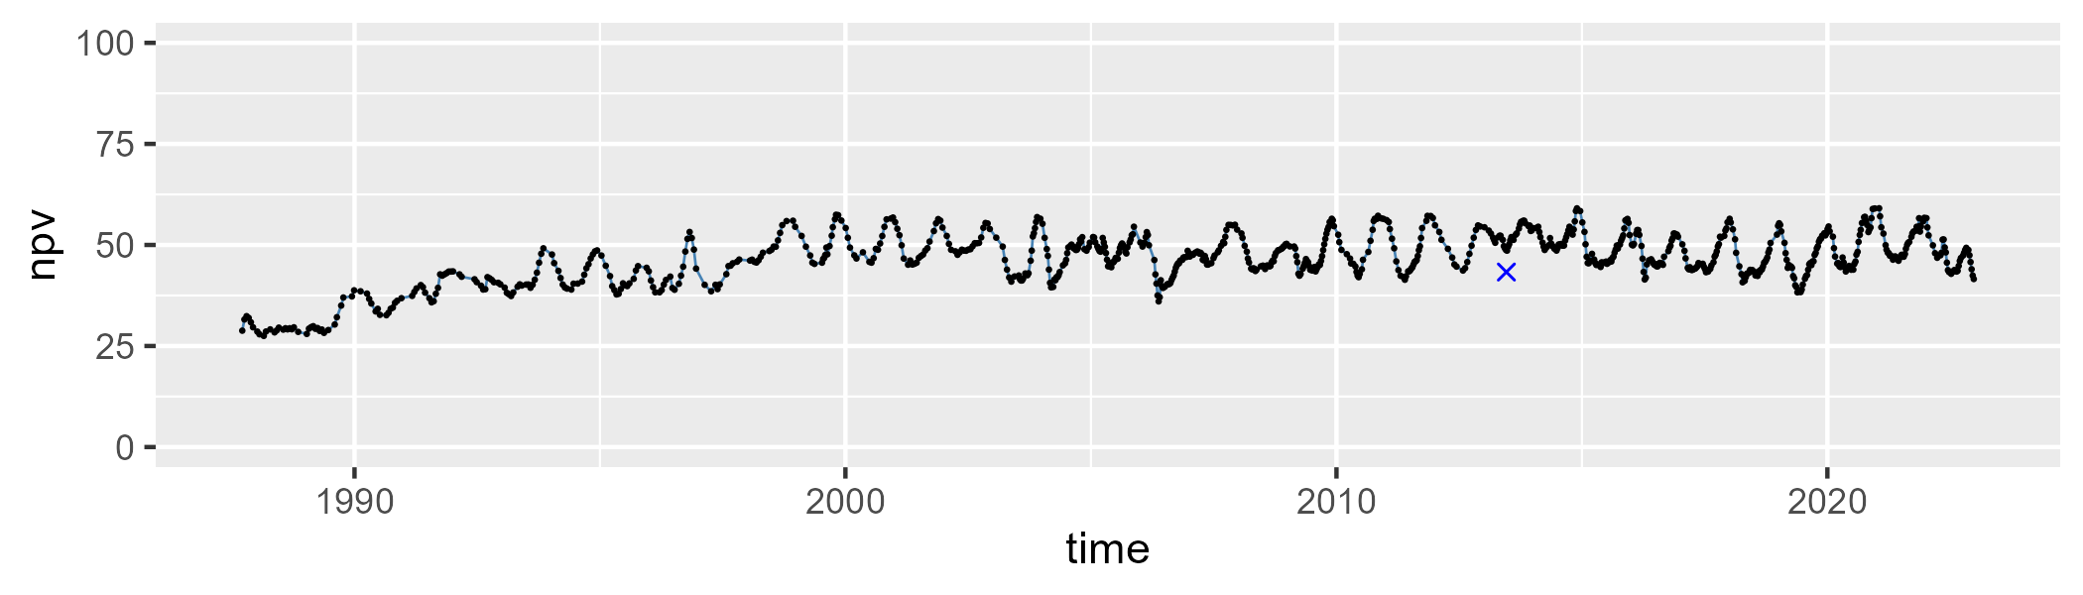

| Min. | 1st Qu. | Median | Mean | 3rd Qu. | Max. |
| --- | --- | --- | --- | --- | --- |
| 6.423169 | 18.08723 | 21.83168 | 23.02296 | 25.59908 | 54.10404 |

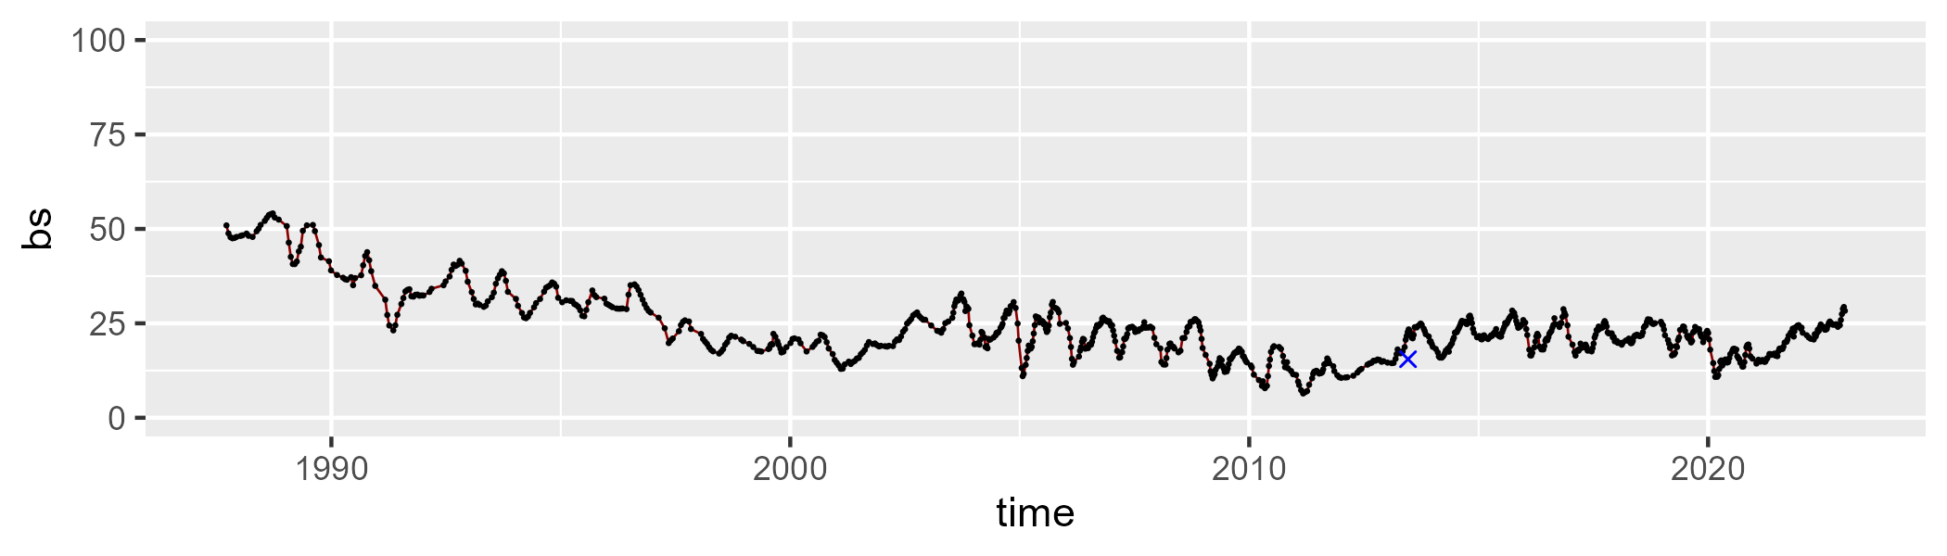

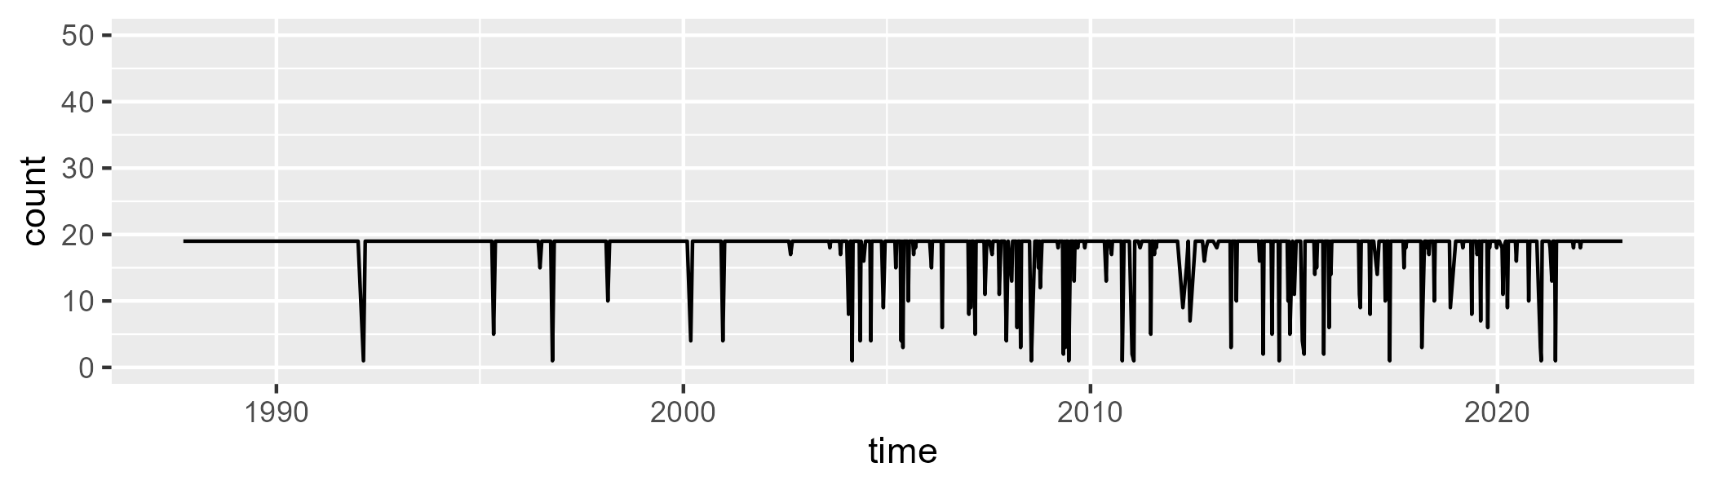

Min. : 1.00 1st Qu.:19.00 Median :19.00 Mean :17.96 3rd Qu.:19.00 Max. :19.00

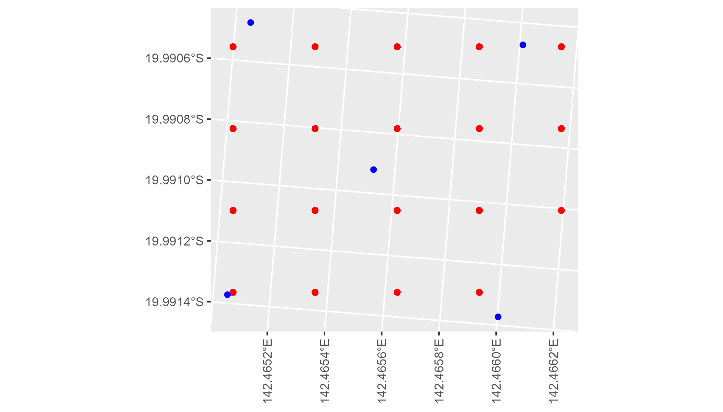

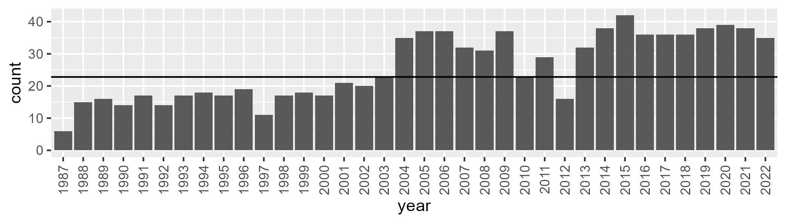

Number of samples: 927

# QDAGUP0006

| Min. | 1st Qu. | Median | Mean | 3rd Qu. | Max. |
| --- | --- | --- | --- | --- | --- |
| 10.15328 | 21.46182 | 26.68607 | 26.72834 | 31.66121 | 48.68024 |

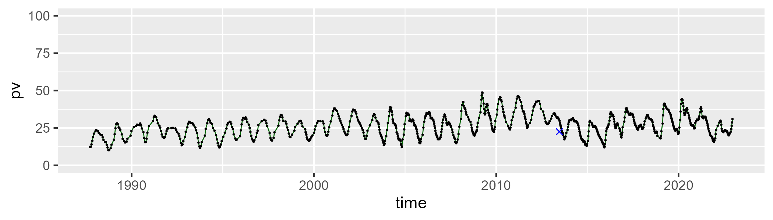

| Min. | 1st Qu. | Median | Mean | 3rd Qu. | Max. |
| --- | --- | --- | --- | --- | --- |
| 22.20857 | 41.55135 | 44.58734 | 44.07641 | 47.85954 | 59.07978 |

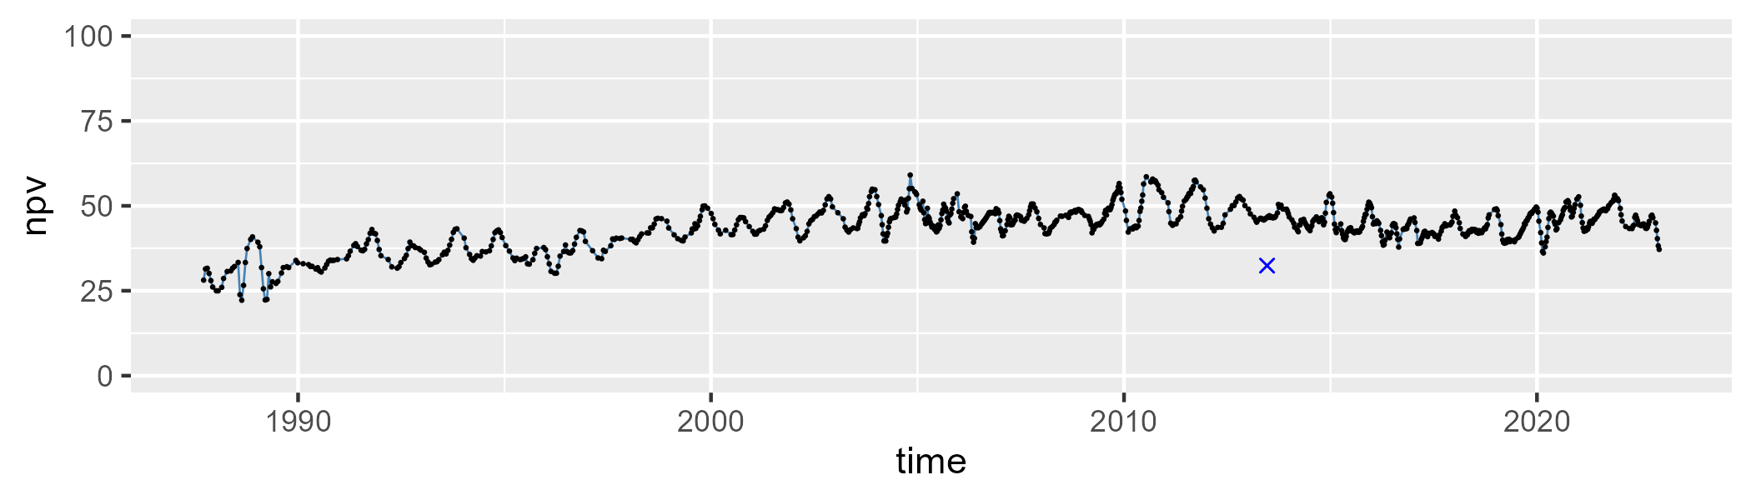

| Min. | 1st Qu. | Median | Mean | 3rd Qu. | Max. |
| --- | --- | --- | --- | --- | --- |
| 7.240983 | 21.71498 | 27.32025 | 27.85547 | 32.81448 | 62.68792 |

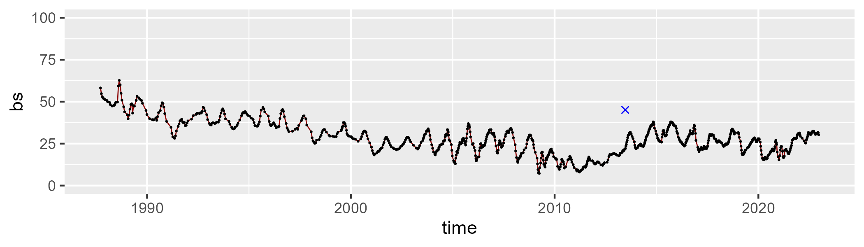

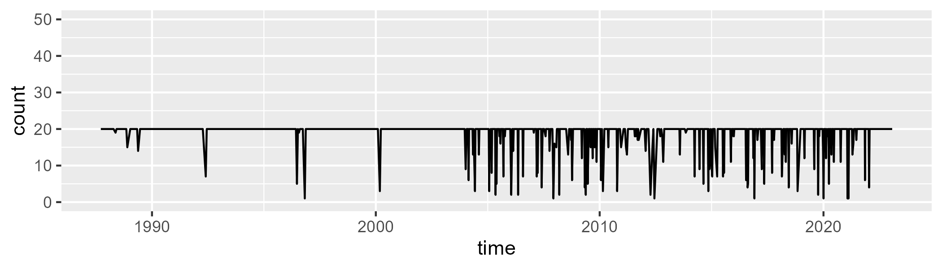

Min. : 1.00 1st Qu.:20.00 Median :20.00 Mean :18.74 3rd Qu.:20.00 Max. :20.00

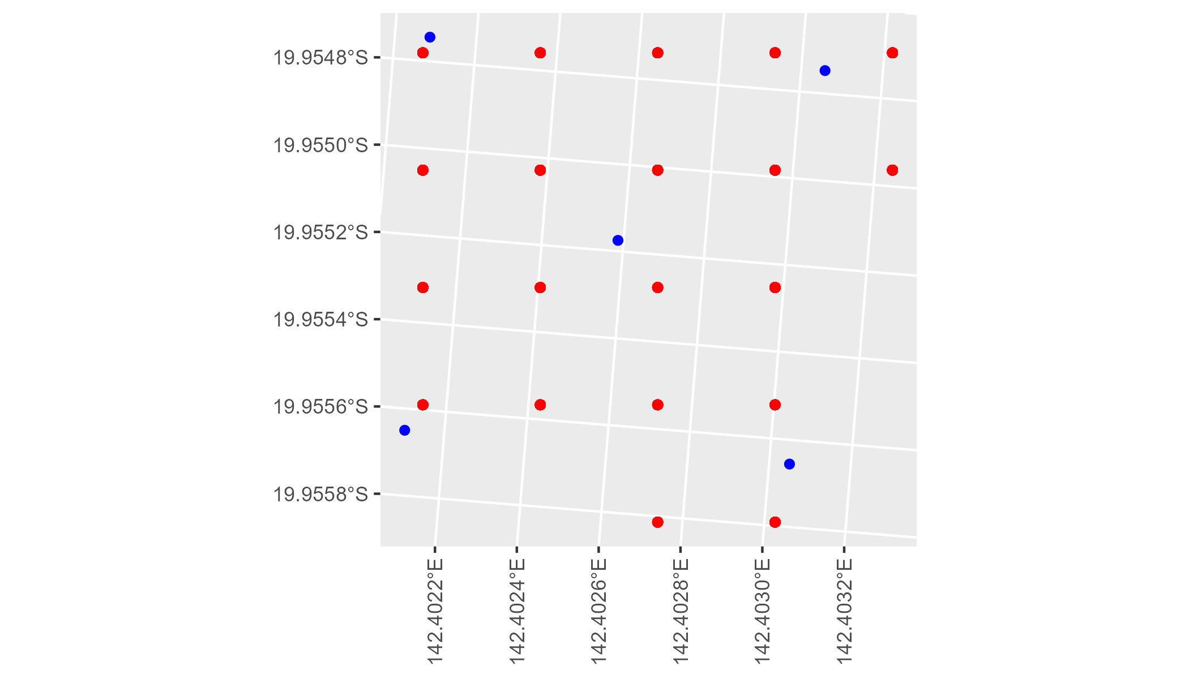

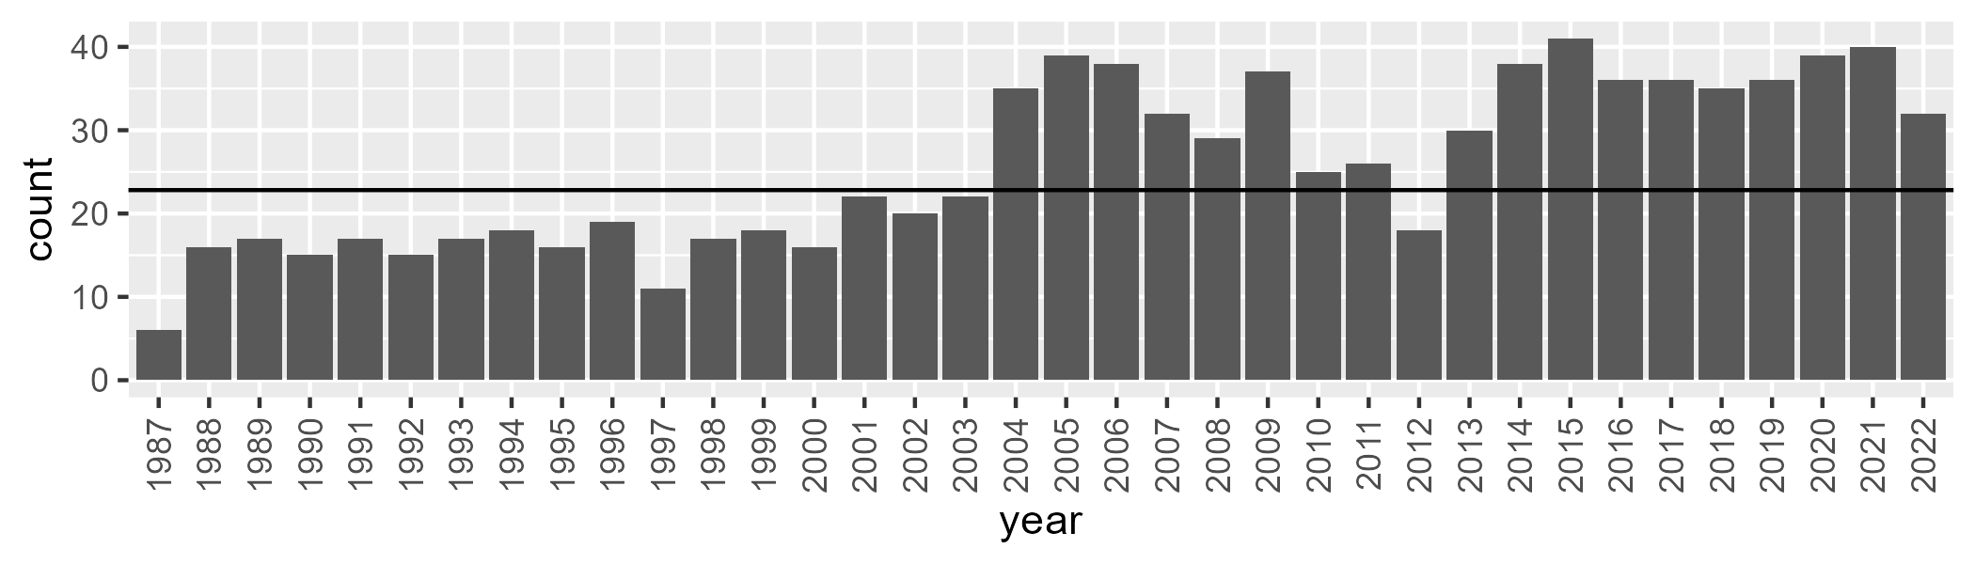

Number of samples: 924

# QDAGUP0007

| Min. | 1st Qu. | Median | Mean | 3rd Qu. | Max. |
| --- | --- | --- | --- | --- | --- |
| 0 | 4.206079 | 8.212527 | 14.38838 | 20.31522 | 71.34959 |

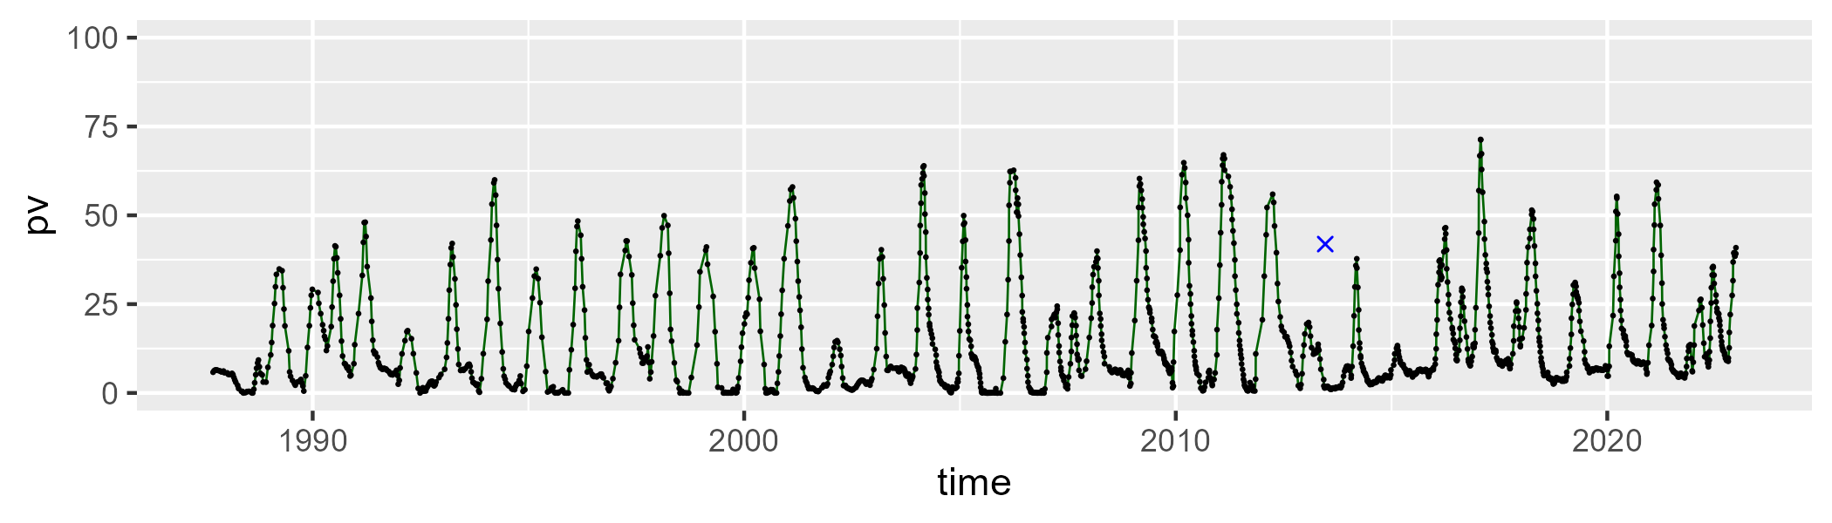

| Min. | 1st Qu. | Median | Mean | 3rd Qu. | Max. |
| --- | --- | --- | --- | --- | --- |
| 13.04342 | 47.71736 | 58.70417 | 58.6346 | 67.77421 | 100.7183 |

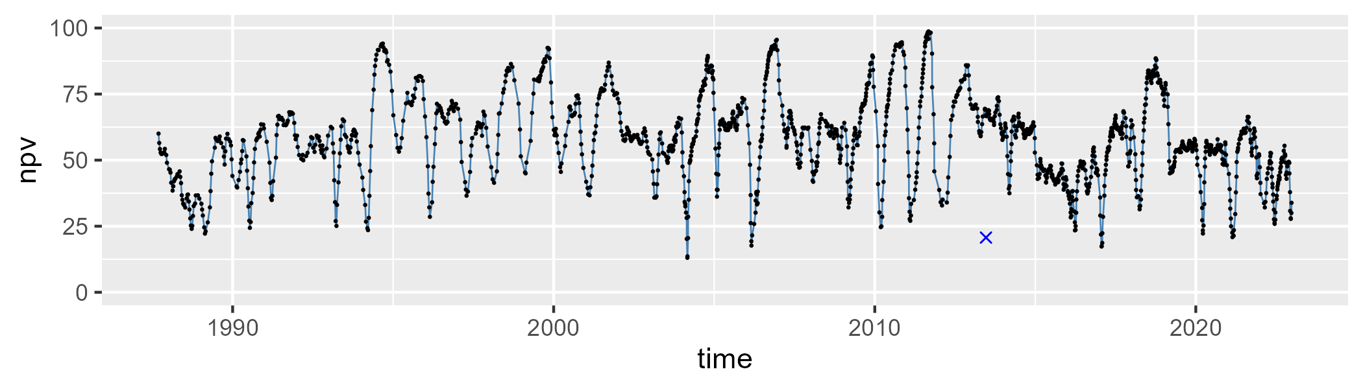

| Min. | 1st Qu. | Median | Mean | 3rd Qu. | Max. |
| --- | --- | --- | --- | --- | --- |
| 0 | 15.39332 | 26.29085 | 25.68916 | 34.80366 | 66.61534 |

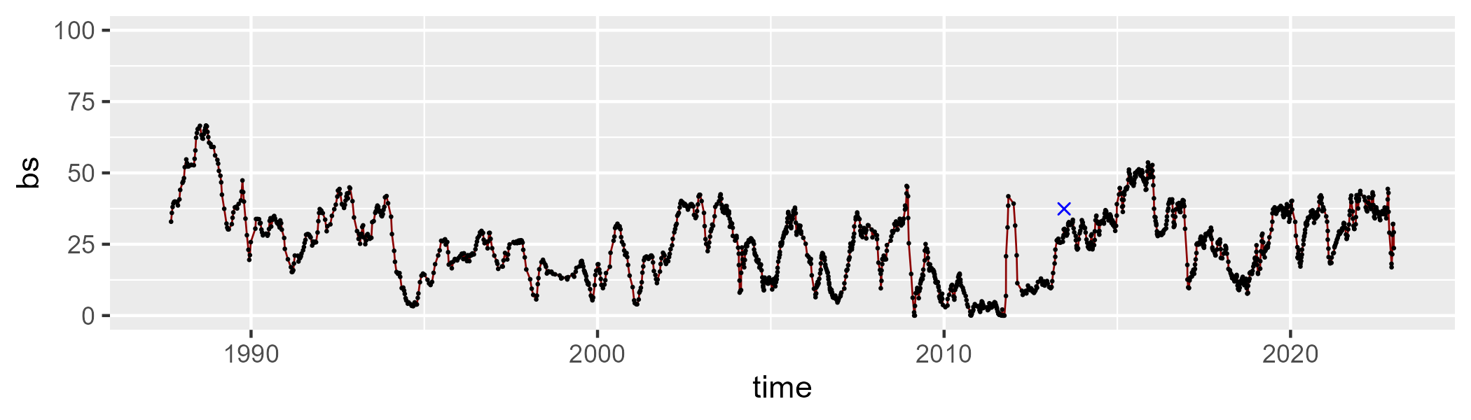

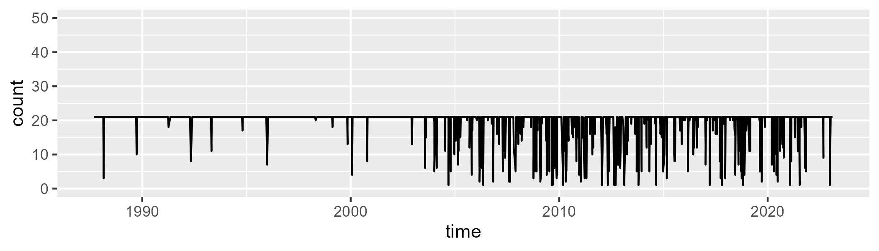

Min. : 1.00 1st Qu.:21.00 Median :21.00 Mean :19.65 3rd Qu.:21.00 Max. :21.00

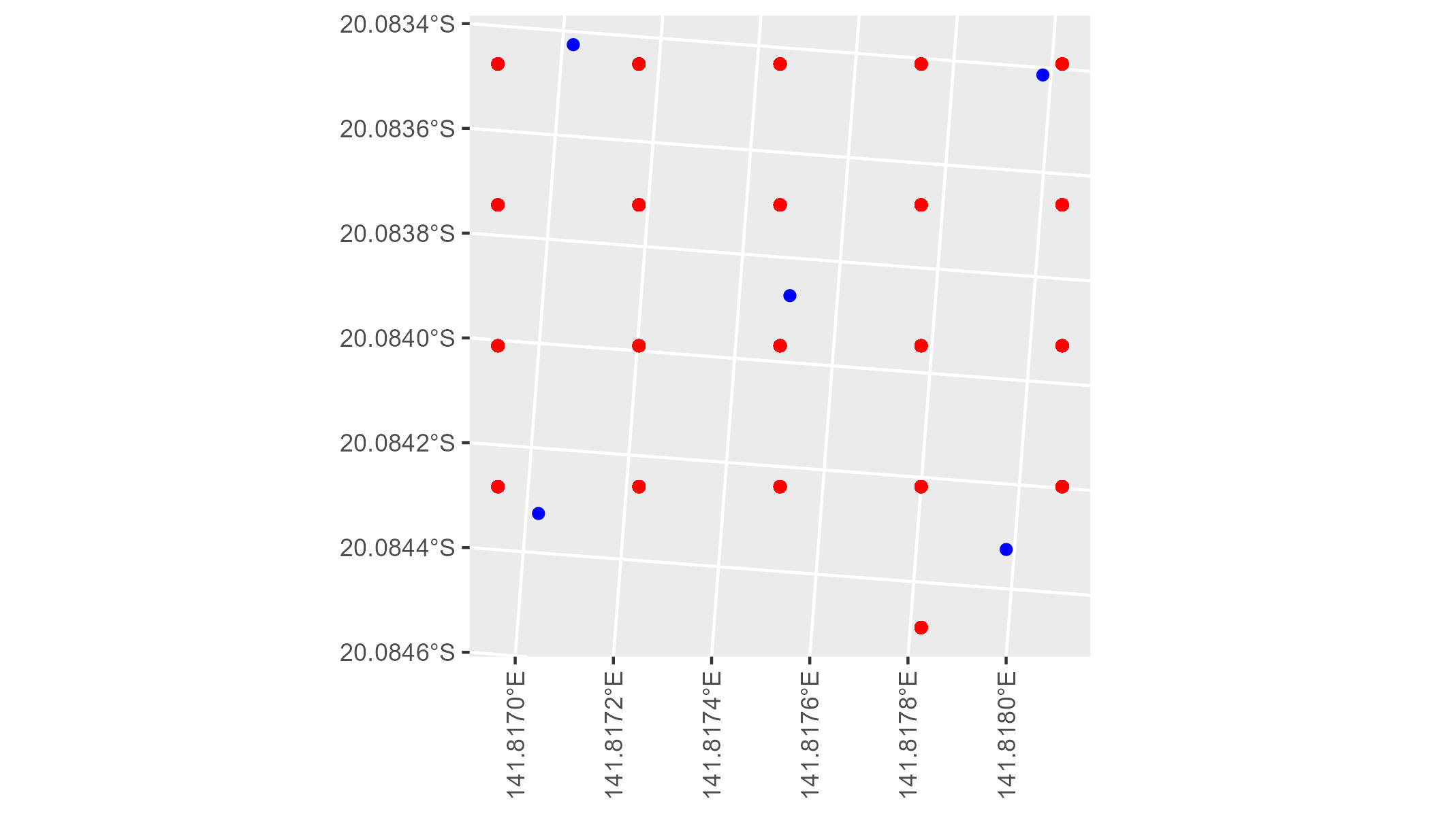

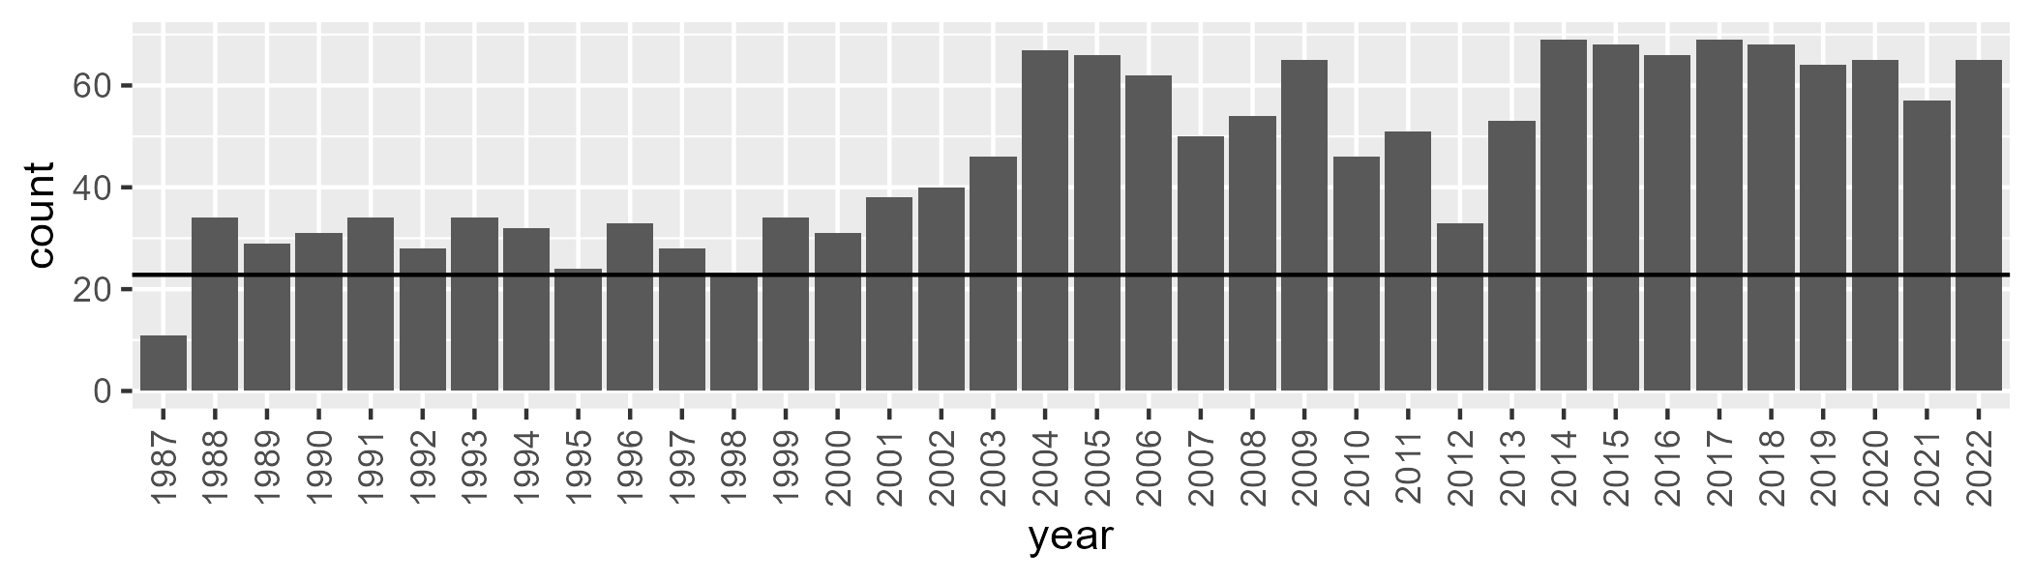

Number of samples: 1668

# QDAGUP0008

| Min. | 1st Qu. | Median | Mean | 3rd Qu. | Max. |
| --- | --- | --- | --- | --- | --- |
| 6.337537 | 20.36809 | 26.70308 | 27.3244 | 34.59005 | 51.49764 |

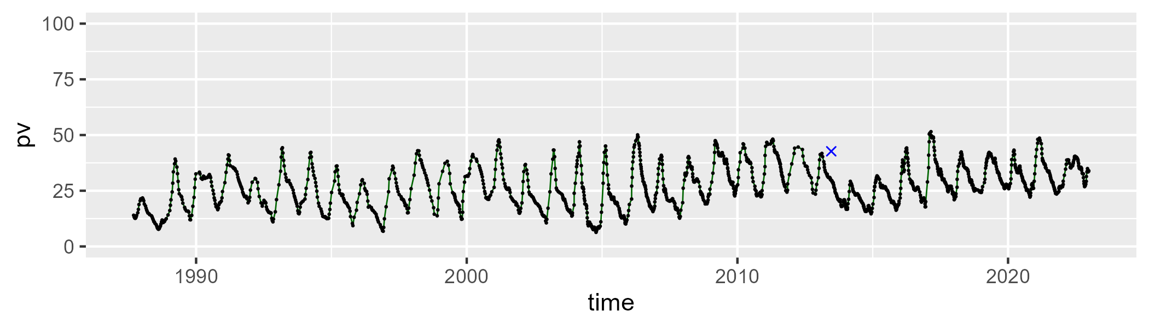

| Min. | 1st Qu. | Median | Mean | 3rd Qu. | Max. |
| --- | --- | --- | --- | --- | --- |
| 25.22326 | 45.26409 | 51.01827 | 51.52107 | 56.787 | 82.27479 |

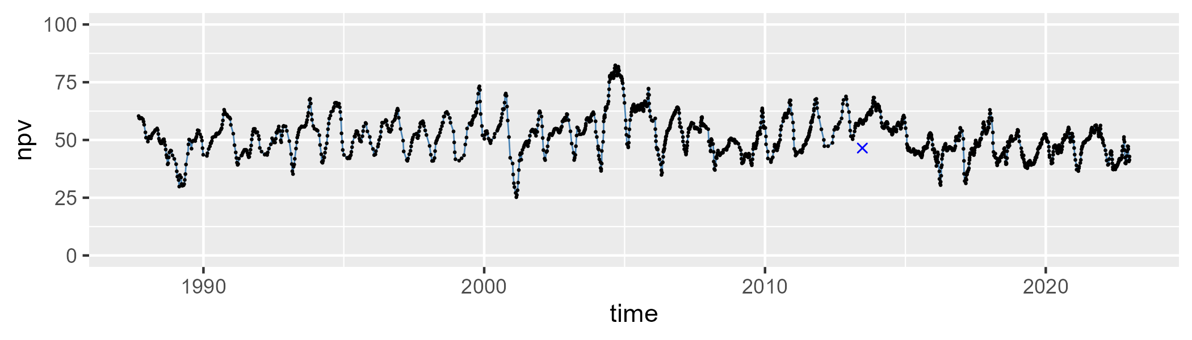

| Min. | 1st Qu. | Median | Mean | 3rd Qu. | Max. |
| --- | --- | --- | --- | --- | --- |
| 5.932954 | 14.99294 | 19.62772 | 19.83549 | 23.81903 | 47.97666 |

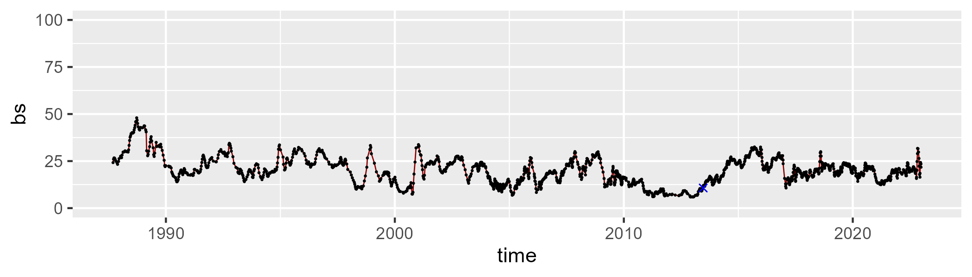

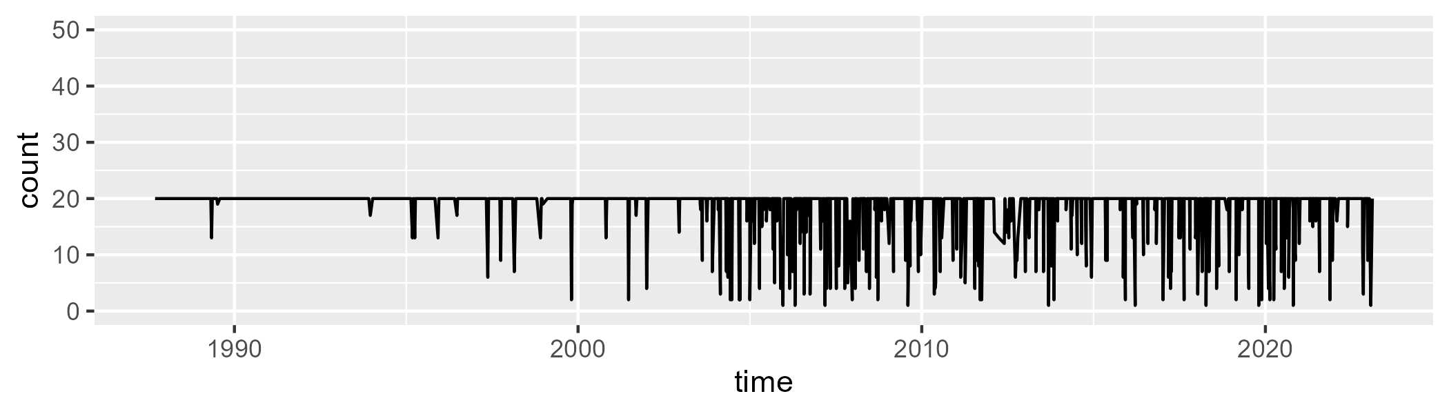

Min. : 1.0 1st Qu.:20.0 Median :20.0 Mean :18.7 3rd Qu.:20.0 Max. :20.0

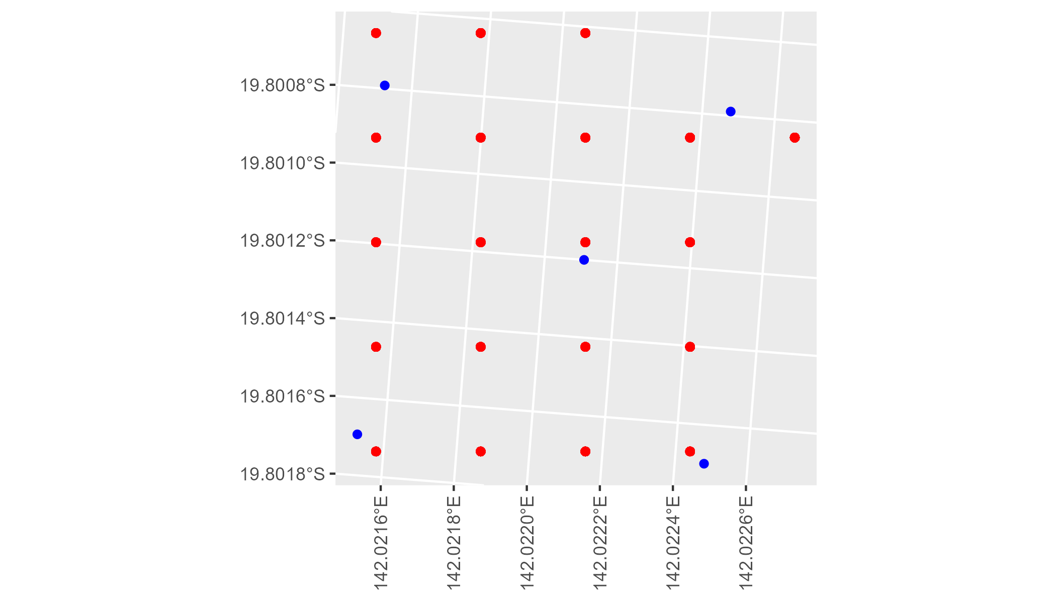

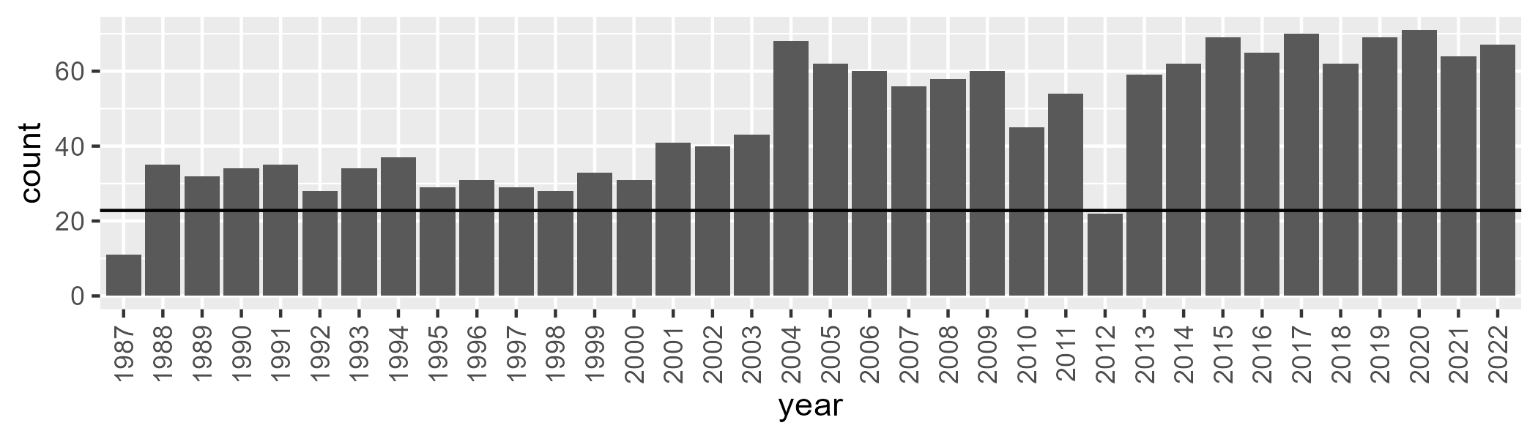

Number of samples: 1694

# QDAGUP0009

| Min. | 1st Qu. | Median | Mean | 3rd Qu. | Max. |
| --- | --- | --- | --- | --- | --- |
| 0 | 5.084788 | 10.30604 | 16.60059 | 24.27207 | 74.13162 |

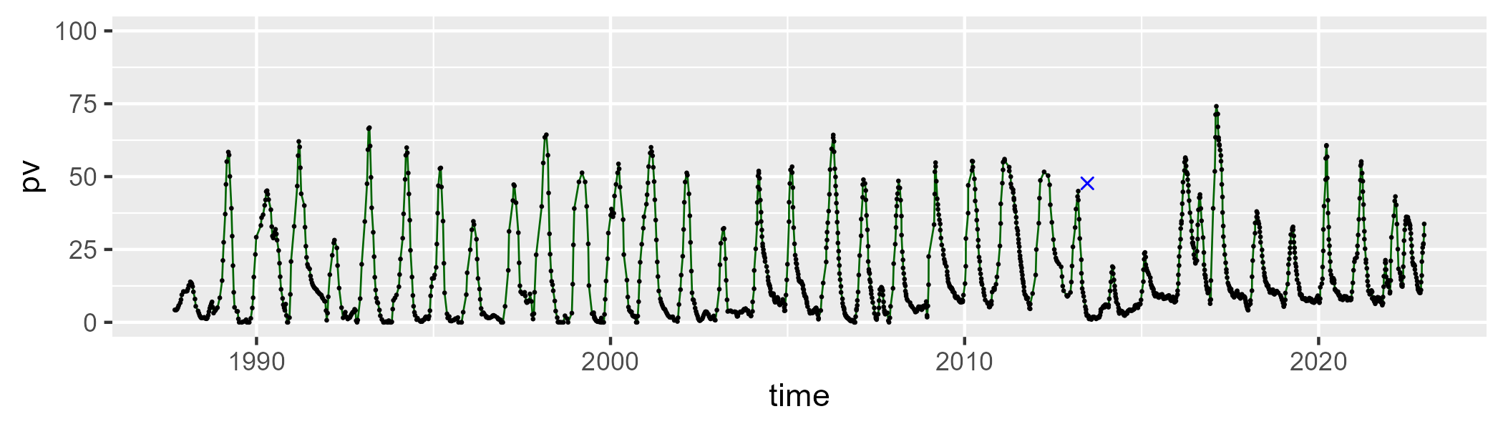

| Min. | 1st Qu. | Median | Mean | 3rd Qu. | Max. |
| --- | --- | --- | --- | --- | --- |
| 14.08227 | 48.25976 | 58.27428 | 59.92291 | 72.22946 | 101.7764 |

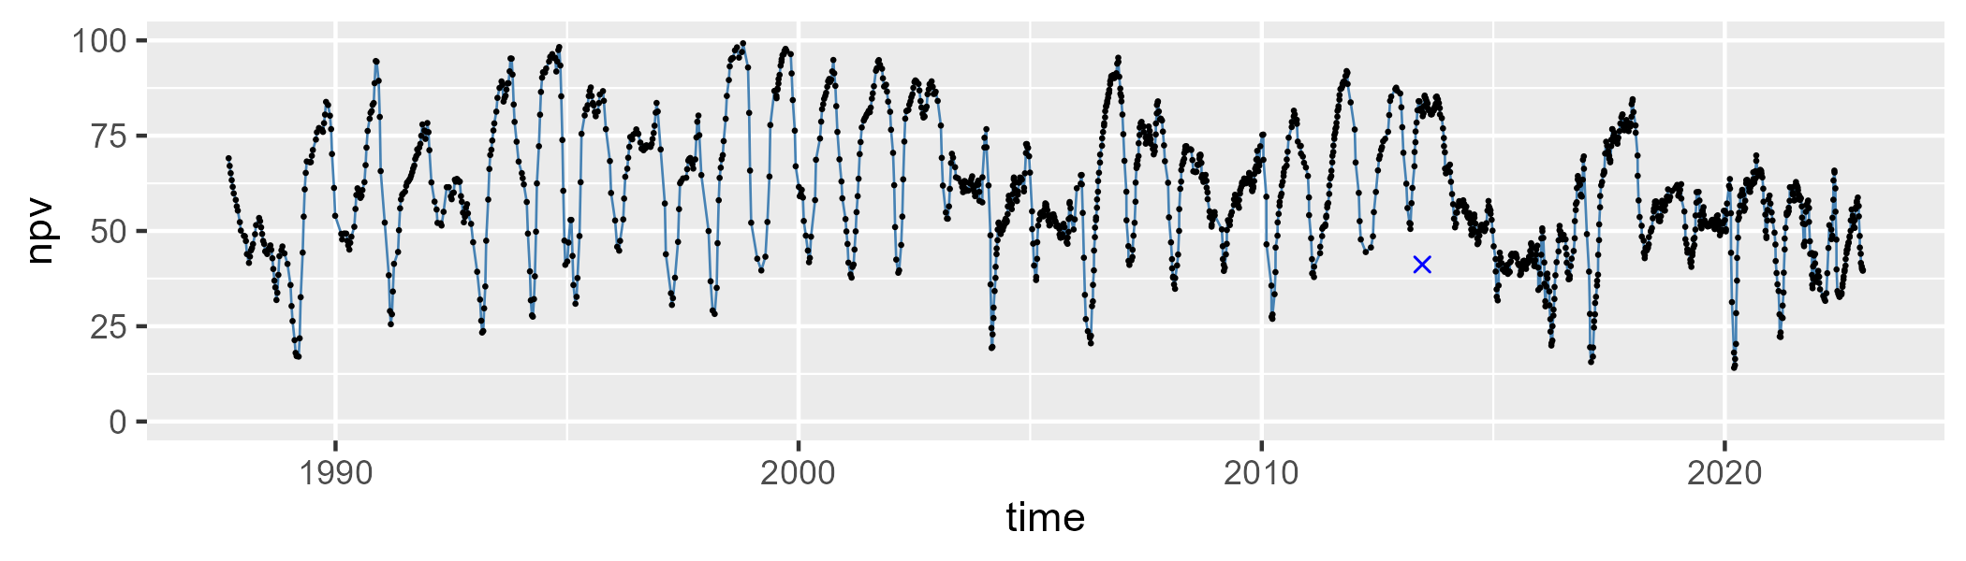

| Min. | 1st Qu. | Median | Mean | 3rd Qu. | Max. |
| --- | --- | --- | --- | --- | --- |
| 0 | 11.79914 | 21.33044 | 22.1997 | 30.80452 | 60.55837 |

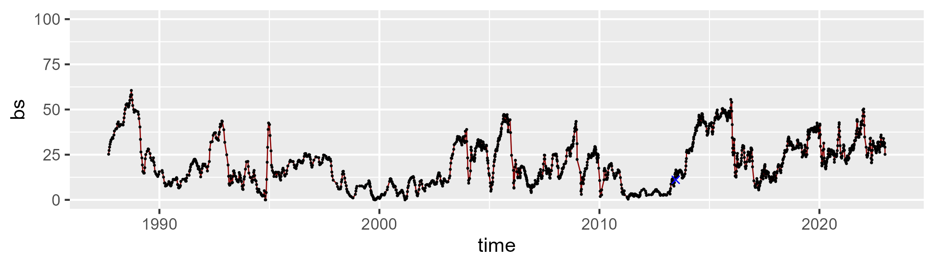

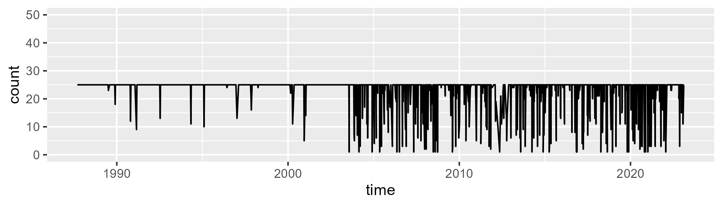

Min. : 1.00 1st Qu.:25.00 Median :25.00 Mean :23.13 3rd Qu.:25.00 Max. :25.00

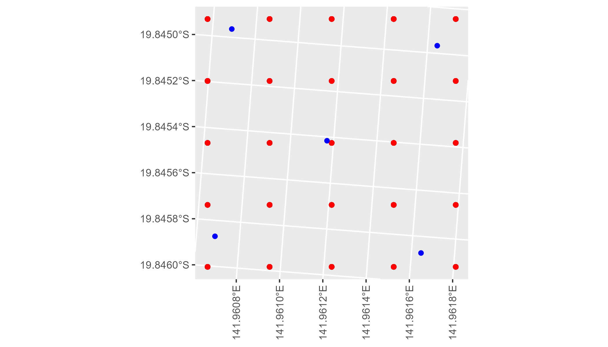

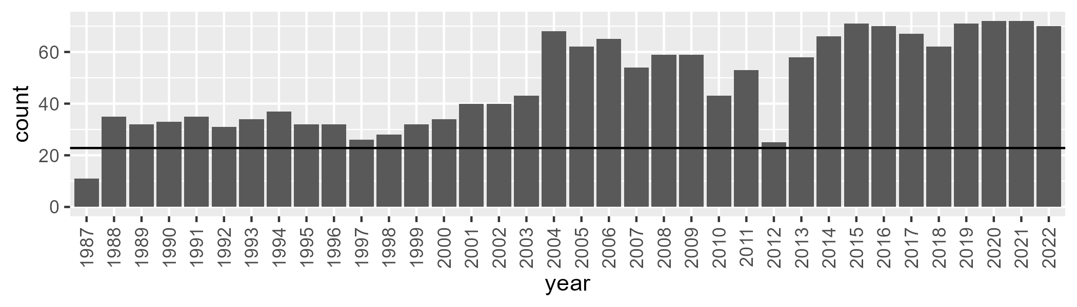

Number of samples: 1722

# QDAGUP0010

| Min. | 1st Qu. | Median | Mean | 3rd Qu. | Max. |
| --- | --- | --- | --- | --- | --- |
| 3.659255 | 18.55132 | 24.94042 | 25.4969 | 32.62025 | 49.16022 |

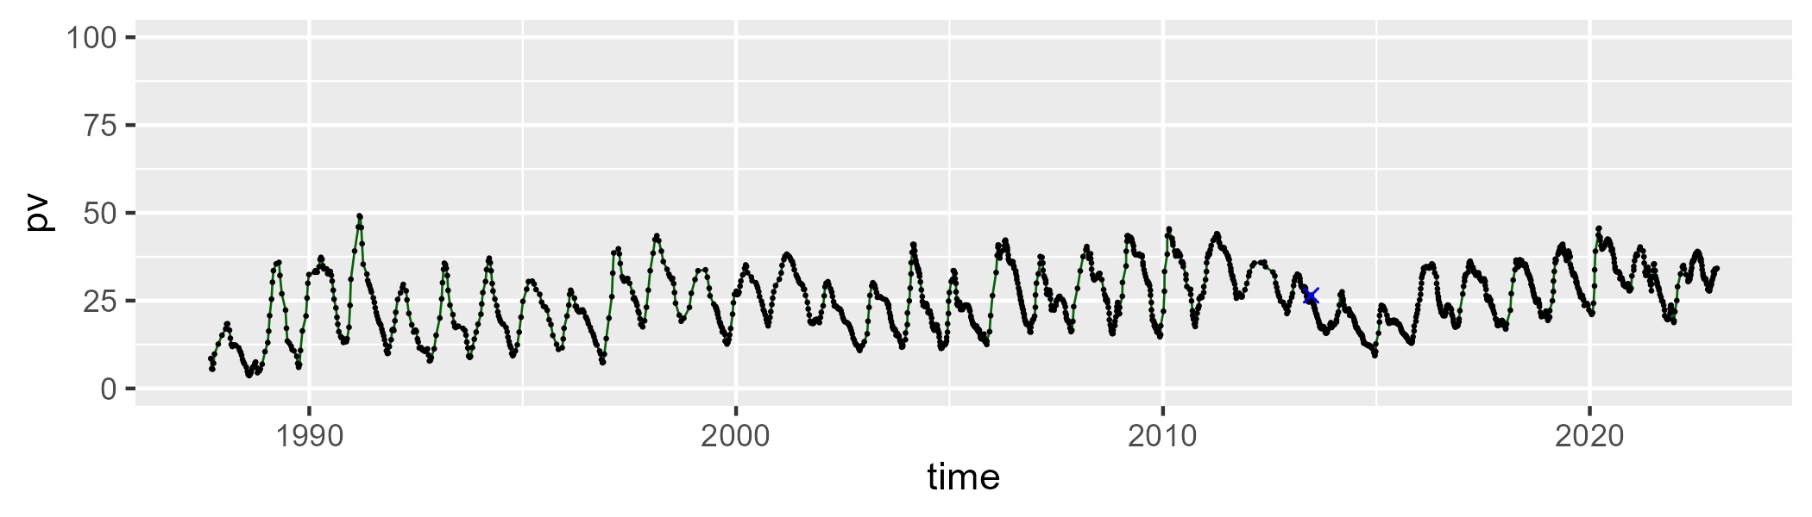

| Min. | 1st Qu. | Median | Mean | 3rd Qu. | Max. |
| --- | --- | --- | --- | --- | --- |
| 23.60718 | 39.39768 | 43.75117 | 44.68177 | 49.09555 | 79.52574 |

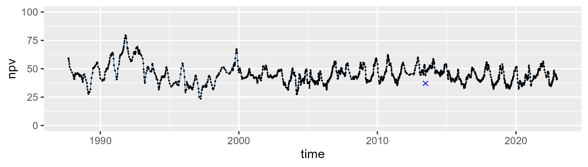

| Min. | 1st Qu. | Median | Mean | 3rd Qu. | Max. |
| --- | --- | --- | --- | --- | --- |
| 8.099896 | 22.8491 | 27.52128 | 28.44858 | 33.84983 | 52.9792 |

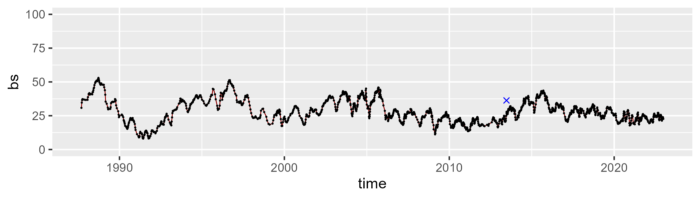

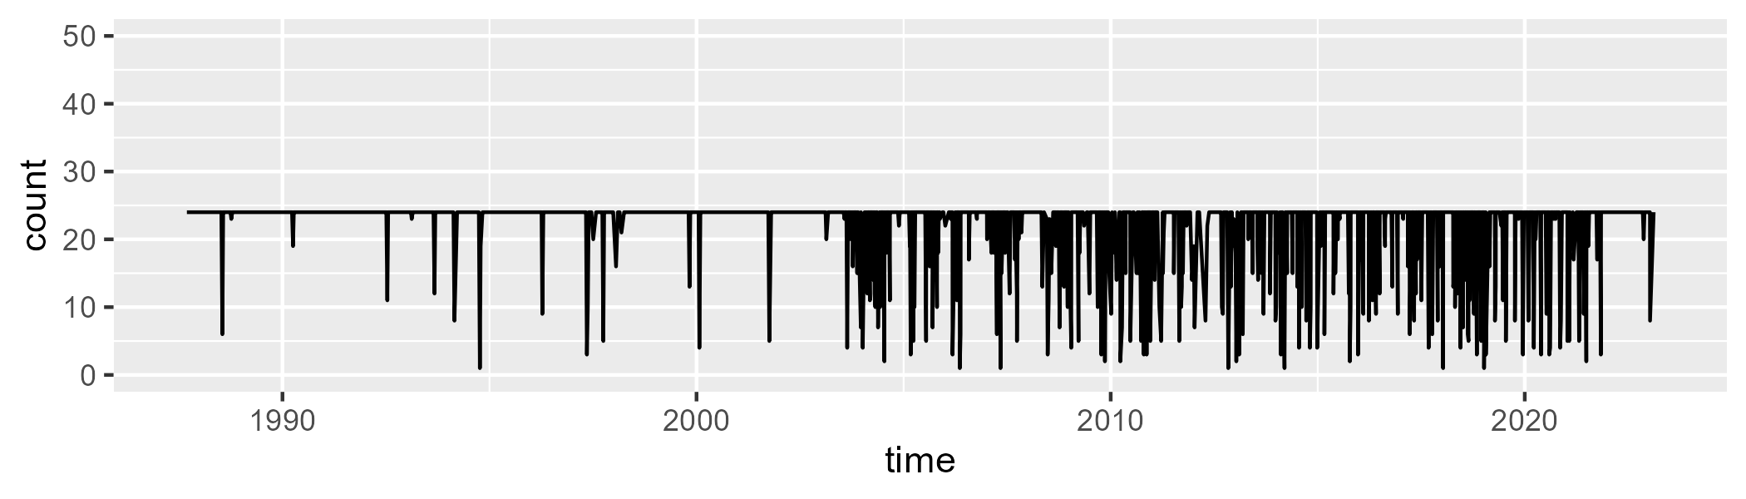

Min. : 1.0 1st Qu.:24.0 Median :24.0 Mean :22.1 3rd Qu.:24.0 Max. :24.0

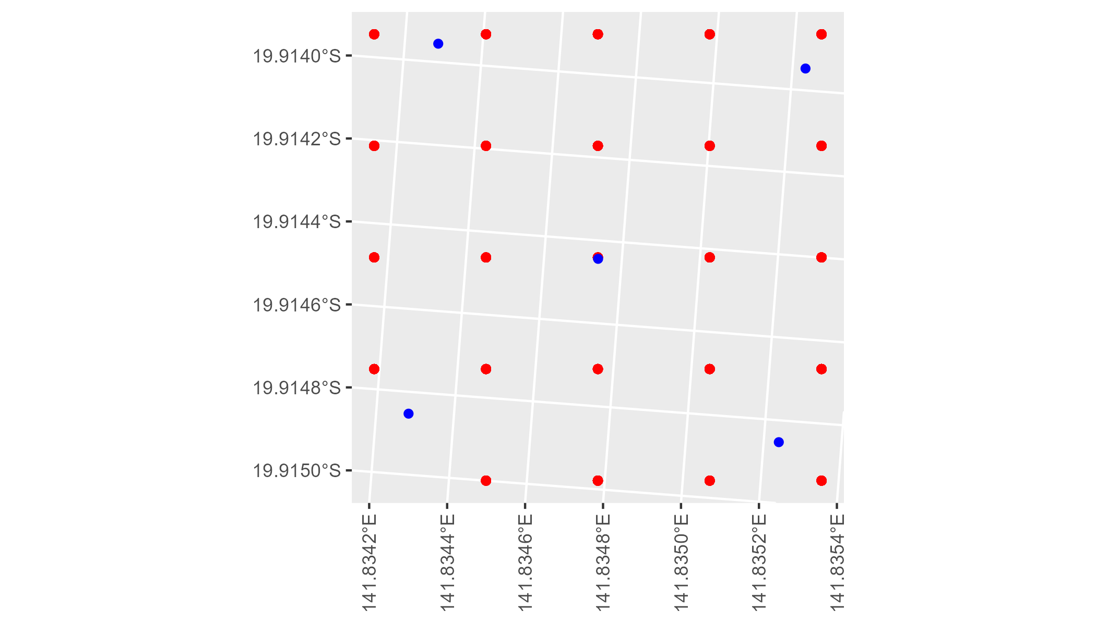

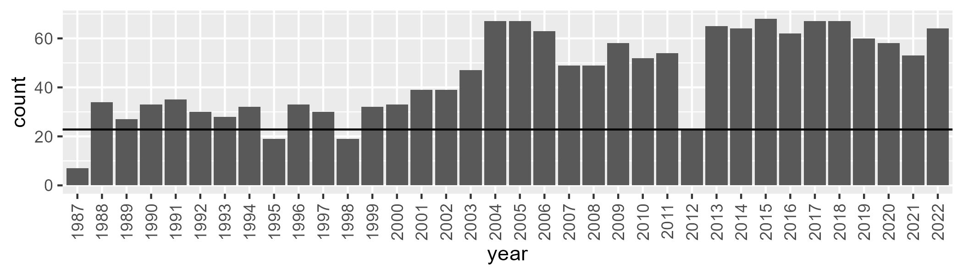

Number of samples: 1627

# QDAGUP0011

| Min. | 1st Qu. | Median | Mean | 3rd Qu. | Max. |
| --- | --- | --- | --- | --- | --- |
| 4.995095 | 16.27067 | 21.08241 | 21.85163 | 27.01828 | 42.12036 |

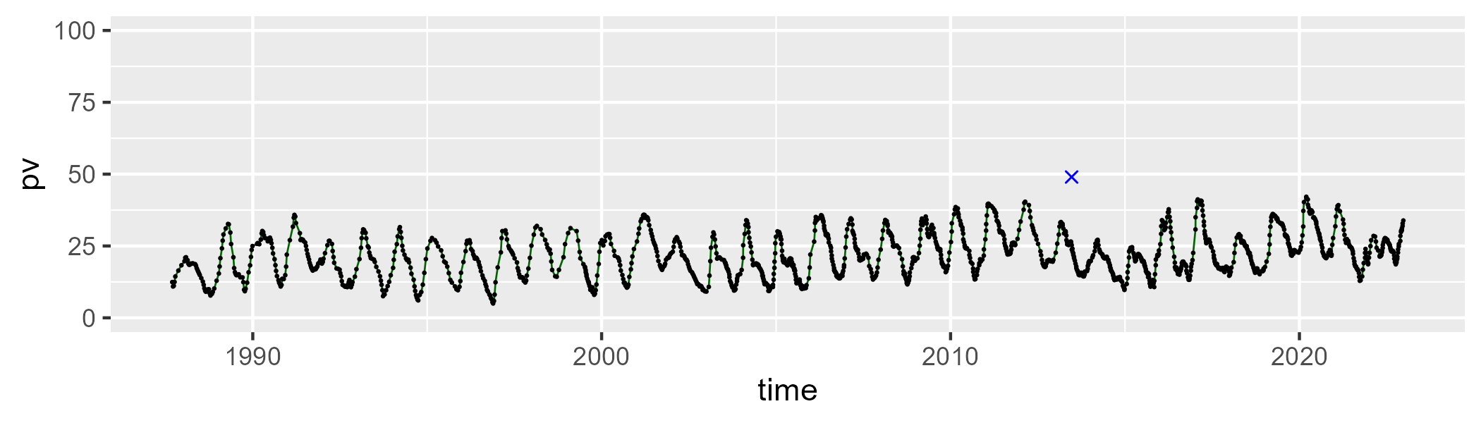

| Min. | 1st Qu. | Median | Mean | 3rd Qu. | Max. |
| --- | --- | --- | --- | --- | --- |
| 20.66871 | 33.94306 | 38.42776 | 38.59679 | 43.13701 | 64.93093 |

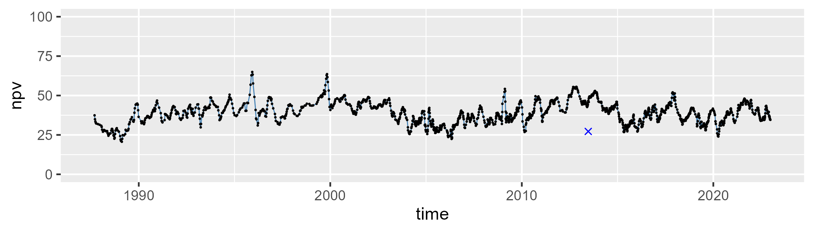

| Min. | 1st Qu. | Median | Mean | 3rd Qu. | Max. |
| --- | --- | --- | --- | --- | --- |
| 17.8467 | 32.40664 | 37.88824 | 38.14157 | 43.3733 | 65.89297 |

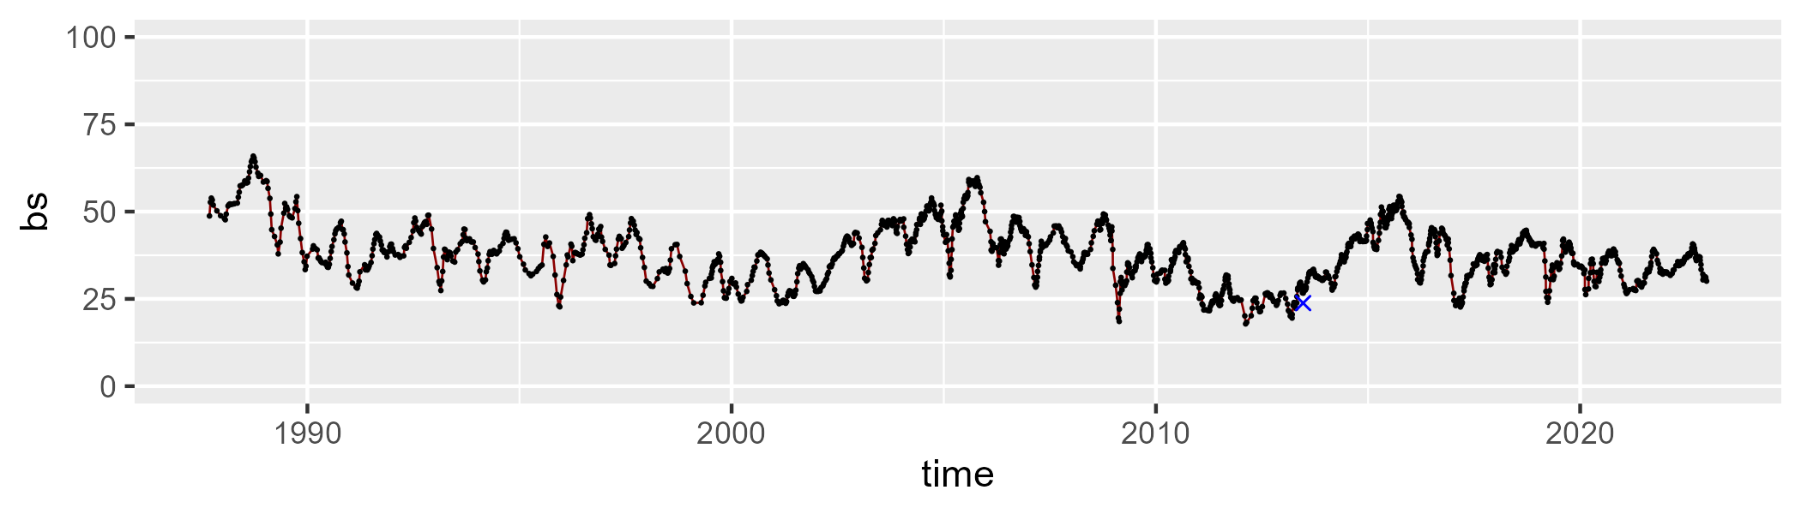

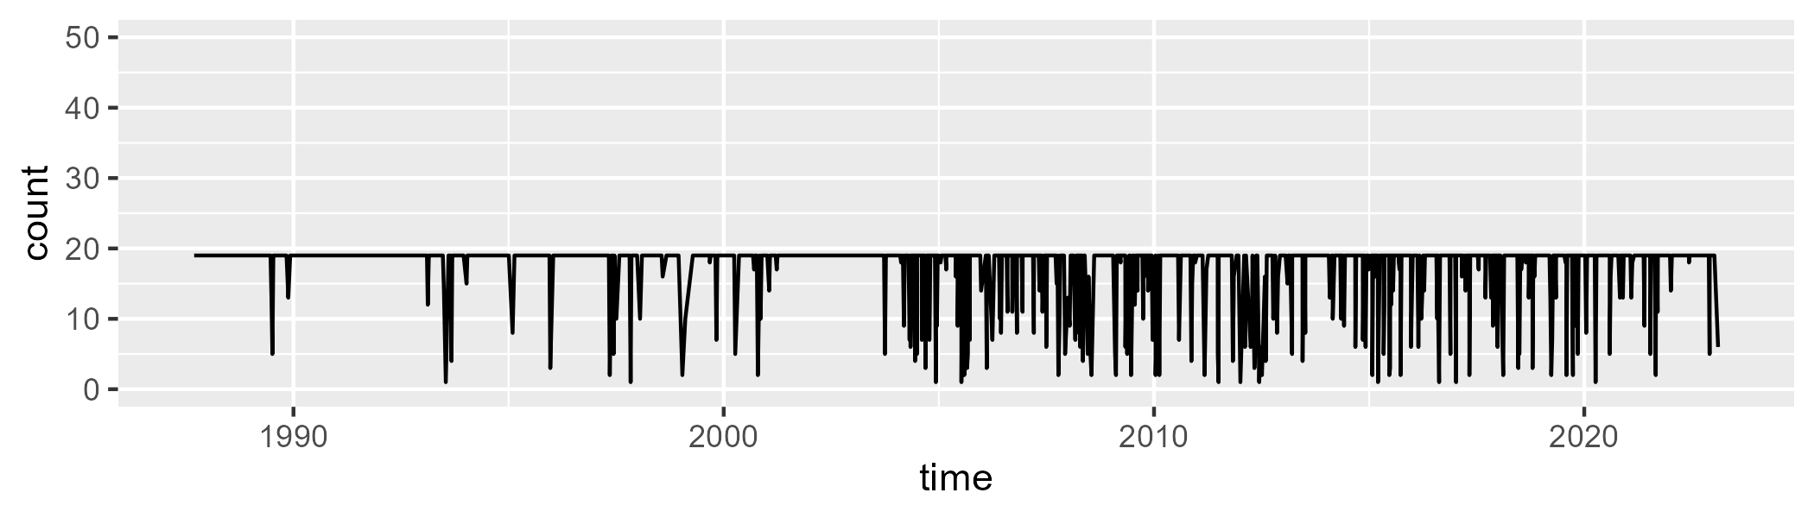

Min. : 1.00 1st Qu.:19.00 Median :19.00 Mean :17.72 3rd Qu.:19.00 Max. :19.00

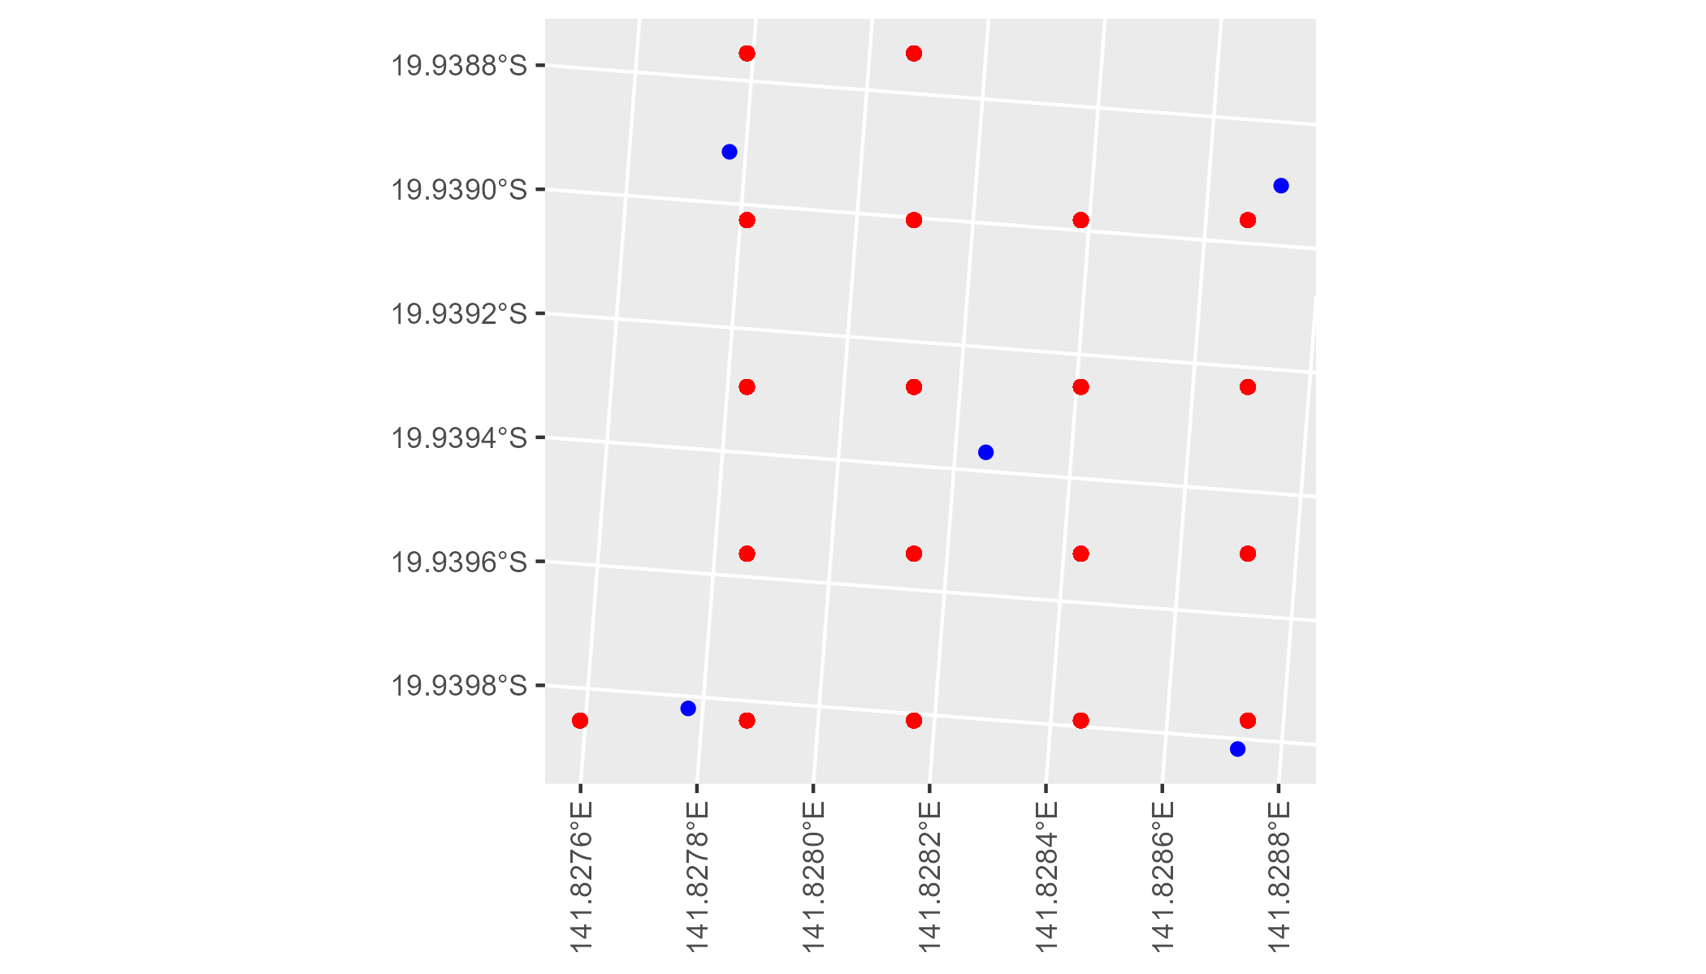

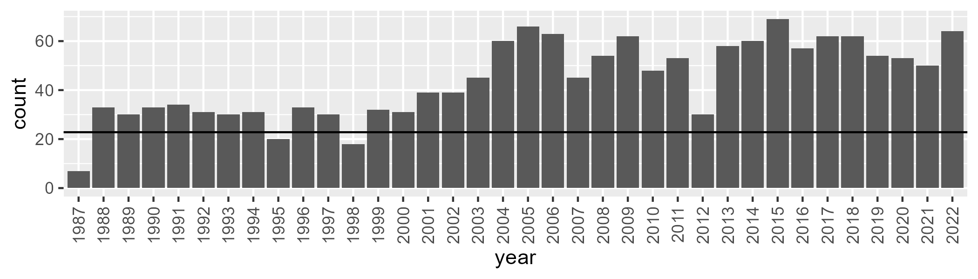

Number of samples: 1586

# QDAGUP0012

| Min. | 1st Qu. | Median | Mean | 3rd Qu. | Max. |
| --- | --- | --- | --- | --- | --- |
| 0 | 7.105716 | 10.90875 | 15.1499 | 20.6401 | 54.27179 |

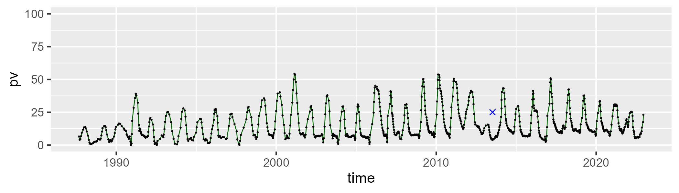

| Min. | 1st Qu. | Median | Mean | 3rd Qu. | Max. |
| --- | --- | --- | --- | --- | --- |
| 17.52937 | 41.80548 | 49.41848 | 49.42803 | 57.1587 | 75.40084 |

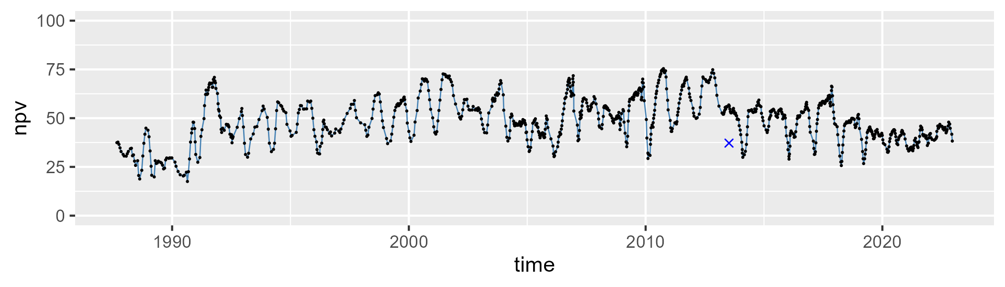

| Min. | 1st Qu. | Median | Mean | 3rd Qu. | Max. |
| --- | --- | --- | --- | --- | --- |
| 2.009794 | 24.99229 | 34.34761 | 34.01973 | 41.56338 | 77.49262 |

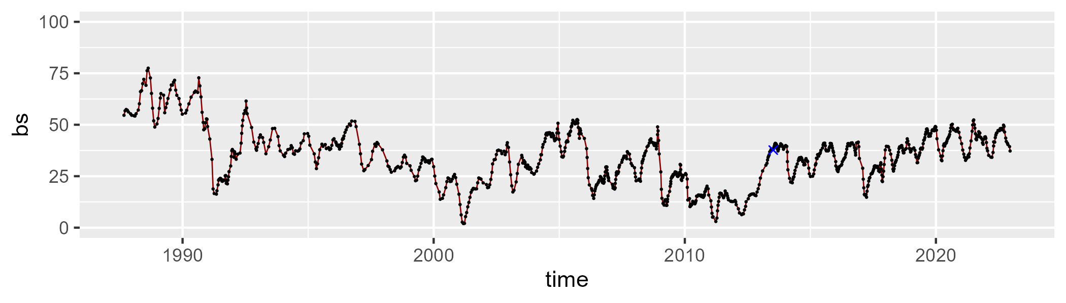

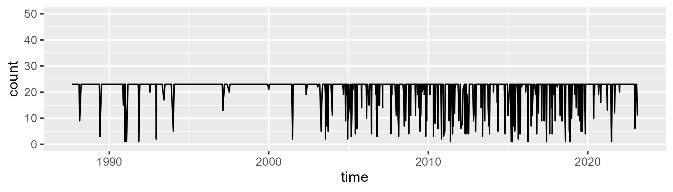

Min. : 1.00 1st Qu.:23.00 Median :23.00 Mean :20.99 3rd Qu.:23.00 Max. :23.00

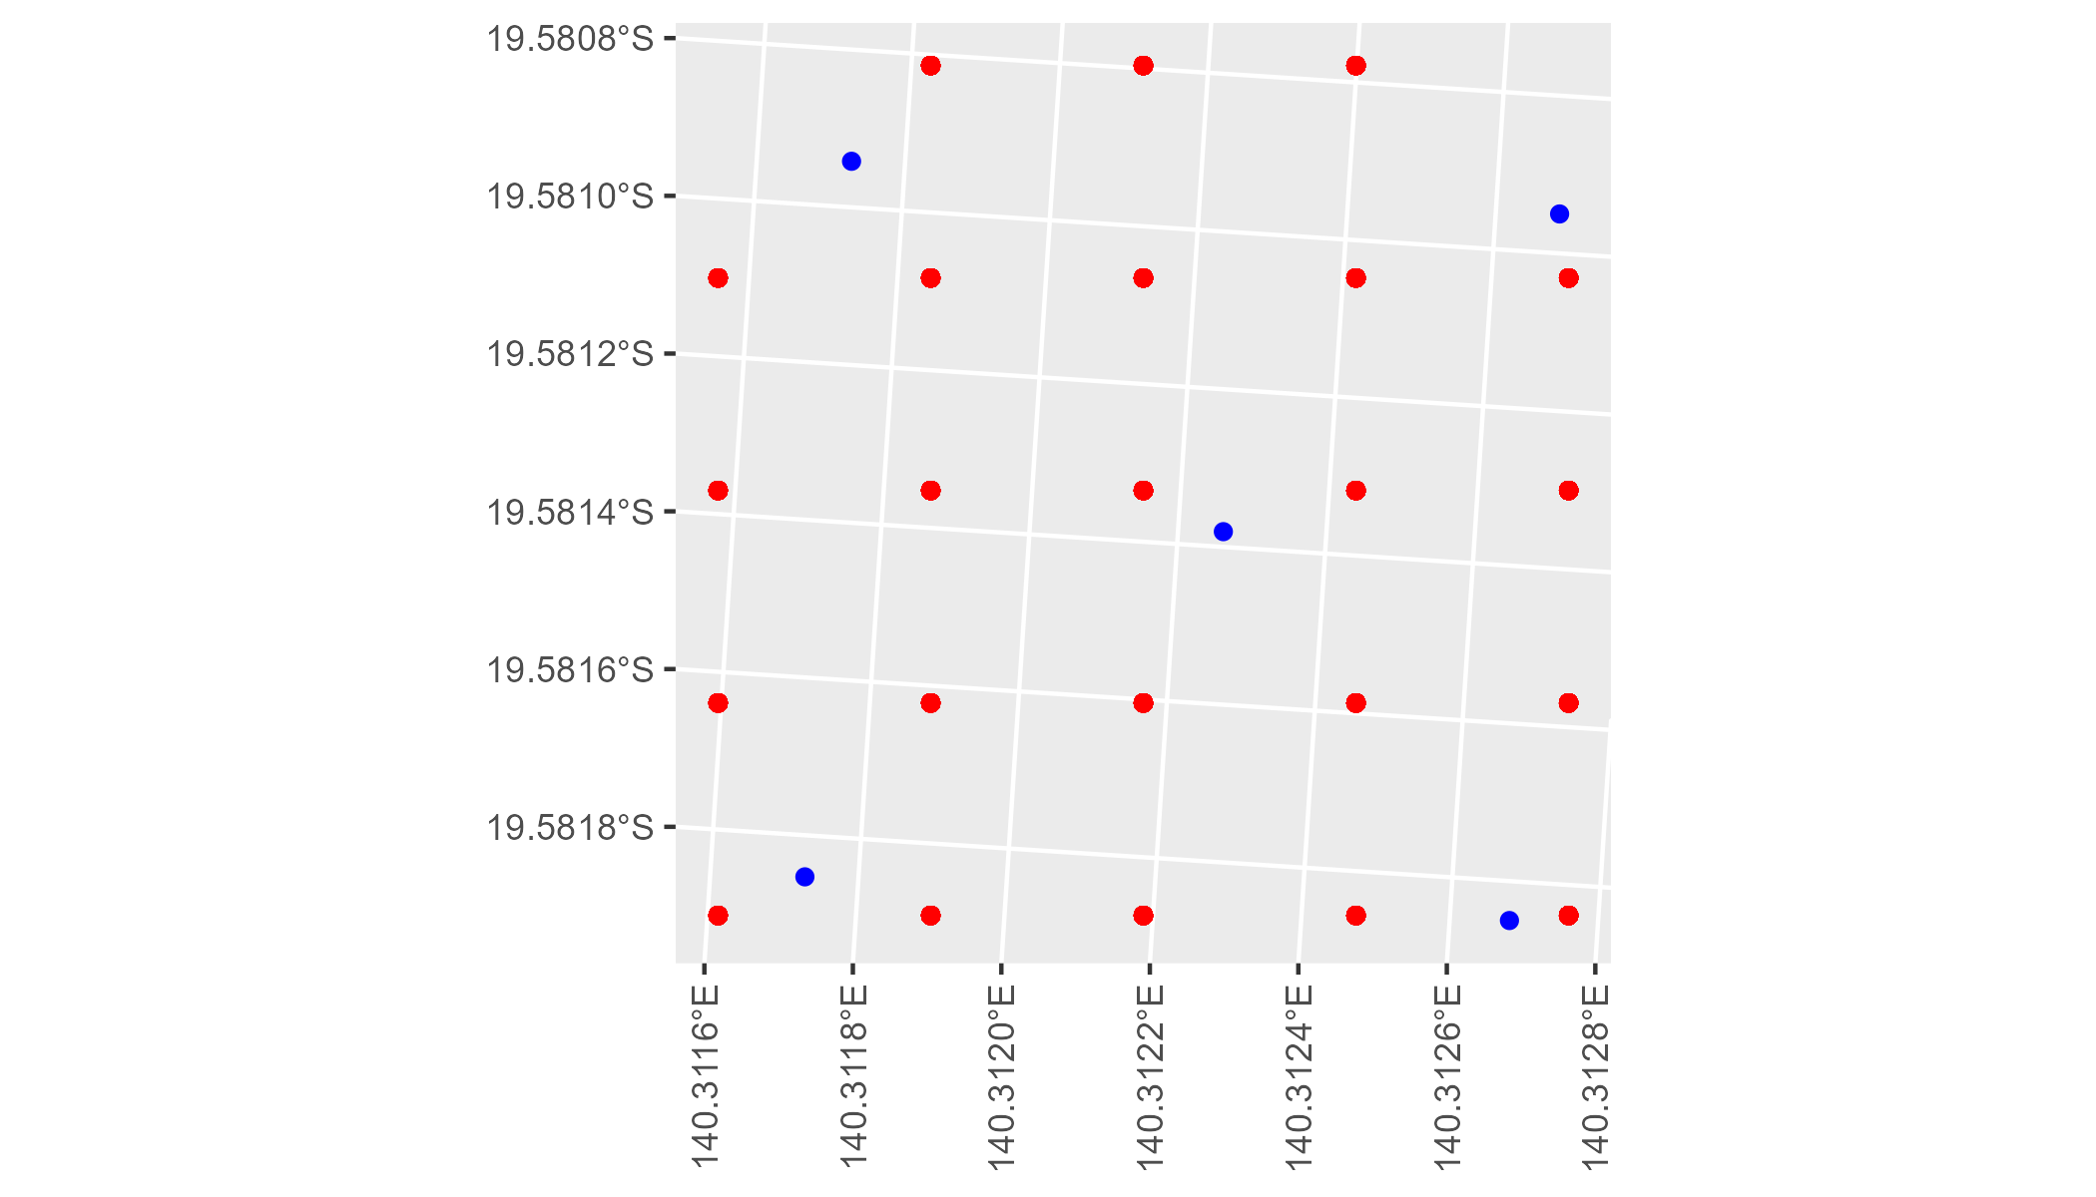

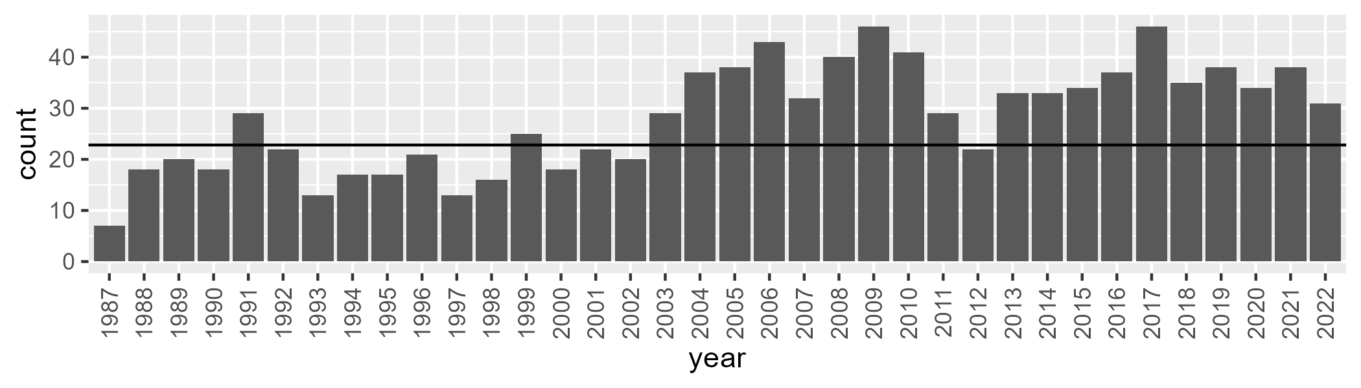

Number of samples: 1012

# QDAGUP0013

| Min. | 1st Qu. | Median | Mean | 3rd Qu. | Max. |
| --- | --- | --- | --- | --- | --- |
| 0 | 5.977927 | 10.92697 | 17.9477 | 25.55189 | 78.95158 |

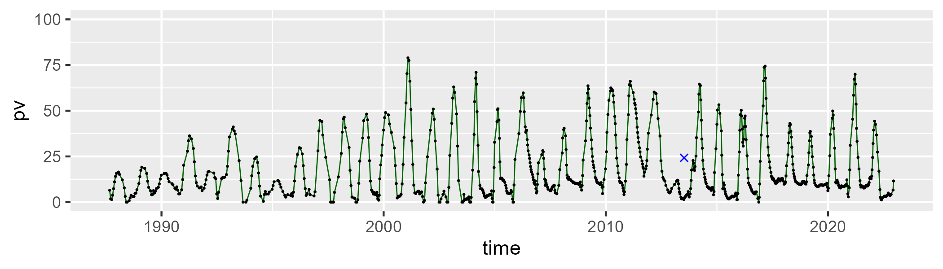

| Min. | 1st Qu. | Median | Mean | 3rd Qu. | Max. |
| --- | --- | --- | --- | --- | --- |
| 19.97569 | 42.31447 | 56.11522 | 57.33871 | 72.73014 | 101.7706 |

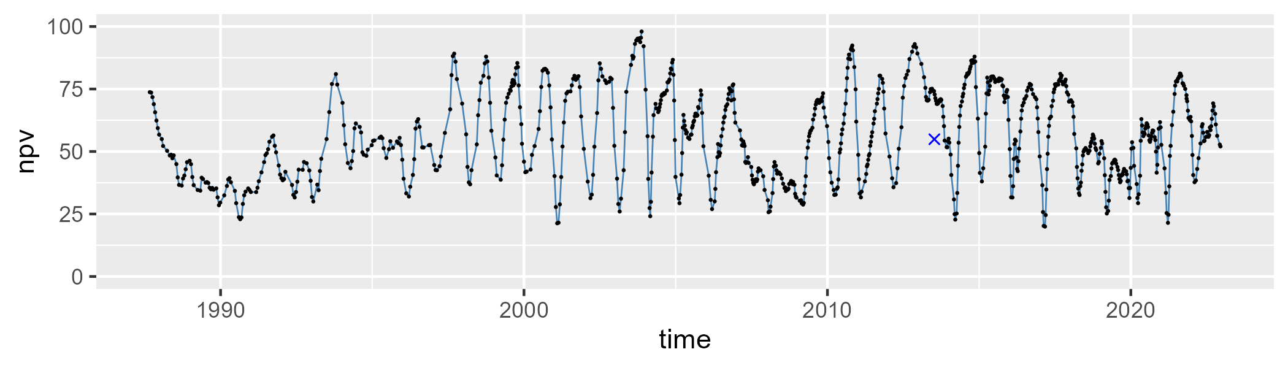

| Min. | 1st Qu. | Median | Mean | 3rd Qu. | Max. |
| --- | --- | --- | --- | --- | --- |
| 0 | 11.86327 | 19.49153 | 23.4339 | 33.75407 | 68.65685 |

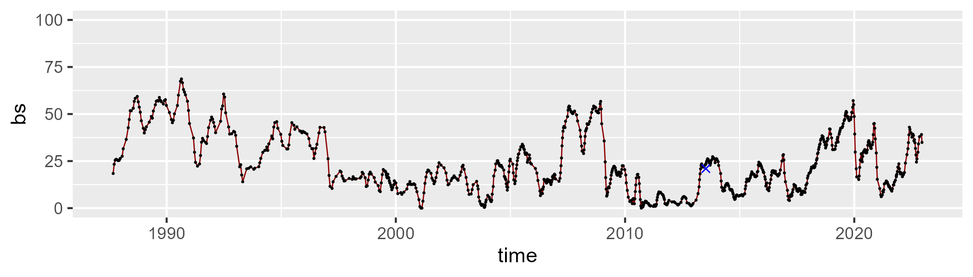

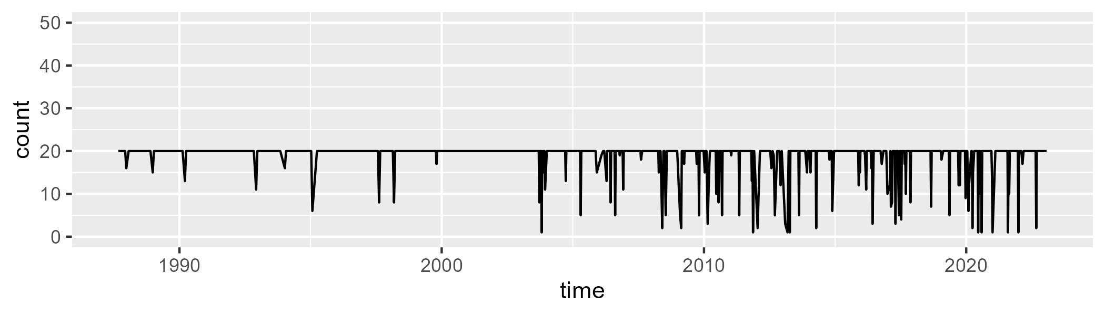

Min. : 1.00 1st Qu.:20.00 Median :20.00 Mean :18.94 3rd Qu.:20.00 Max. :20.00

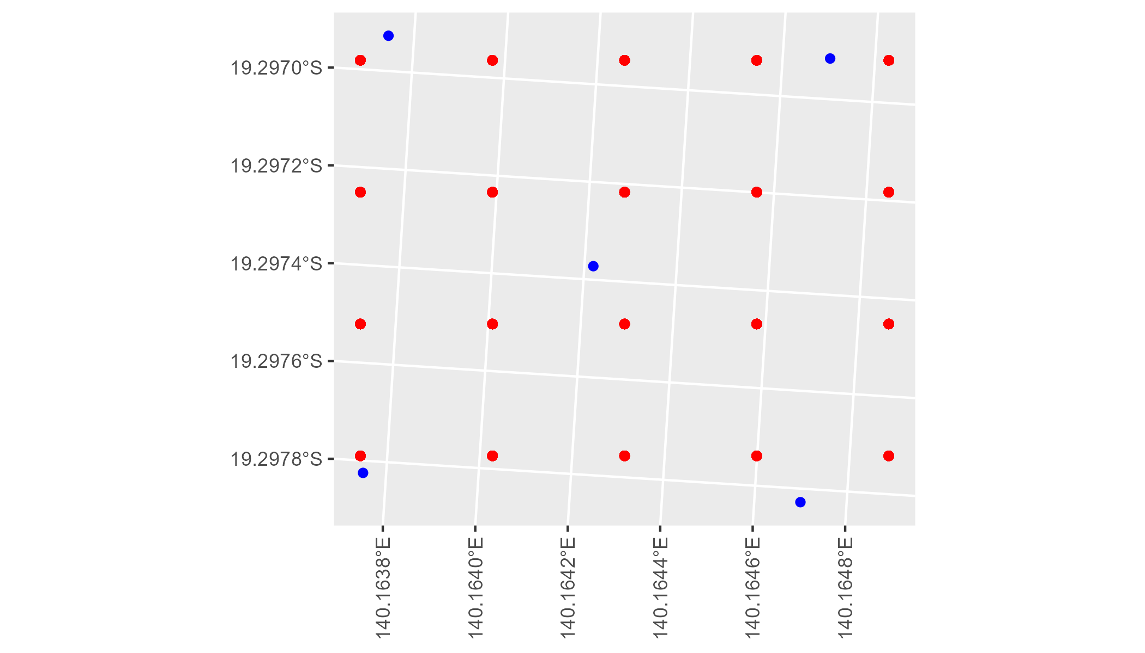

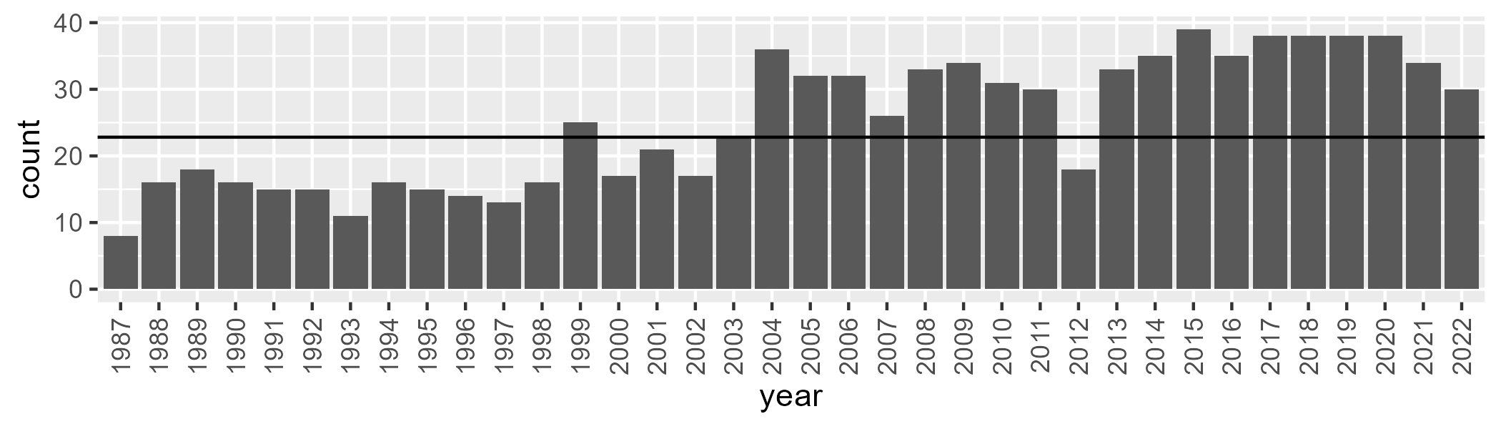

Number of samples: 906

# QDAGUP0014

| Min. | 1st Qu. | Median | Mean | 3rd Qu. | Max. |
| --- | --- | --- | --- | --- | --- |
| 0 | 7.021792 | 12.51682 | 19.7618 | 29.36249 | 75.07068 |

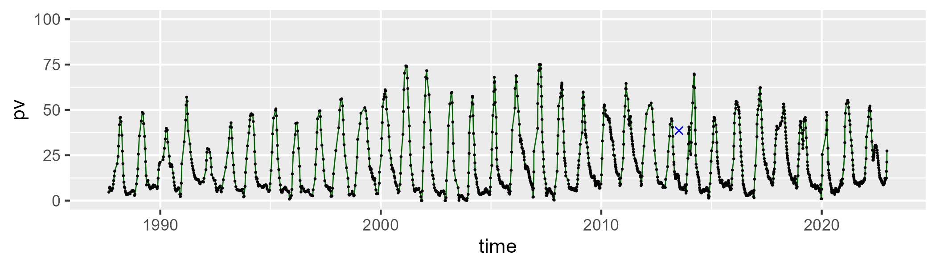

| Min. | 1st Qu. | Median | Mean | 3rd Qu. | Max. |
| --- | --- | --- | --- | --- | --- |
| 21.20444 | 52.89243 | 66.55565 | 63.82568 | 74.45823 | 101.265 |

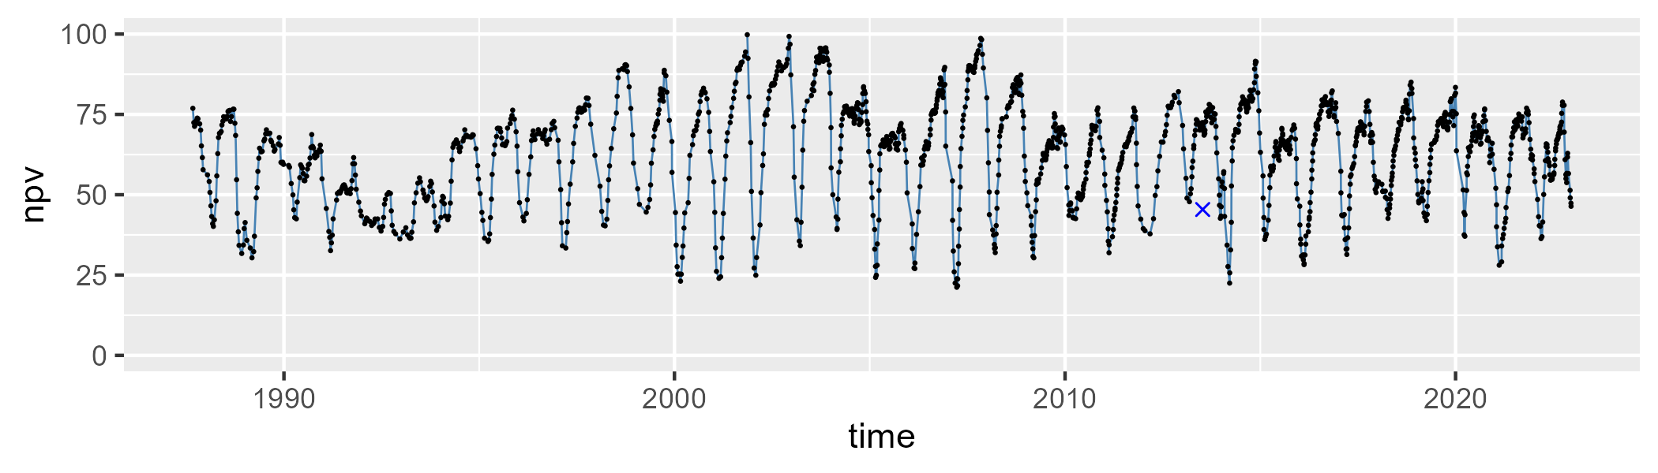

| Min. | 1st Qu. | Median | Mean | 3rd Qu. | Max. |
| --- | --- | --- | --- | --- | --- |
| 0 | 8.481164 | 14.24019 | 15.19424 | 20.5185 | 61.03269 |

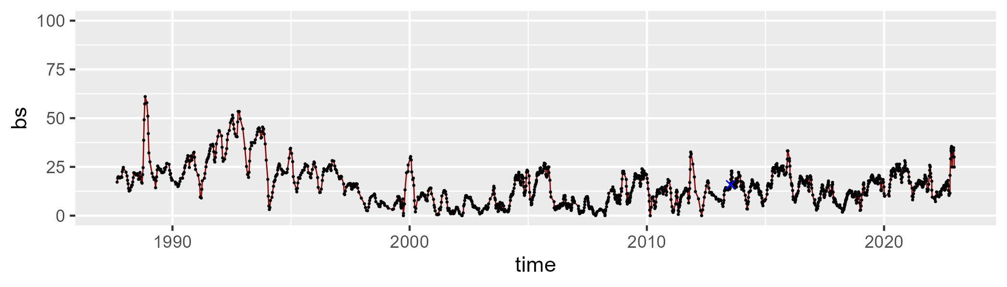

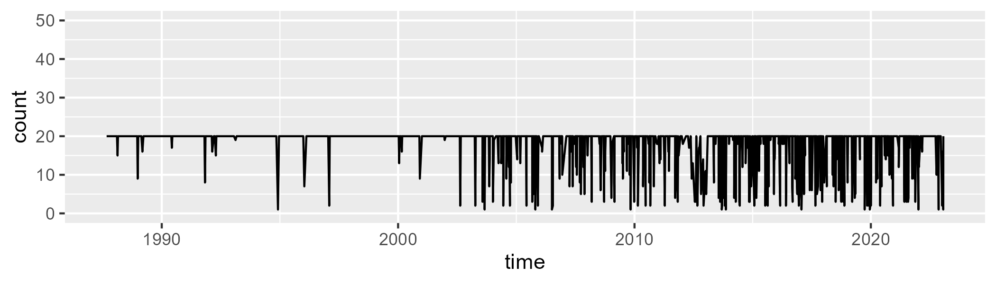

Min. : 1.00 1st Qu.:20.00 Median :20.00 Mean :18.27 3rd Qu.:20.00 Max. :20.00

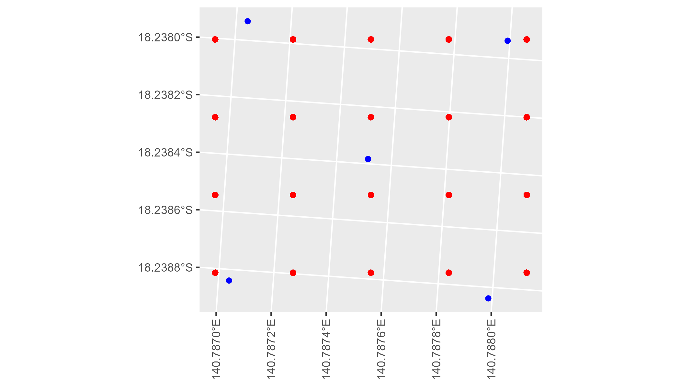

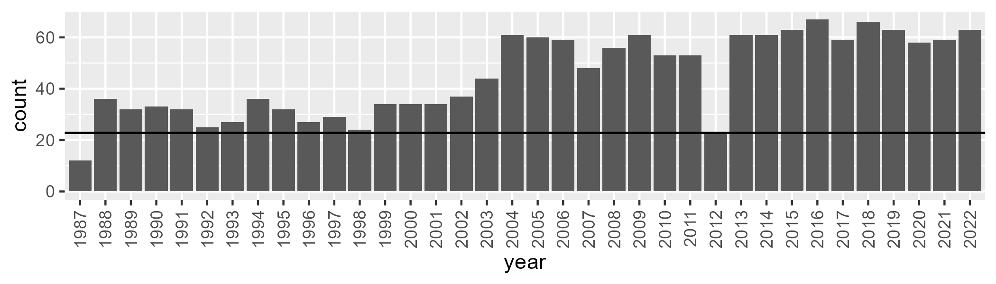

Number of samples: 1622

# QDAGUP0015

| Min. | 1st Qu. | Median | Mean | 3rd Qu. | Max. |
| --- | --- | --- | --- | --- | --- |
| 0 | 7.350882 | 12.96437 | 20.69967 | 30.81306 | 73.68016 |

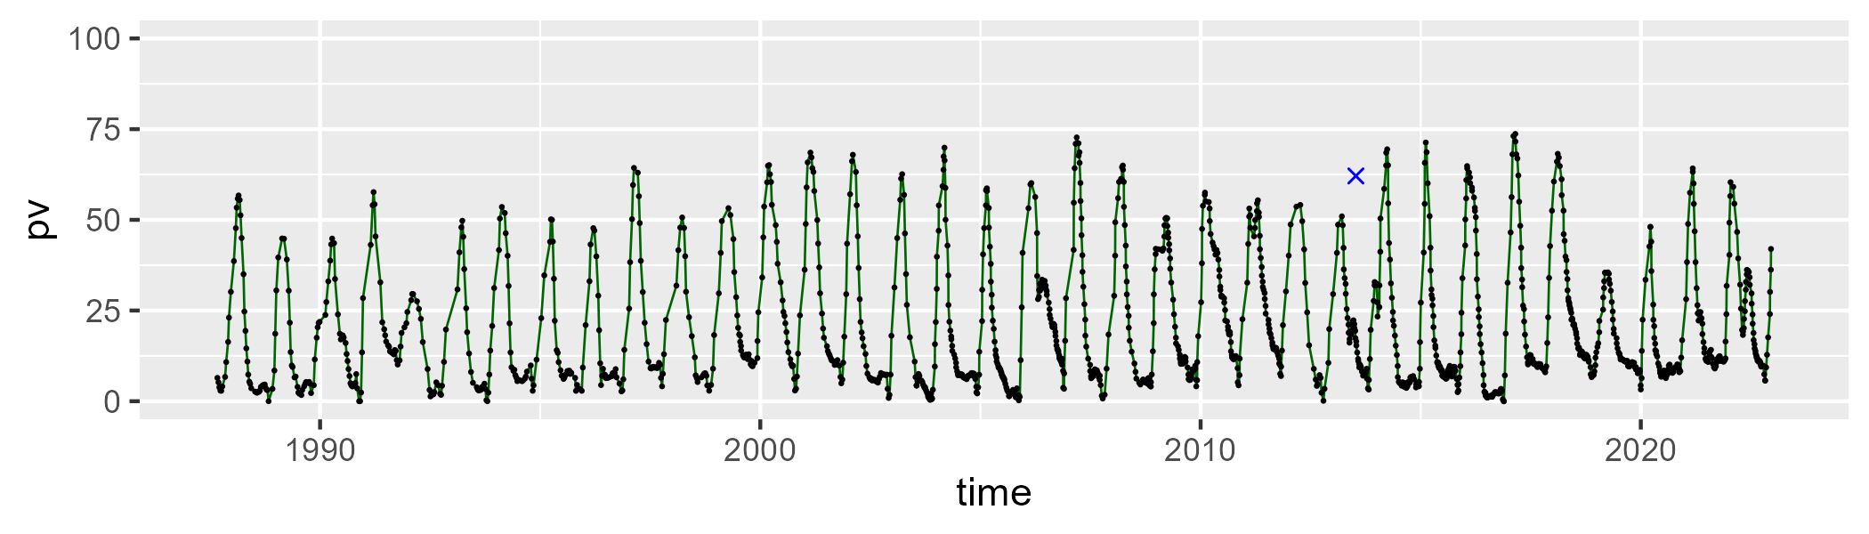

| Min. | 1st Qu. | Median | Mean | 3rd Qu. | Max. |
| --- | --- | --- | --- | --- | --- |
| 10.00213 | 52.2859 | 71.13057 | 67.11328 | 83.06318 | 98.46058 |

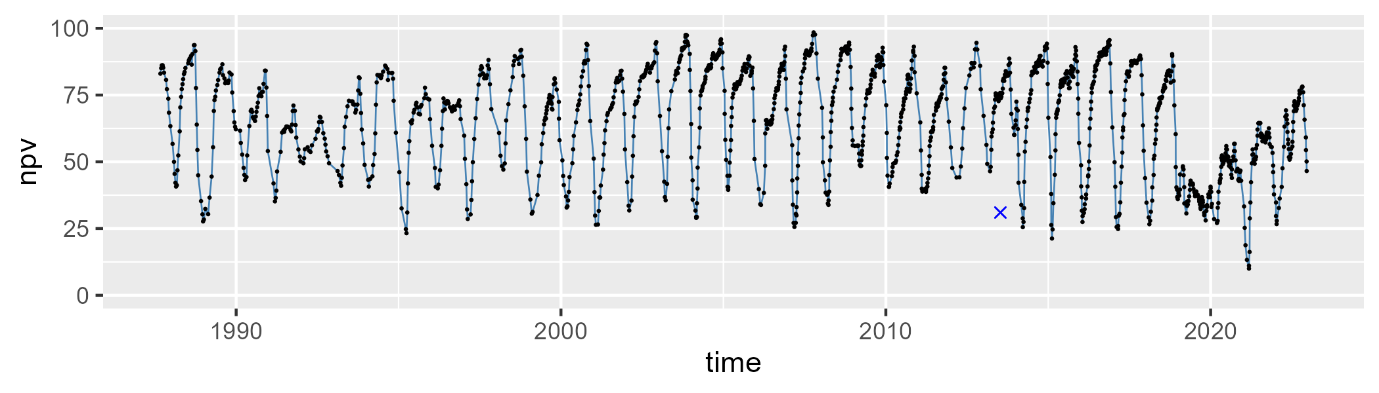

| Min. | 1st Qu. | Median | Mean | 3rd Qu. | Max. |
| --- | --- | --- | --- | --- | --- |
| 0 | 2.599713 | 6.956877 | 11.10091 | 13.8123 | 60.02039 |

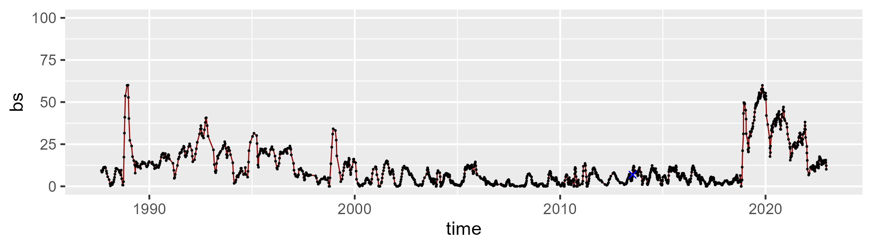

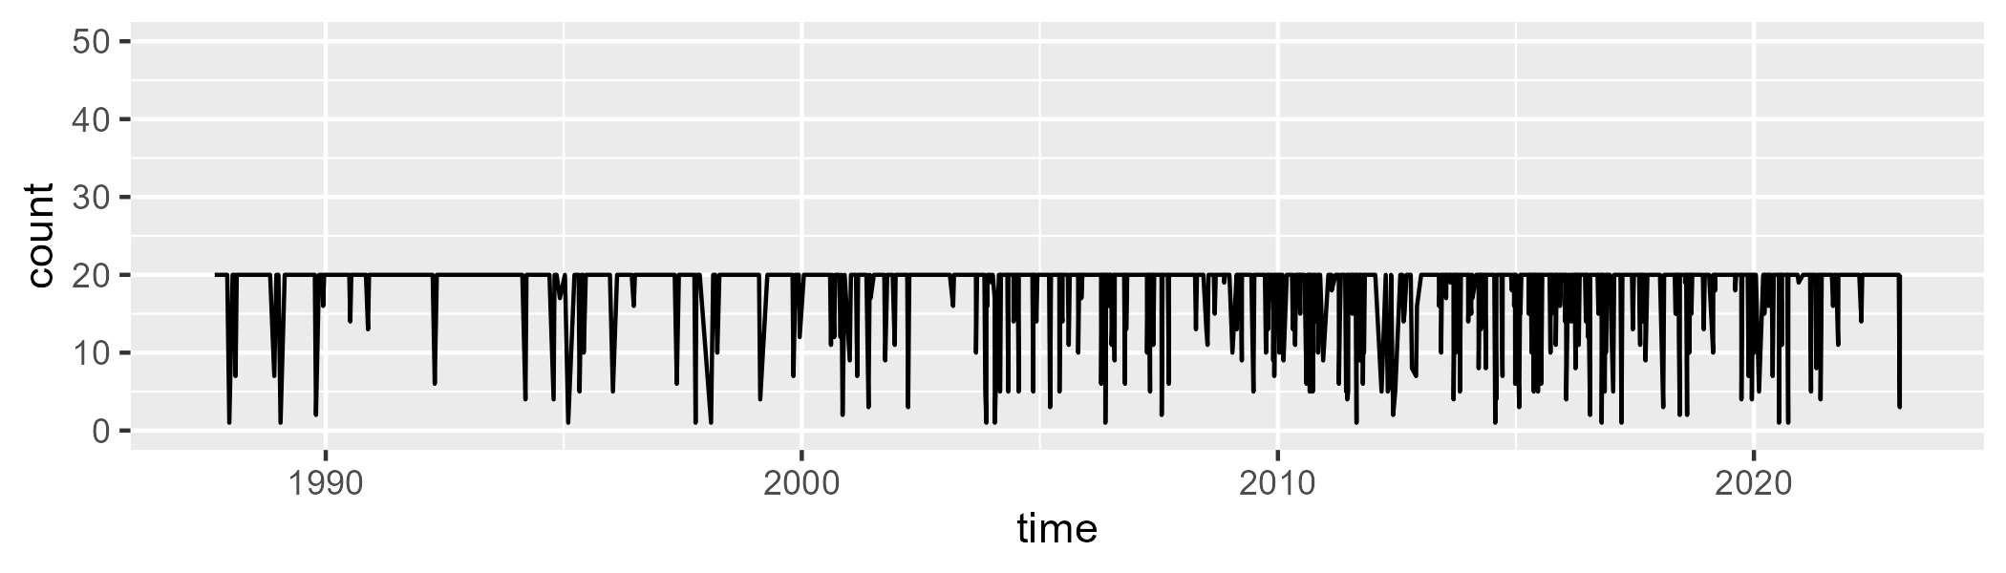

Min. : 1.00 1st Qu.:20.00 Median :20.00 Mean :18.58 3rd Qu.:20.00 Max. :20.00

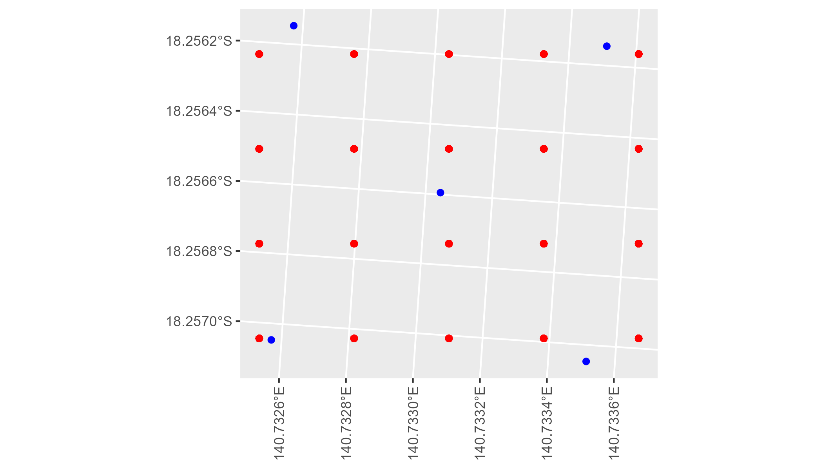

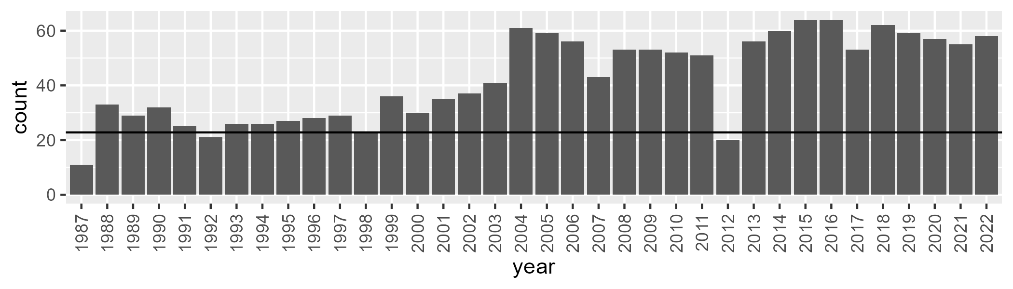

Number of samples: 1525

# QDAGUP0016

| Min. | 1st Qu. | Median | Mean | 3rd Qu. | Max. |
| --- | --- | --- | --- | --- | --- |
| 4.302698 | 14.0901 | 20.13964 | 23.84213 | 30.84067 | 65.71418 |

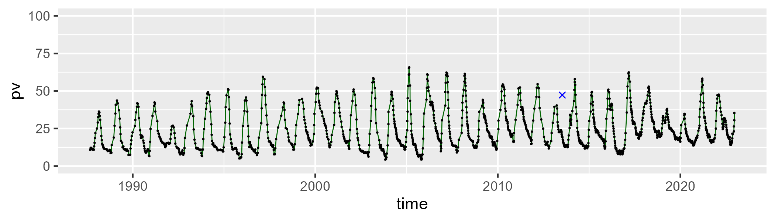

| Min. | 1st Qu. | Median | Mean | 3rd Qu. | Max. |
| --- | --- | --- | --- | --- | --- |
| 25.13923 | 48.04885 | 56.60967 | 57.34613 | 66.80355 | 93.1723 |

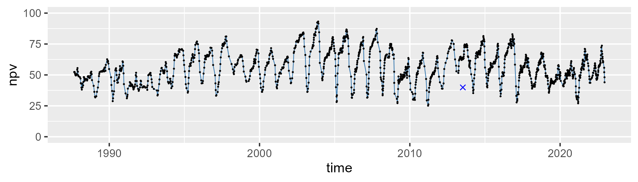

| Min. | 1st Qu. | Median | Mean | 3rd Qu. | Max. |
| --- | --- | --- | --- | --- | --- |
| 0 | 10.82718 | 16.23953 | 17.57314 | 22.54537 | 49.88201 |

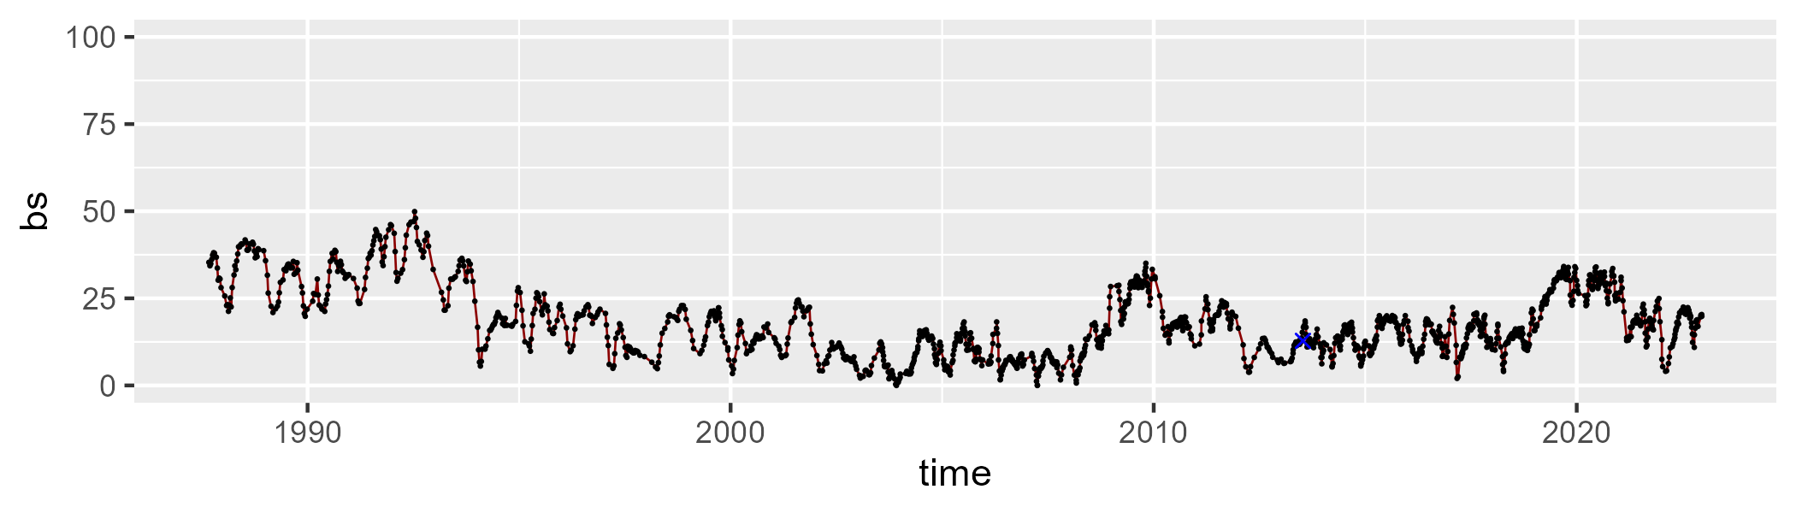

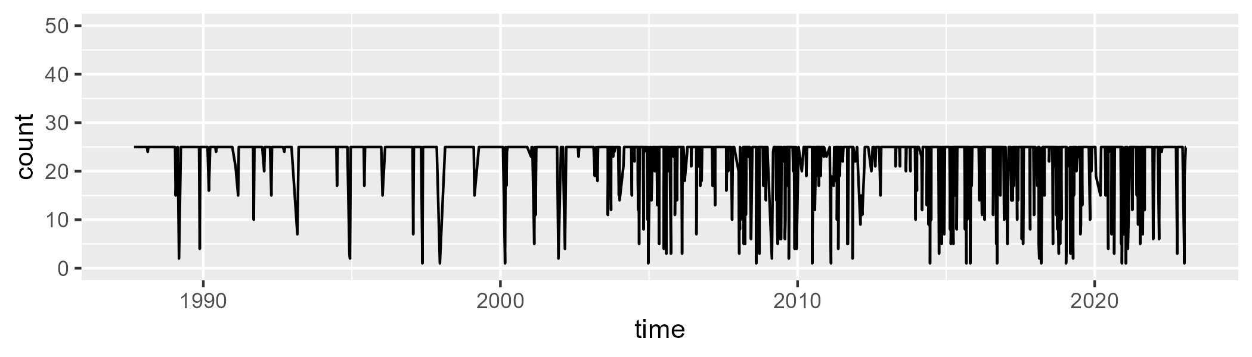

Min. : 1.00 1st Qu.:25.00 Median :25.00 Mean :22.92 3rd Qu.:25.00 Max. :25.00

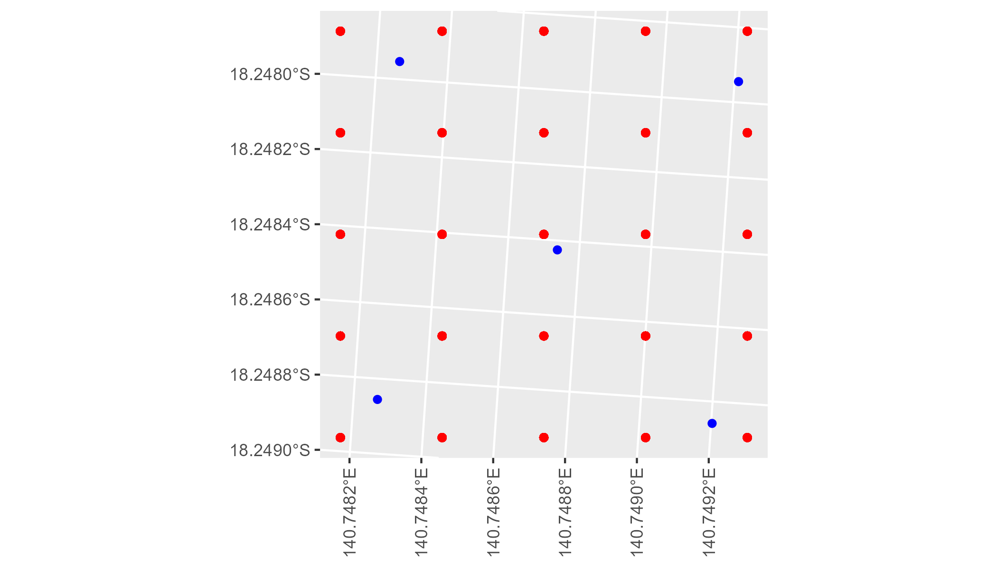

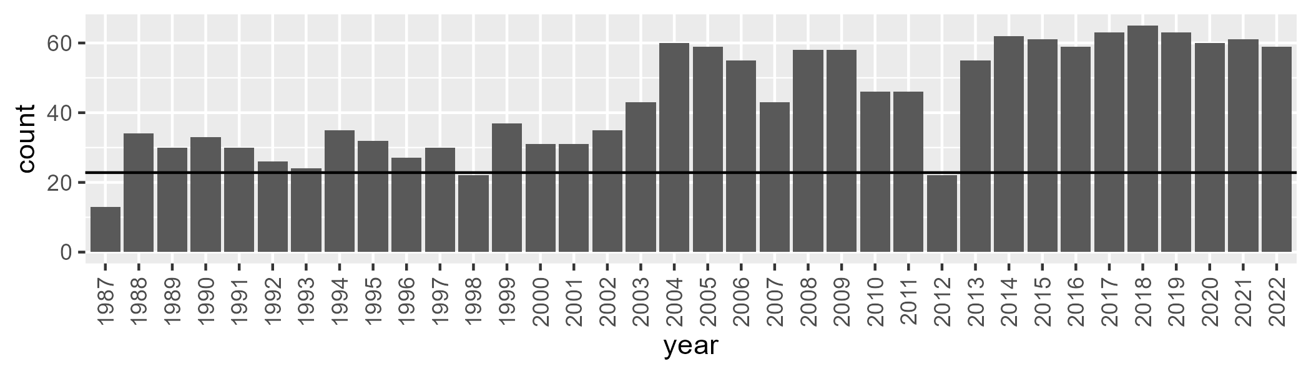

Number of samples: 1568

# QDAGUP0017

| Min. | 1st Qu. | Median | Mean | 3rd Qu. | Max. |
| --- | --- | --- | --- | --- | --- |
| 2.203456 | 11.40746 | 15.74019 | 18.0402 | 23.0616 | 59.48083 |

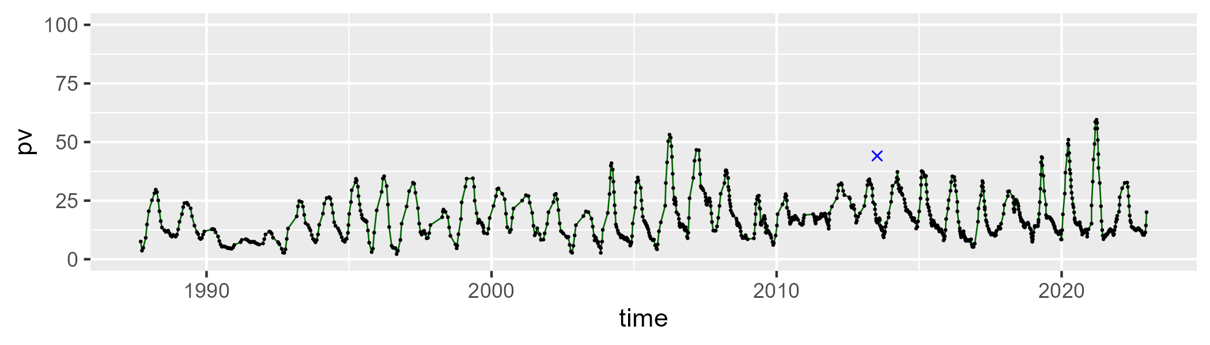

| Min. | 1st Qu. | Median | Mean | 3rd Qu. | Max. |
| --- | --- | --- | --- | --- | --- |
| 17.87593 | 39.88664 | 47.27671 | 47.41454 | 54.41002 | 76.72951 |

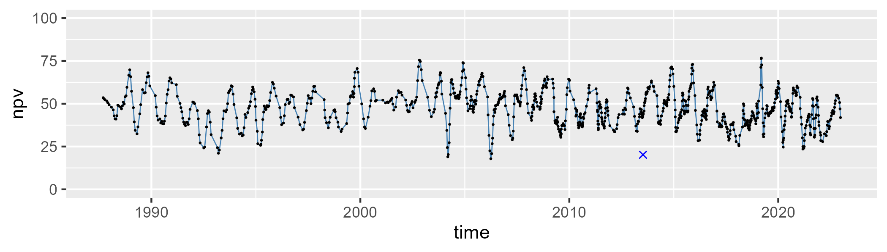

| Min. | 1st Qu. | Median | Mean | 3rd Qu. | Max. |
| --- | --- | --- | --- | --- | --- |
| 5.911633 | 27.20068 | 32.75559 | 33.26238 | 38.87429 | 67.62987 |

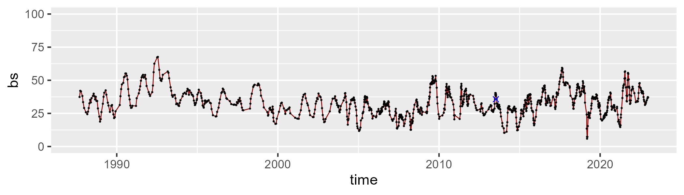

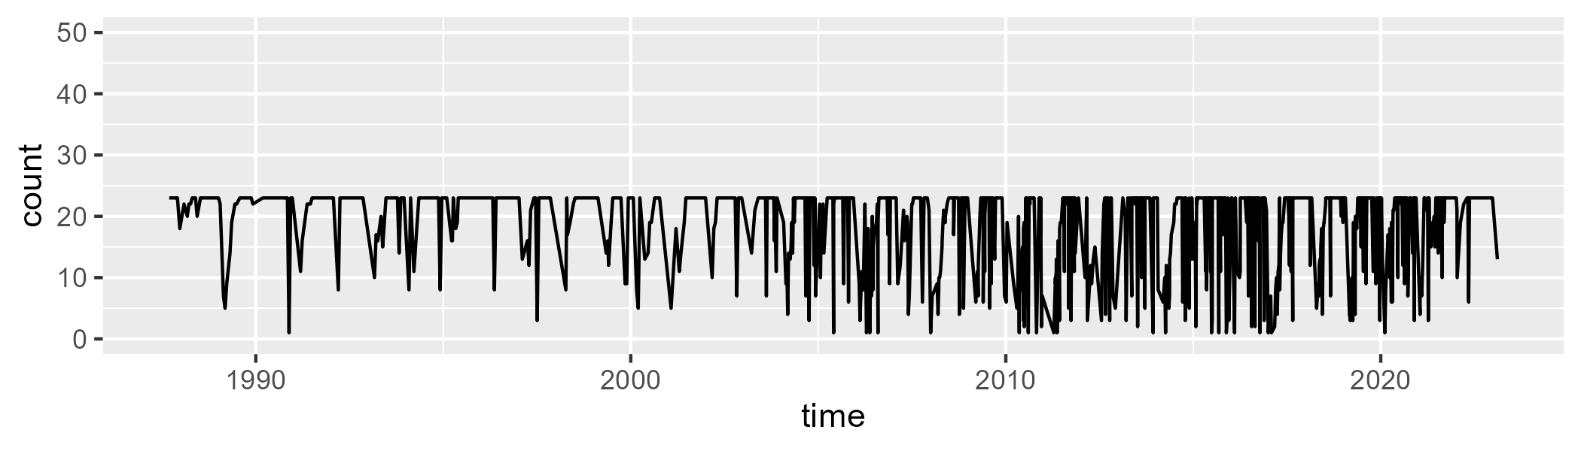

Min. : 1.00 1st Qu.:15.00 Median :23.00 Mean :18.67 3rd Qu.:23.00 Max. :23.00

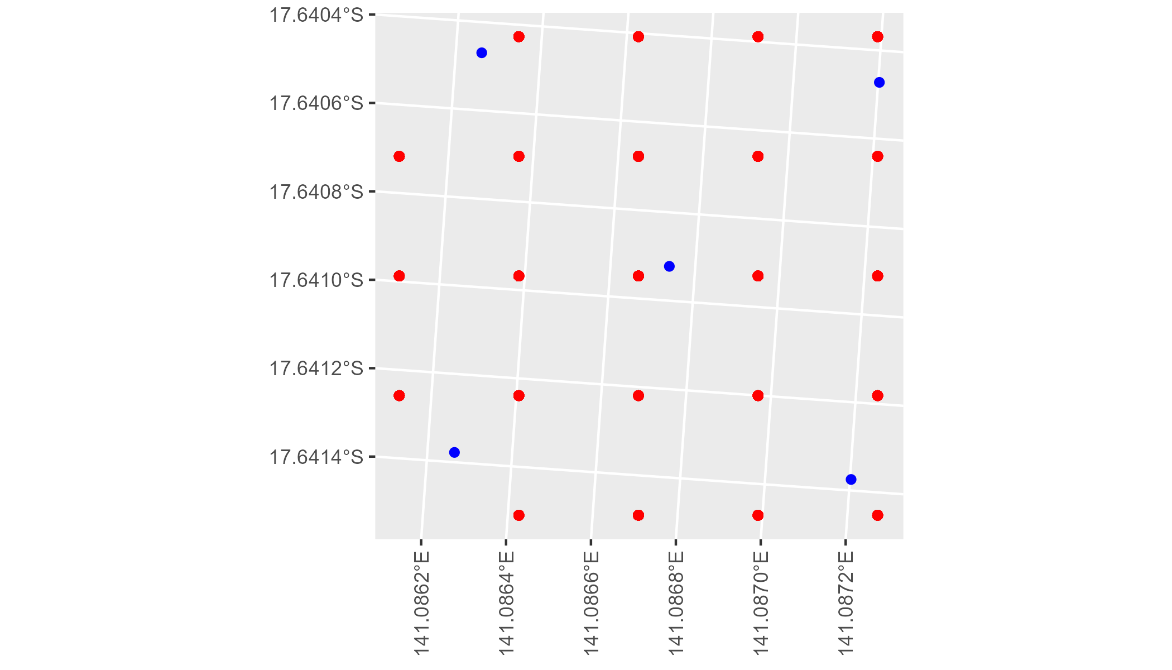

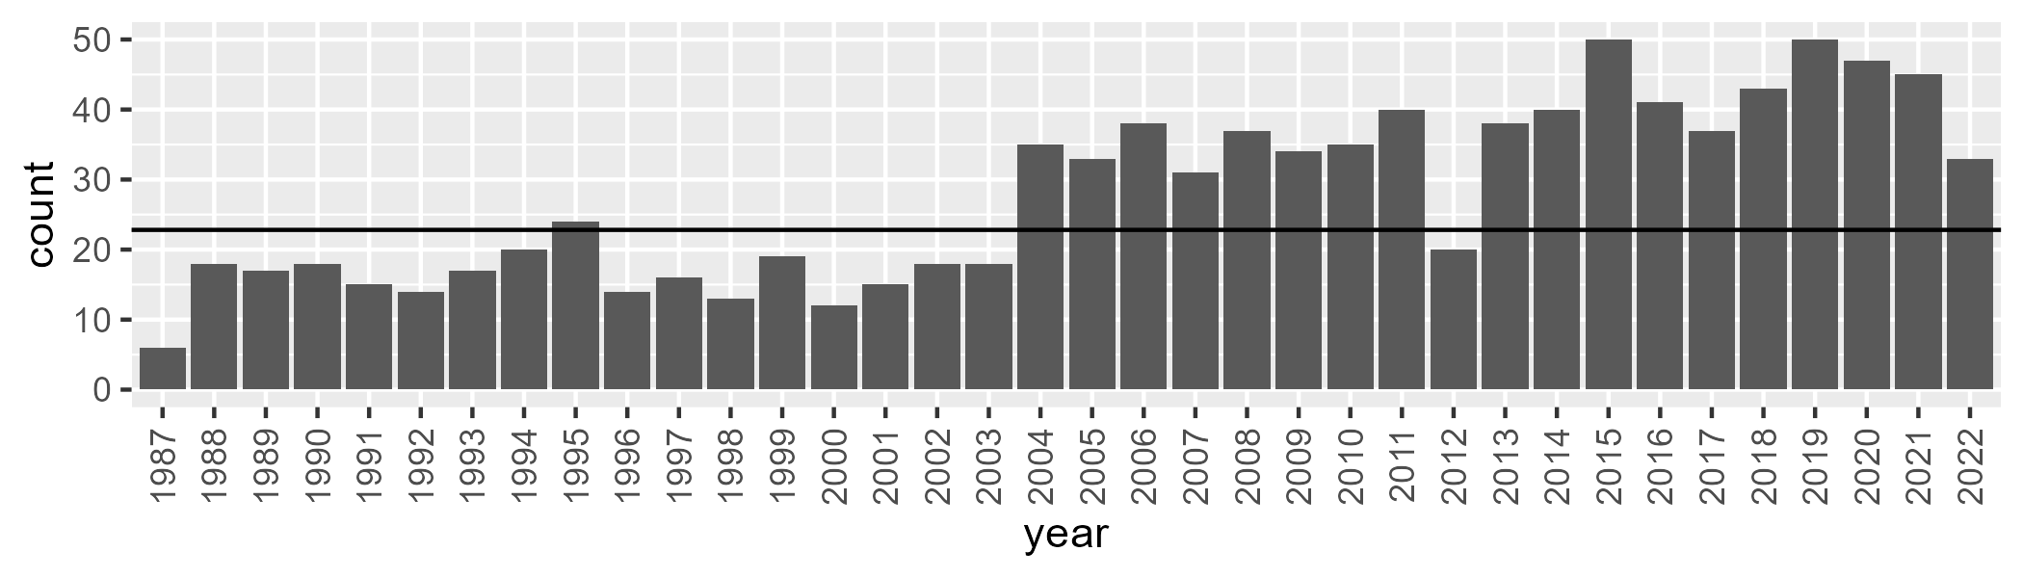

Number of samples: 1001

# QDAGUP0018

| Min. | 1st Qu. | Median | Mean | 3rd Qu. | Max. |
| --- | --- | --- | --- | --- | --- |
| 9.598147 | 30.18411 | 36.7222 | 36.9982 | 44.18983 | 66.78512 |

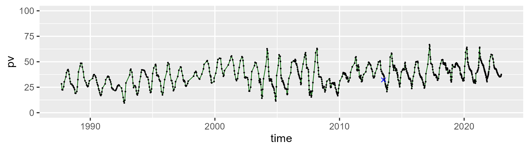

| Min. | 1st Qu. | Median | Mean | 3rd Qu. | Max. |
| --- | --- | --- | --- | --- | --- |
| 23.80867 | 44.78455 | 51.89164 | 51.93073 | 58.45532 | 87.43984 |

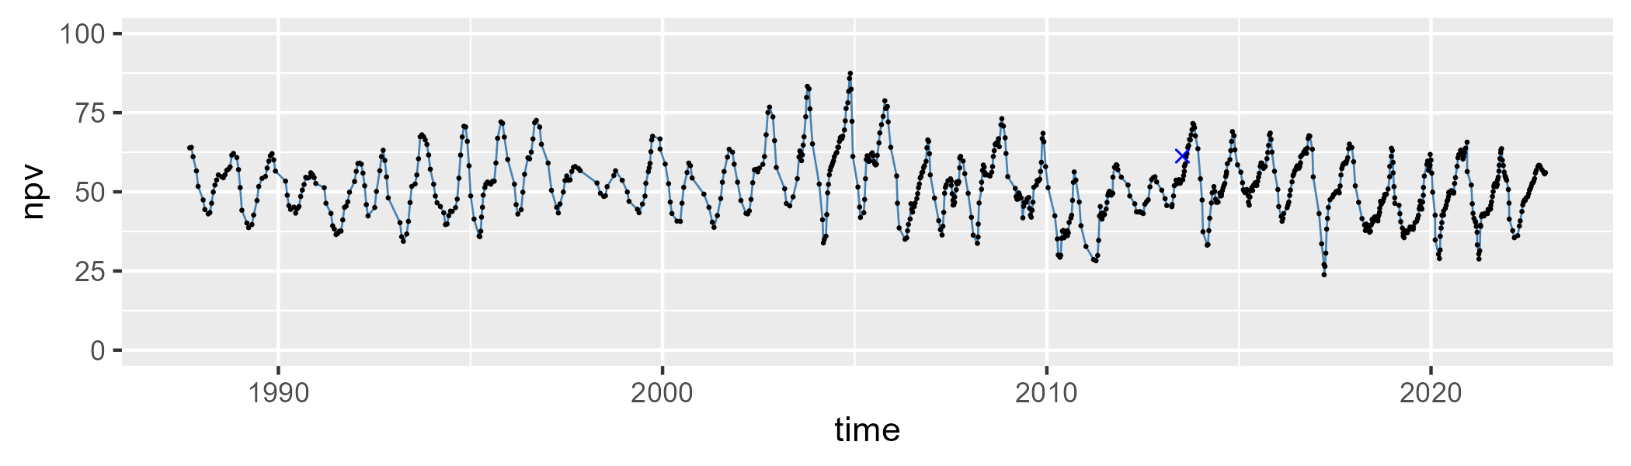

| Min. | 1st Qu. | Median | Mean | 3rd Qu. | Max. |
| --- | --- | --- | --- | --- | --- |
| 0 | 5.218888 | 7.409666 | 9.84444 | 13.0801 | 34.64997 |

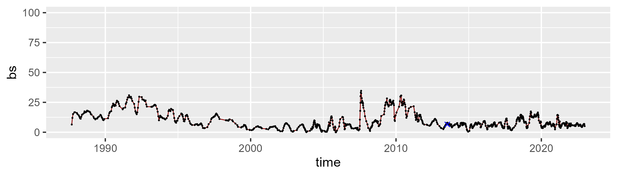

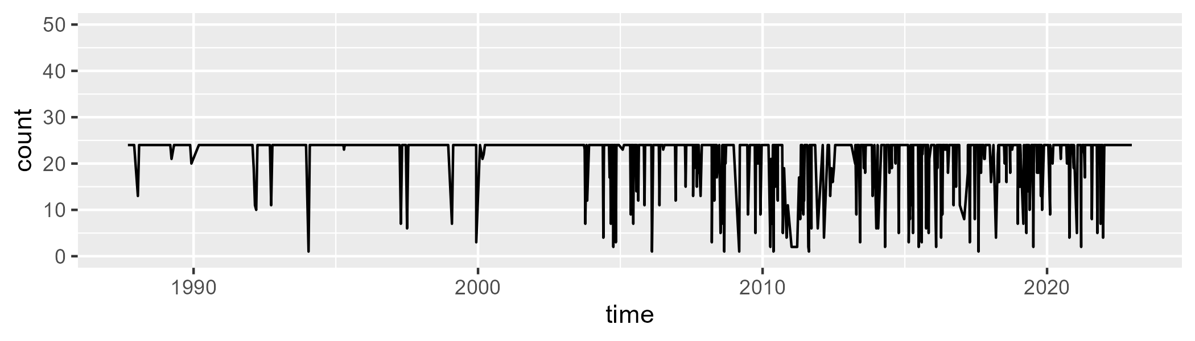

Min. : 1.00 1st Qu.:24.00 Median :24.00 Mean :21.74 3rd Qu.:24.00 Max. :24.00

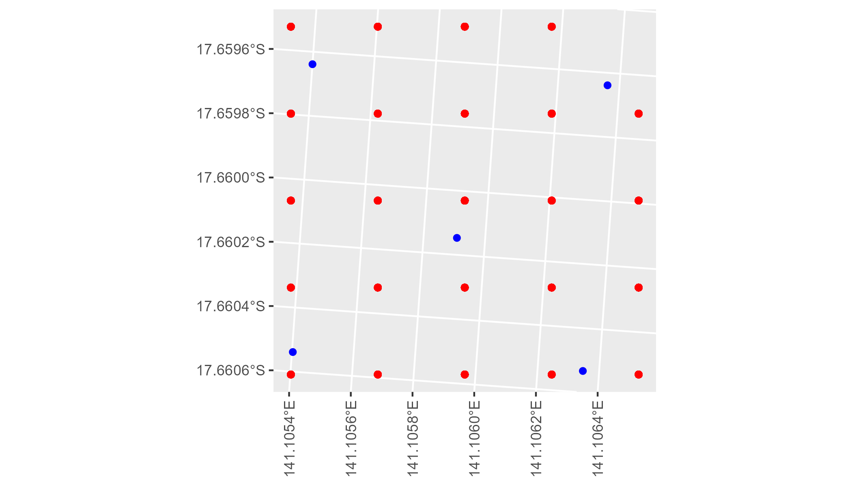

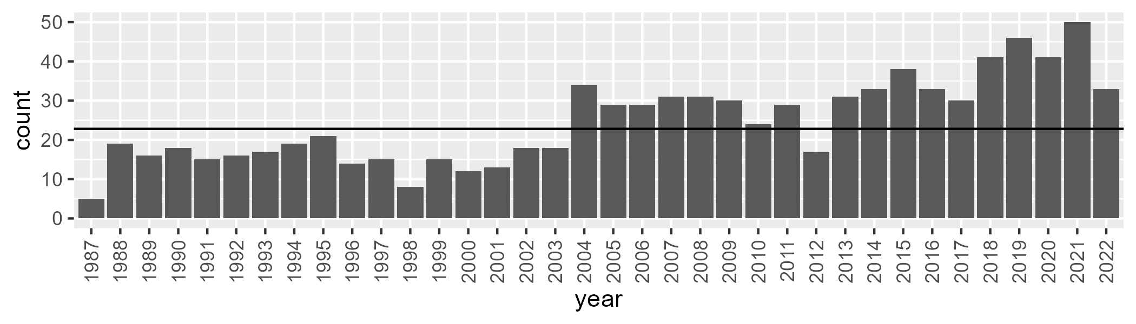

Number of samples: 889

# QDAGUP0019

| Min. | 1st Qu. | Median | Mean | 3rd Qu. | Max. |
| --- | --- | --- | --- | --- | --- |
| 0 | 6.519417 | 8.944158 | 9.587141 | 11.54821 | 35.4077 |

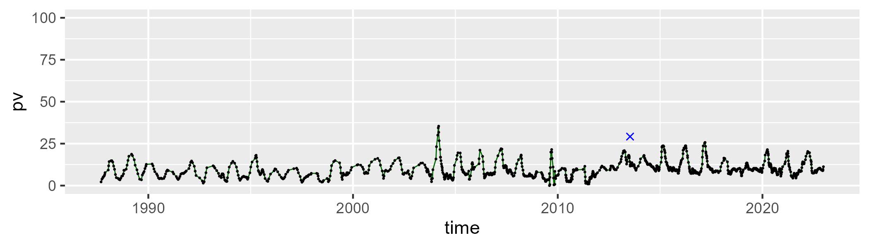

| Min. | 1st Qu. | Median | Mean | 3rd Qu. | Max. |
| --- | --- | --- | --- | --- | --- |
| 17.51109 | 48.94728 | 57.79163 | 58.02384 | 68.20695 | 89.1897 |

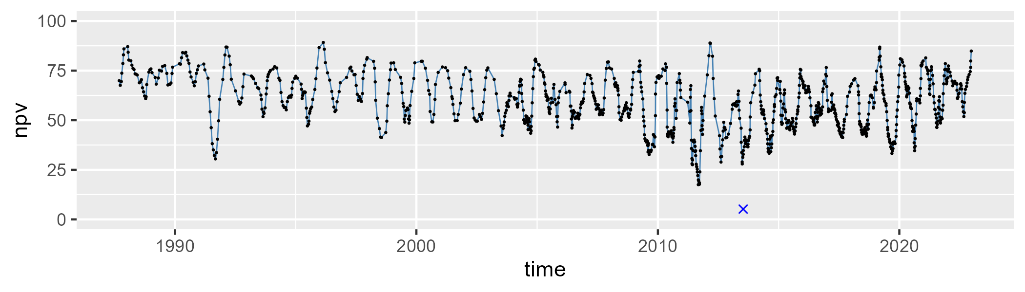

| Min. | 1st Qu. | Median | Mean | 3rd Qu. | Max. |
| --- | --- | --- | --- | --- | --- |
| 0 | 19.20812 | 32.17723 | 31.21133 | 41.84526 | 75.54141 |

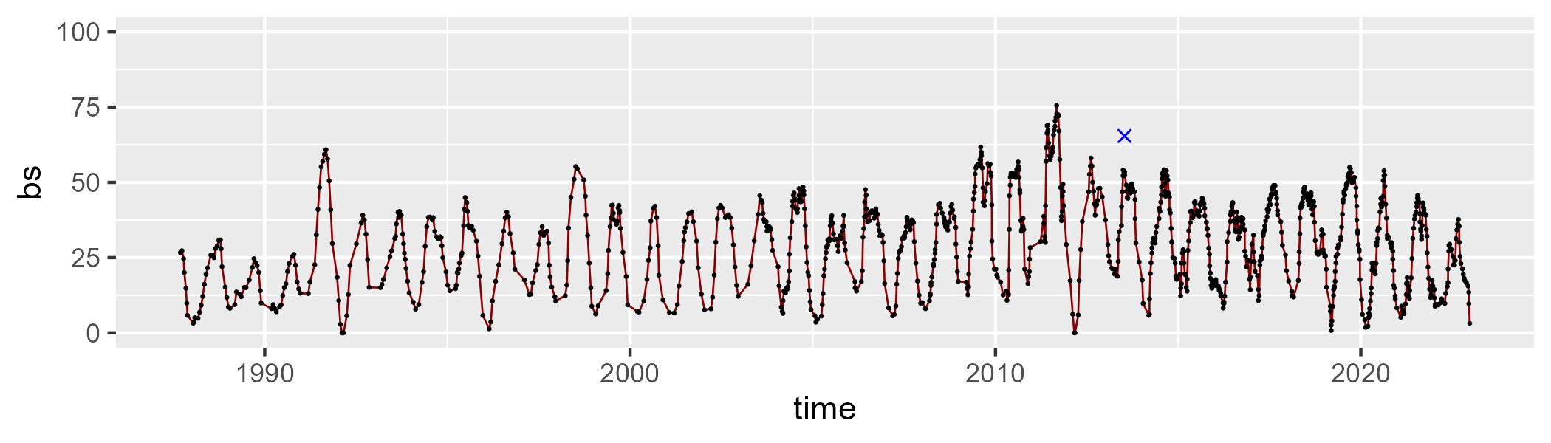

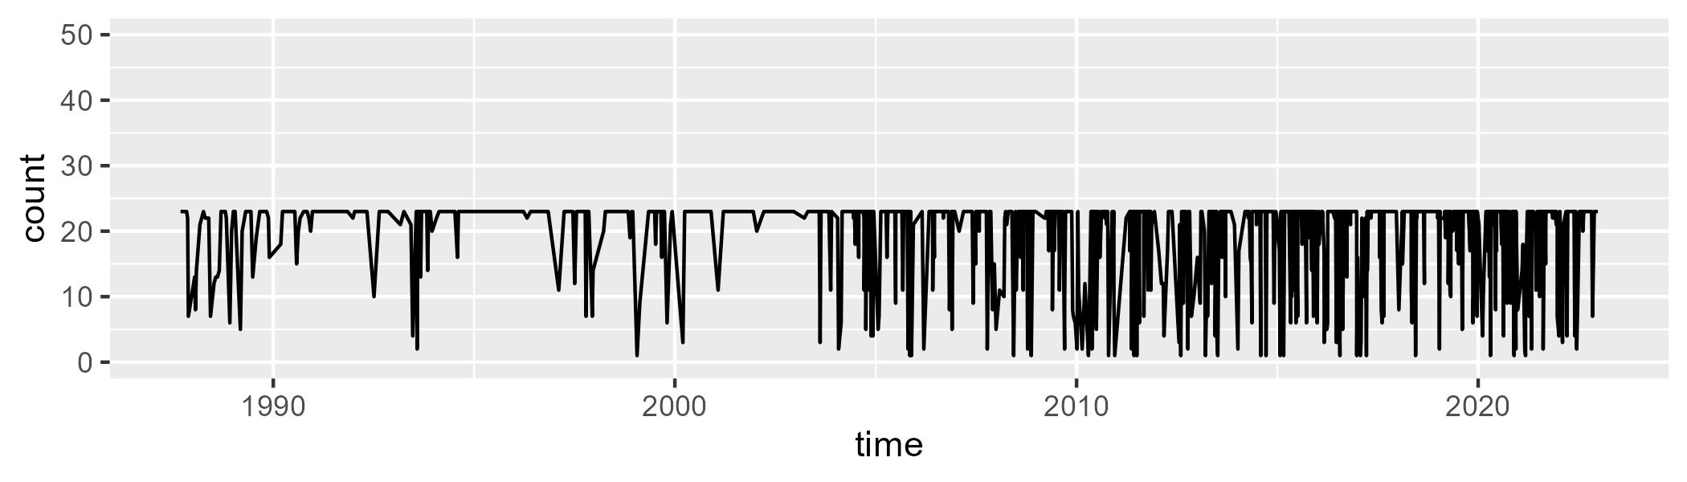

Min. : 1.00 1st Qu.:22.00 Median :23.00 Mean :19.87 3rd Qu.:23.00 Max. :23.00

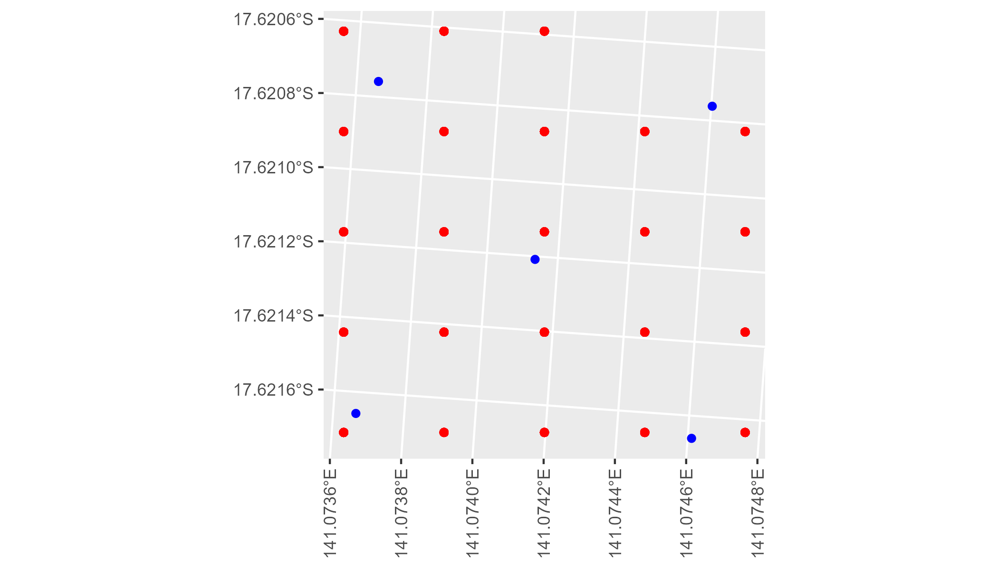

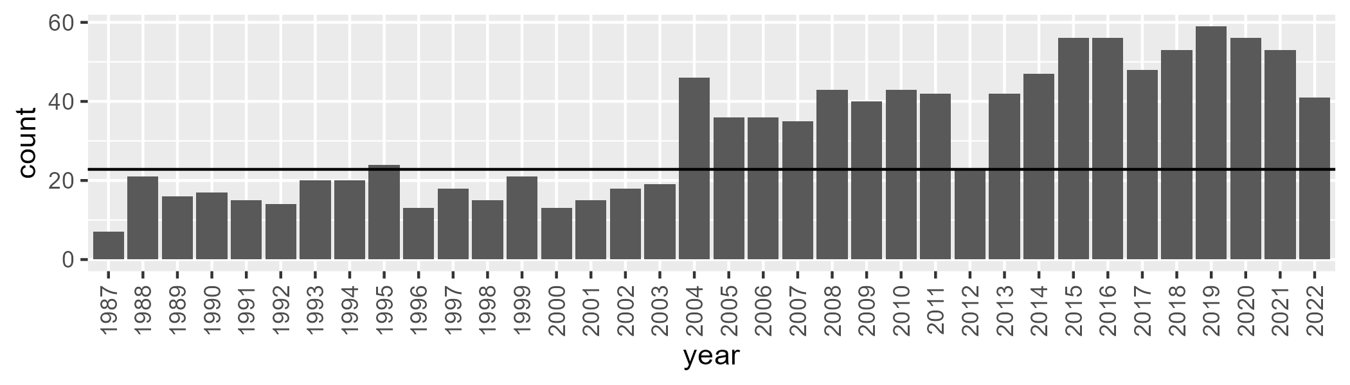

Number of samples: 1141

# QDAGUP0021

| Min. | 1st Qu. | Median | Mean | 3rd Qu. | Max. |
| --- | --- | --- | --- | --- | --- |
| 11.59955 | 36.37359 | 46.53107 | 48.86461 | 60.79176 | 87.86203 |

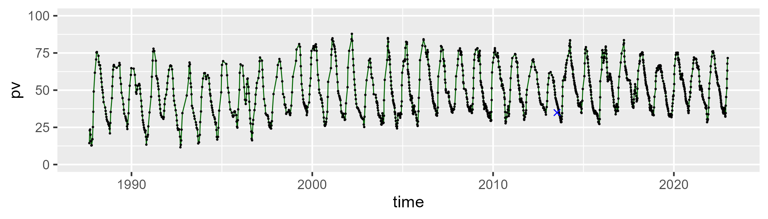

| Min. | 1st Qu. | Median | Mean | 3rd Qu. | Max. |
| --- | --- | --- | --- | --- | --- |
| 9.655315 | 30.42237 | 46.38619 | 43.47514 | 55.51931 | 73.1981 |

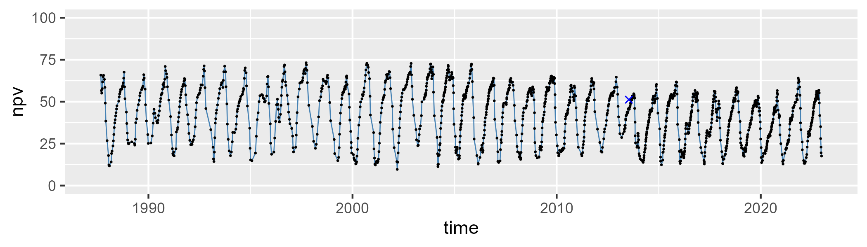

| Min. | 1st Qu. | Median | Mean | 3rd Qu. | Max. |
| --- | --- | --- | --- | --- | --- |
| 0 | 2.581175 | 6.036816 | 6.426026 | 9.292326 | 21.82255 |

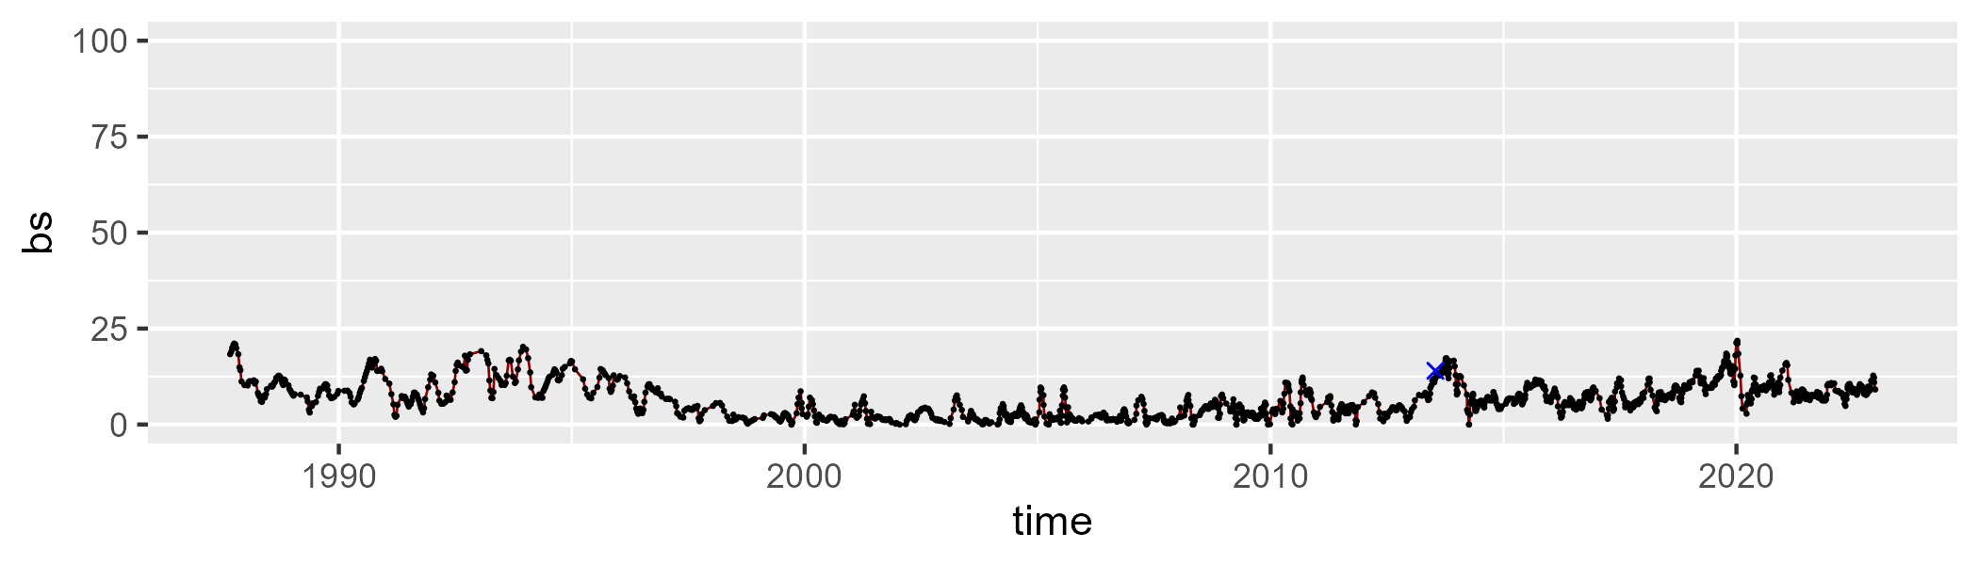

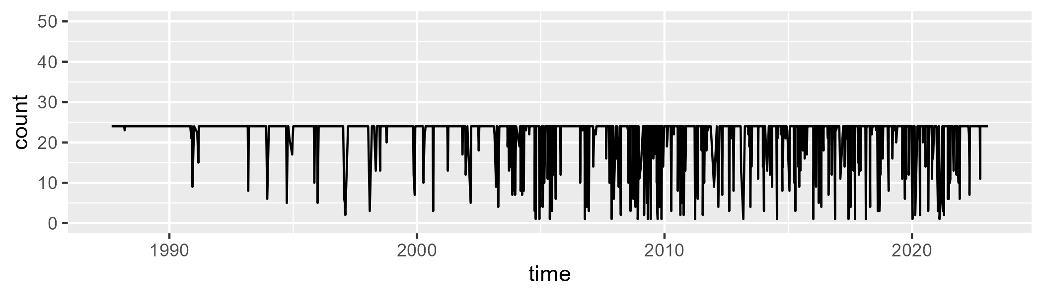

Min. : 1 1st Qu.:24 Median :24 Mean :22 3rd Qu.:24 Max. :24

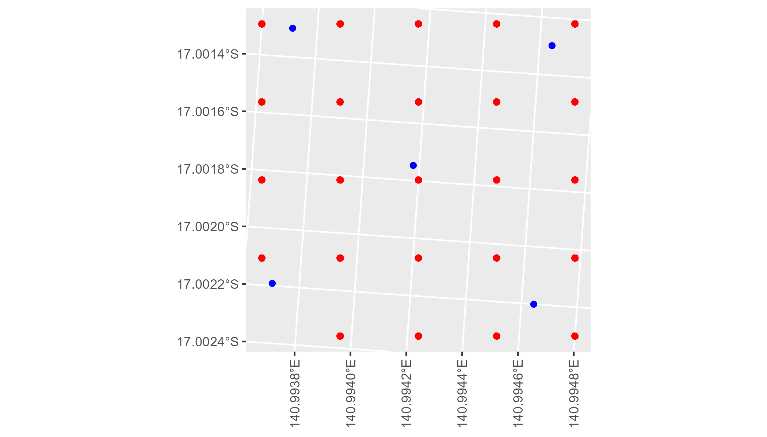

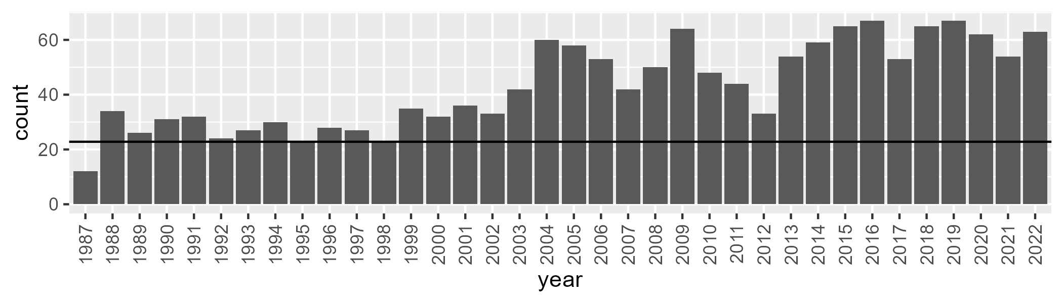

Number of samples: 1556

# QDAGUP0022

| Min. | 1st Qu. | Median | Mean | 3rd Qu. | Max. |
| --- | --- | --- | --- | --- | --- |
| 0 | 7.209451 | 9.694317 | 12.23902 | 14.71545 | 48.76714 |

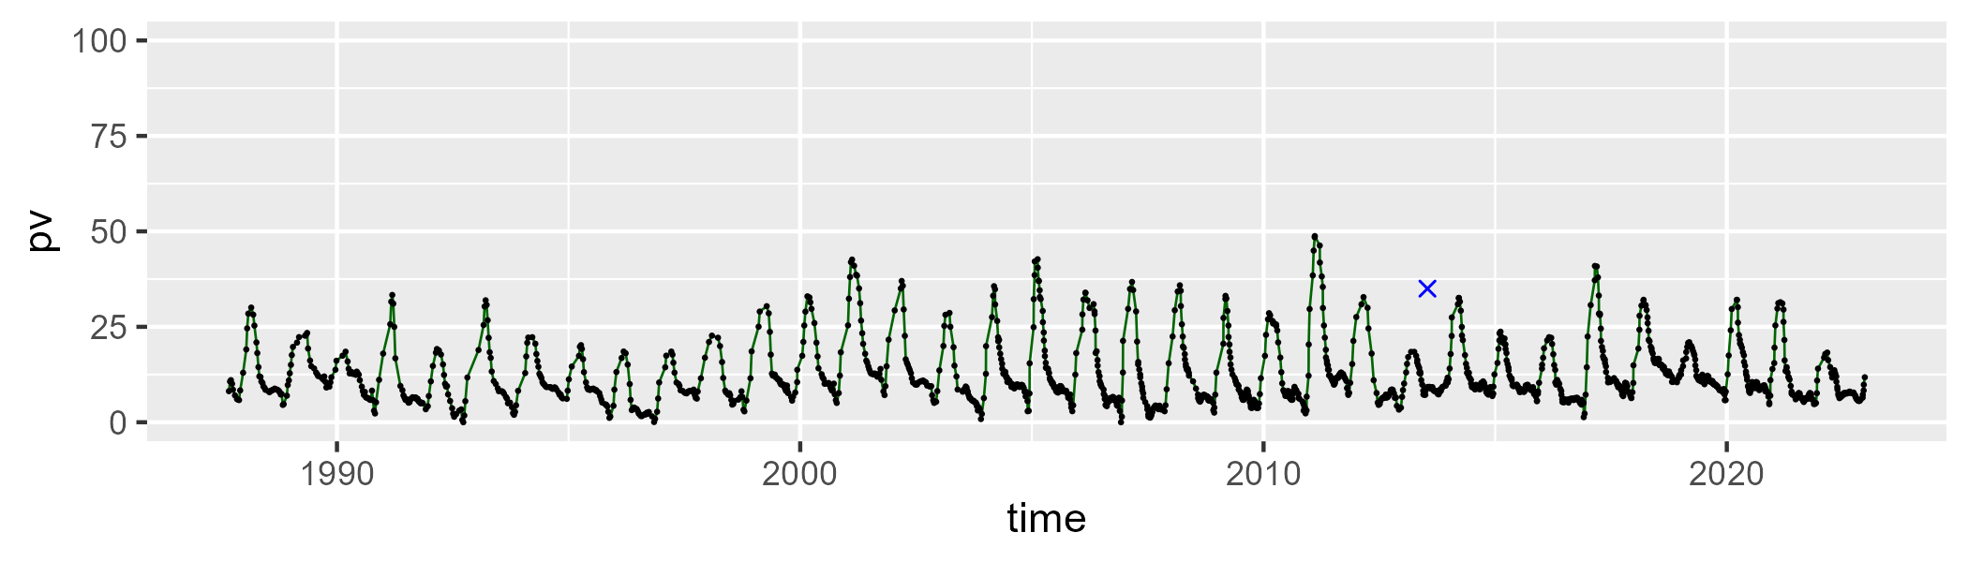

| Min. | 1st Qu. | Median | Mean | 3rd Qu. | Max. |
| --- | --- | --- | --- | --- | --- |
| 32.38157 | 50.67312 | 57.0152 | 57.78929 | 64.14148 | 91.01092 |

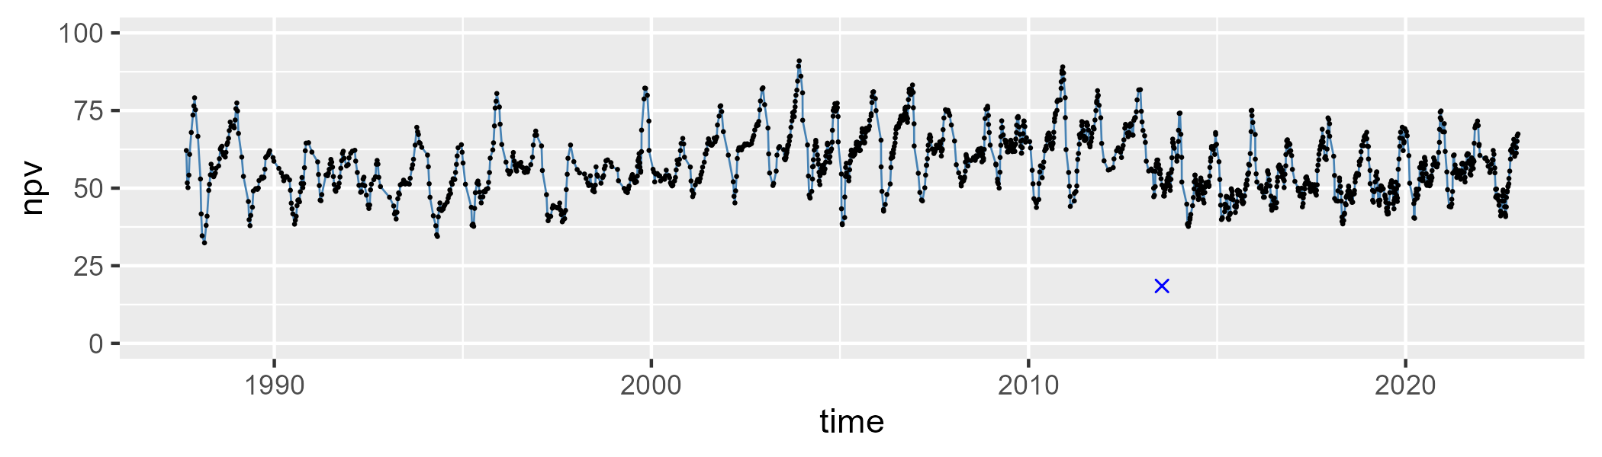

| Min. | 1st Qu. | Median | Mean | 3rd Qu. | Max. |
| --- | --- | --- | --- | --- | --- |
| 3.398546 | 21.7457 | 28.93705 | 28.72759 | 36.19032 | 53.26564 |

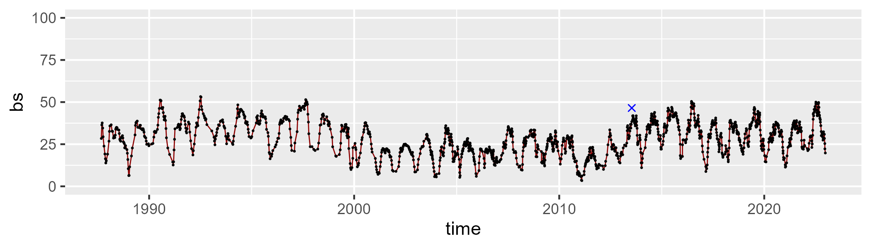

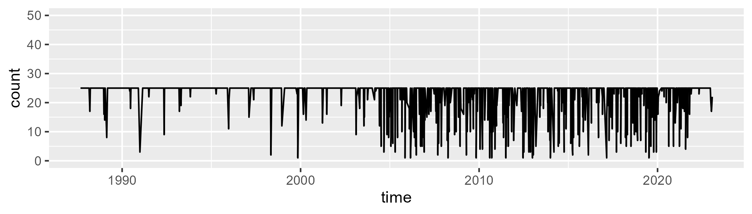

Min. : 1.00 1st Qu.:25.00 Median :25.00 Mean :22.93 3rd Qu.:25.00 Max. :25.00

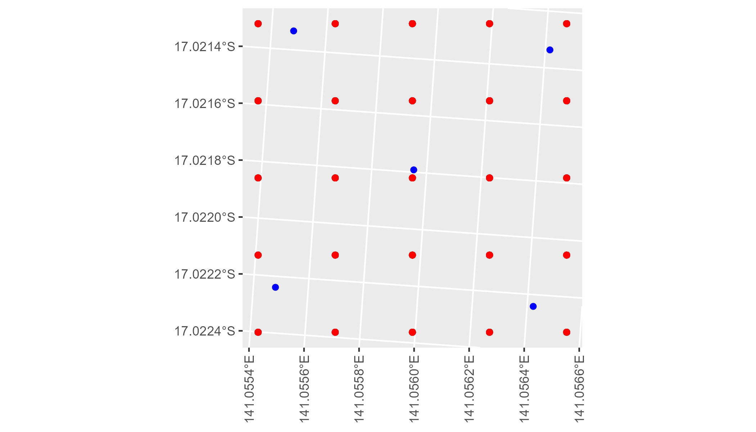

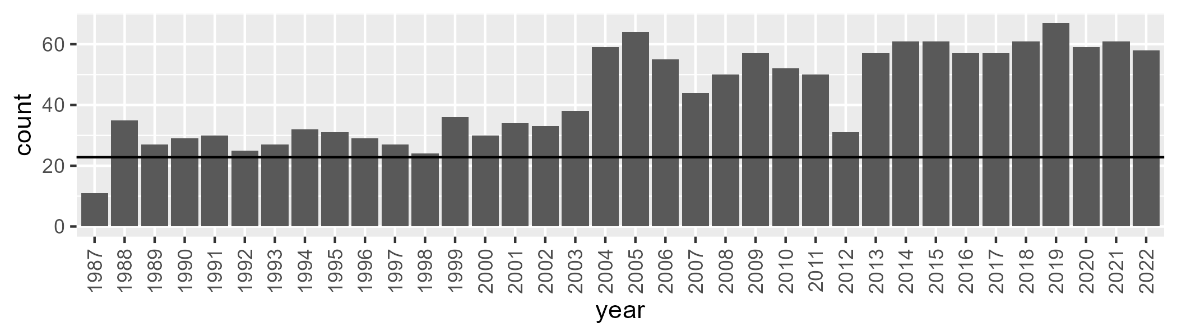

Number of samples: 1559

# QDAGUP0023

| Min. | 1st Qu. | Median | Mean | 3rd Qu. | Max. |
| --- | --- | --- | --- | --- | --- |
| 0 | 11.75354 | 20.82128 | 27.12021 | 41.27011 | 85.99024 |

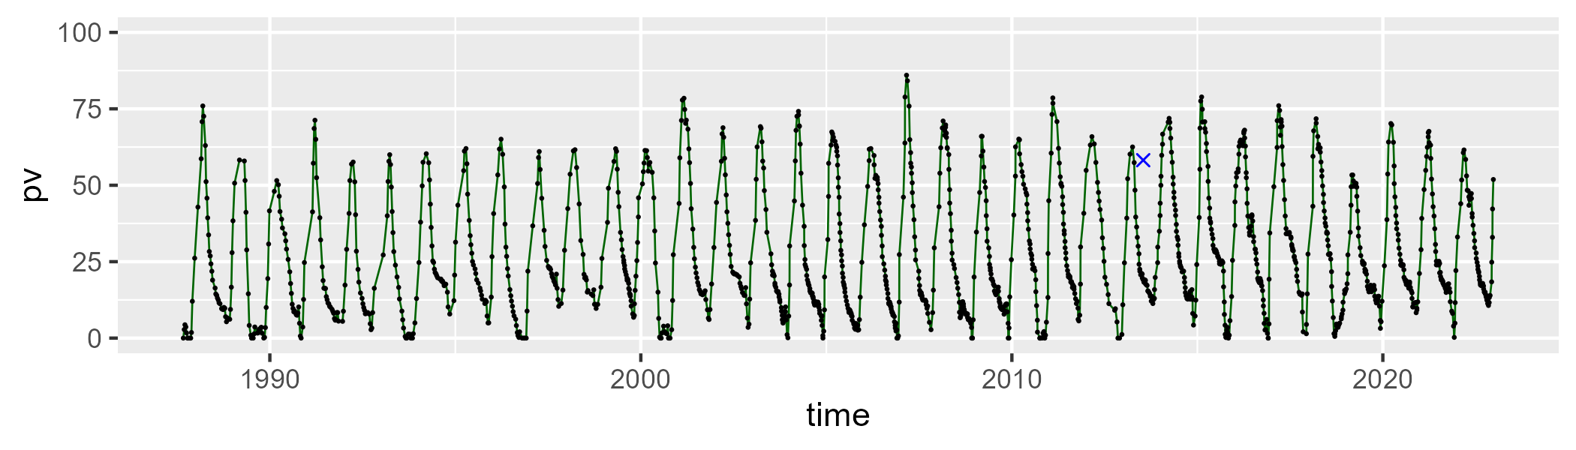

| Min. | 1st Qu. | Median | Mean | 3rd Qu. | Max. |
| --- | --- | --- | --- | --- | --- |
| 4.69664 | 47.25406 | 64.64173 | 61.88504 | 77.195 | 102.6801 |

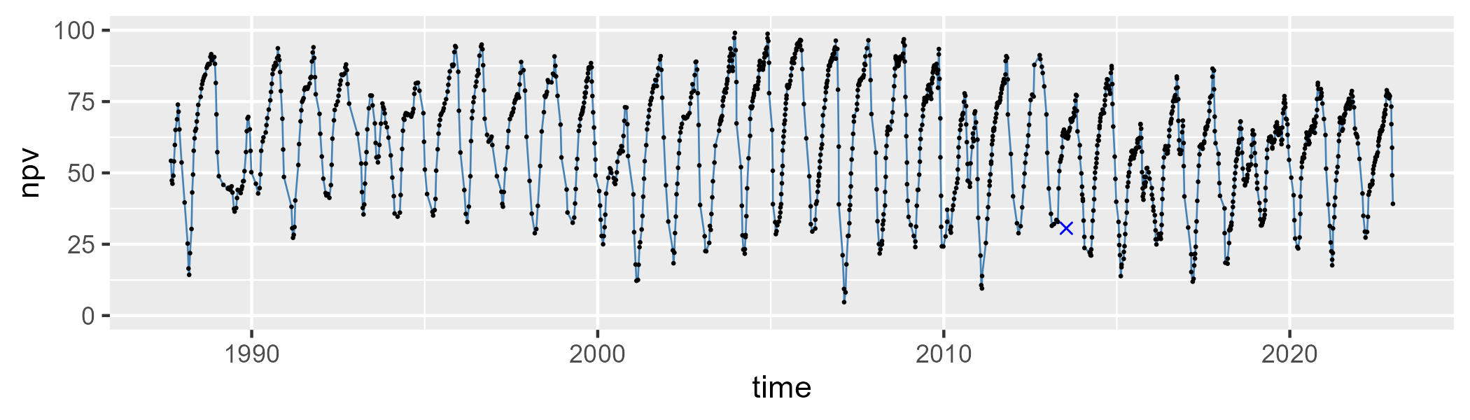

| Min. | 1st Qu. | Median | Mean | 3rd Qu. | Max. |
| --- | --- | --- | --- | --- | --- |
| 0 | 2.643518 | 5.751214 | 10.02923 | 12.71117 | 64.7186 |

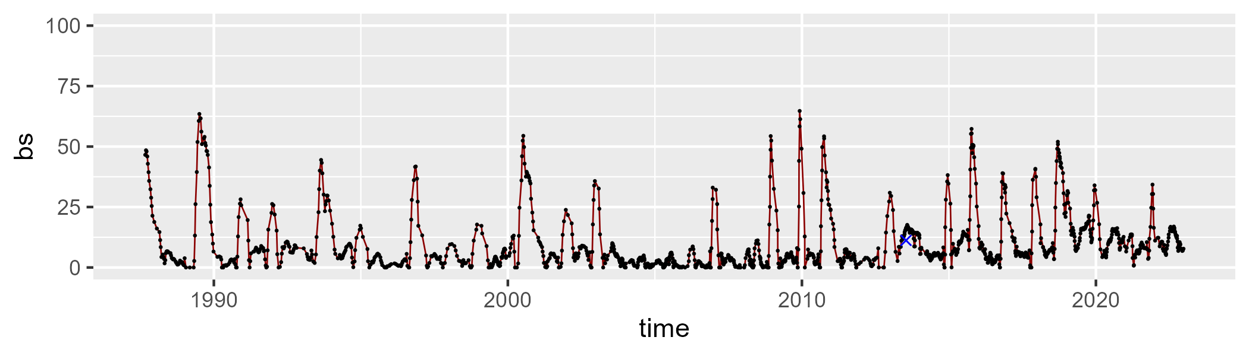

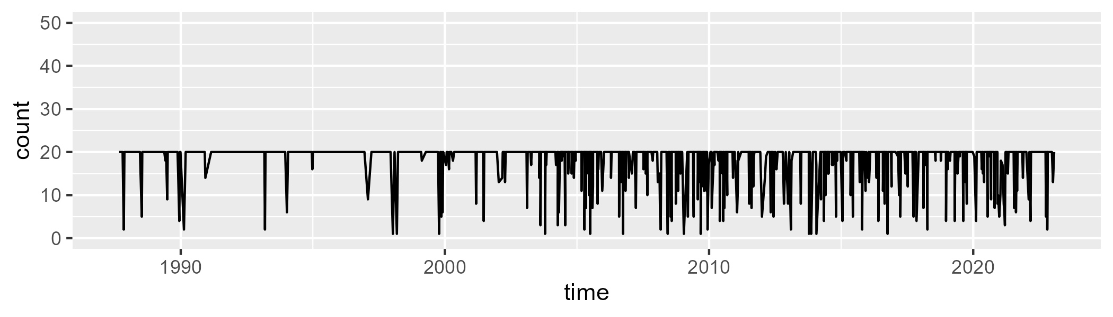

Min. : 1.00 1st Qu.:20.00 Median :20.00 Mean :18.68 3rd Qu.:20.00 Max. :20.00

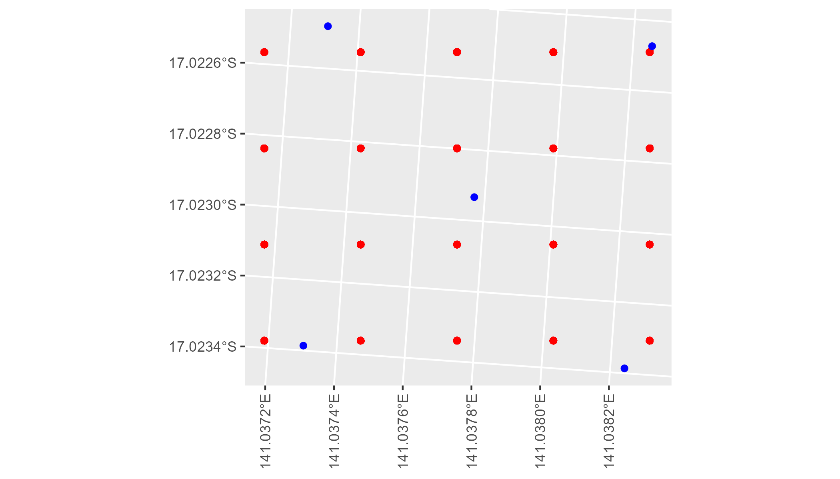

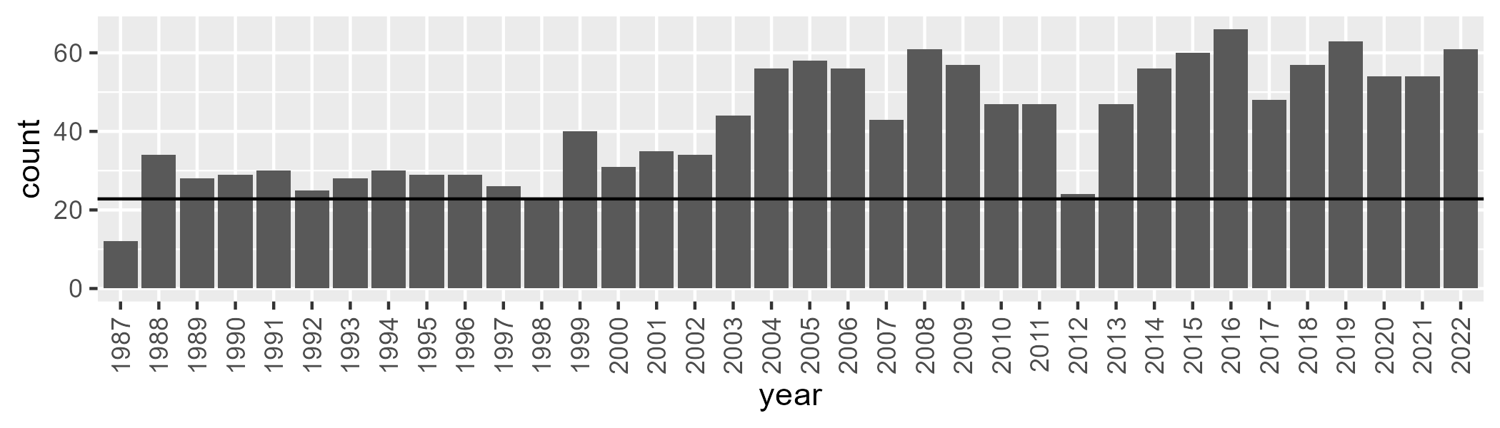

Number of samples: 1522

# QDAGUP0024

| Min. | 1st Qu. | Median | Mean | 3rd Qu. | Max. |
| --- | --- | --- | --- | --- | --- |
| 0 | 1.971631 | 4.278073 | 6.828464 | 7.515131 | 54.35677 |

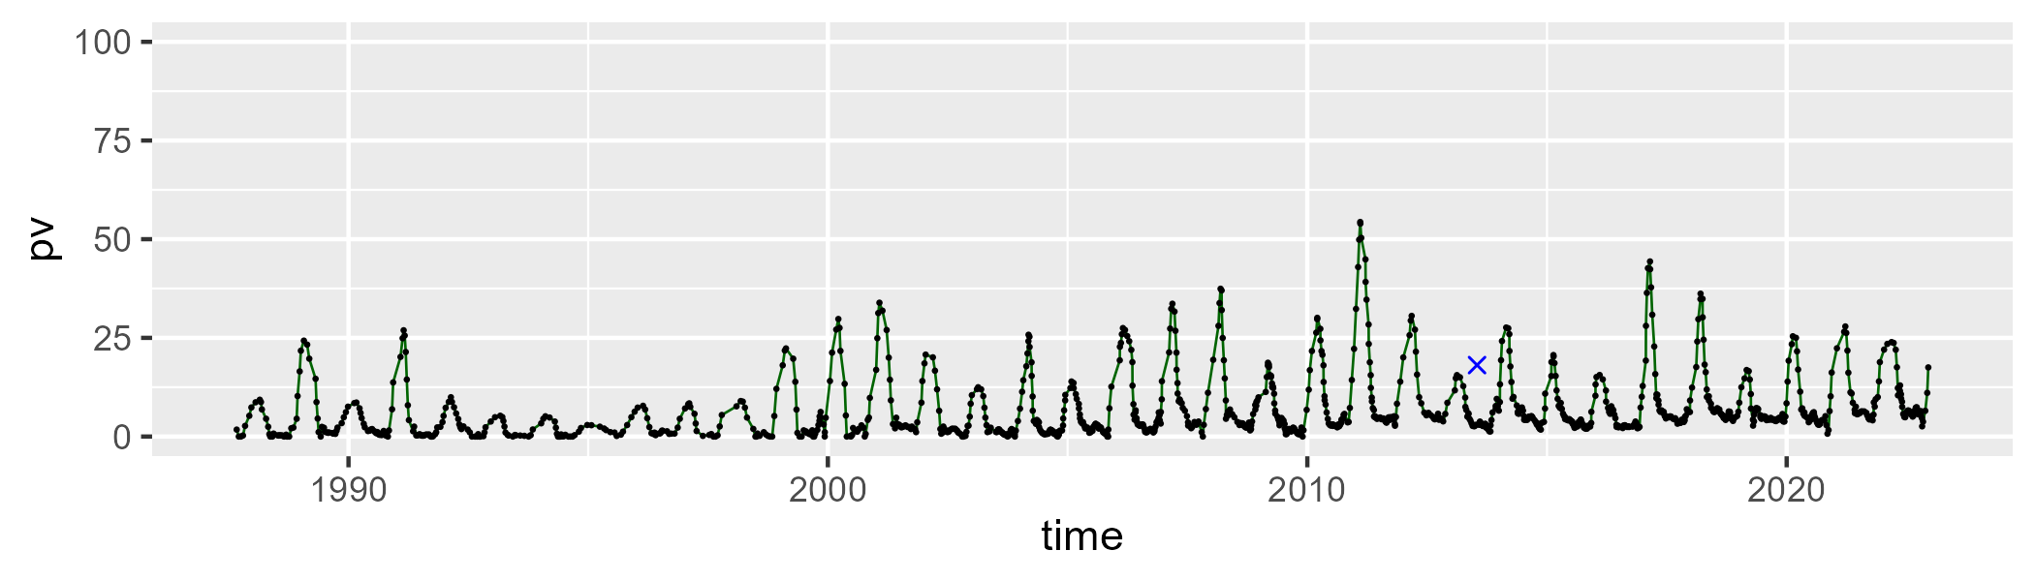

| Min. | 1st Qu. | Median | Mean | 3rd Qu. | Max. |
| --- | --- | --- | --- | --- | --- |
| 31.44183 | 60.14034 | 68.89556 | 69.7981 | 79.62701 | 100.3624 |

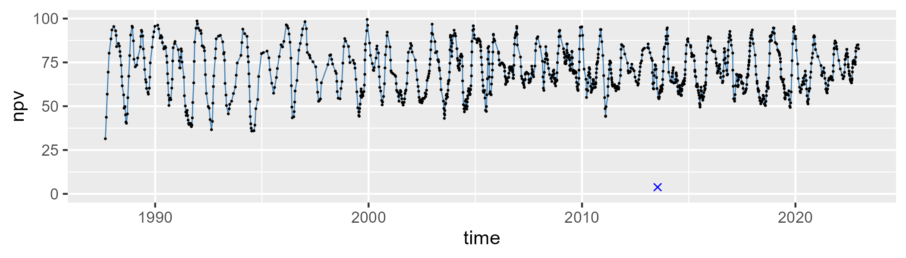

| Min. | 1st Qu. | Median | Mean | 3rd Qu. | Max. |
| --- | --- | --- | --- | --- | --- |
| 0 | 8.781719 | 24.22782 | 22.75993 | 34.48759 | 66.16064 |

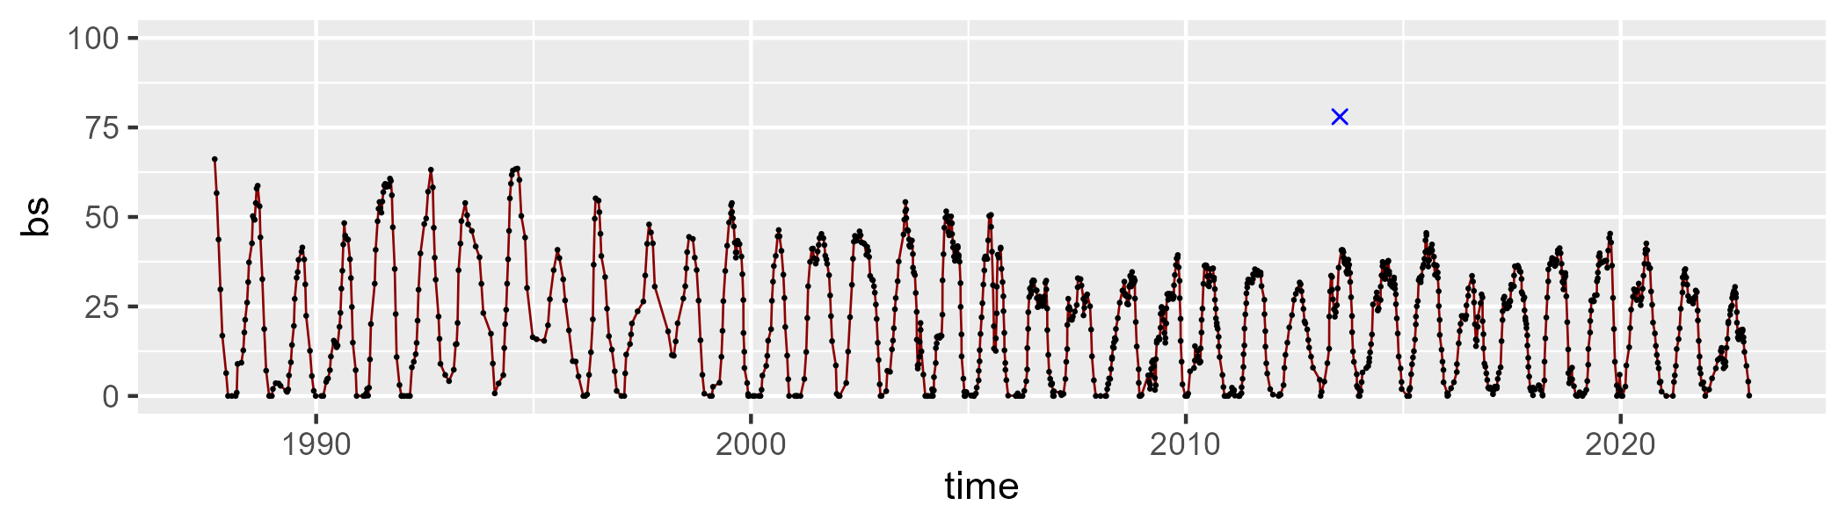

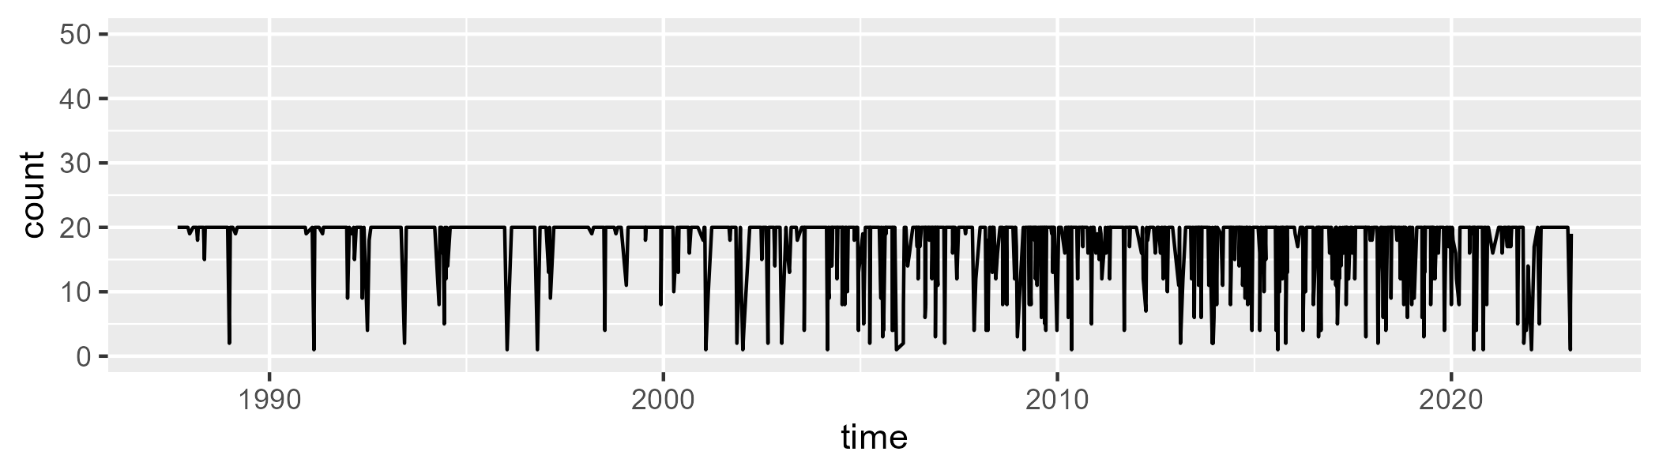

Min. : 1.00 1st Qu.:20.00 Median :20.00 Mean :18.02 3rd Qu.:20.00 Max. :20.00

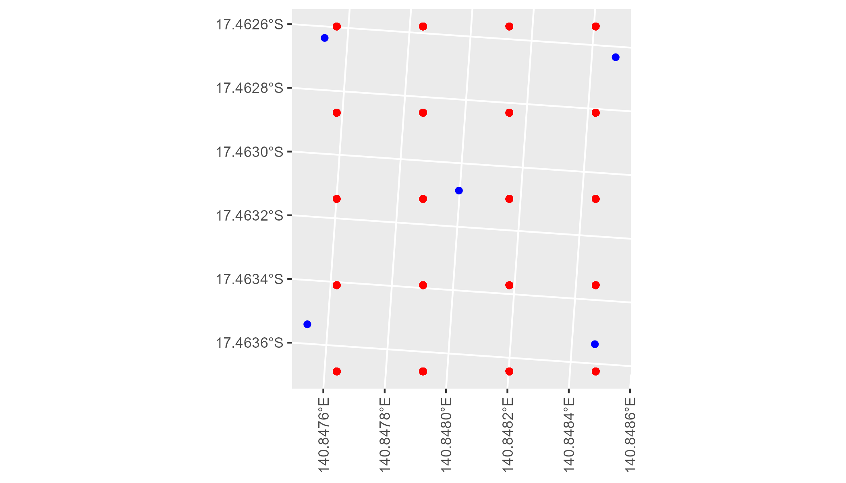

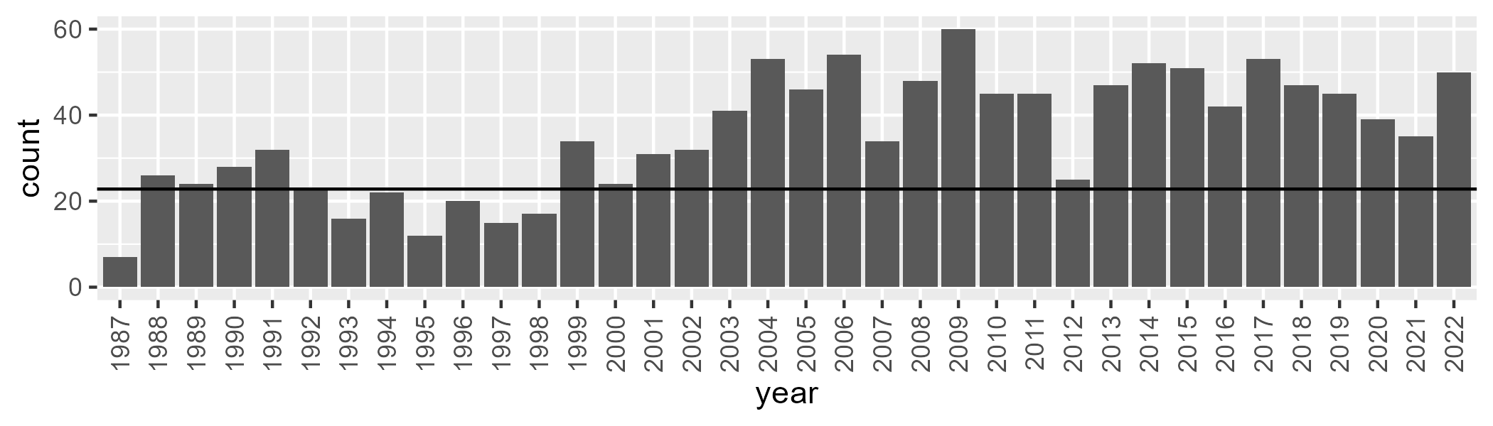

Number of samples: 1275

# QDAGUP0026

| Min. | 1st Qu. | Median | Mean | 3rd Qu. | Max. |
| --- | --- | --- | --- | --- | --- |
| 0 | 14.89918 | 24.29627 | 28.01638 | 39.71817 | 76.37228 |

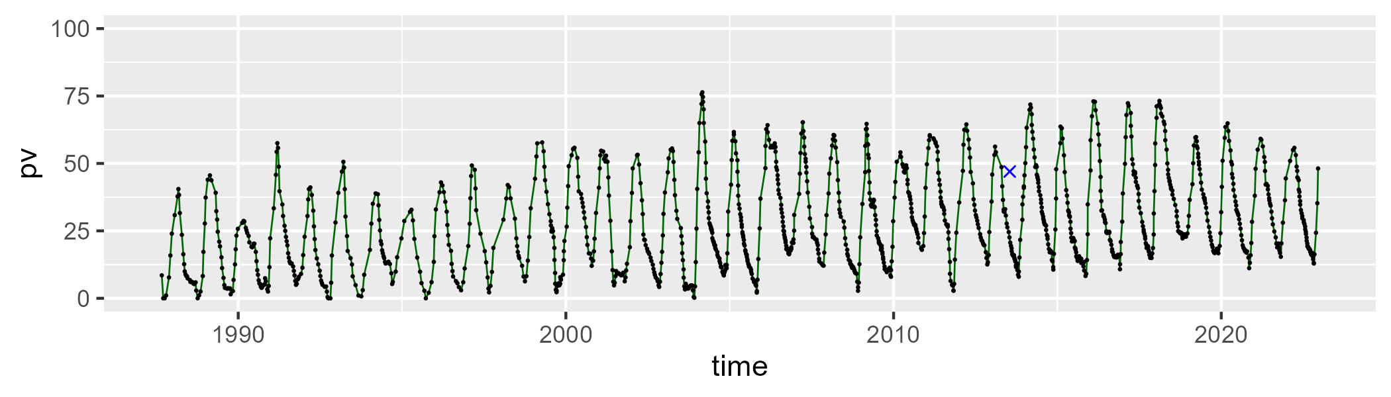

| Min. | 1st Qu. | Median | Mean | 3rd Qu. | Max. |
| --- | --- | --- | --- | --- | --- |
| 13.38716 | 45.82742 | 59.19231 | 57.97022 | 70.02182 | 94.49473 |

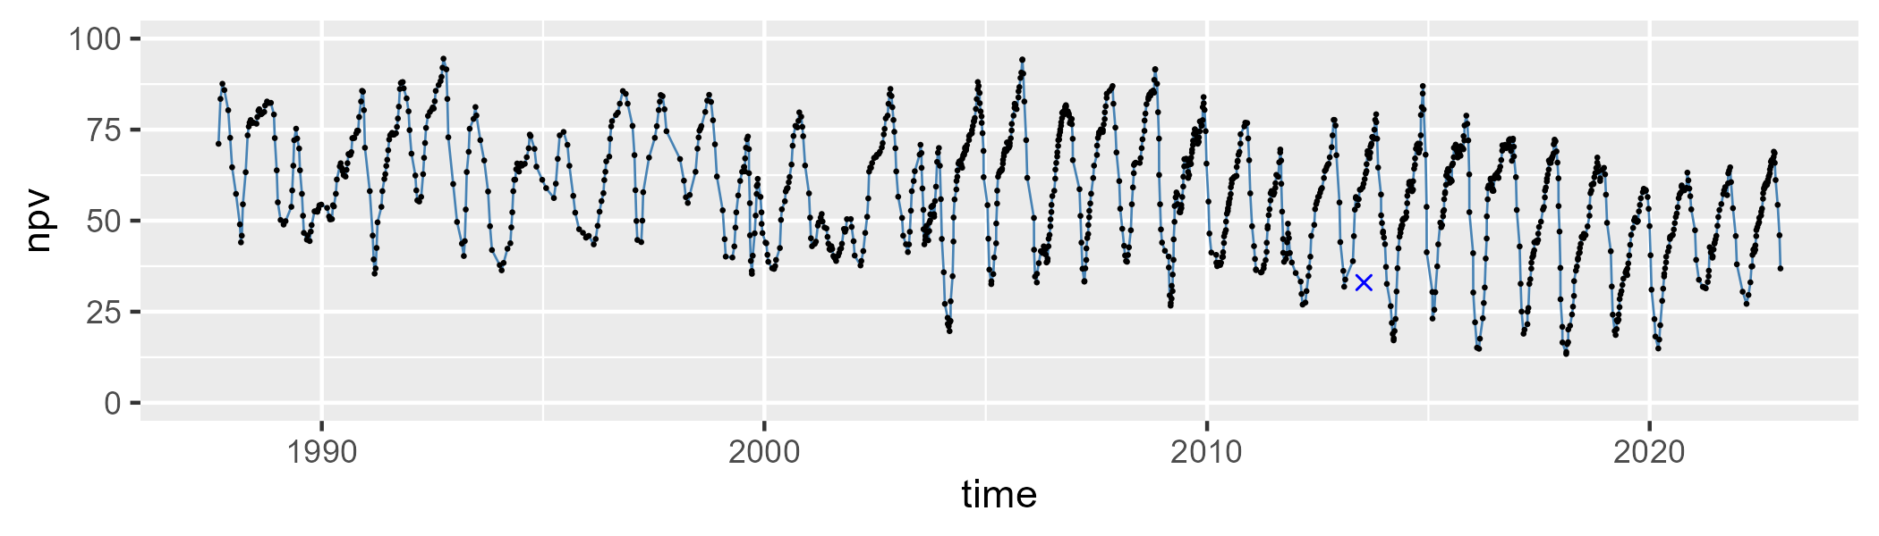

| Min. | 1st Qu. | Median | Mean | 3rd Qu. | Max. |
| --- | --- | --- | --- | --- | --- |
| 0 | 6.012298 | 10.91138 | 12.80792 | 15.84902 | 60.4364 |

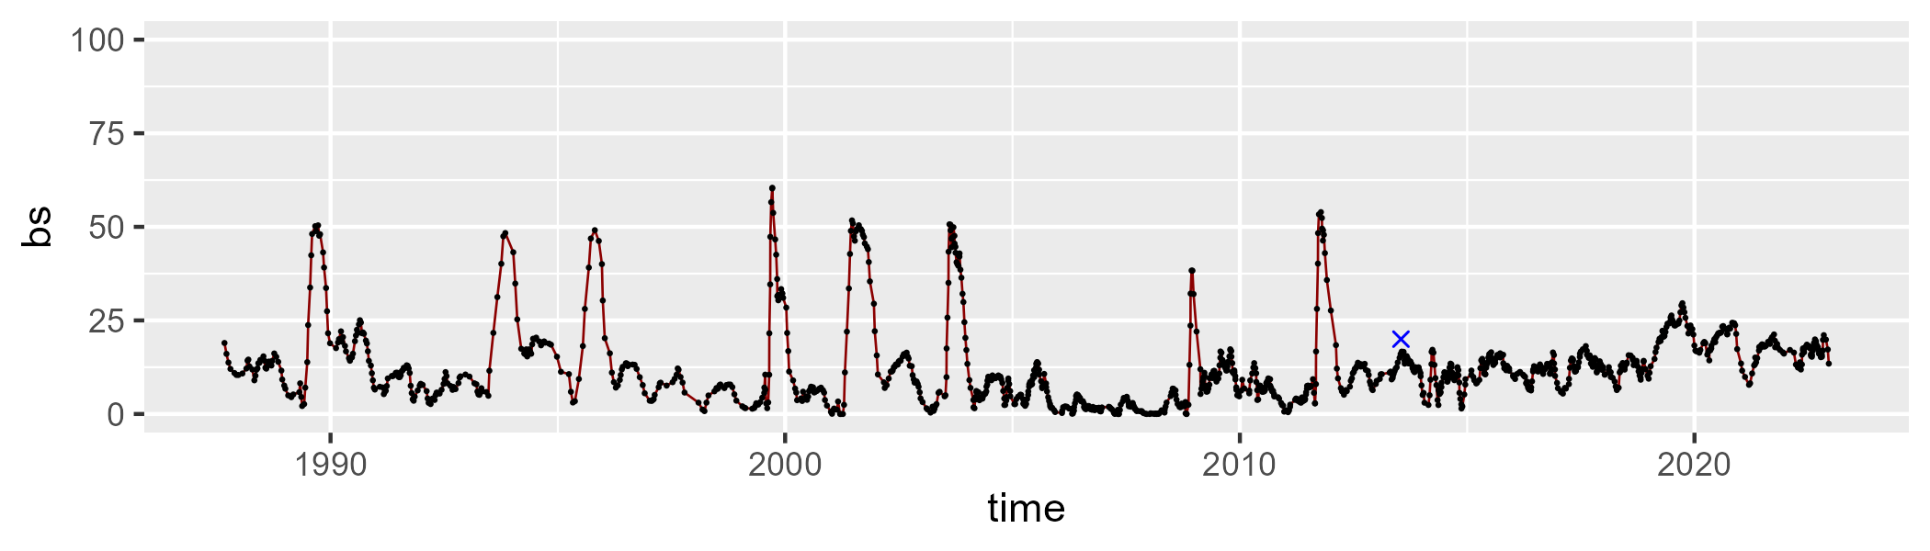

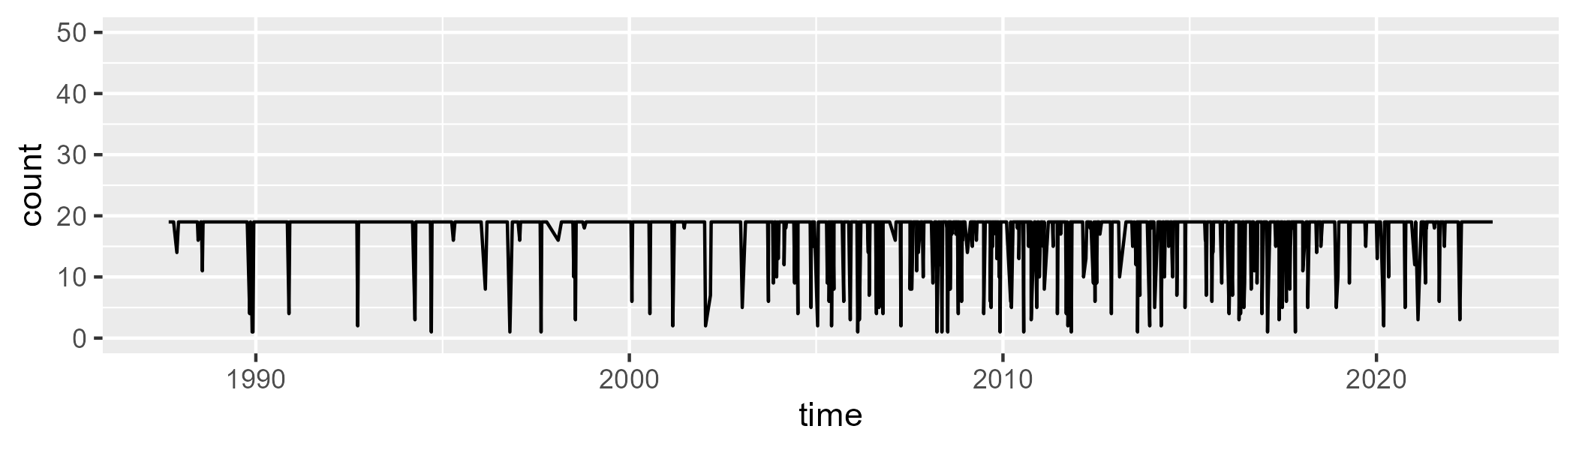

Min. : 1.00 1st Qu.:19.00 Median :19.00 Mean :17.66 3rd Qu.:19.00 Max. :19.00

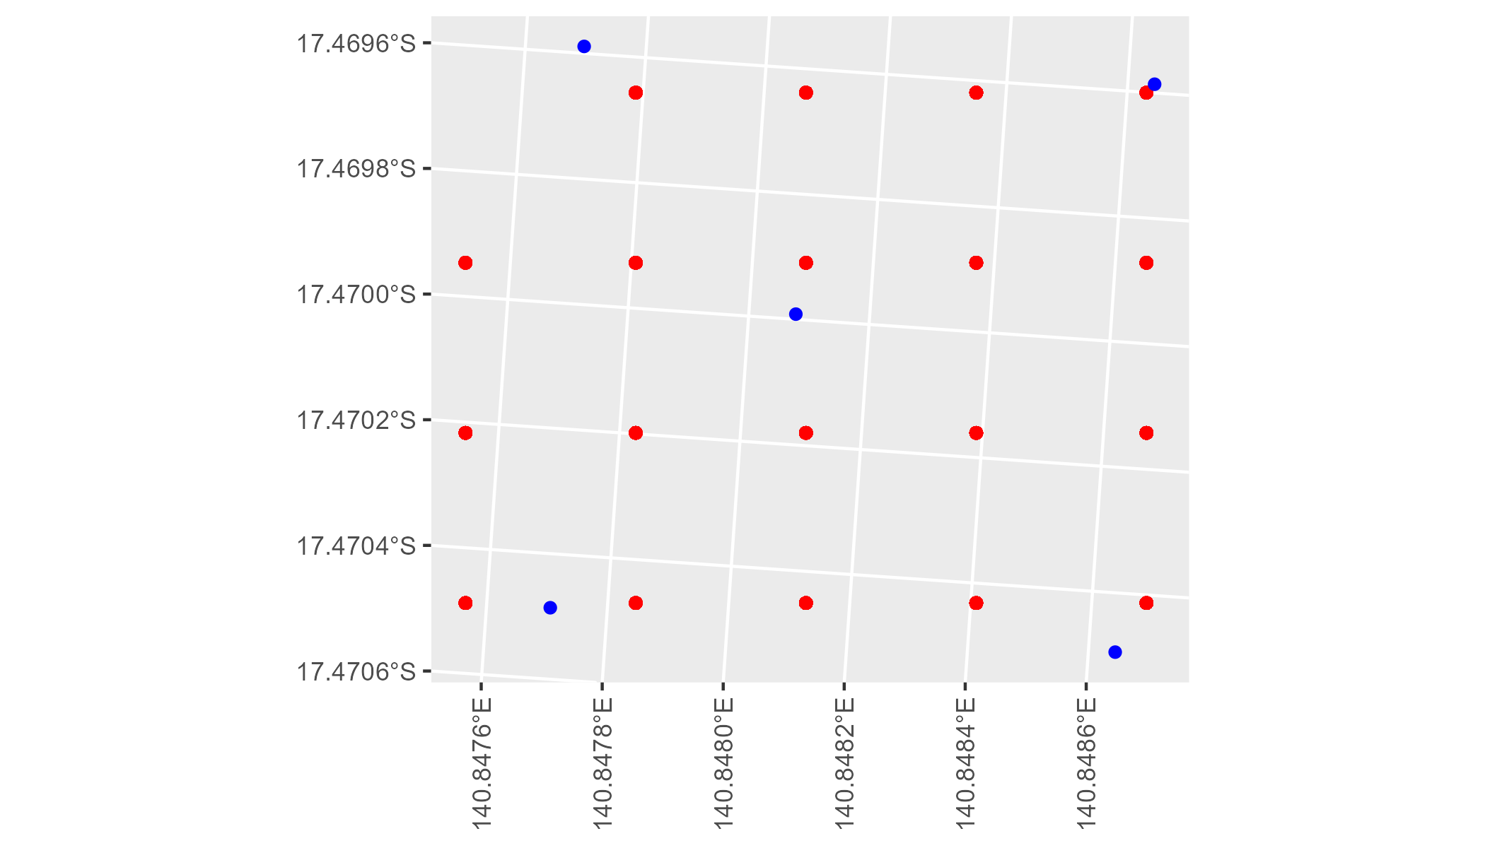

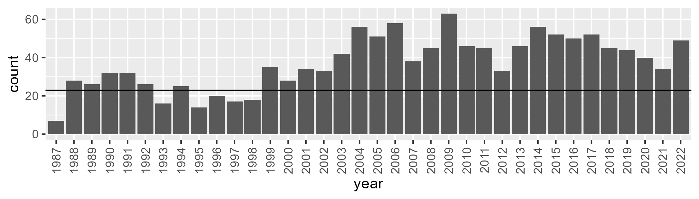

Number of samples: 1336

# QDAGUP0027

| Min. | 1st Qu. | Median | Mean | 3rd Qu. | Max. |
| --- | --- | --- | --- | --- | --- |
| 16.16064 | 29.45575 | 35.11979 | 34.66281 | 40.15254 | 49.87474 |

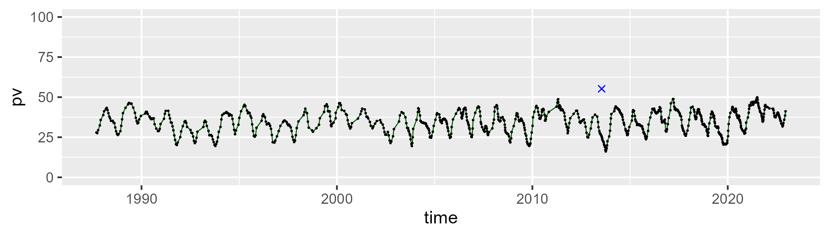

| Min. | 1st Qu. | Median | Mean | 3rd Qu. | Max. |
| --- | --- | --- | --- | --- | --- |
| 36.13412 | 46.62052 | 51.17682 | 51.90843 | 56.508 | 72.51459 |

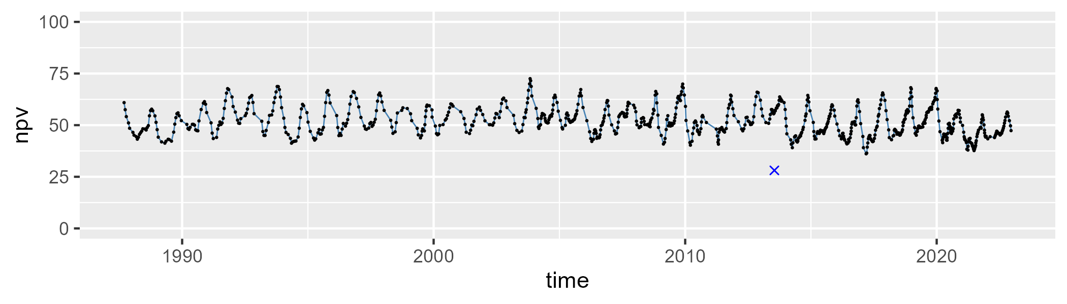

| Min. | 1st Qu. | Median | Mean | 3rd Qu. | Max. |
| --- | --- | --- | --- | --- | --- |
| 3.216549 | 10.03639 | 12.07327 | 12.17906 | 14.26996 | 21.84324 |

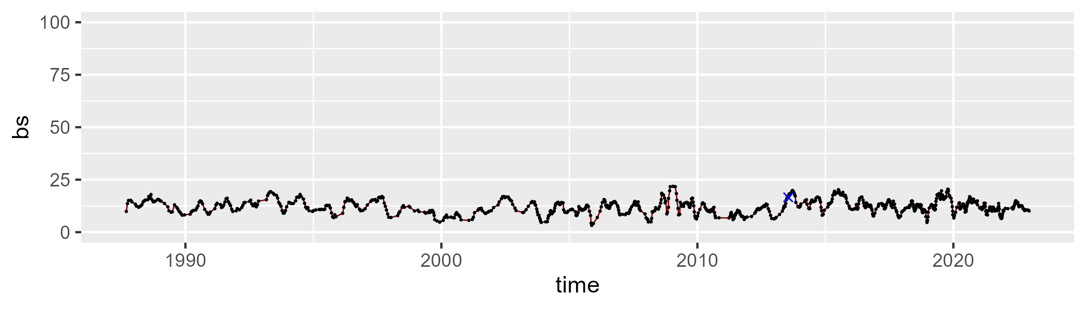

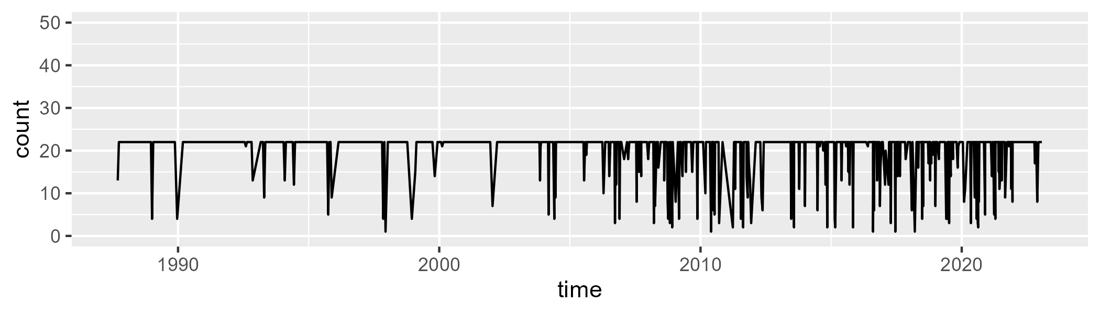

Min. : 1.0 1st Qu.:22.0 Median :22.0 Mean :20.1 3rd Qu.:22.0 Max. :22.0

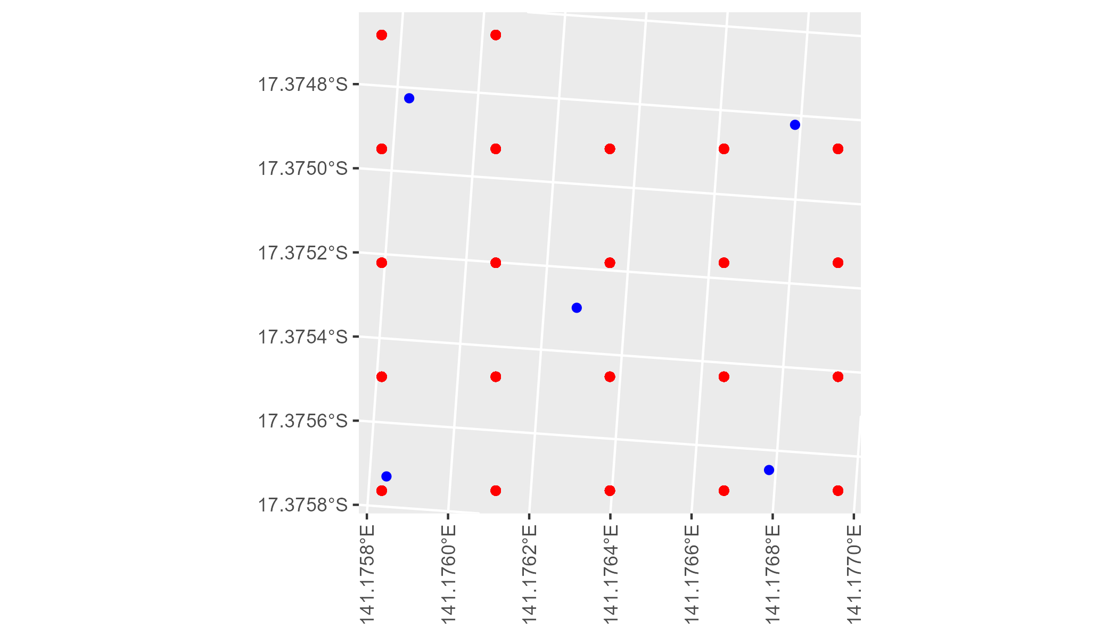

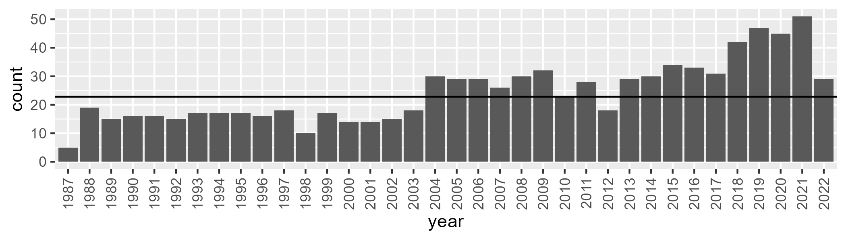

Number of samples: 875

# QDAGUP0028

| Min. | 1st Qu. | Median | Mean | 3rd Qu. | Max. |
| --- | --- | --- | --- | --- | --- |
| 16.68077 | 31.12504 | 36.04589 | 35.5491 | 40.40304 | 50.11419 |

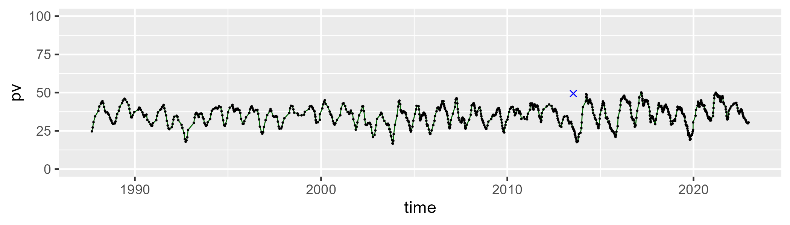

| Min. | 1st Qu. | Median | Mean | 3rd Qu. | Max. |
| --- | --- | --- | --- | --- | --- |
| 38.36126 | 46.22297 | 50.52783 | 51.39315 | 55.77554 | 76.36416 |

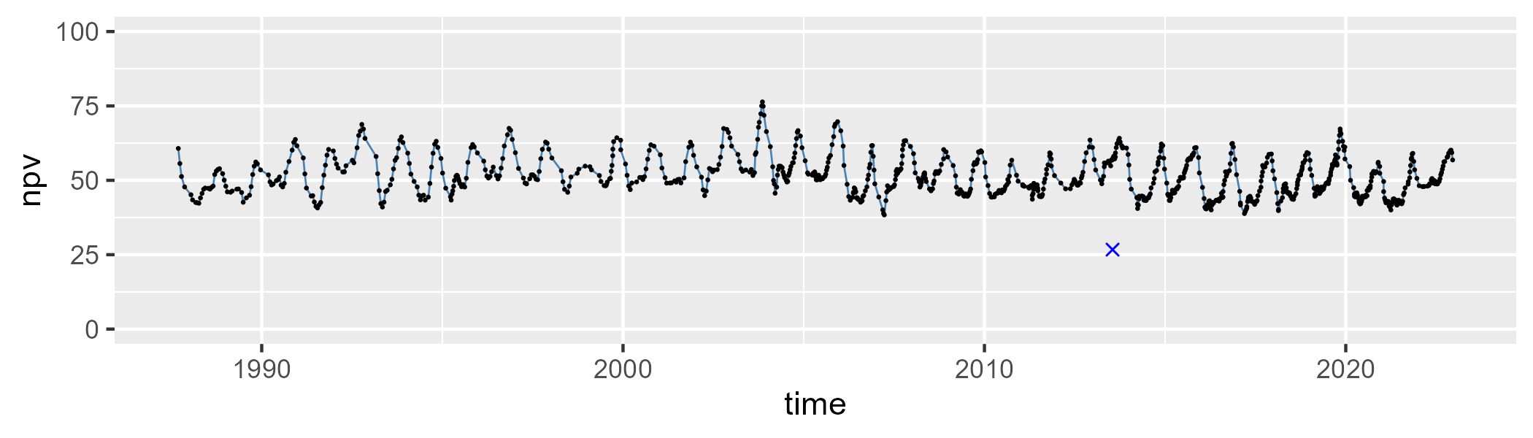

| Min. | 1st Qu. | Median | Mean | 3rd Qu. | Max. |
| --- | --- | --- | --- | --- | --- |
| 2.885274 | 9.587841 | 11.80433 | 11.82272 | 13.8081 | 21.39434 |

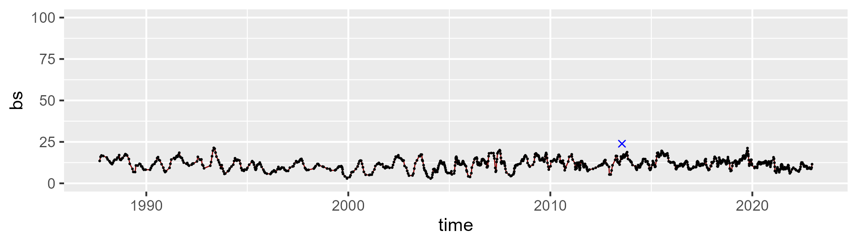

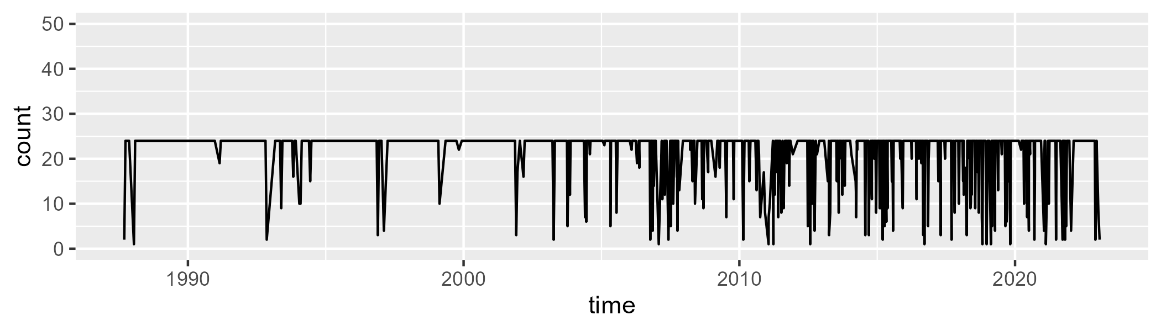

Min. : 1.00 1st Qu.:24.00 Median :24.00 Mean :21.47 3rd Qu.:24.00 Max. :24.00

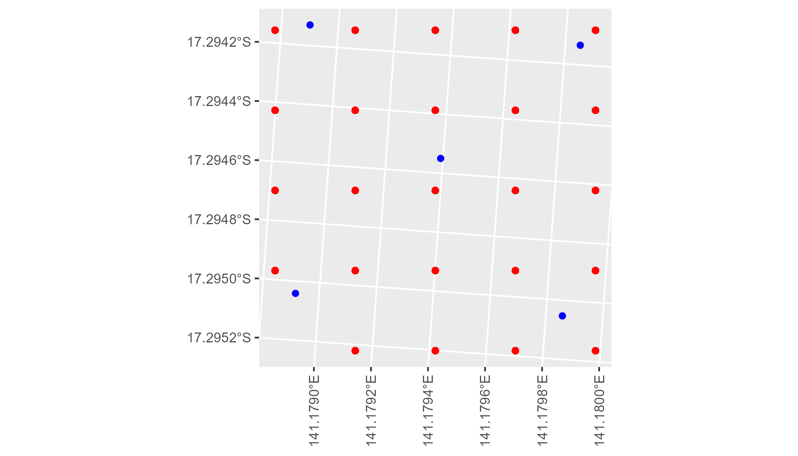

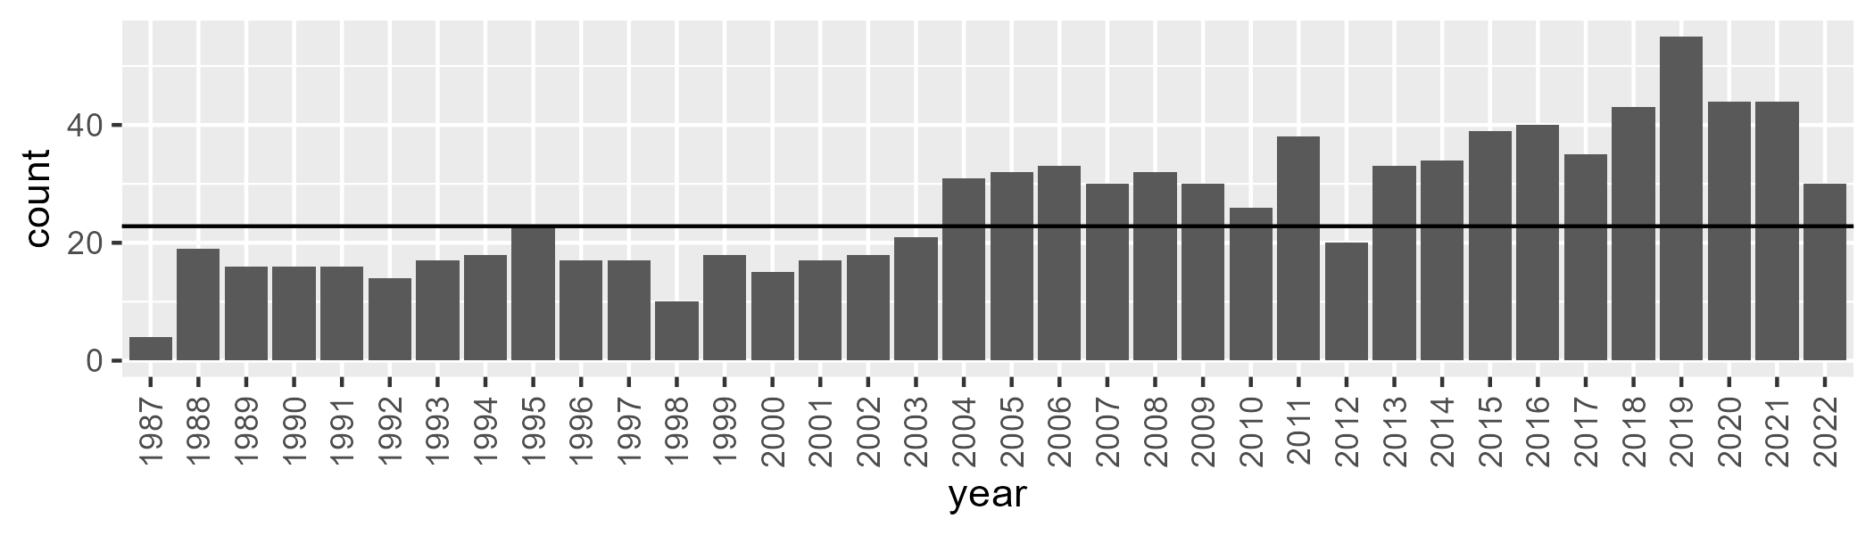

Number of samples: 945

# QDAGUP0029

| Min. | 1st Qu. | Median | Mean | 3rd Qu. | Max. |
| --- | --- | --- | --- | --- | --- |
| 1.730613 | 14.92971 | 21.48365 | 23.92797 | 32.44944 | 56.6399 |

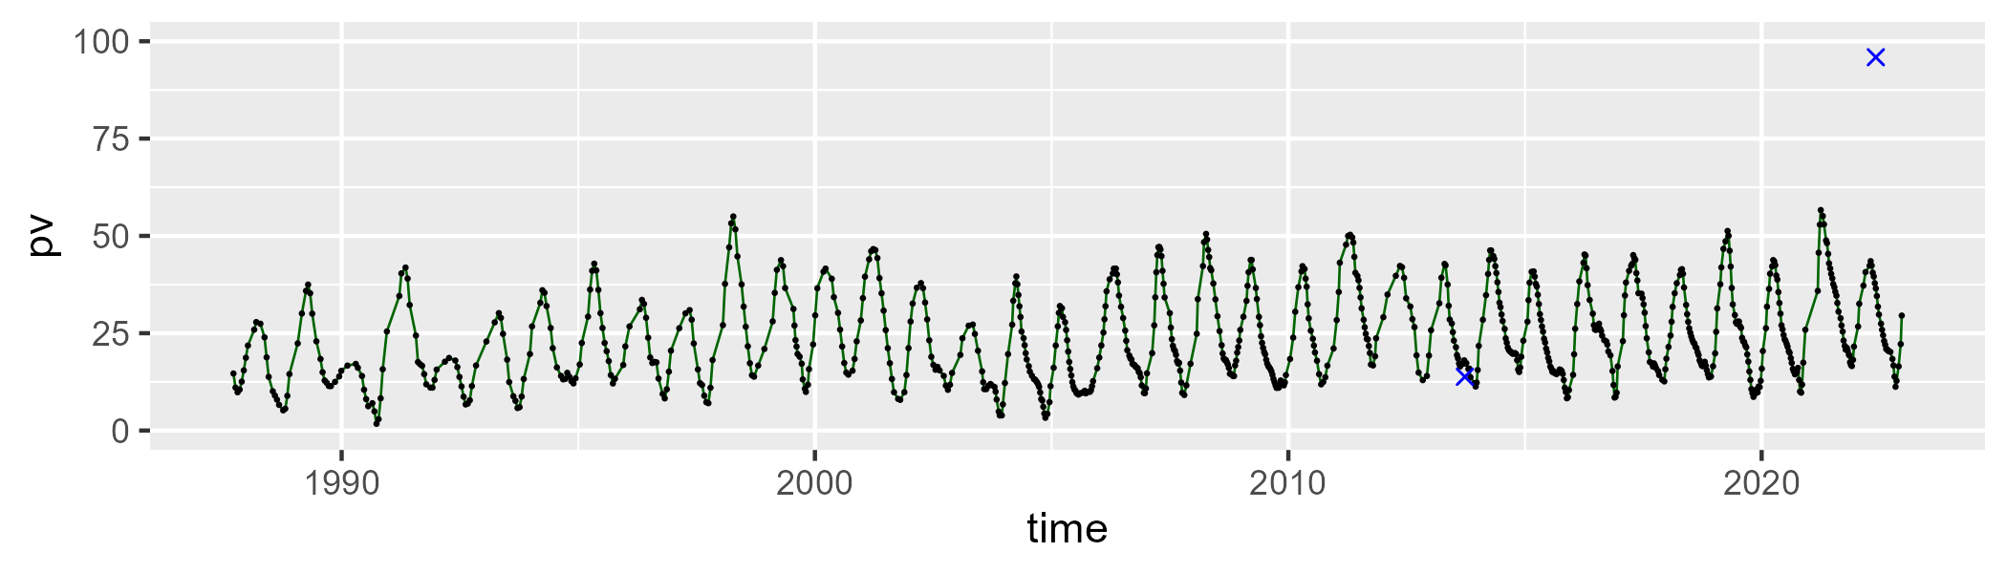

| Min. | 1st Qu. | Median | Mean | 3rd Qu. | Max. |
| --- | --- | --- | --- | --- | --- |
| 32.17276 | 49.20334 | 56.08203 | 56.35895 | 63.74779 | 81.68088 |

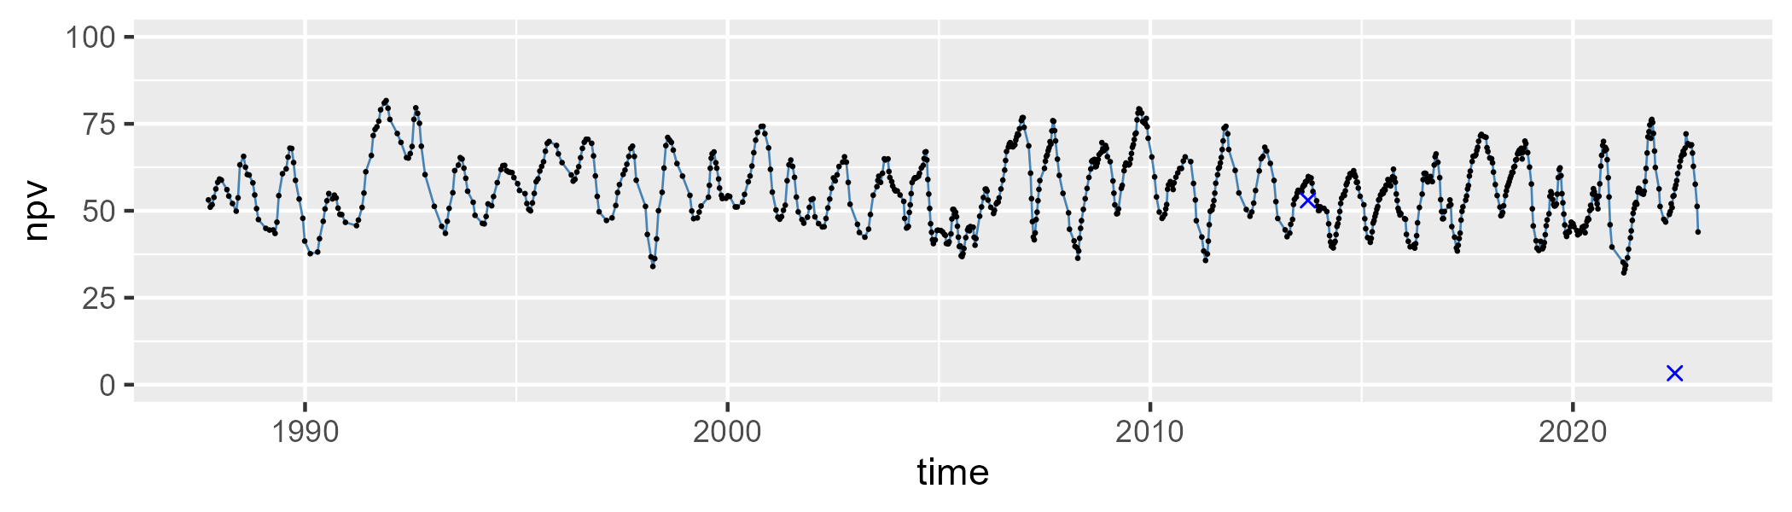

| Min. | 1st Qu. | Median | Mean | 3rd Qu. | Max. |
| --- | --- | --- | --- | --- | --- |
| 2.60104 | 11.11327 | 15.76376 | 18.47396 | 23.81304 | 54.66863 |

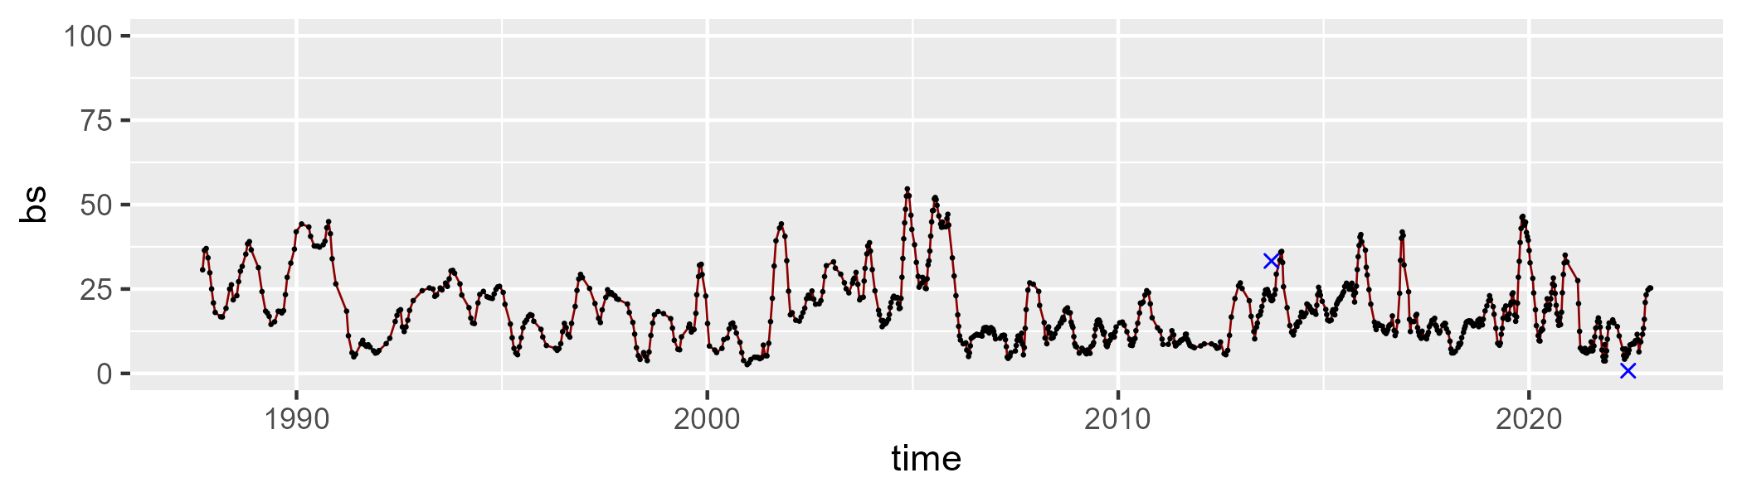

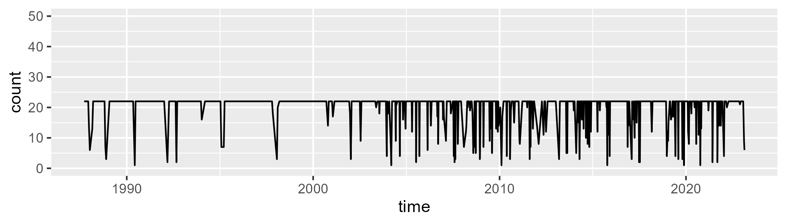

Min. : 1.00 1st Qu.:22.00 Median :22.00 Mean :20.08 3rd Qu.:22.00 Max. :22.00

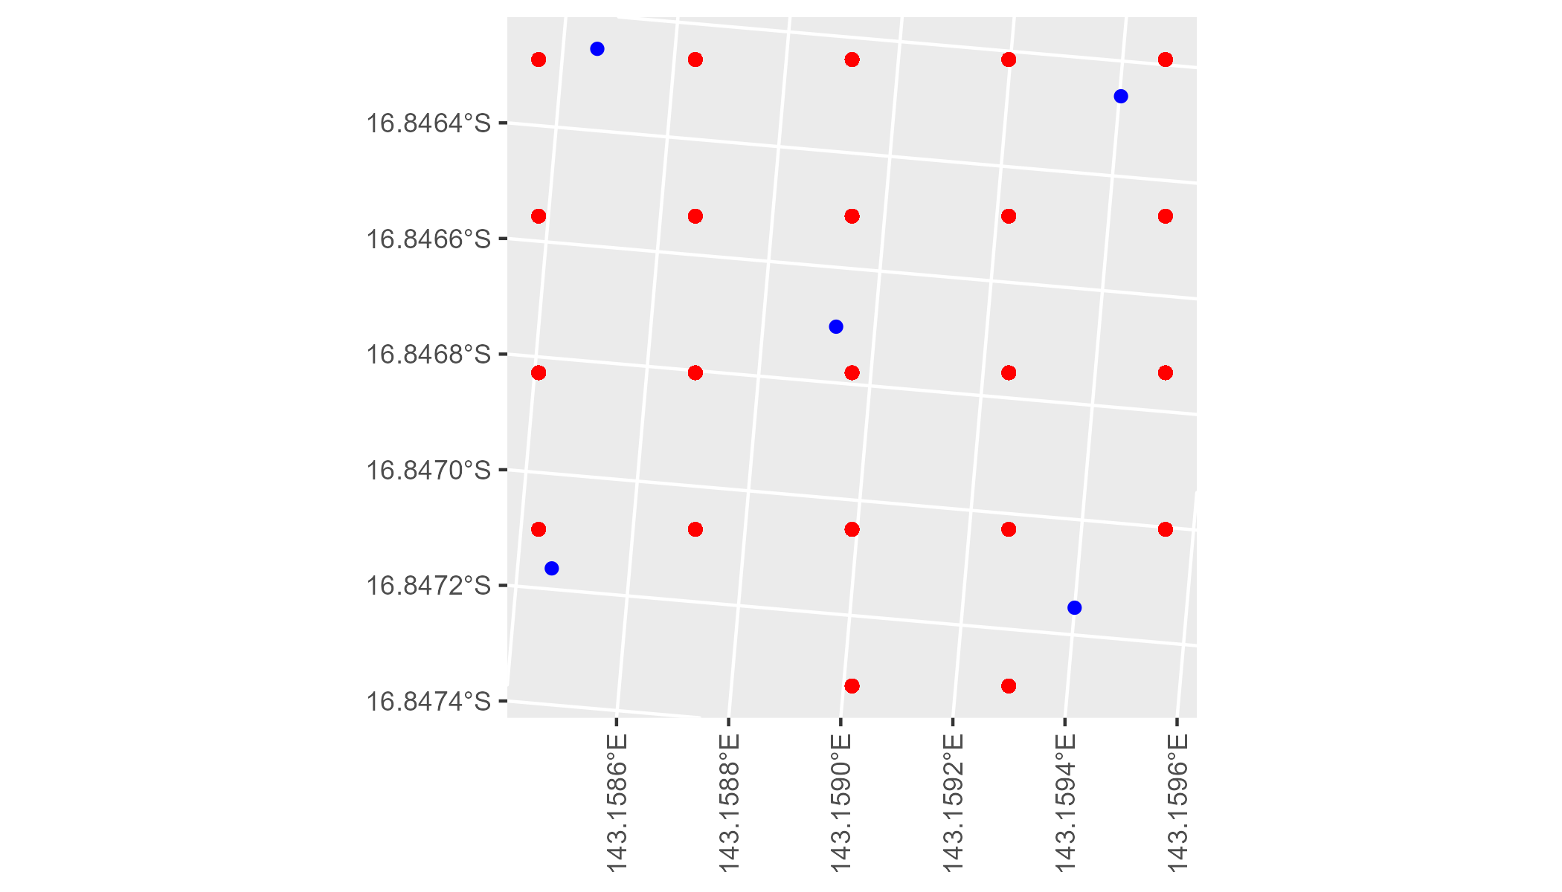

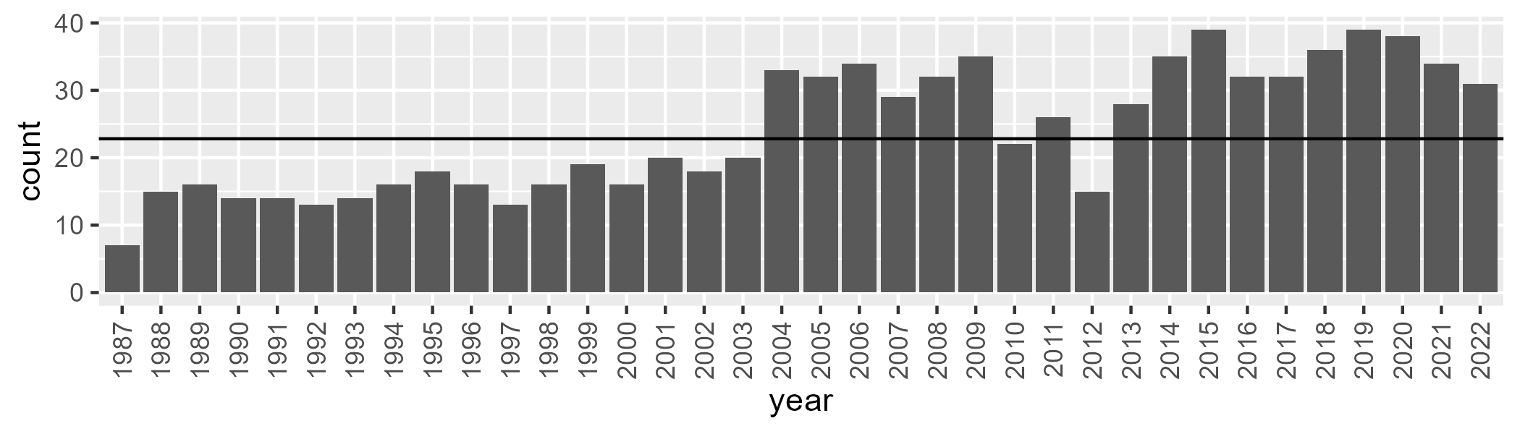

Number of samples: 867

# QDAGUP0030

| Min. | 1st Qu. | Median | Mean | 3rd Qu. | Max. |
| --- | --- | --- | --- | --- | --- |
| 2.530092 | 19.40147 | 27.9649 | 29.57979 | 38.53966 | 64.77056 |

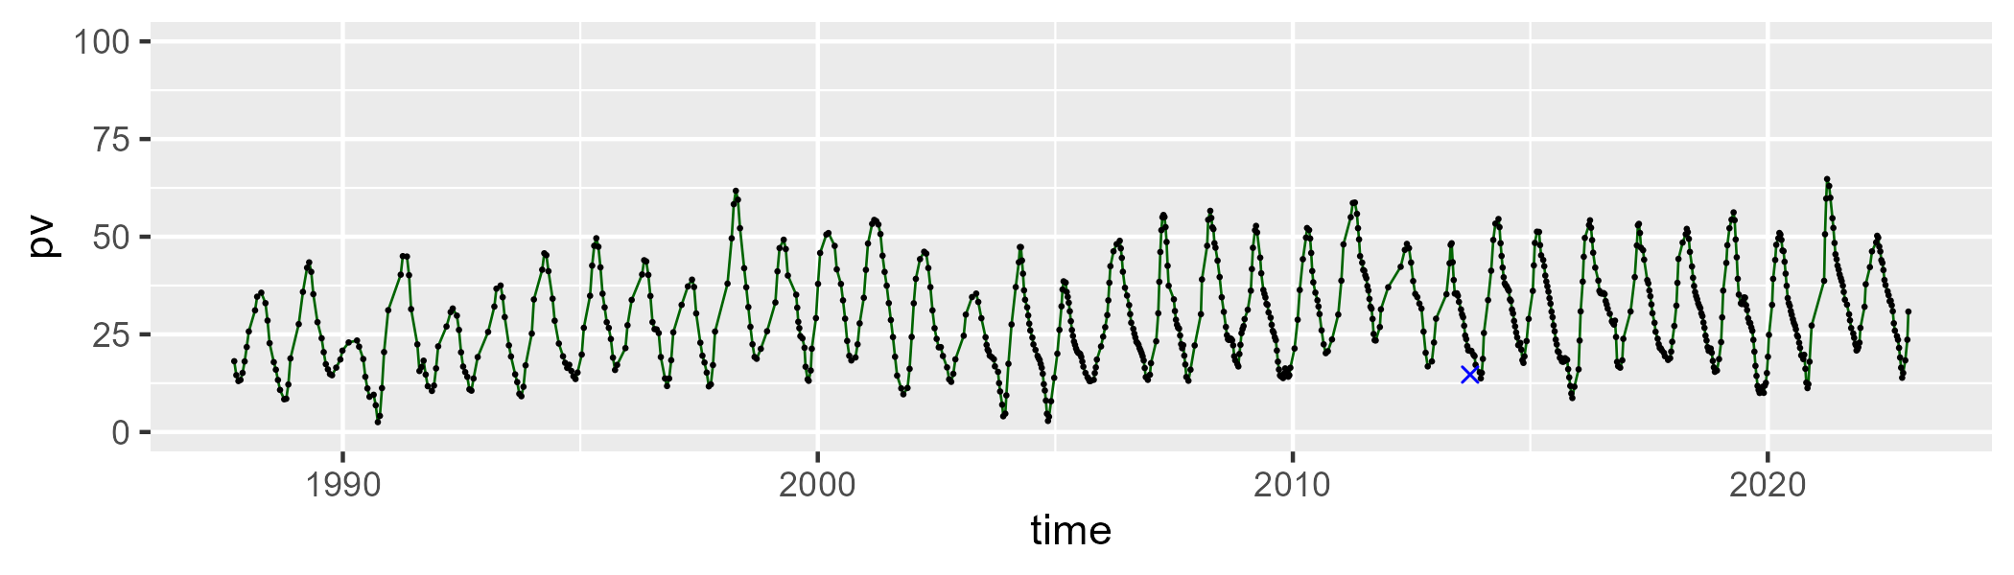

| Min. | 1st Qu. | Median | Mean | 3rd Qu. | Max. |
| --- | --- | --- | --- | --- | --- |
| 32.31752 | 46.82195 | 55.43764 | 55.64534 | 63.81291 | 83.29159 |

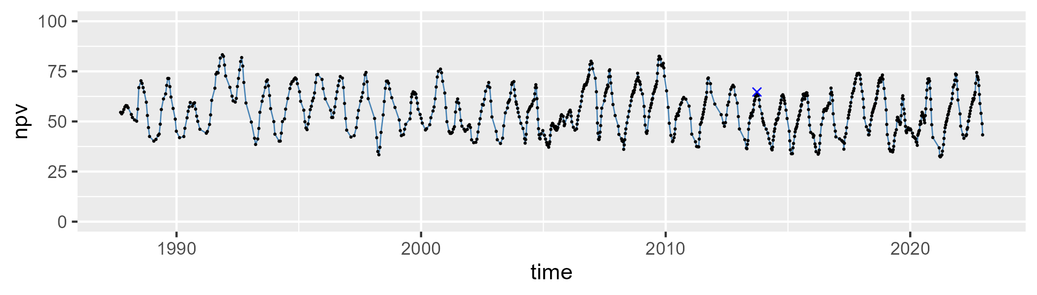

| Min. | 1st Qu. | Median | Mean | 3rd Qu. | Max. |
| --- | --- | --- | --- | --- | --- |
| 0.2059468 | 6.279778 | 11.29734 | 13.57588 | 17.71444 | 54.02193 |

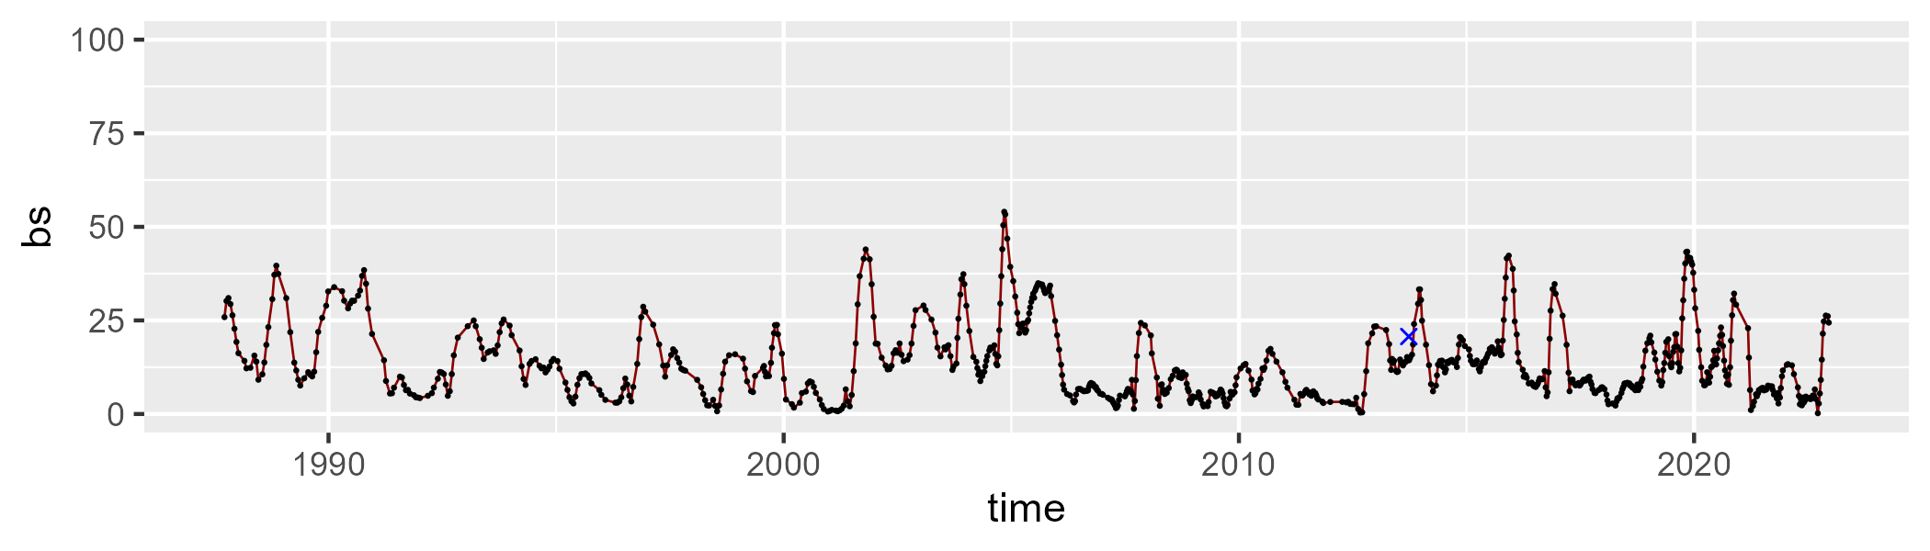

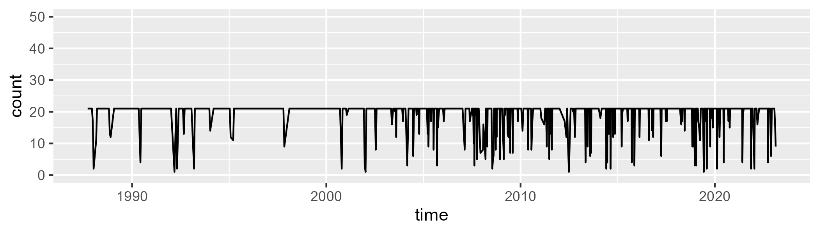

Min. : 1.00 1st Qu.:21.00 Median :21.00 Mean :19.36 3rd Qu.:21.00 Max. :21.00

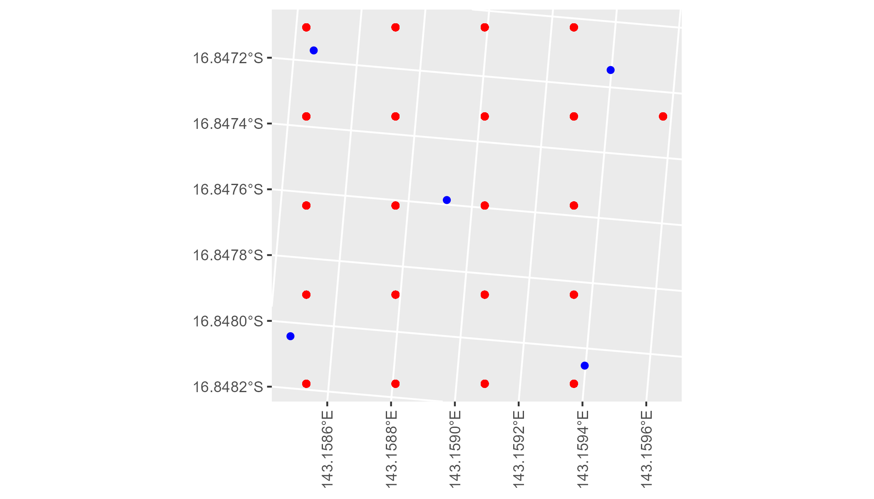

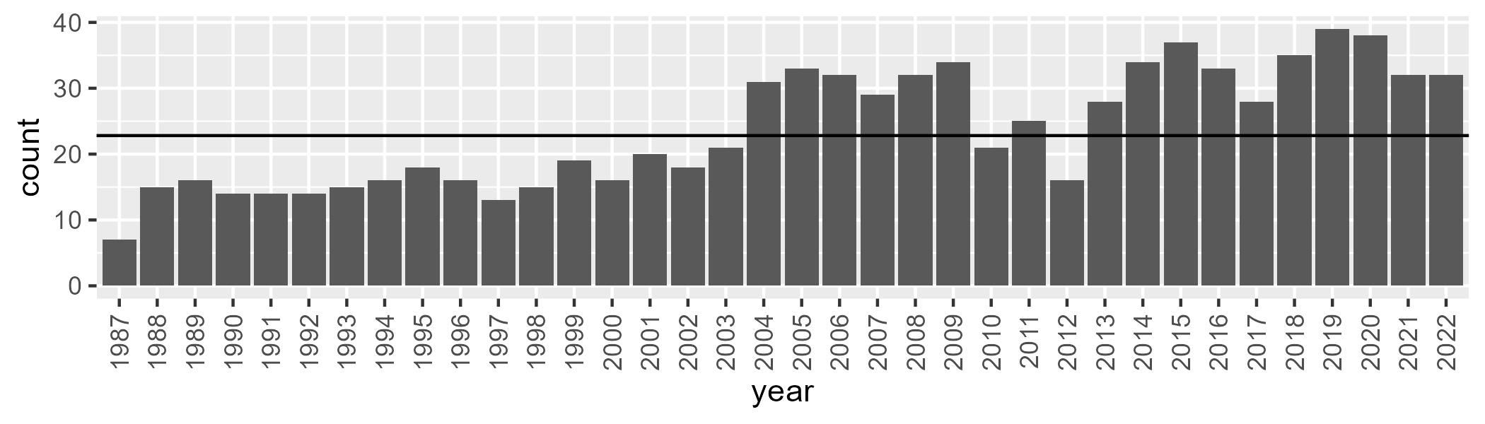

Number of samples: 856

# QDAGUP0031

| Min. | 1st Qu. | Median | Mean | 3rd Qu. | Max. |
| --- | --- | --- | --- | --- | --- |
| 4.472064 | 15.69942 | 21.57314 | 23.37899 | 30.06747 | 53.02327 |

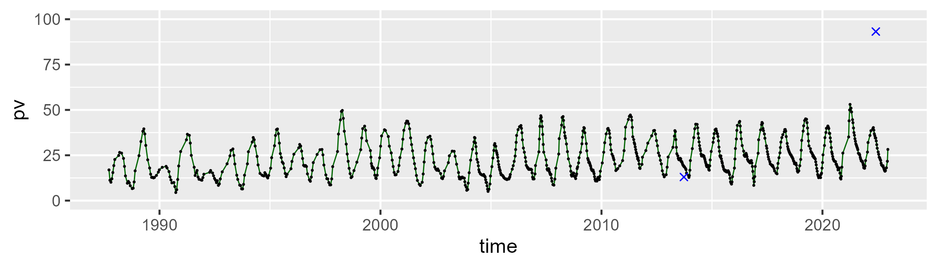

| Min. | 1st Qu. | Median | Mean | 3rd Qu. | Max. |
| --- | --- | --- | --- | --- | --- |
| 38.673 | 52.00167 | 57.98844 | 58.20474 | 64.02323 | 78.61039 |

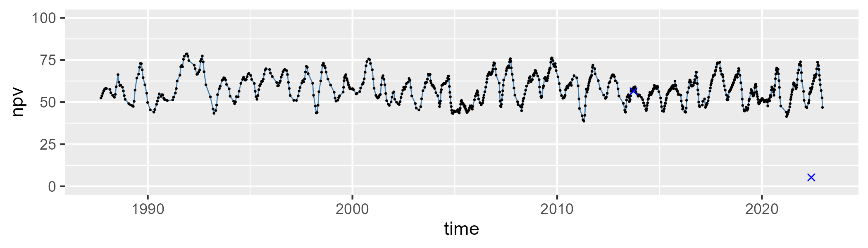

| Min. | 1st Qu. | Median | Mean | 3rd Qu. | Max. |
| --- | --- | --- | --- | --- | --- |
| 1.4998 | 11.01638 | 15.36566 | 17.19396 | 22.03002 | 50.0827 |

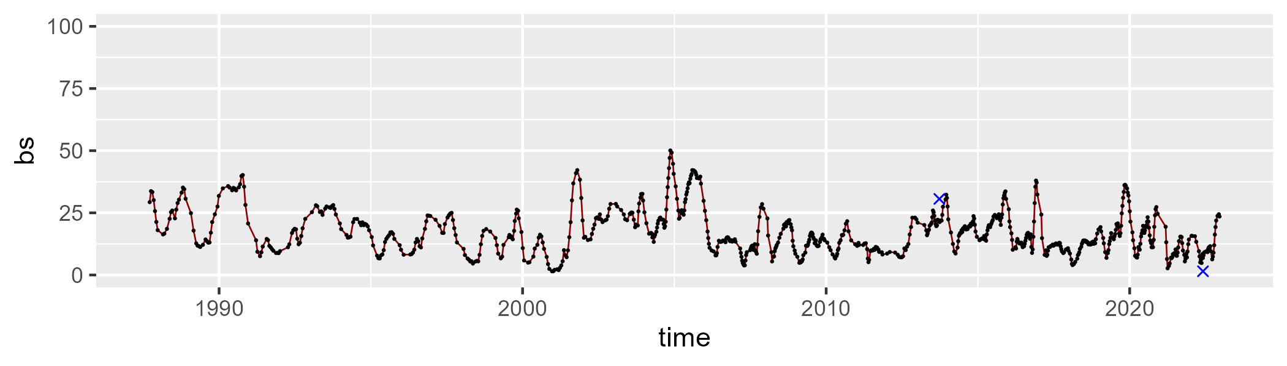

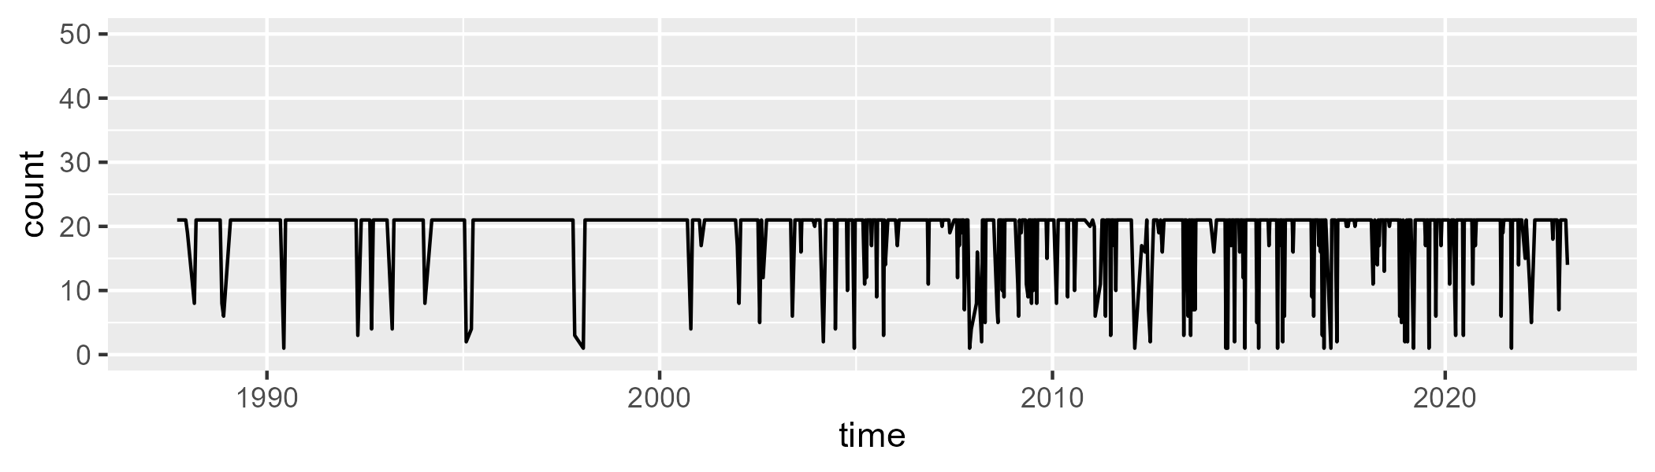

Min. : 1.00 1st Qu.:21.00 Median :21.00 Mean :19.13 3rd Qu.:21.00 Max. :21.00

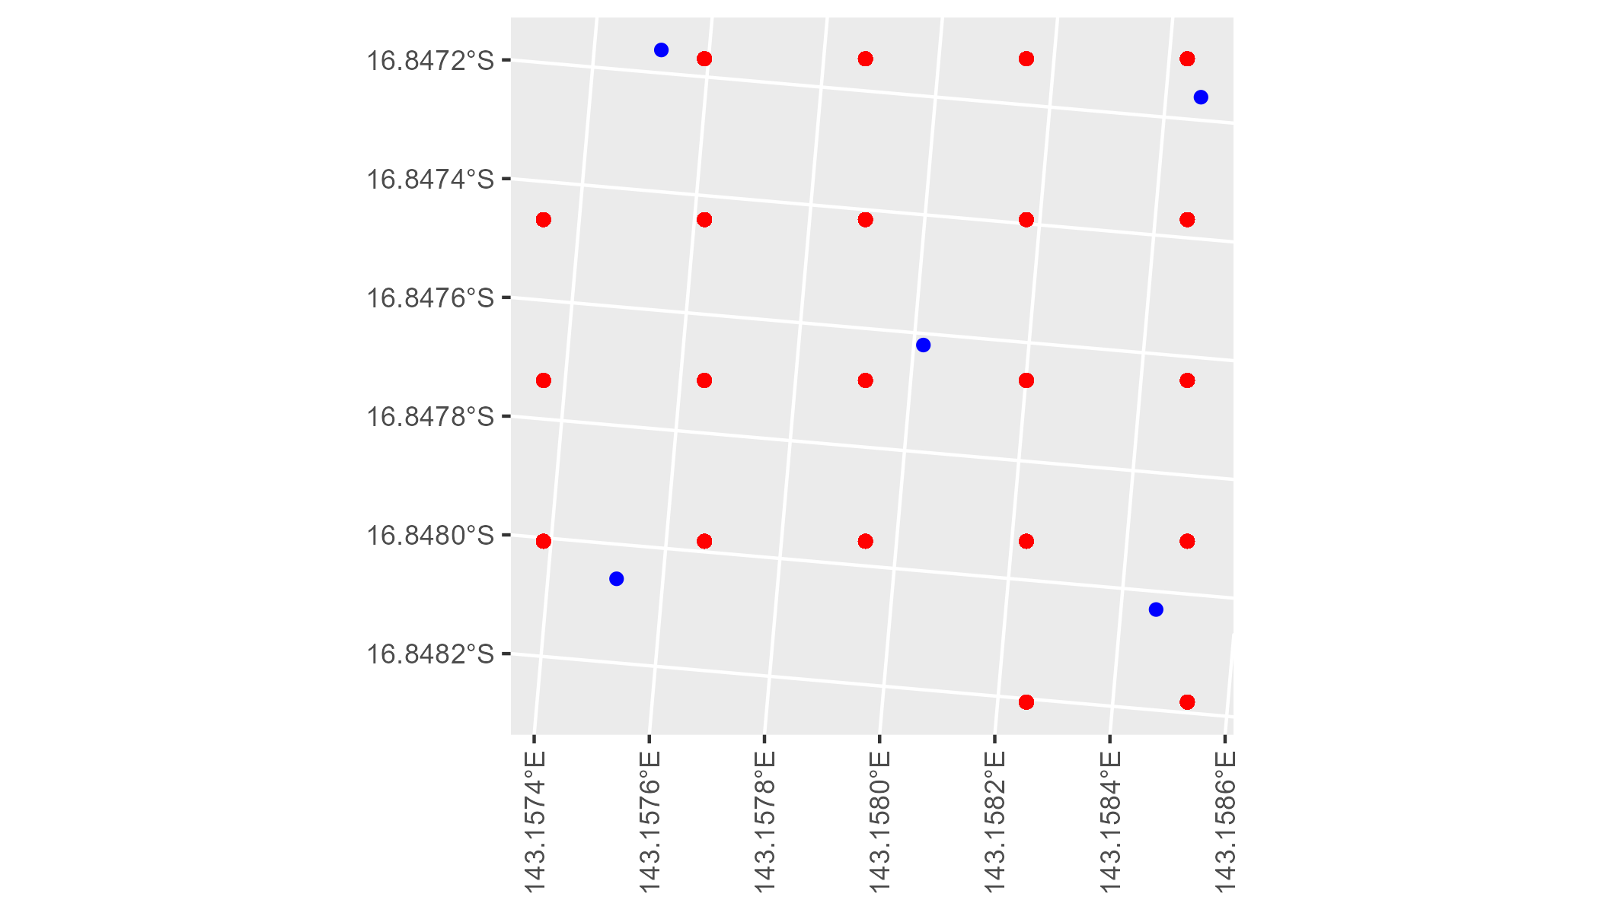

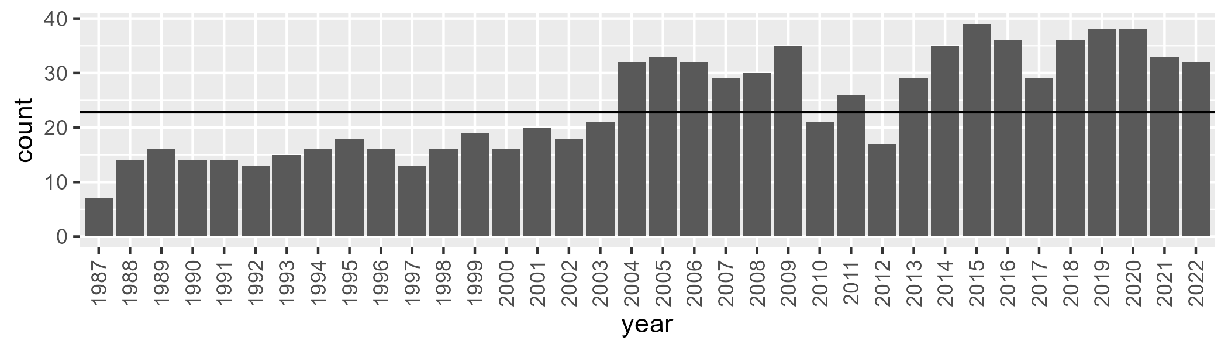

Number of samples: 866

# QDAMGD0001

| Min. | 1st Qu. | Median | Mean | 3rd Qu. | Max. |
| --- | --- | --- | --- | --- | --- |
| 0 | 1.791016 | 5.821561 | 11.24371 | 15.53536 | 65.73979 |

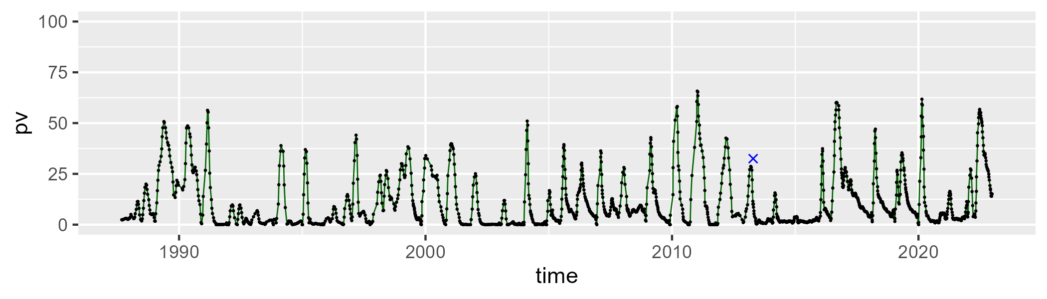

| Min. | 1st Qu. | Median | Mean | 3rd Qu. | Max. |
| --- | --- | --- | --- | --- | --- |
| 5.314382 | 37.5638 | 46.02362 | 48.53236 | 58.13046 | 94.7627 |

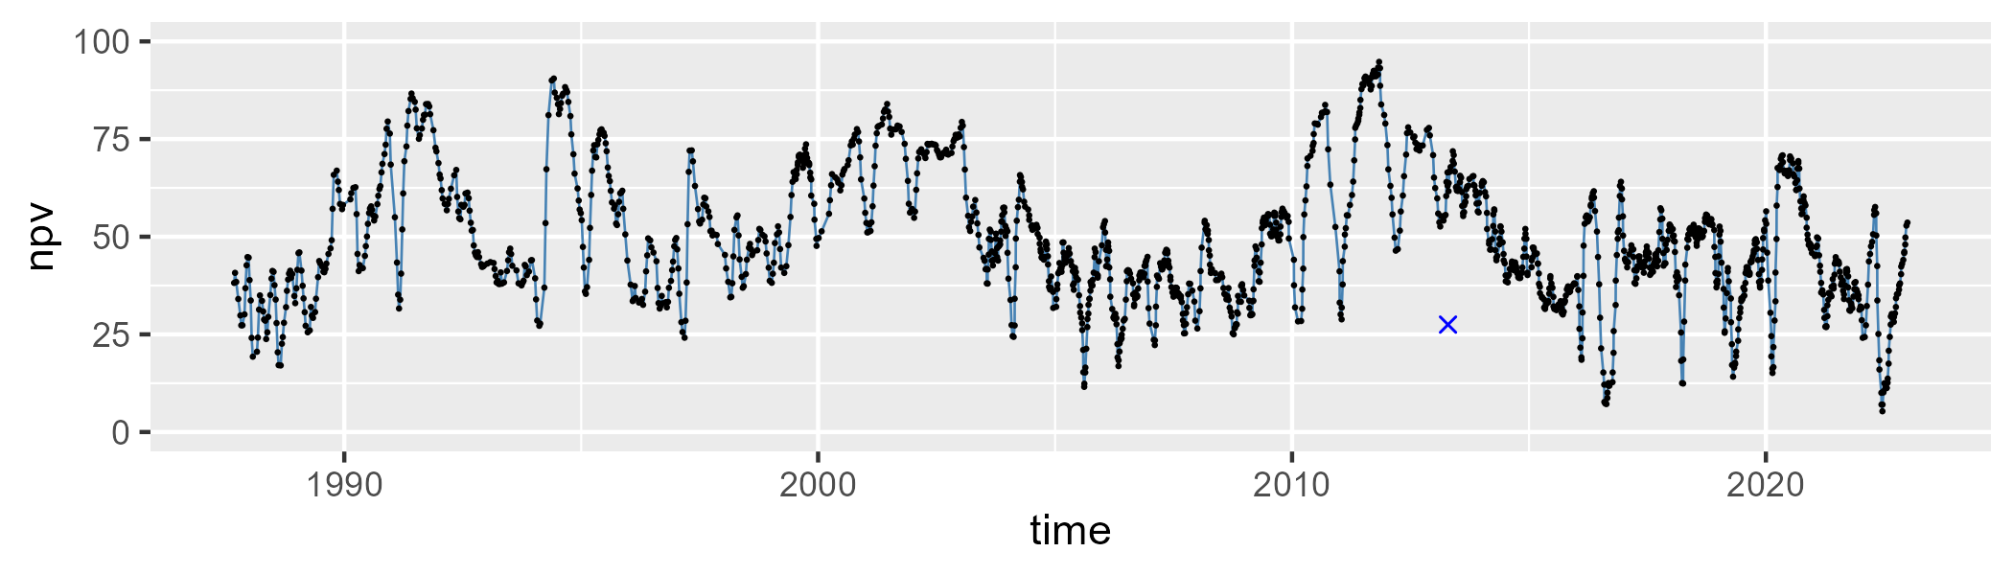

| Min. | 1st Qu. | Median | Mean | 3rd Qu. | Max. |
| --- | --- | --- | --- | --- | --- |
| 1.791937 | 26.75896 | 41.00877 | 39.05181 | 51.87469 | 75.56355 |

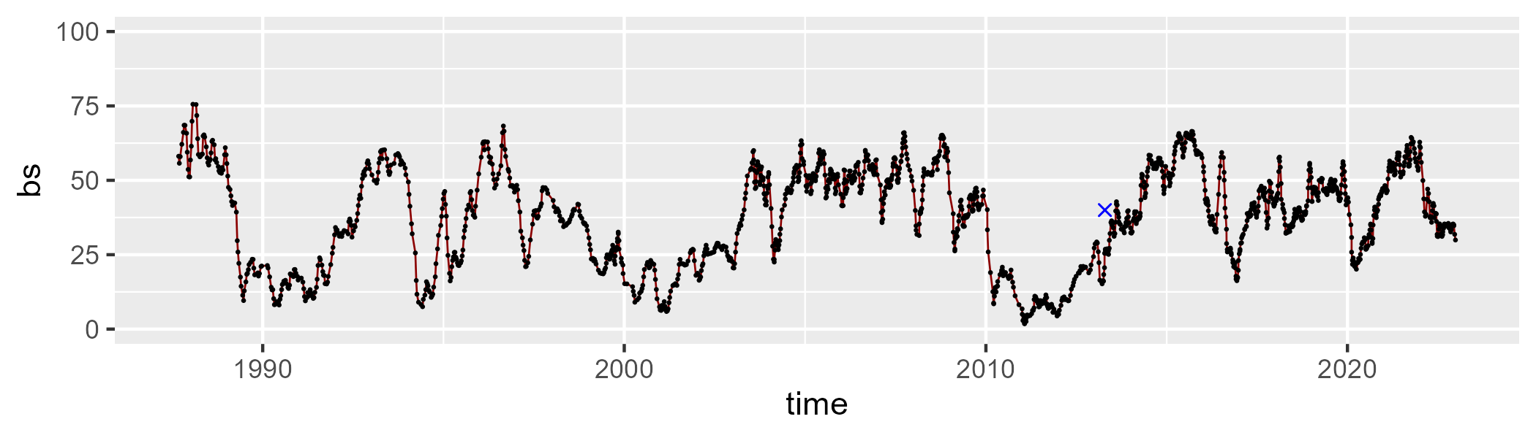

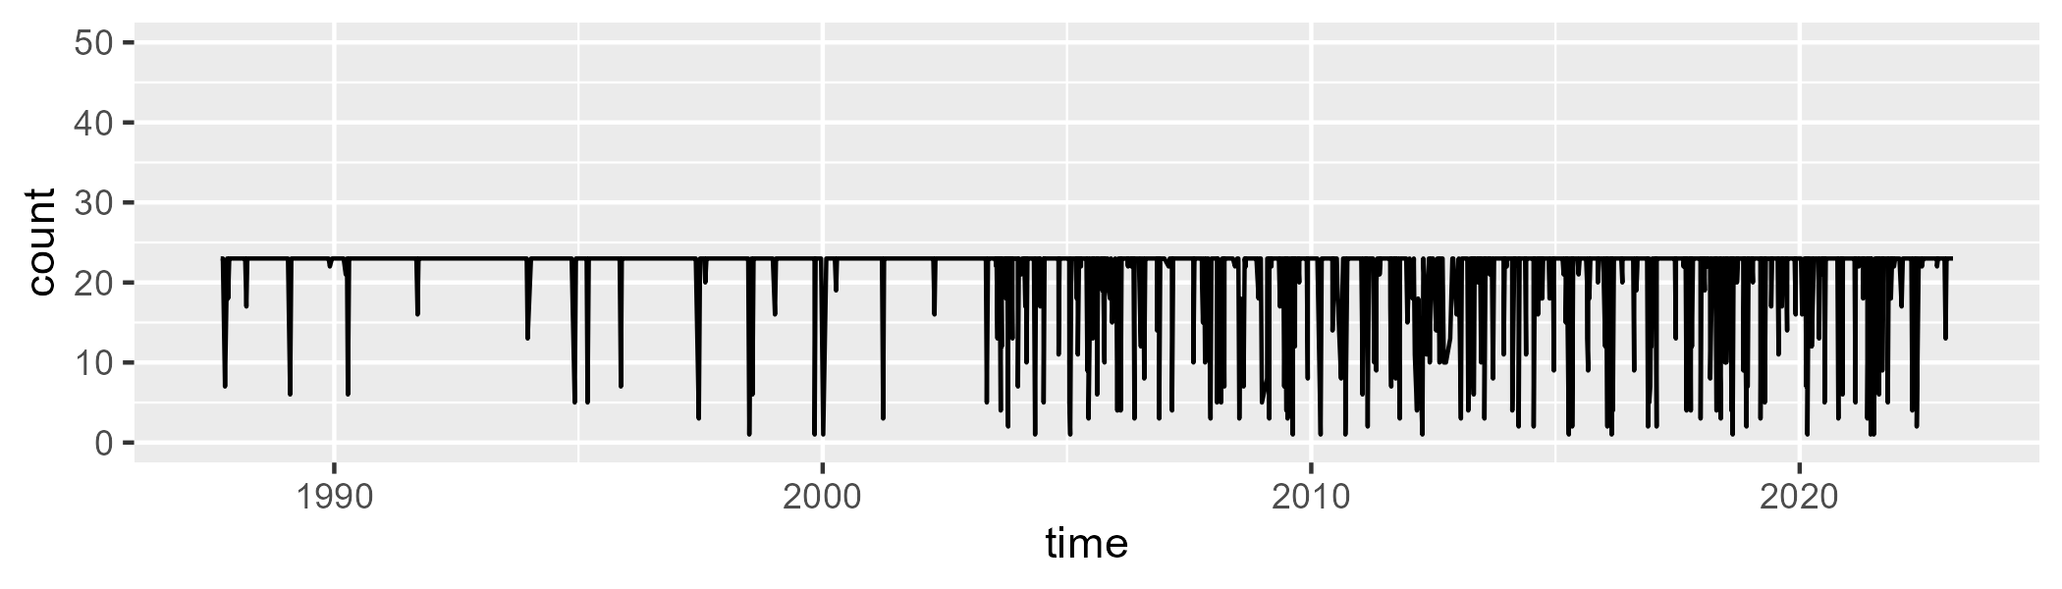

Min. : 1.00 1st Qu.:23.00 Median :23.00 Mean :21.34 3rd Qu.:23.00 Max. :23.00

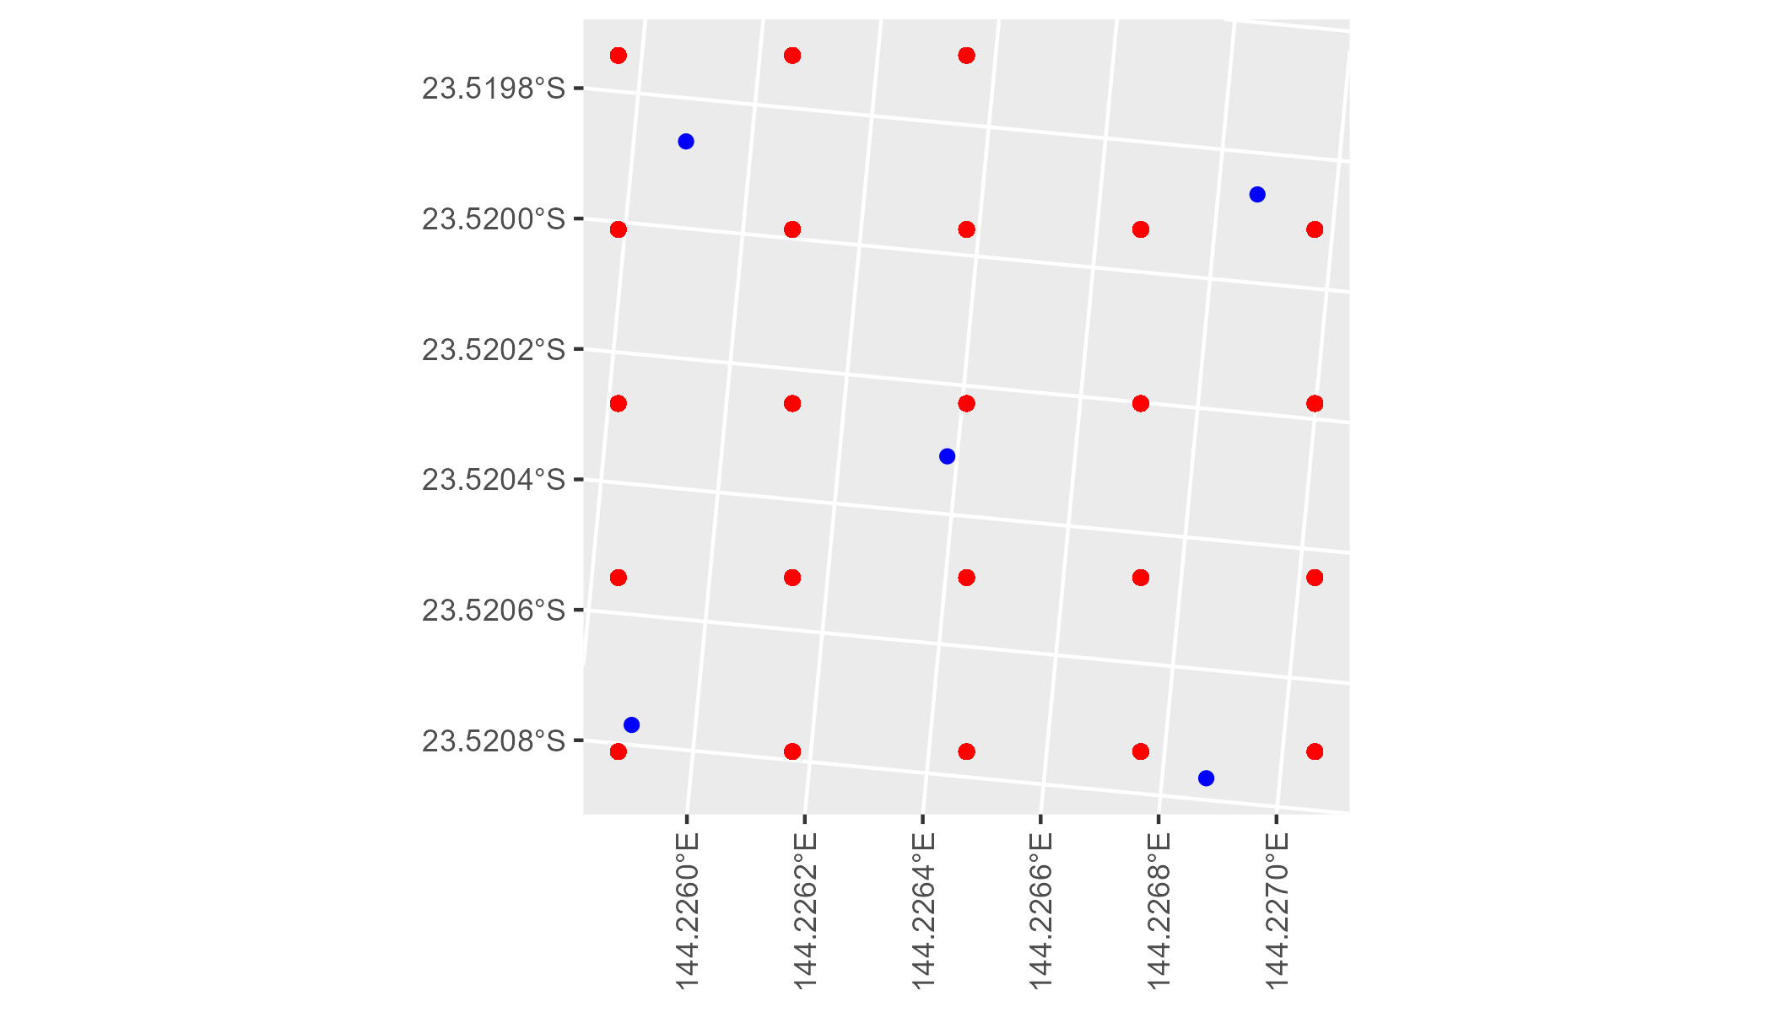

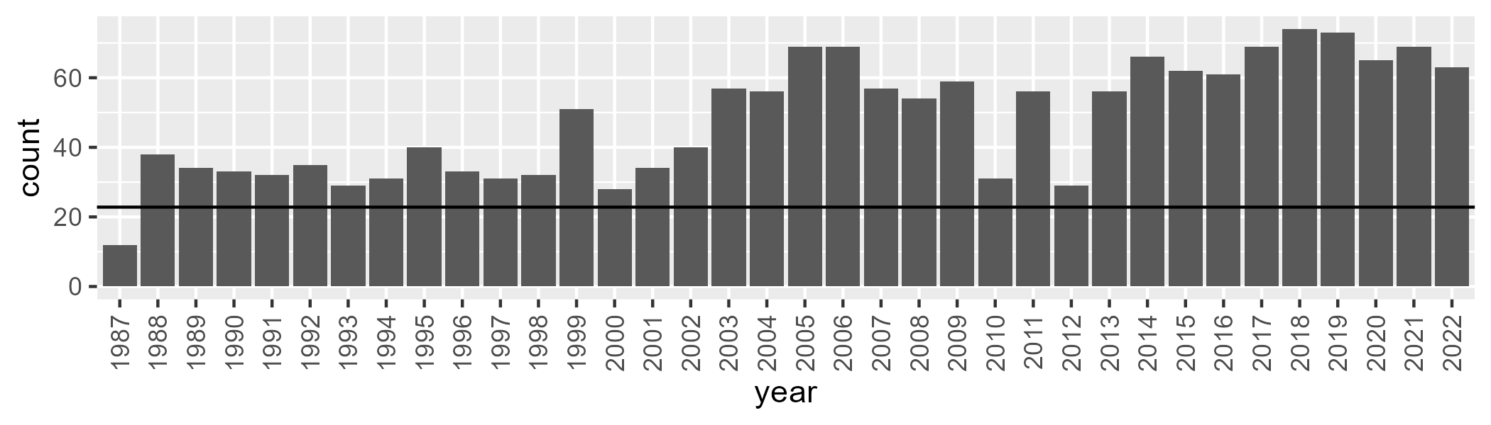

Number of samples: 1728

# QDAMGD0002

| Min. | 1st Qu. | Median | Mean | 3rd Qu. | Max. |
| --- | --- | --- | --- | --- | --- |
| 3.205178 | 13.642 | 19.06159 | 21.88173 | 28.49156 | 59.83832 |

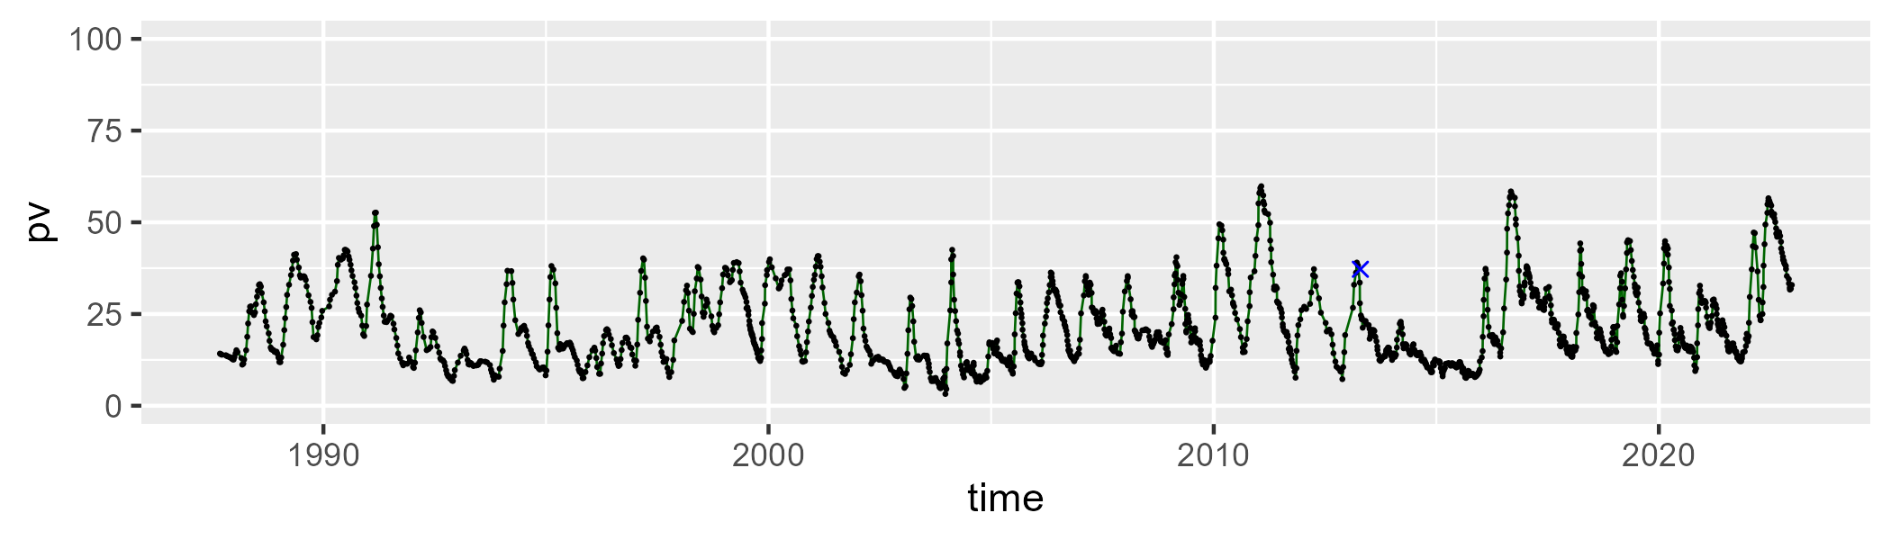

| Min. | 1st Qu. | Median | Mean | 3rd Qu. | Max. |
| --- | --- | --- | --- | --- | --- |
| 6.107346 | 31.43977 | 38.32571 | 38.18611 | 44.54015 | 81.46336 |

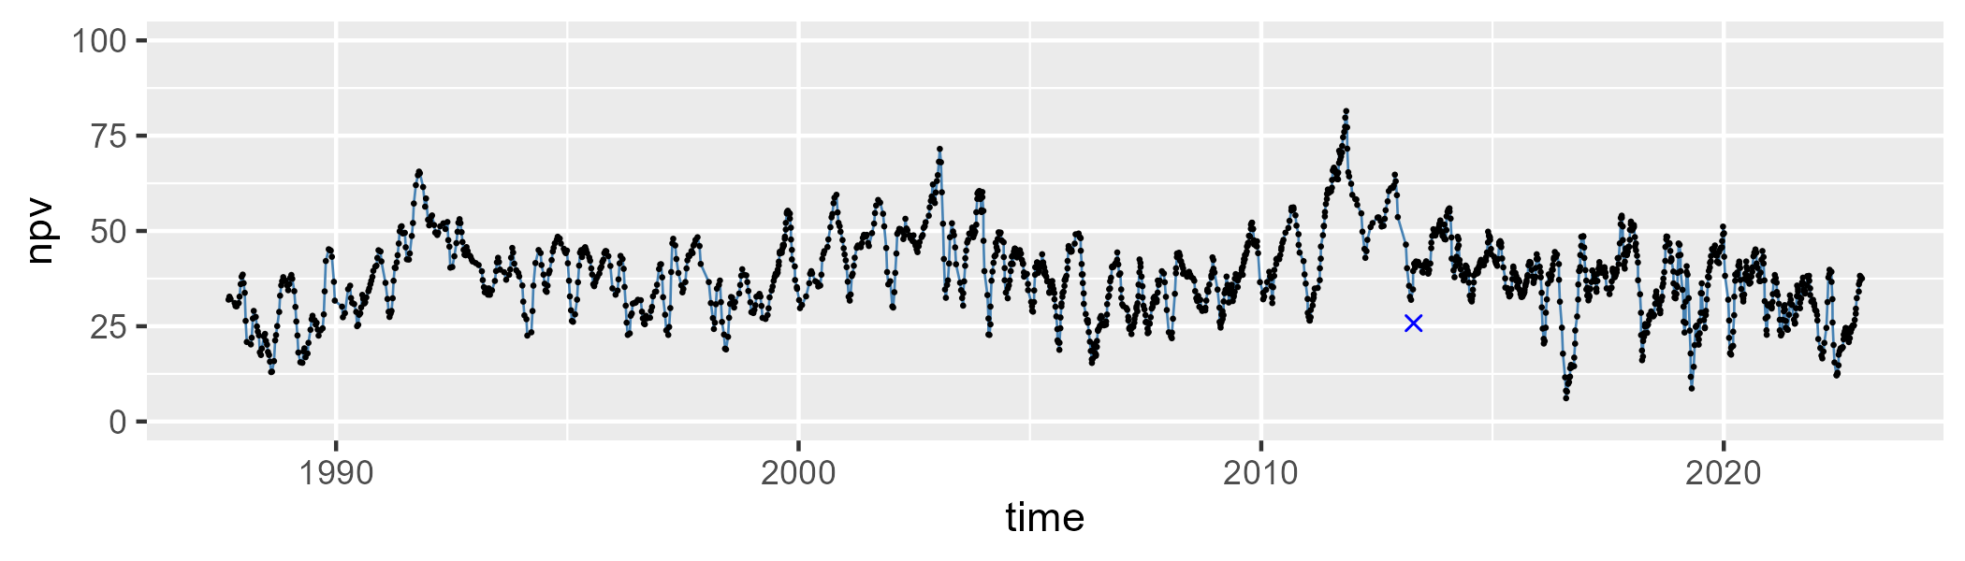

| Min. | 1st Qu. | Median | Mean | 3rd Qu. | Max. |
| --- | --- | --- | --- | --- | --- |
| 8.173628 | 32.84627 | 39.38806 | 38.62836 | 45.94729 | 65.72482 |

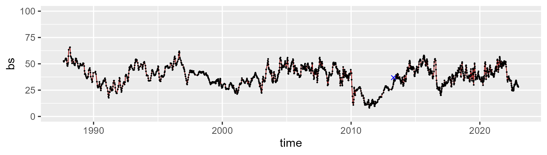

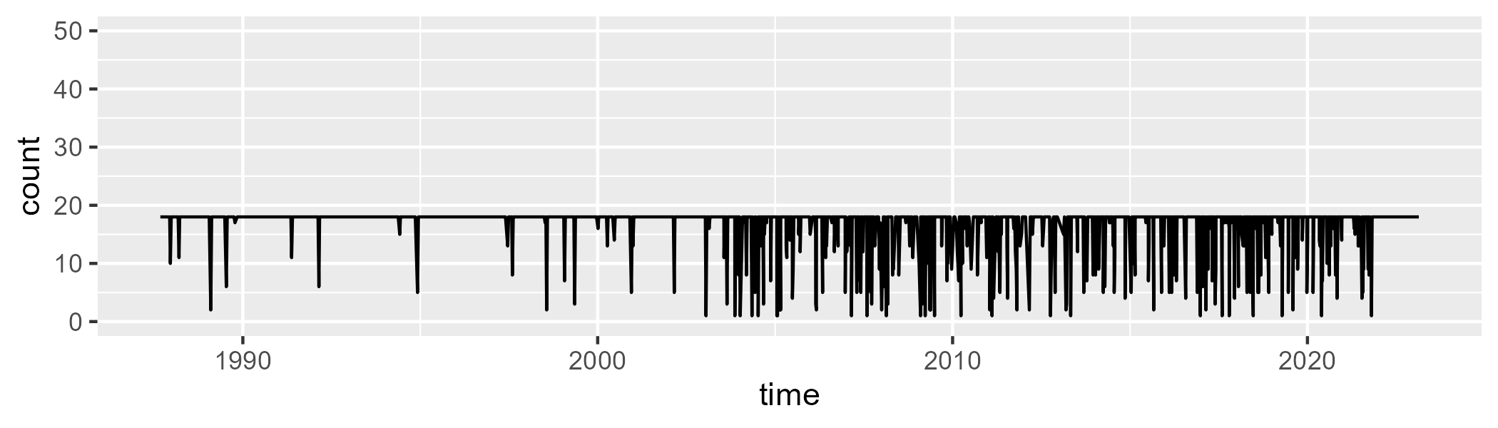

Min. : 1.0 1st Qu.:18.0 Median :18.0 Mean :16.7 3rd Qu.:18.0 Max. :18.0

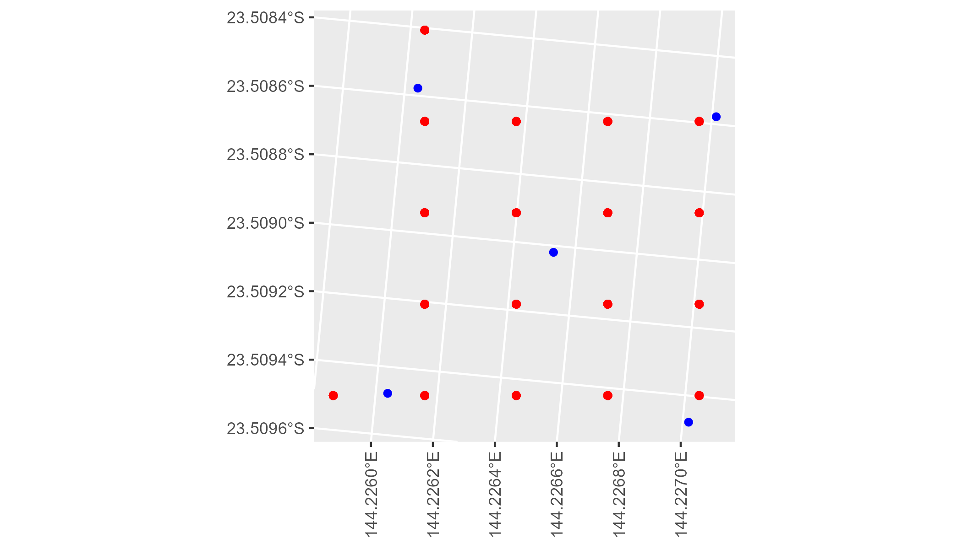

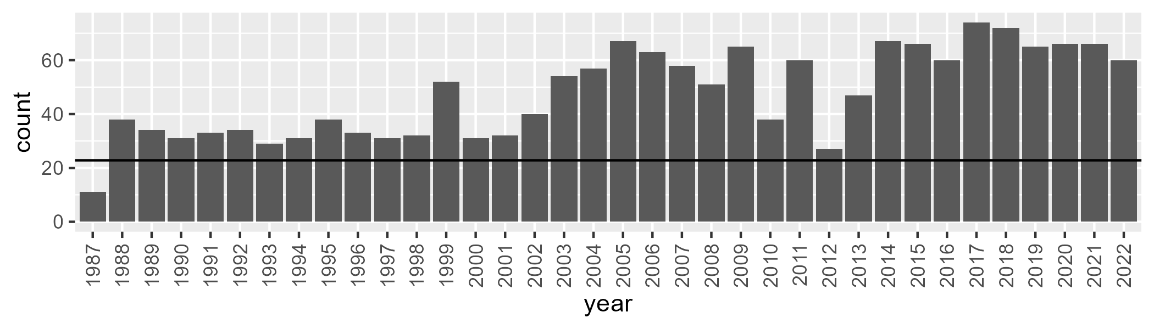

Number of samples: 1713

# QDAMGD0003

| Min. | 1st Qu. | Median | Mean | 3rd Qu. | Max. |
| --- | --- | --- | --- | --- | --- |
| 0 | 1.302555 | 4.495605 | 12.41456 | 17.21654 | 86.09381 |

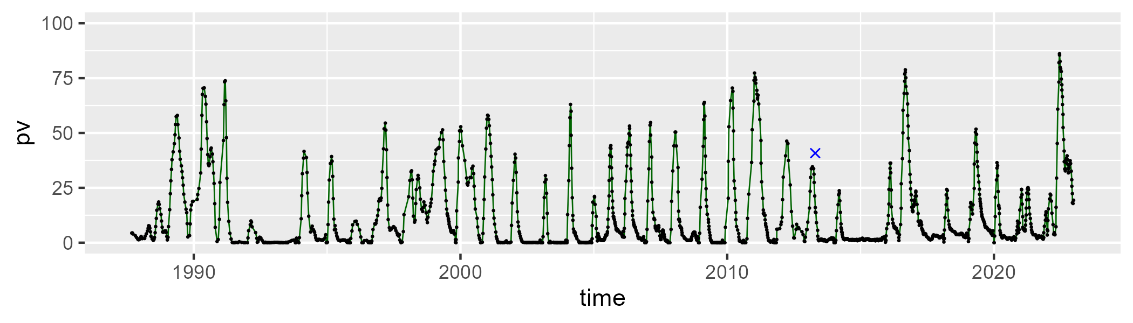

| Min. | 1st Qu. | Median | Mean | 3rd Qu. | Max. |
| --- | --- | --- | --- | --- | --- |
| 1.231338 | 43.33936 | 52.7391 | 53.90631 | 66.60918 | 97.41949 |

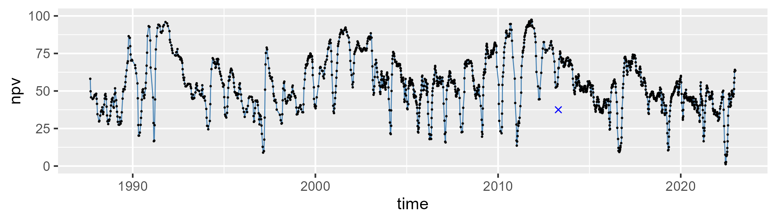

| Min. | 1st Qu. | Median | Mean | 3rd Qu. | Max. |
| --- | --- | --- | --- | --- | --- |
| 0 | 18.70832 | 34.99327 | 32.51178 | 45.79334 | 70.00117 |

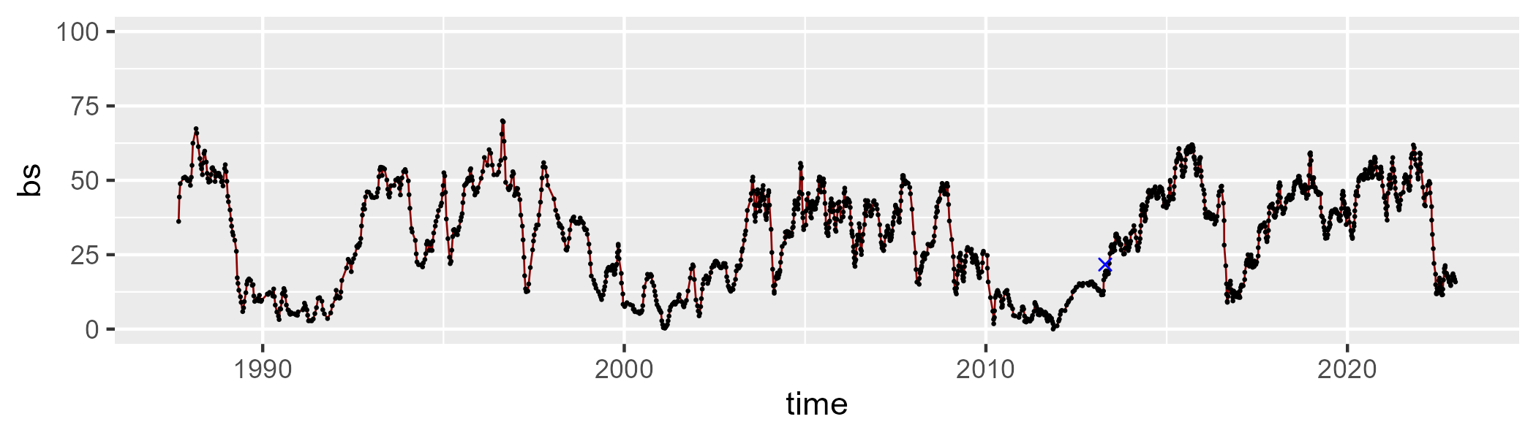

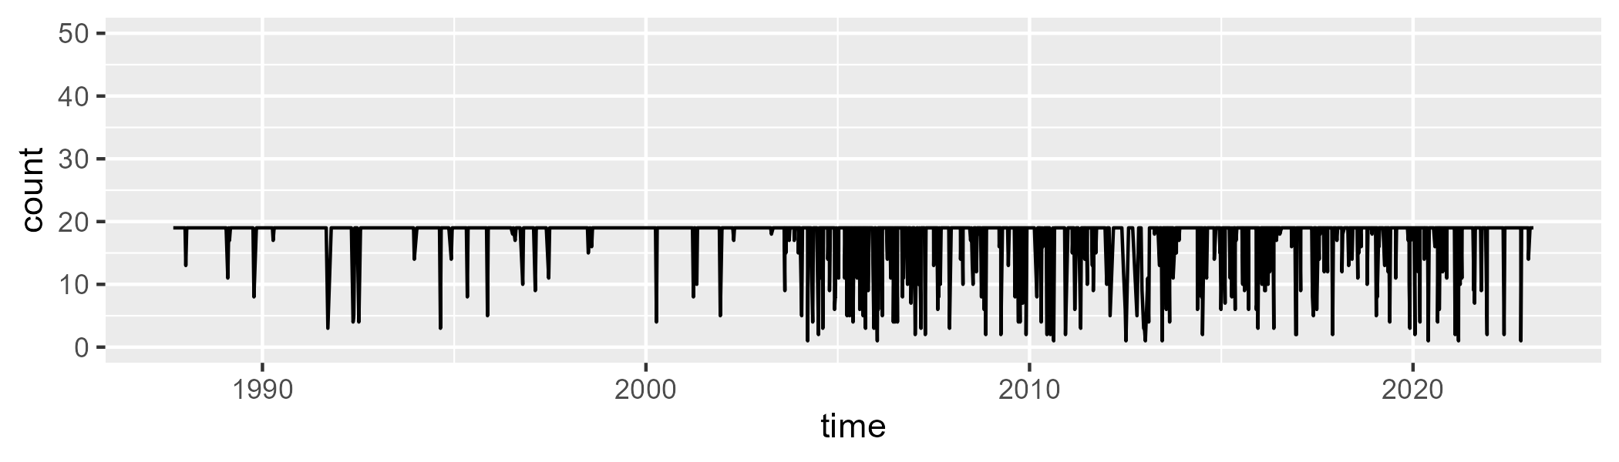

Min. : 1.00 1st Qu.:19.00 Median :19.00 Mean :17.67 3rd Qu.:19.00 Max. :19.00

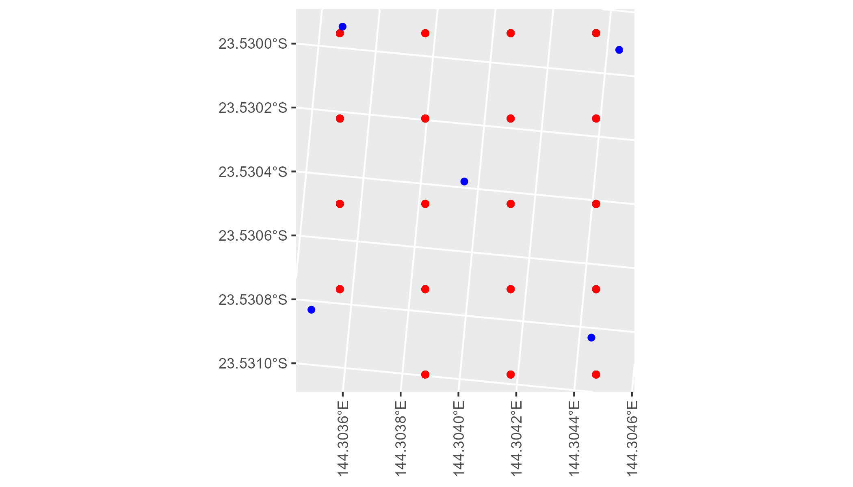

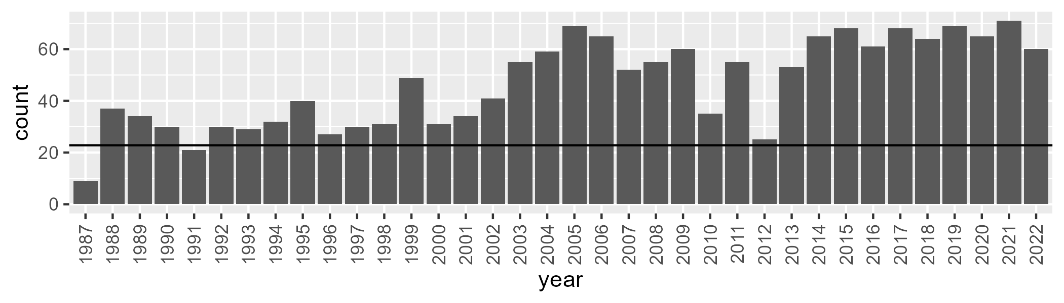

Number of samples: 1679

# QDAMGD0004

| Min. | 1st Qu. | Median | Mean | 3rd Qu. | Max. |
| --- | --- | --- | --- | --- | --- |
| 0 | 6.812609 | 9.046364 | 11.89356 | 14.51651 | 50.52719 |

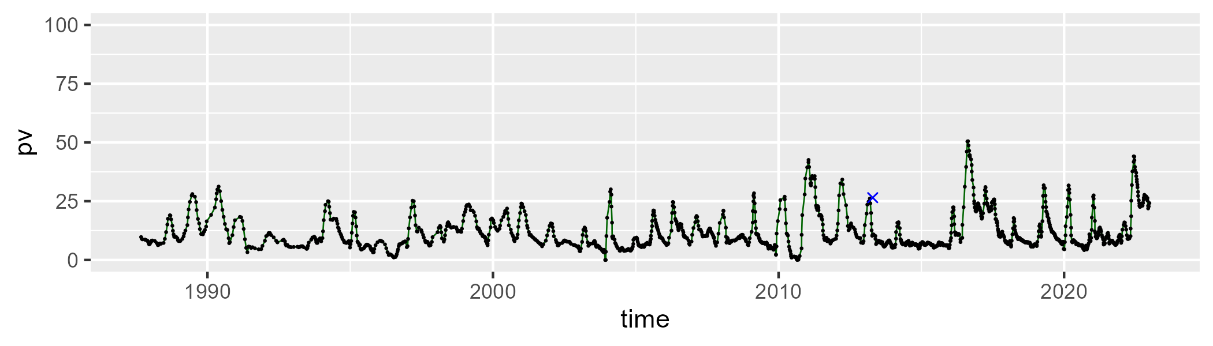

| Min. | 1st Qu. | Median | Mean | 3rd Qu. | Max. |
| --- | --- | --- | --- | --- | --- |
| 0.7893127 | 25.54321 | 30.63984 | 31.3427 | 36.3249 | 66.87271 |

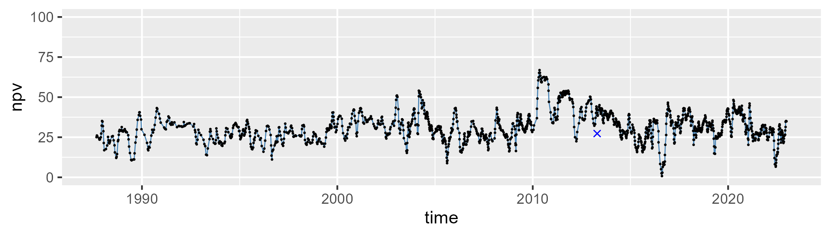

| Min. | 1st Qu. | Median | Mean | 3rd Qu. | Max. |
| --- | --- | --- | --- | --- | --- |
| 20.33293 | 49.65006 | 56.6974 | 55.41887 | 62.39022 | 84.21588 |

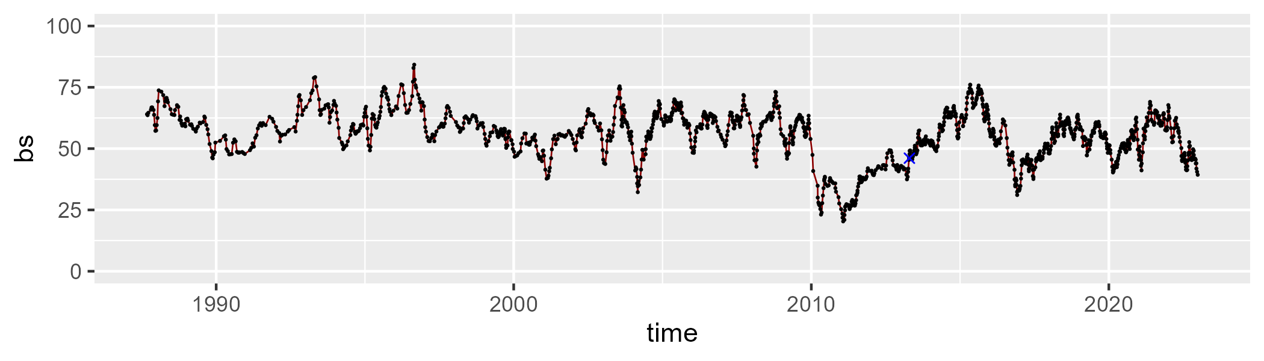

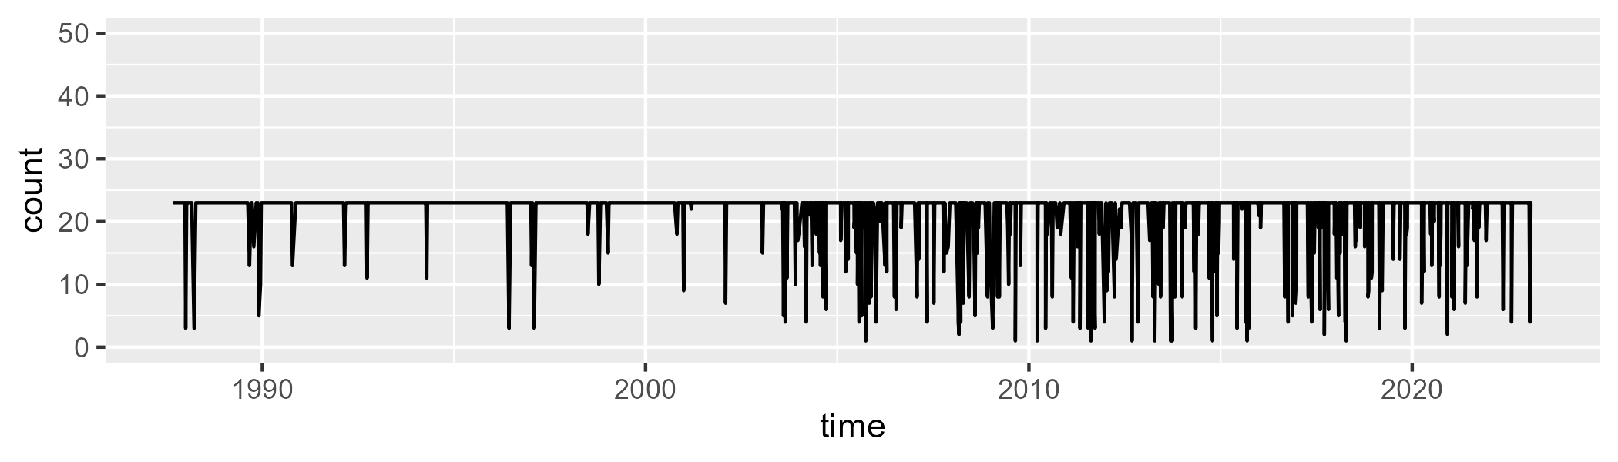

Min. : 1.00 1st Qu.:23.00 Median :23.00 Mean :21.34 3rd Qu.:23.00 Max. :23.00

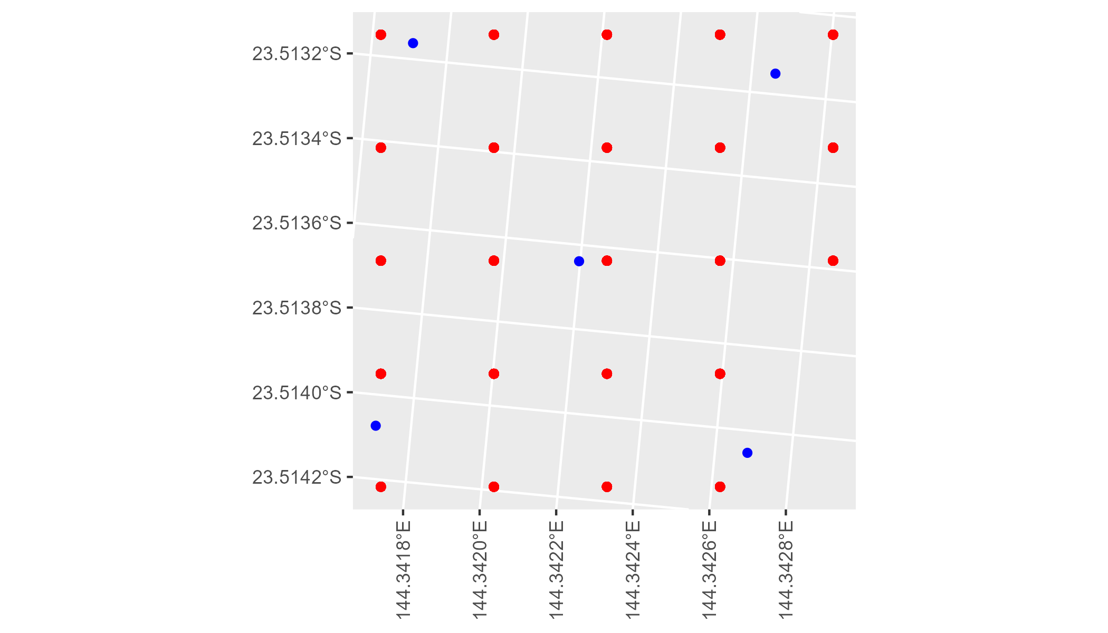

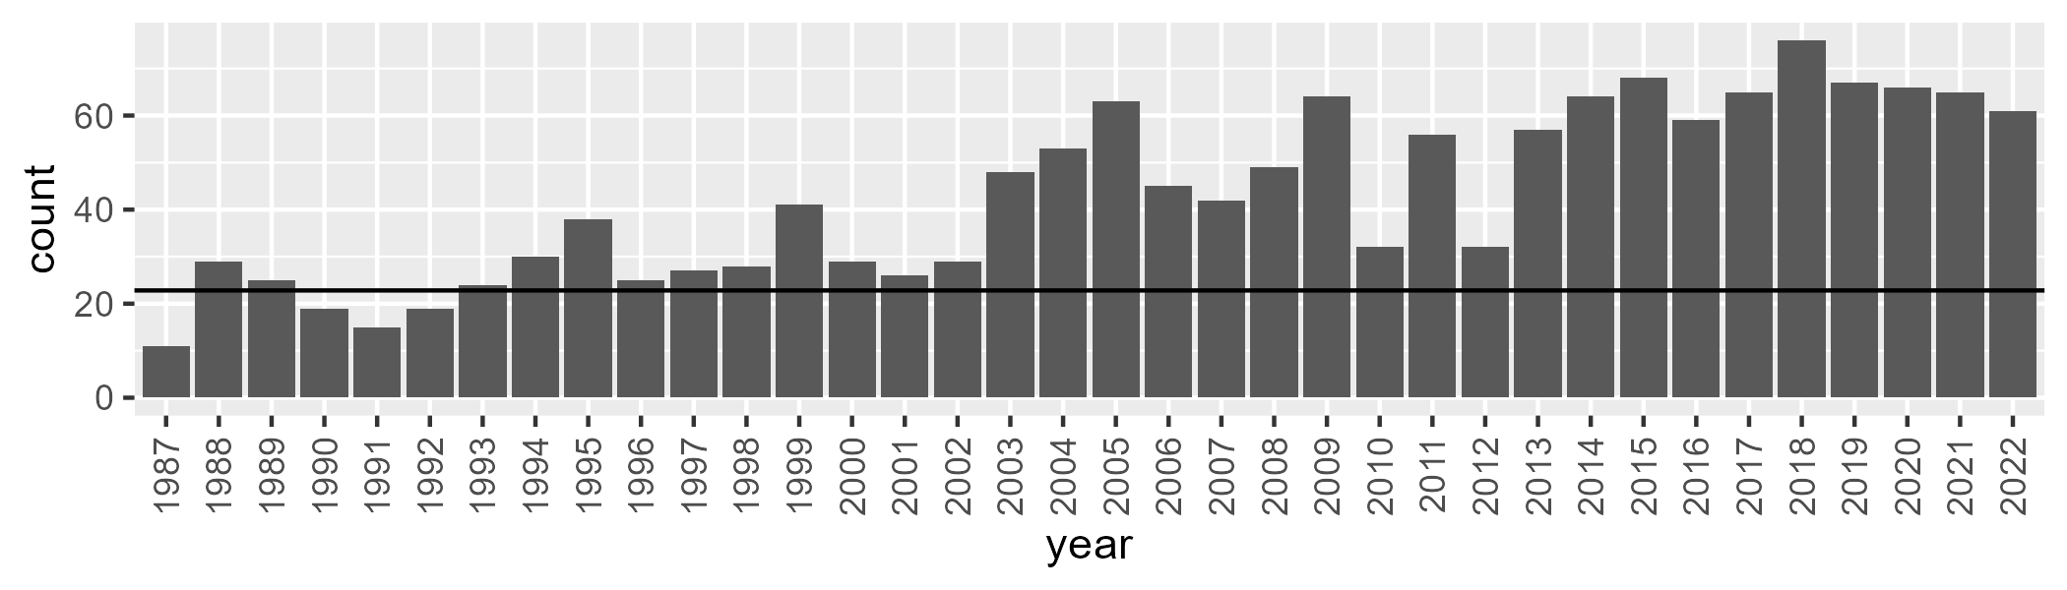

Number of samples: 1547

# QDAMGD0005

| Min. | 1st Qu. | Median | Mean | 3rd Qu. | Max. |
| --- | --- | --- | --- | --- | --- |
| 5.924102 | 13.21058 | 16.94618 | 19.67734 | 24.26889 | 54.77051 |

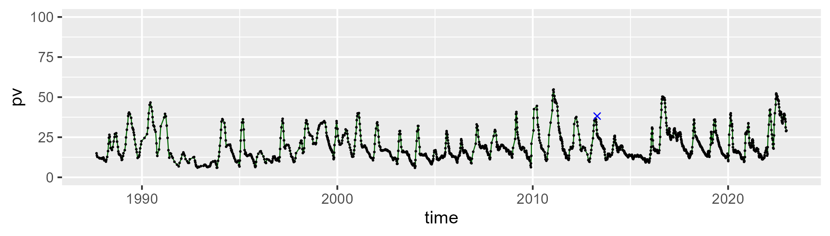

| Min. | 1st Qu. | Median | Mean | 3rd Qu. | Max. |
| --- | --- | --- | --- | --- | --- |
| 6.29344 | 29.32352 | 34.42981 | 35.25577 | 40.15483 | 70.70214 |

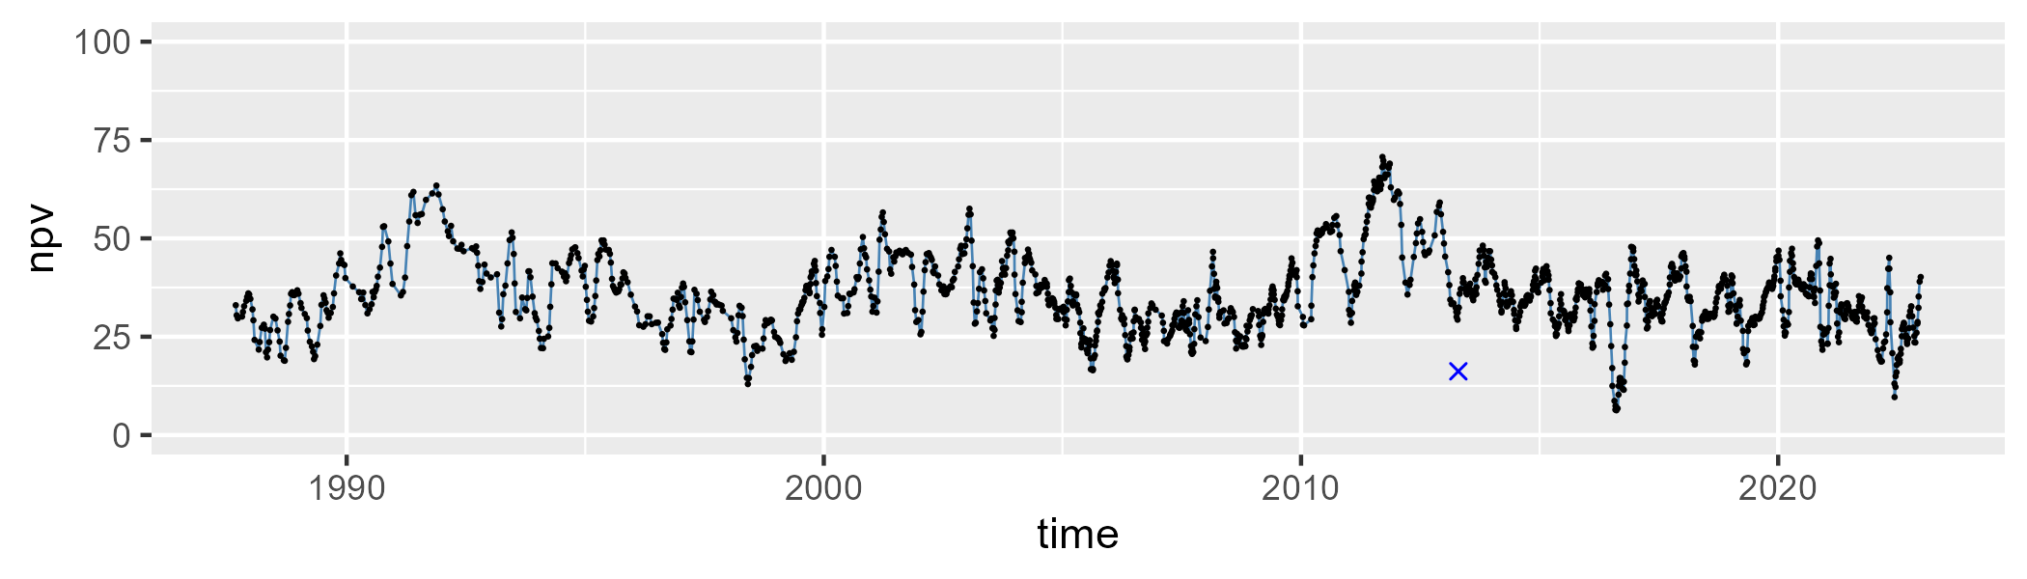

| Min. | 1st Qu. | Median | Mean | 3rd Qu. | Max. |
| --- | --- | --- | --- | --- | --- |
| 11.23783 | 38.48264 | 44.92433 | 43.75385 | 50.65893 | 67.64644 |

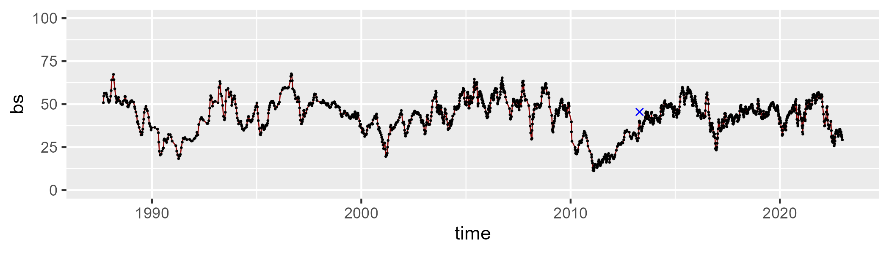

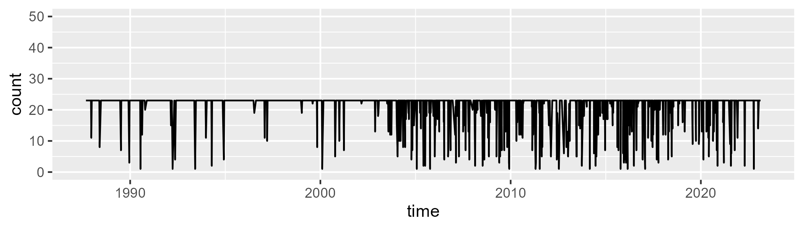

Min. : 1.00 1st Qu.:23.00 Median :23.00 Mean :21.27 3rd Qu.:23.00 Max. :23.00

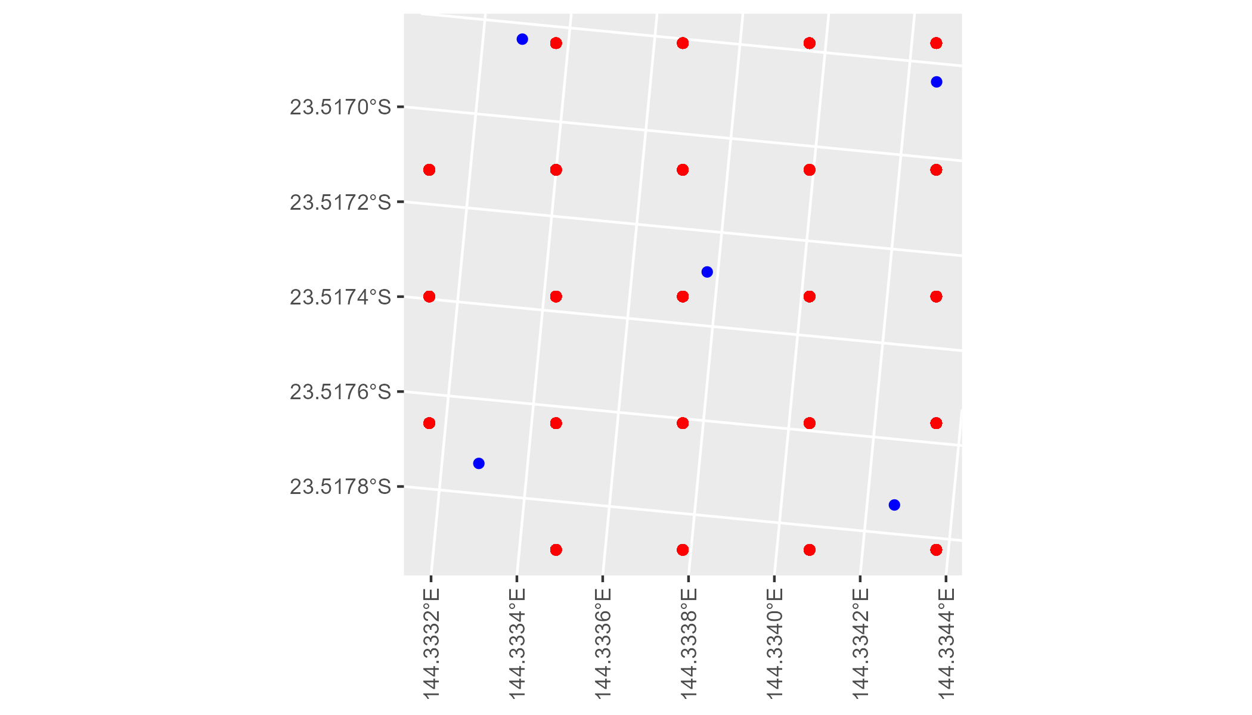

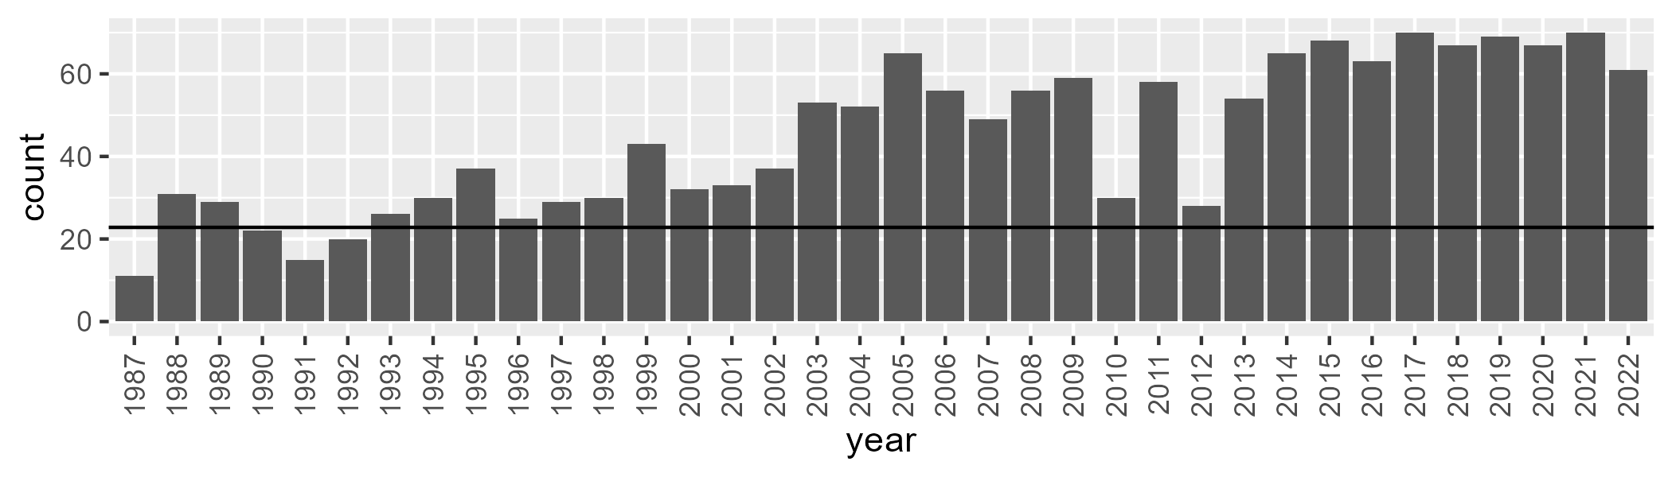

Number of samples: 1610

# QDAMGD0006

| Min. | 1st Qu. | Median | Mean | 3rd Qu. | Max. |
| --- | --- | --- | --- | --- | --- |
| 0 | 1.09514 | 4.079798 | 11.21926 | 14.79245 | 90.04459 |

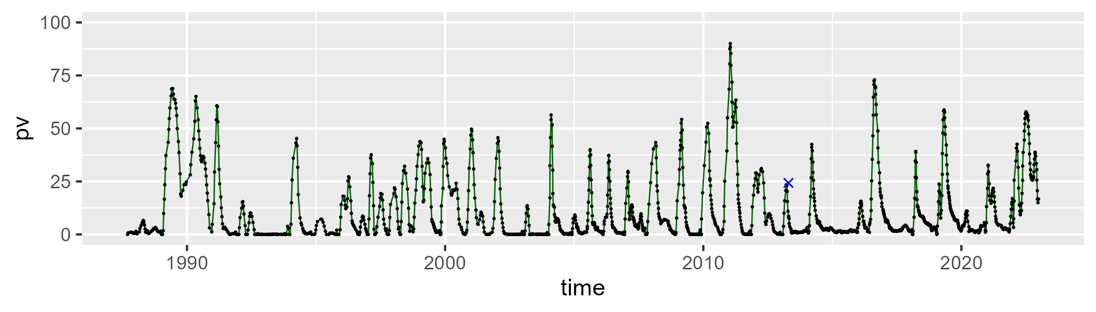

| Min. | 1st Qu. | Median | Mean | 3rd Qu. | Max. |
| --- | --- | --- | --- | --- | --- |
| 4.077806 | 42.31554 | 52.23939 | 53.17268 | 62.16105 | 99.03818 |

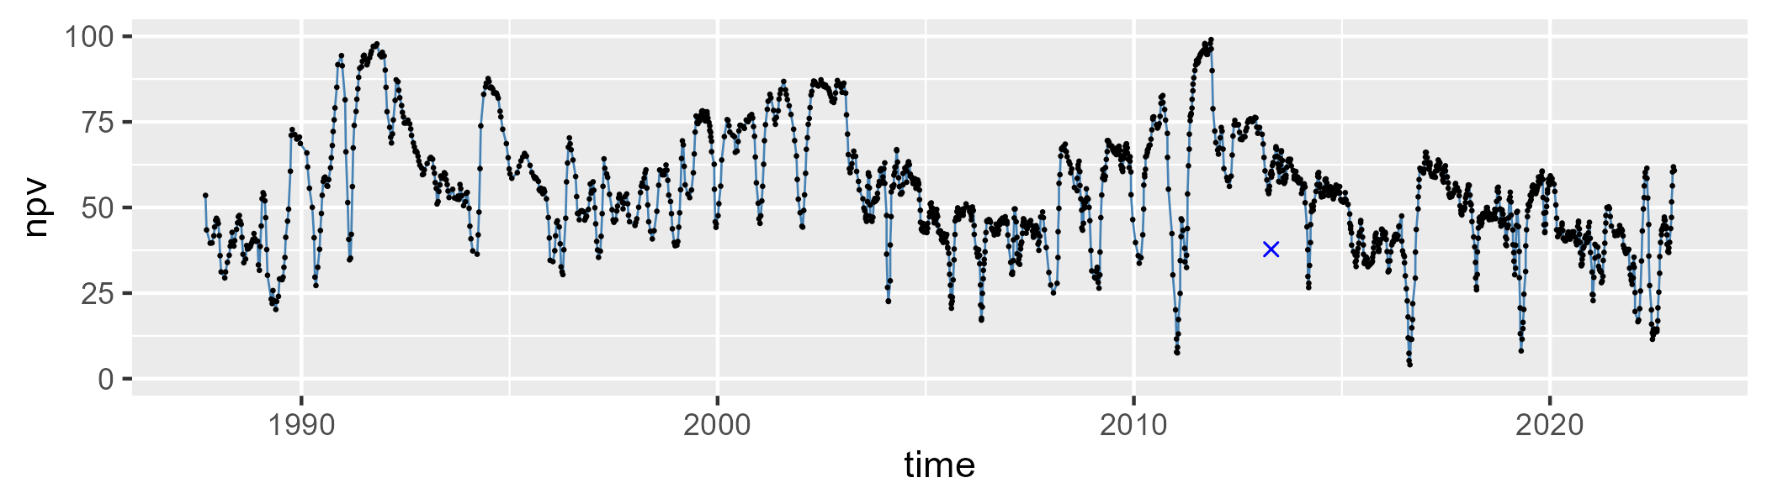

| Min. | 1st Qu. | Median | Mean | 3rd Qu. | Max. |
| --- | --- | --- | --- | --- | --- |
| 0.1089166 | 21.79614 | 37.54853 | 34.43585 | 47.10112 | 68.10604 |

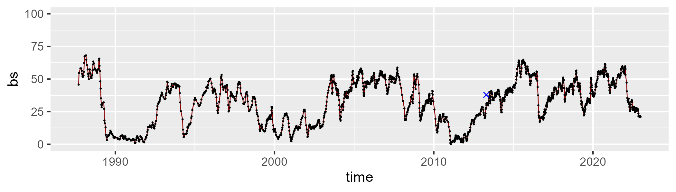

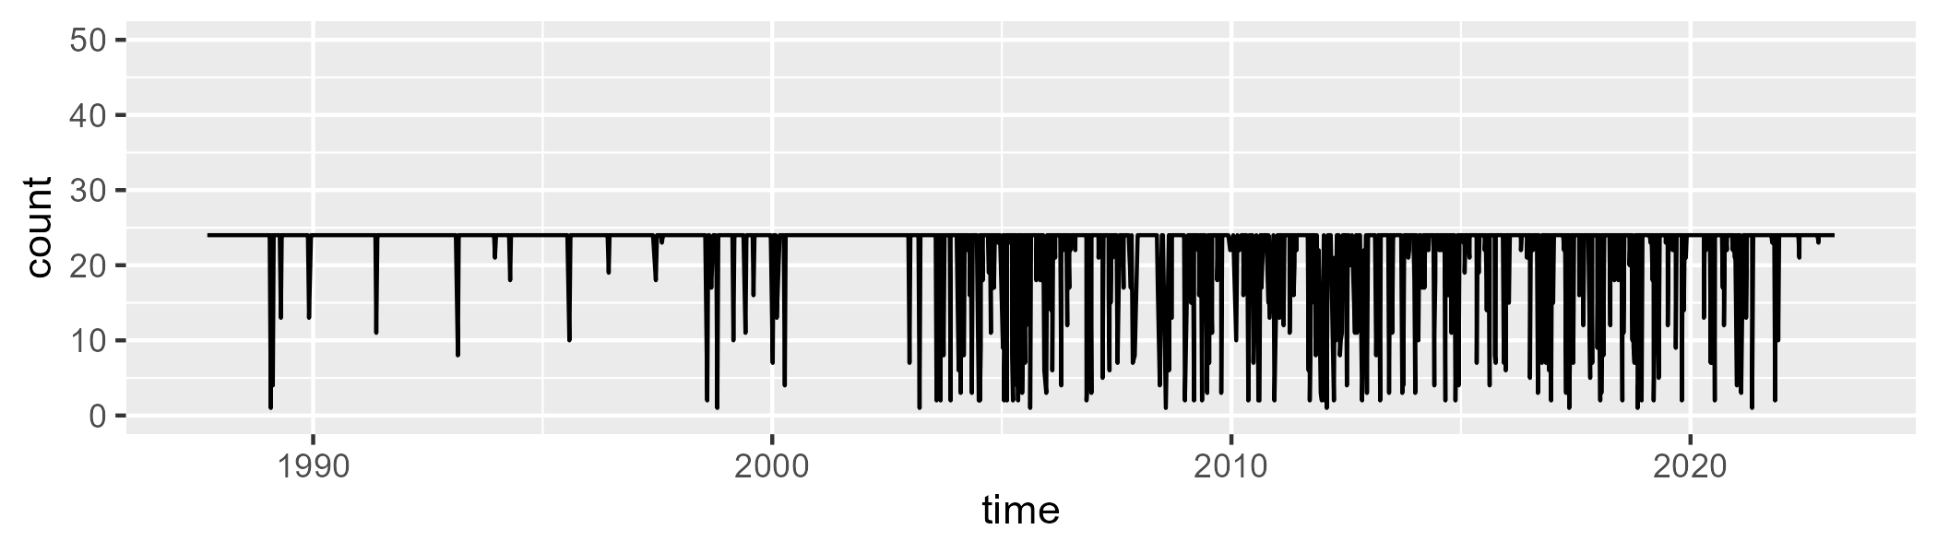

Min. : 1.00 1st Qu.:24.00 Median :24.00 Mean :22.05 3rd Qu.:24.00 Max. :24.00

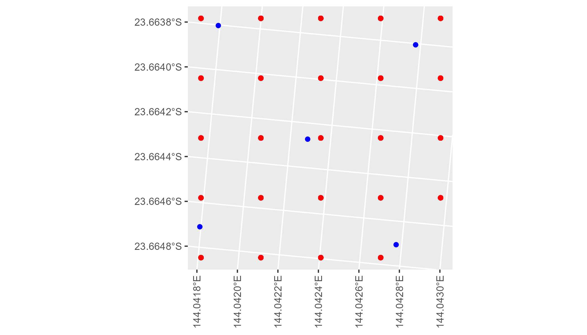

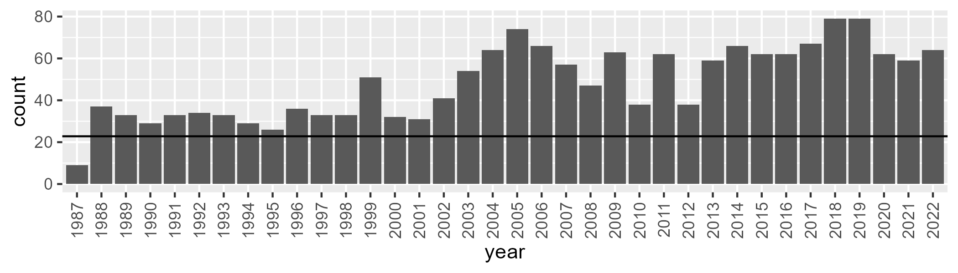

Number of samples: 1742

# QDAMGD0007

| Min. | 1st Qu. | Median | Mean | 3rd Qu. | Max. |
| --- | --- | --- | --- | --- | --- |
| 0 | 3.741951 | 6.208964 | 11.33193 | 15.26191 | 55.24639 |

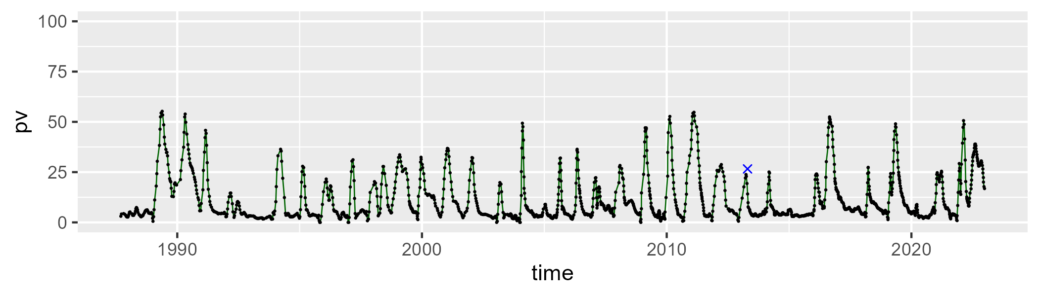

| Min. | 1st Qu. | Median | Mean | 3rd Qu. | Max. |
| --- | --- | --- | --- | --- | --- |
| 6.5818 | 40.18342 | 47.76813 | 48.3542 | 56.12749 | 82.58328 |

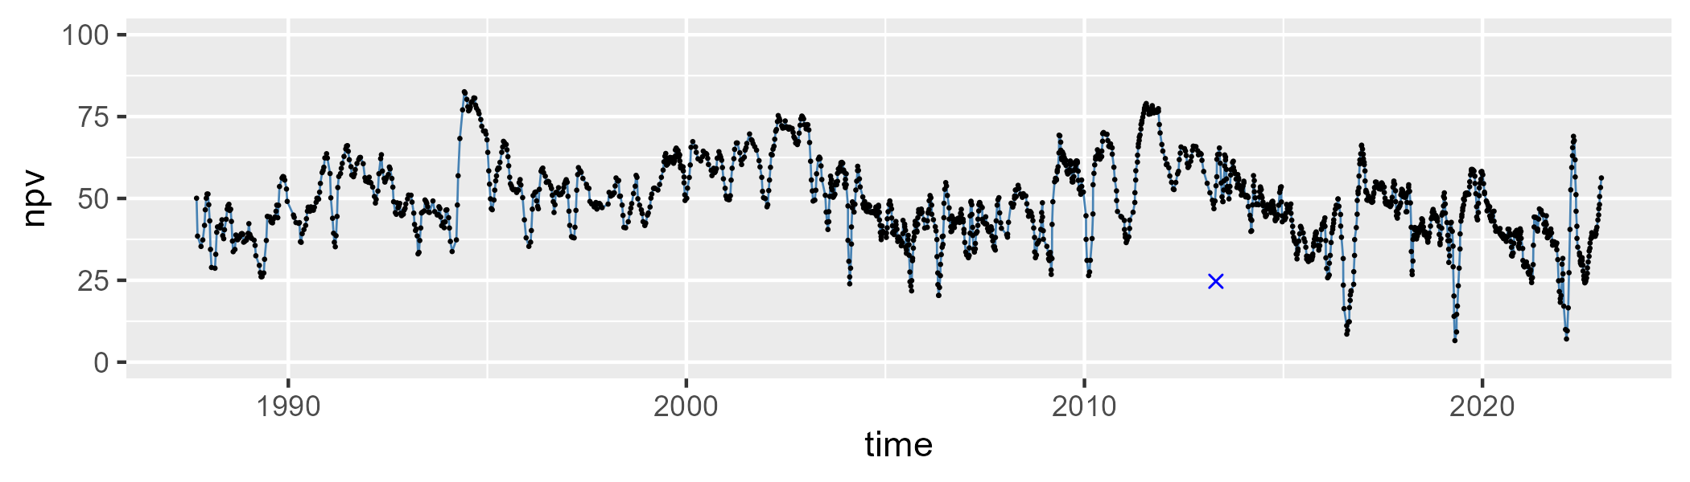

| Min. | 1st Qu. | Median | Mean | 3rd Qu. | Max. |
| --- | --- | --- | --- | --- | --- |
| 4.916823 | 29.71353 | 40.79237 | 39.03905 | 48.68661 | 65.86932 |

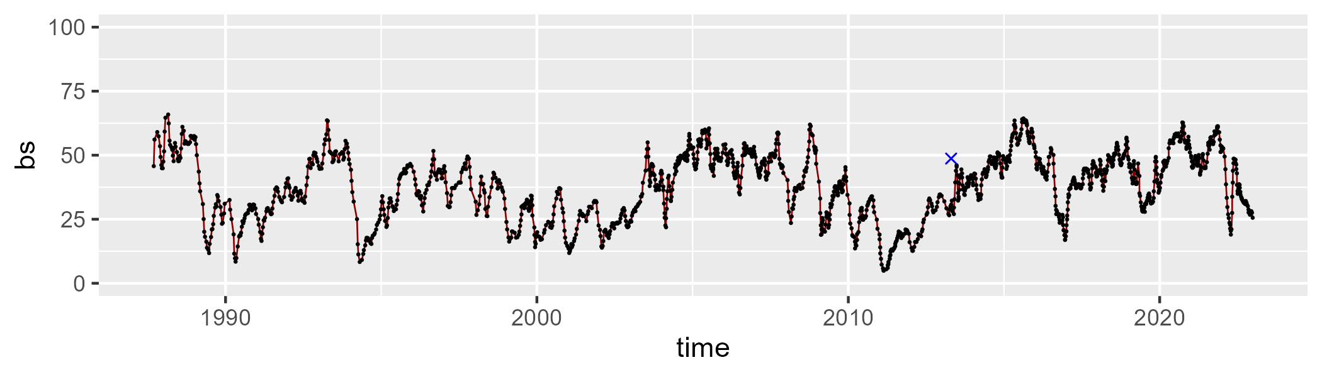

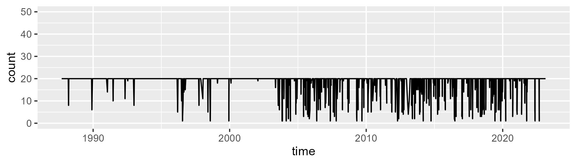

Min. : 1.00 1st Qu.:20.00 Median :20.00 Mean :18.66 3rd Qu.:20.00 Max. :20.00

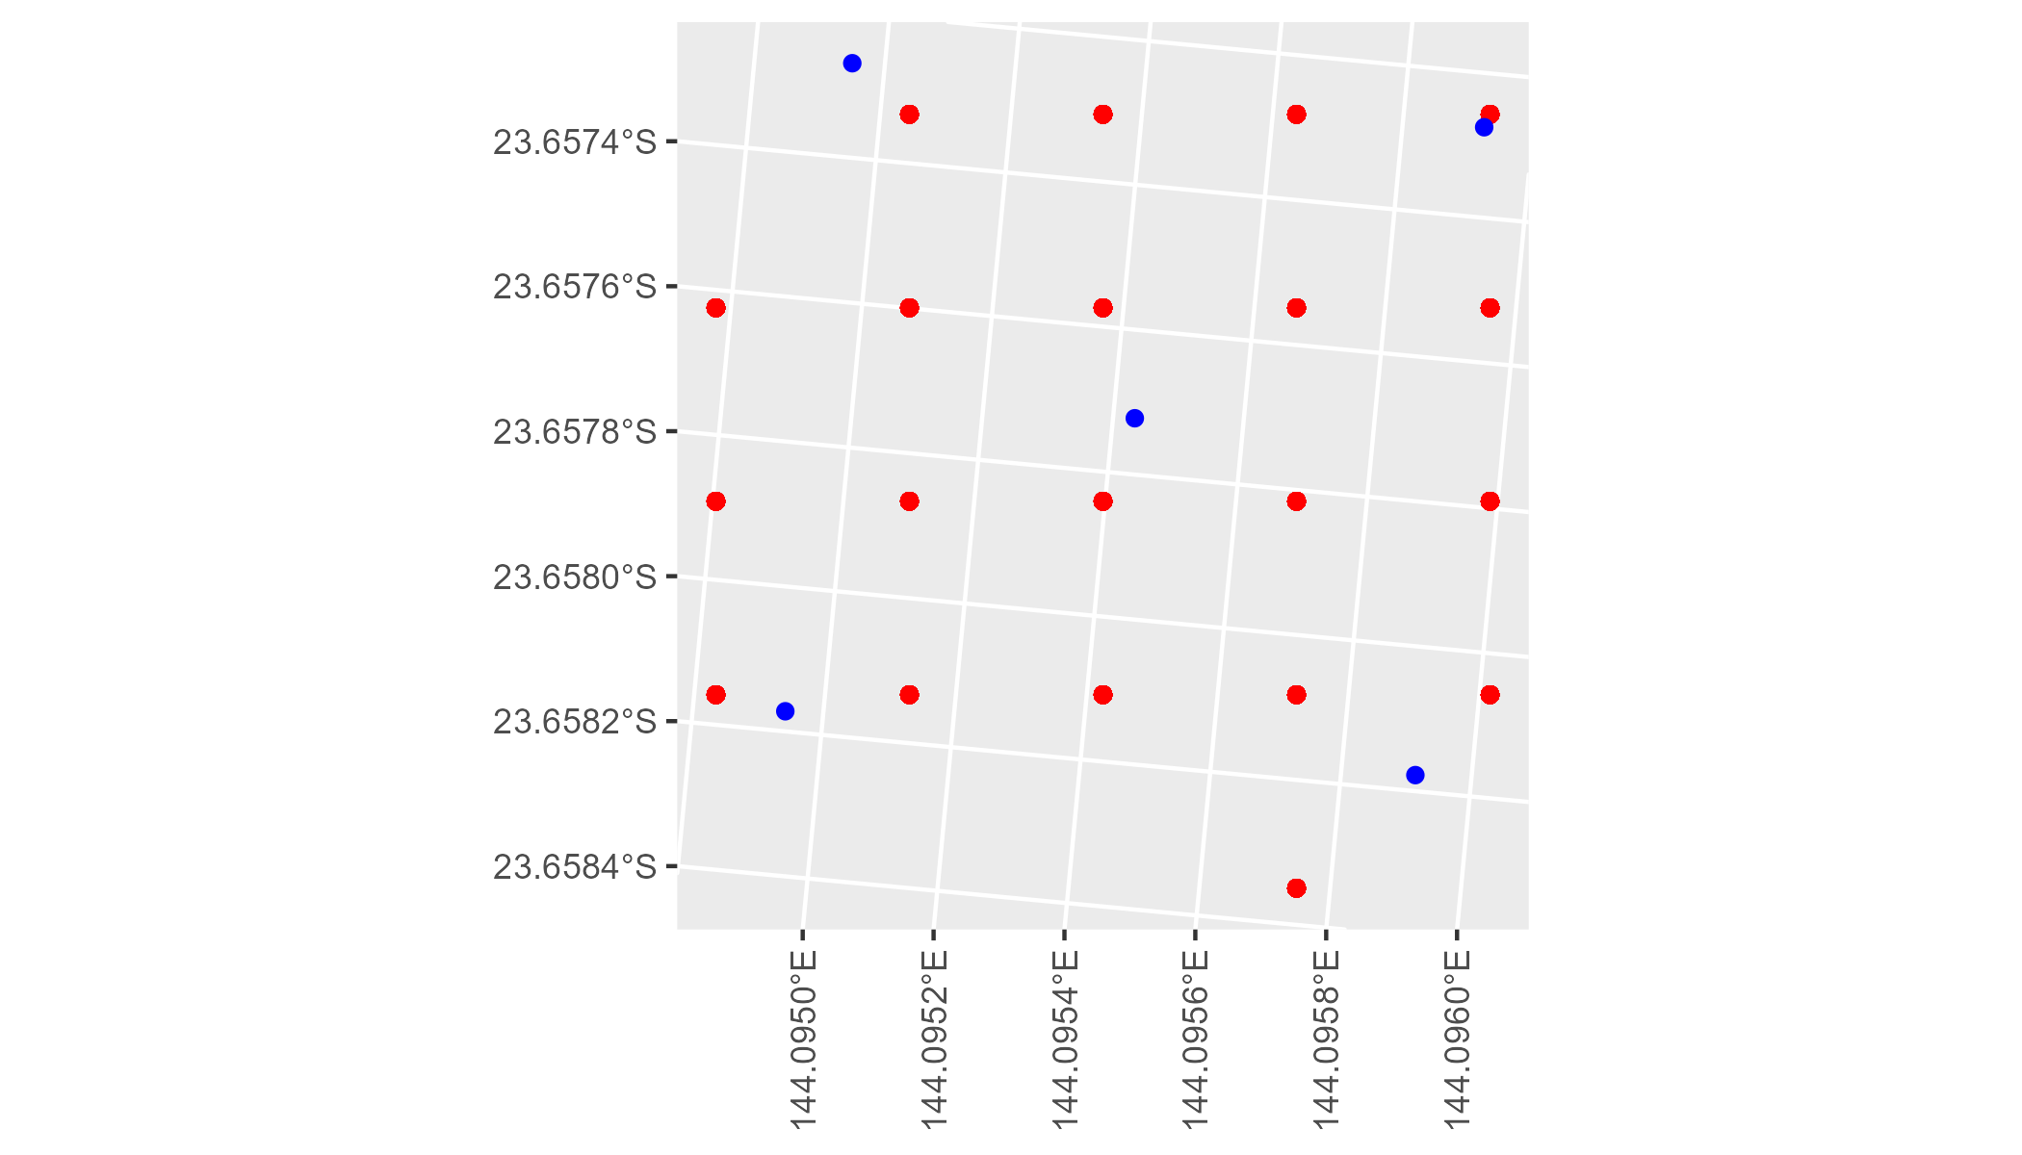

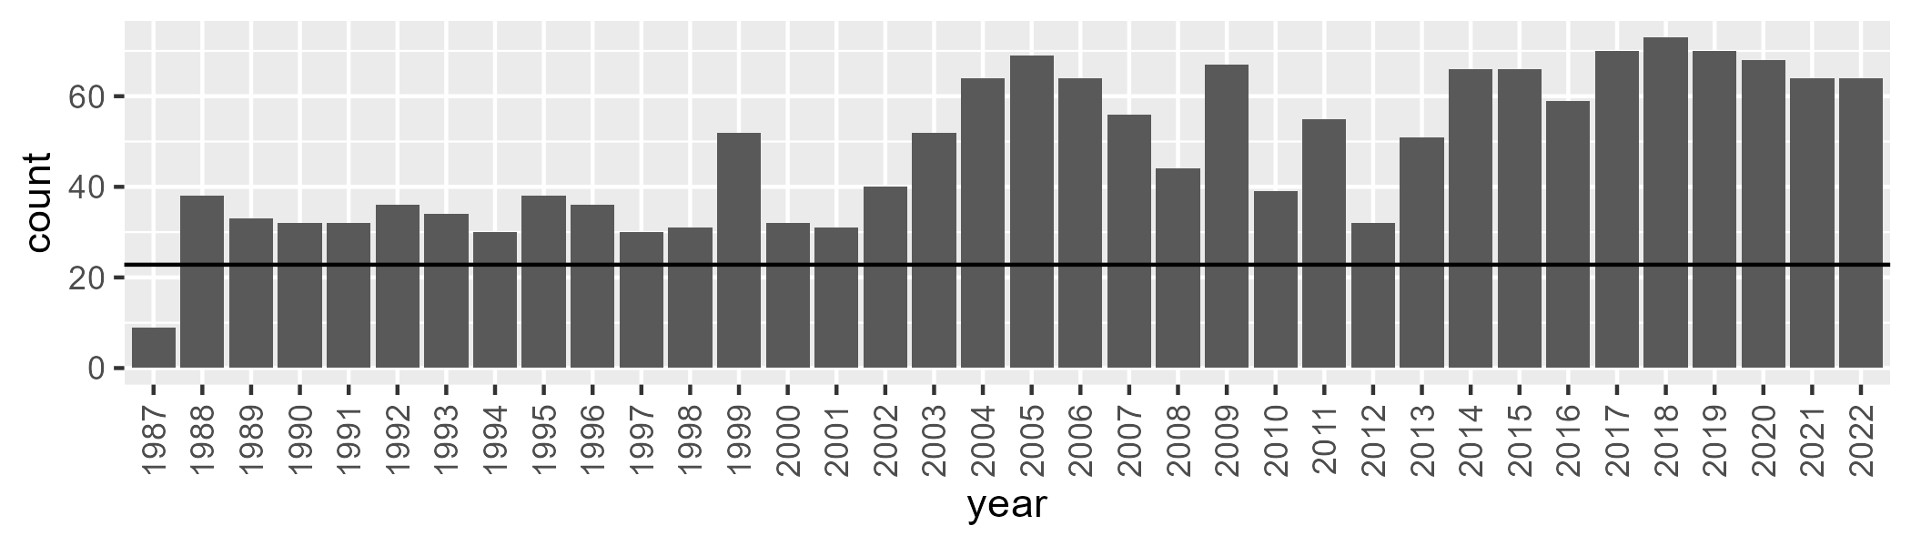

Number of samples: 1727

# QDAMGD0008

| Min. | 1st Qu. | Median | Mean | 3rd Qu. | Max. |
| --- | --- | --- | --- | --- | --- |
| 0 | 1.20665 | 3.702097 | 10.45301 | 14.57097 | 67.8924 |

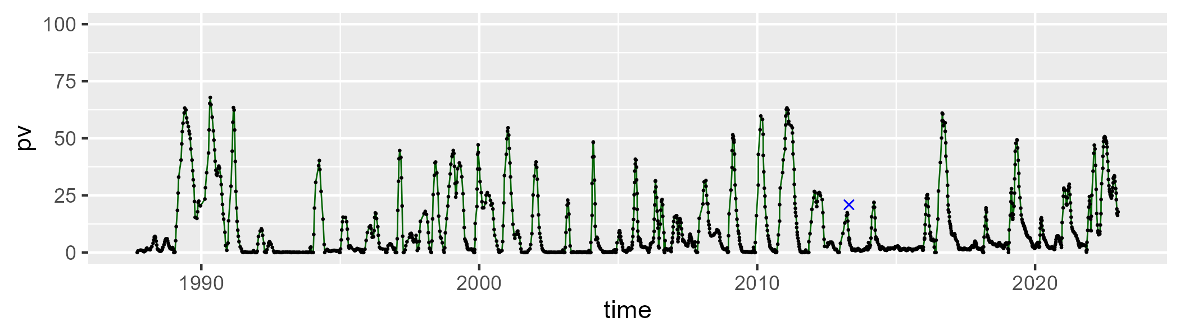

| Min. | 1st Qu. | Median | Mean | 3rd Qu. | Max. |
| --- | --- | --- | --- | --- | --- |
| 6.309454 | 40.69043 | 49.52415 | 51.25168 | 59.78454 | 95.15903 |

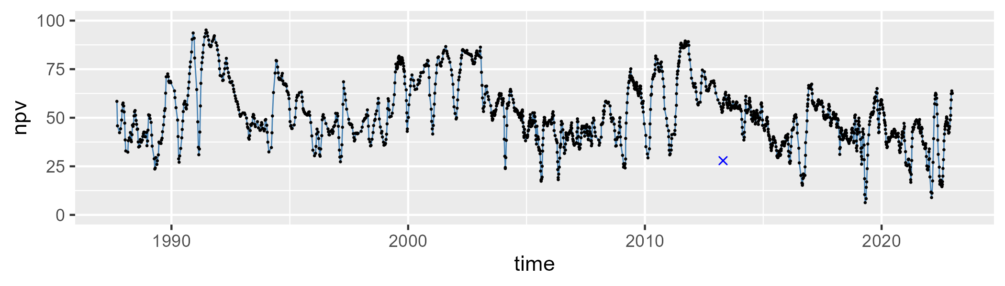

| Min. | 1st Qu. | Median | Mean | 3rd Qu. | Max. |
| --- | --- | --- | --- | --- | --- |
| 1.072989 | 23.49923 | 41.26557 | 37.11903 | 49.50449 | 67.92445 |

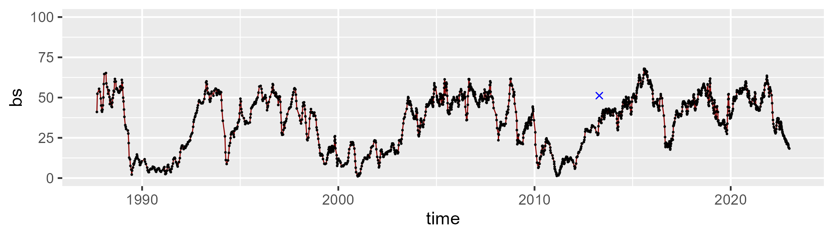

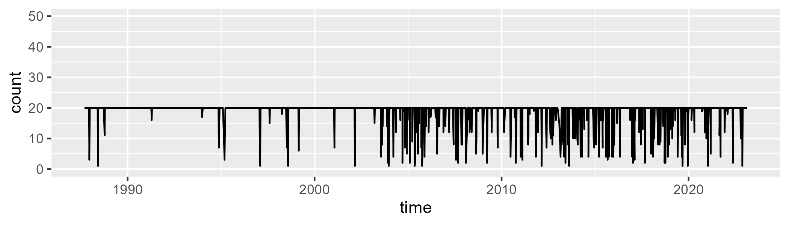

Min. : 1.00 1st Qu.:20.00 Median :20.00 Mean :18.72 3rd Qu.:20.00 Max. :20.00

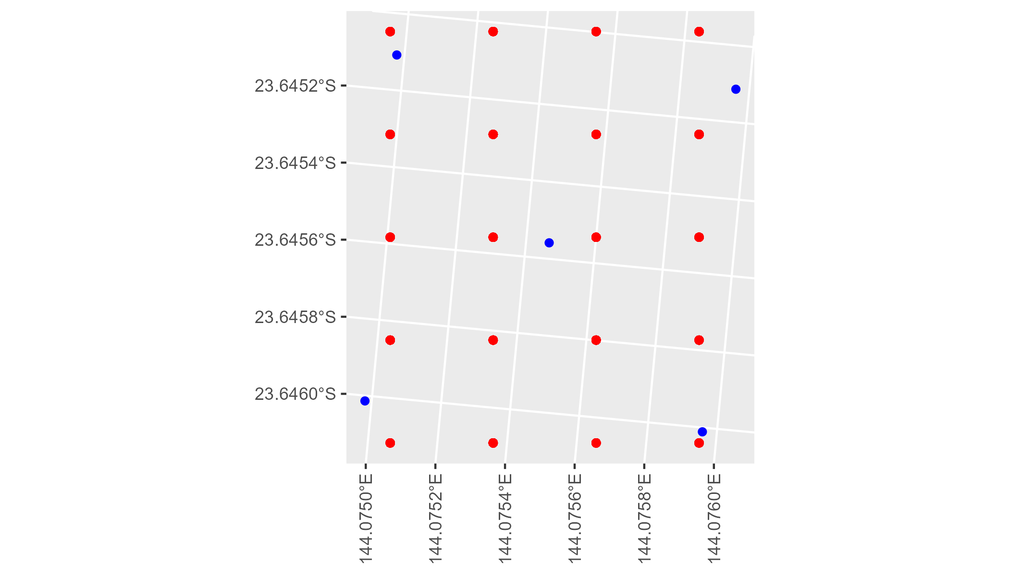

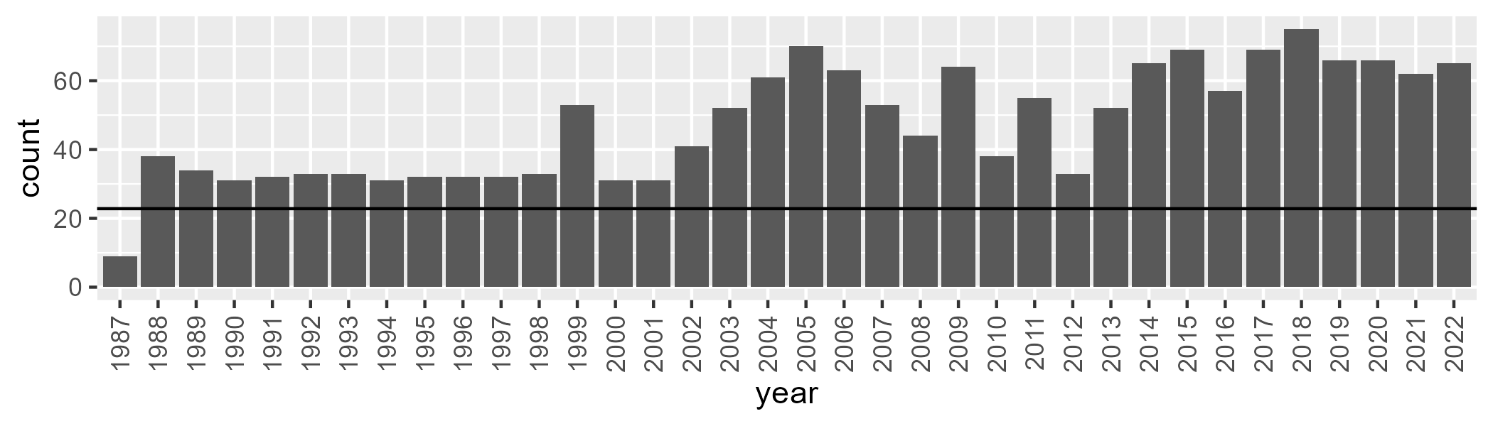

Number of samples: 1705

# QDAMGD0009

| Min. | 1st Qu. | Median | Mean | 3rd Qu. | Max. |
| --- | --- | --- | --- | --- | --- |
| 0 | 5.788599 | 10.12388 | 16.7534 | 24.09262 | 78.92995 |

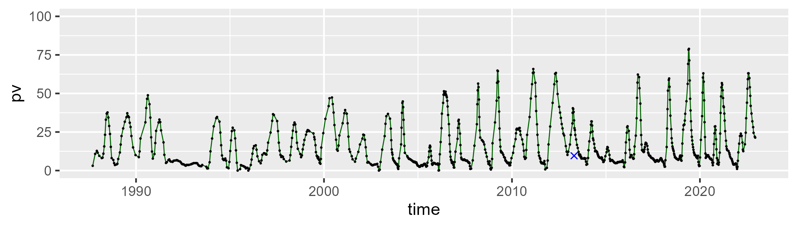

| Min. | 1st Qu. | Median | Mean | 3rd Qu. | Max. |
| --- | --- | --- | --- | --- | --- |
| 16.22782 | 42.25262 | 49.85554 | 49.9598 | 58.03229 | 79.92288 |

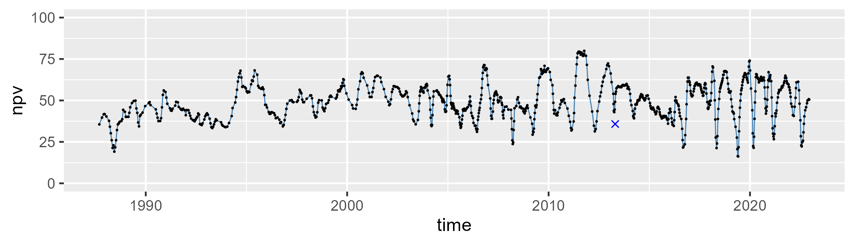

| Min. | 1st Qu. | Median | Mean | 3rd Qu. | Max. |
| --- | --- | --- | --- | --- | --- |
| 0.999553 | 23.11263 | 31.09741 | 32.00033 | 40.8967 | 62.71071 |

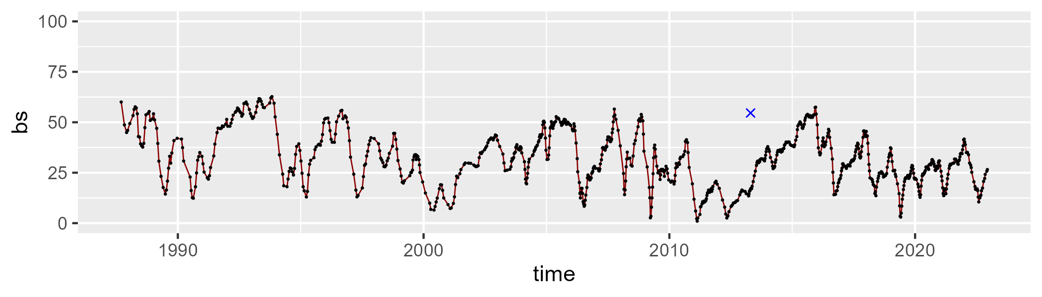

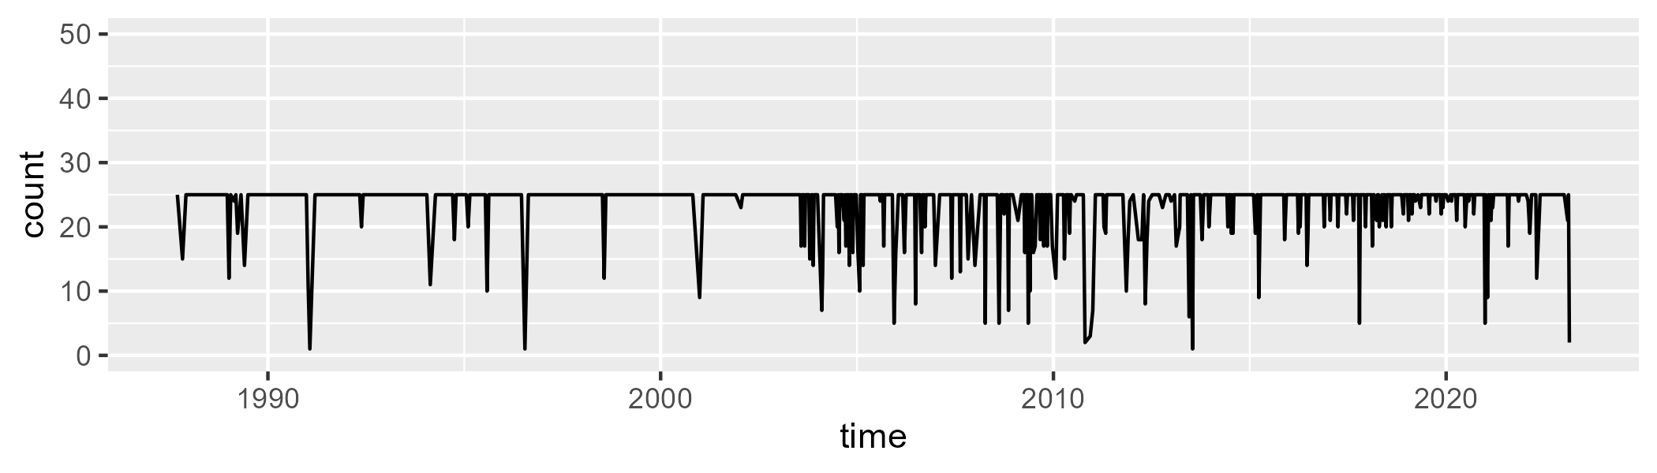

Min. : 1.00 1st Qu.:25.00 Median :25.00 Mean :23.75 3rd Qu.:25.00 Max. :25.00

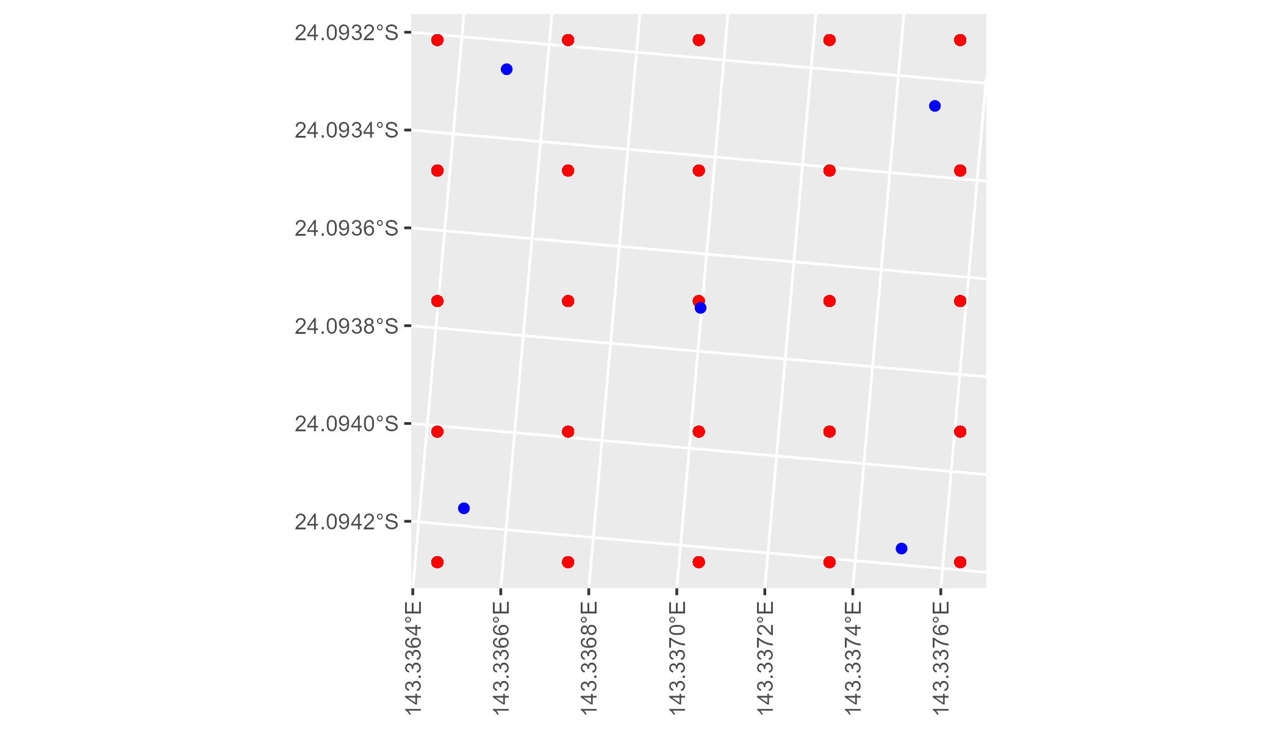

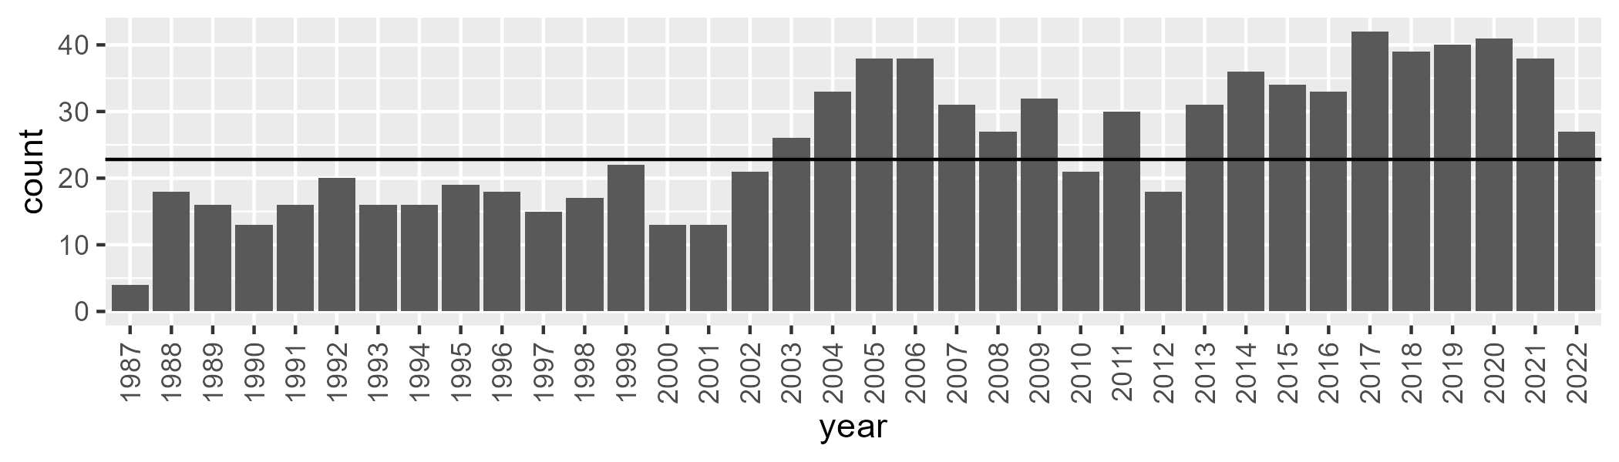

Number of samples: 912

# QDAMGD0010

| Min. | 1st Qu. | Median | Mean | 3rd Qu. | Max. |
| --- | --- | --- | --- | --- | --- |
| 8.649395 | 19.67721 | 25.24453 | 26.54054 | 31.96012 | 52.68694 |

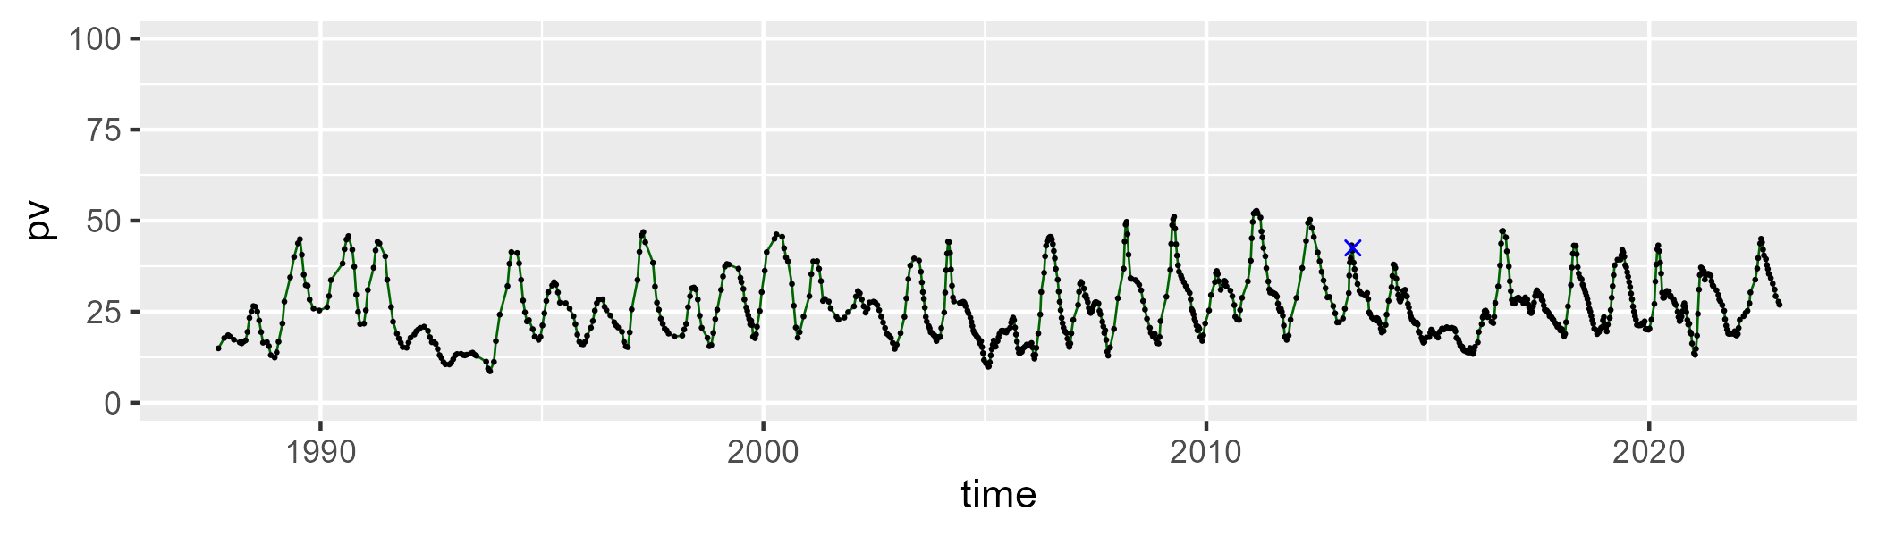

| Min. | 1st Qu. | Median | Mean | 3rd Qu. | Max. |
| --- | --- | --- | --- | --- | --- |
| 25.86928 | 40.09901 | 44.54248 | 44.23765 | 48.23964 | 61.44561 |

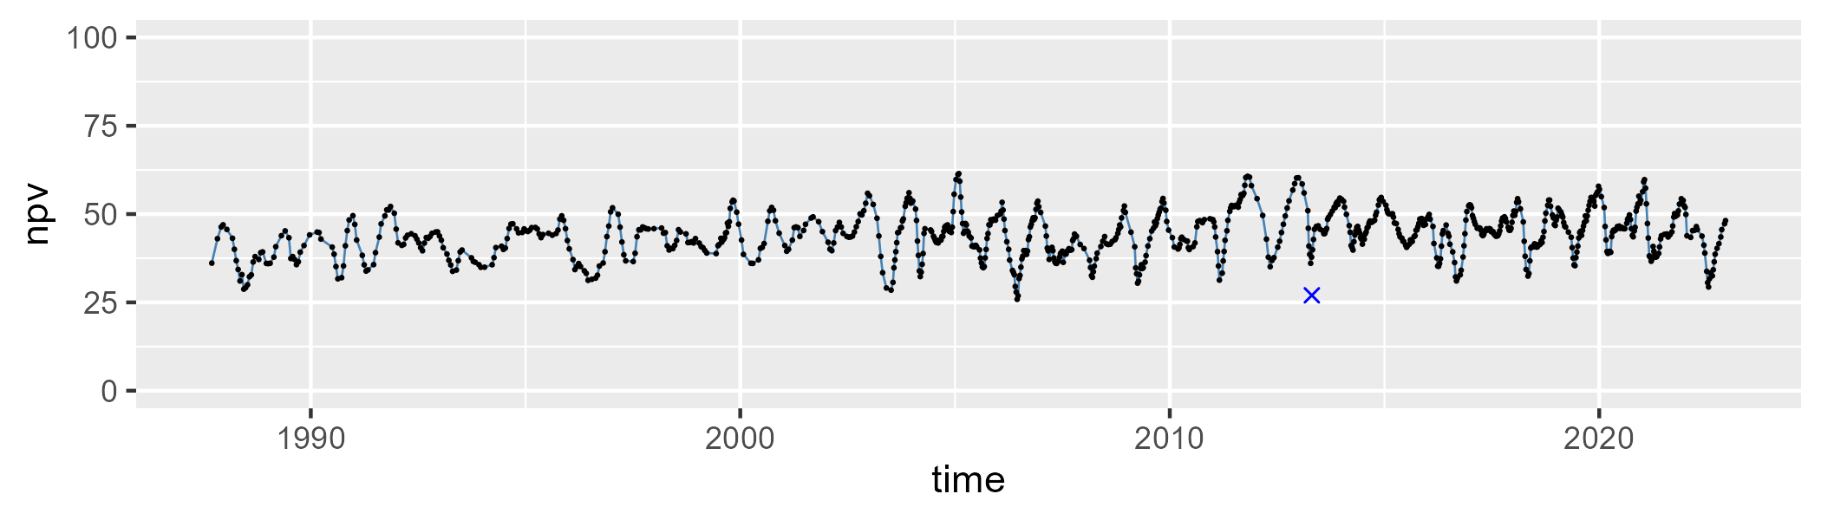

| Min. | 1st Qu. | Median | Mean | 3rd Qu. | Max. |
| --- | --- | --- | --- | --- | --- |
| 3.264616 | 23.04978 | 27.1023 | 27.92076 | 32.0393 | 53.89514 |

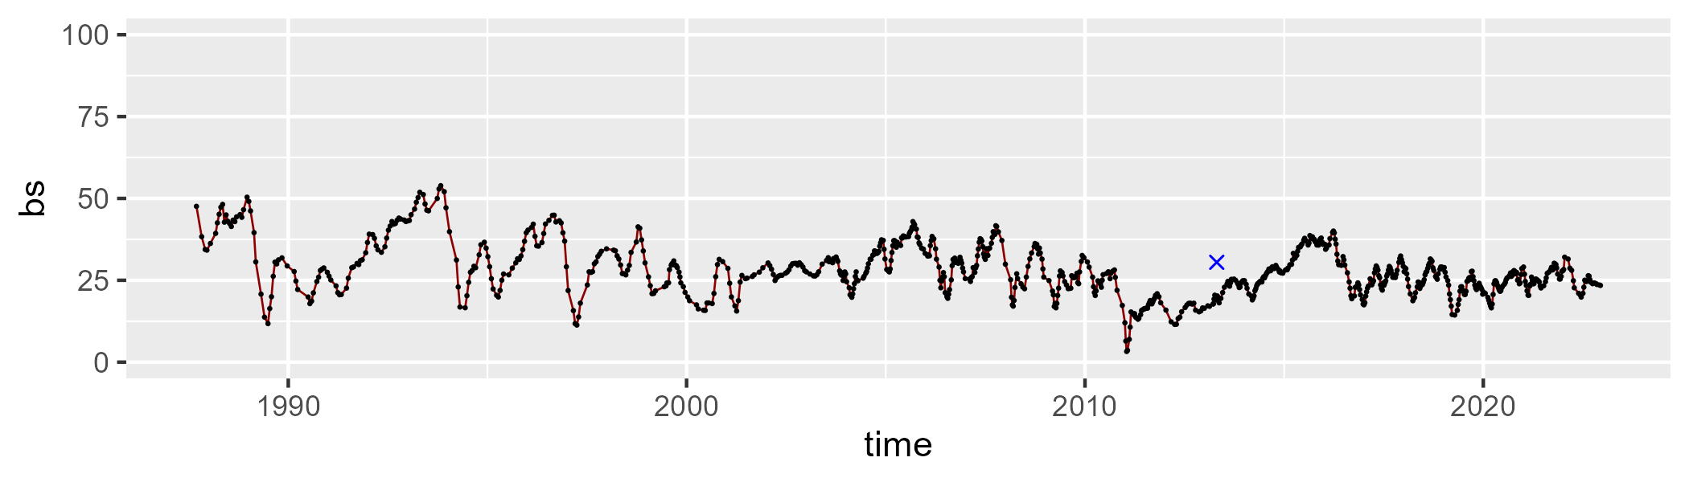

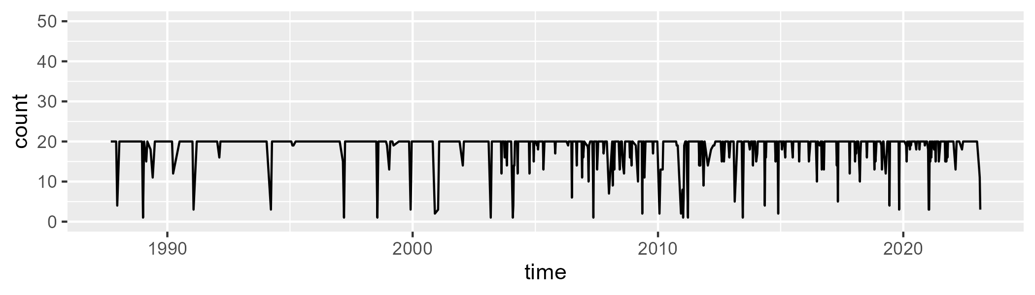

Min. : 1.00 1st Qu.:20.00 Median :20.00 Mean :18.83 3rd Qu.:20.00 Max. :20.00

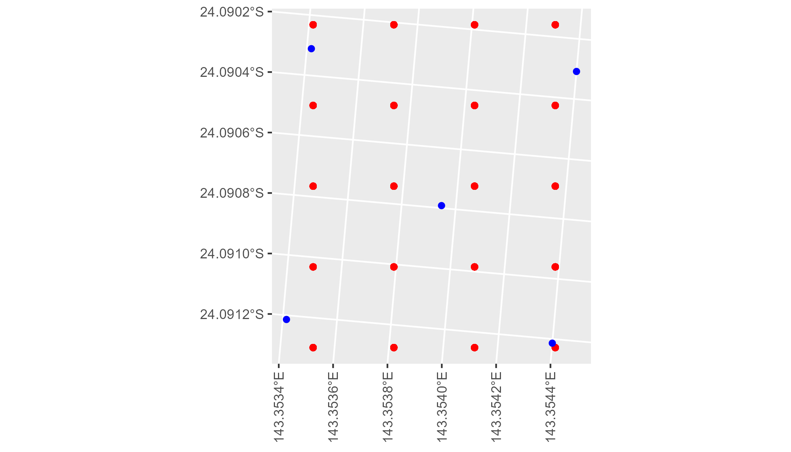

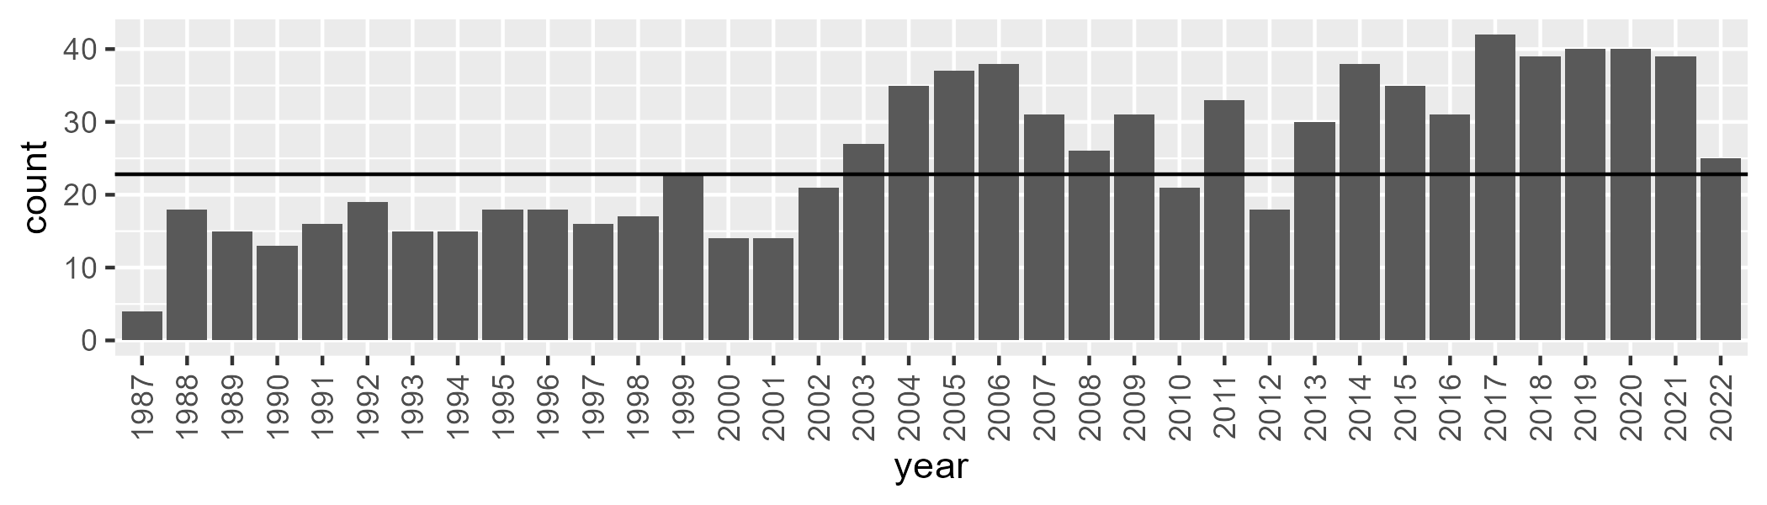

Number of samples: 912

# QDAMGD0011

| Min. | 1st Qu. | Median | Mean | 3rd Qu. | Max. |
| --- | --- | --- | --- | --- | --- |
| 0 | 2.125665 | 6.293004 | 11.47726 | 16.45526 | 67.58359 |

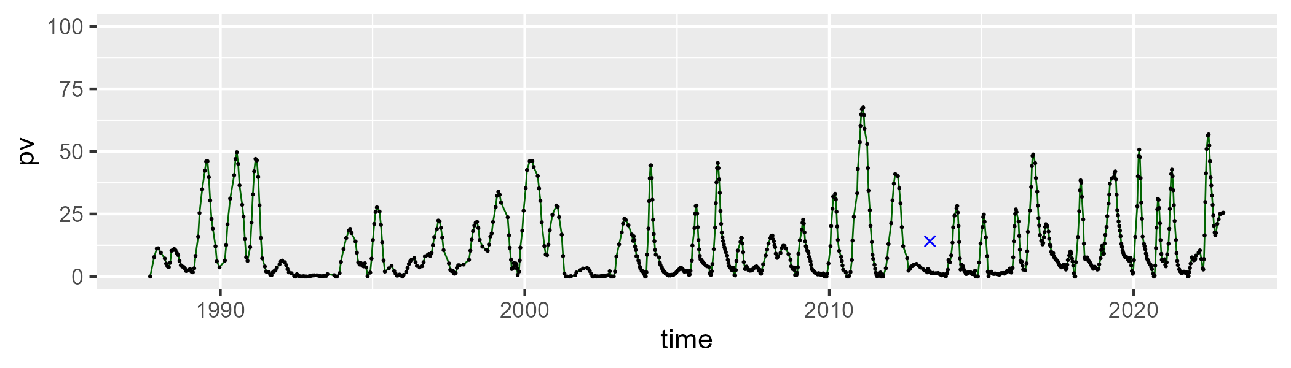

| Min. | 1st Qu. | Median | Mean | 3rd Qu. | Max. |
| --- | --- | --- | --- | --- | --- |
| 13.97973 | 37.11518 | 47.77343 | 48.63421 | 58.89134 | 95.04435 |

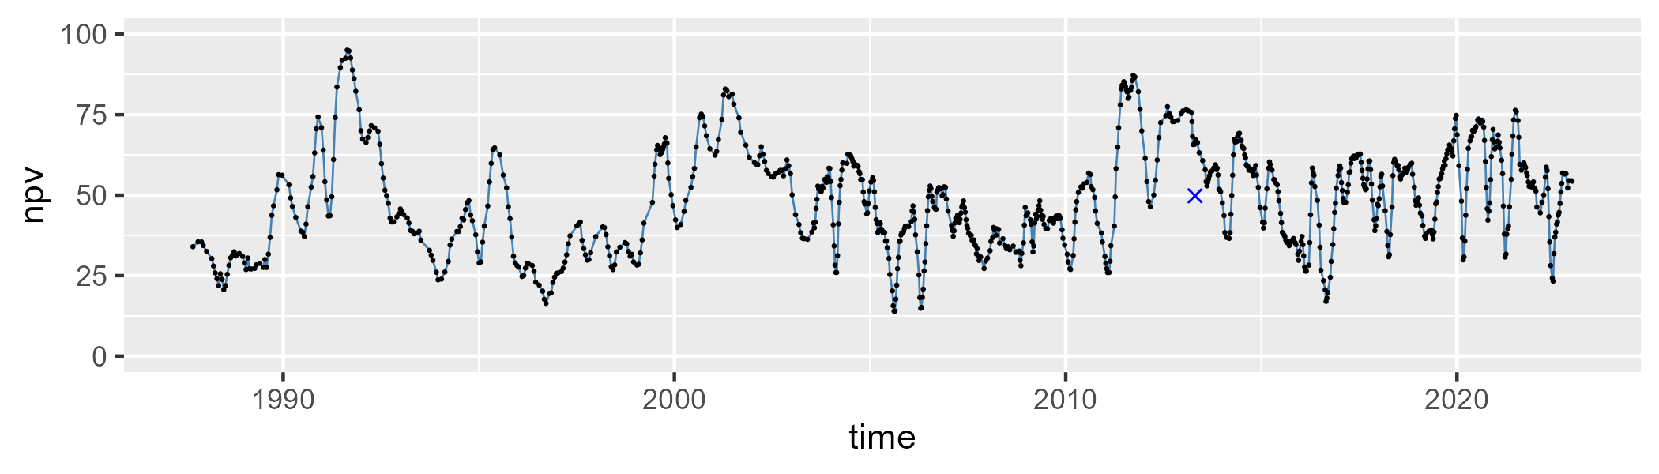

| Min. | 1st Qu. | Median | Mean | 3rd Qu. | Max. |
| --- | --- | --- | --- | --- | --- |
| 3.408631 | 27.61965 | 39.03254 | 38.67154 | 51.05948 | 75.4722 |

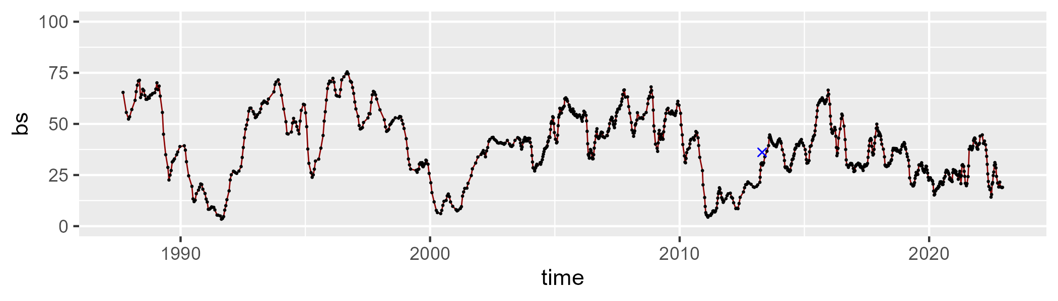

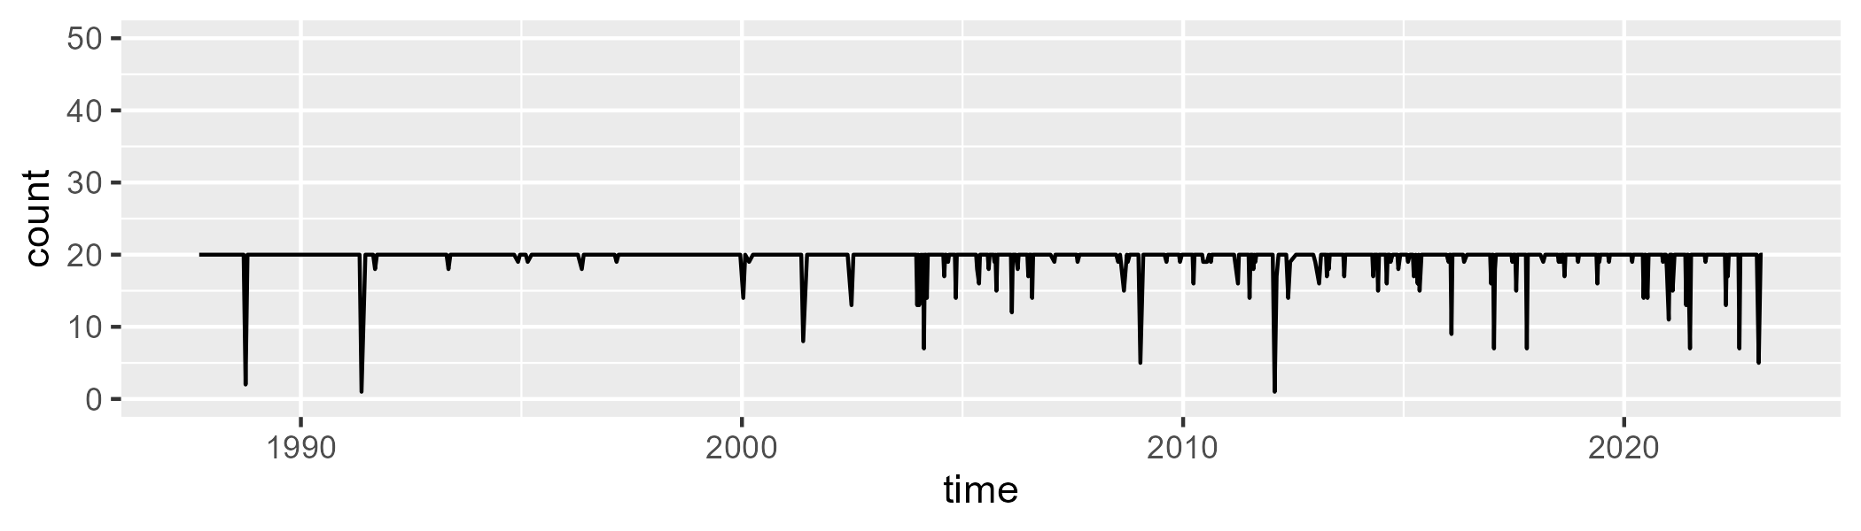

Min. : 1.00 1st Qu.:20.00 Median :20.00 Mean :19.56 3rd Qu.:20.00 Max. :20.00

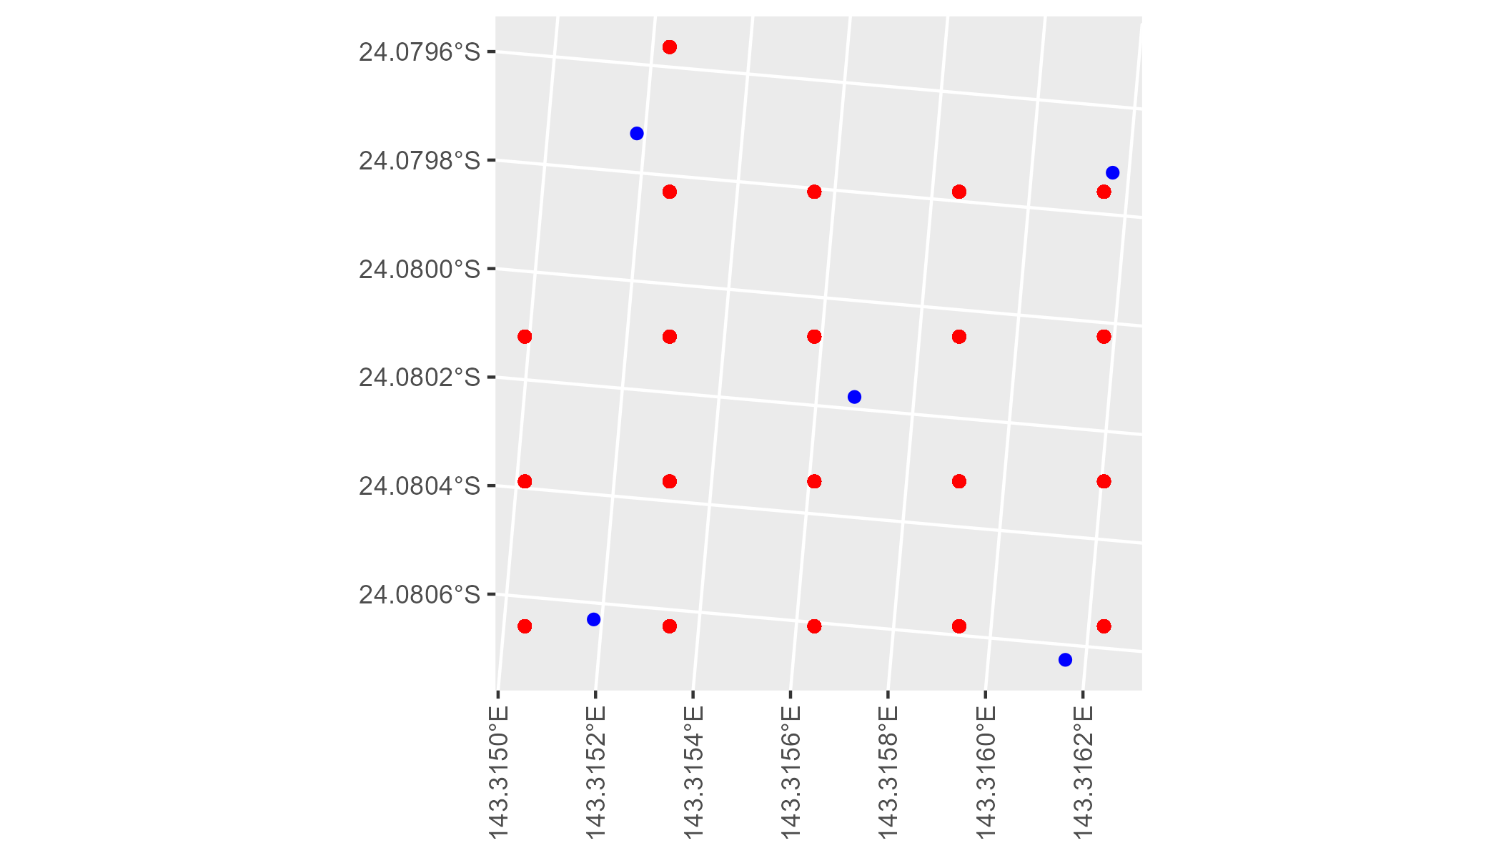

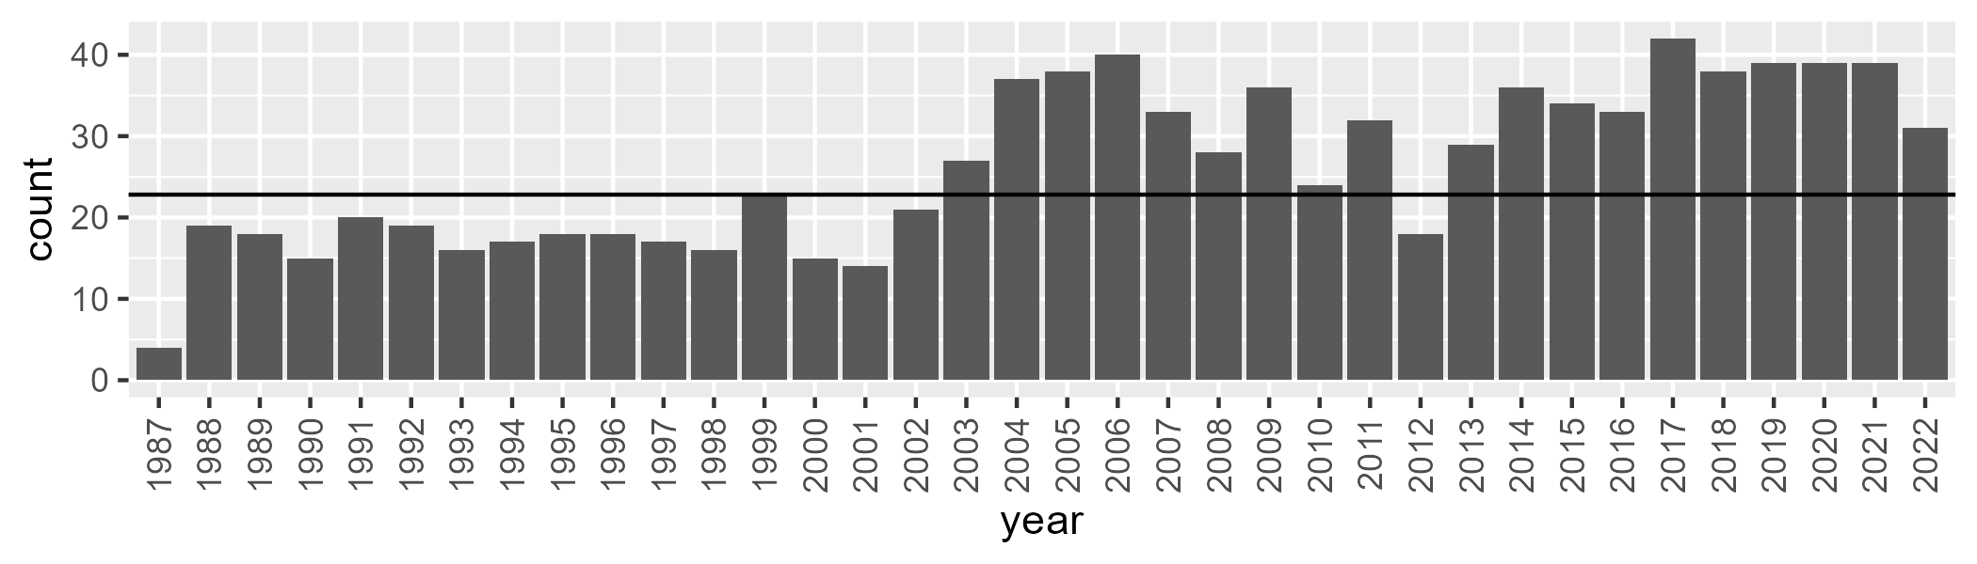

Number of samples: 943

# QDAMGD0012

| Min. | 1st Qu. | Median | Mean | 3rd Qu. | Max. |
| --- | --- | --- | --- | --- | --- |
| 6.32783 | 14.83282 | 19.67692 | 20.40376 | 25.27639 | 44.12138 |

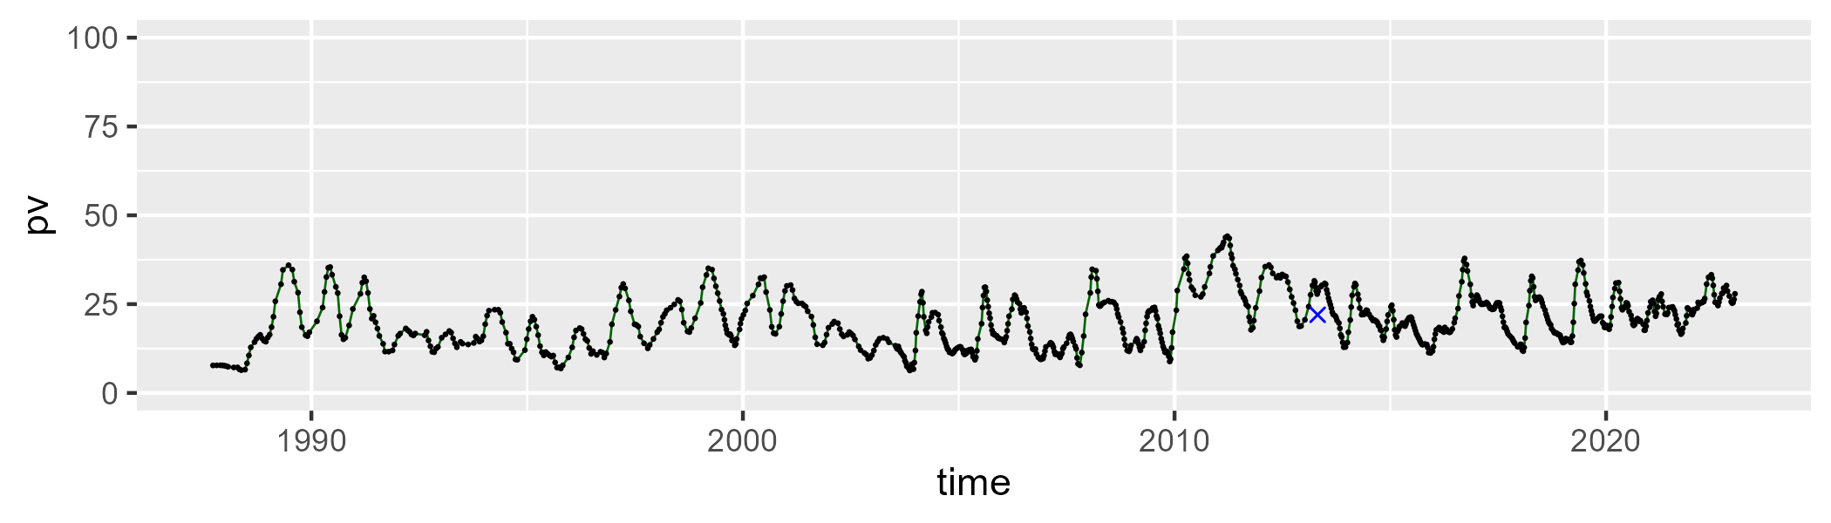

| Min. | 1st Qu. | Median | Mean | 3rd Qu. | Max. |
| --- | --- | --- | --- | --- | --- |
| 19.07722 | 38.46708 | 42.85778 | 41.94239 | 46.40067 | 59.42466 |

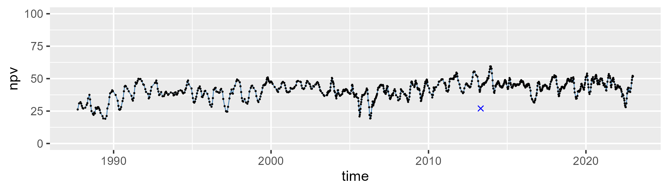

| Min. | 1st Qu. | Median | Mean | 3rd Qu. | Max. |
| --- | --- | --- | --- | --- | --- |
| 10.74869 | 30.08971 | 35.32997 | 36.29515 | 42.75359 | 64.58798 |

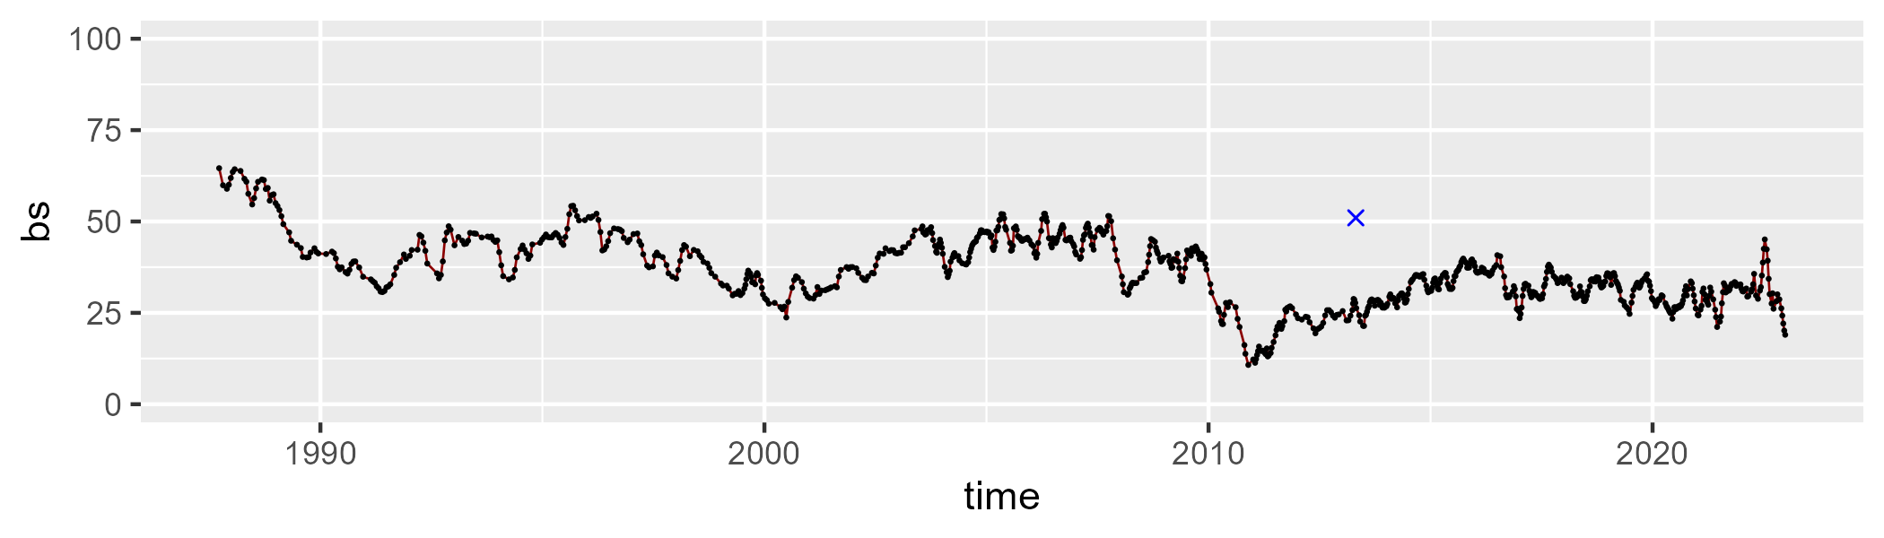

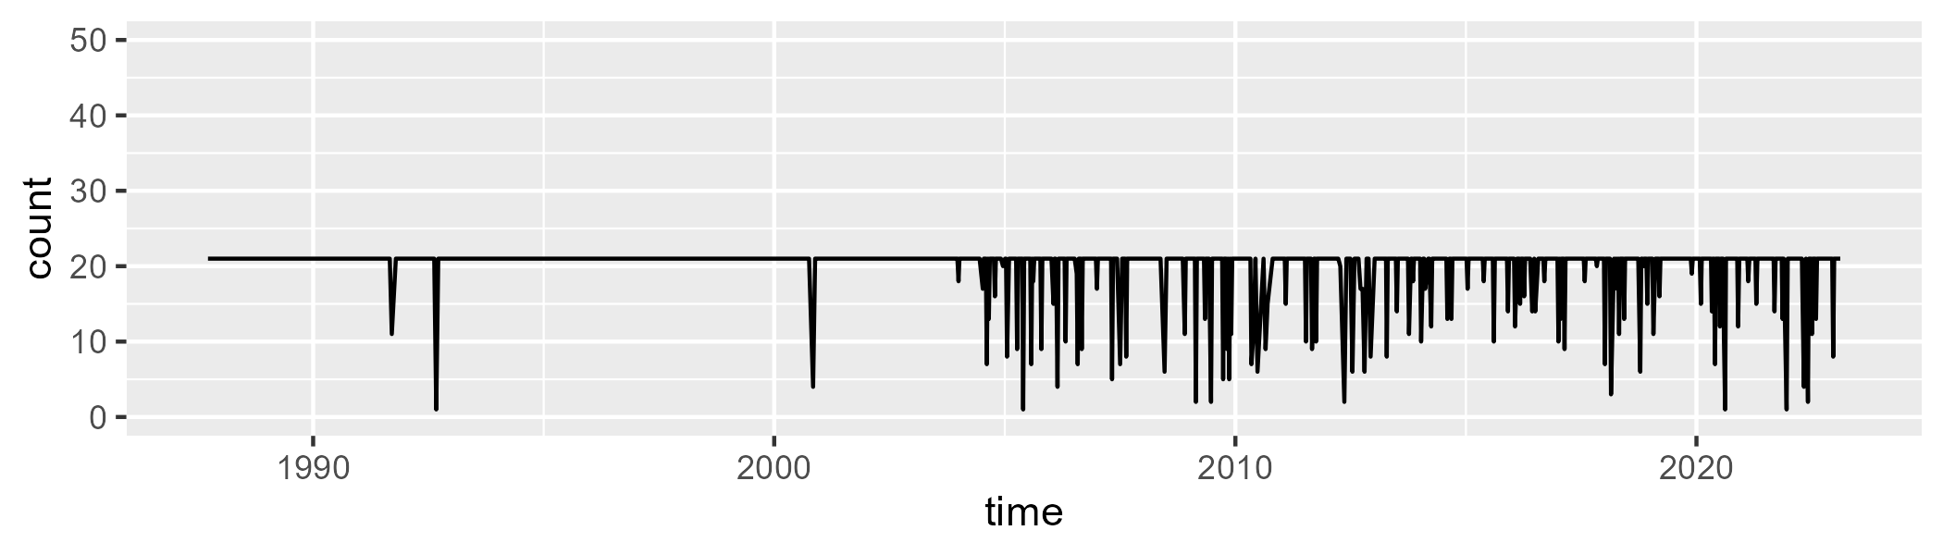

Min. : 1.00 1st Qu.:21.00 Median :21.00 Mean :19.91 3rd Qu.:21.00 Max. :21.00

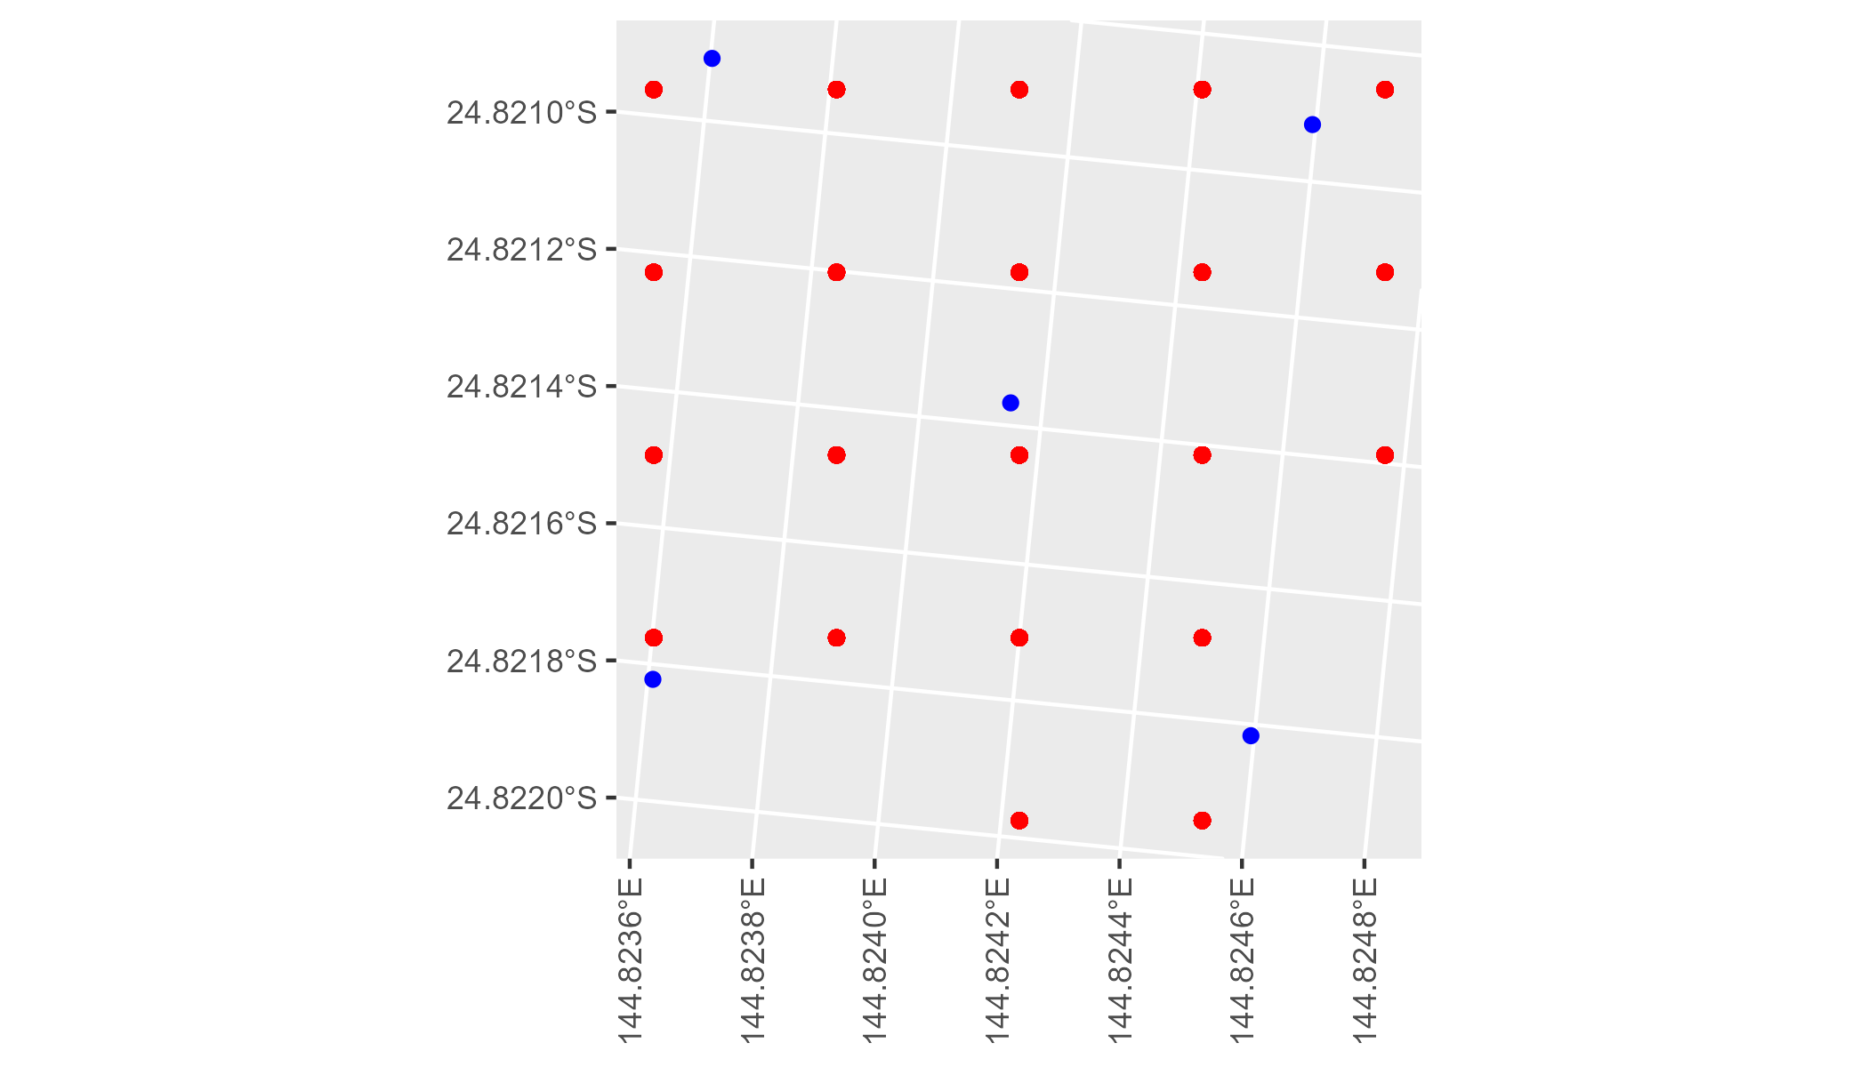

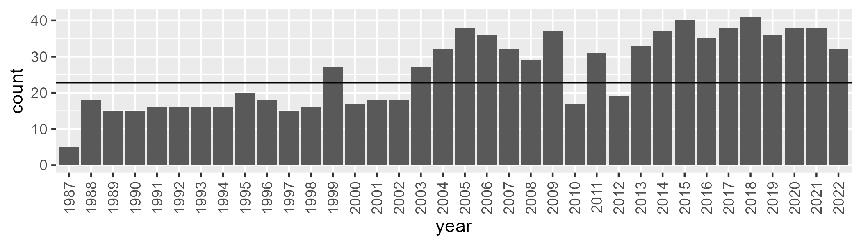

Number of samples: 932

# QDAMGD0013

| Min. | 1st Qu. | Median | Mean | 3rd Qu. | Max. |
| --- | --- | --- | --- | --- | --- |
| 0 | 1.086818 | 2.763206 | 7.139617 | 9.668148 | 56.41495 |

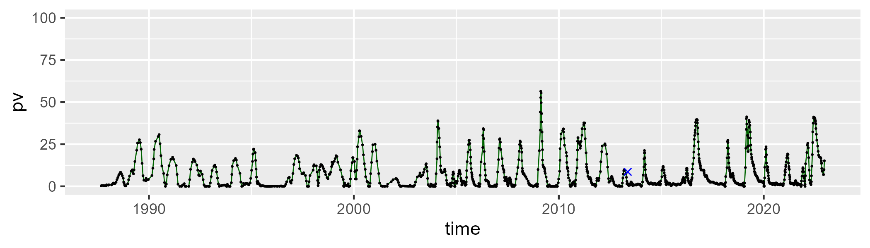

| Min. | 1st Qu. | Median | Mean | 3rd Qu. | Max. |
| --- | --- | --- | --- | --- | --- |
| 22.61835 | 42.09126 | 48.13815 | 48.63613 | 54.2989 | 79.37256 |

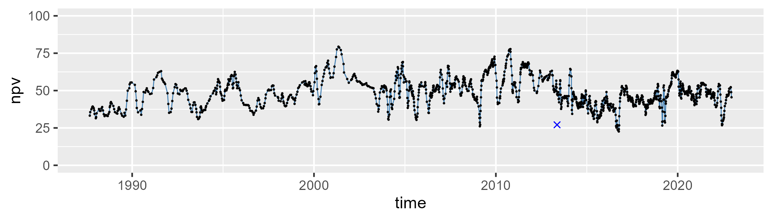

| Min. | 1st Qu. | Median | Mean | 3rd Qu. | Max. |
| --- | --- | --- | --- | --- | --- |
| 14.92508 | 35.36623 | 43.89176 | 42.98799 | 50.92348 | 68.09105 |

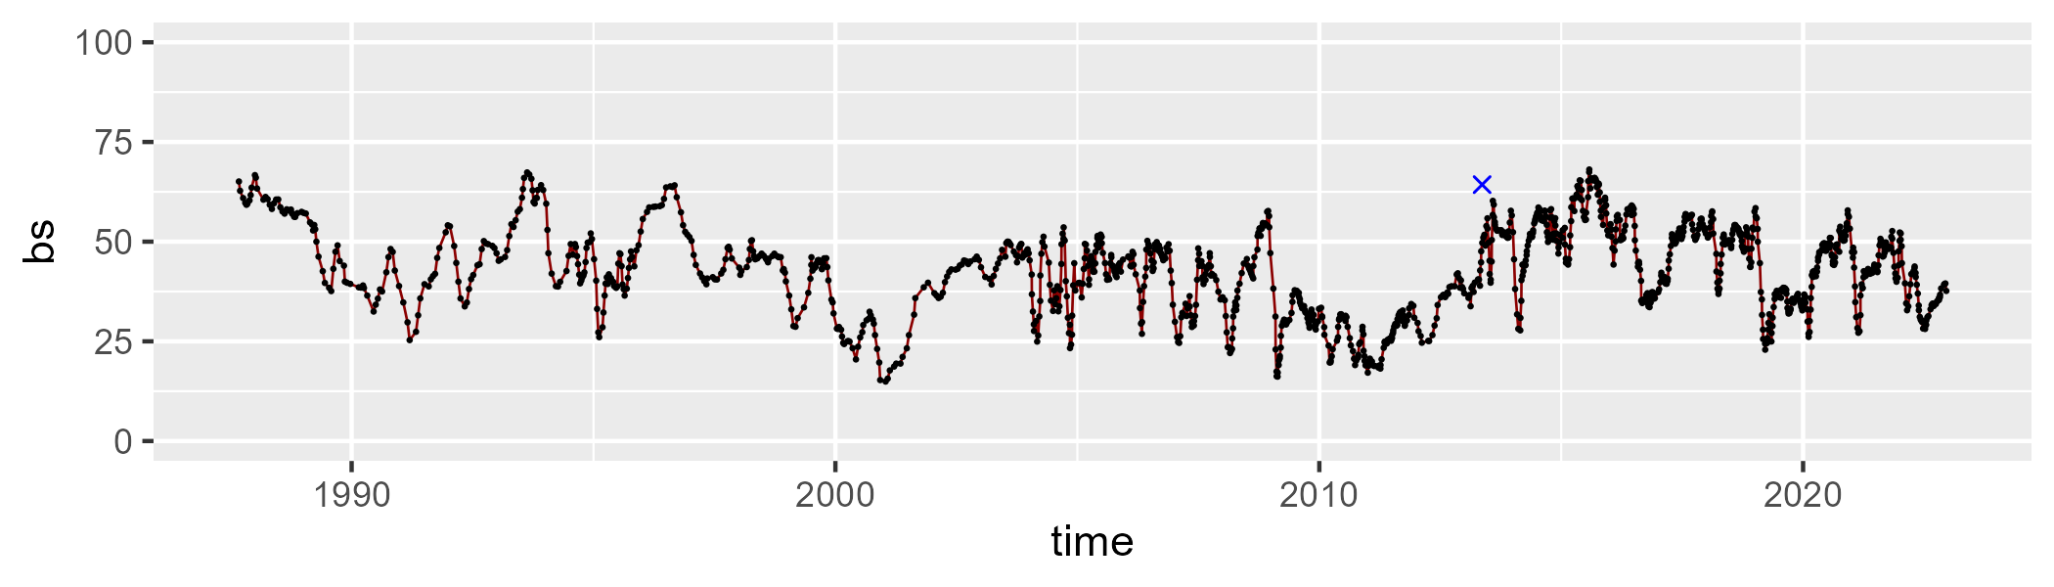

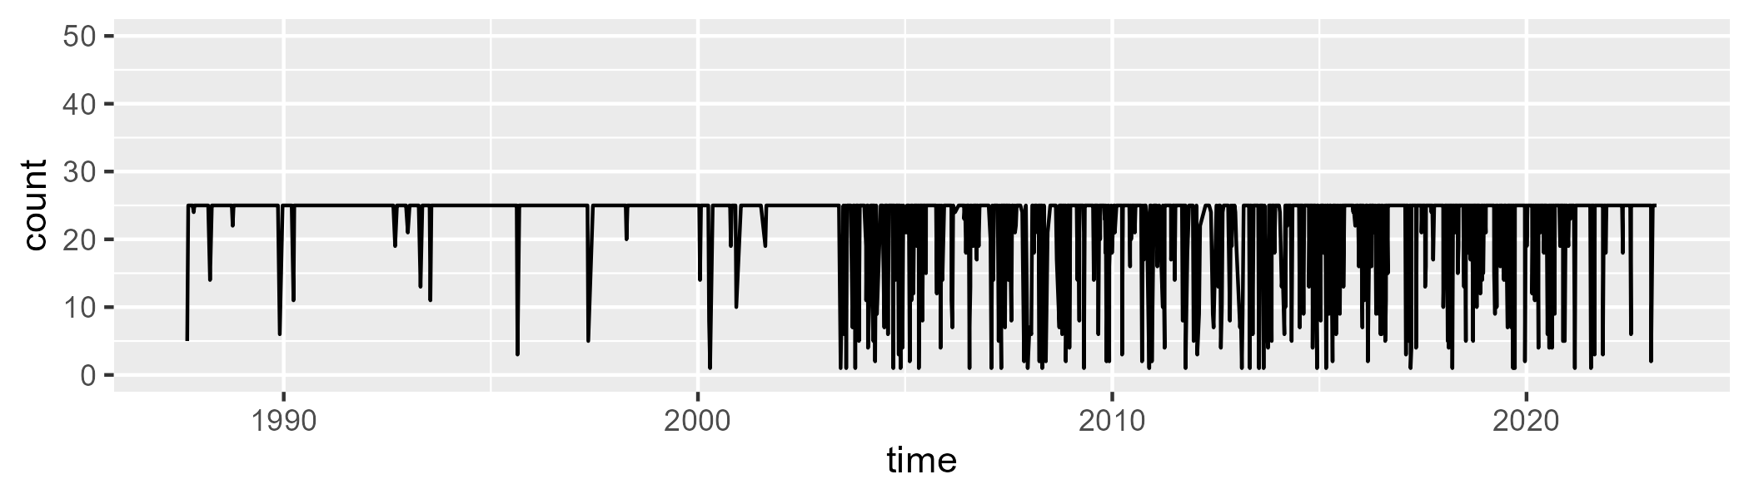

Min. : 1.00 1st Qu.:25.00 Median :25.00 Mean :22.38 3rd Qu.:25.00 Max. :25.00

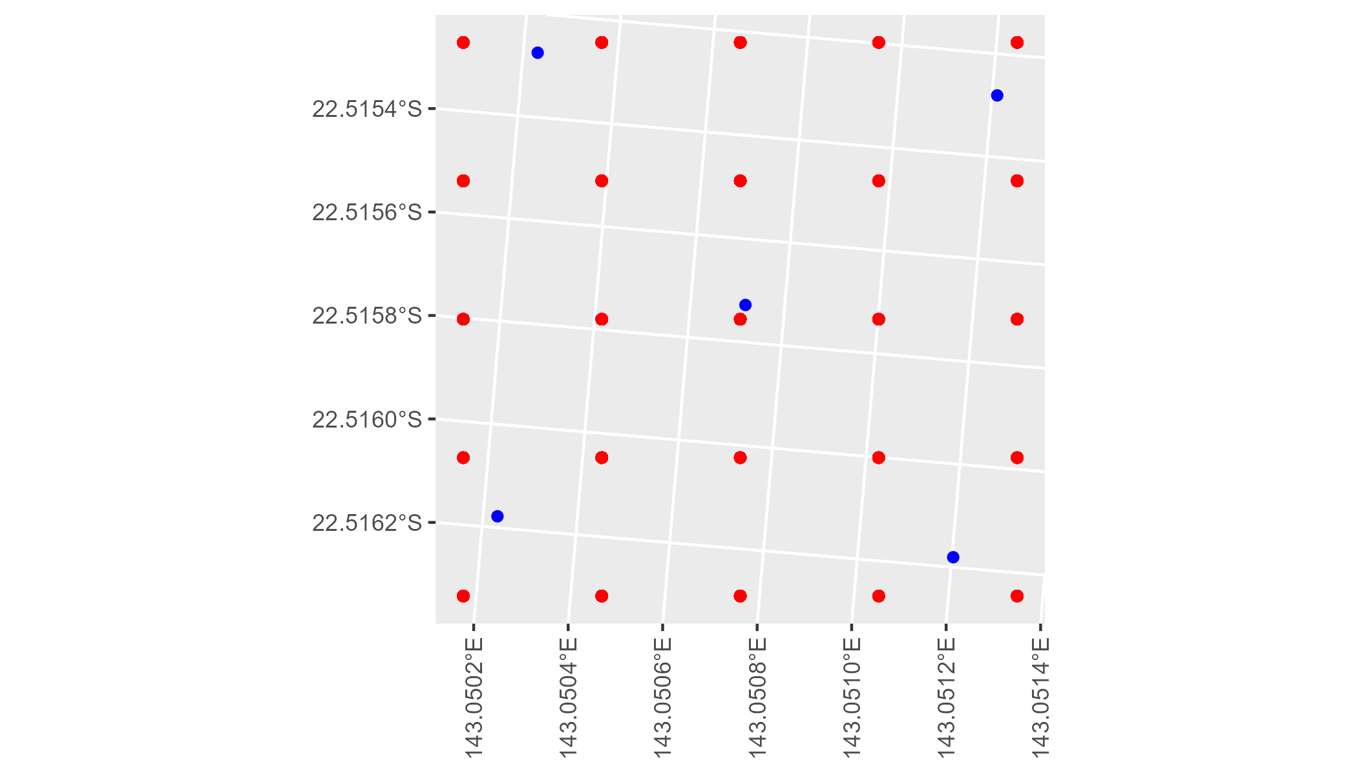

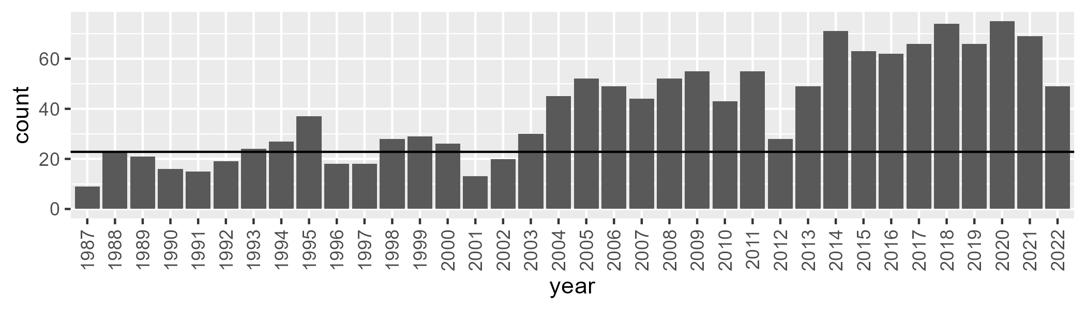

Number of samples: 1440

# QDAMGD0014

| Min. | 1st Qu. | Median | Mean | 3rd Qu. | Max. |
| --- | --- | --- | --- | --- | --- |
| 0 | 1.20426 | 4.219014 | 9.547413 | 13.32985 | 71.44154 |

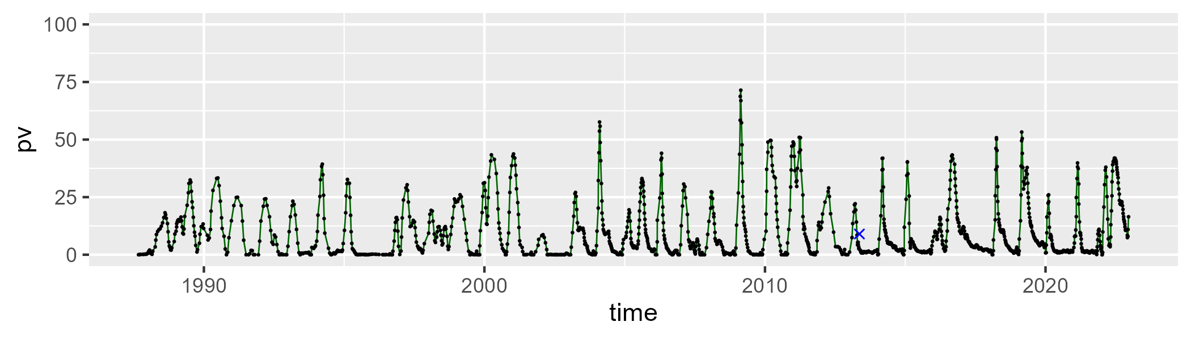

| Min. | 1st Qu. | Median | Mean | 3rd Qu. | Max. |
| --- | --- | --- | --- | --- | --- |
| 11.57168 | 46.04744 | 53.45483 | 54.92668 | 63.09822 | 96.53768 |

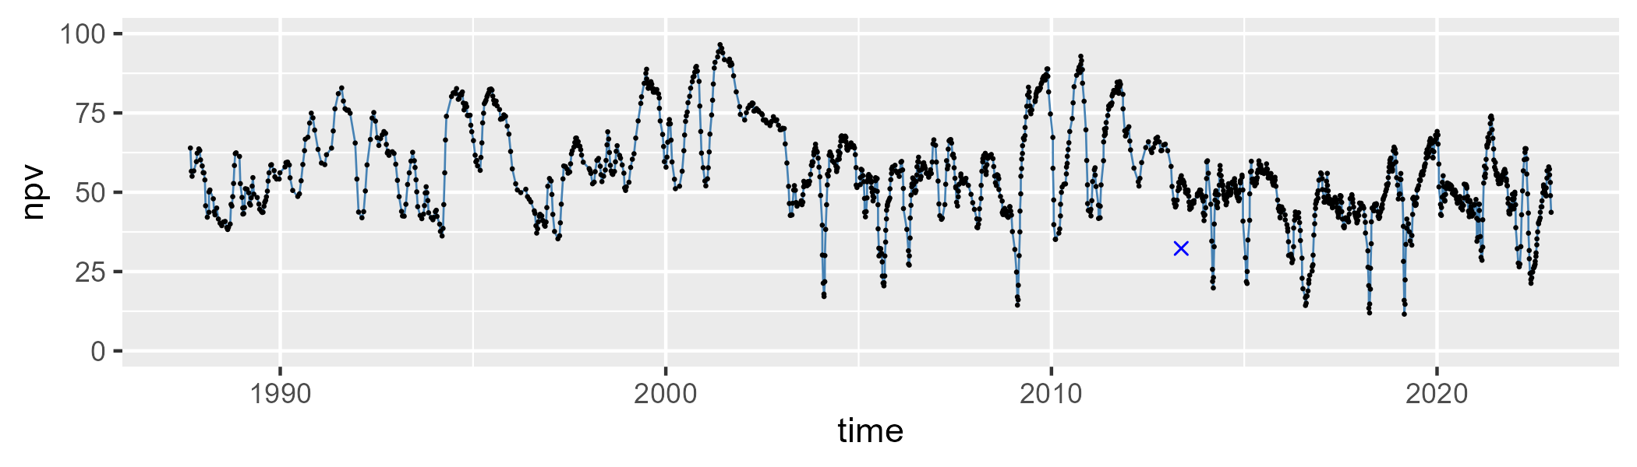

| Min. | 1st Qu. | Median | Mean | 3rd Qu. | Max. |
| --- | --- | --- | --- | --- | --- |
| 1.730764 | 26.6085 | 35.60584 | 34.29233 | 43.84186 | 61.93618 |

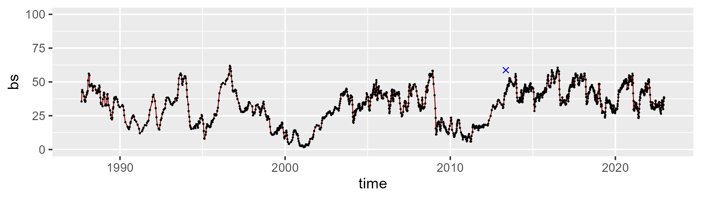

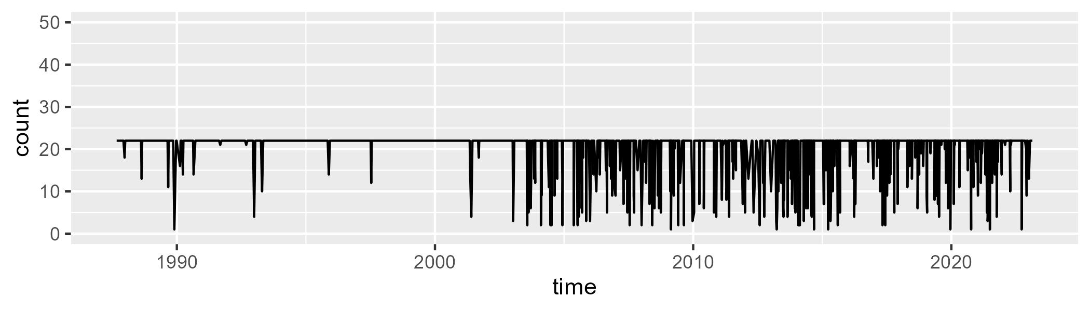

Min. : 1.00 1st Qu.:22.00 Median :22.00 Mean :20.36 3rd Qu.:22.00 Max. :22.00

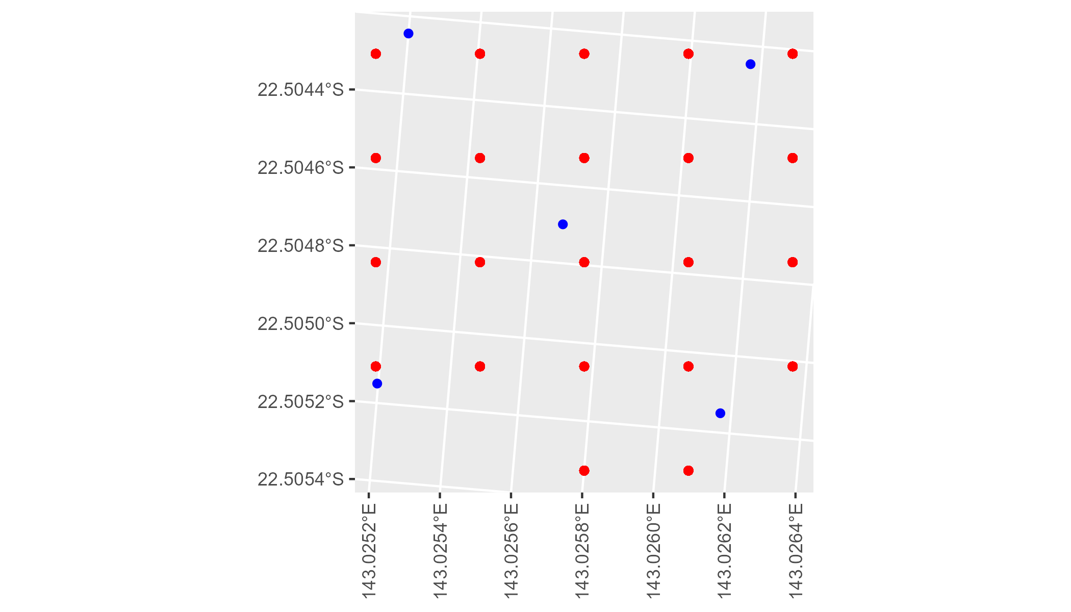

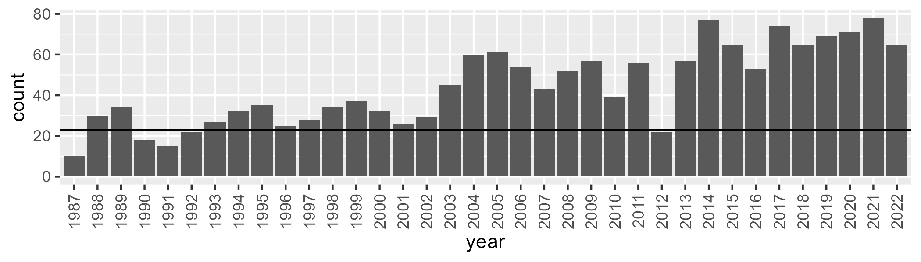

Number of samples: 1597

# QDAMGD0015

| Min. | 1st Qu. | Median | Mean | 3rd Qu. | Max. |
| --- | --- | --- | --- | --- | --- |
| 0 | 7.68166 | 11.8532 | 14.72963 | 19.82521 | 51.88655 |

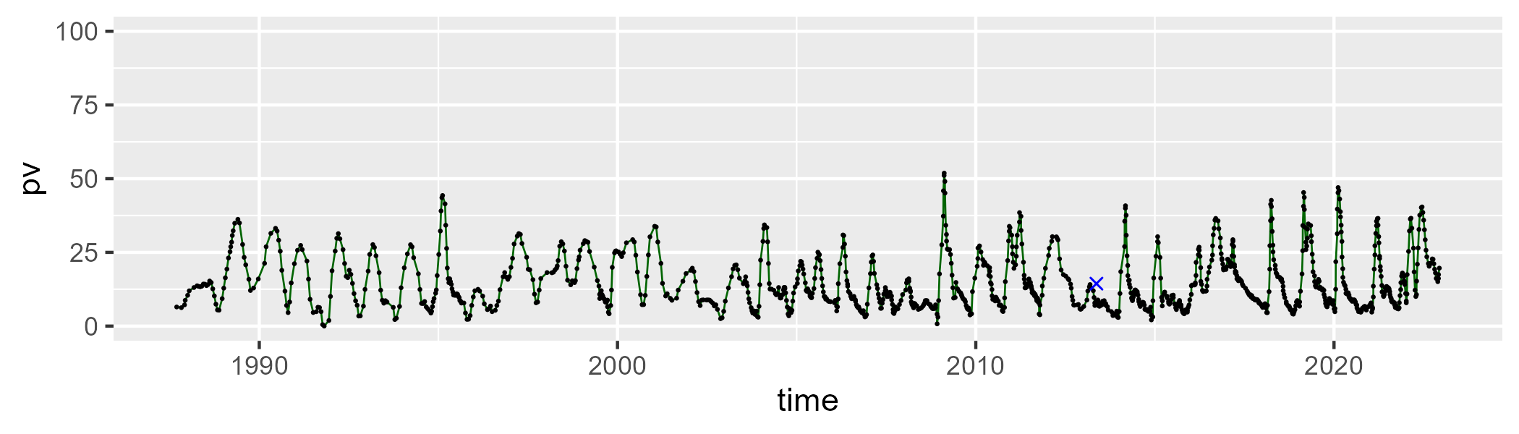

| Min. | 1st Qu. | Median | Mean | 3rd Qu. | Max. |
| --- | --- | --- | --- | --- | --- |
| 22.66141 | 48.92261 | 56.47443 | 55.96716 | 63.12157 | 82.66027 |

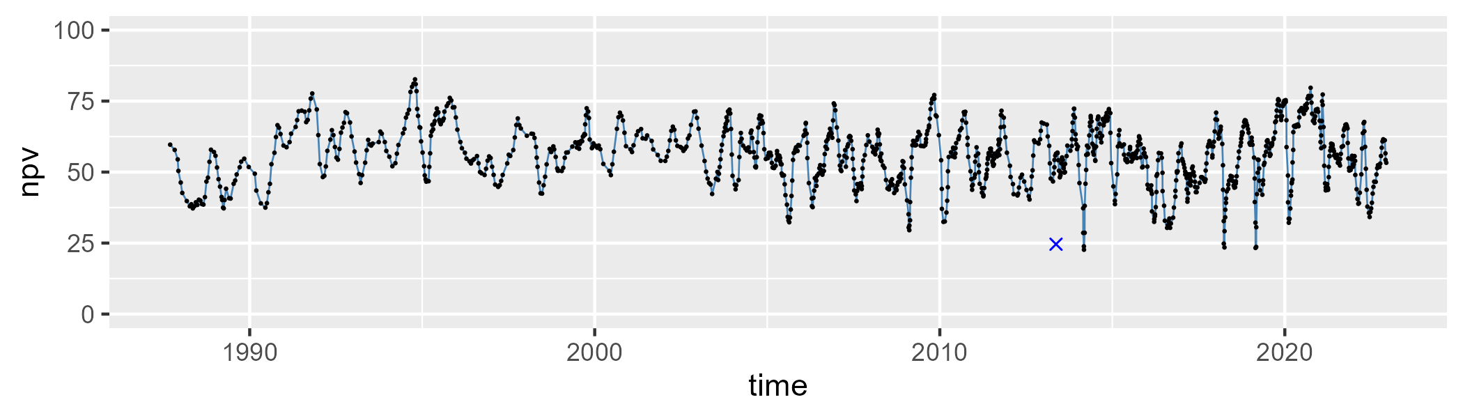

| Min. | 1st Qu. | Median | Mean | 3rd Qu. | Max. |
| --- | --- | --- | --- | --- | --- |
| 6.983663 | 22.44033 | 27.26441 | 27.87968 | 32.4804 | 49.72949 |

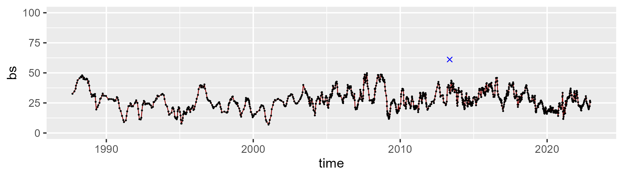

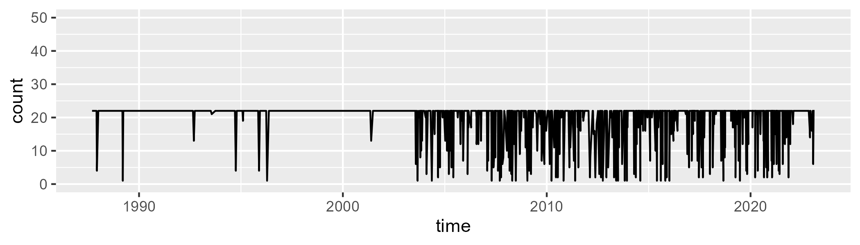

Min. : 1.00 1st Qu.:22.00 Median :22.00 Mean :19.79 3rd Qu.:22.00 Max. :22.00

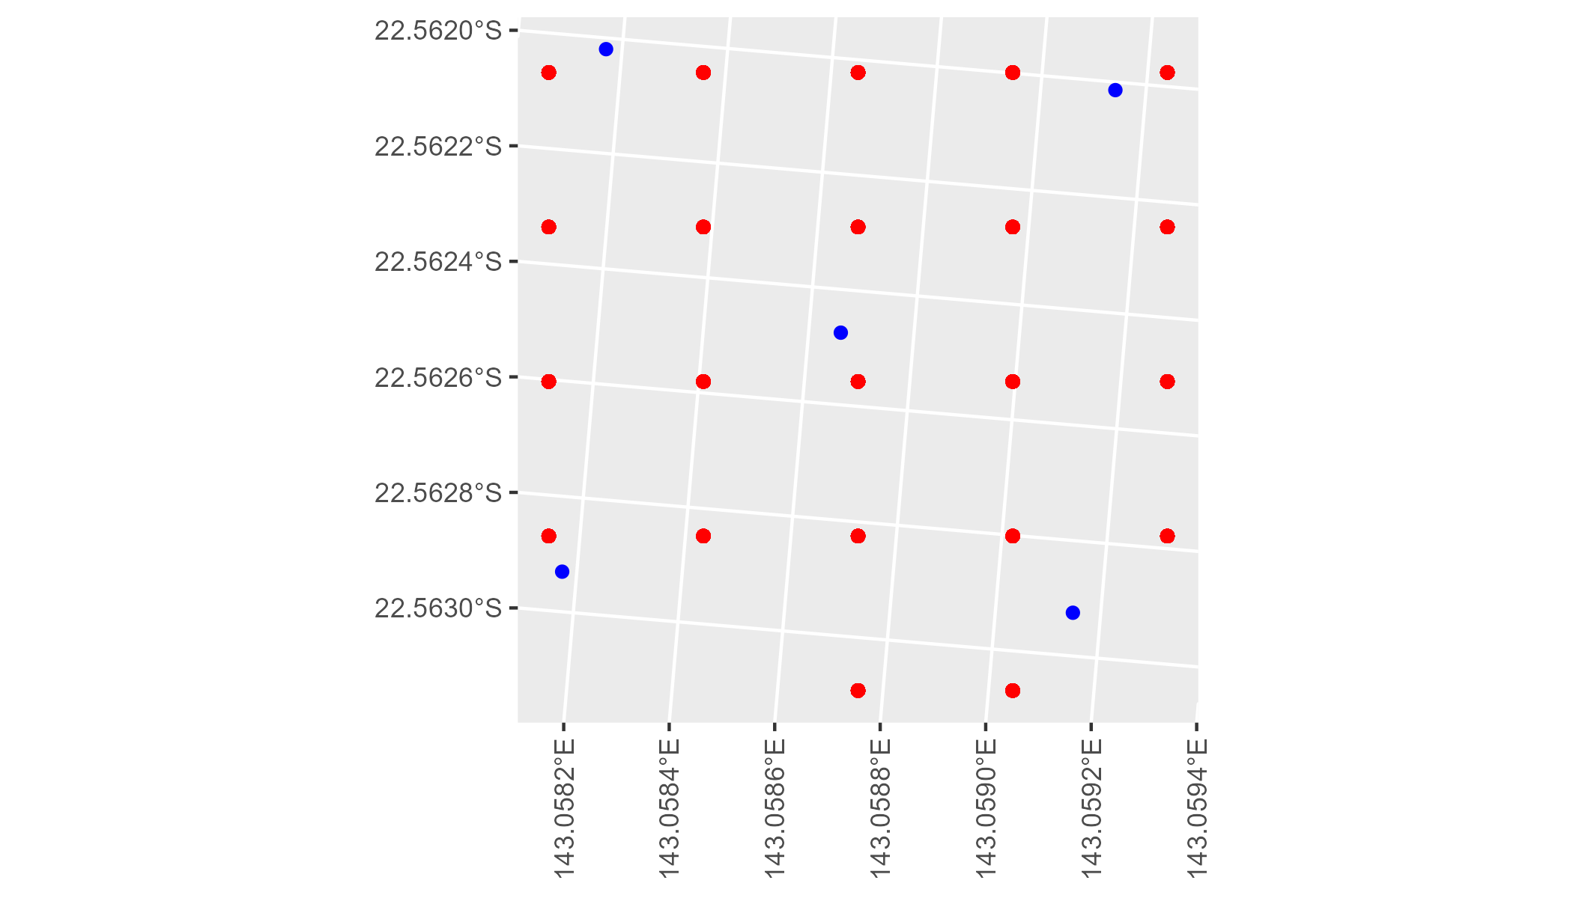

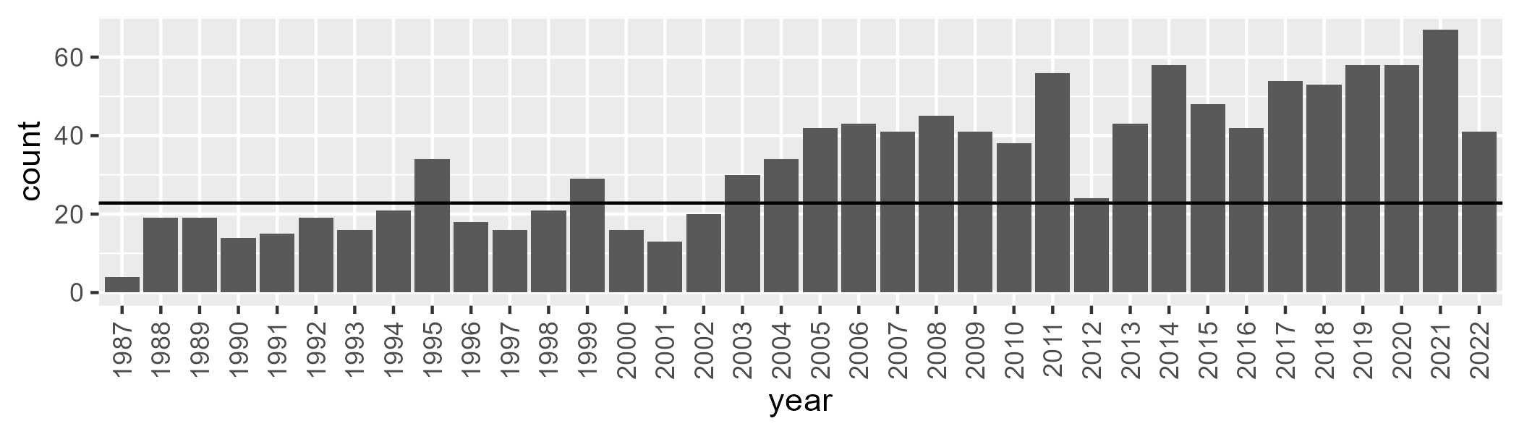

Number of samples: 1210

# QDAMGD0016

| Min. | 1st Qu. | Median | Mean | 3rd Qu. | Max. |
| --- | --- | --- | --- | --- | --- |
| 0 | 7.046976 | 11.57027 | 15.74718 | 21.40081 | 63.66178 |

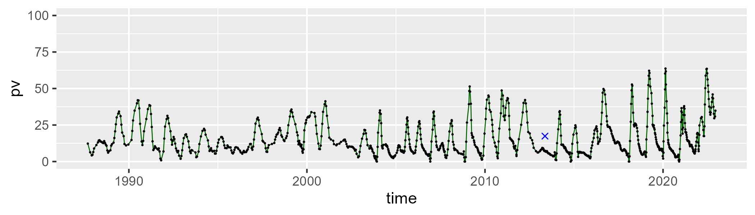

| Min. | 1st Qu. | Median | Mean | 3rd Qu. | Max. |
| --- | --- | --- | --- | --- | --- |
| 11.72533 | 48.20307 | 57.2452 | 56.14764 | 64.11814 | 89.5382 |

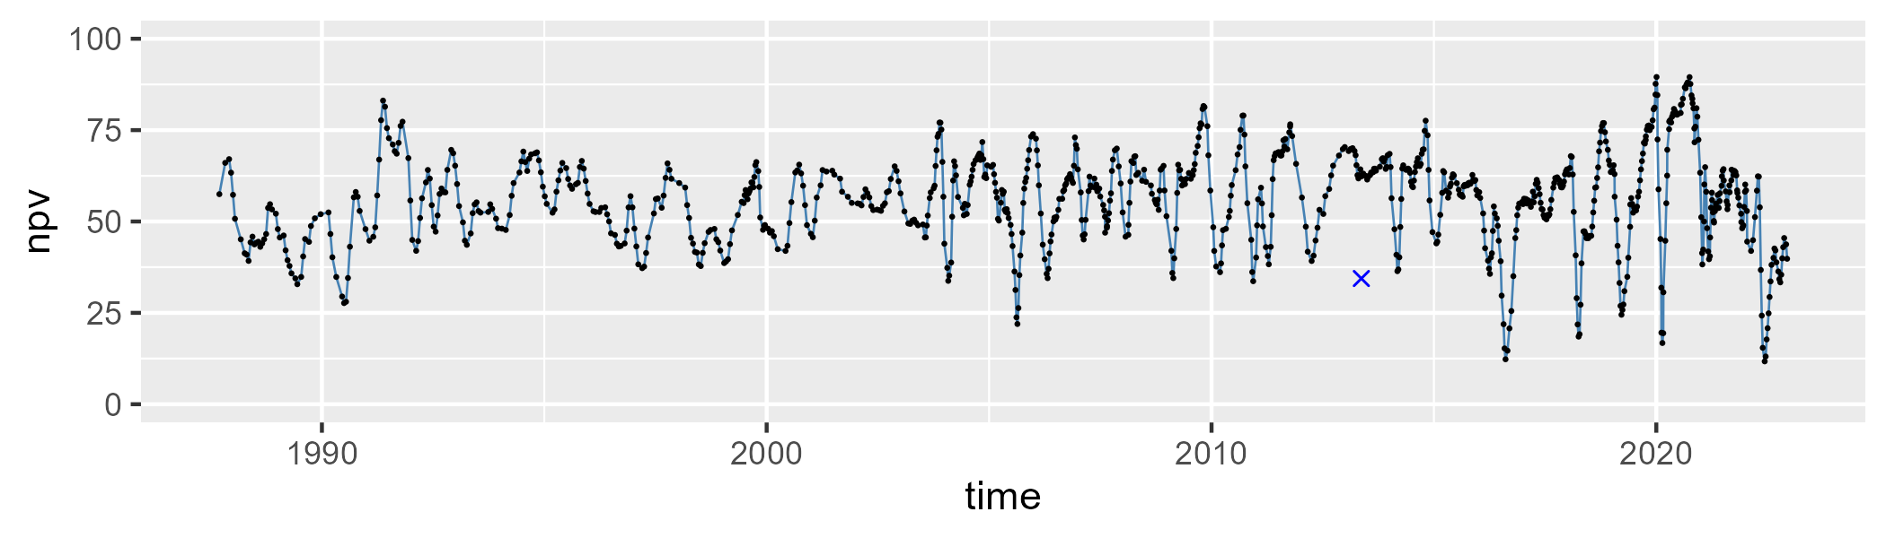

| Min. | 1st Qu. | Median | Mean | 3rd Qu. | Max. |
| --- | --- | --- | --- | --- | --- |
| 6.180291 | 21.0992 | 27.51102 | 26.75972 | 32.27393 | 47.31007 |

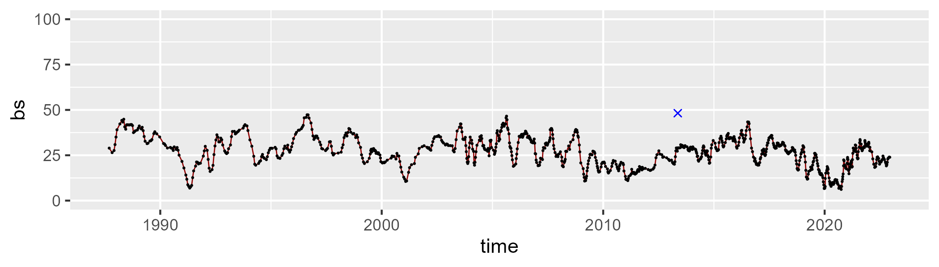

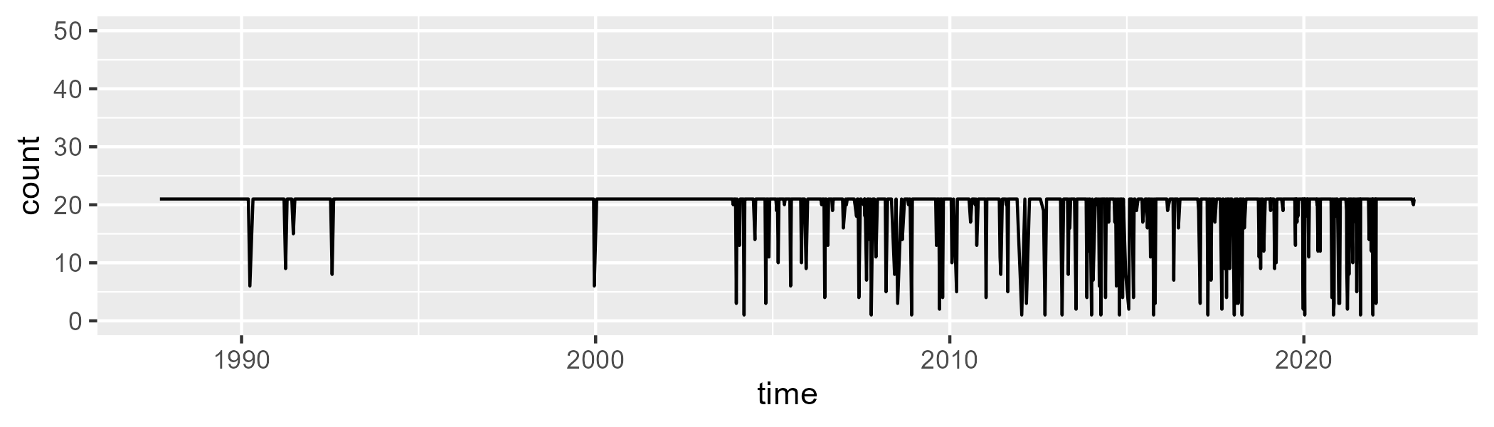

Min. : 1.00 1st Qu.:21.00 Median :21.00 Mean :19.37 3rd Qu.:21.00 Max. :21.00

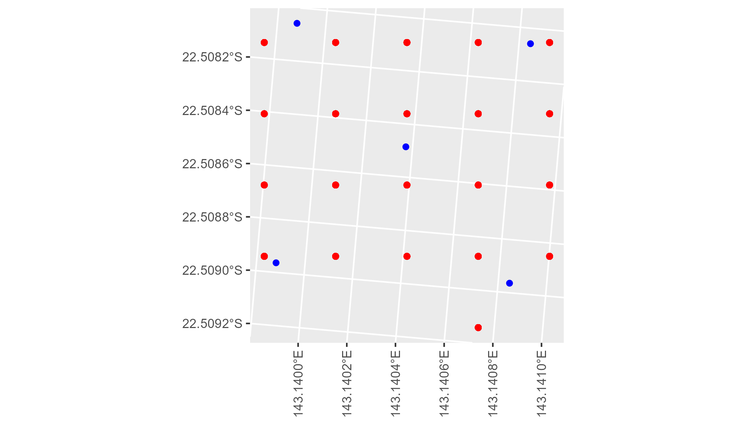

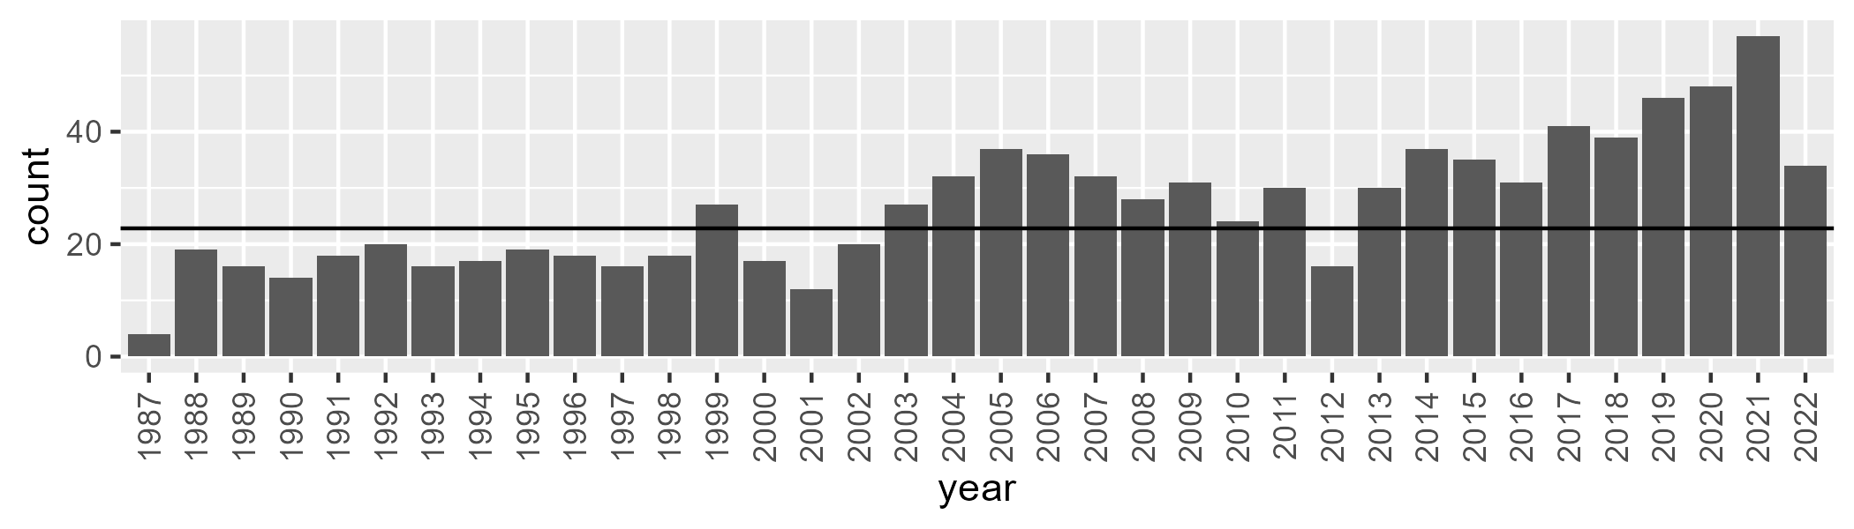

Number of samples: 962

# QDAMGD0017

| Min. | 1st Qu. | Median | Mean | 3rd Qu. | Max. |
| --- | --- | --- | --- | --- | --- |
| 0 | 1.425151 | 4.0762 | 10.67886 | 14.84108 | 82.2423 |

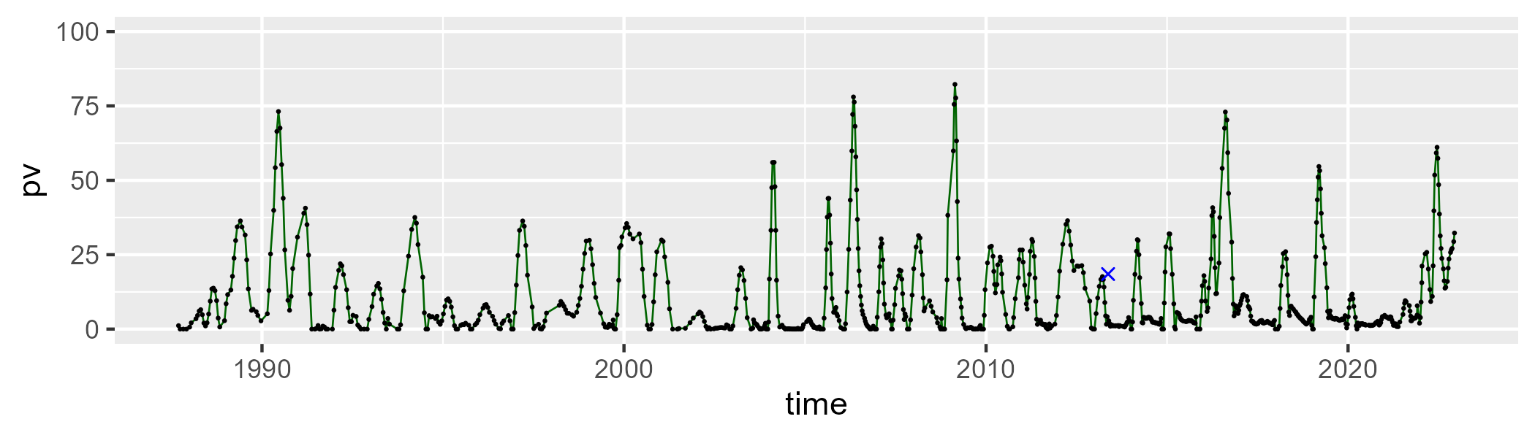

| Min. | 1st Qu. | Median | Mean | 3rd Qu. | Max. |
| --- | --- | --- | --- | --- | --- |
| 9.748614 | 43.5716 | 52.28041 | 52.22676 | 58.46764 | 100.8486 |

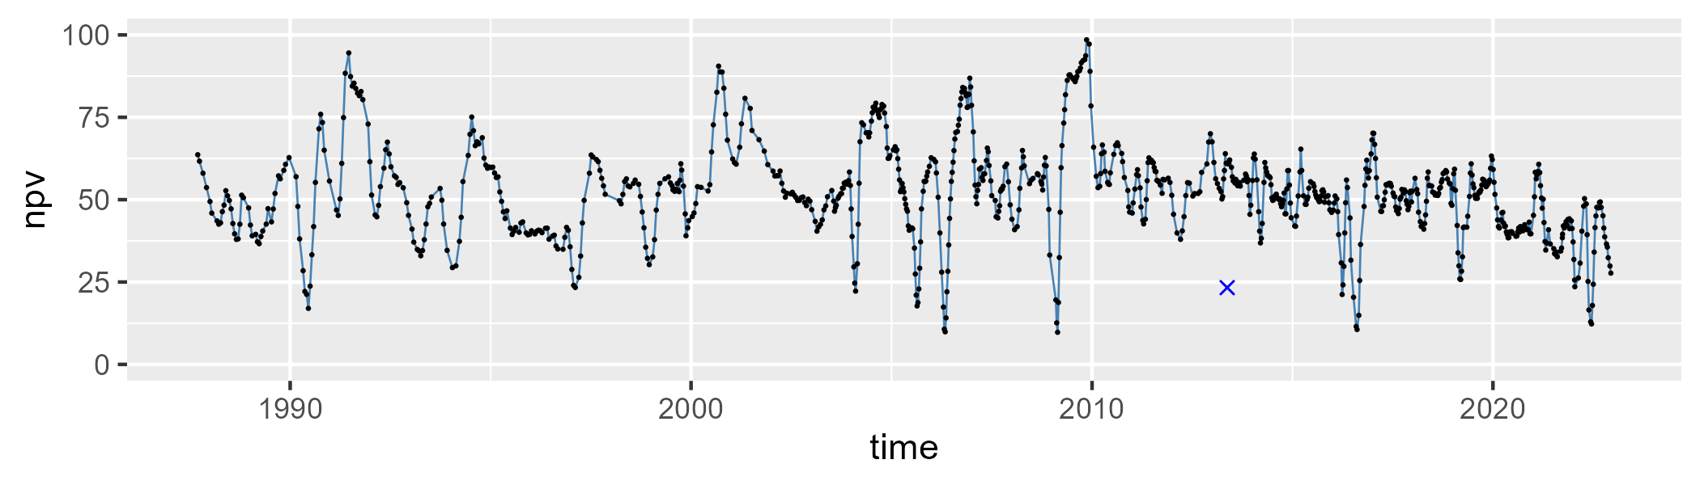

| Min. | 1st Qu. | Median | Mean | 3rd Qu. | Max. |
| --- | --- | --- | --- | --- | --- |
| 2.115176 | 27.34534 | 37.52132 | 36.01193 | 45.10464 | 62.06679 |

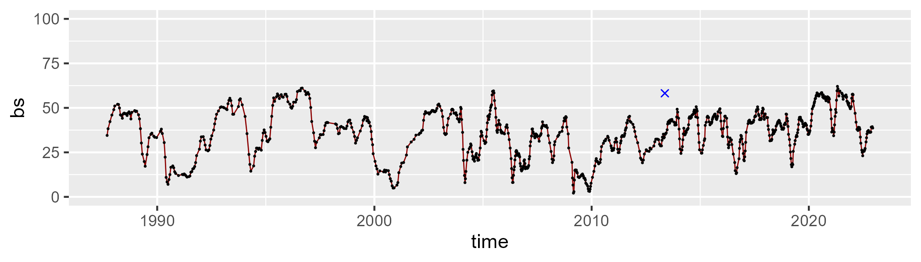

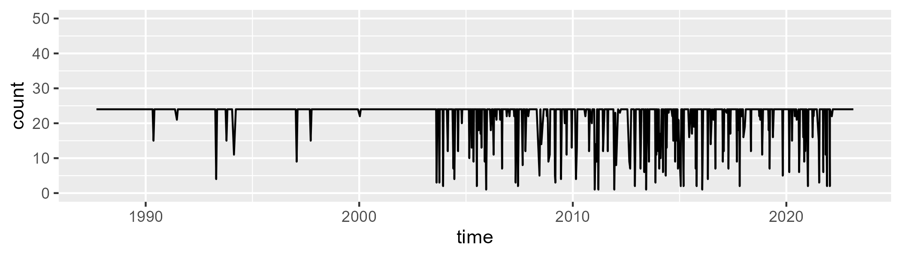

Min. : 1.00 1st Qu.:24.00 Median :24.00 Mean :22.13 3rd Qu.:24.00 Max. :24.00

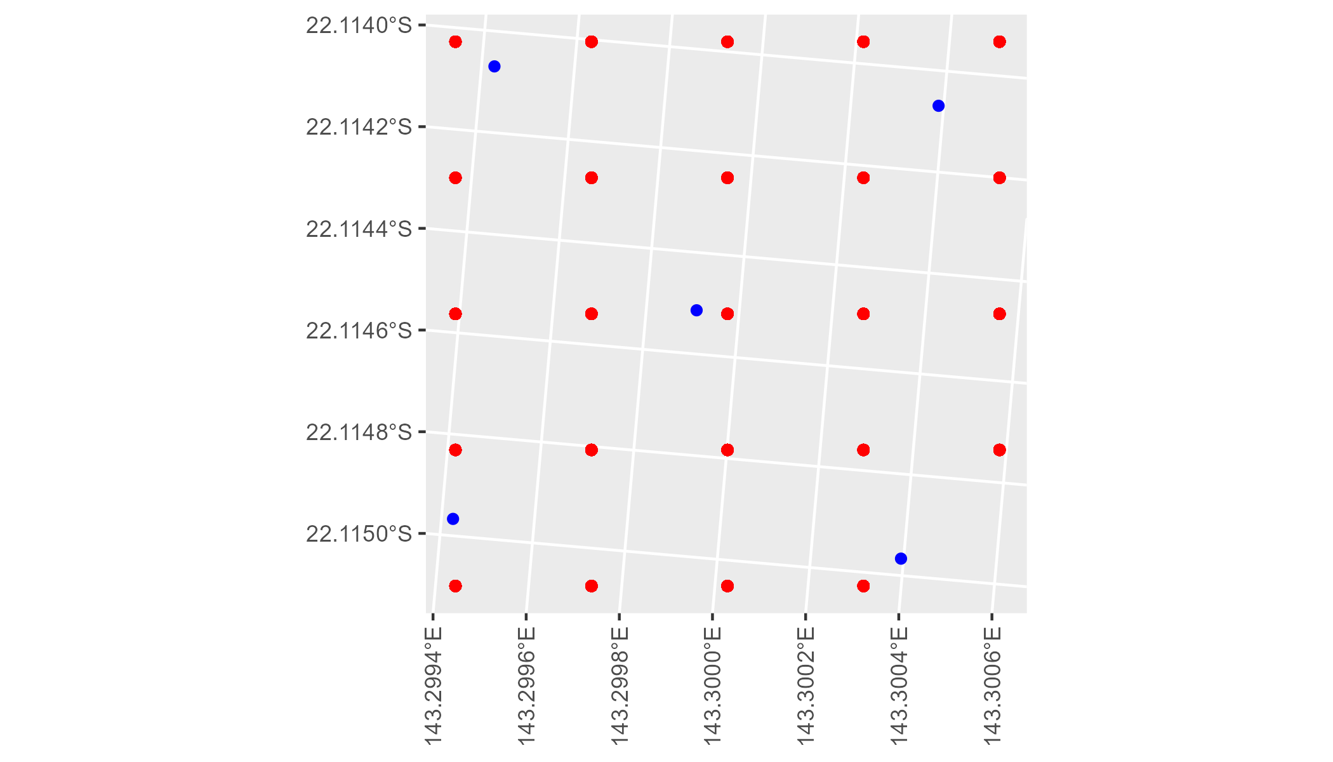

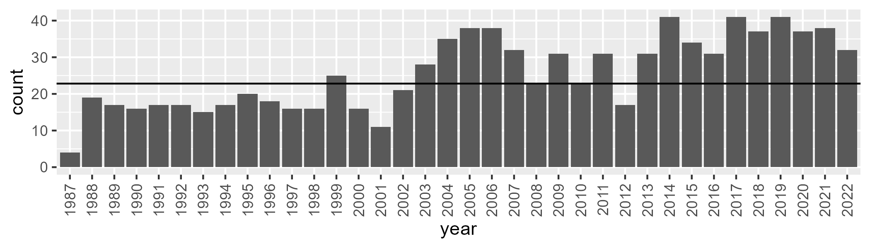

Number of samples: 924

# QDAMGD0018

| Min. | 1st Qu. | Median | Mean | 3rd Qu. | Max. |
| --- | --- | --- | --- | --- | --- |
| 0 | 2.165005 | 5.616963 | 12.87518 | 19.47317 | 80.17548 |

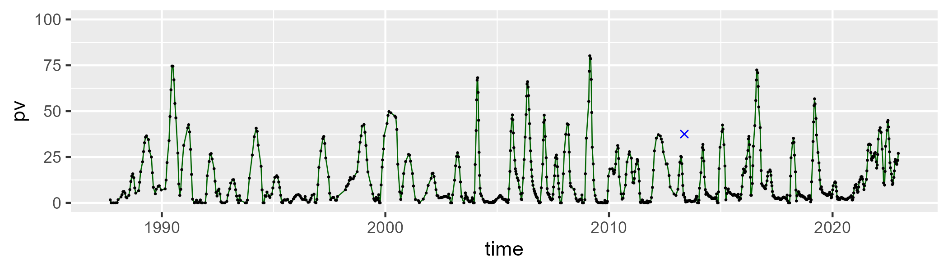

| Min. | 1st Qu. | Median | Mean | 3rd Qu. | Max. |
| --- | --- | --- | --- | --- | --- |
| 9.58991 | 41.76355 | 51.51057 | 52.07265 | 61.47431 | 98.02413 |

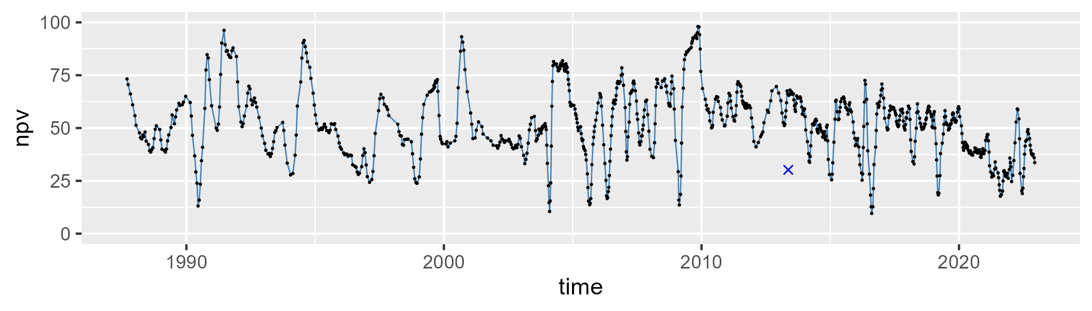

| Min. | 1st Qu. | Median | Mean | 3rd Qu. | Max. |
| --- | --- | --- | --- | --- | --- |
| 1.376899 | 24.04194 | 34.99011 | 33.94184 | 44.35335 | 68.28755 |

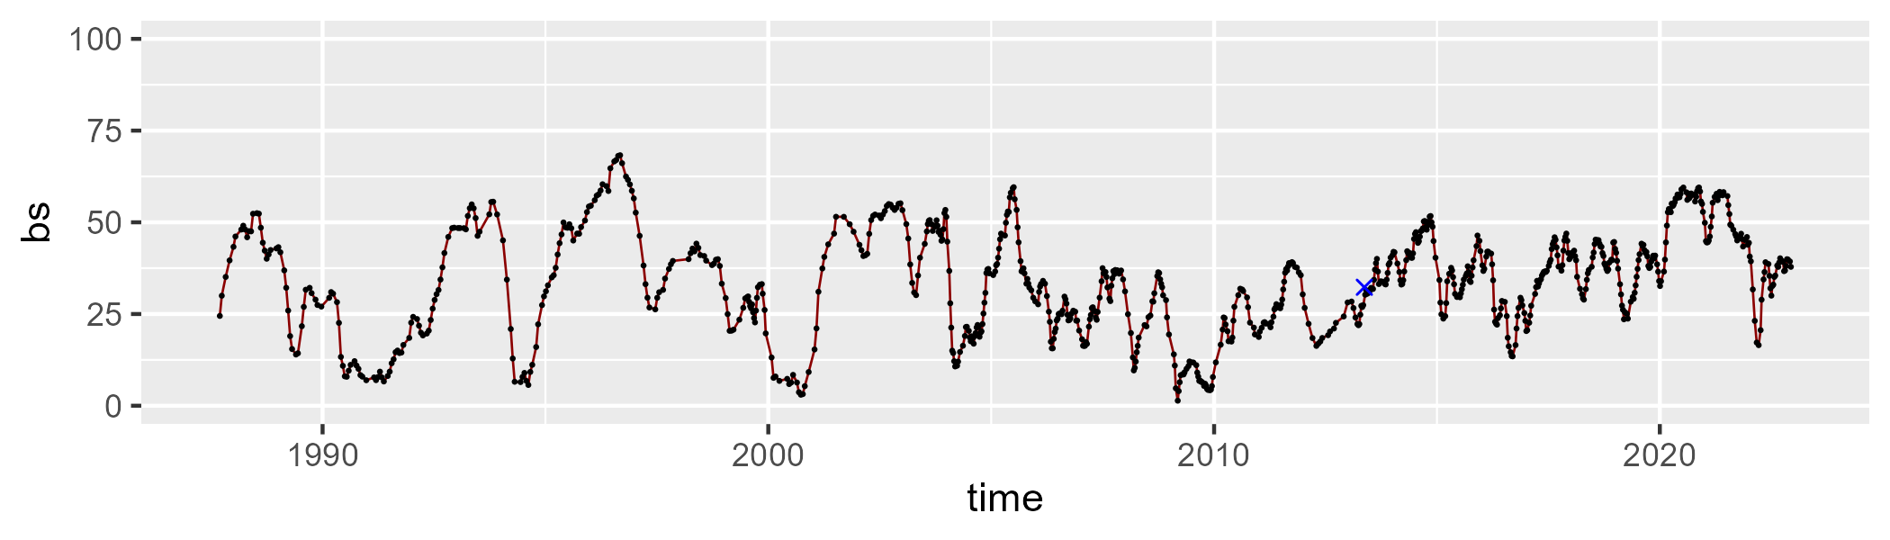

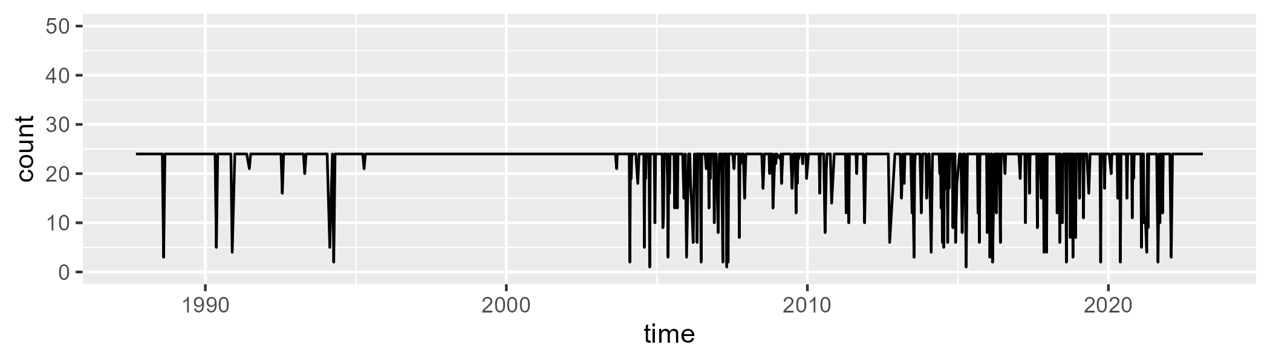

Min. : 1.00 1st Qu.:24.00 Median :24.00 Mean :22.21 3rd Qu.:24.00 Max. :24.00

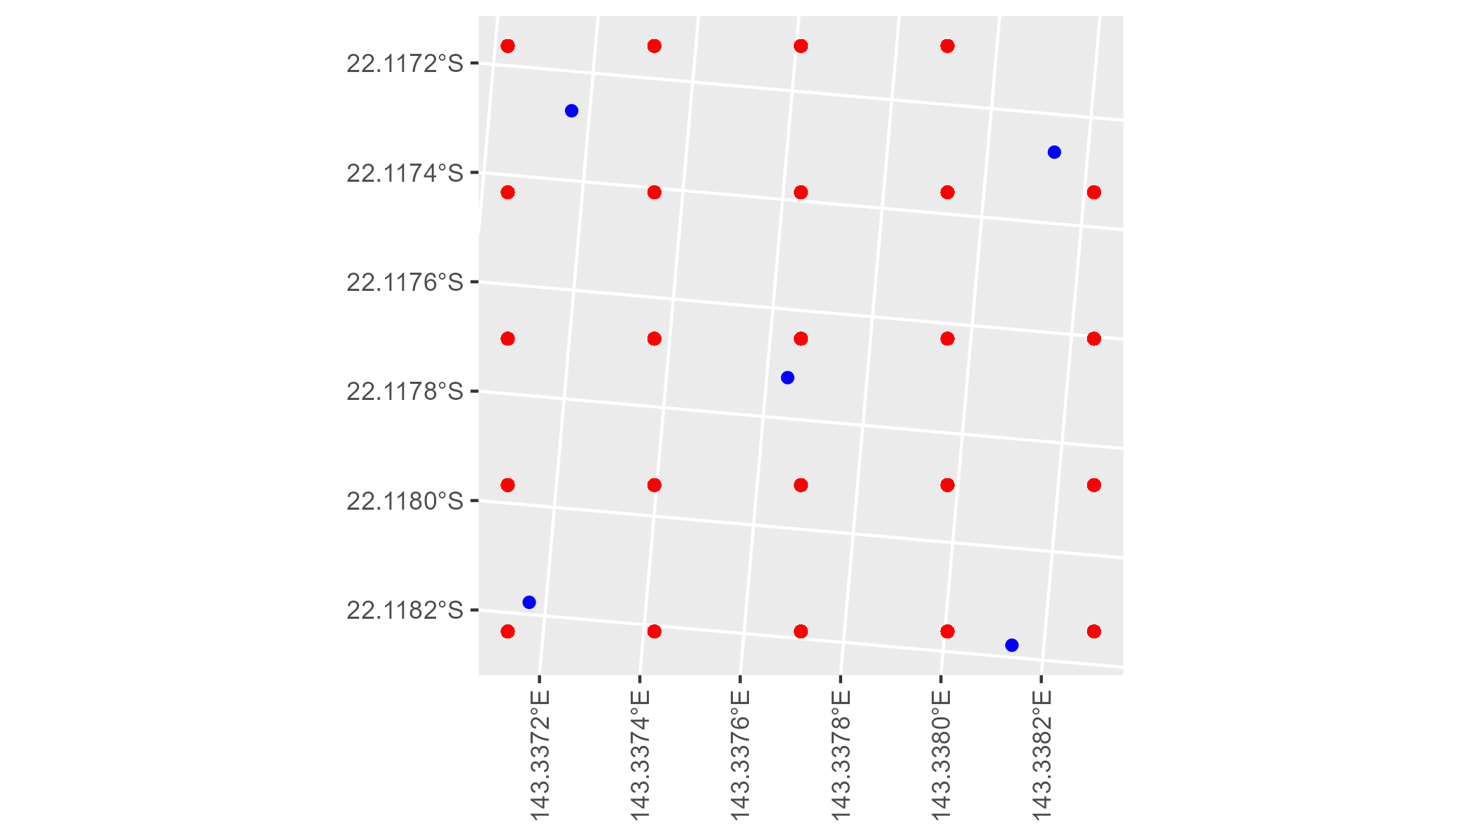

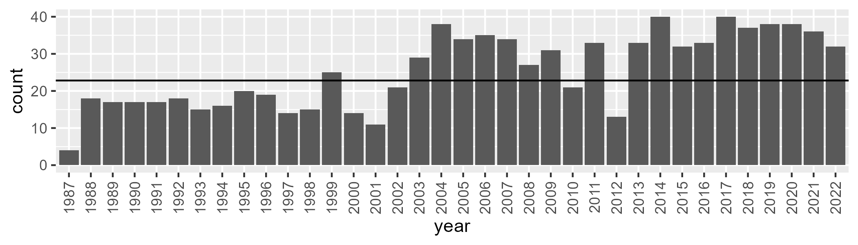

Number of samples: 915

# QDAMGD0019

| Min. | 1st Qu. | Median | Mean | 3rd Qu. | Max. |
| --- | --- | --- | --- | --- | --- |
| 0 | 2.320612 | 5.110719 | 8.492326 | 11.43882 | 56.34665 |

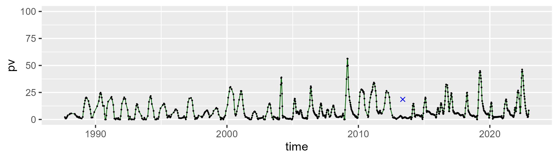

| Min. | 1st Qu. | Median | Mean | 3rd Qu. | Max. |
| --- | --- | --- | --- | --- | --- |
| 25.99686 | 43.80546 | 48.27341 | 49.8168 | 54.96748 | 81.02224 |

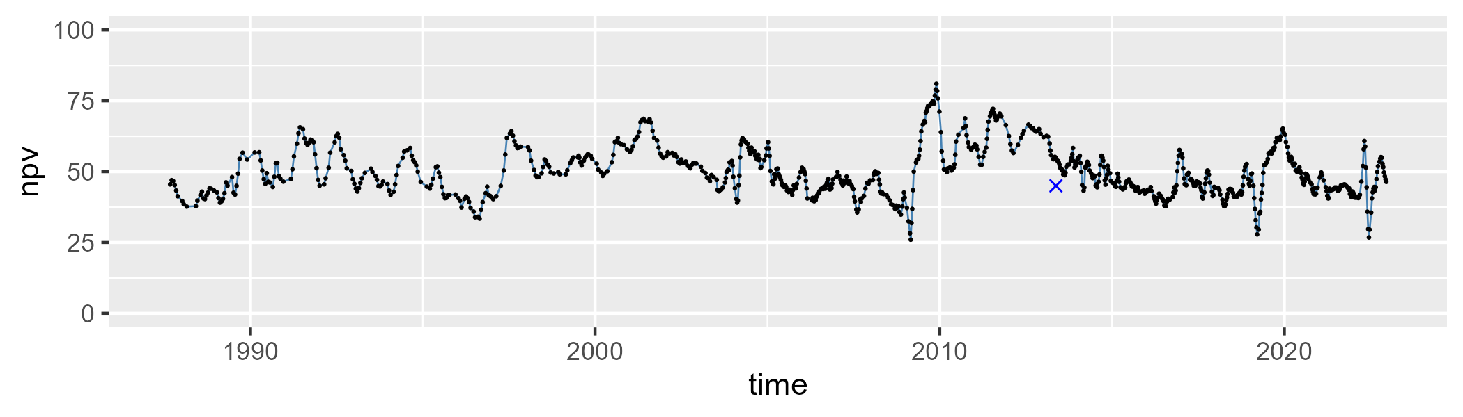

| Min. | 1st Qu. | Median | Mean | 3rd Qu. | Max. |
| --- | --- | --- | --- | --- | --- |
| 10.44969 | 33.59816 | 42.9311 | 40.3528 | 48.14506 | 63.6639 |

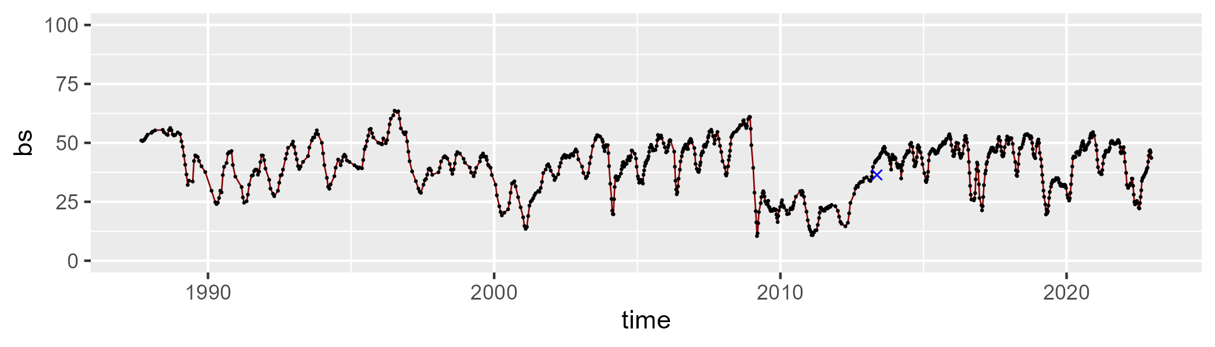

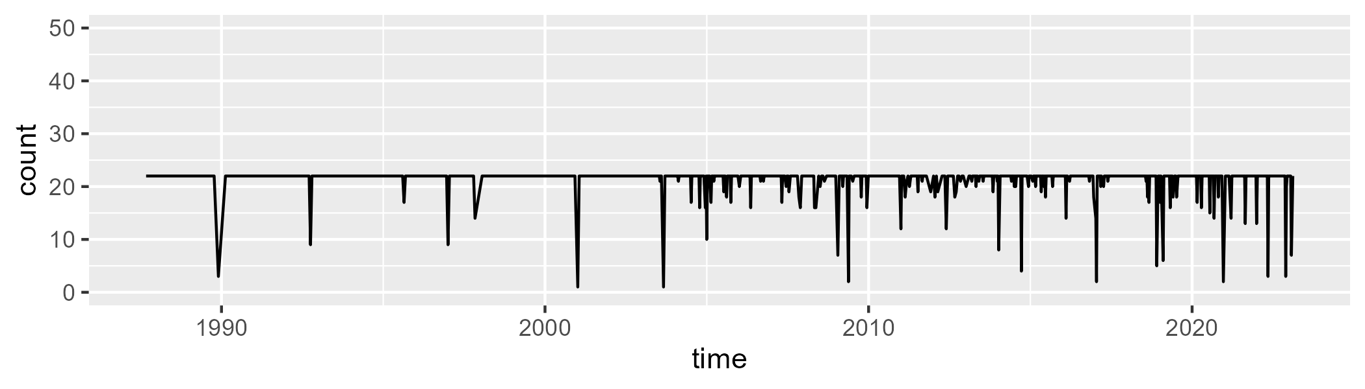

Min. : 1.00 1st Qu.:22.00 Median :22.00 Mean :21.36 3rd Qu.:22.00 Max. :22.00

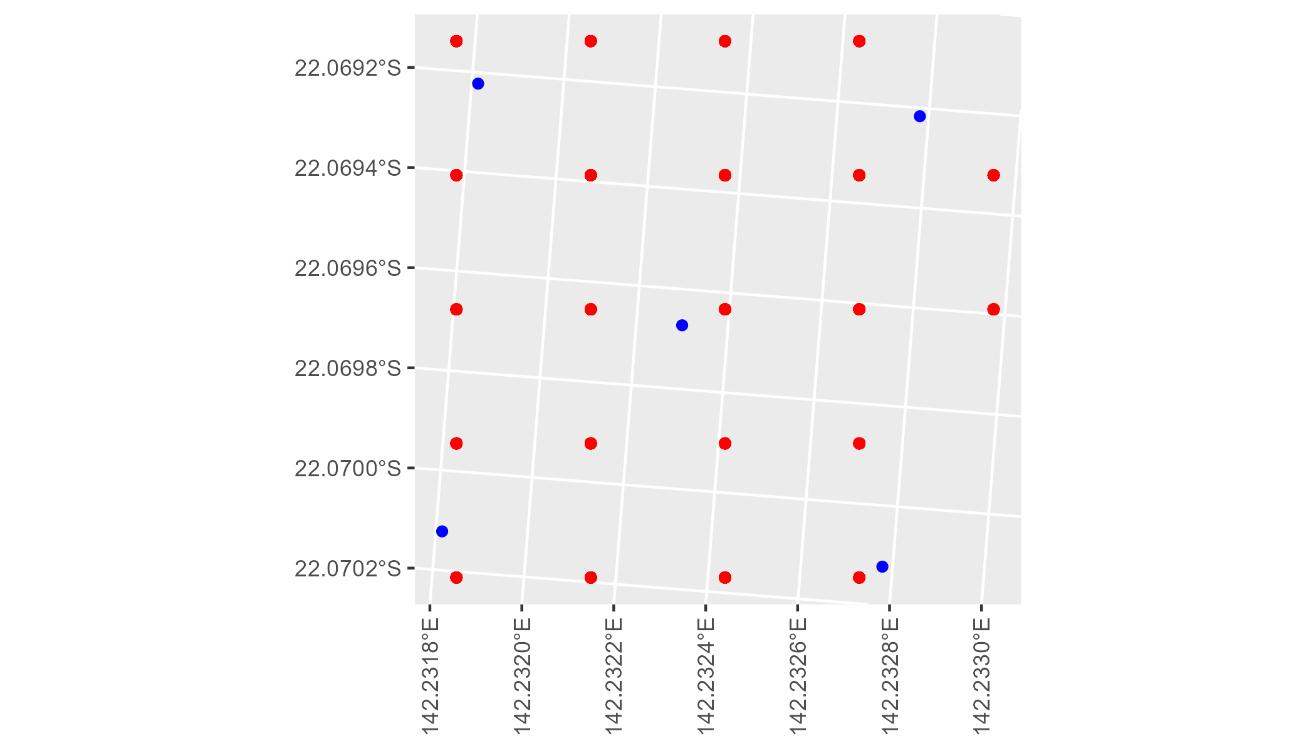

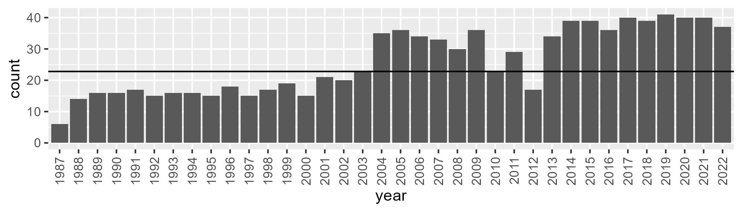

Number of samples: 937

# QDAMGD0020

| Min. | 1st Qu. | Median | Mean | 3rd Qu. | Max. |
| --- | --- | --- | --- | --- | --- |
| 0 | 7.891133 | 10.75081 | 12.97809 | 16.39269 | 42.24045 |

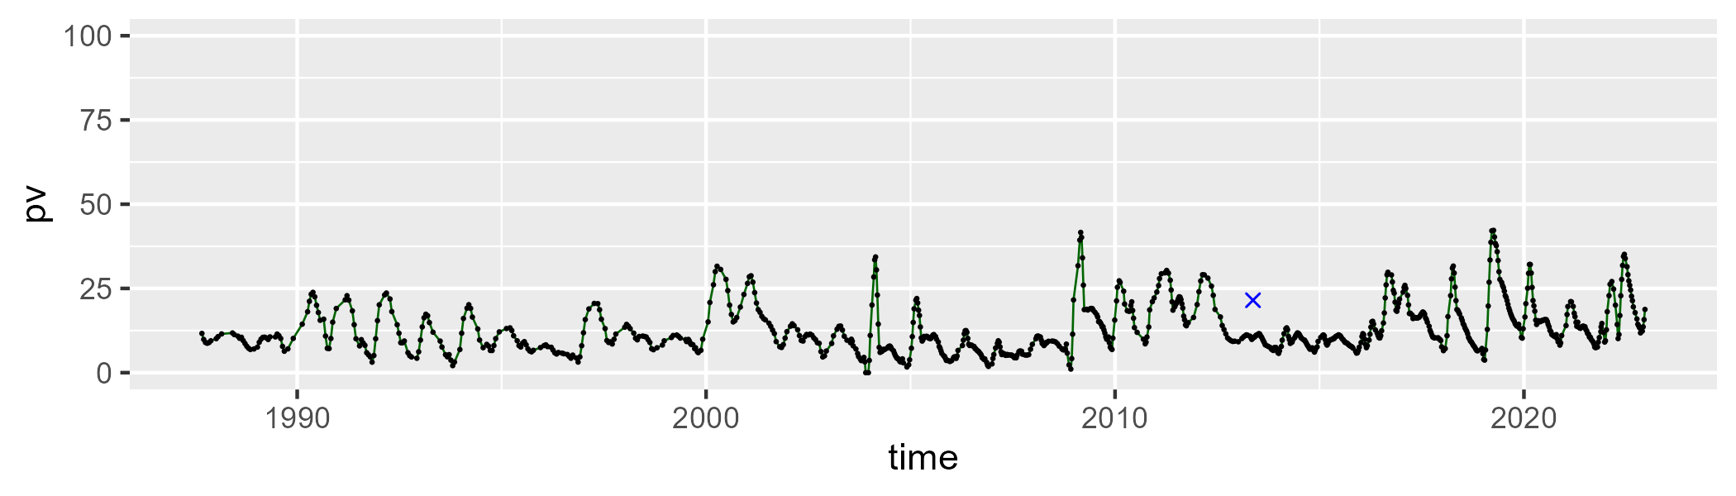

| Min. | 1st Qu. | Median | Mean | 3rd Qu. | Max. |
| --- | --- | --- | --- | --- | --- |
| 24.51106 | 44.05871 | 48.3042 | 48.68831 | 53.03825 | 75.93826 |

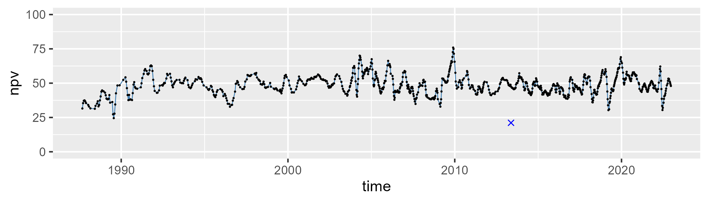

| Min. | 1st Qu. | Median | Mean | 3rd Qu. | Max. |
| --- | --- | --- | --- | --- | --- |
| 15.52286 | 31.24172 | 36.61797 | 36.91528 | 42.69058 | 63.14381 |

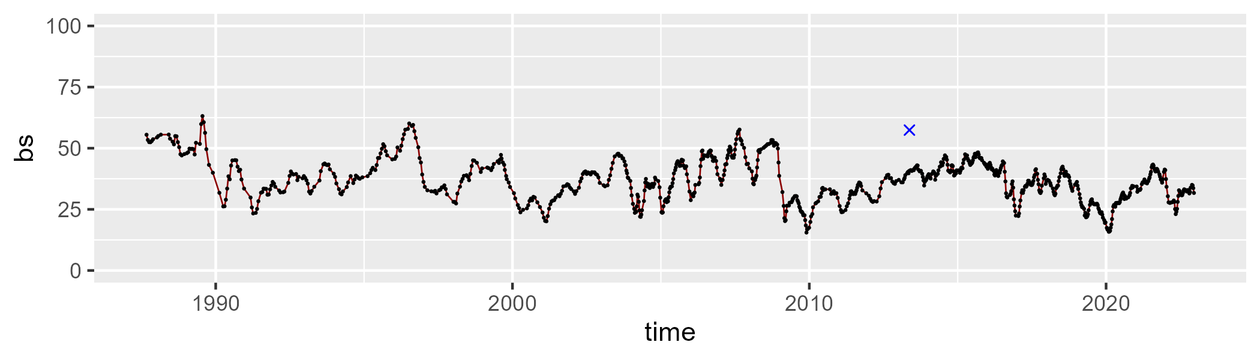

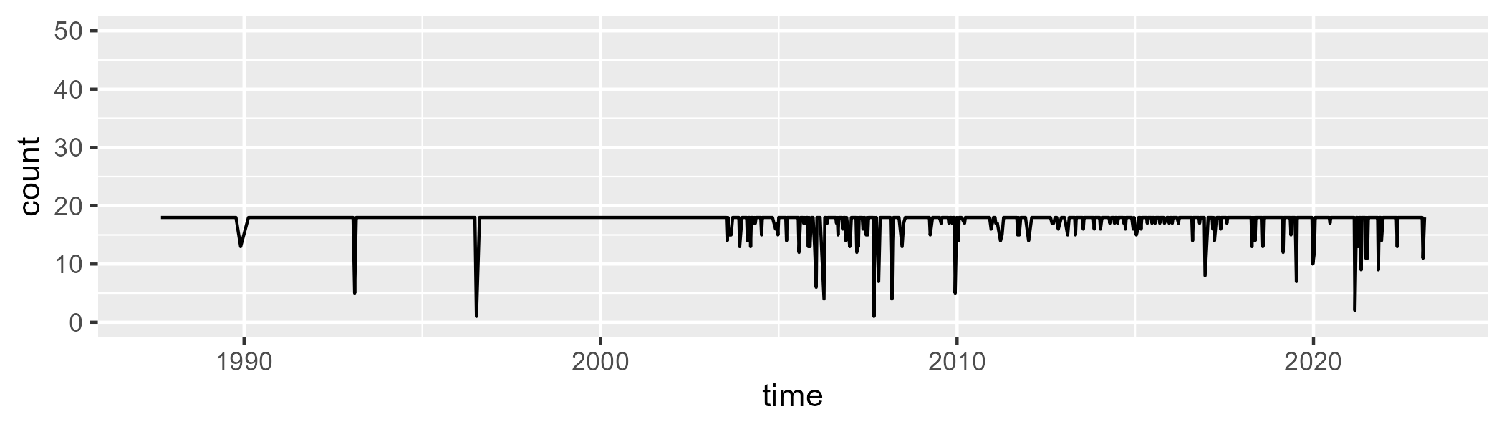

Min. : 1.00 1st Qu.:18.00 Median :18.00 Mean :17.52 3rd Qu.:18.00 Max. :18.00

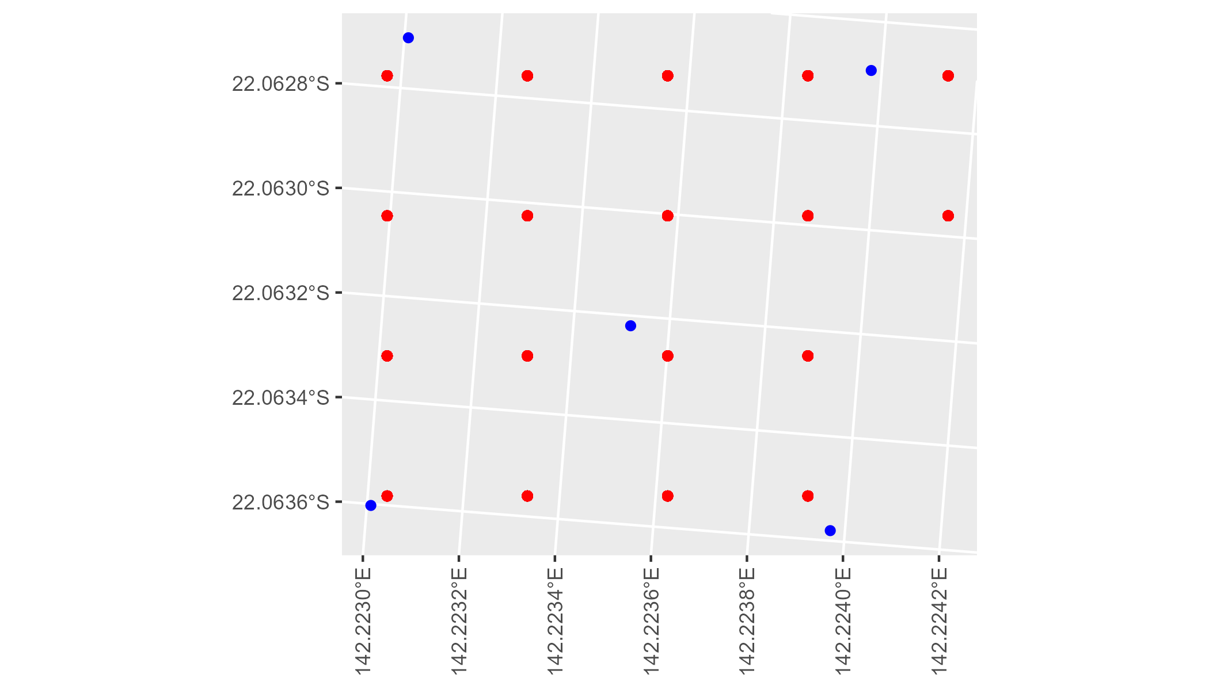

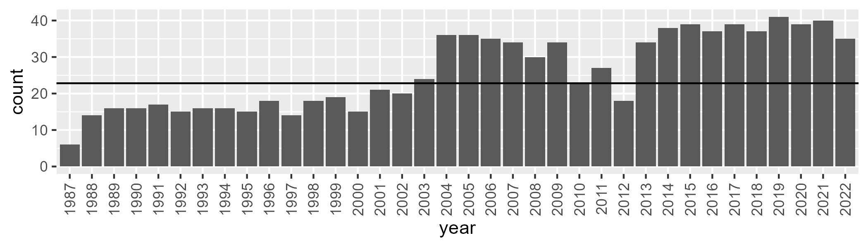

Number of samples: 932

# QDAMGD0021

| Min. | 1st Qu. | Median | Mean | 3rd Qu. | Max. |
| --- | --- | --- | --- | --- | --- |
| 0 | 2.148701 | 3.370128 | 7.611604 | 9.413741 | 56.372 |

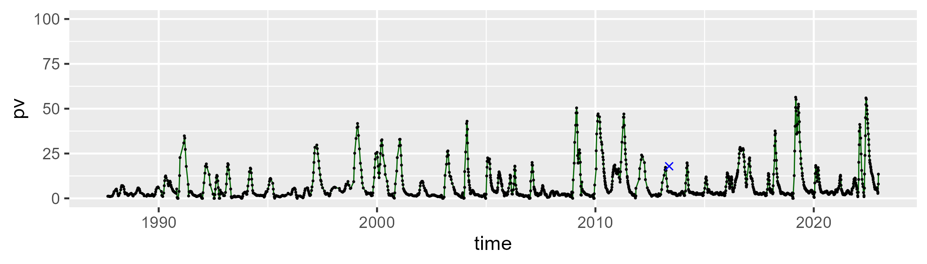

| Min. | 1st Qu. | Median | Mean | 3rd Qu. | Max. |
| --- | --- | --- | --- | --- | --- |
| 9.842739 | 35.48211 | 43.31758 | 44.24881 | 51.45161 | 77.34815 |

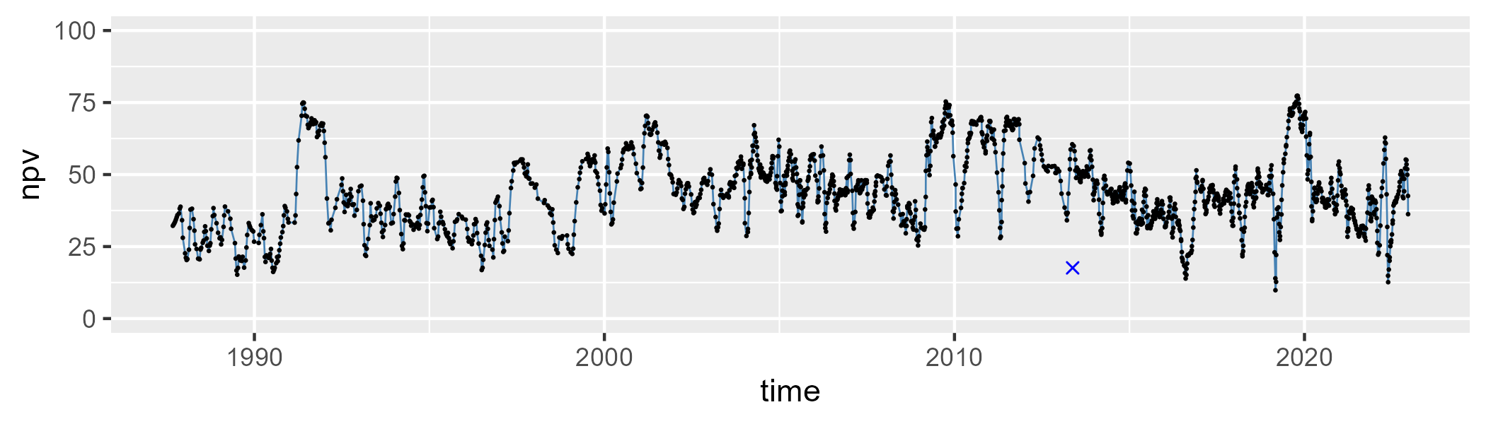

| Min. | 1st Qu. | Median | Mean | 3rd Qu. | Max. |
| --- | --- | --- | --- | --- | --- |
| 13.96434 | 37.7107 | 48.82459 | 46.82381 | 56.33028 | 81.47438 |

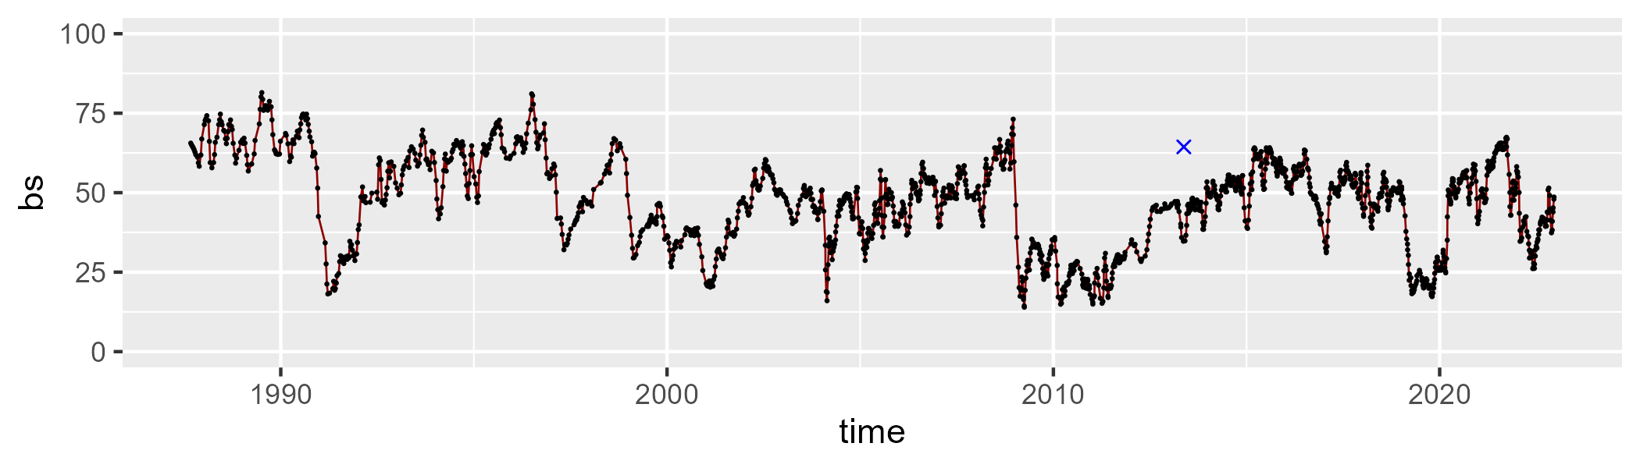

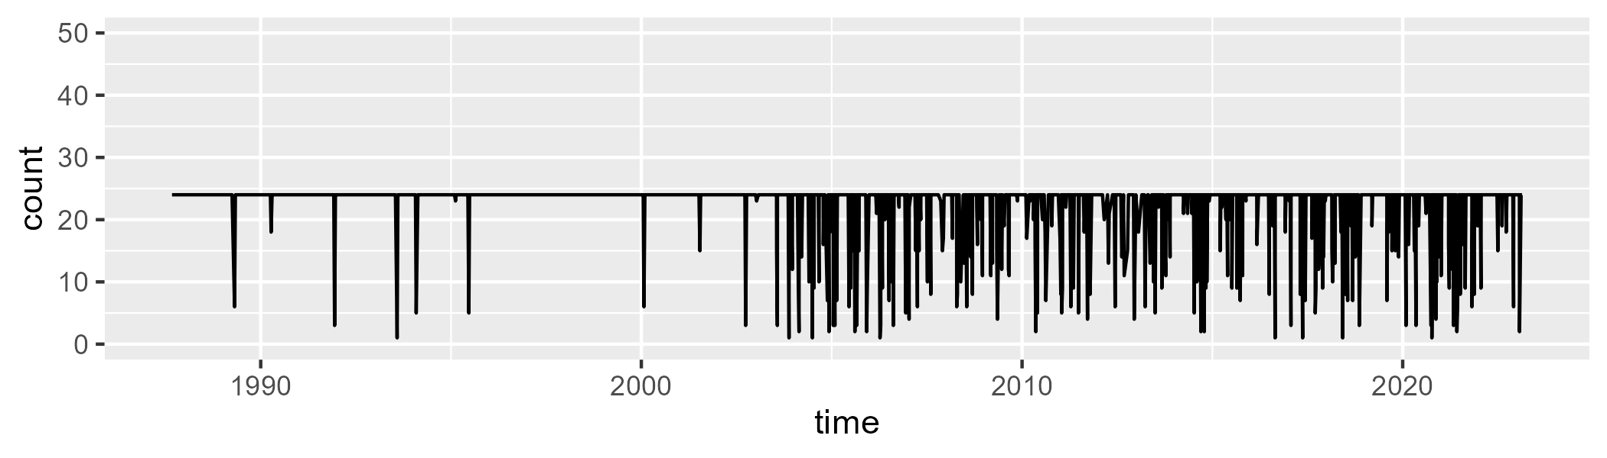

Min. : 1.00 1st Qu.:24.00 Median :24.00 Mean :22.44 3rd Qu.:24.00 Max. :24.00

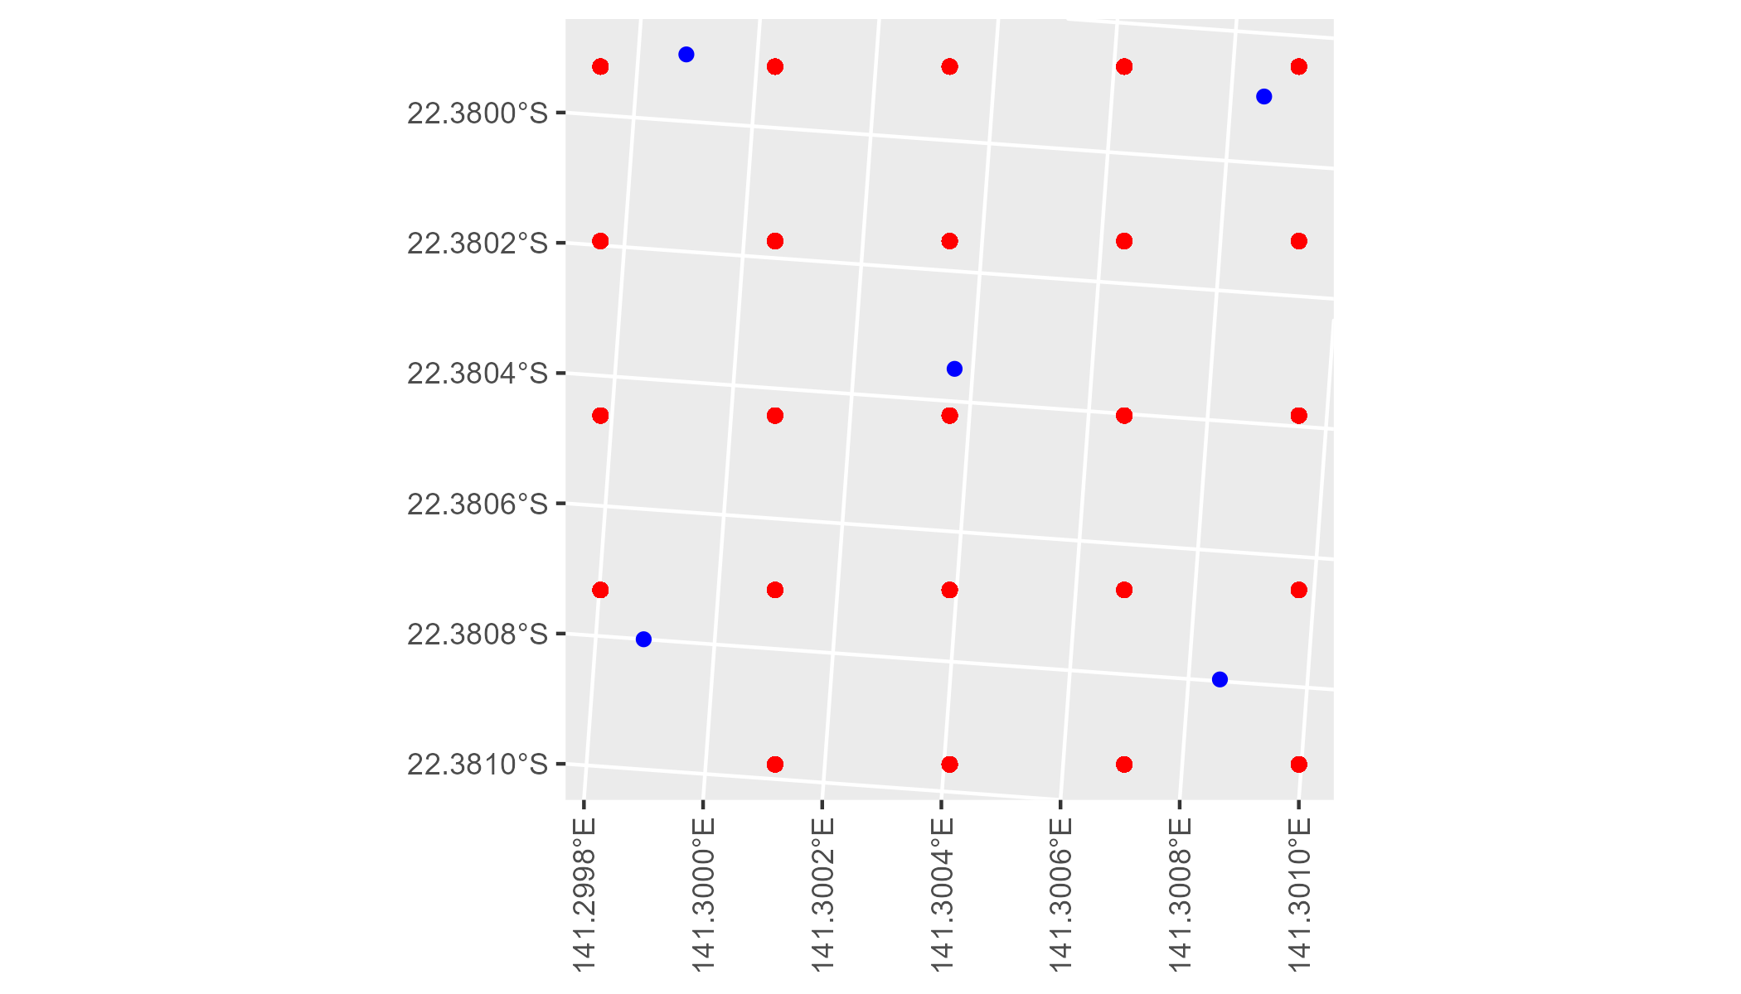

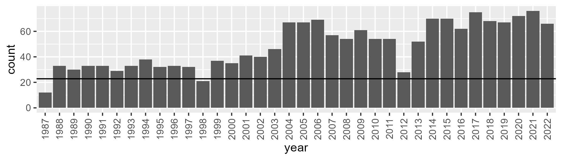

Number of samples: 1747

# QDAMGD0022

| Min. | 1st Qu. | Median | Mean | 3rd Qu. | Max. |
| --- | --- | --- | --- | --- | --- |
| 0 | 1.758162 | 3.3021 | 6.870711 | 7.802249 | 54.94592 |

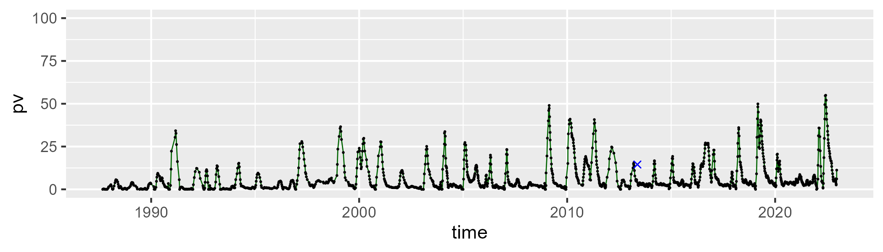

| Min. | 1st Qu. | Median | Mean | 3rd Qu. | Max. |
| --- | --- | --- | --- | --- | --- |
| 17.07073 | 41.18613 | 47.23153 | 48.05303 | 53.67301 | 84.78531 |

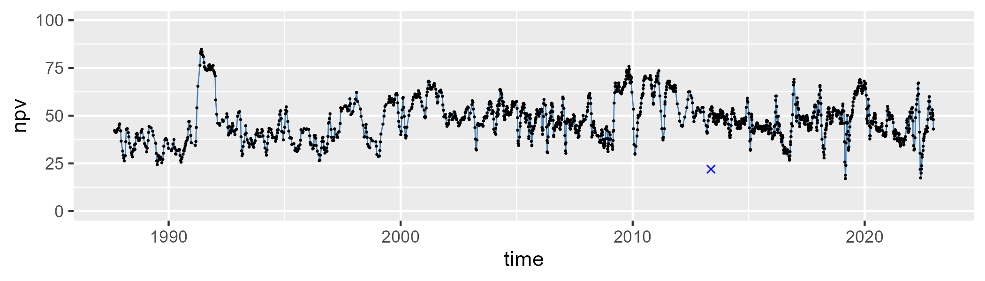

| Min. | 1st Qu. | Median | Mean | 3rd Qu. | Max. |
| --- | --- | --- | --- | --- | --- |
| 12.47187 | 35.67428 | 45.26979 | 43.80958 | 51.65276 | 74.36036 |

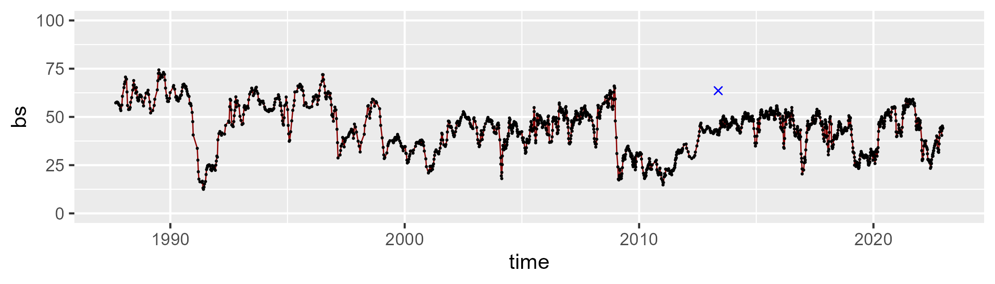

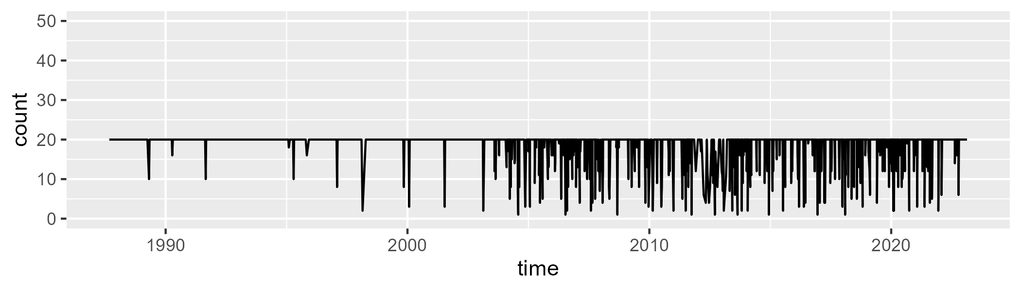

Min. : 1.00 1st Qu.:20.00 Median :20.00 Mean :18.65 3rd Qu.:20.00 Max. :20.00

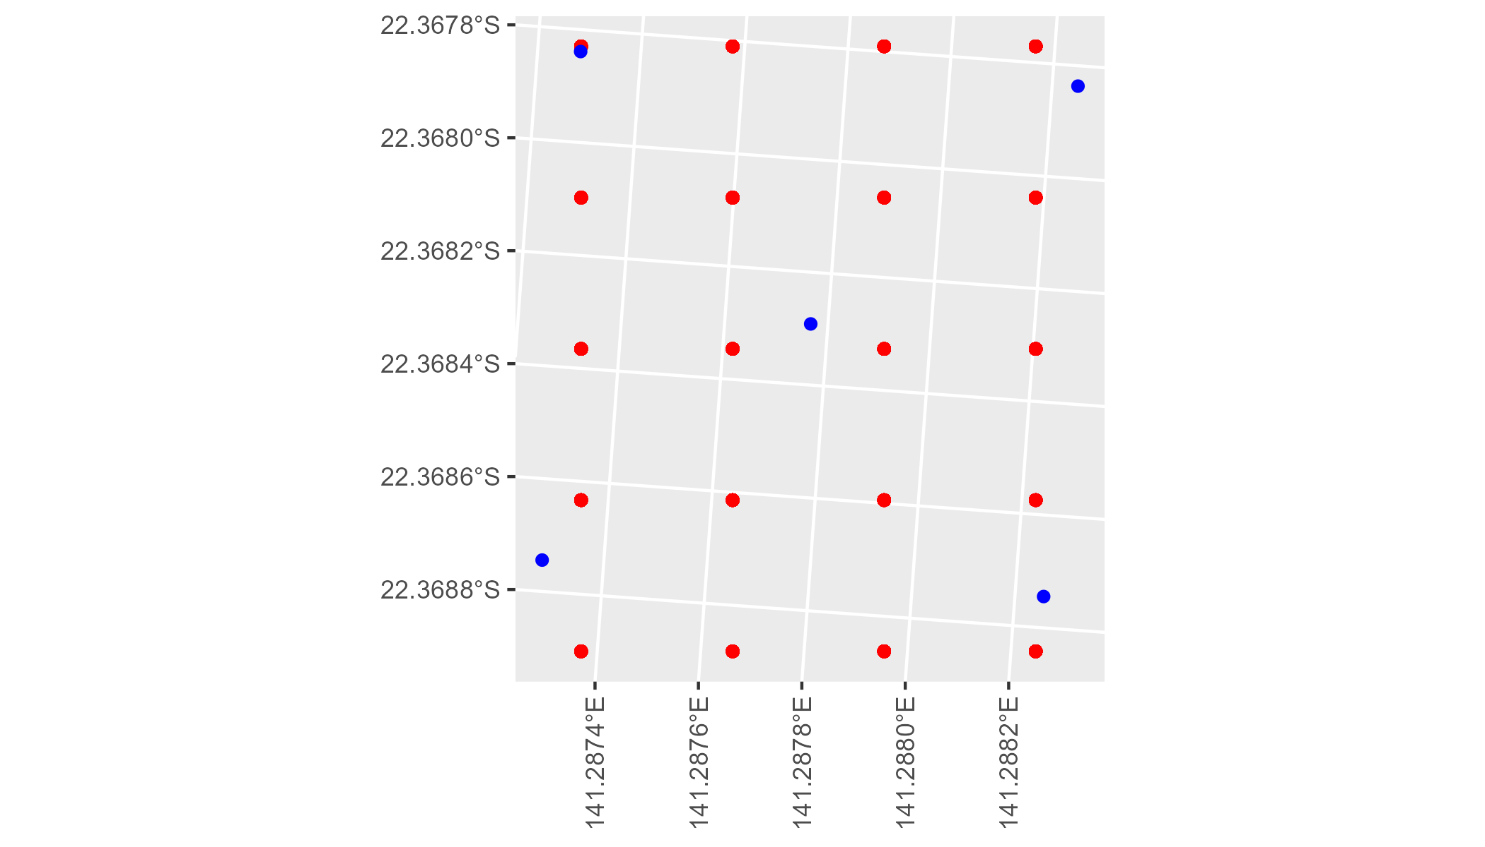

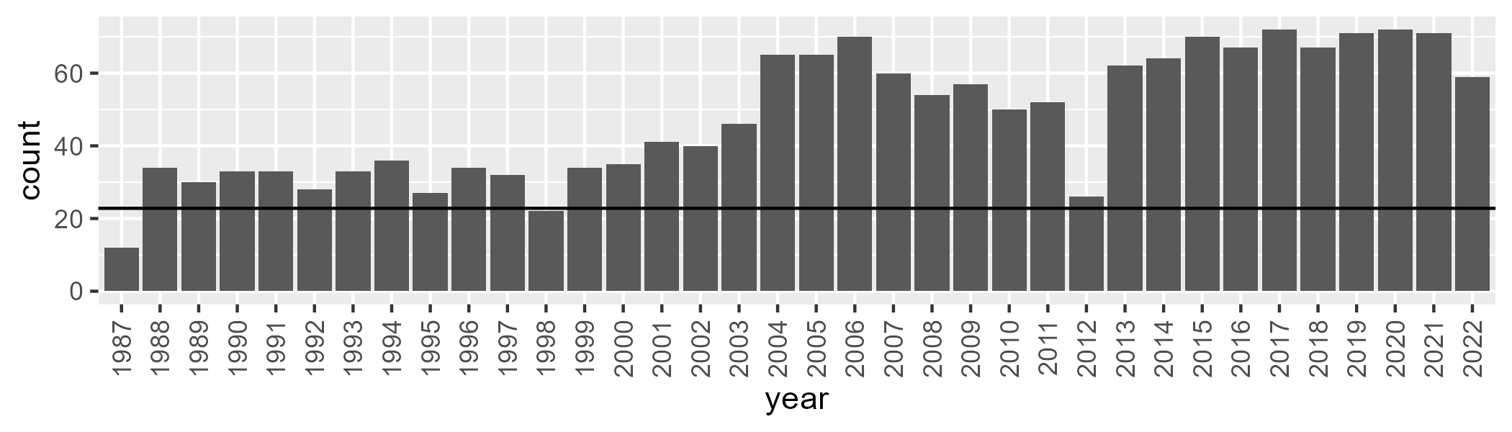

Number of samples: 1724

# QDAMGD0023

| Min. | 1st Qu. | Median | Mean | 3rd Qu. | Max. |
| --- | --- | --- | --- | --- | --- |
| 7.211733 | 20.89519 | 27.32394 | 27.86335 | 34.03347 | 55.7713 |

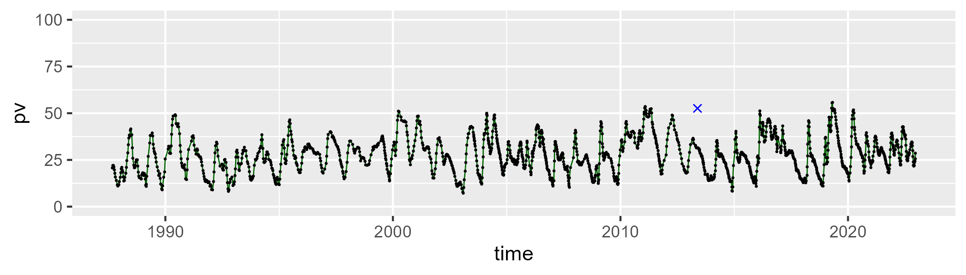

| Min. | 1st Qu. | Median | Mean | 3rd Qu. | Max. |
| --- | --- | --- | --- | --- | --- |
| 31.4194 | 47.28029 | 52.07986 | 52.68226 | 57.99532 | 74.91261 |

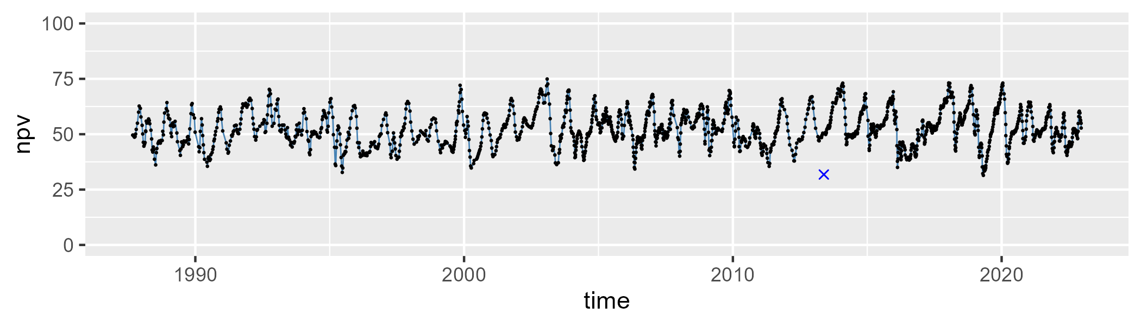

| Min. | 1st Qu. | Median | Mean | 3rd Qu. | Max. |
| --- | --- | --- | --- | --- | --- |
| 4.512556 | 14.78881 | 17.64083 | 18.07516 | 20.75743 | 35.82903 |

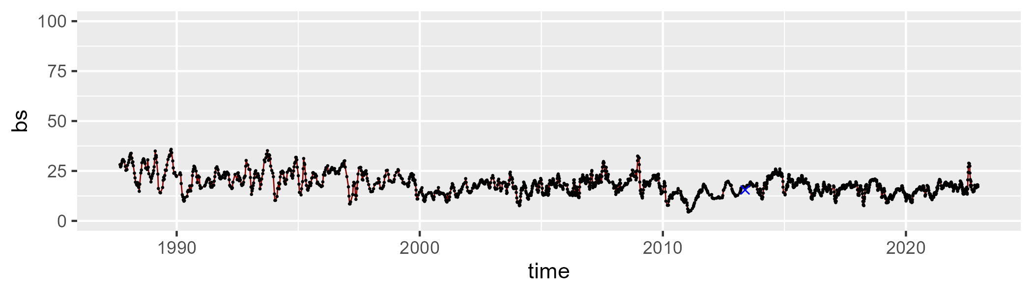

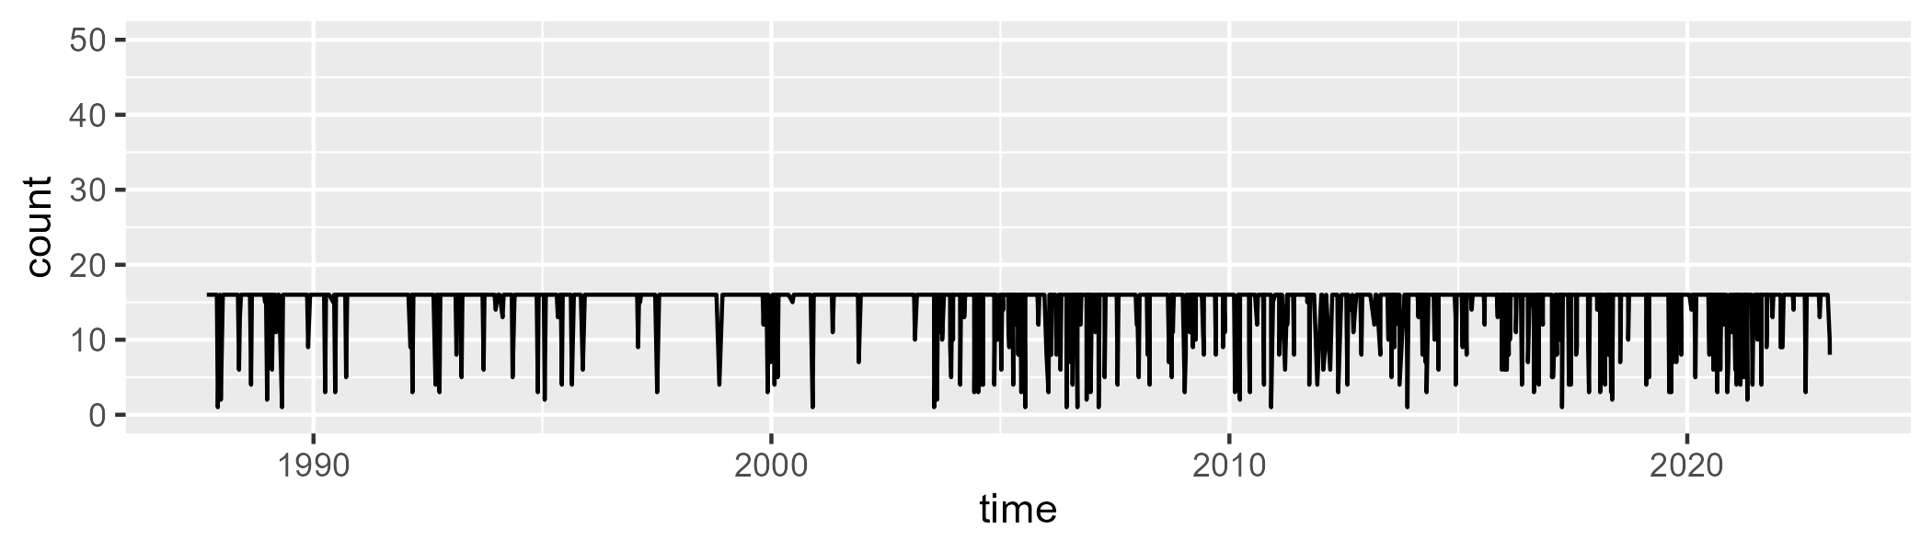

Min. : 1.00 1st Qu.:16.00 Median :16.00 Mean :14.83 3rd Qu.:16.00 Max. :16.00

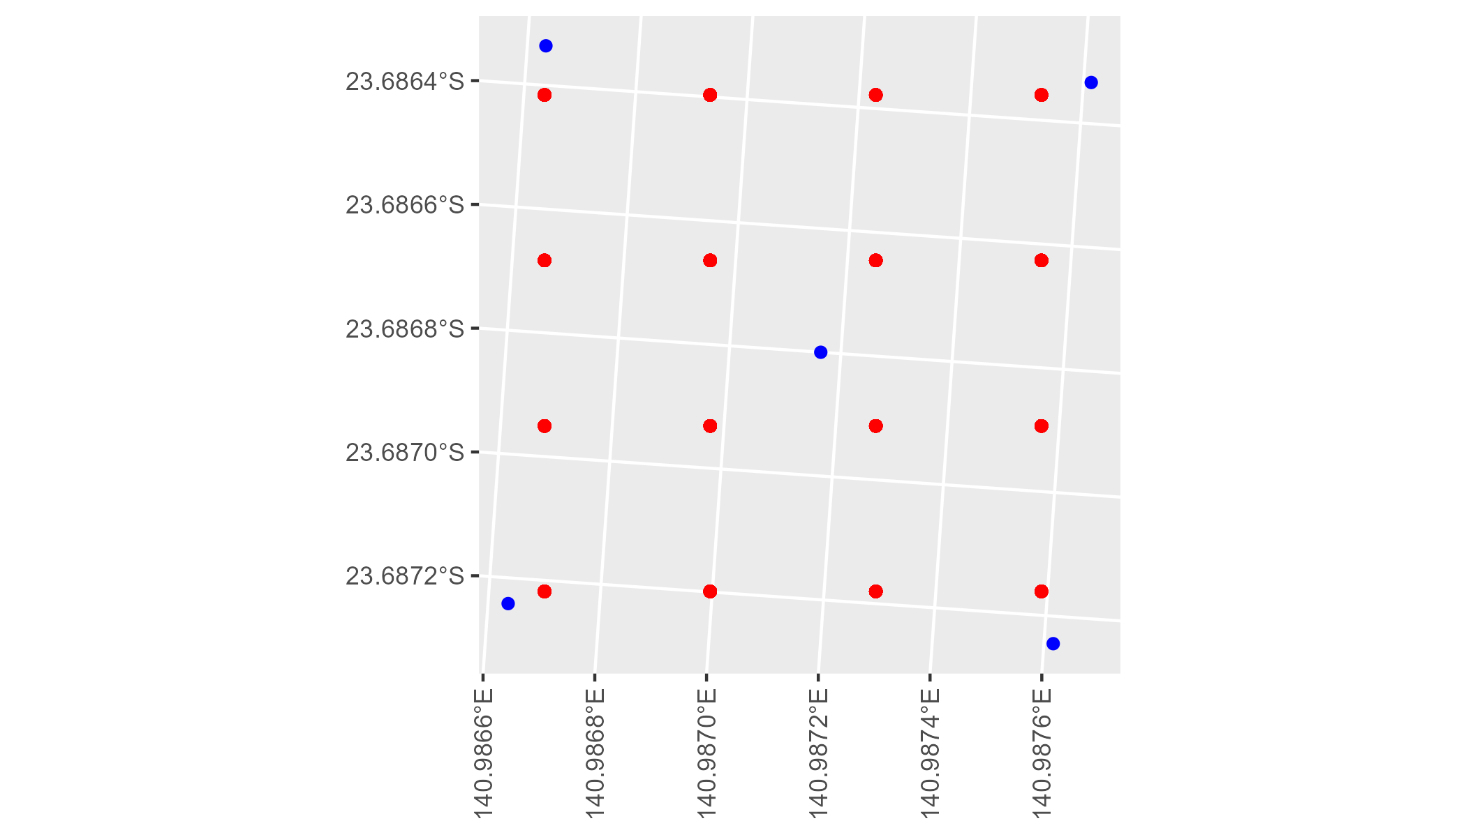

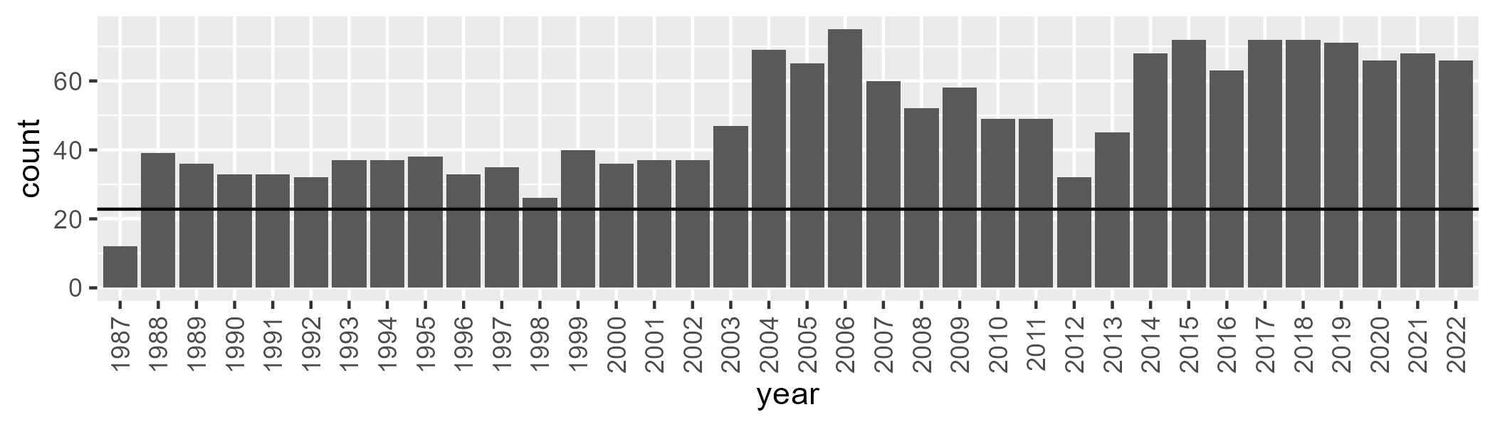

Number of samples: 1760

# QDAMGD0024

| Min. | 1st Qu. | Median | Mean | 3rd Qu. | Max. |
| --- | --- | --- | --- | --- | --- |
| 0 | 1.000088 | 2.149124 | 3.429708 | 4.421184 | 25.70266 |

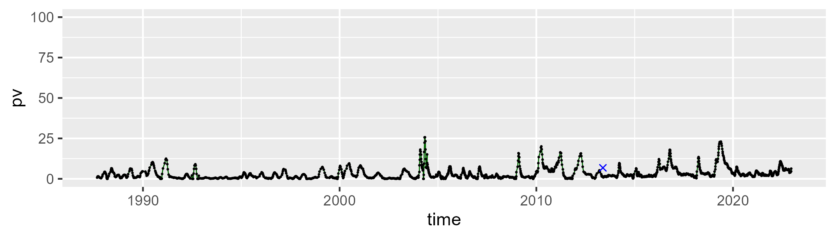

| Min. | 1st Qu. | Median | Mean | 3rd Qu. | Max. |
| --- | --- | --- | --- | --- | --- |
| 12.59318 | 33.01856 | 38.68368 | 39.03765 | 44.28295 | 64.76124 |

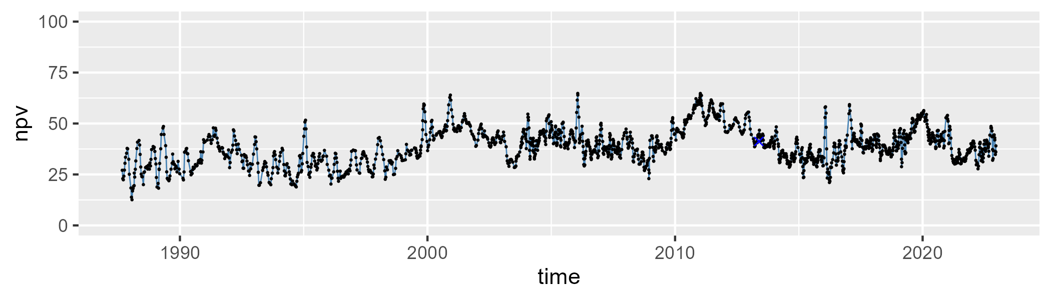

| Min. | 1st Qu. | Median | Mean | 3rd Qu. | Max. |
| --- | --- | --- | --- | --- | --- |
| 25.04887 | 50.68247 | 56.82255 | 56.16334 | 62.99652 | 81.66536 |

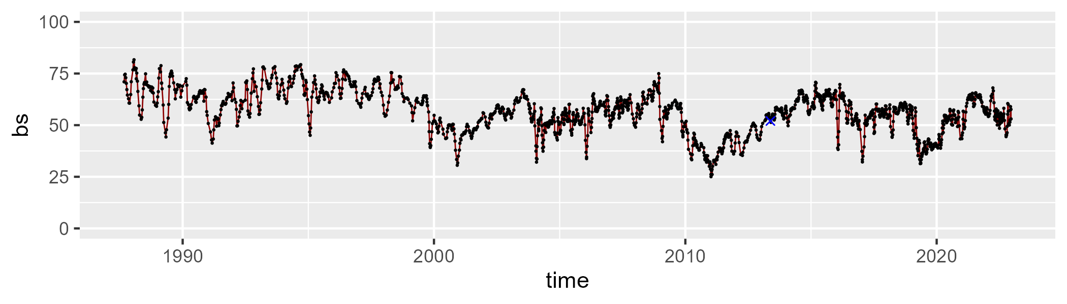

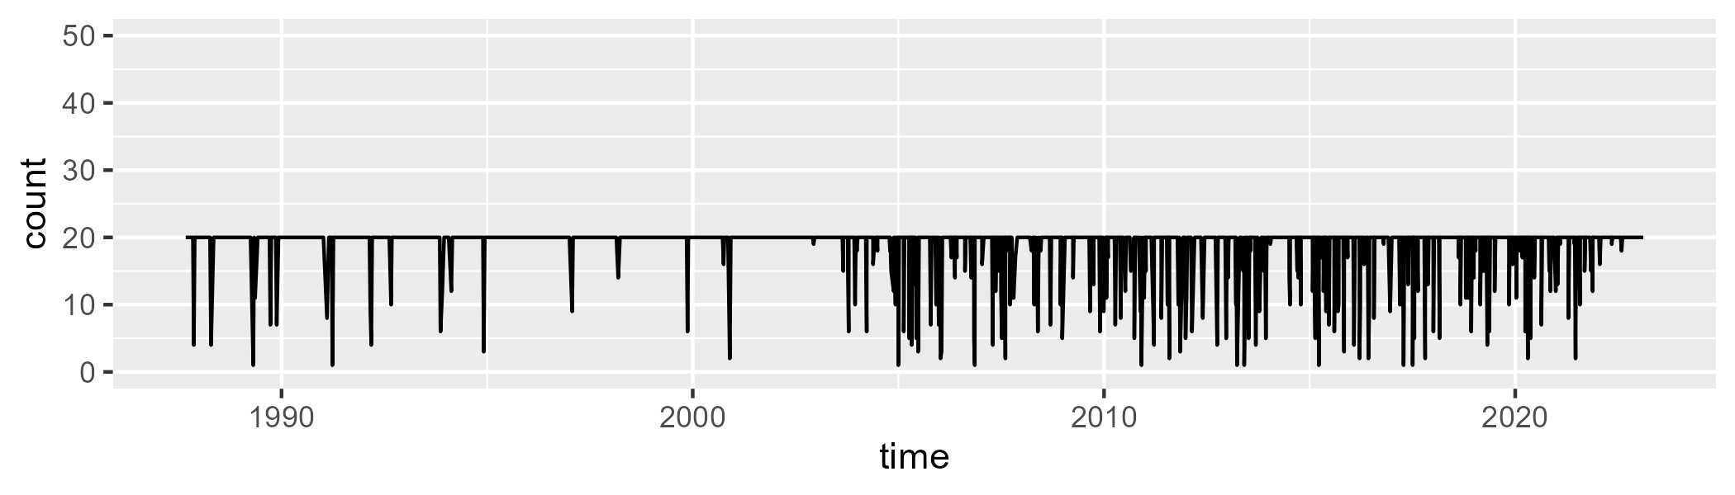

Min. : 1.00 1st Qu.:20.00 Median :20.00 Mean :18.87 3rd Qu.:20.00 Max. :20.00

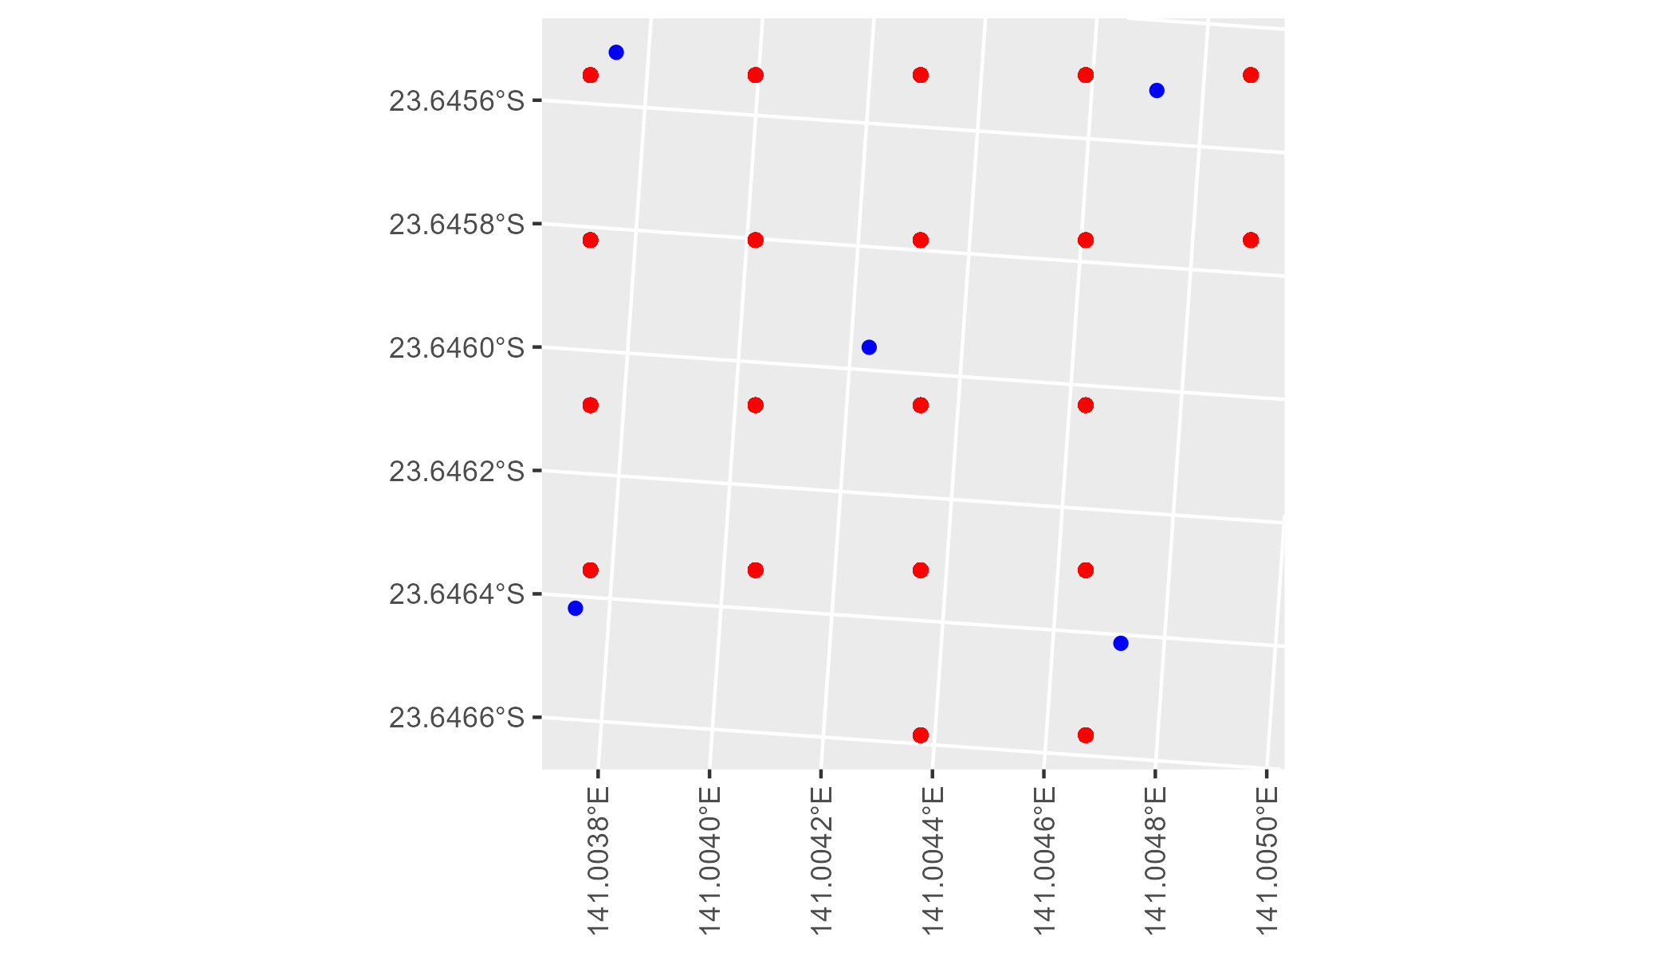

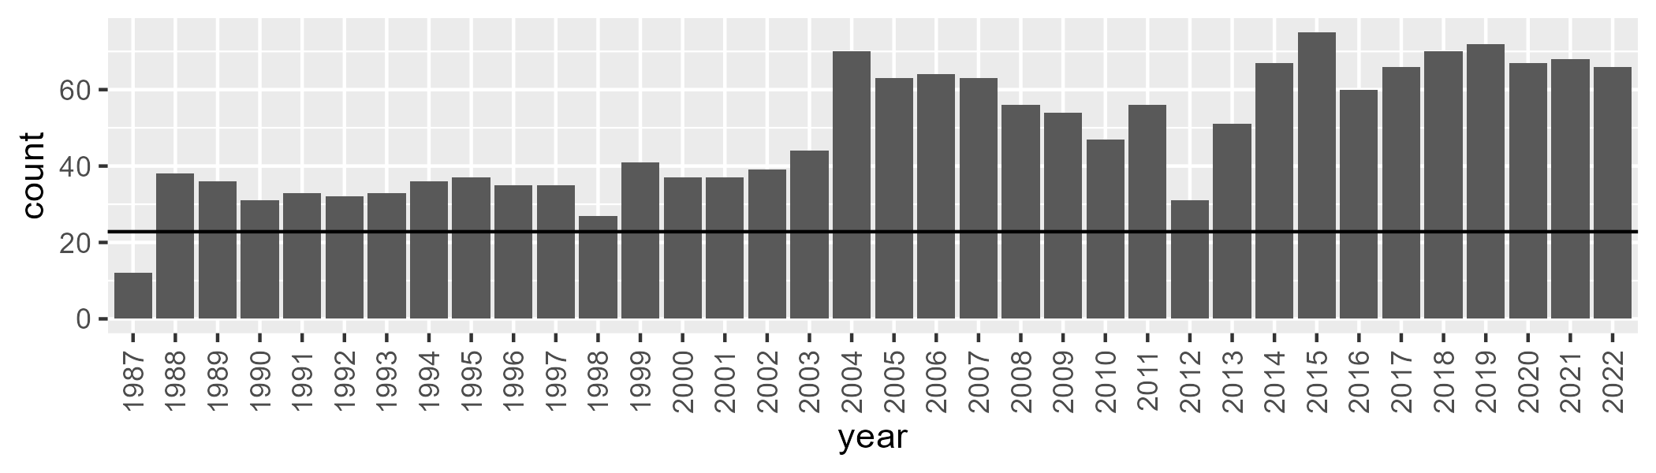

Number of samples: 1749

# QDAMGD0025

| Min. | 1st Qu. | Median | Mean | 3rd Qu. | Max. |
| --- | --- | --- | --- | --- | --- |
| 3.429212 | 15.56779 | 20.09769 | 20.88542 | 25.84173 | 43.03479 |

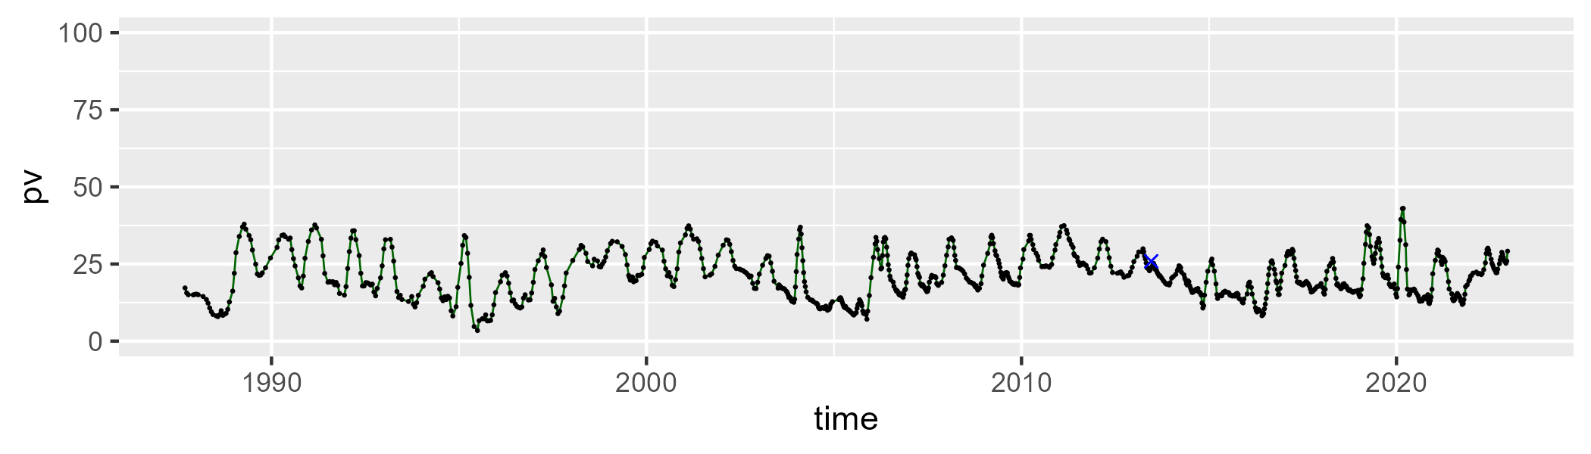

| Min. | 1st Qu. | Median | Mean | 3rd Qu. | Max. |
| --- | --- | --- | --- | --- | --- |
| 34.92248 | 47.49549 | 51.0229 | 51.15504 | 54.91002 | 68.71354 |

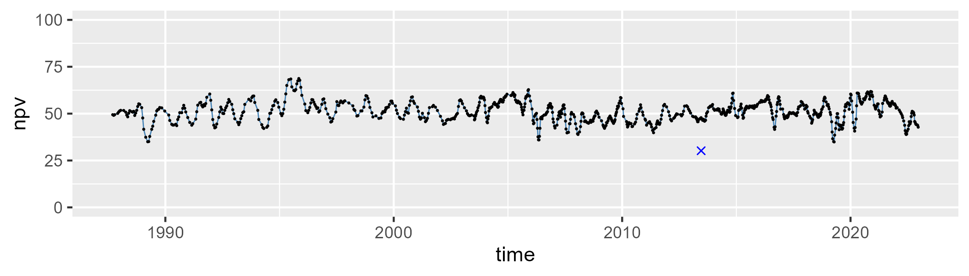

| Min. | 1st Qu. | Median | Mean | 3rd Qu. | Max. |
| --- | --- | --- | --- | --- | --- |
| 10.82374 | 23.63832 | 27.06635 | 26.66703 | 30.04196 | 39.94976 |

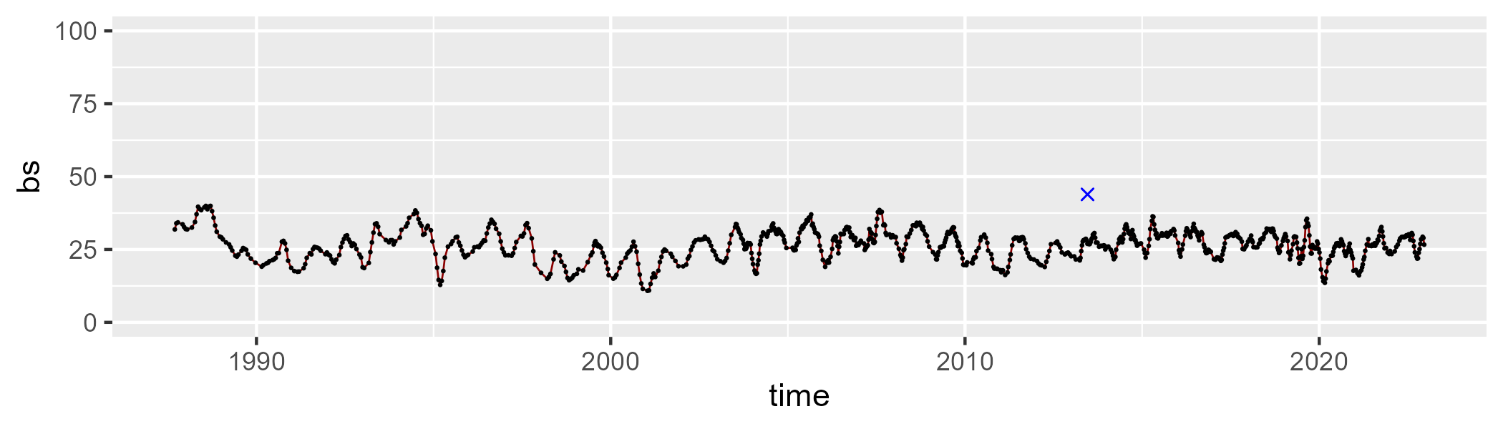

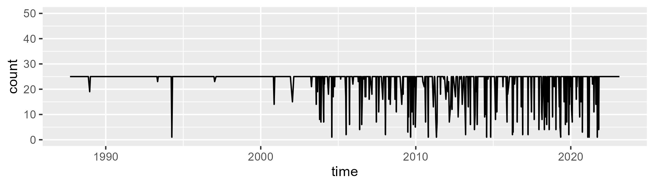

Min. : 1.00 1st Qu.:25.00 Median :25.00 Mean :23.11 3rd Qu.:25.00 Max. :25.00

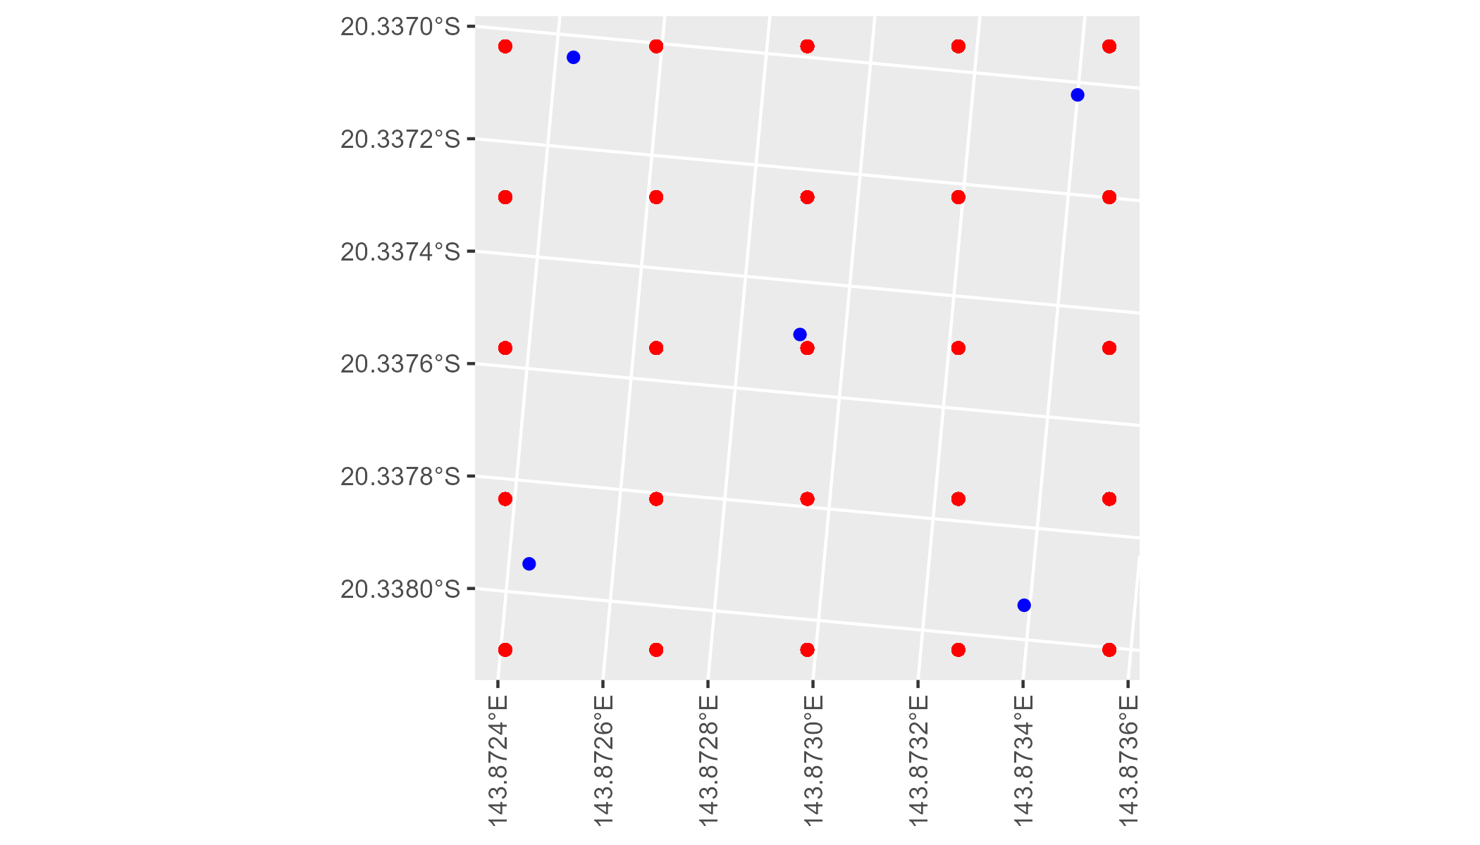

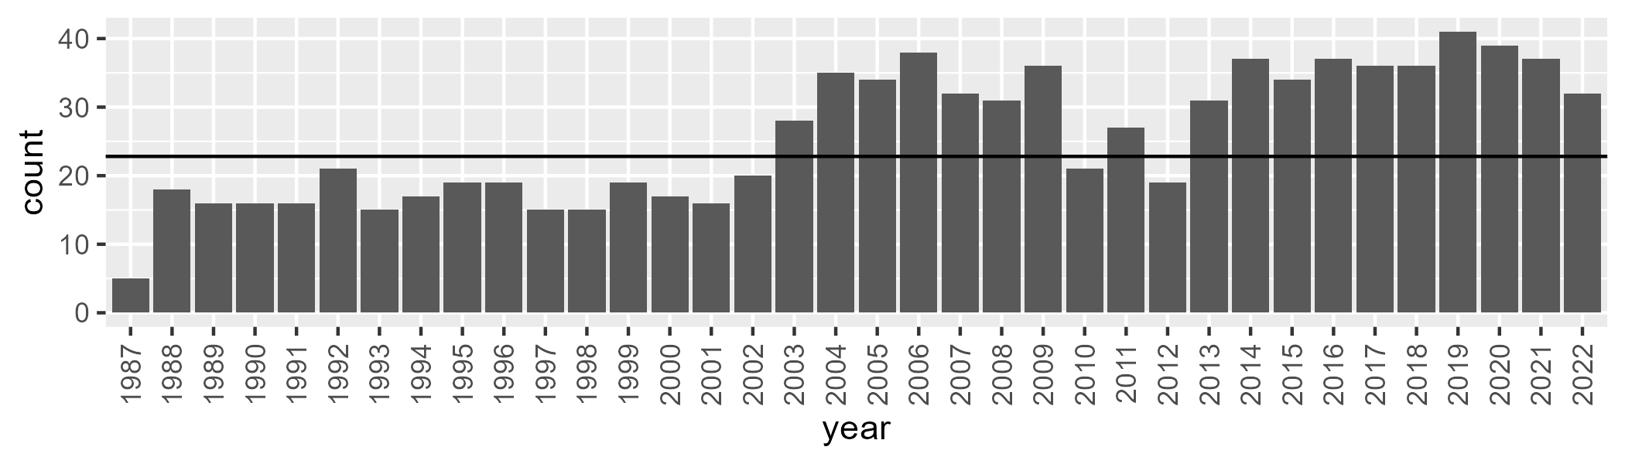

Number of samples: 925

# QDAMGD0026

| Min. | 1st Qu. | Median | Mean | 3rd Qu. | Max. |
| --- | --- | --- | --- | --- | --- |
| 5.939962 | 14.77631 | 18.42609 | 19.30432 | 22.89286 | 37.72322 |

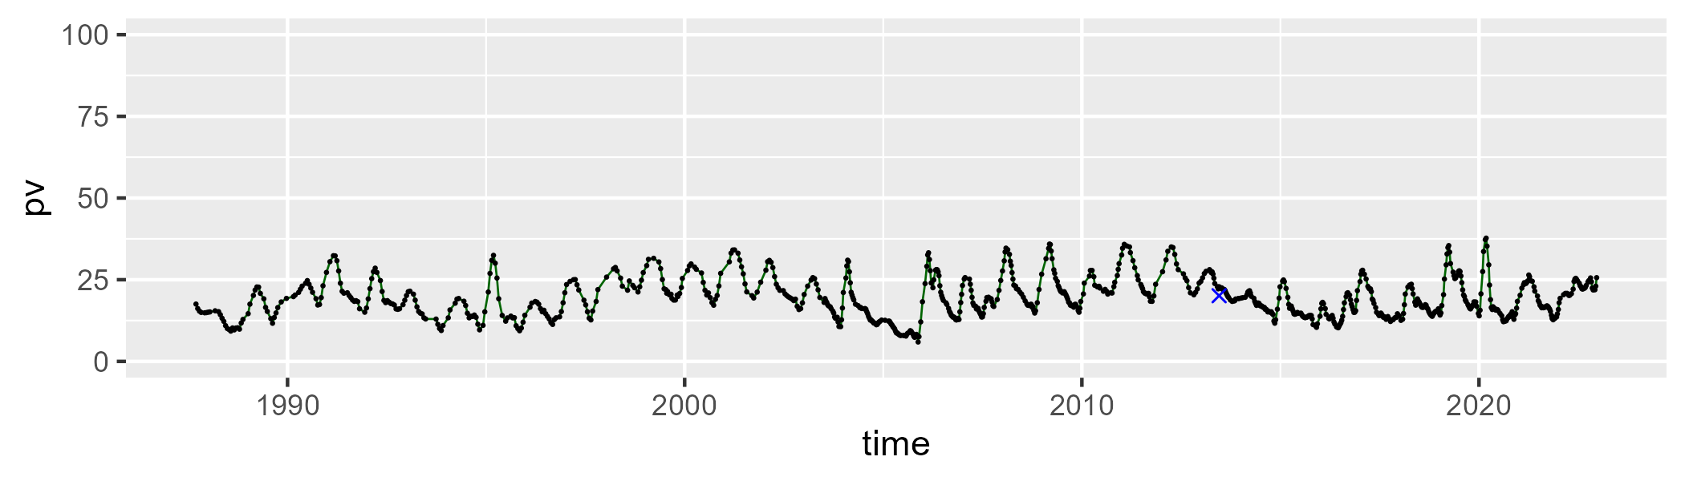

| Min. | 1st Qu. | Median | Mean | 3rd Qu. | Max. |
| --- | --- | --- | --- | --- | --- |
| 36.41577 | 47.05982 | 49.83863 | 49.8824 | 53.05221 | 64.47345 |

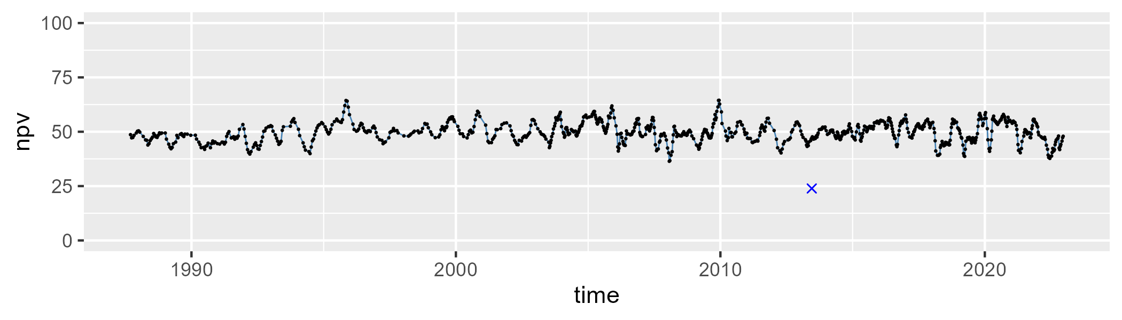

| Min. | 1st Qu. | Median | Mean | 3rd Qu. | Max. |
| --- | --- | --- | --- | --- | --- |
| 14.83725 | 26.07095 | 29.97276 | 29.50952 | 33.19312 | 41.82222 |

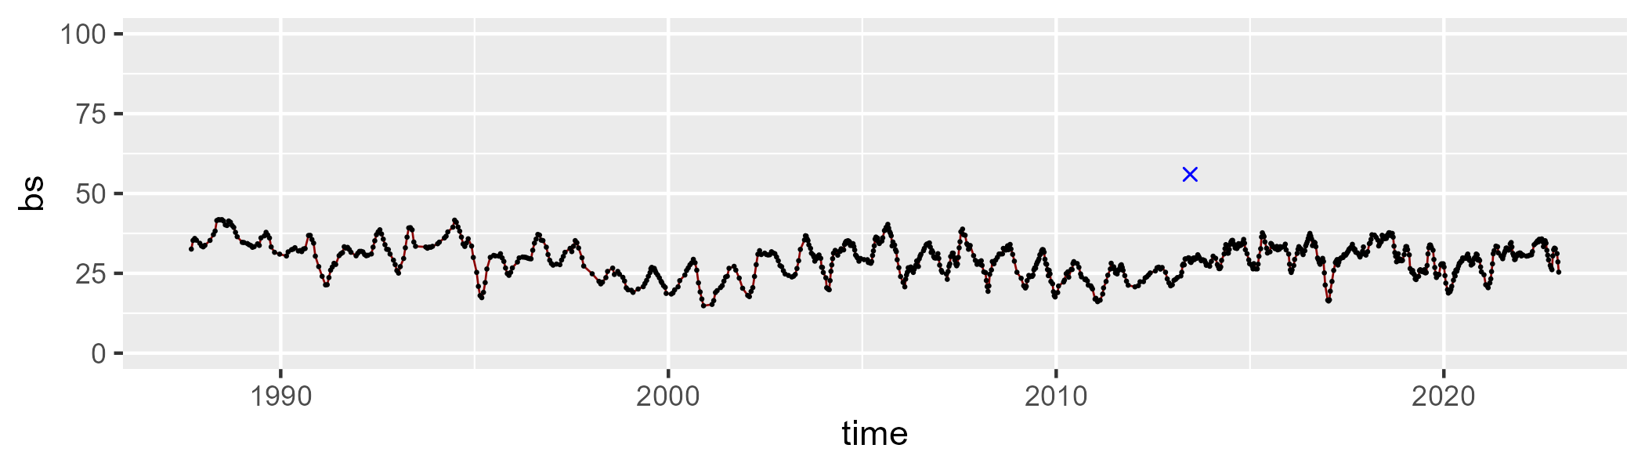

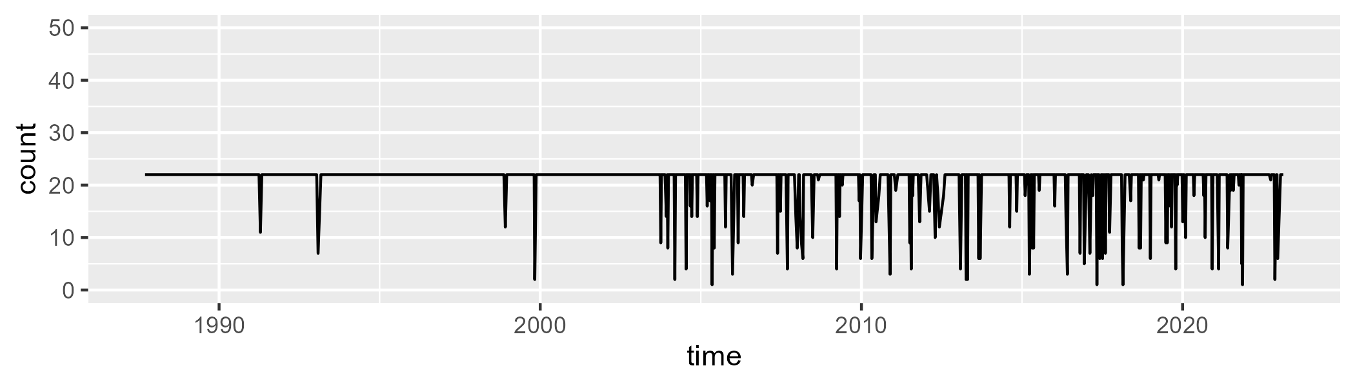

Min. : 1.00 1st Qu.:22.00 Median :22.00 Mean :20.71 3rd Qu.:22.00 Max. :22.00

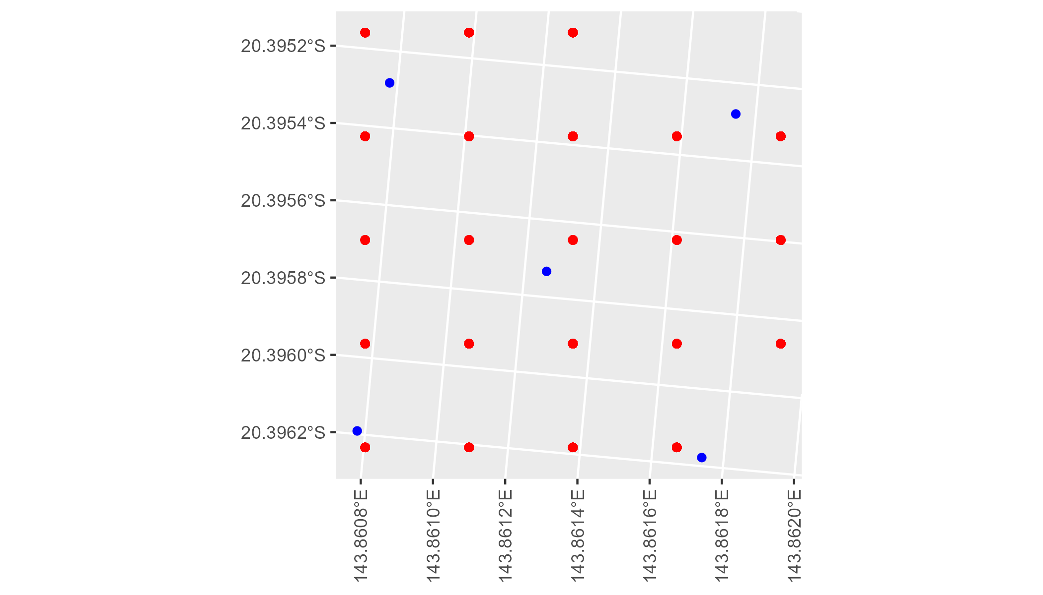

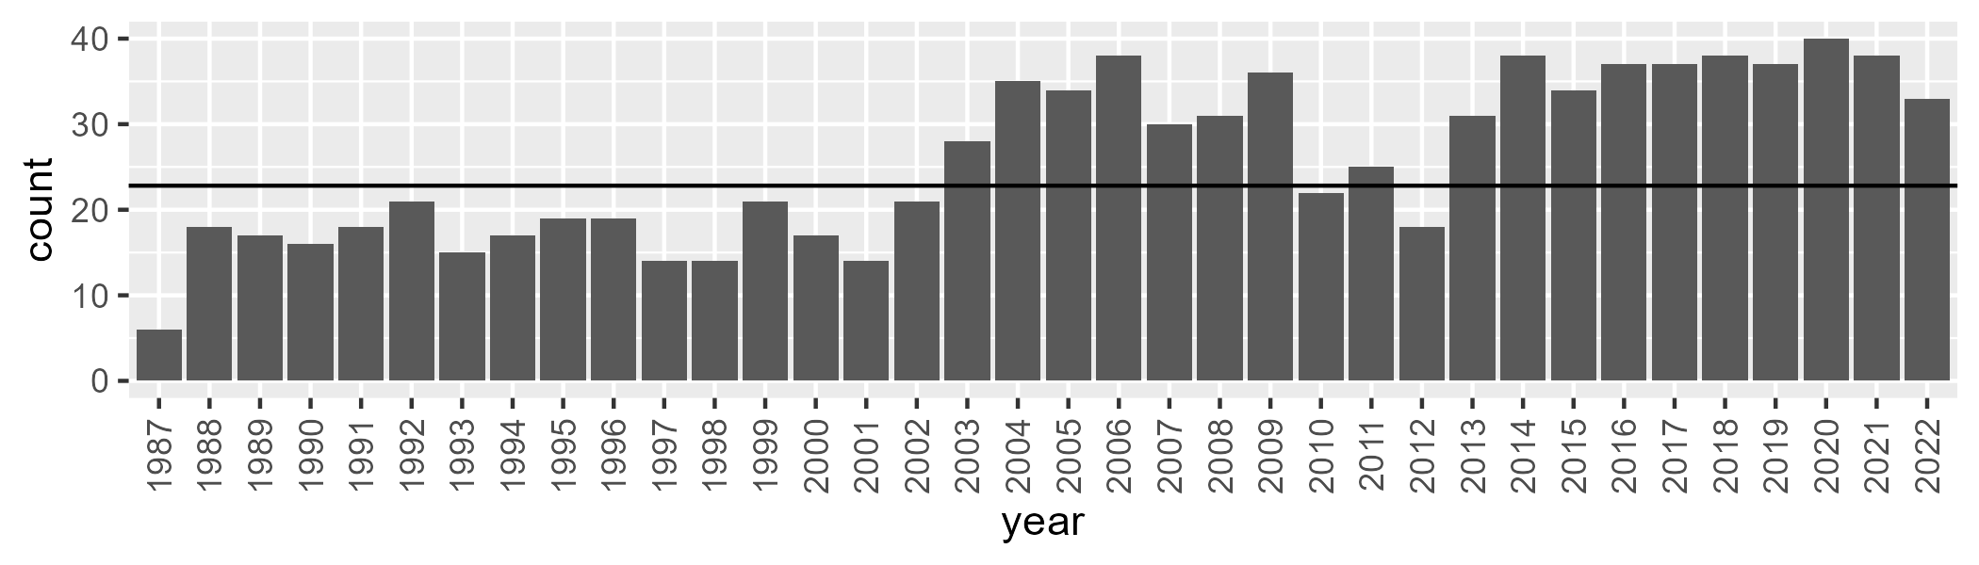

Number of samples: 927

# QDAMGD0027

| Min. | 1st Qu. | Median | Mean | 3rd Qu. | Max. |
| --- | --- | --- | --- | --- | --- |
| 0 | 1.633269 | 4.325373 | 9.843871 | 13.3291 | 53.758 |

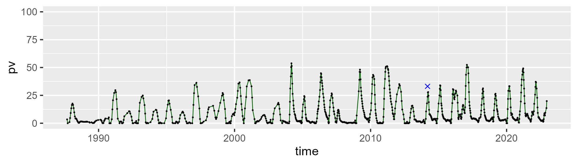

| Min. | 1st Qu. | Median | Mean | 3rd Qu. | Max. |
| --- | --- | --- | --- | --- | --- |
| 25.0027 | 49.351 | 56.85587 | 57.72472 | 65.9007 | 98.60532 |

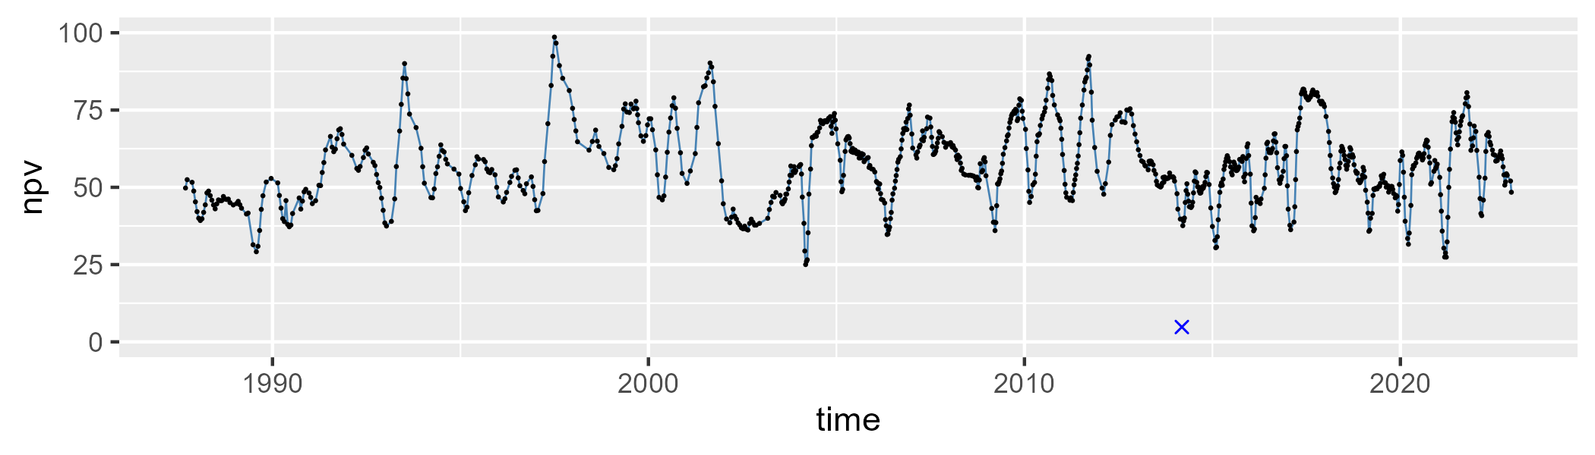

| Min. | 1st Qu. | Median | Mean | 3rd Qu. | Max. |
| --- | --- | --- | --- | --- | --- |
| 1.164187 | 21.43739 | 31.11111 | 31.22582 | 41.3637 | 69.66446 |

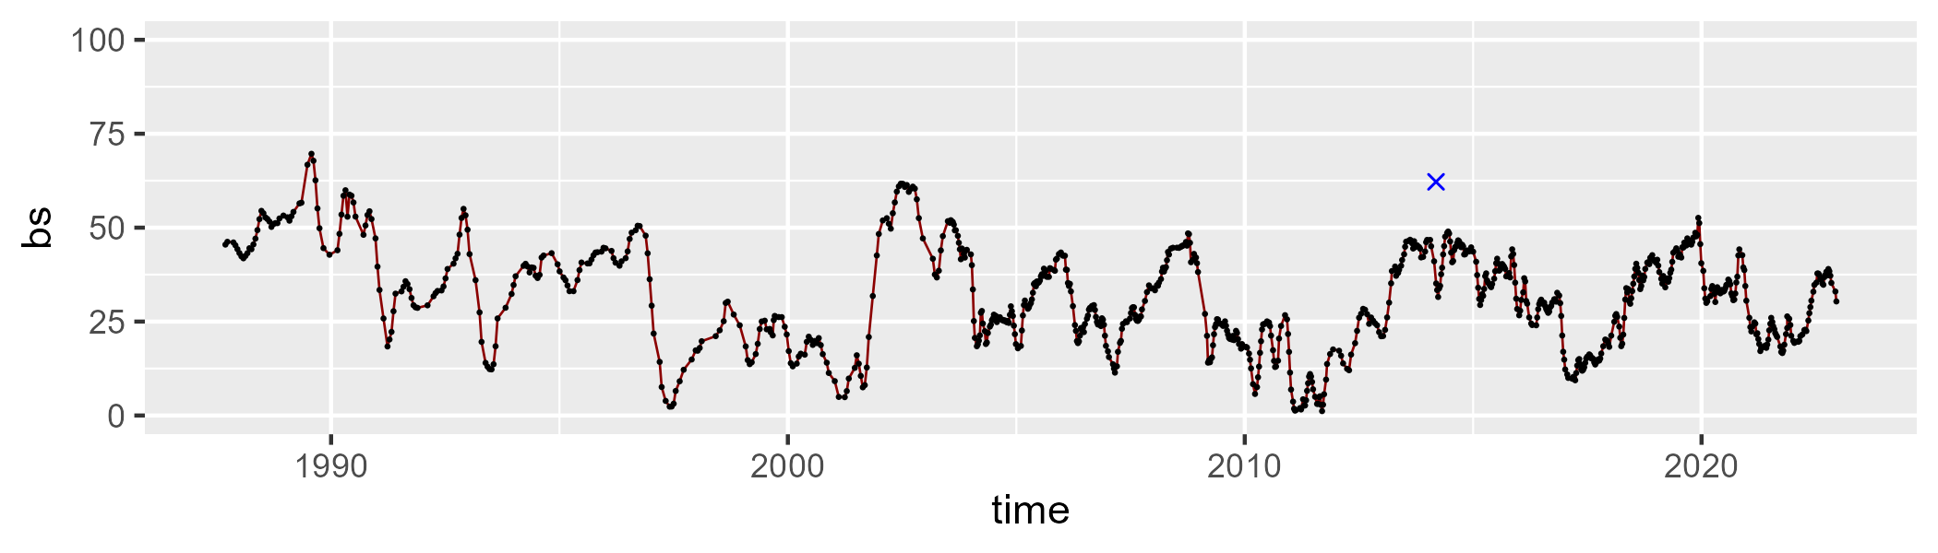

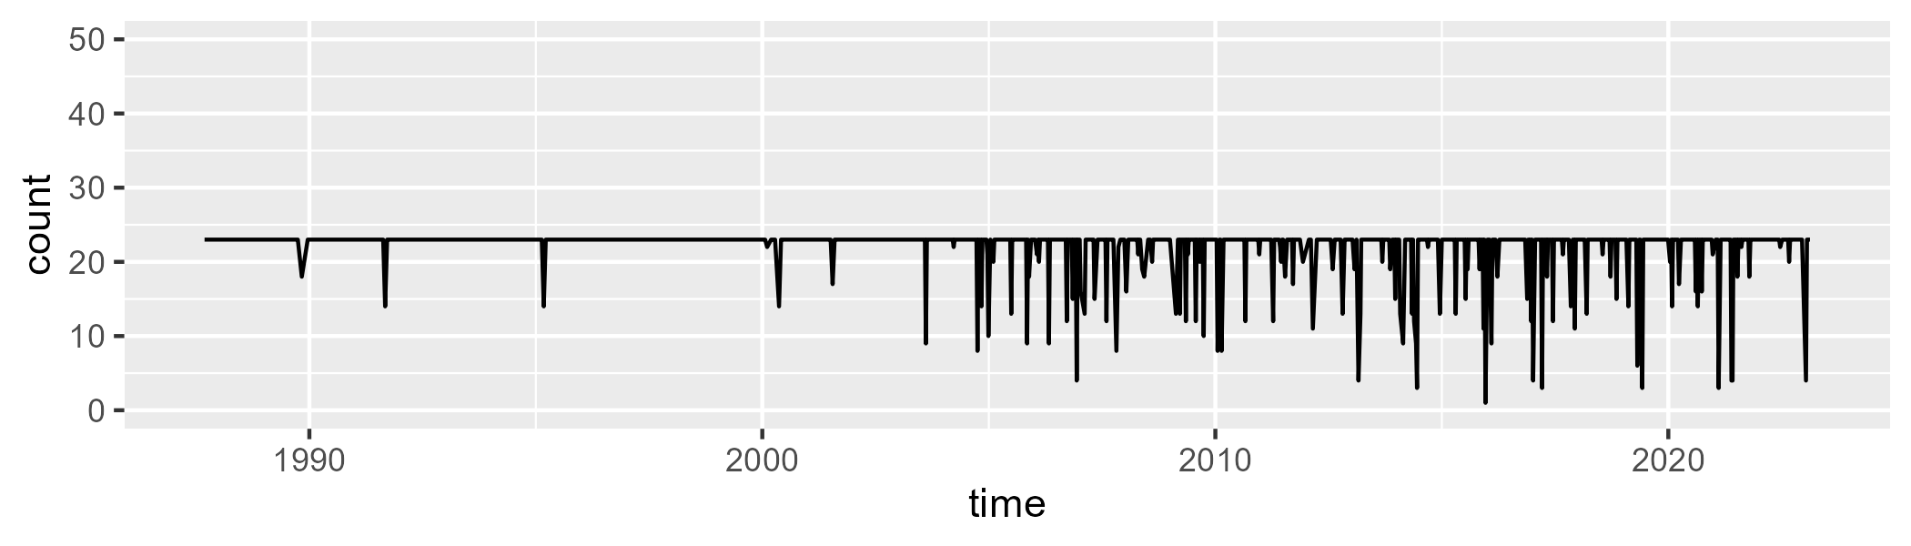

Min. : 1 1st Qu.:23 Median :23 Mean :22 3rd Qu.:23 Max. :23

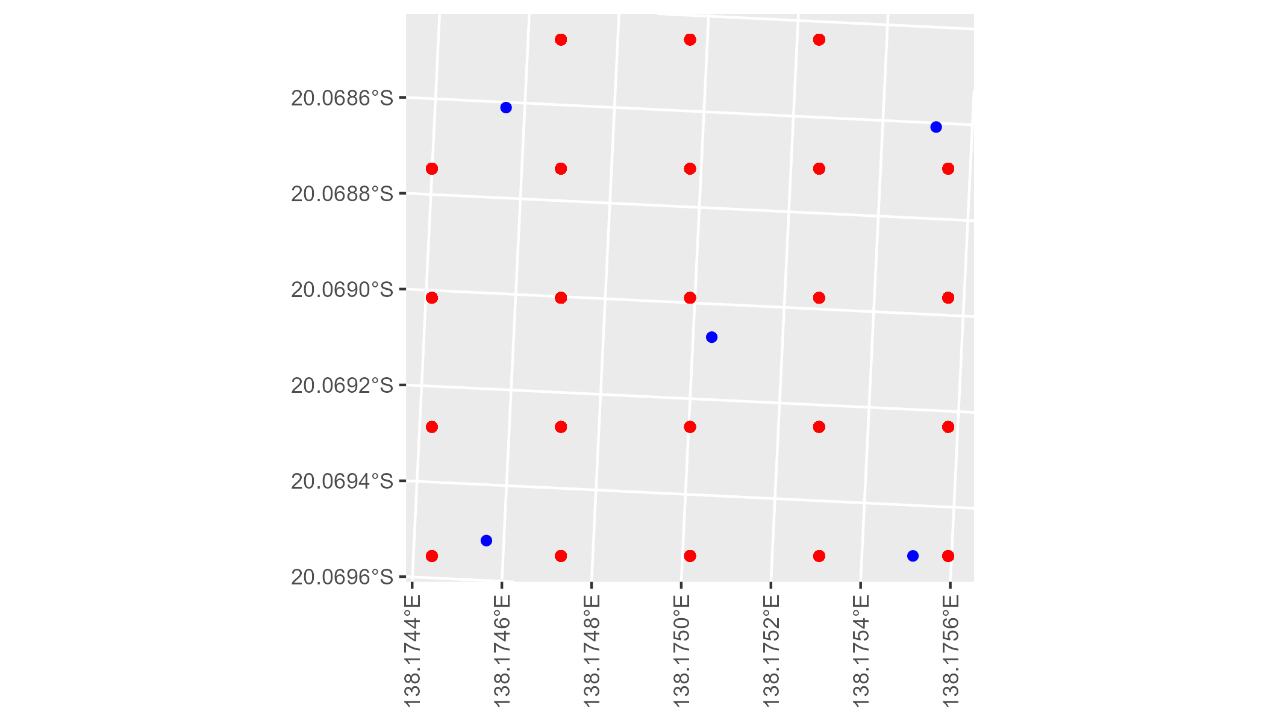

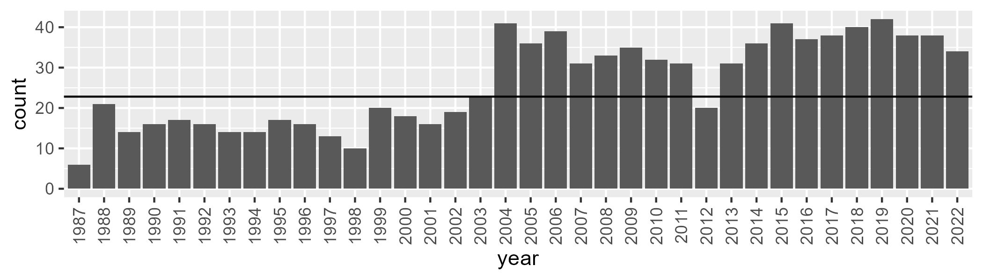

Number of samples: 943

# QDAMGD0028

| Min. | 1st Qu. | Median | Mean | 3rd Qu. | Max. |
| --- | --- | --- | --- | --- | --- |
| 0 | 0.7634994 | 2.822043 | 8.648336 | 13.64592 | 50.32567 |

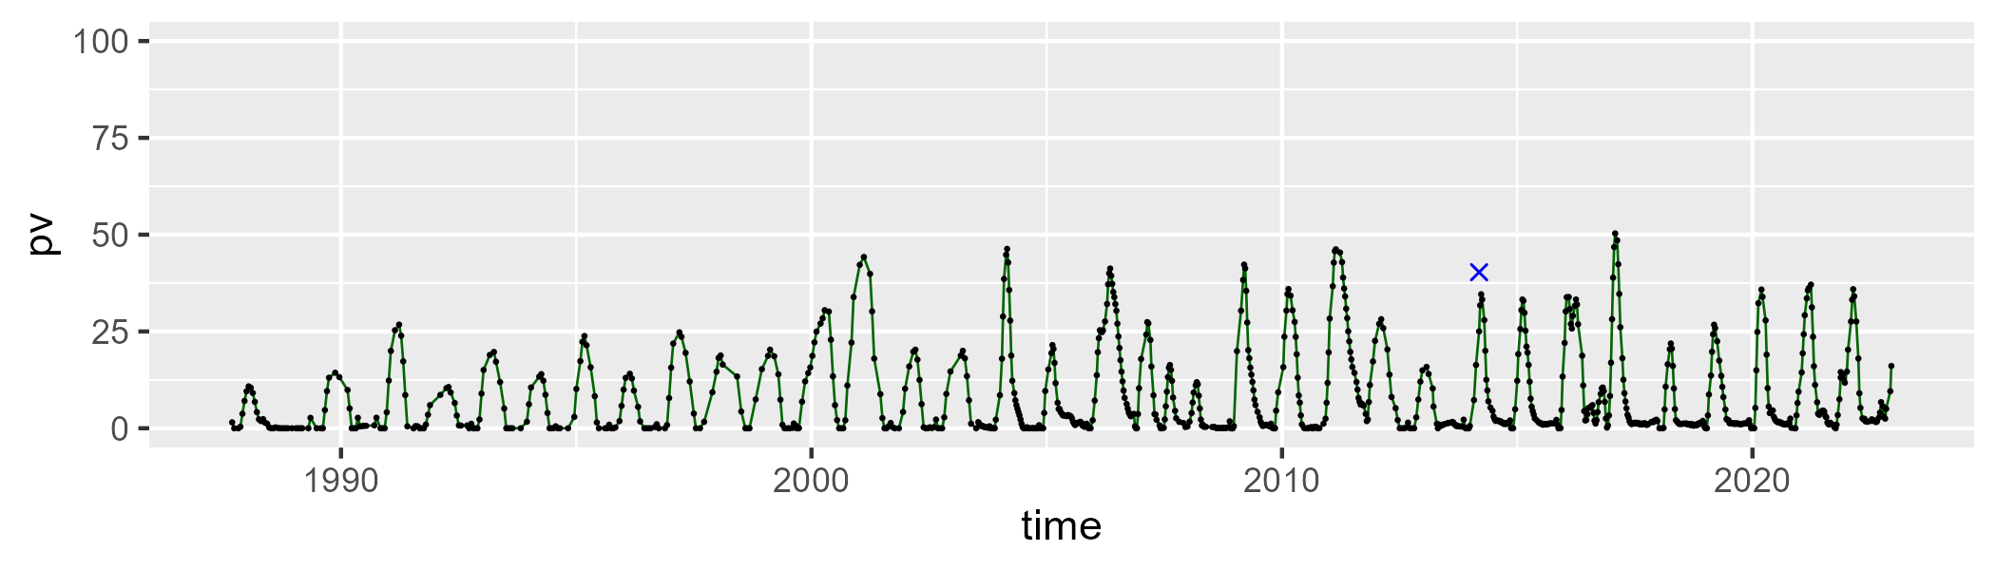

| Min. | 1st Qu. | Median | Mean | 3rd Qu. | Max. |
| --- | --- | --- | --- | --- | --- |
| 32.13005 | 56.46999 | 65.01016 | 64.29806 | 71.5042 | 96.12059 |

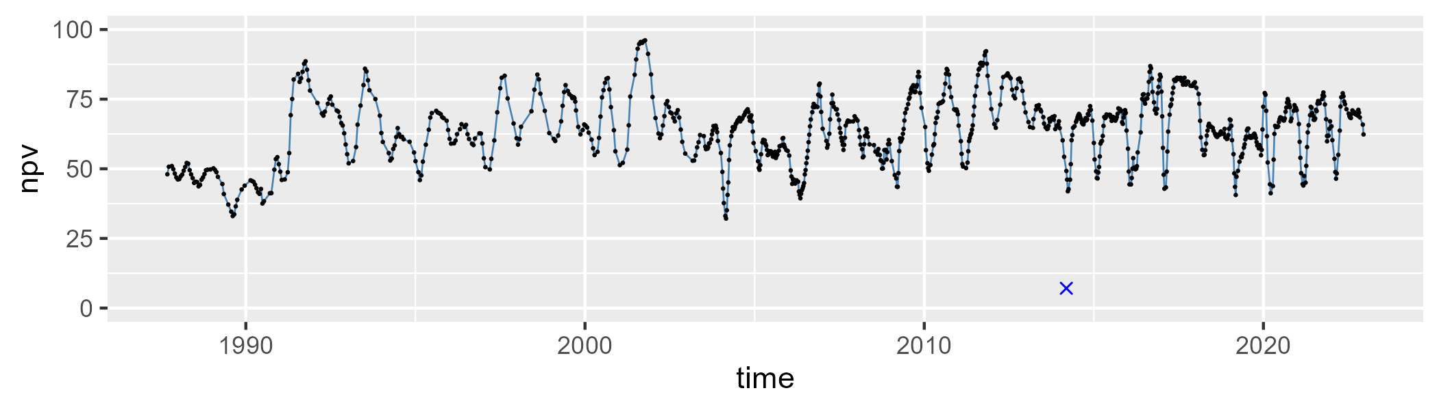

| Min. | 1st Qu. | Median | Mean | 3rd Qu. | Max. |
| --- | --- | --- | --- | --- | --- |
| 1.020969 | 18.50748 | 25.716 | 26.06621 | 32.01939 | 68.45153 |

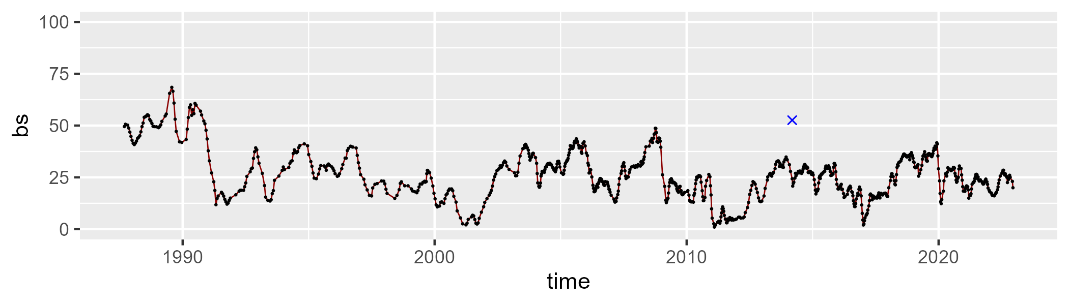

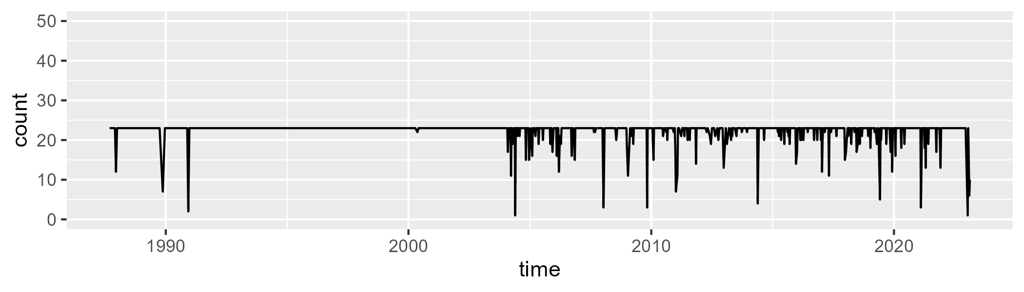

Min. : 1.00 1st Qu.:23.00 Median :23.00 Mean :22.27 3rd Qu.:23.00 Max. :23.00

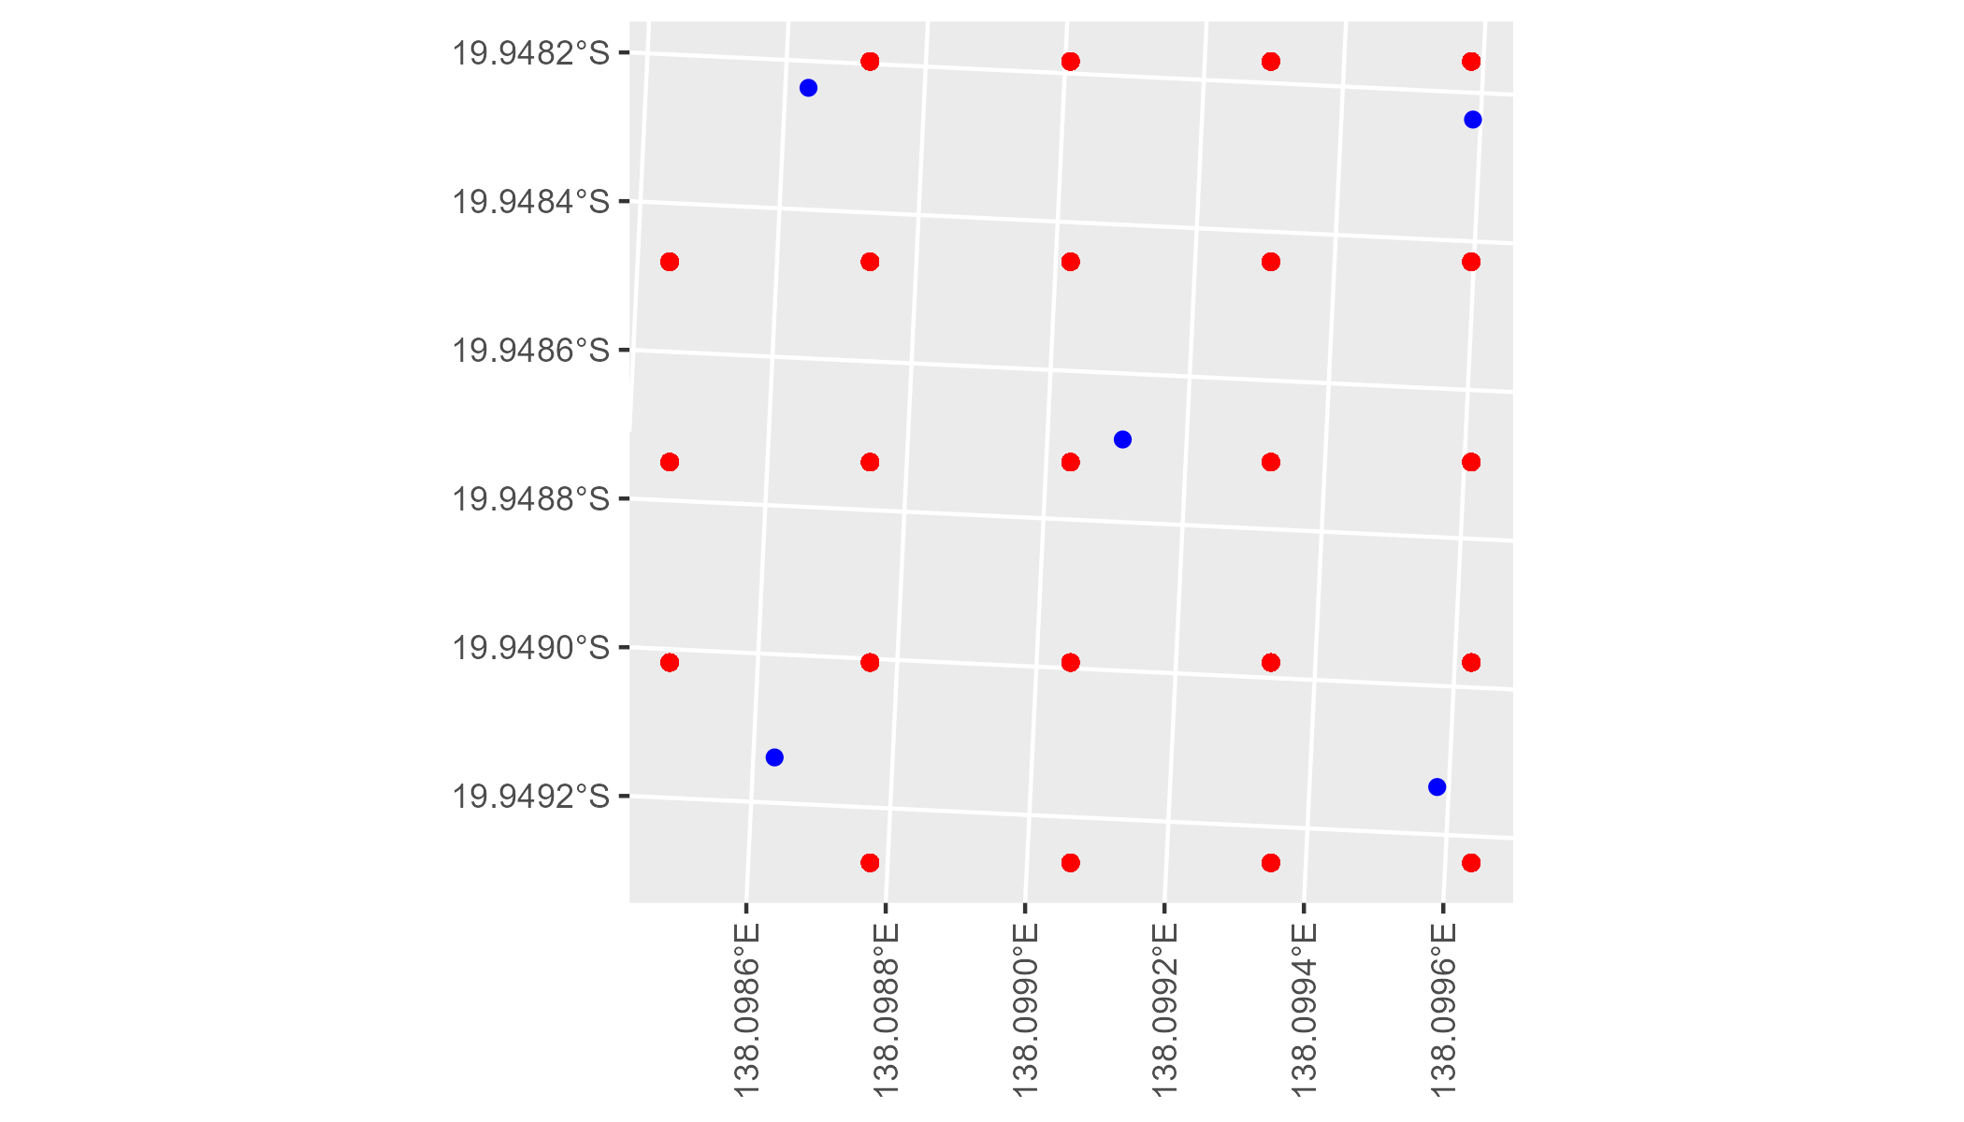

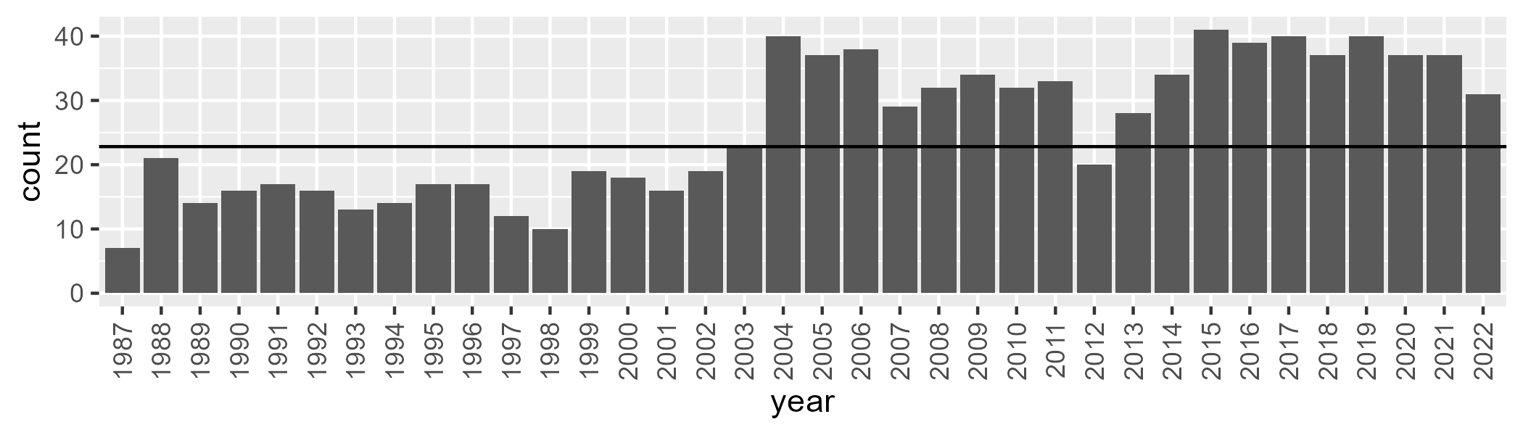

Number of samples: 928

# QDAMII0001

| Min. | 1st Qu. | Median | Mean | 3rd Qu. | Max. |
| --- | --- | --- | --- | --- | --- |
| 0.4205831 | 10.43534 | 15.32656 | 18.35733 | 24.44506 | 56.8162 |

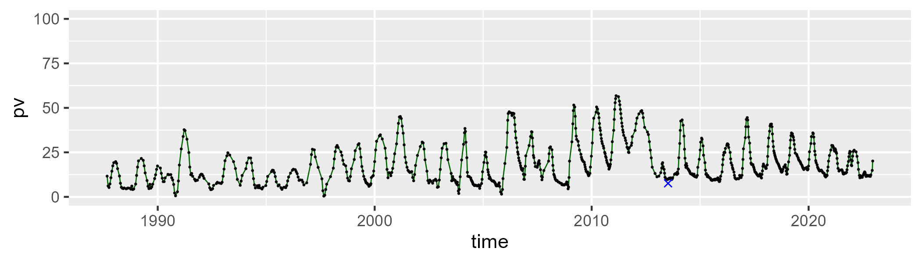

| Min. | 1st Qu. | Median | Mean | 3rd Qu. | Max. |
| --- | --- | --- | --- | --- | --- |
| 32.24 | 41.83132 | 47.27975 | 49.01957 | 54.8873 | 75.08523 |

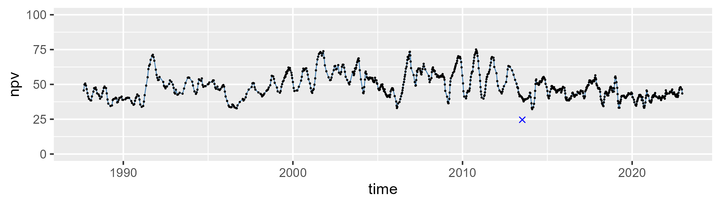

| Min. | 1st Qu. | Median | Mean | 3rd Qu. | Max. |
| --- | --- | --- | --- | --- | --- |
| 0.9596028 | 22.44945 | 32.74392 | 31.20817 | 40.38606 | 57.3514 |

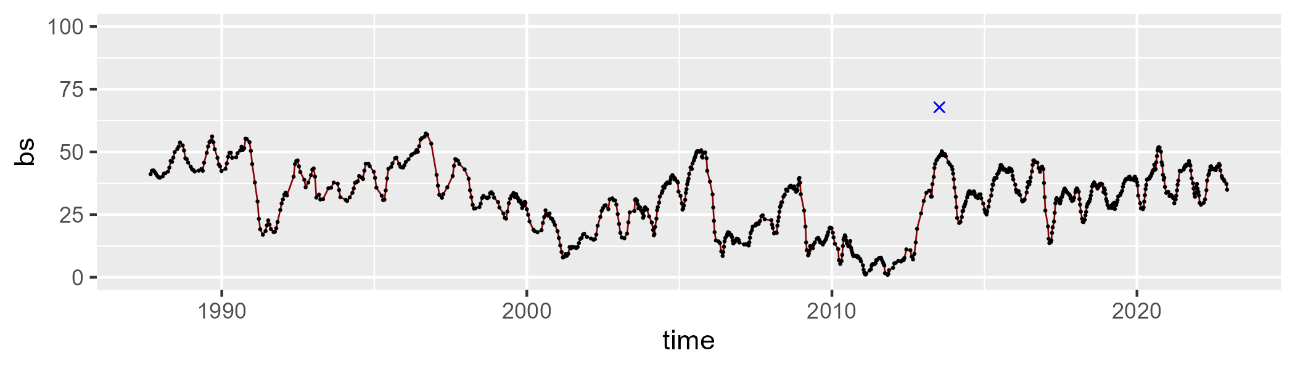

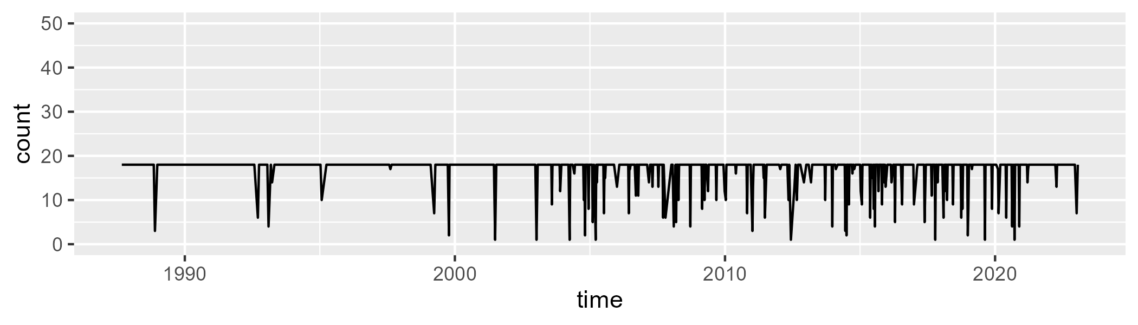

Min. : 1.00 1st Qu.:18.00 Median :18.00 Mean :16.95 3rd Qu.:18.00 Max. :18.00

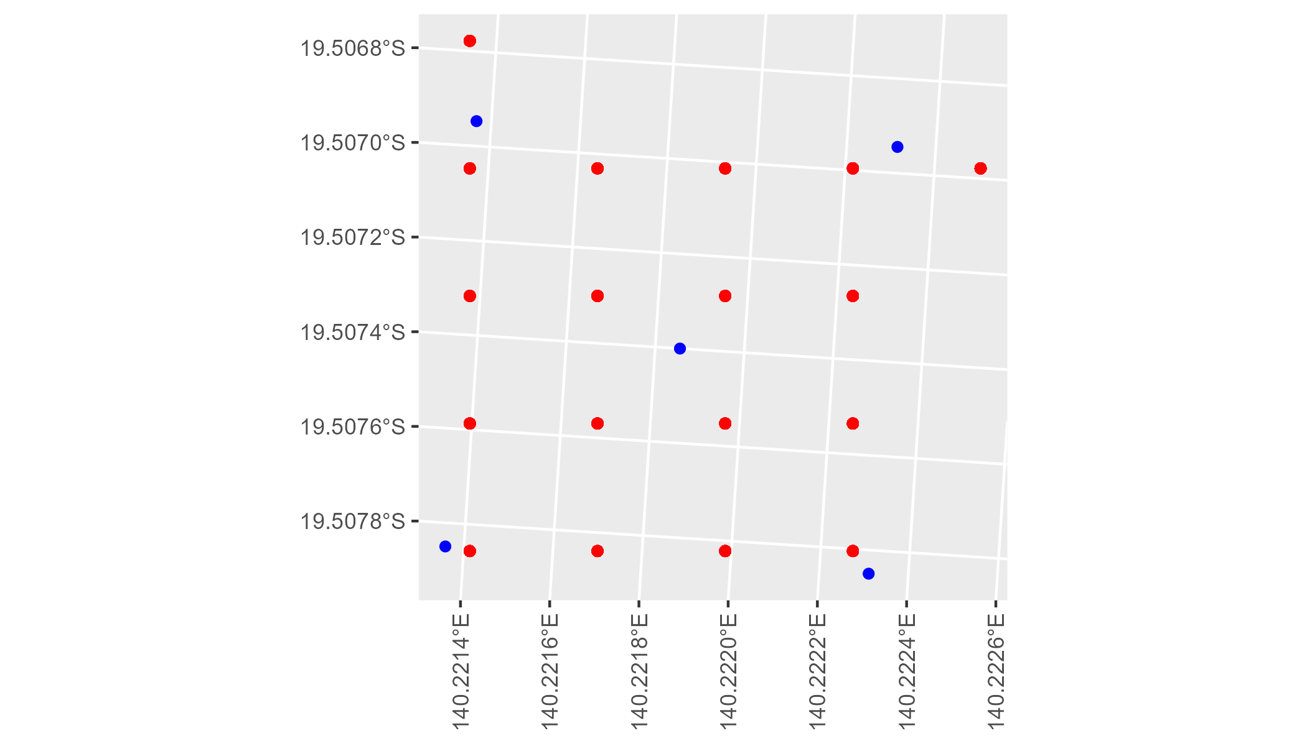

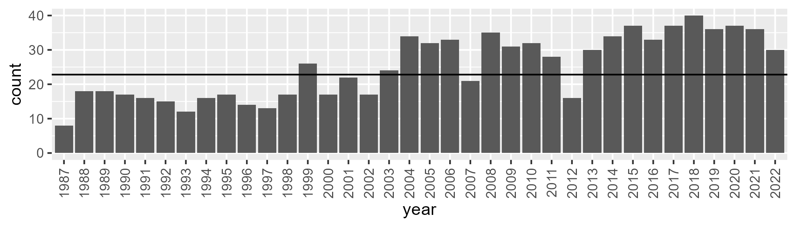

Number of samples: 899

# QDAMII0002

| Min. | 1st Qu. | Median | Mean | 3rd Qu. | Max. |
| --- | --- | --- | --- | --- | --- |
| 0 | 7.286541 | 12.55481 | 14.9955 | 20.75417 | 49.55403 |

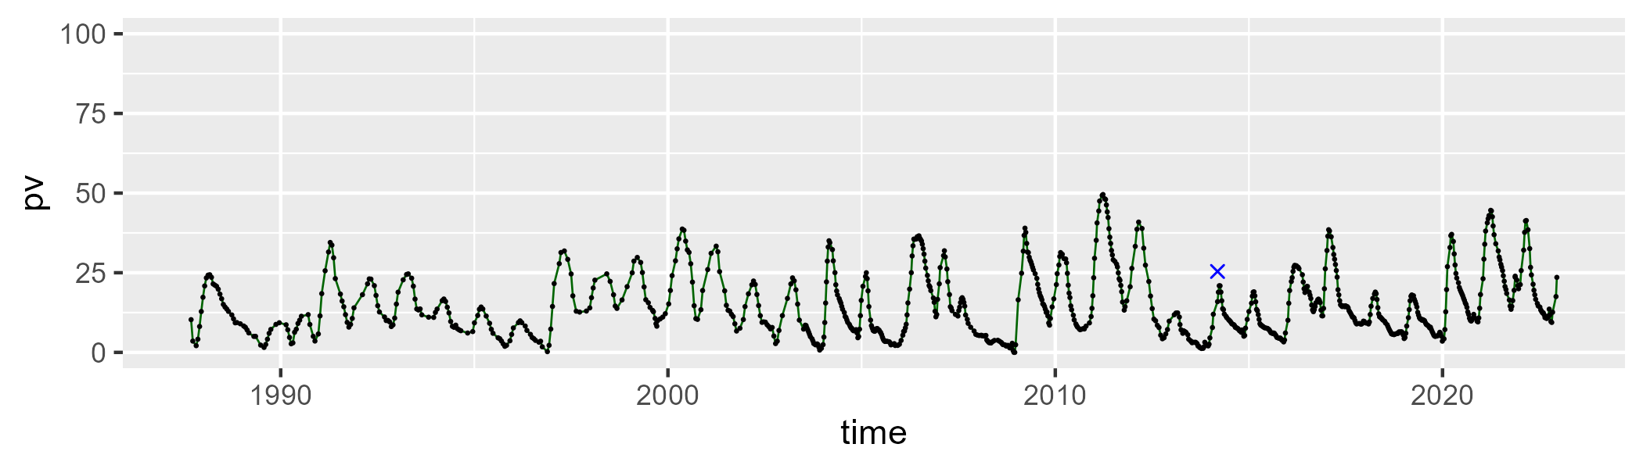

| Min. | 1st Qu. | Median | Mean | 3rd Qu. | Max. |
| --- | --- | --- | --- | --- | --- |
| 37.39687 | 50.36647 | 56.95525 | 56.57011 | 62.3211 | 78.39468 |

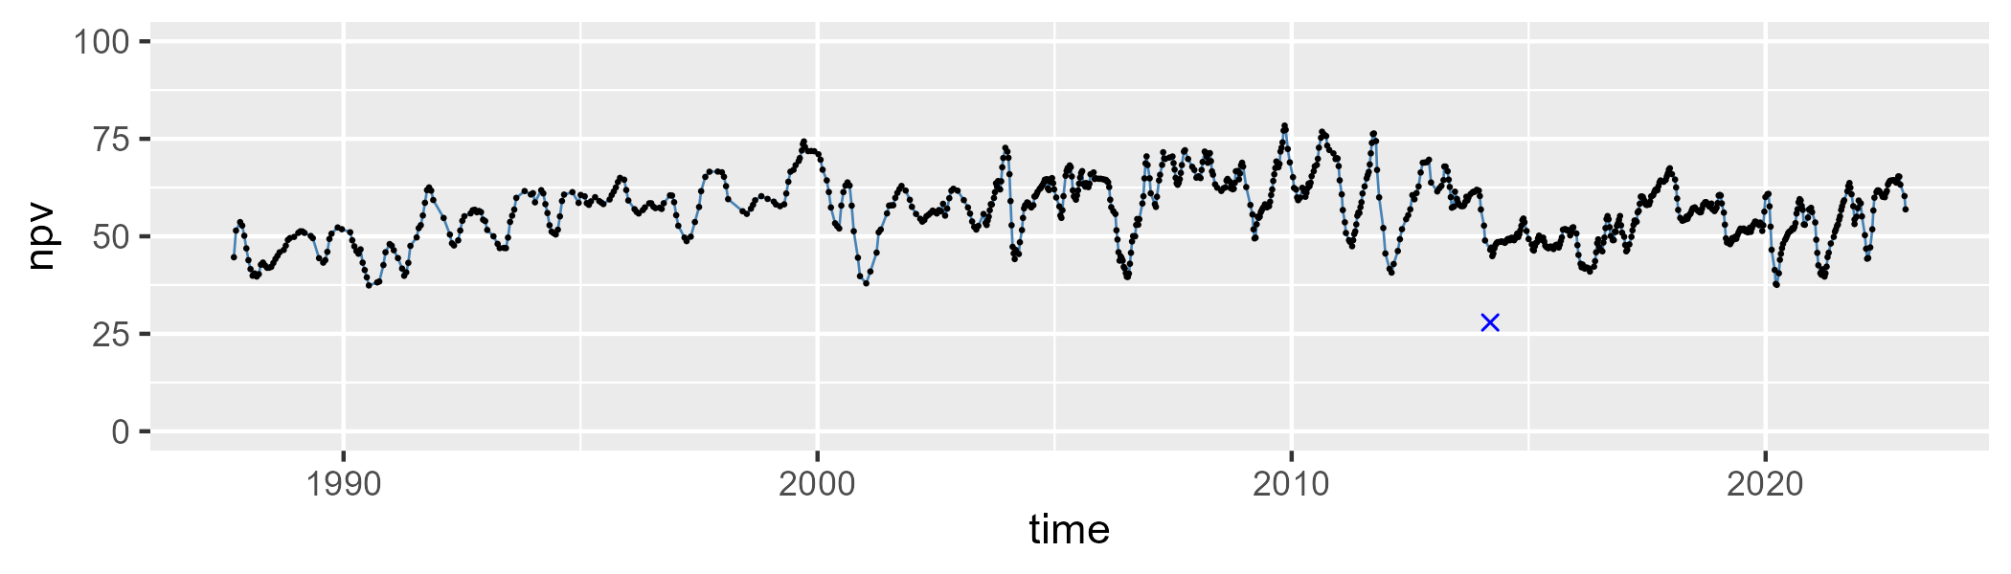

| Min. | 1st Qu. | Median | Mean | 3rd Qu. | Max. |
| --- | --- | --- | --- | --- | --- |
| 0.8072615 | 20.29313 | 27.58262 | 27.07697 | 34.01964 | 53.94236 |

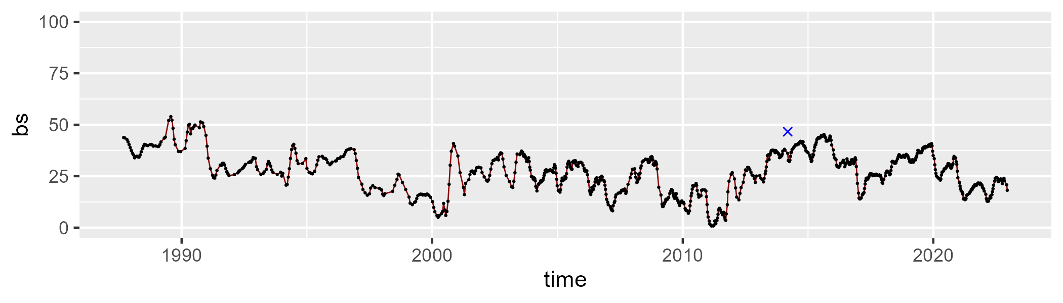

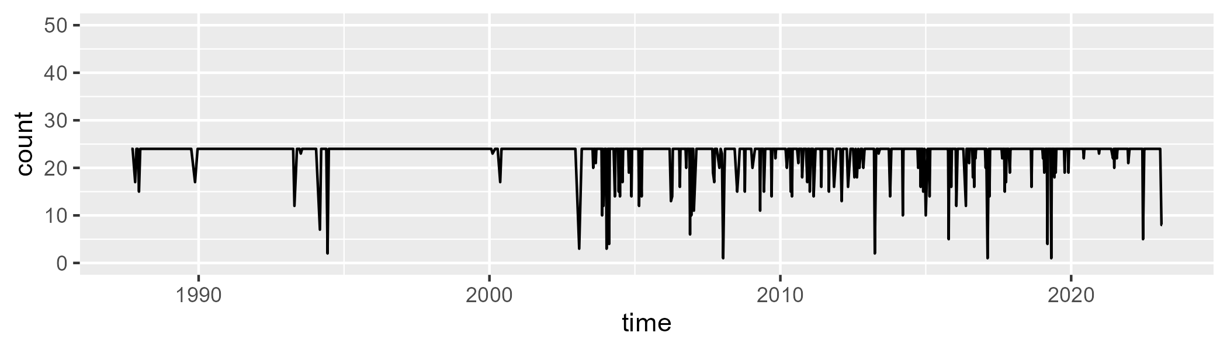

Min. : 1 1st Qu.:24 Median :24 Mean :23 3rd Qu.:24 Max. :24

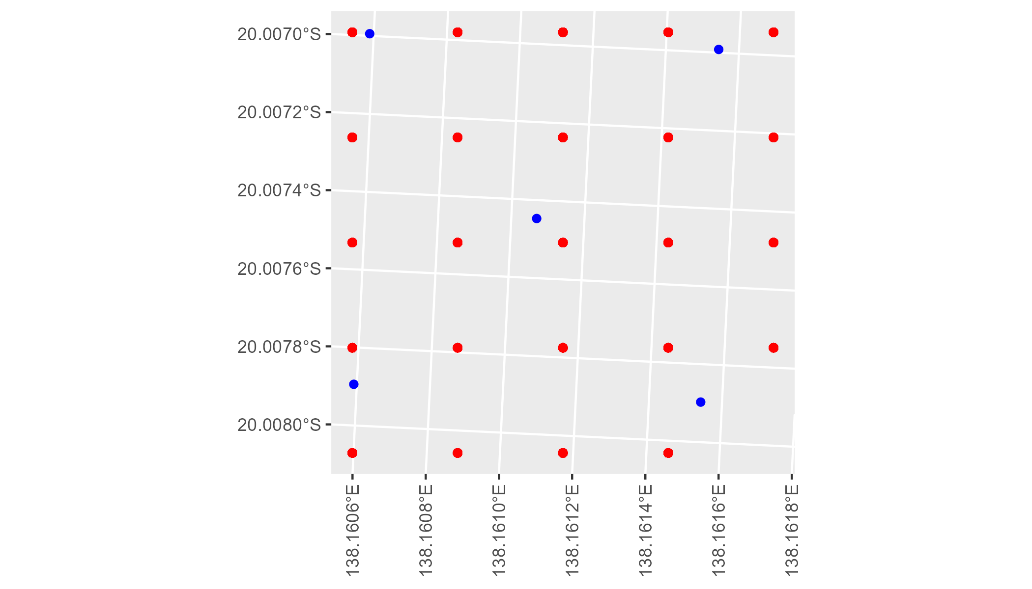

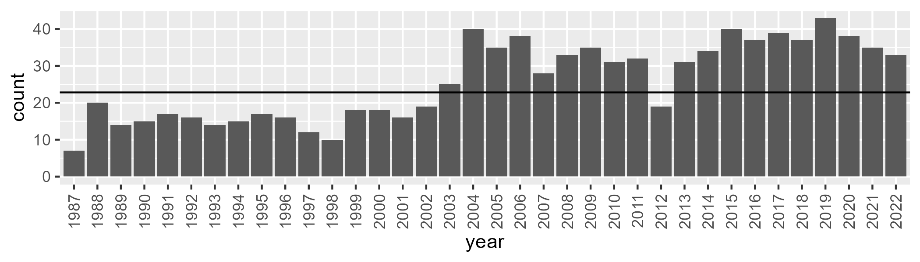

Number of samples: 927

# QDAMUL0001

| Min. | 1st Qu. | Median | Mean | 3rd Qu. | Max. |
| --- | --- | --- | --- | --- | --- |
| 11.5934 | 24.16939 | 28.87351 | 28.75549 | 33.0035 | 44.69829 |

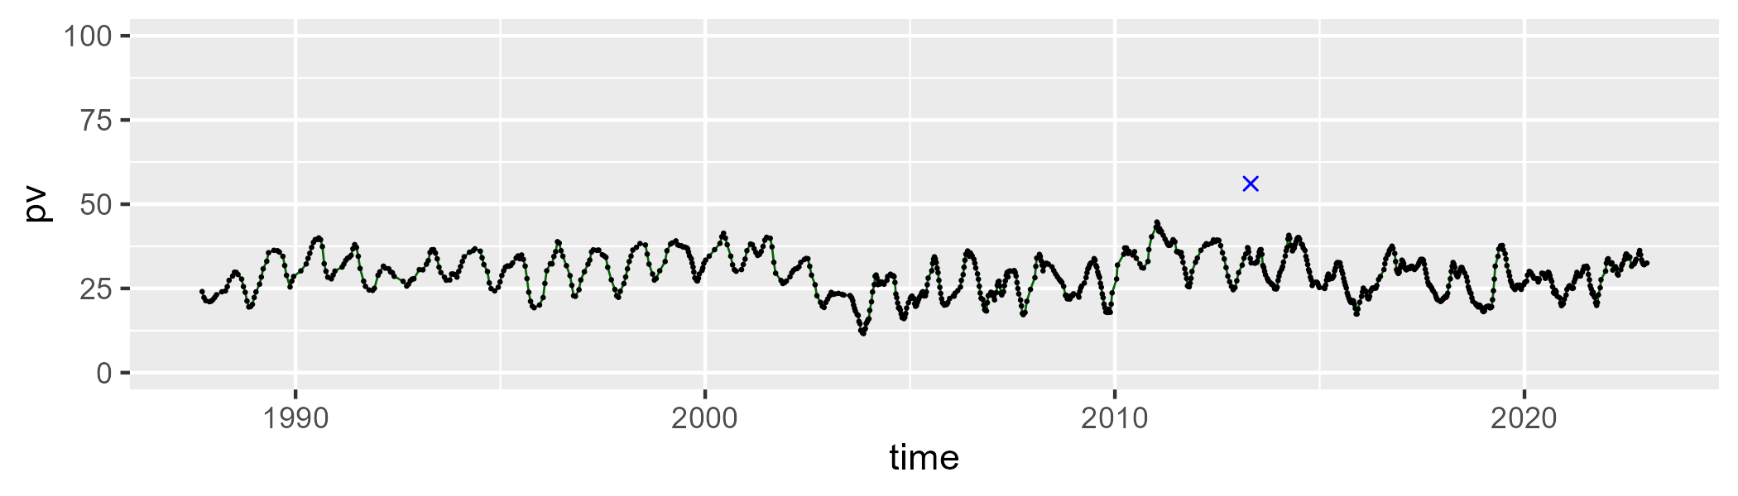

| Min. | 1st Qu. | Median | Mean | 3rd Qu. | Max. |
| --- | --- | --- | --- | --- | --- |
| 39.88734 | 50.8842 | 53.74541 | 53.89791 | 57.0266 | 68.82797 |

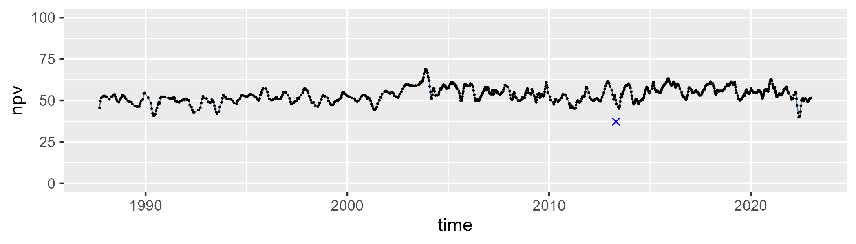

| Min. | 1st Qu. | Median | Mean | 3rd Qu. | Max. |
| --- | --- | --- | --- | --- | --- |
| 7.282806 | 13.44456 | 15.91347 | 16.16861 | 18.57713 | 29.04223 |

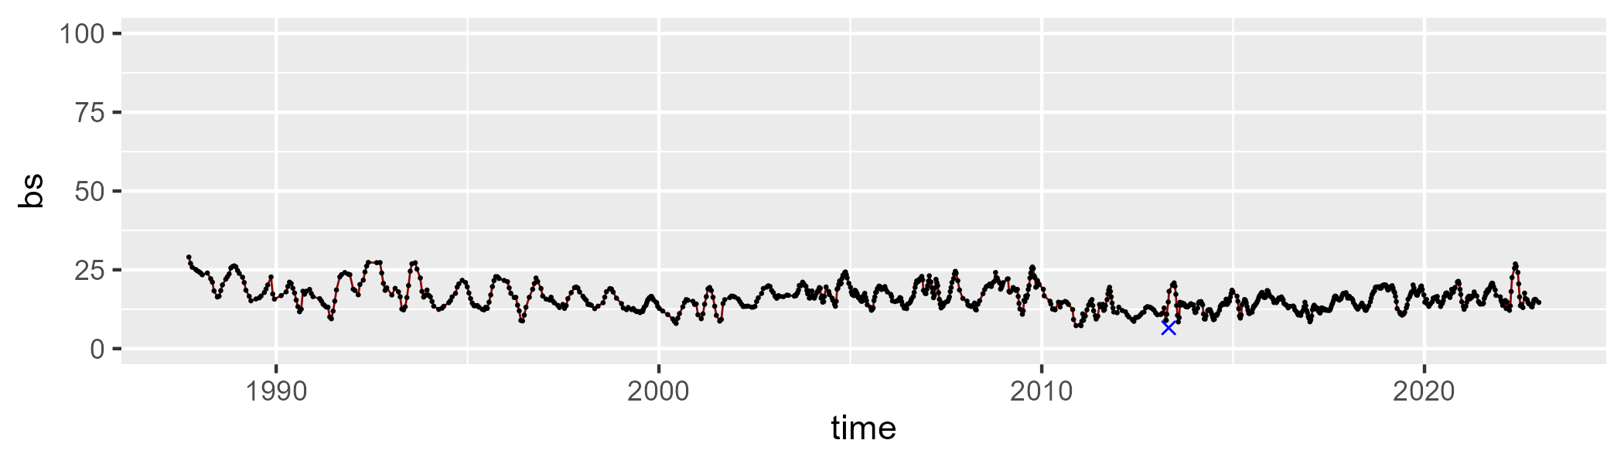

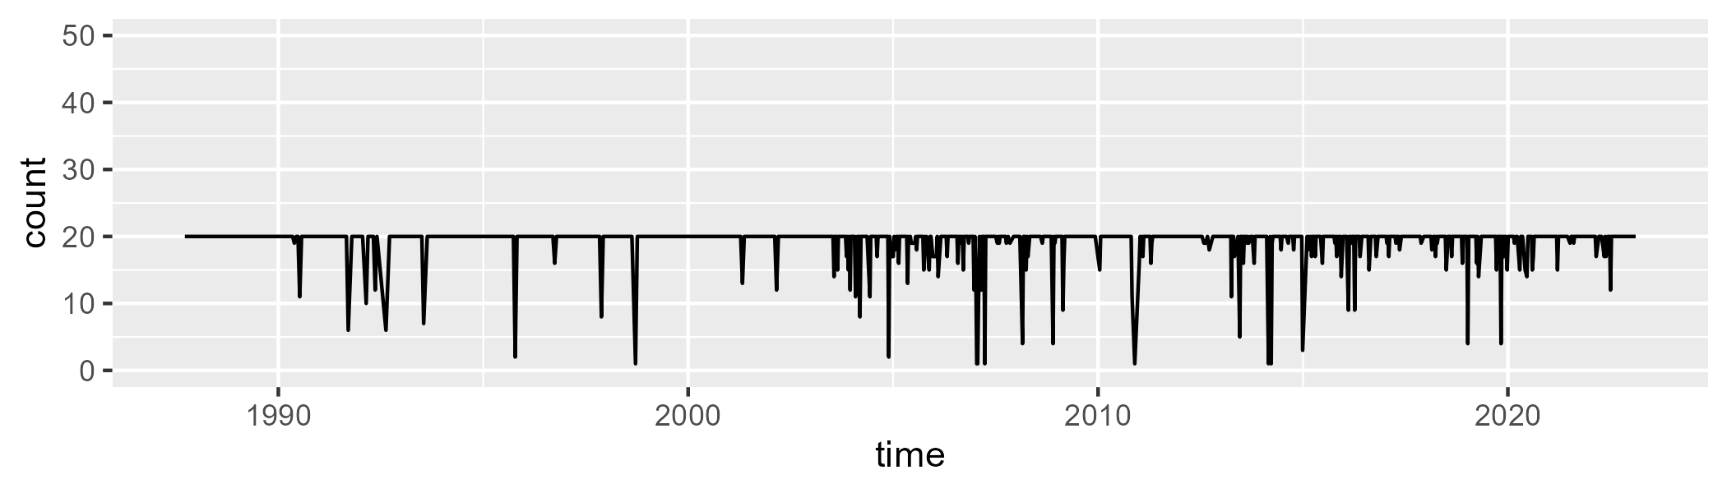

Min. : 1.00 1st Qu.:20.00 Median :20.00 Mean :19.19 3rd Qu.:20.00 Max. :20.00

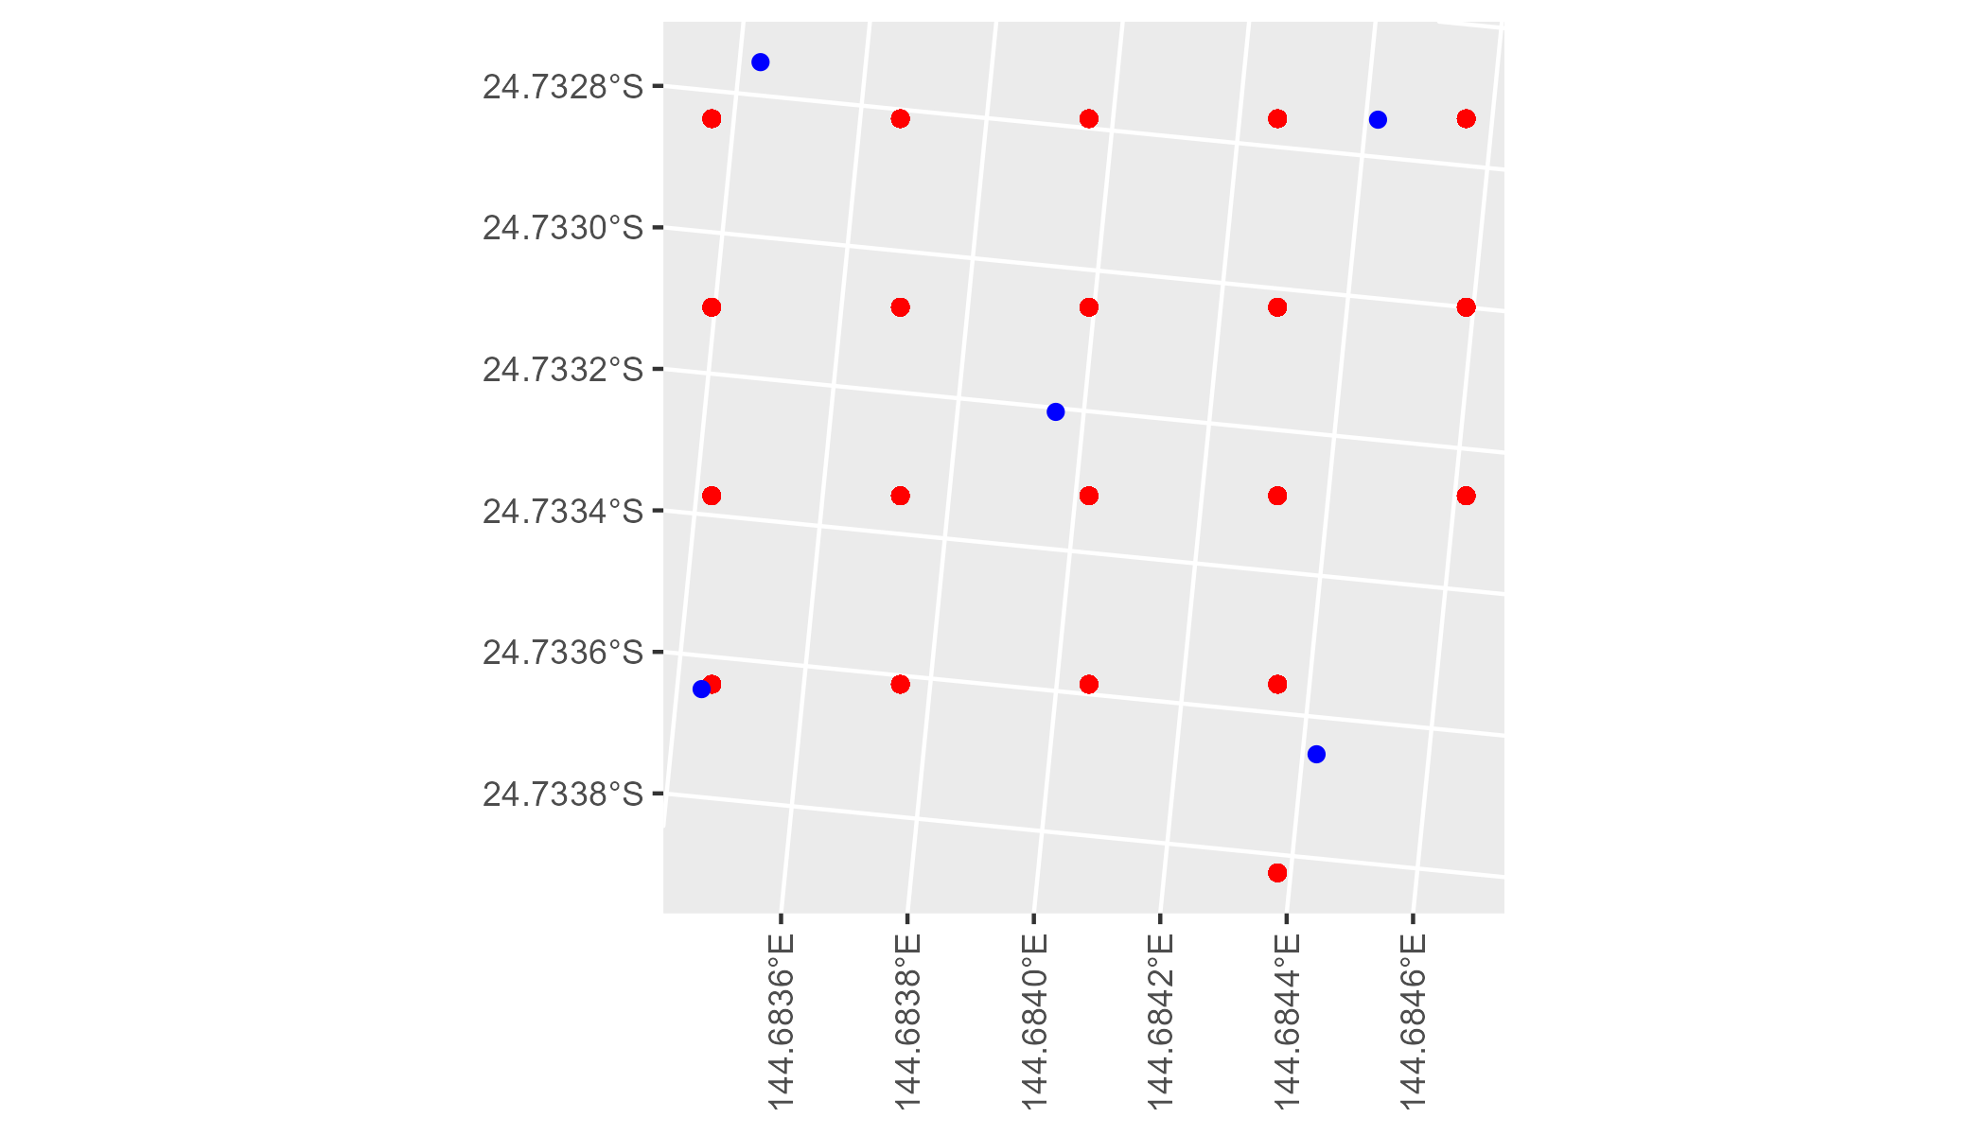

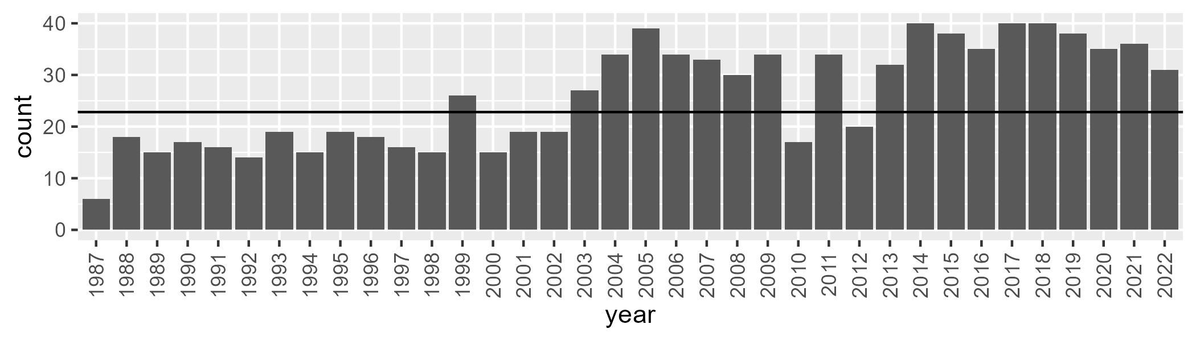

Number of samples: 934

# QDAMUL0002

| Min. | 1st Qu. | Median | Mean | 3rd Qu. | Max. |
| --- | --- | --- | --- | --- | --- |
| 11.10088 | 24.7336 | 29.79185 | 29.71853 | 34.87478 | 45.61377 |

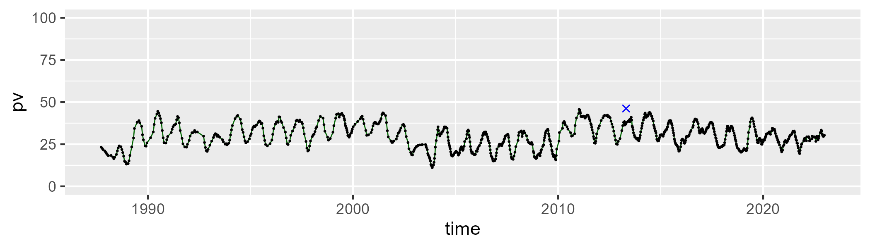

| Min. | 1st Qu. | Median | Mean | 3rd Qu. | Max. |
| --- | --- | --- | --- | --- | --- |
| 37.84695 | 51.71016 | 55.9087 | 55.80596 | 60.04265 | 71.14015 |

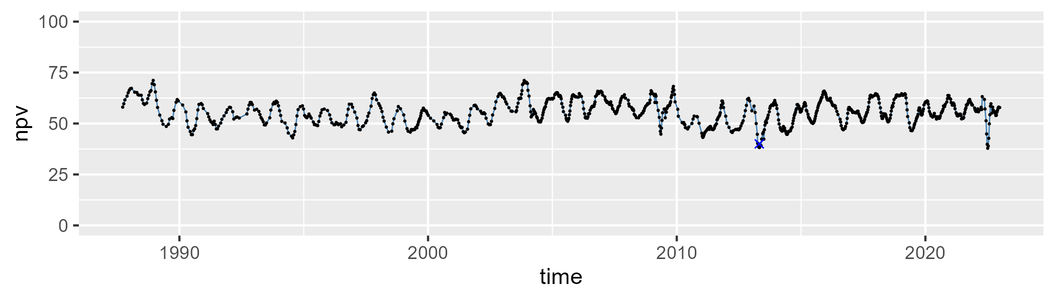

| Min. | 1st Qu. | Median | Mean | 3rd Qu. | Max. |
| --- | --- | --- | --- | --- | --- |
| 7.09322 | 11.00487 | 12.80756 | 13.35517 | 15.10157 | 31.90148 |

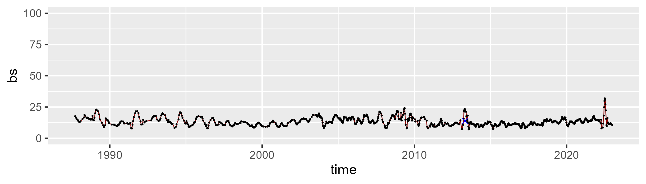

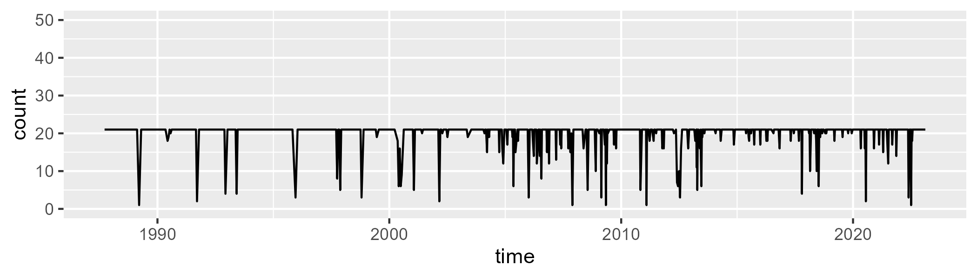

Min. : 1.00 1st Qu.:21.00 Median :21.00 Mean :20.02 3rd Qu.:21.00 Max. :21.00

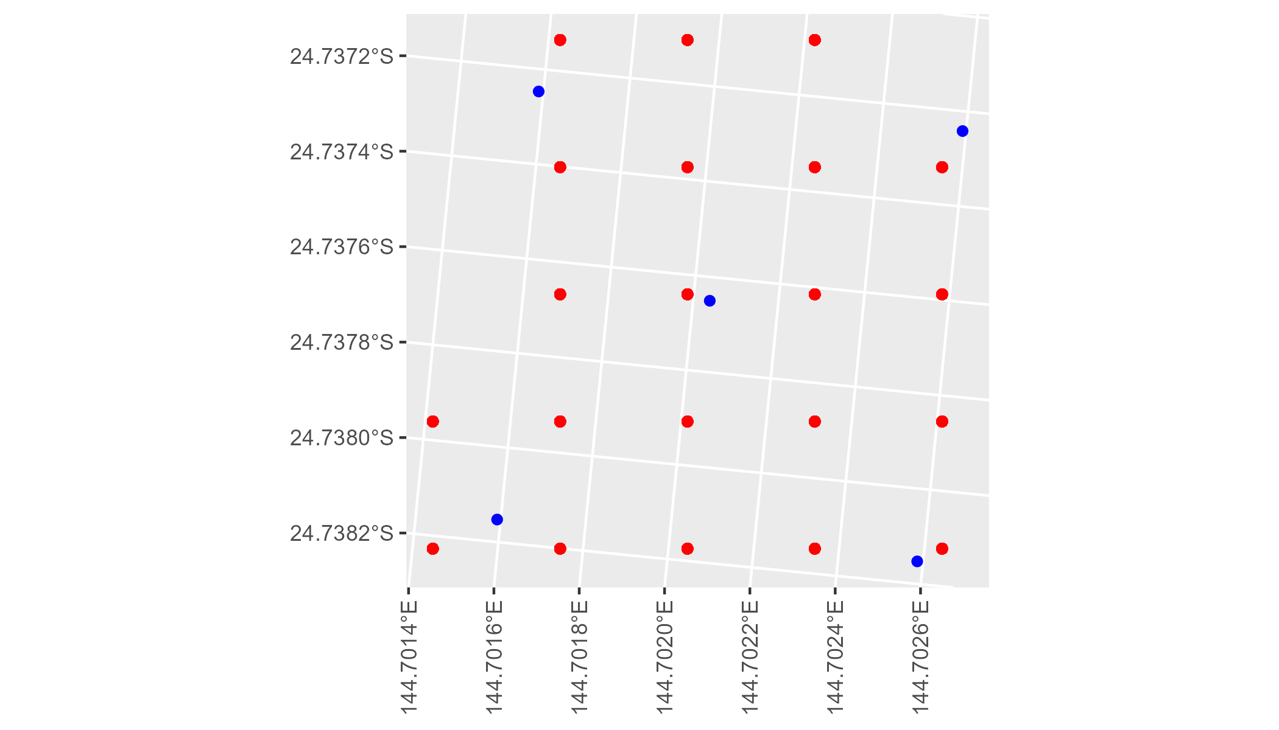

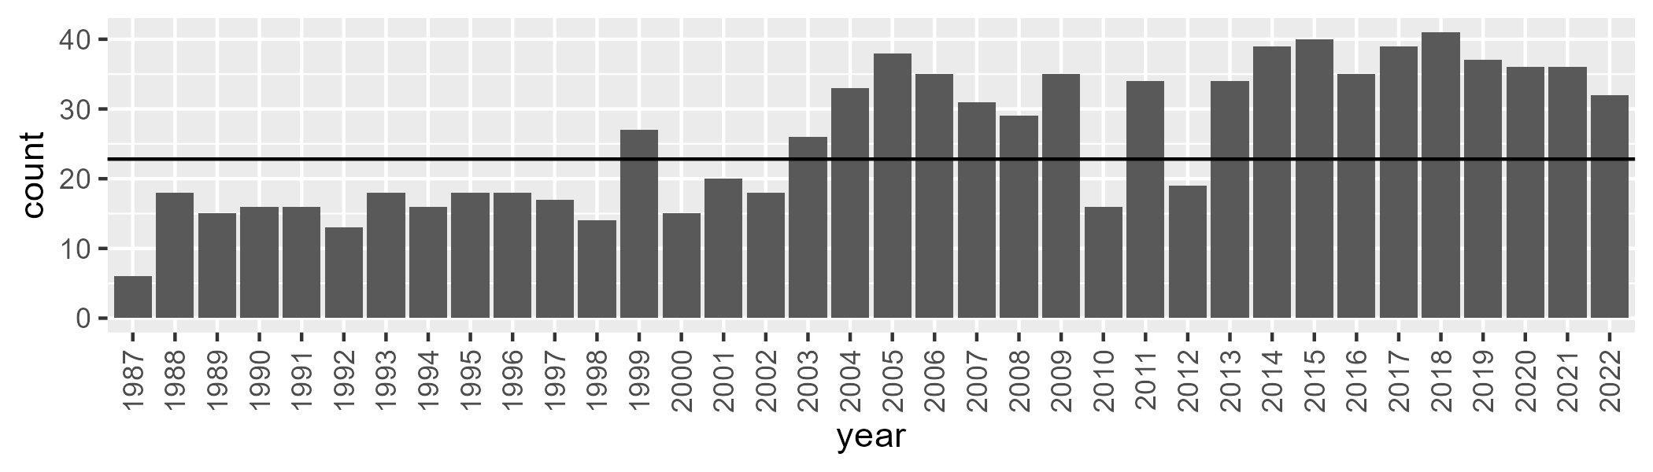

Number of samples: 930

# QDAMUL0003

| Min. | 1st Qu. | Median | Mean | 3rd Qu. | Max. |
| --- | --- | --- | --- | --- | --- |
| 7.681087 | 19.66625 | 23.59971 | 23.69609 | 27.45667 | 40.26533 |

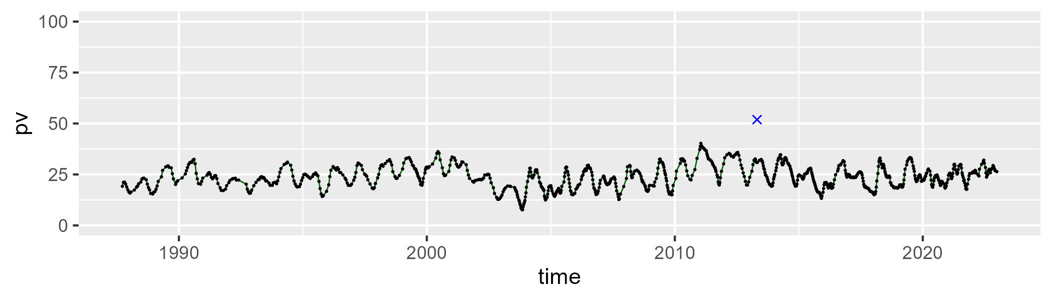

| Min. | 1st Qu. | Median | Mean | 3rd Qu. | Max. |
| --- | --- | --- | --- | --- | --- |
| 34.75059 | 48.02702 | 52.03718 | 51.5341 | 55.70981 | 64.99903 |

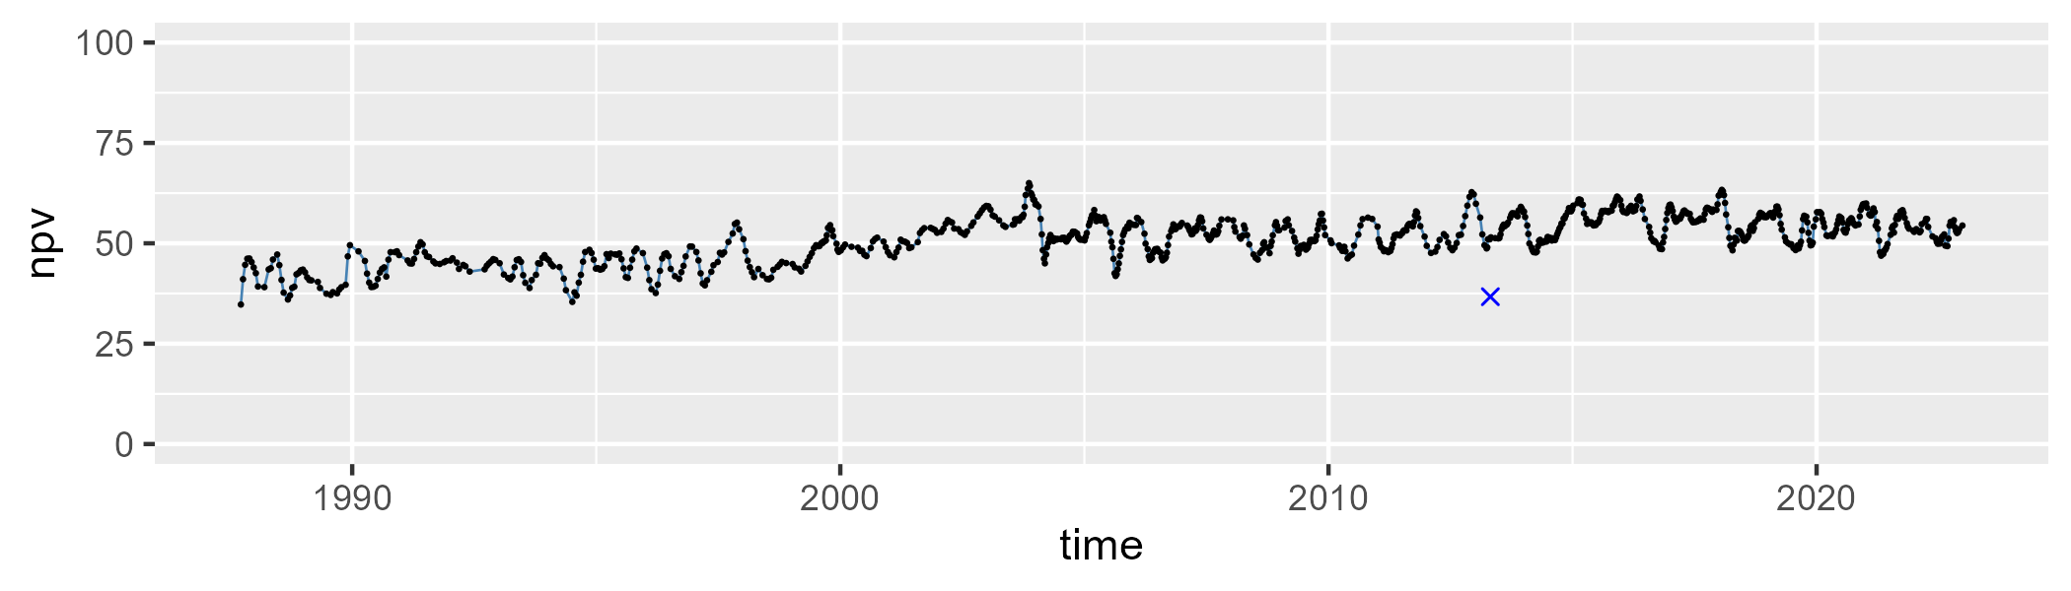

| Min. | 1st Qu. | Median | Mean | 3rd Qu. | Max. |
| --- | --- | --- | --- | --- | --- |
| 7.380869 | 18.81639 | 22.68973 | 23.50439 | 27.49232 | 44.4536 |

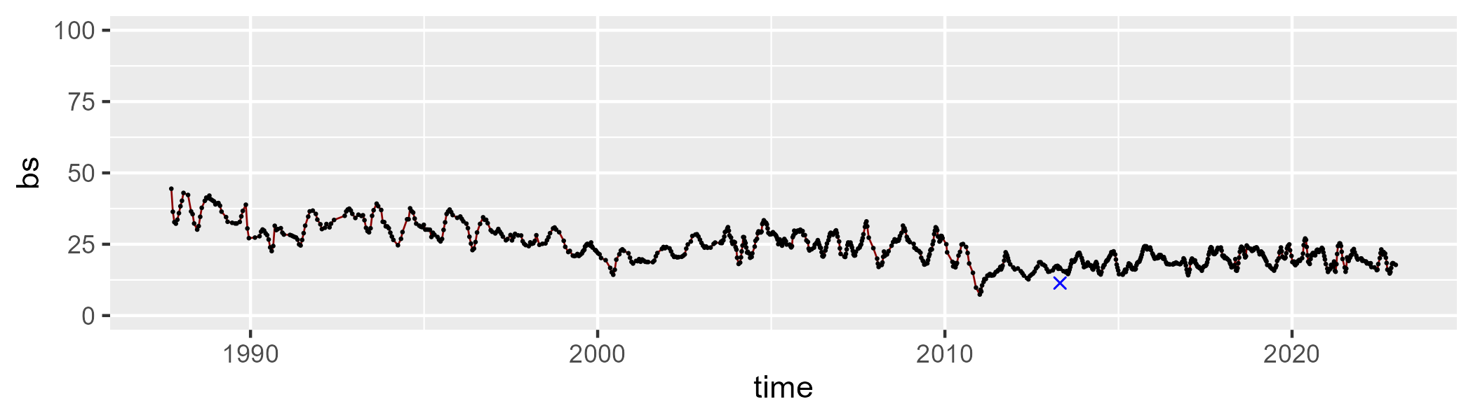

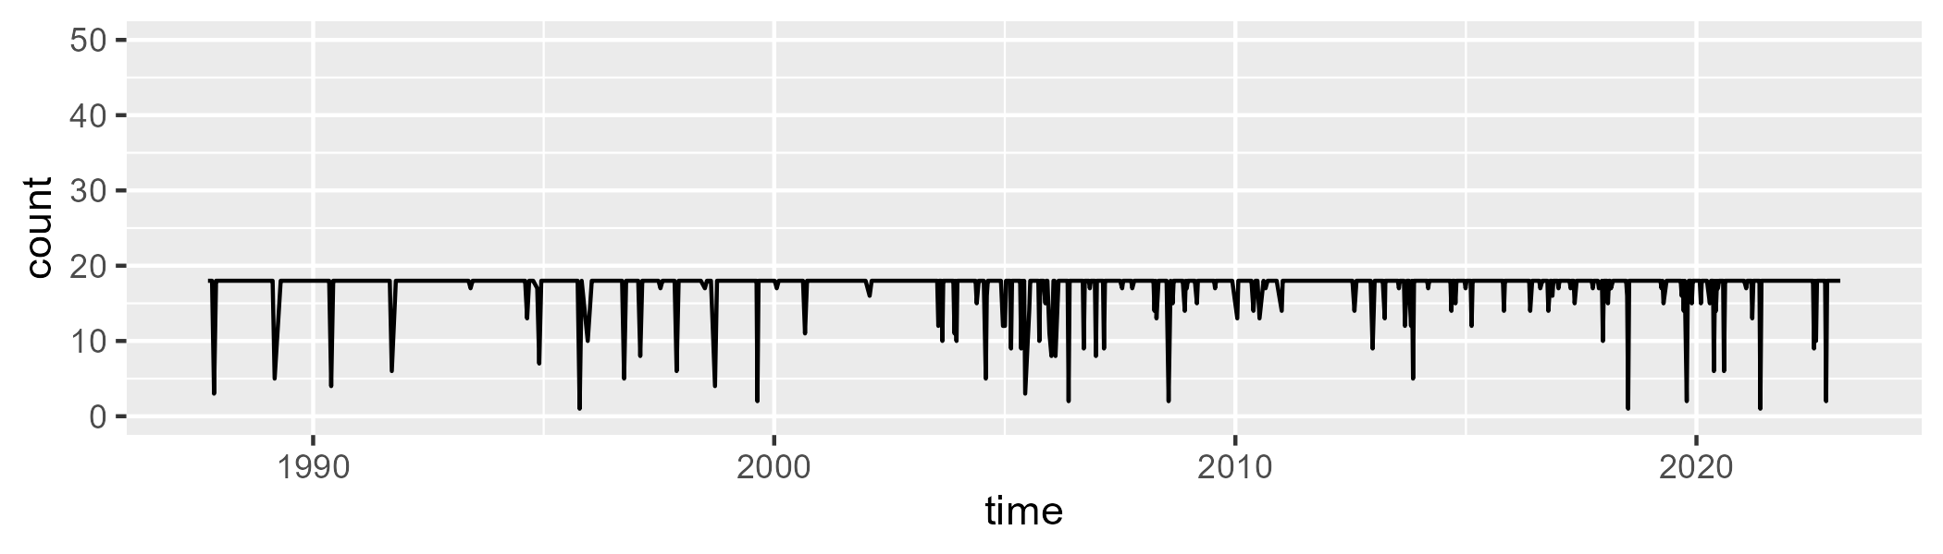

Min. : 1.00 1st Qu.:18.00 Median :18.00 Mean :17.31 3rd Qu.:18.00 Max. :18.00

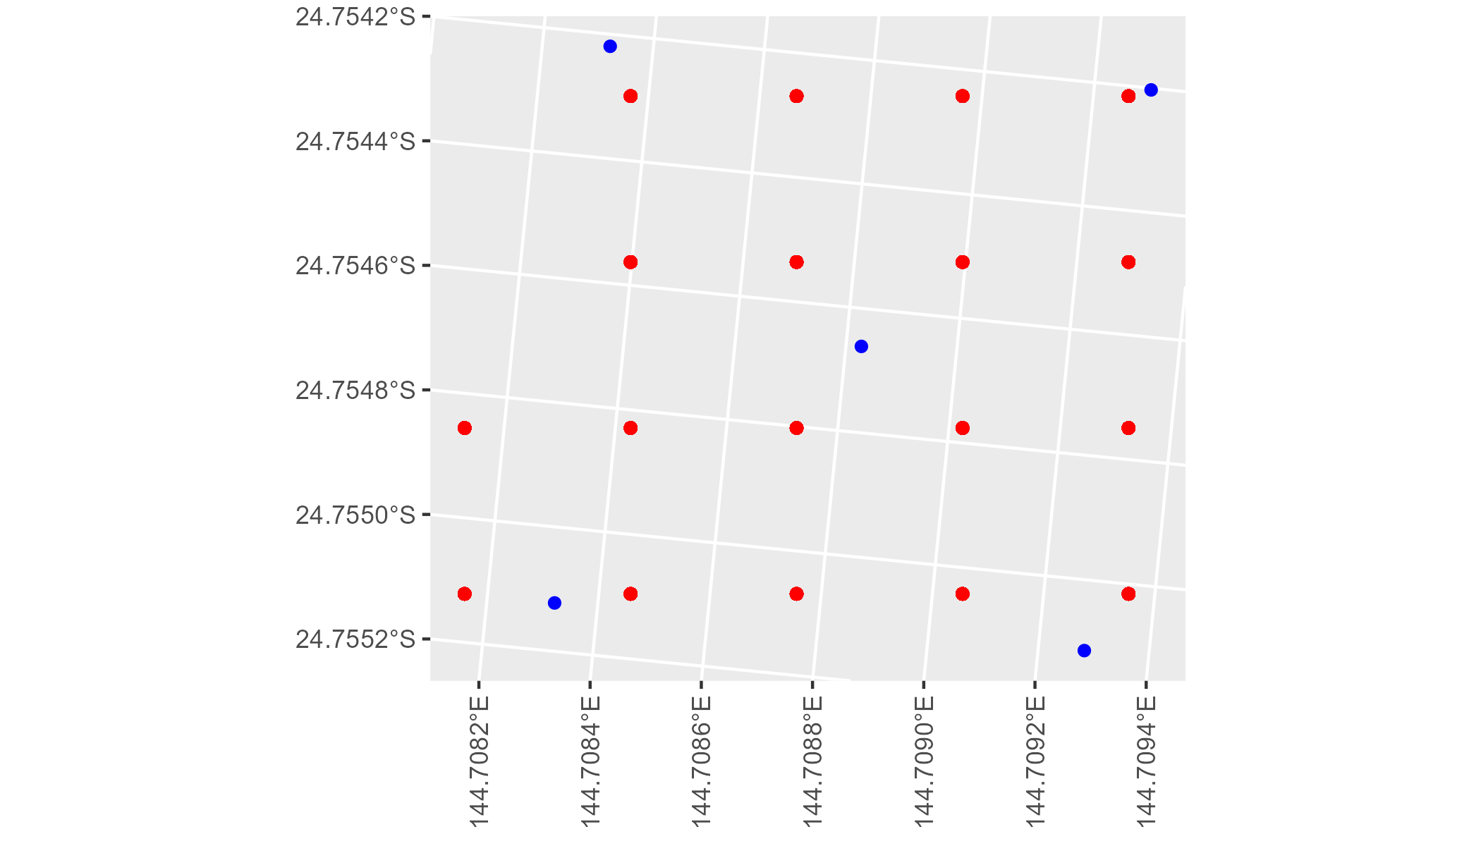

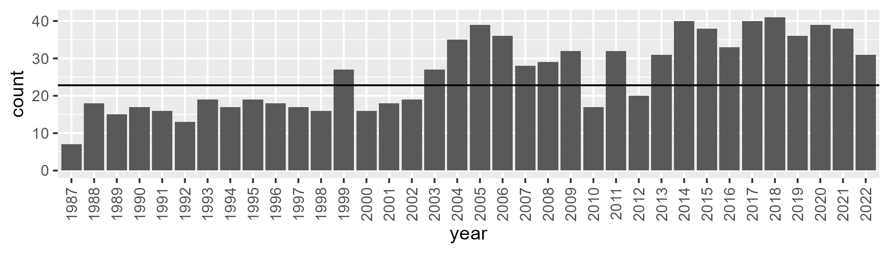

Number of samples: 934

# QDASEQ0001

| Min. | 1st Qu. | Median | Mean | 3rd Qu. | Max. |
| --- | --- | --- | --- | --- | --- |
| 42.79523 | 62.49118 | 67.53526 | 66.63189 | 72.17045 | 81.85423 |

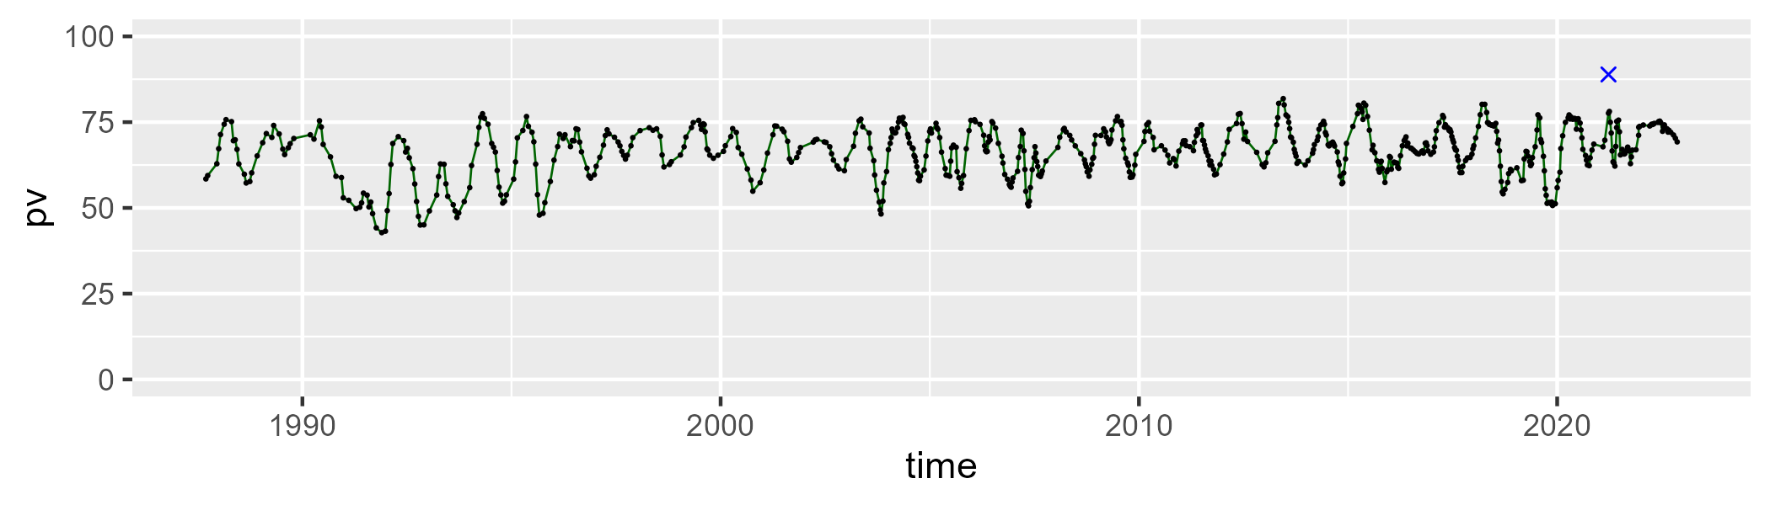

| Min. | 1st Qu. | Median | Mean | 3rd Qu. | Max. |
| --- | --- | --- | --- | --- | --- |
| 15.4419 | 24.19696 | 28.17744 | 29.1137 | 32.95384 | 52.47103 |

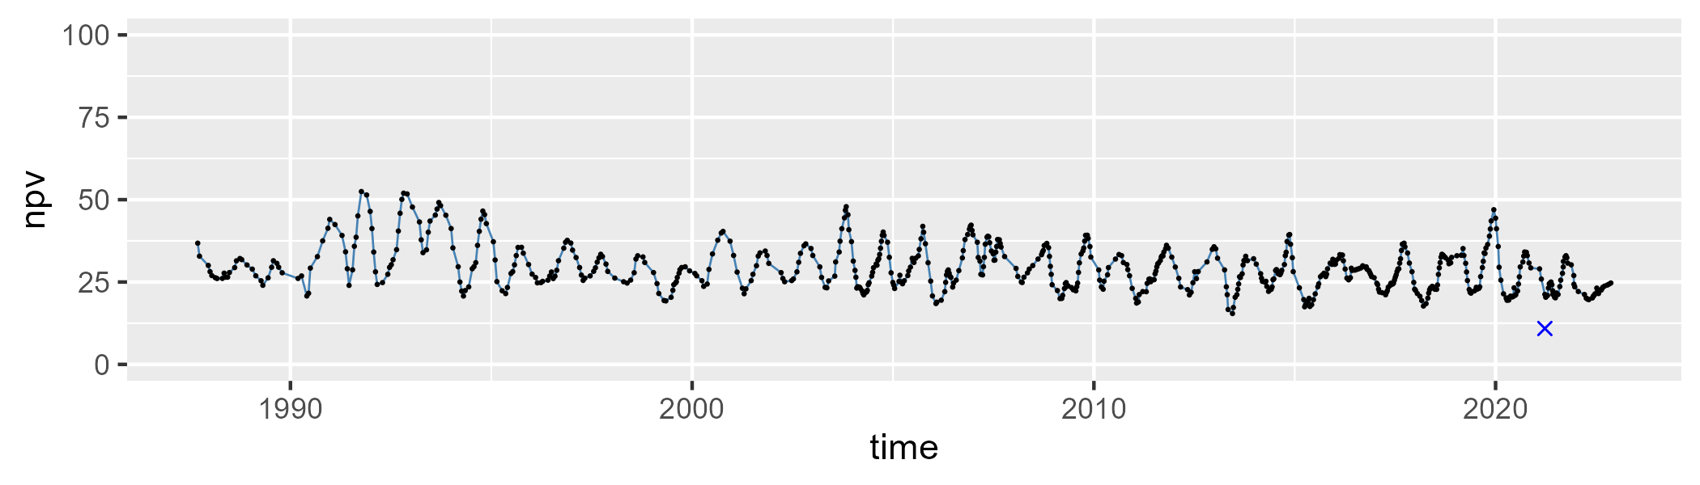

| Min. | 1st Qu. | Median | Mean | 3rd Qu. | Max. |
| --- | --- | --- | --- | --- | --- |
| 0 | 0.9964927 | 1.873172 | 2.946025 | 3.739774 | 20.50998 |

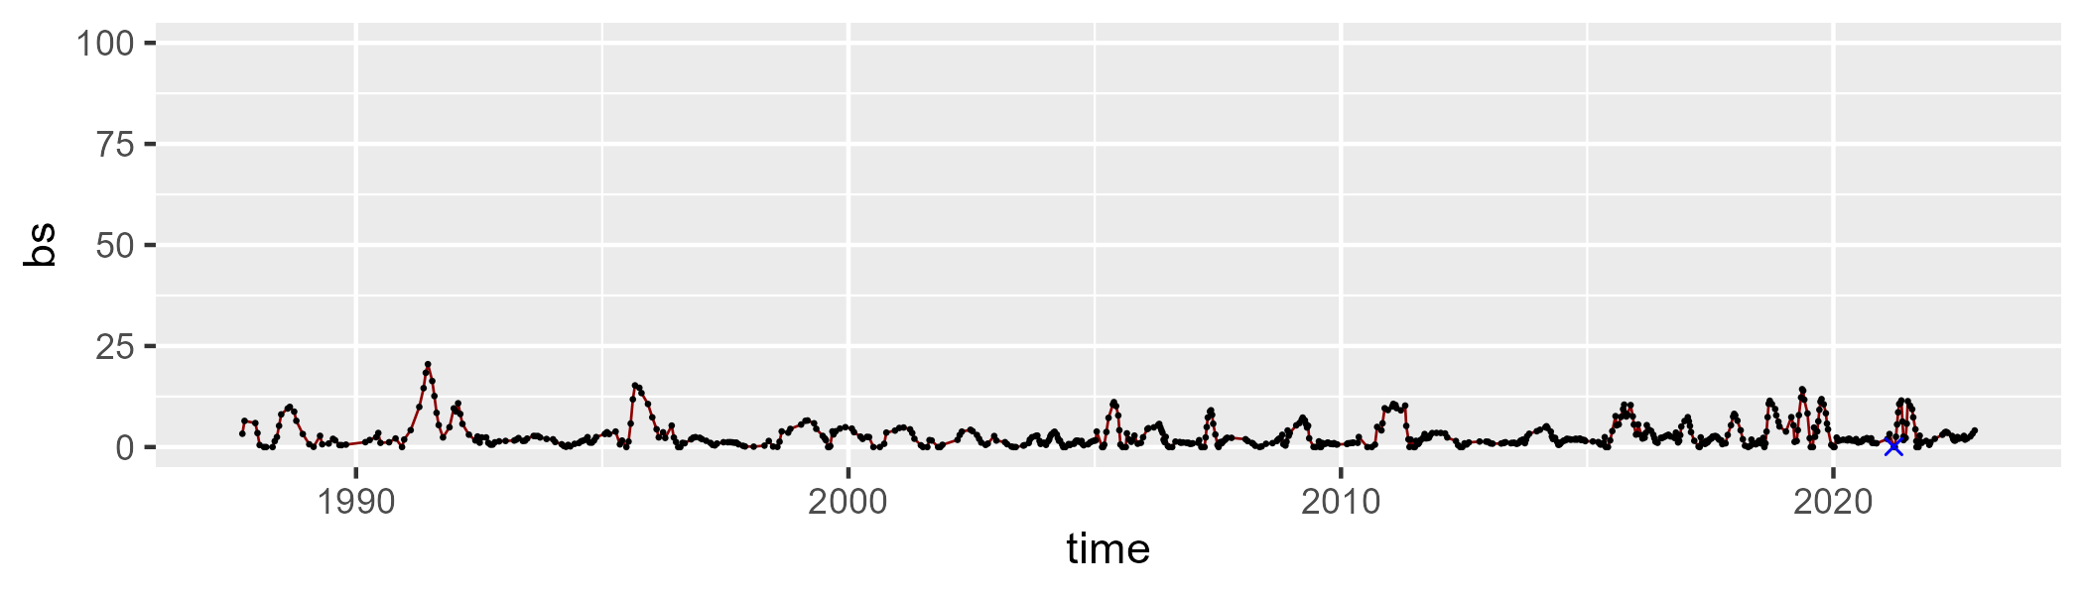

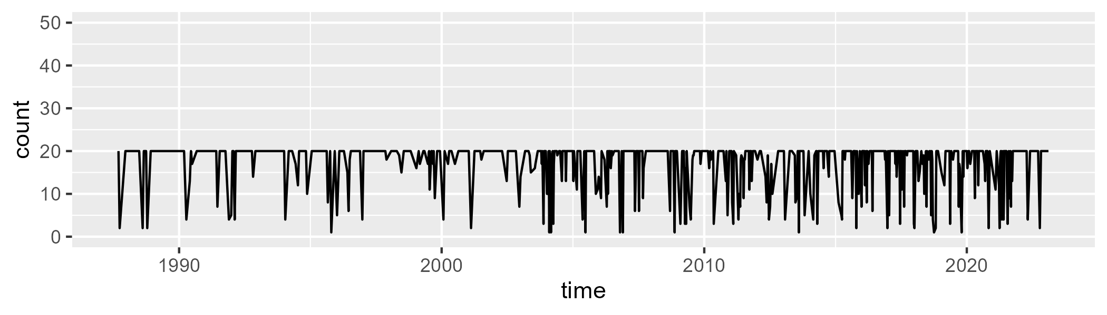

Min. : 1.00 1st Qu.:18.00 Median :20.00 Mean :17.23 3rd Qu.:20.00 Max. :20.00

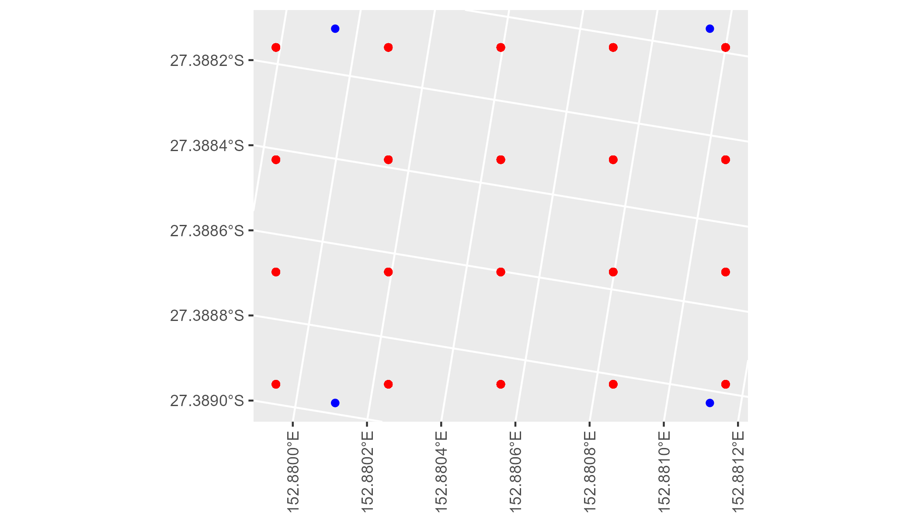

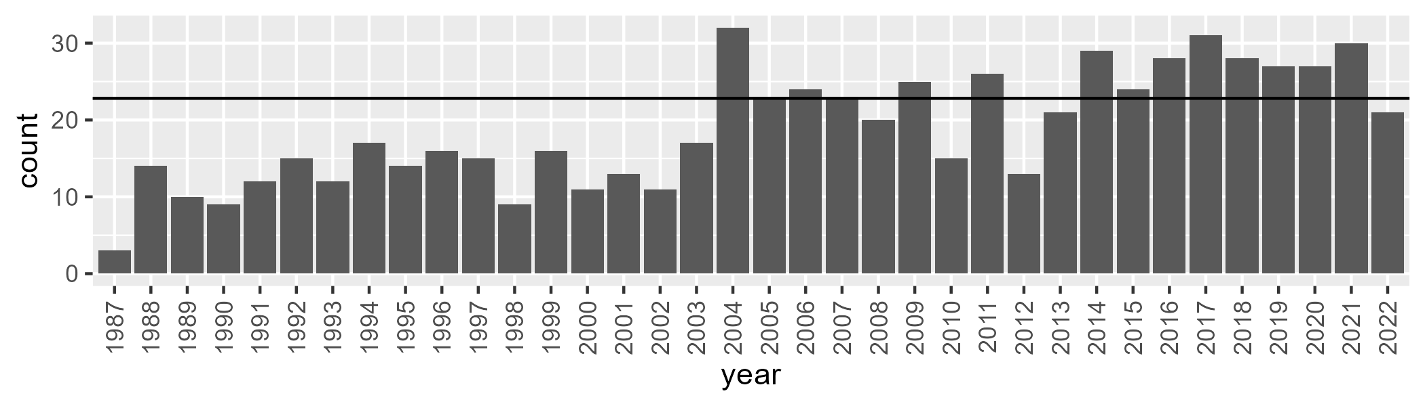

Number of samples: 681

# QDASEQ0002

| Min. | 1st Qu. | Median | Mean | 3rd Qu. | Max. |
| --- | --- | --- | --- | --- | --- |
| 22.12813 | 42.23039 | 51.12068 | 51.25304 | 59.26308 | 84.27948 |

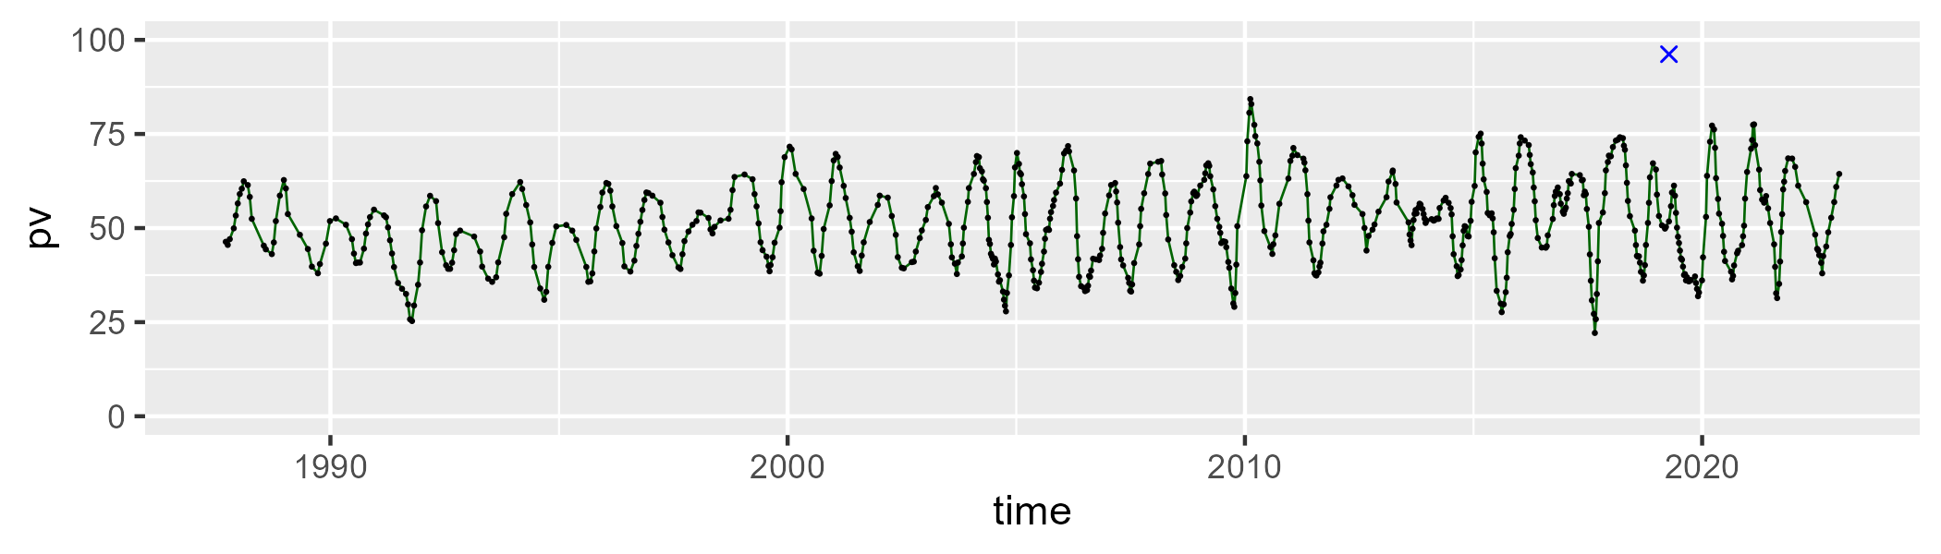

| Min. | 1st Qu. | Median | Mean | 3rd Qu. | Max. |
| --- | --- | --- | --- | --- | --- |
| 9.987851 | 30.51842 | 37.88056 | 37.1468 | 44.54987 | 66.72009 |

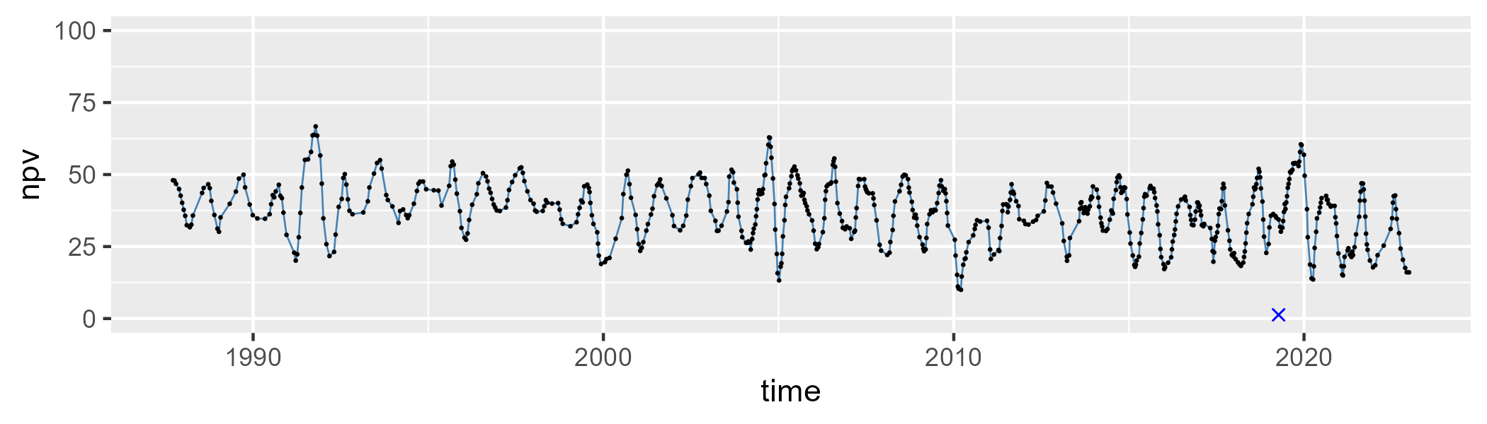

| Min. | 1st Qu. | Median | Mean | 3rd Qu. | Max. |
| --- | --- | --- | --- | --- | --- |
| 0 | 6.052382 | 9.226002 | 10.26448 | 13.16492 | 35.70003 |

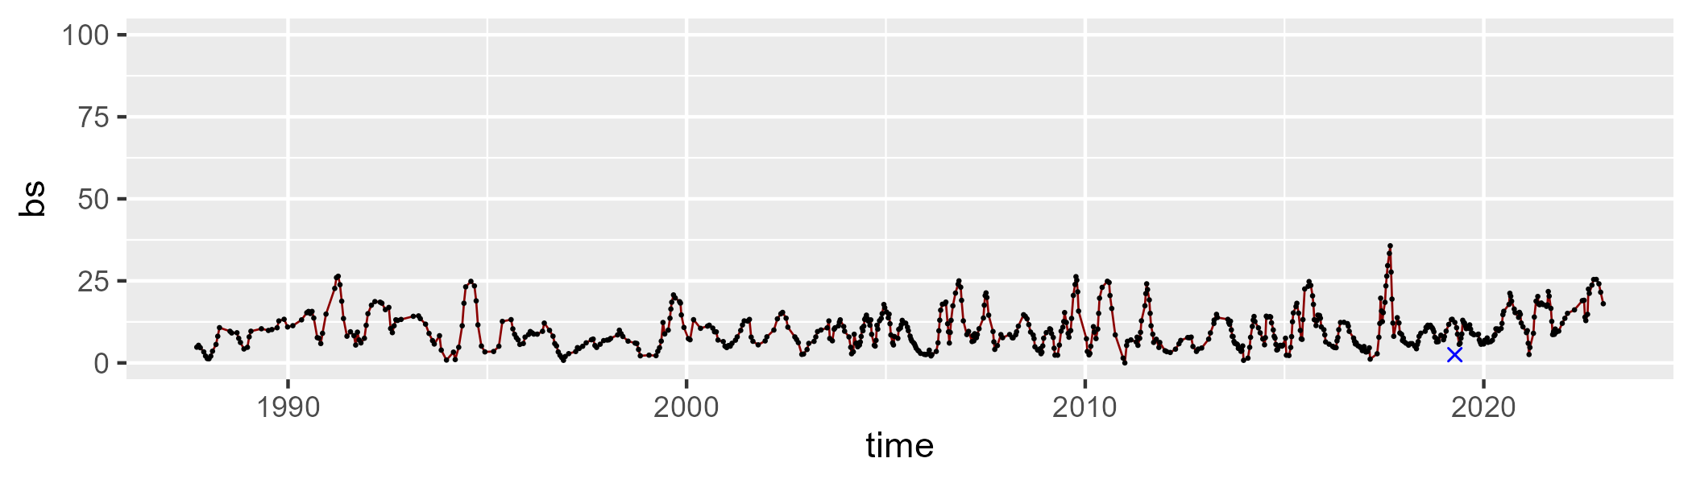

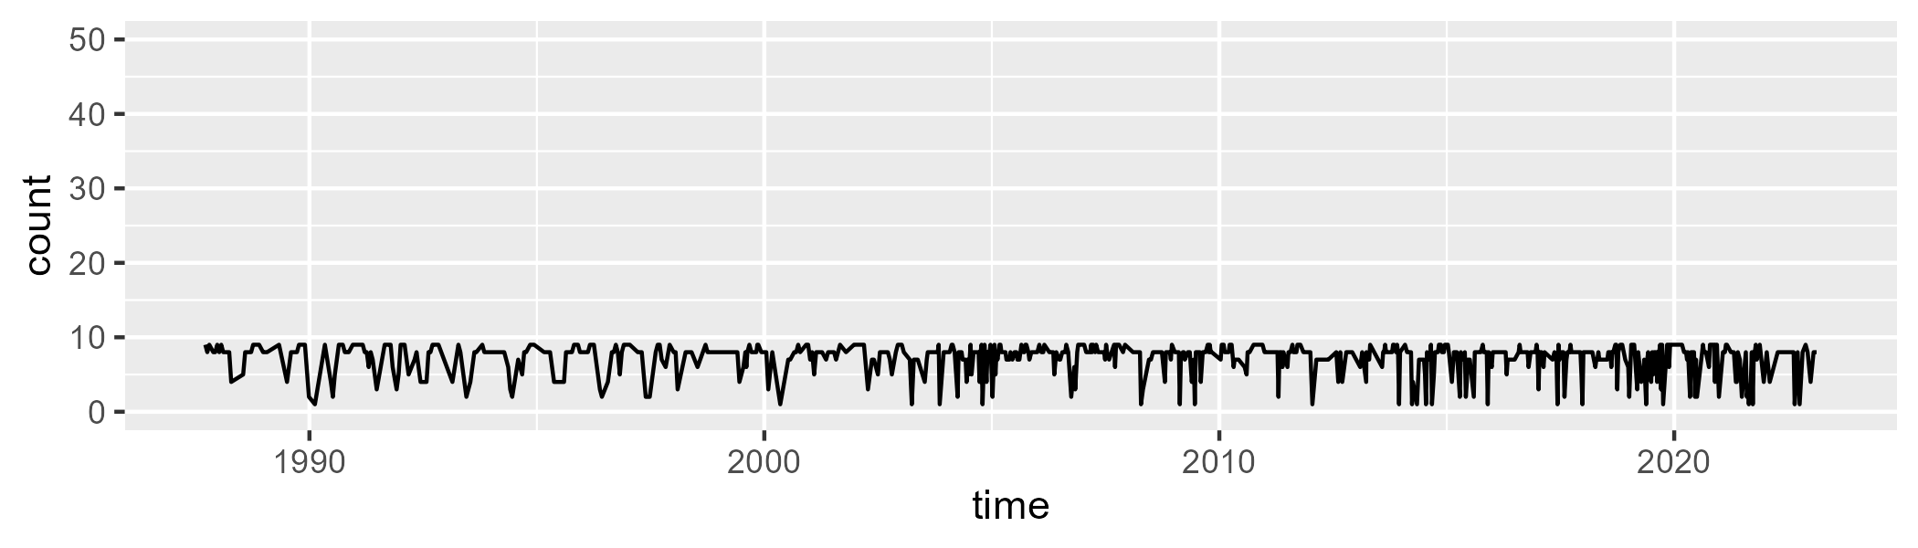

Min. :1.000 1st Qu.:7.000 Median :8.000 Mean :7.175 3rd Qu.:8.000 Max. :9.000

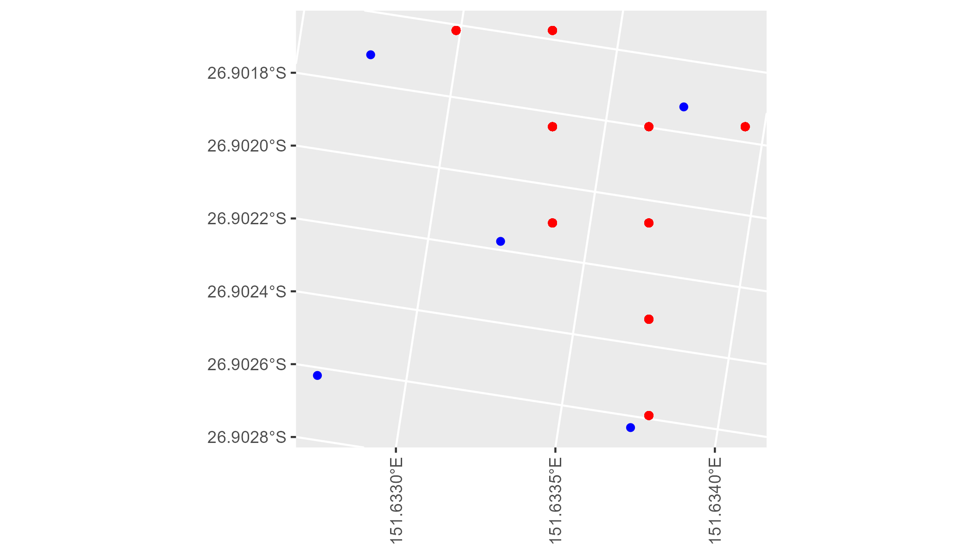

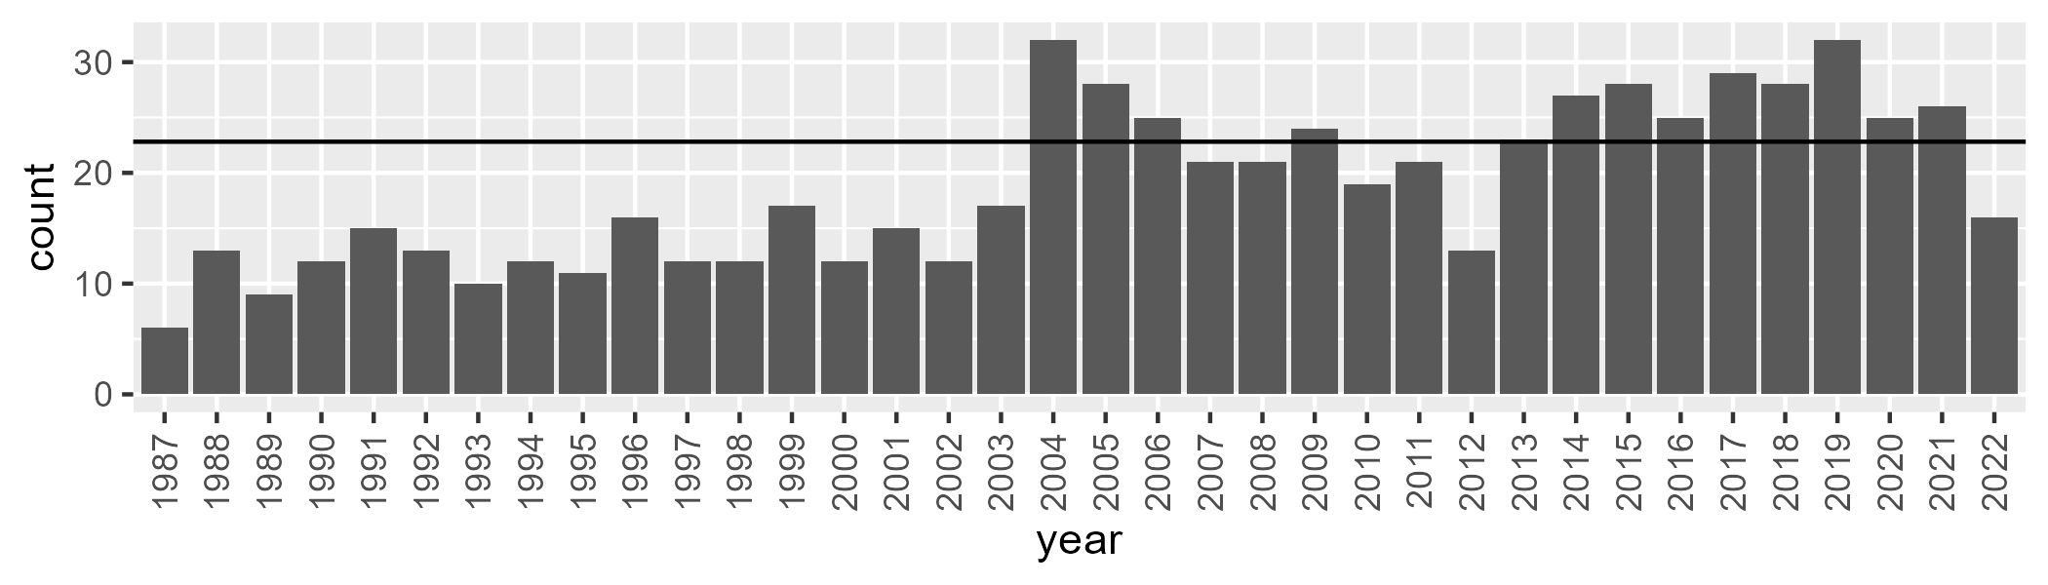

Number of samples: 677

# QDASEQ0003

| Min. | 1st Qu. | Median | Mean | 3rd Qu. | Max. |
| --- | --- | --- | --- | --- | --- |
| 34.89633 | 58.99975 | 64.11646 | 63.4471 | 68.73988 | 77.64326 |

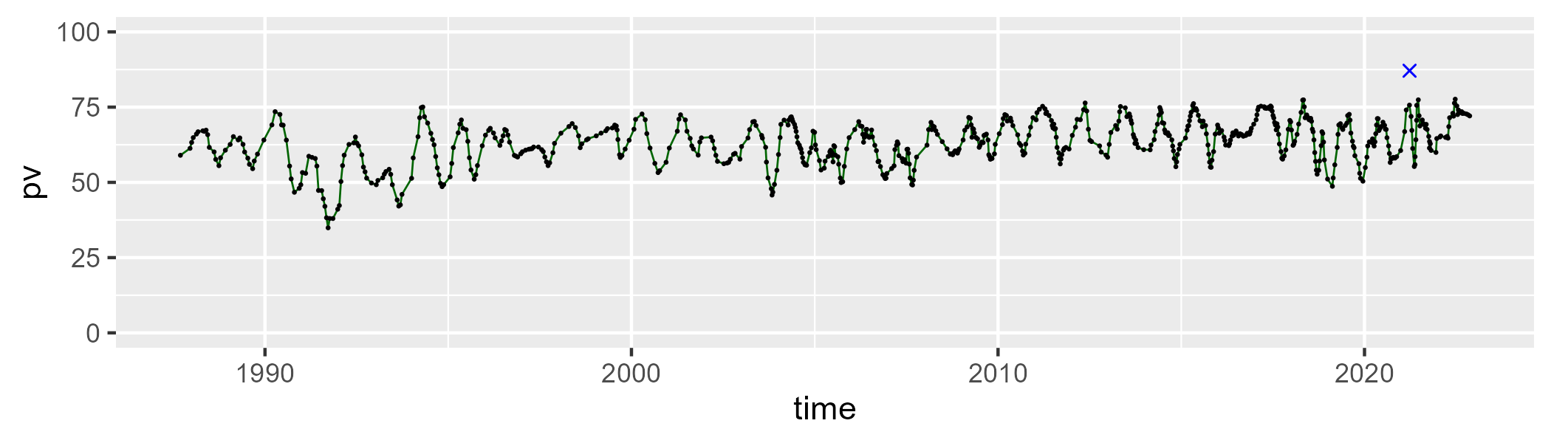

| Min. | 1st Qu. | Median | Mean | 3rd Qu. | Max. |
| --- | --- | --- | --- | --- | --- |
| 18.46398 | 26.56894 | 30.61394 | 31.3371 | 35.29656 | 67.10527 |

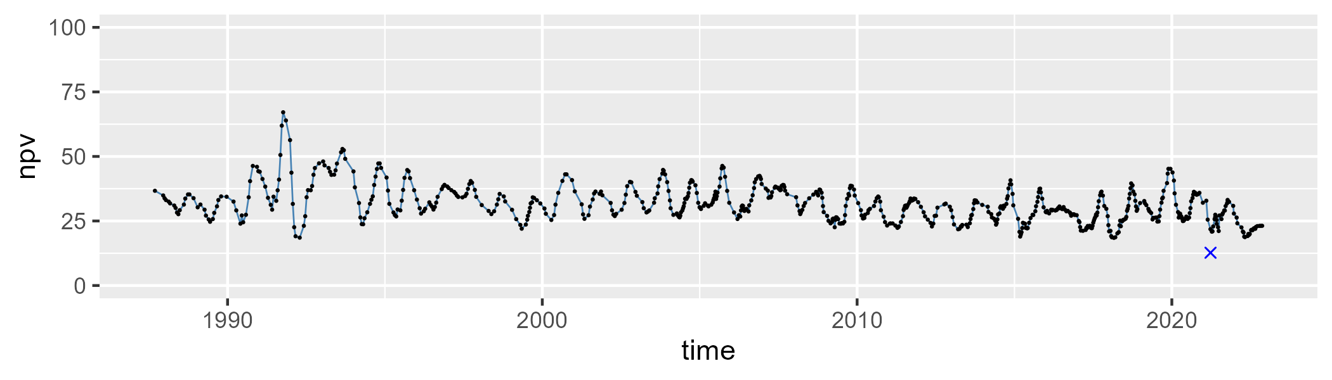

| Min. | 1st Qu. | Median | Mean | 3rd Qu. | Max. |
| --- | --- | --- | --- | --- | --- |
| 0 | 1.414427 | 2.657003 | 3.894255 | 5.267135 | 20.85266 |

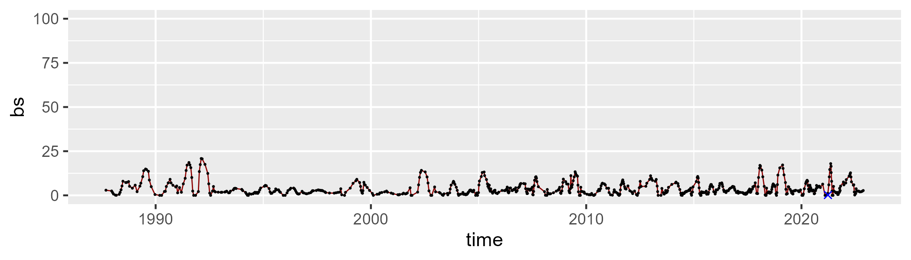

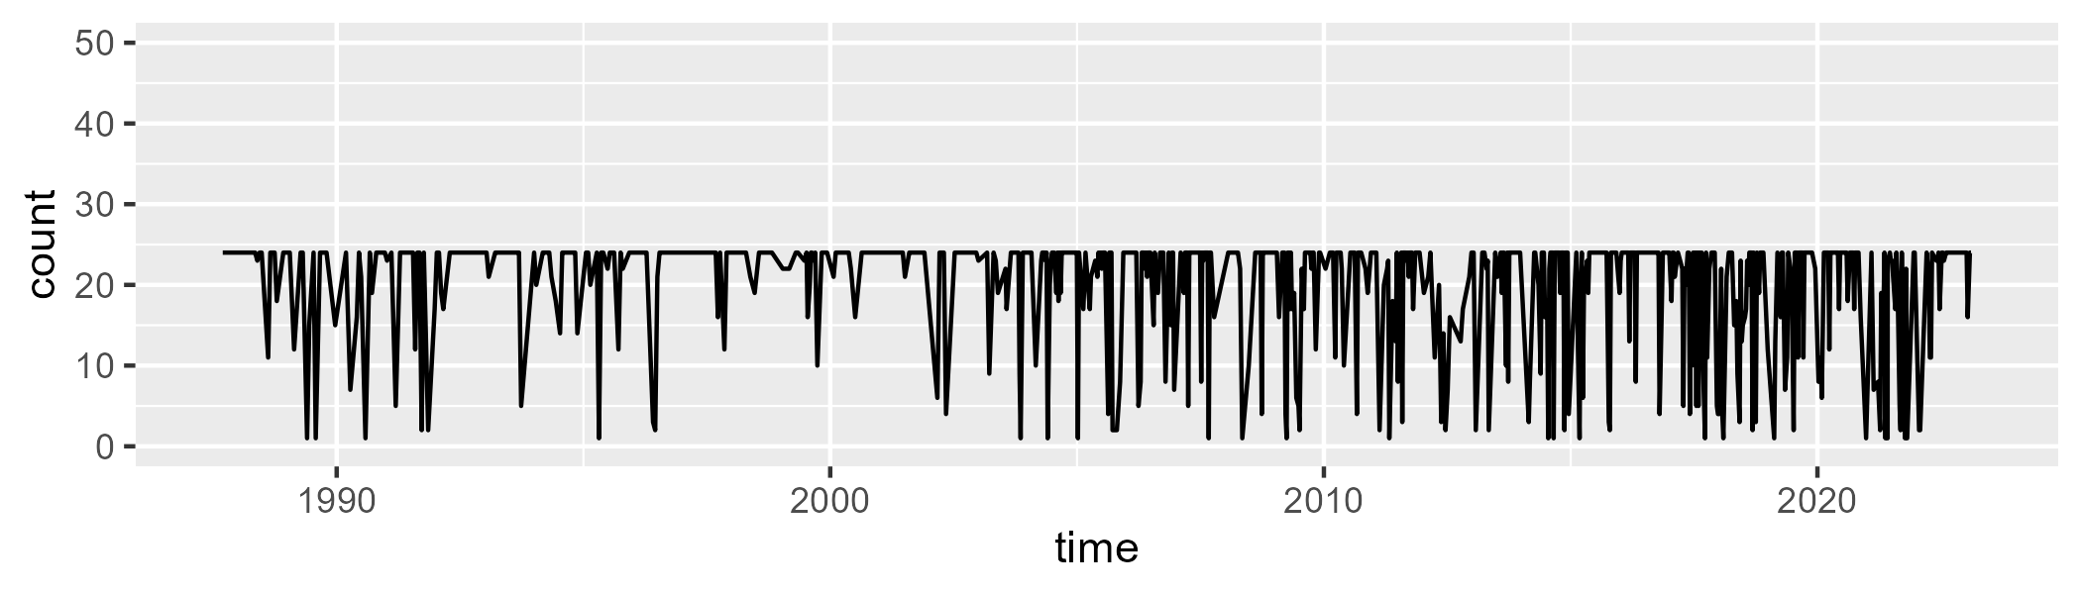

Min. : 1.00 1st Qu.:18.00 Median :24.00 Mean :19.76 3rd Qu.:24.00 Max. :24.00

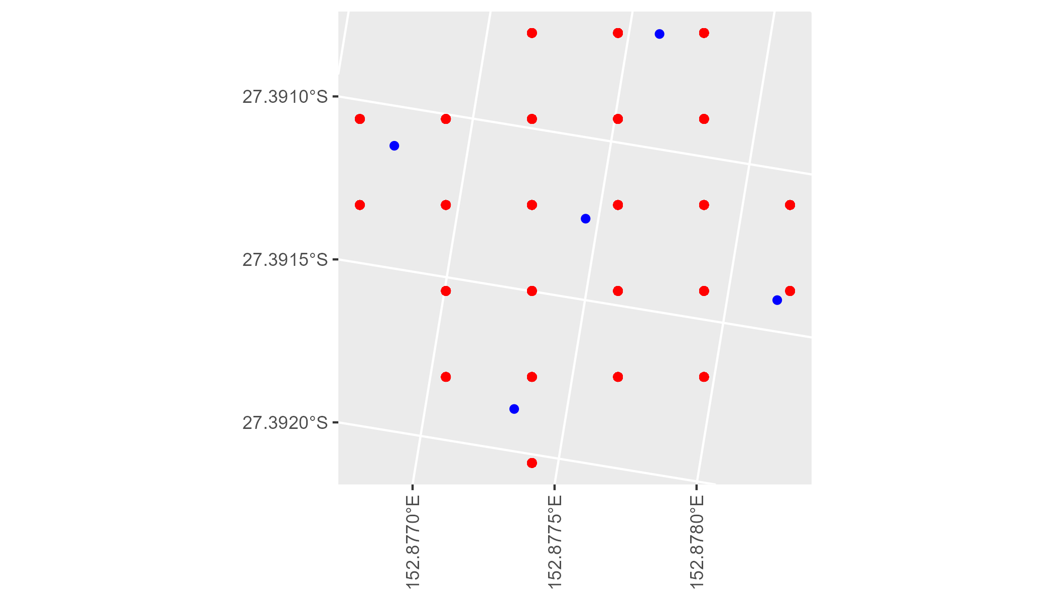

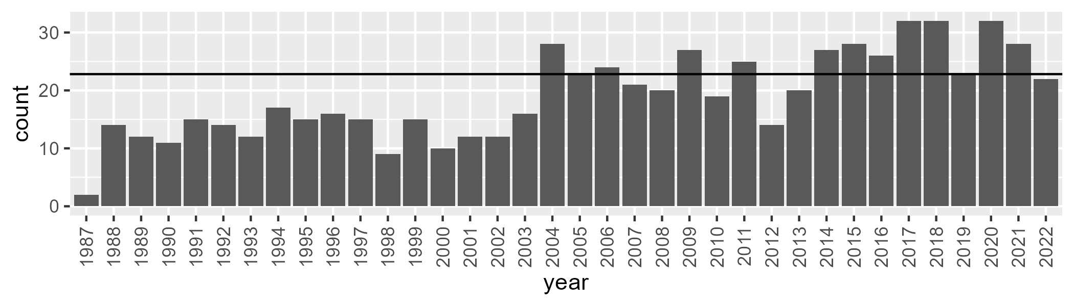

Number of samples: 688

# QDASEQ0004

| Min. | 1st Qu. | Median | Mean | 3rd Qu. | Max. |
| --- | --- | --- | --- | --- | --- |
| 37.49206 | 58.04647 | 63.30867 | 62.39817 | 67.2574 | 76.50267 |

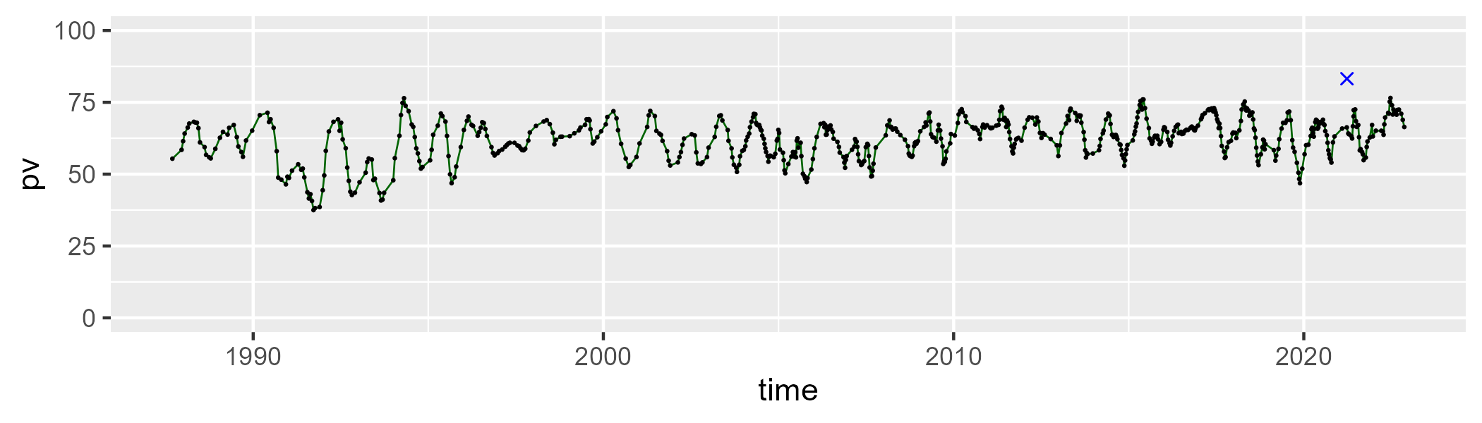

| Min. | 1st Qu. | Median | Mean | 3rd Qu. | Max. |
| --- | --- | --- | --- | --- | --- |
| 17.44713 | 26.85979 | 30.79573 | 31.86013 | 36.11244 | 62.63218 |

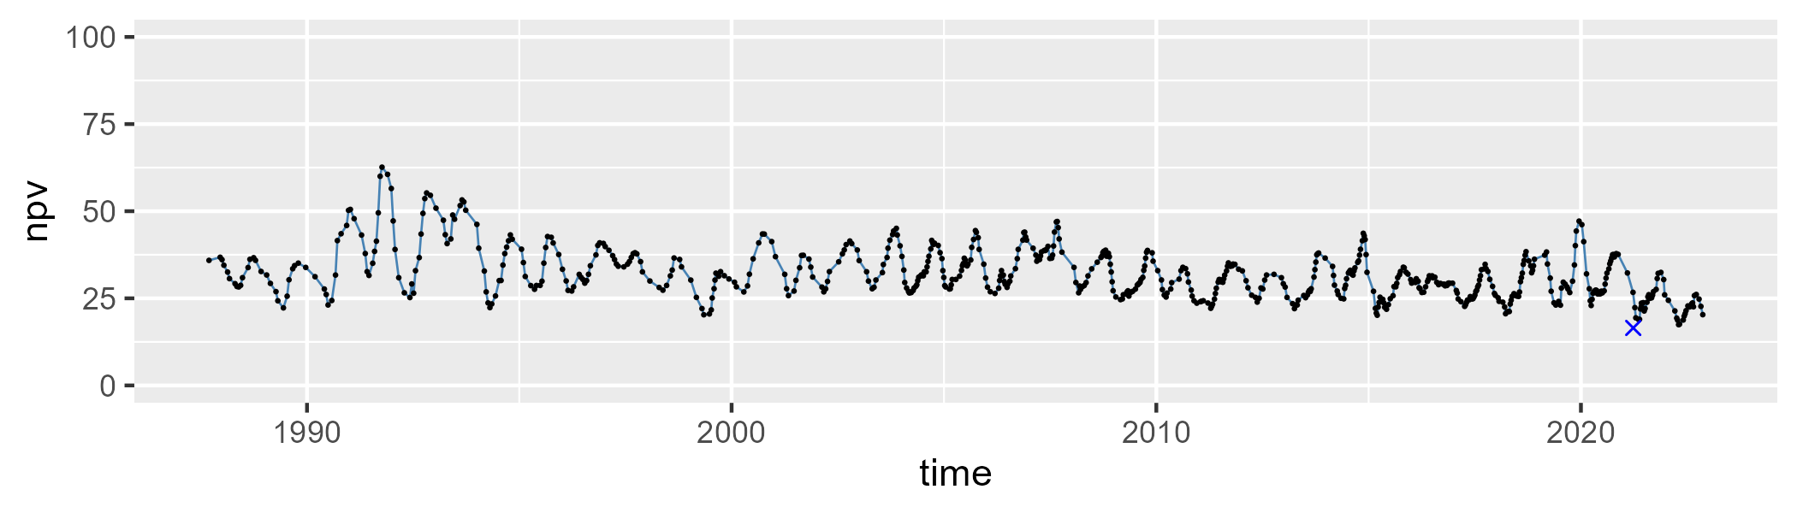

| Min. | 1st Qu. | Median | Mean | 3rd Qu. | Max. |
| --- | --- | --- | --- | --- | --- |
| 0 | 1.661637 | 3.301643 | 4.413254 | 6.458928 | 19.91712 |

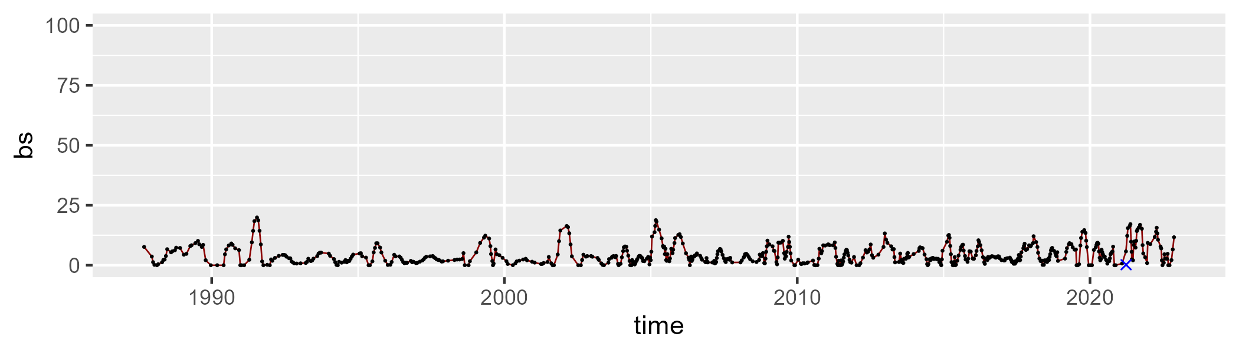

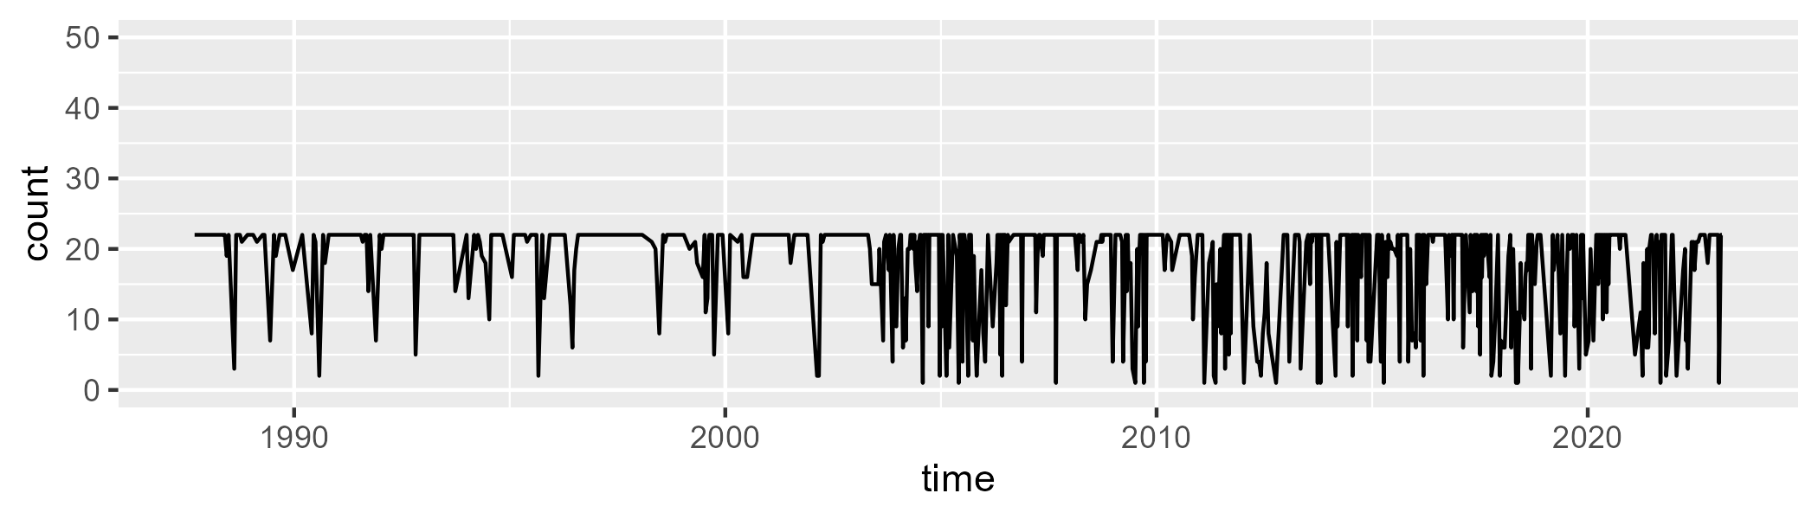

Min. : 1.00 1st Qu.:16.00 Median :22.00 Mean :17.87 3rd Qu.:22.00 Max. :22.00

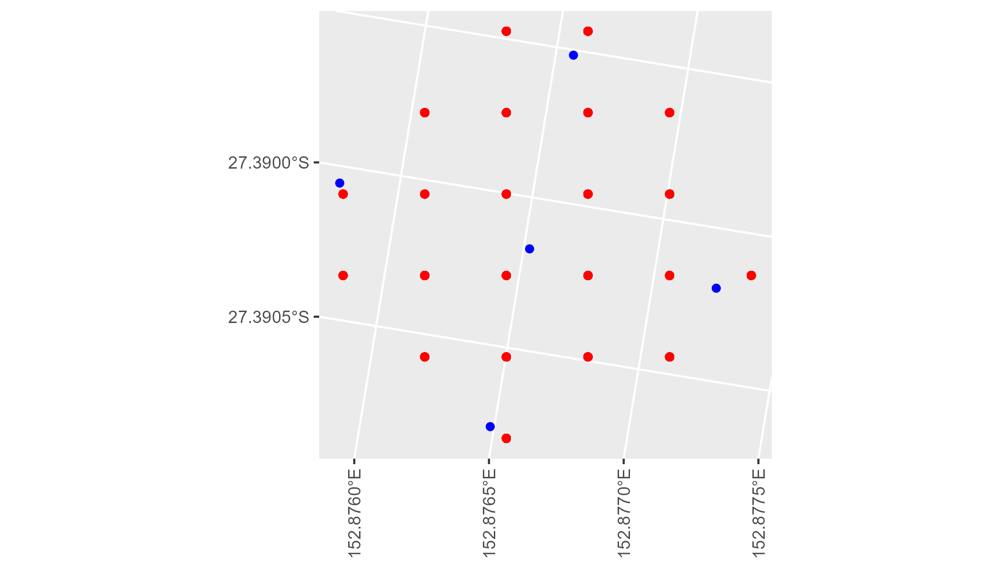

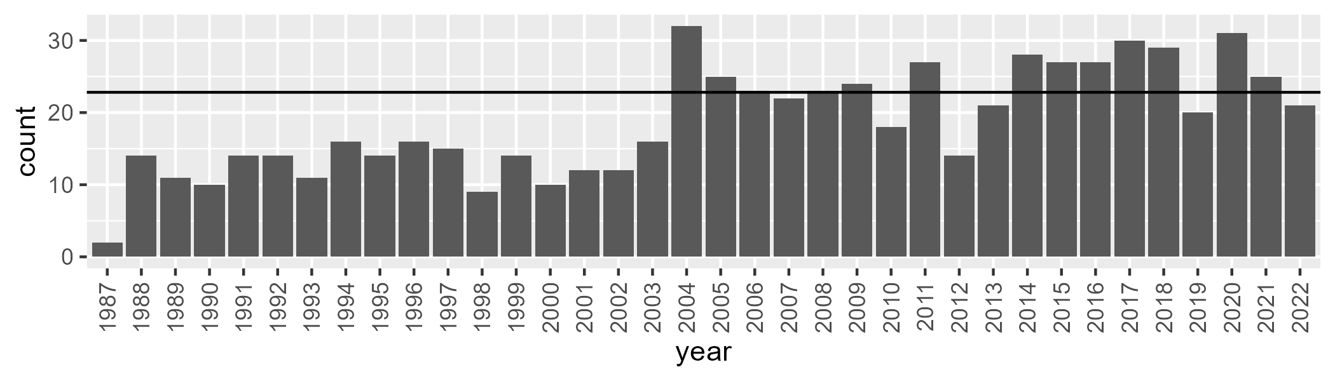

Number of samples: 677

# QDASSD0001

| Min. | 1st Qu. | Median | Mean | 3rd Qu. | Max. |
| --- | --- | --- | --- | --- | --- |
| 0.4480627 | 2.788996 | 5.593717 | 7.166527 | 10.06774 | 29.18926 |

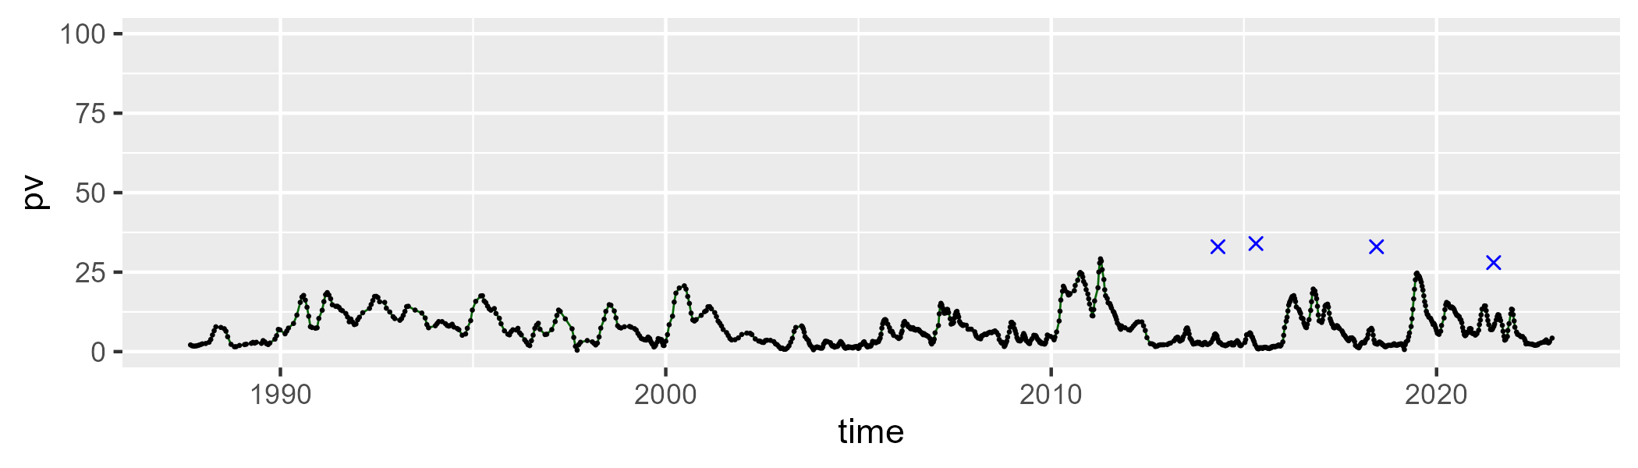

| Min. | 1st Qu. | Median | Mean | 3rd Qu. | Max. |
| --- | --- | --- | --- | --- | --- |
| 15.18108 | 29.73029 | 33.69913 | 34.40876 | 39.19393 | 55.16751 |

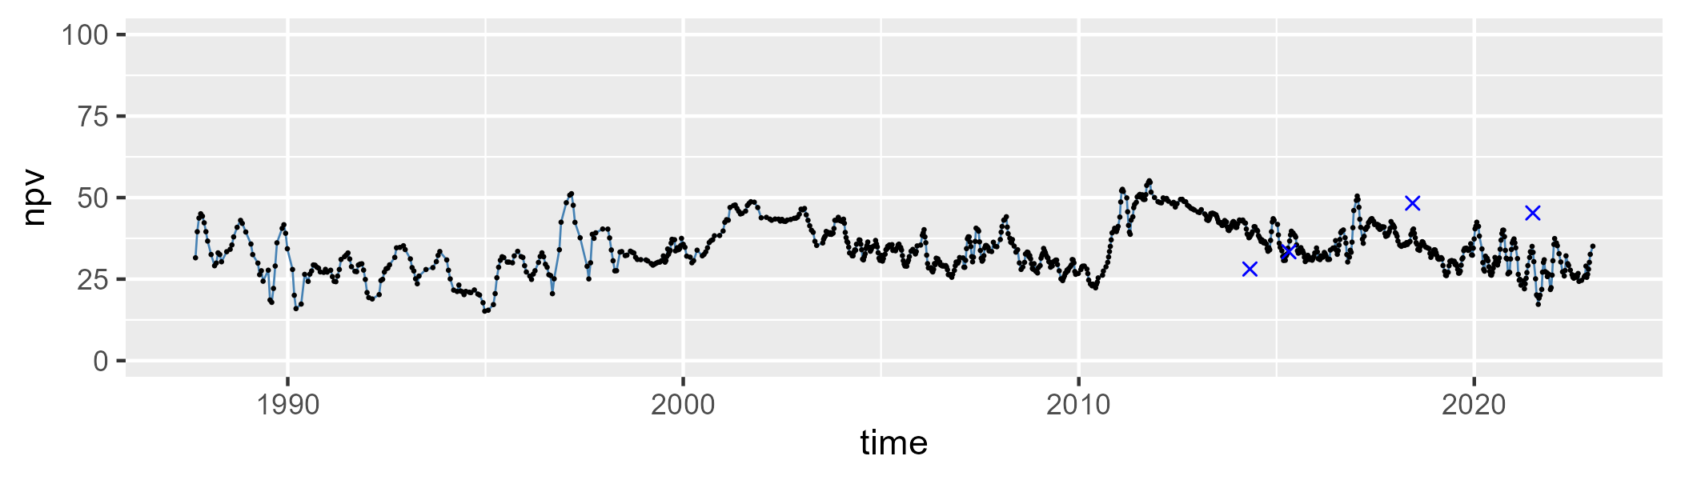

| Min. | 1st Qu. | Median | Mean | 3rd Qu. | Max. |
| --- | --- | --- | --- | --- | --- |
| 27.9146 | 52.58387 | 57.5776 | 56.91144 | 62.87065 | 77.61735 |

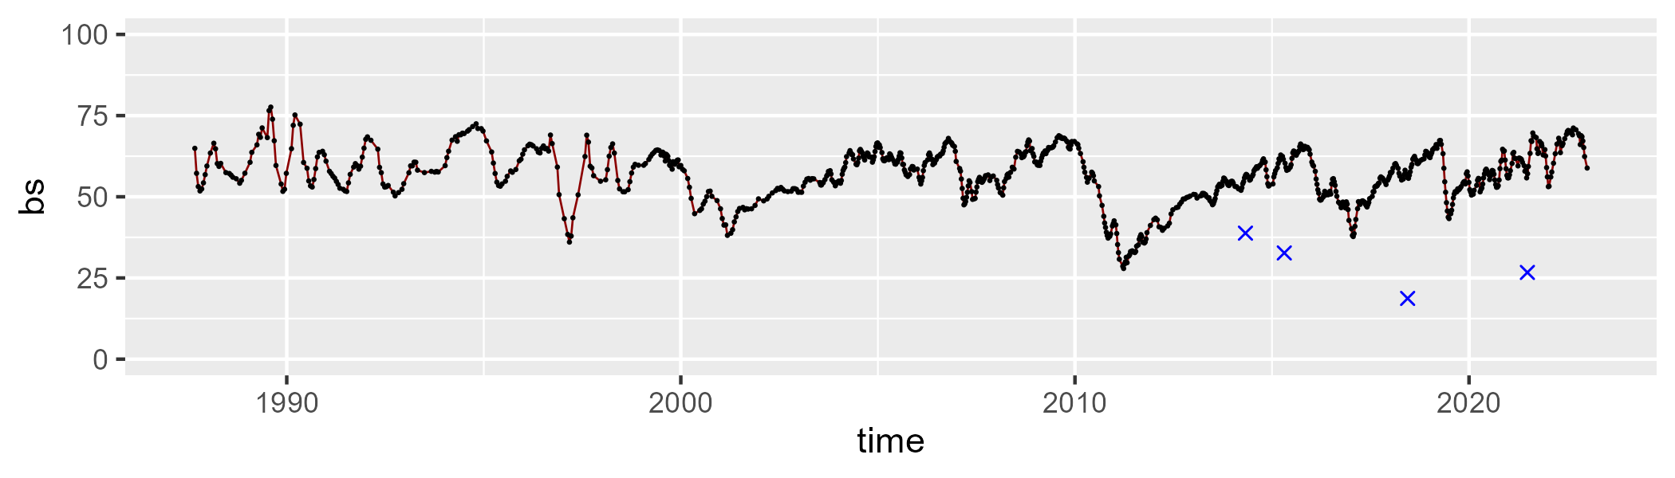

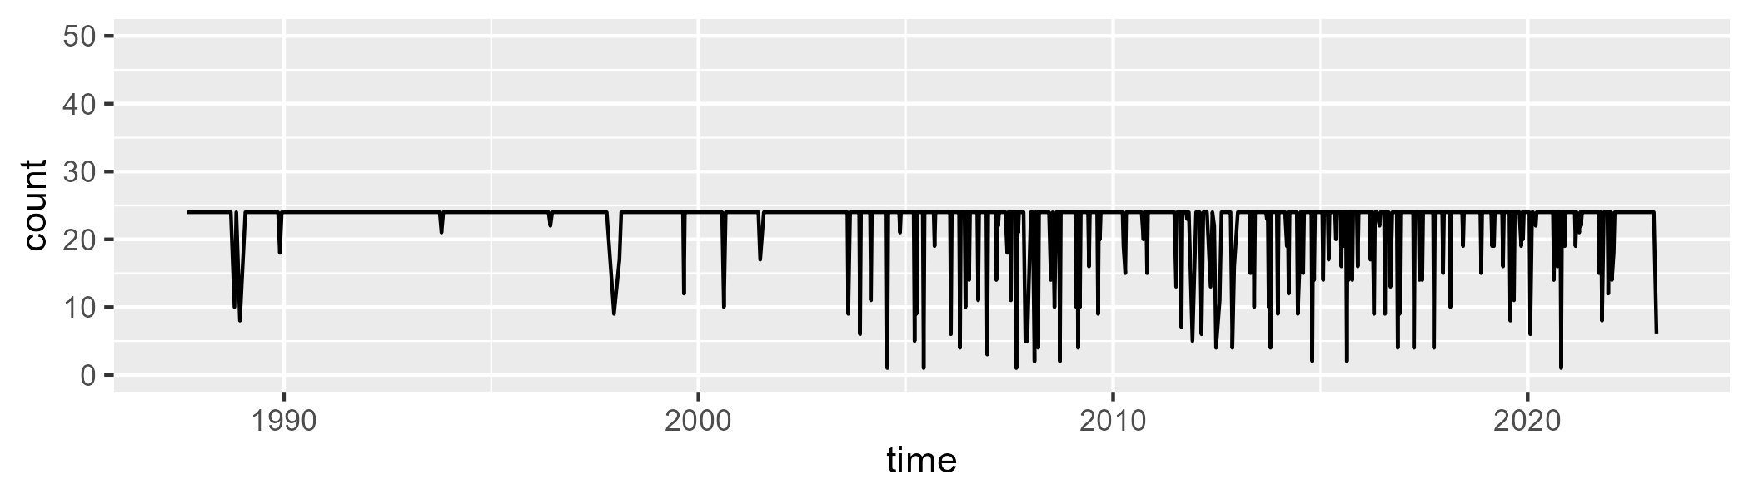

Min. : 1.00 1st Qu.:24.00 Median :24.00 Mean :22.58 3rd Qu.:24.00 Max. :24.00

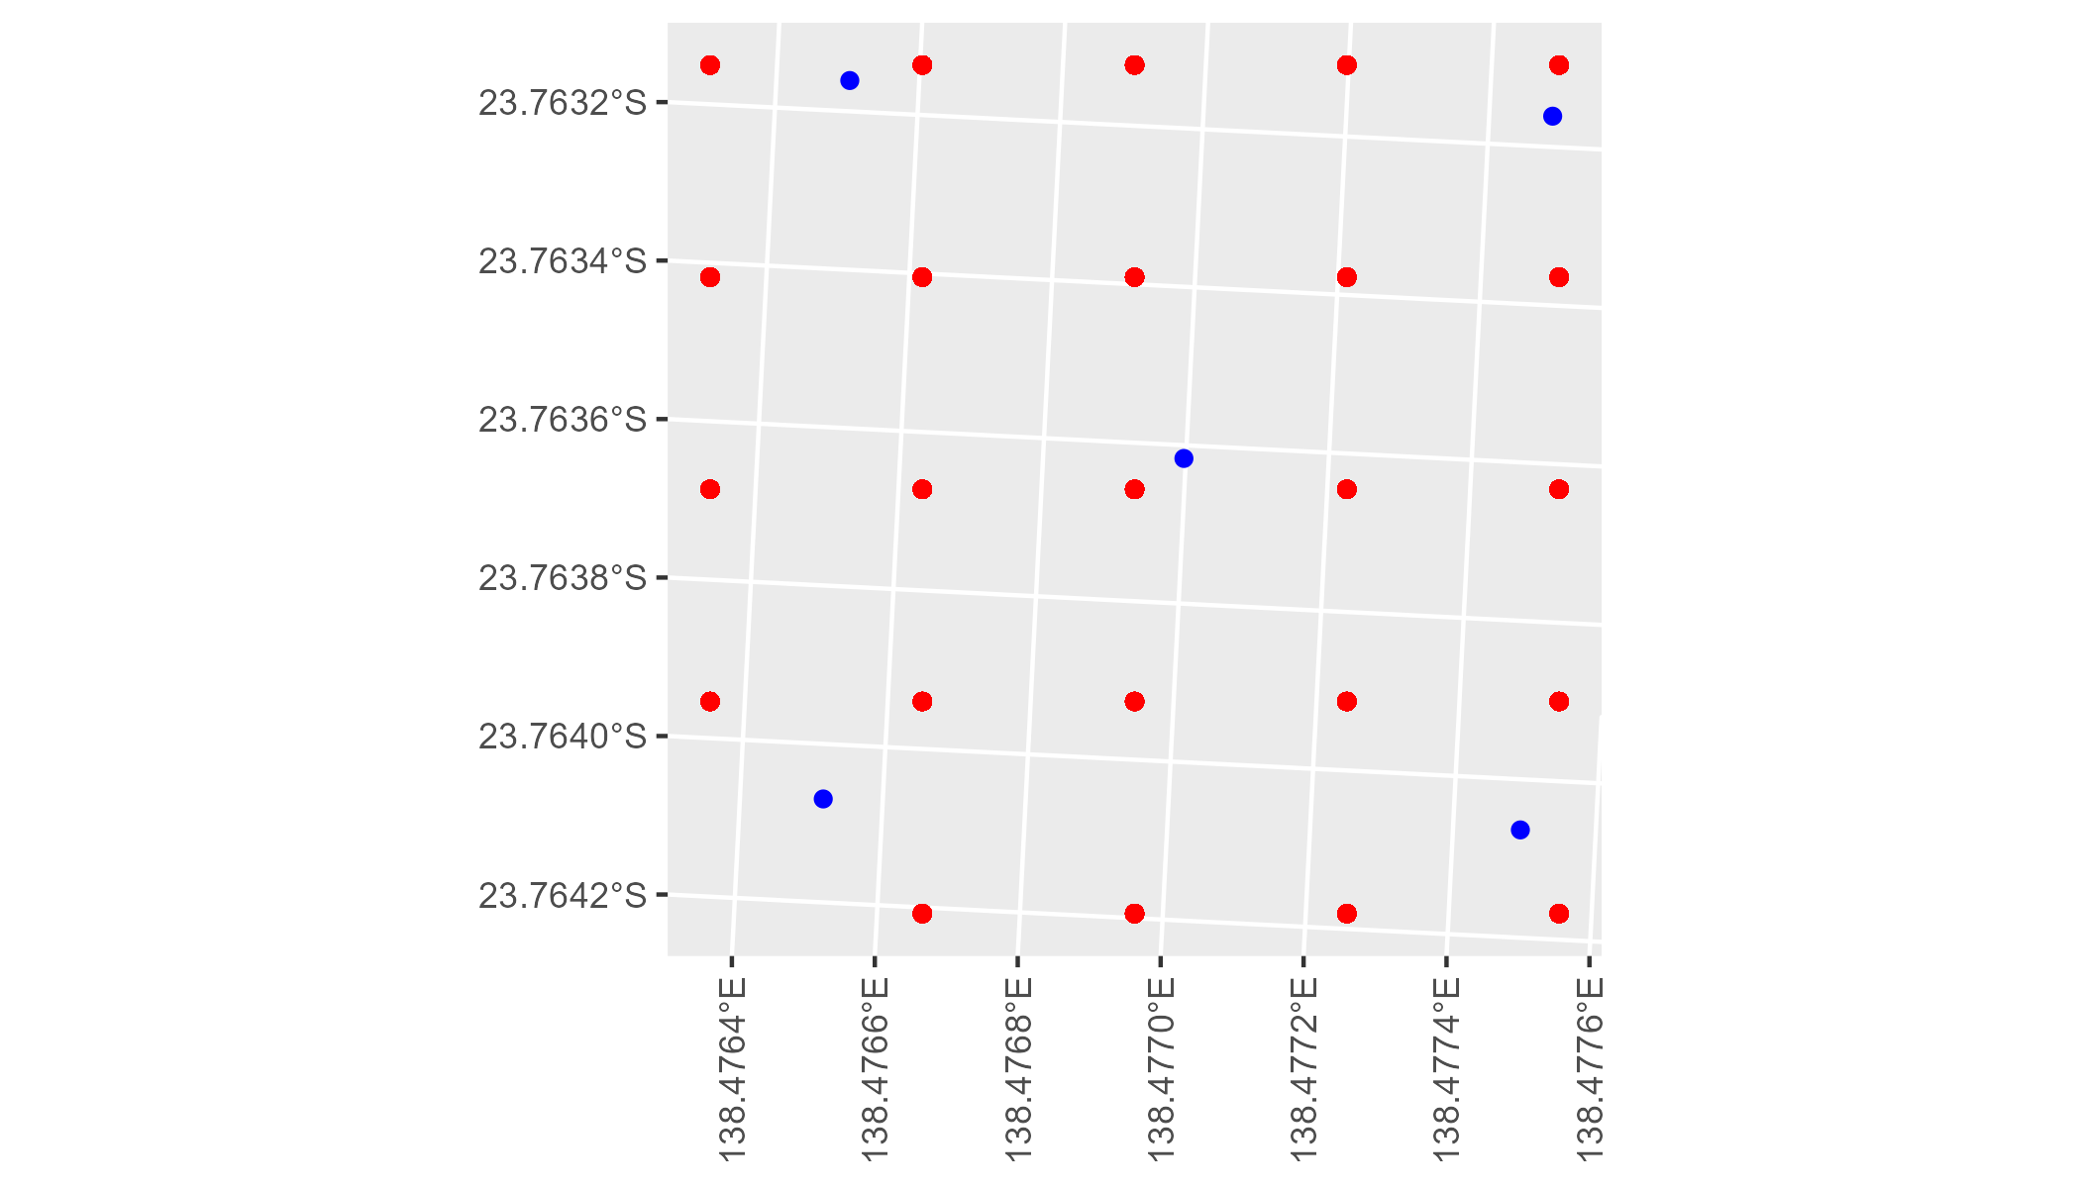

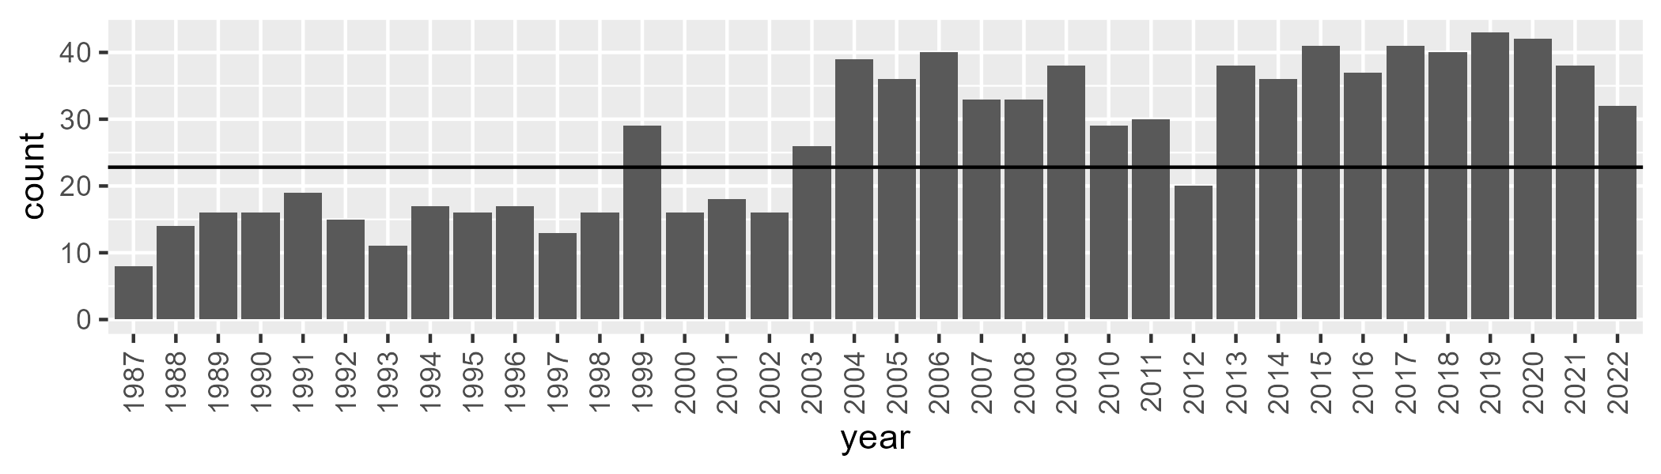

Number of samples: 969

# QDASSD0002

| Min. | 1st Qu. | Median | Mean | 3rd Qu. | Max. |
| --- | --- | --- | --- | --- | --- |
| 1.689373 | 8.173098 | 10.47987 | 11.17904 | 13.37047 | 30.9354 |

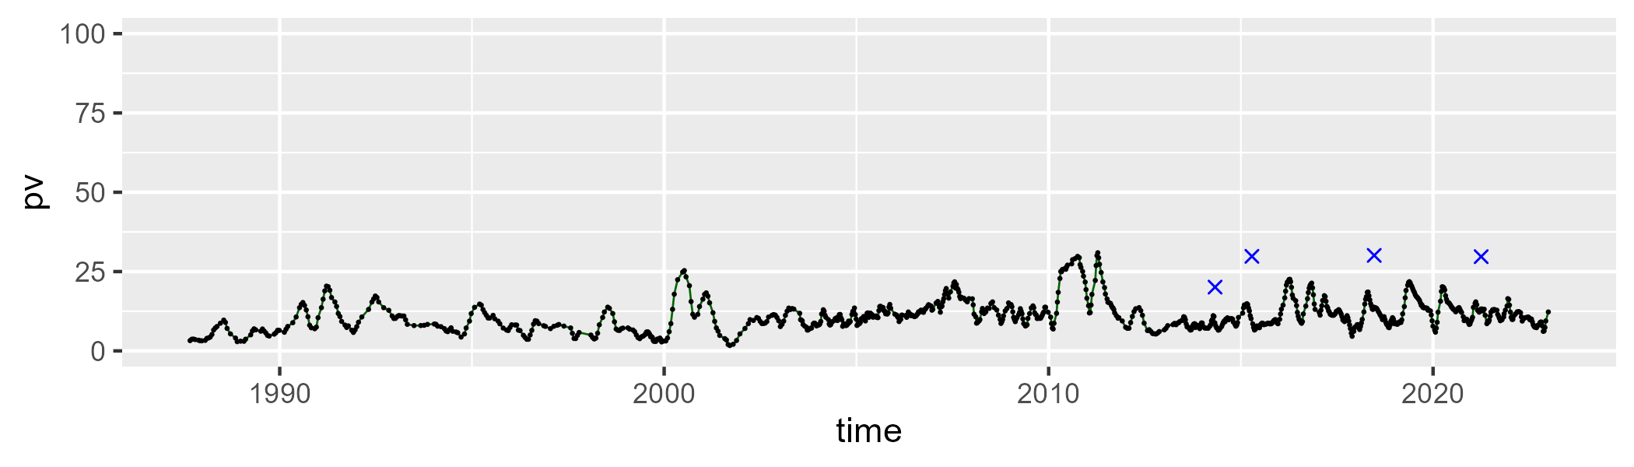

| Min. | 1st Qu. | Median | Mean | 3rd Qu. | Max. |
| --- | --- | --- | --- | --- | --- |
| 0 | 12.77797 | 20.28391 | 20.28608 | 29.1752 | 52.68645 |

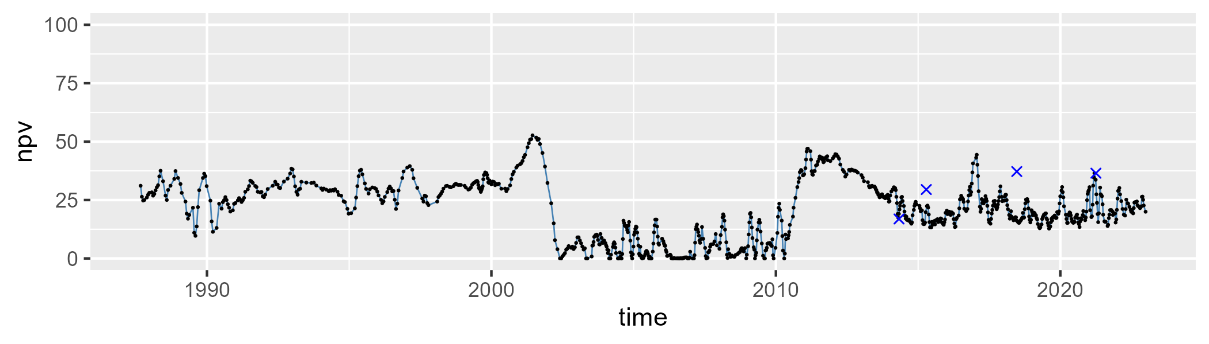

| Min. | 1st Qu. | Median | Mean | 3rd Qu. | Max. |
| --- | --- | --- | --- | --- | --- |
| 29.60804 | 60.70262 | 66.62314 | 67.08145 | 75.23847 | 92.28199 |

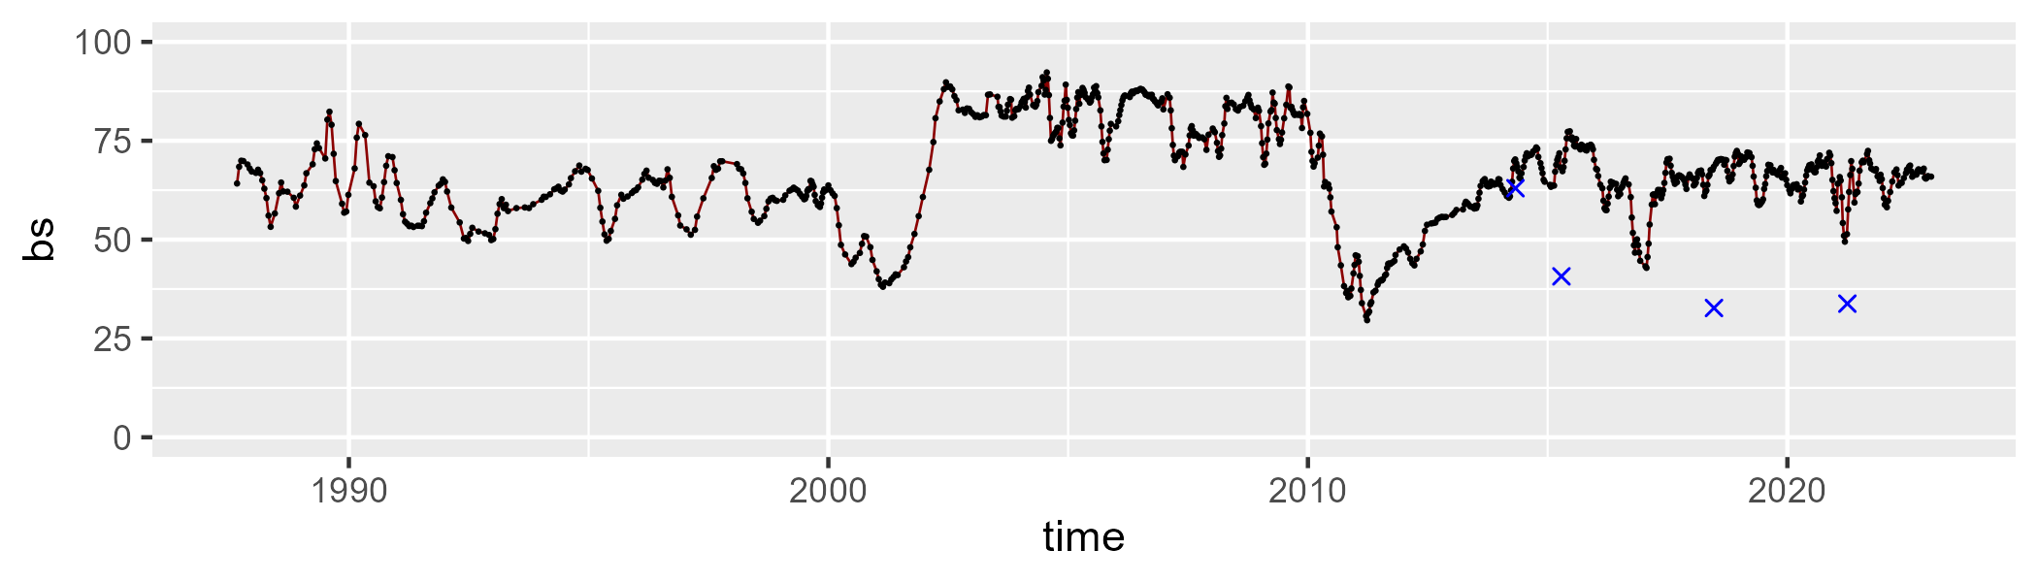

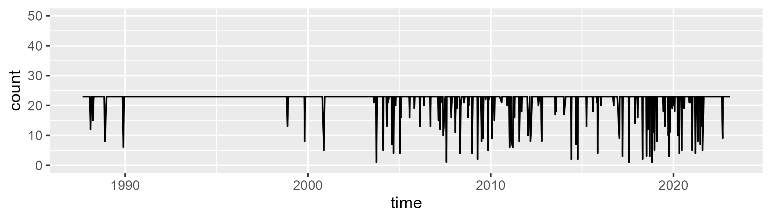

Min. : 1.00 1st Qu.:23.00 Median :23.00 Mean :21.74 3rd Qu.:23.00 Max. :23.00

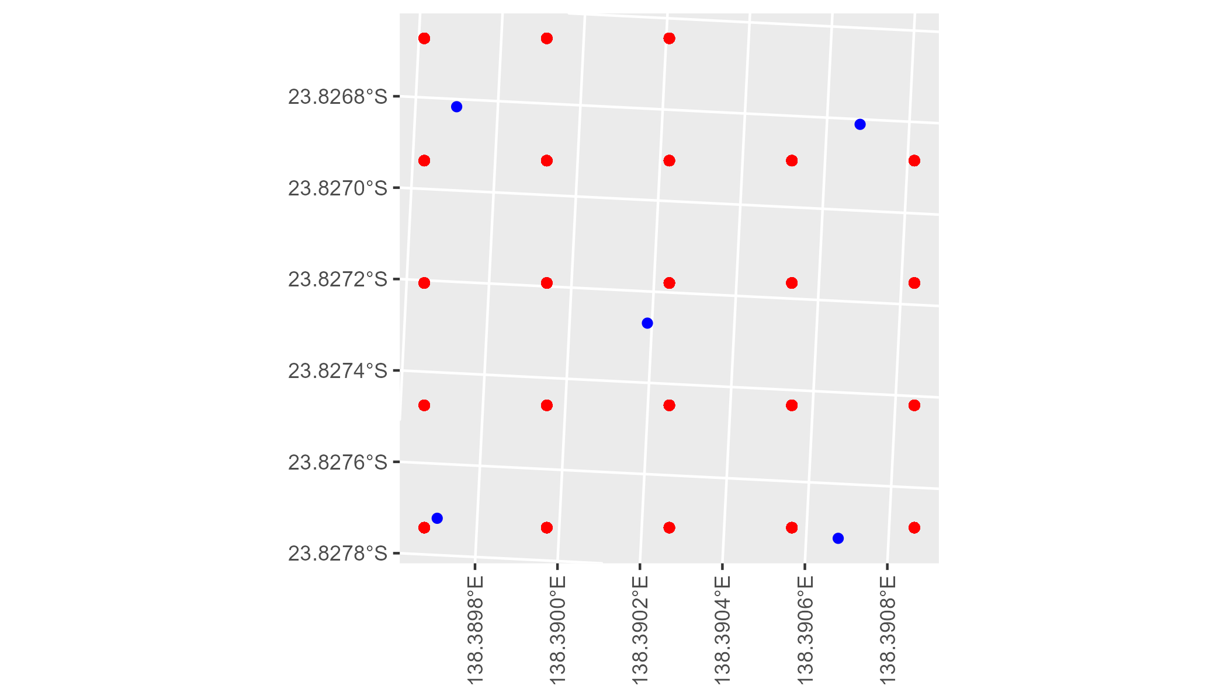

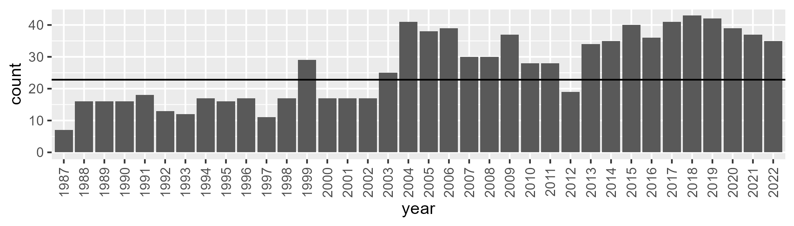

Number of samples: 953

# QDASSD0003

| Min. | 1st Qu. | Median | Mean | 3rd Qu. | Max. |
| --- | --- | --- | --- | --- | --- |
| 2.85358 | 7.742652 | 10.17364 | 11.14654 | 12.74846 | 35.20948 |

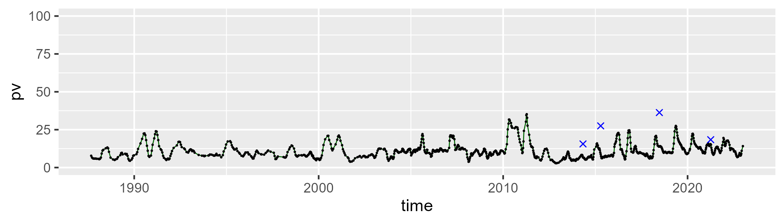

| Min. | 1st Qu. | Median | Mean | 3rd Qu. | Max. |
| --- | --- | --- | --- | --- | --- |
| 0 | 15.95045 | 22.80663 | 24.2311 | 31.84979 | 62.64575 |

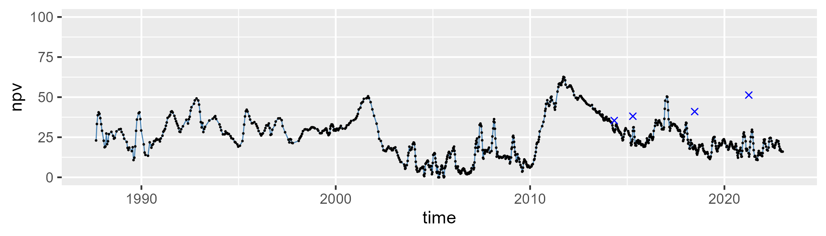

| Min. | 1st Qu. | Median | Mean | 3rd Qu. | Max. |
| --- | --- | --- | --- | --- | --- |
| 20.68992 | 56.17023 | 63.72417 | 63.10576 | 71.94385 | 88.34746 |

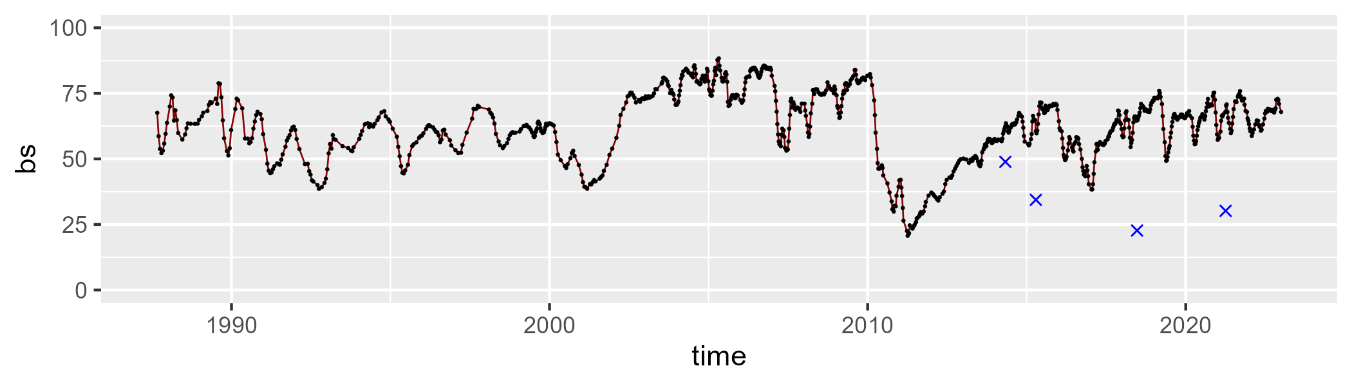

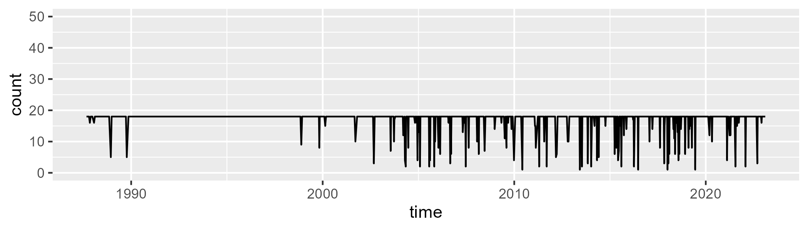

Min. : 1.00 1st Qu.:18.00 Median :18.00 Mean :16.93 3rd Qu.:18.00 Max. :18.00

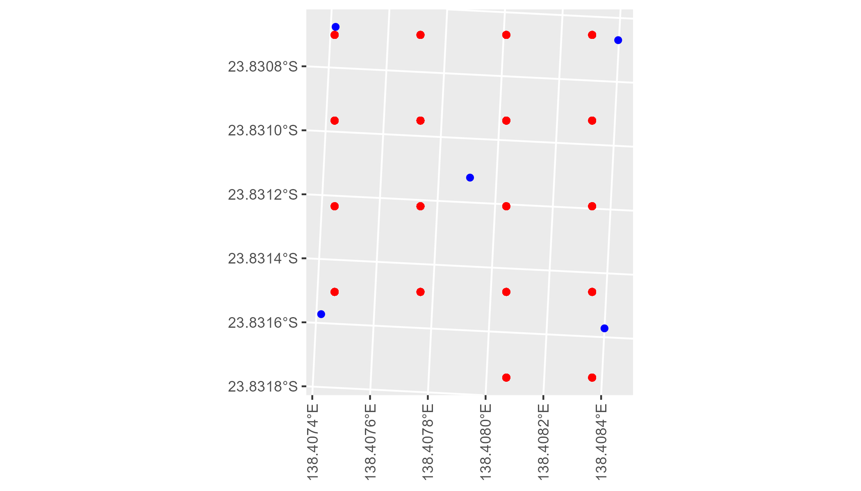

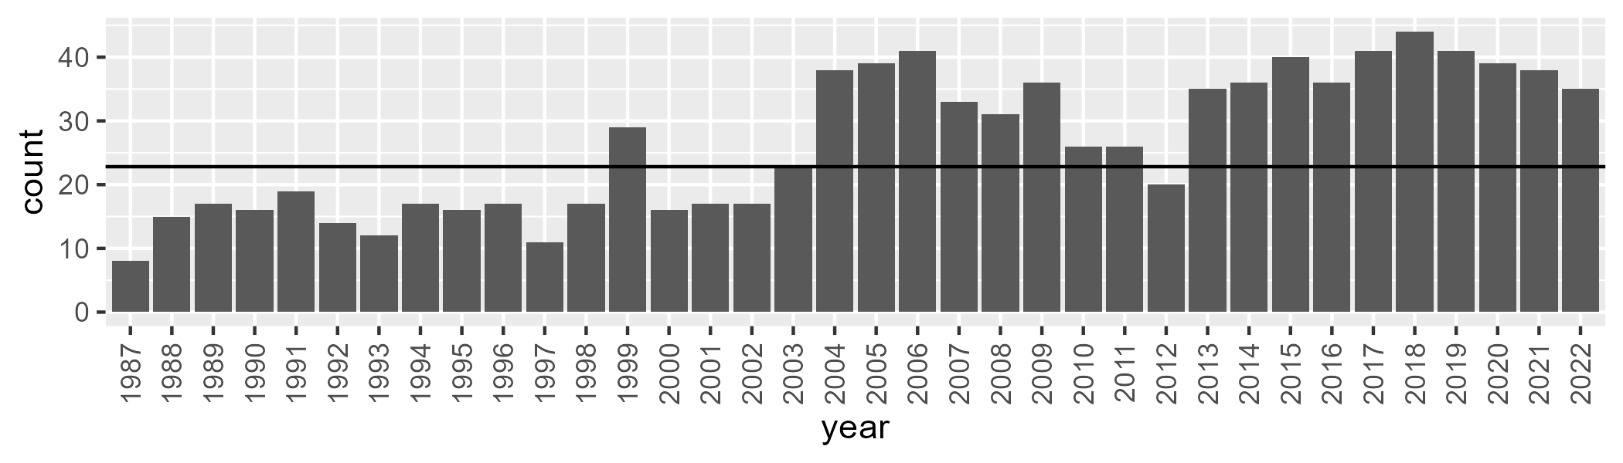

Number of samples: 956

# QDASSD0004

| Min. | 1st Qu. | Median | Mean | 3rd Qu. | Max. |
| --- | --- | --- | --- | --- | --- |
| 0 | 2.358106 | 4.877263 | 7.174442 | 10.33047 | 31.34037 |

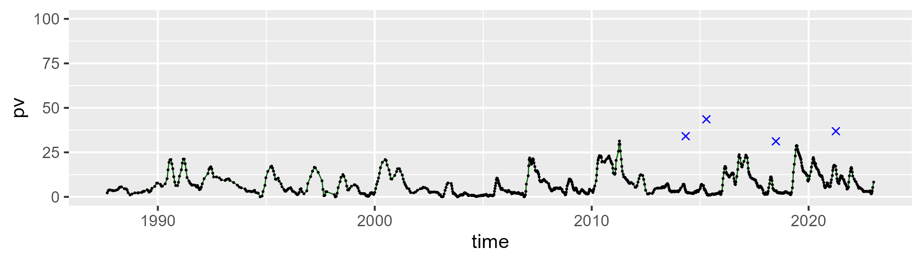

| Min. | 1st Qu. | Median | Mean | 3rd Qu. | Max. |
| --- | --- | --- | --- | --- | --- |
| 20.35694 | 34.10042 | 38.73145 | 39.43496 | 43.75598 | 65.90852 |

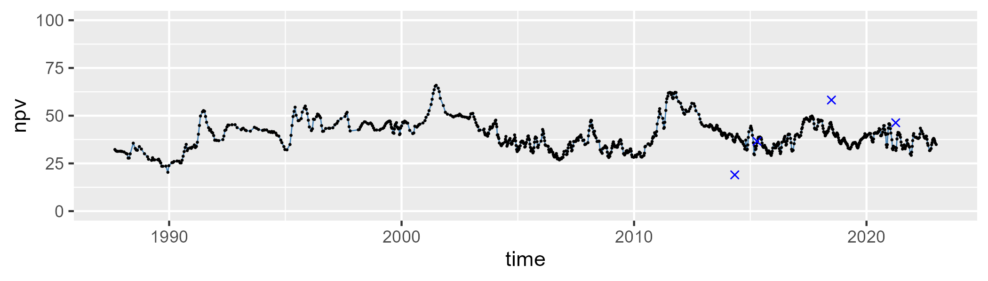

| Min. | 1st Qu. | Median | Mean | 3rd Qu. | Max. |
| --- | --- | --- | --- | --- | --- |
| 22.94964 | 46.32577 | 52.01513 | 51.89519 | 59.42075 | 71.44612 |

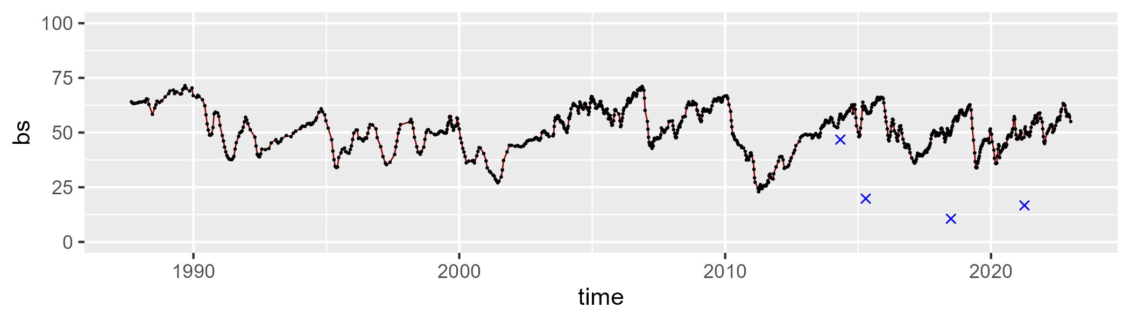

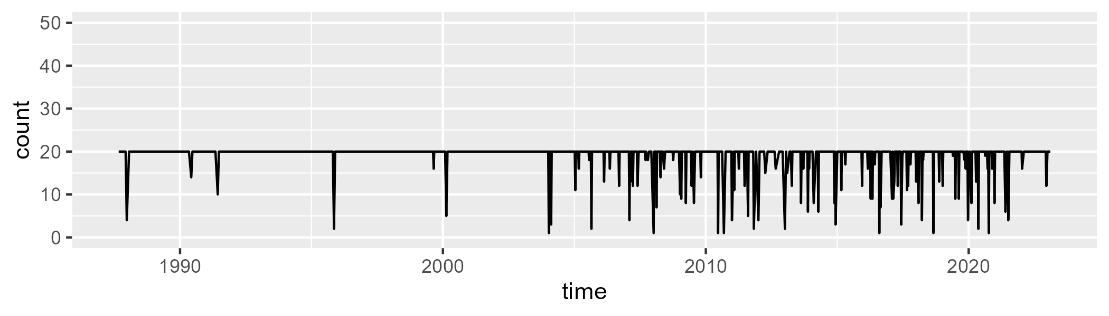

Min. : 1.00 1st Qu.:20.00 Median :20.00 Mean :18.97 3rd Qu.:20.00 Max. :20.00

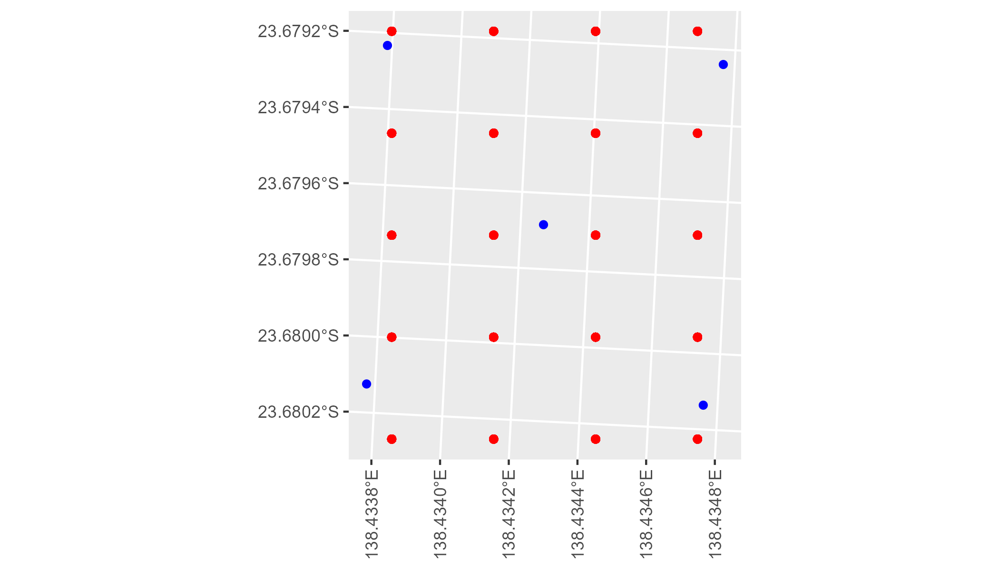

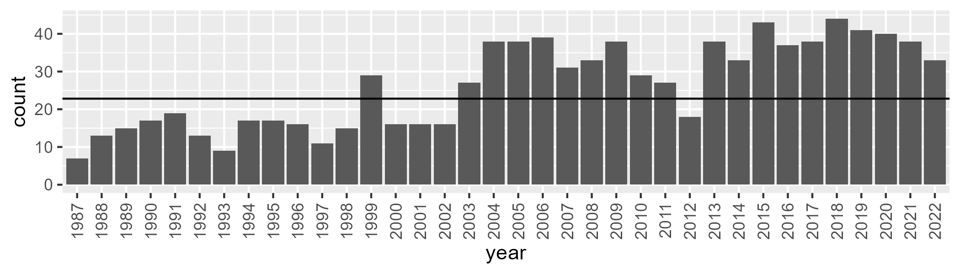

Number of samples: 949

# QDASSD0005

| Min. | 1st Qu. | Median | Mean | 3rd Qu. | Max. |
| --- | --- | --- | --- | --- | --- |
| 3.298311 | 7.109316 | 9.037527 | 10.39881 | 12.62558 | 35.41397 |

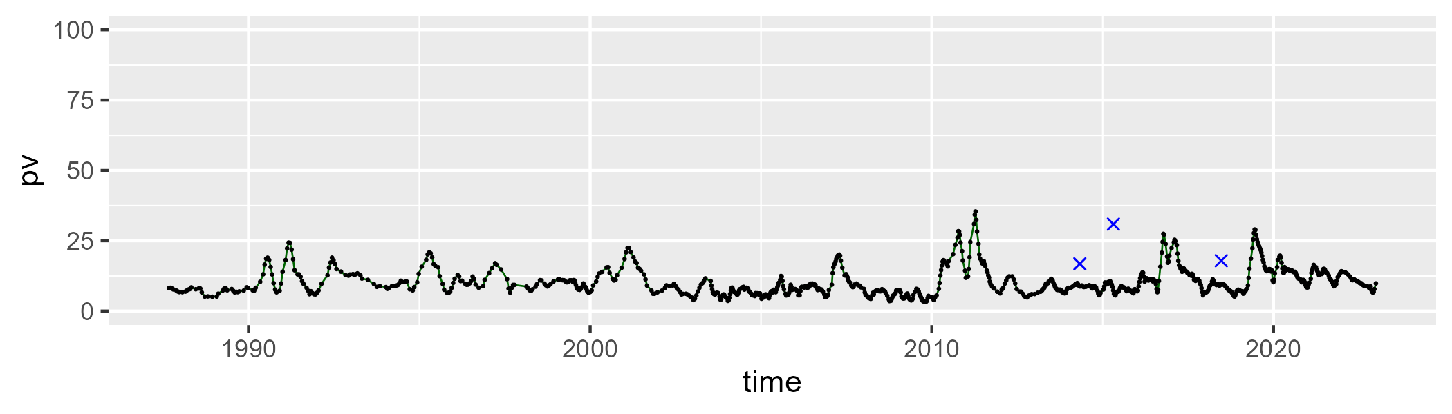

| Min. | 1st Qu. | Median | Mean | 3rd Qu. | Max. |
| --- | --- | --- | --- | --- | --- |
| 10.837 | 22.8176 | 28.10394 | 28.50574 | 32.8104 | 54.05236 |

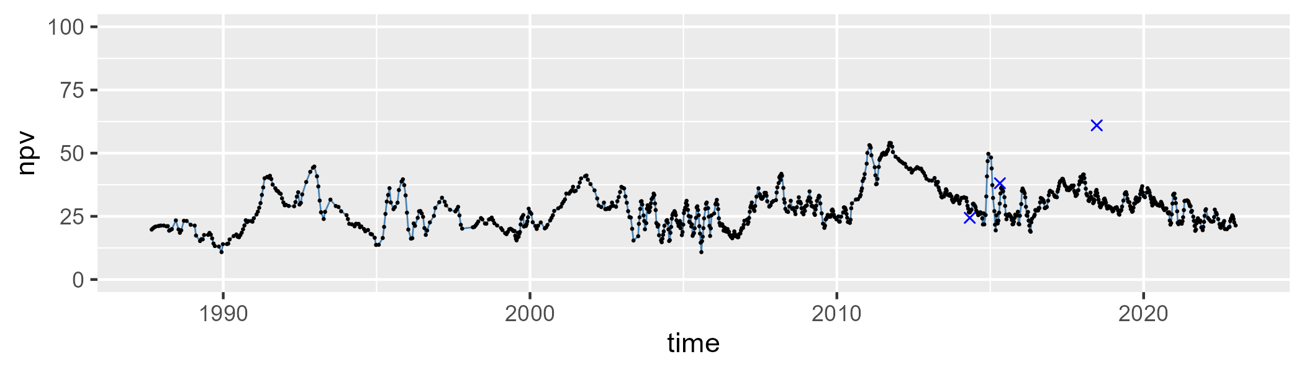

| Min. | 1st Qu. | Median | Mean | 3rd Qu. | Max. |
| --- | --- | --- | --- | --- | --- |
| 23.12962 | 53.48879 | 61.59912 | 59.52628 | 66.63076 | 79.06318 |

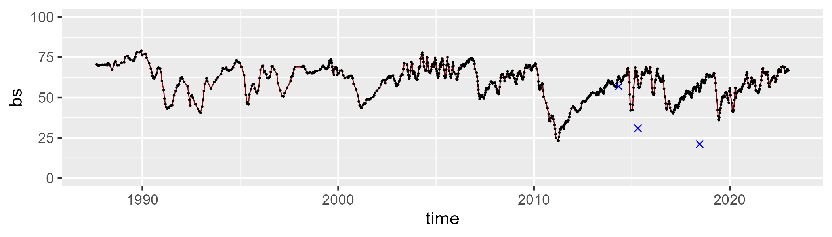

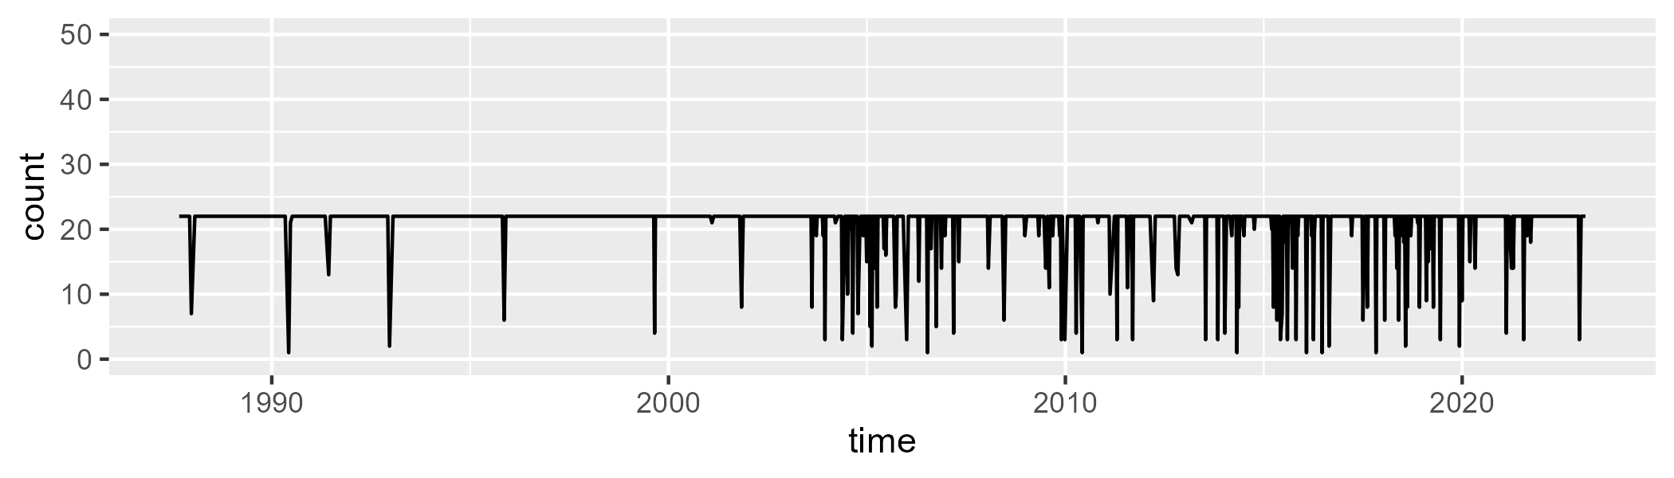

Min. : 1.00 1st Qu.:22.00 Median :22.00 Mean :20.62 3rd Qu.:22.00 Max. :22.00

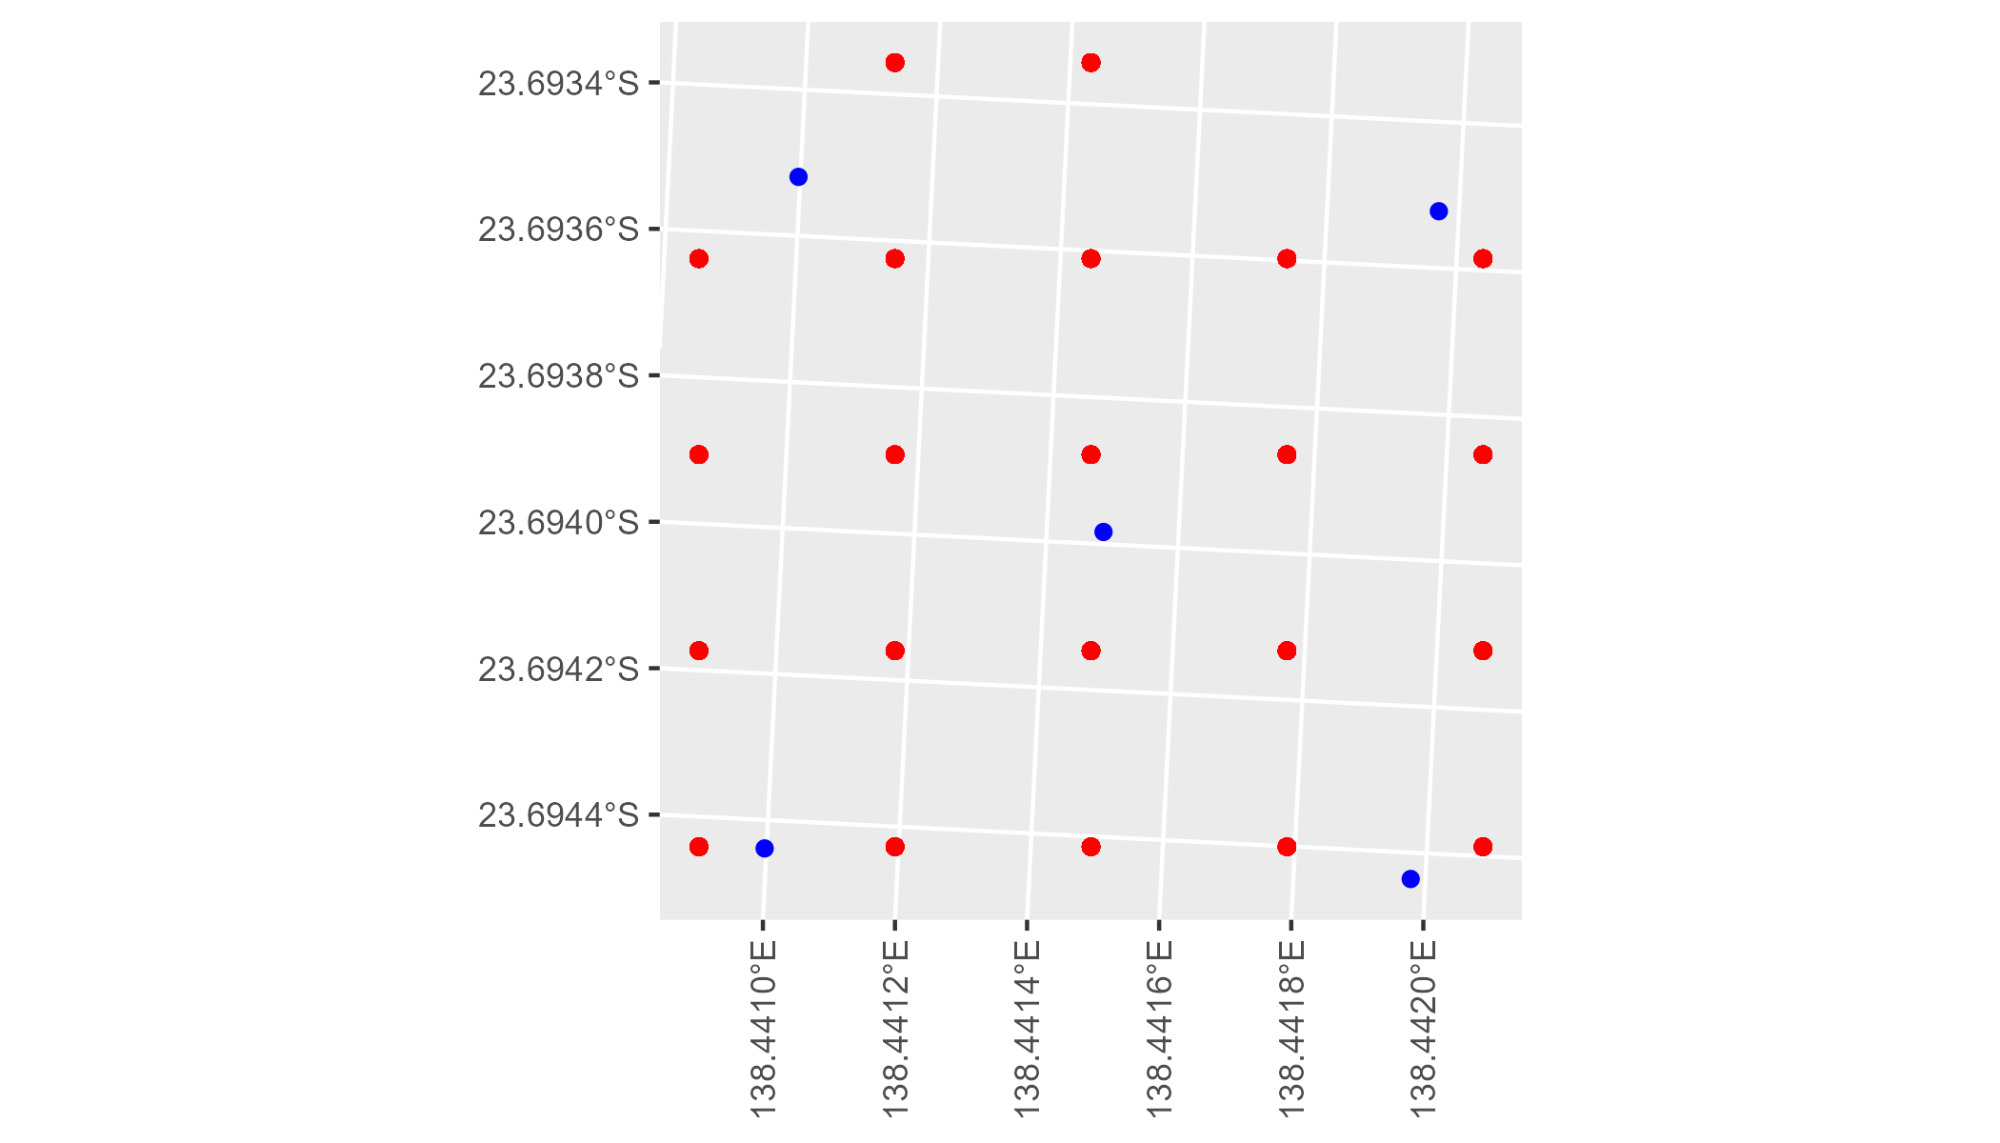

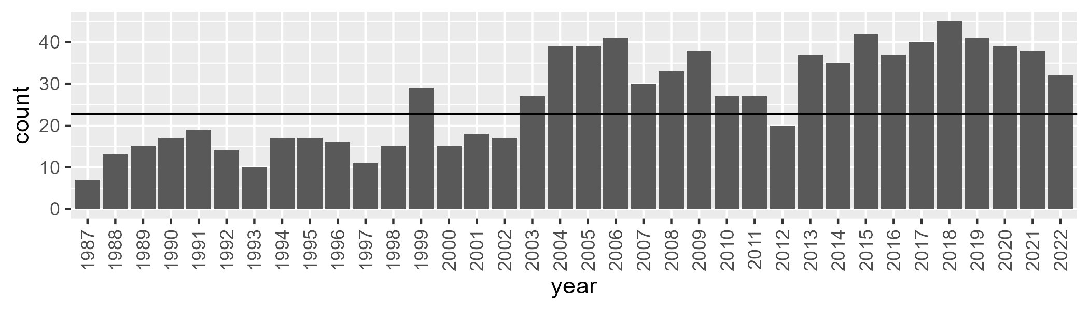

Number of samples: 957

# QDASSD0006

| Min. | 1st Qu. | Median | Mean | 3rd Qu. | Max. |
| --- | --- | --- | --- | --- | --- |
| 4.036073 | 10.53448 | 13.85334 | 14.06811 | 16.71973 | 31.21925 |

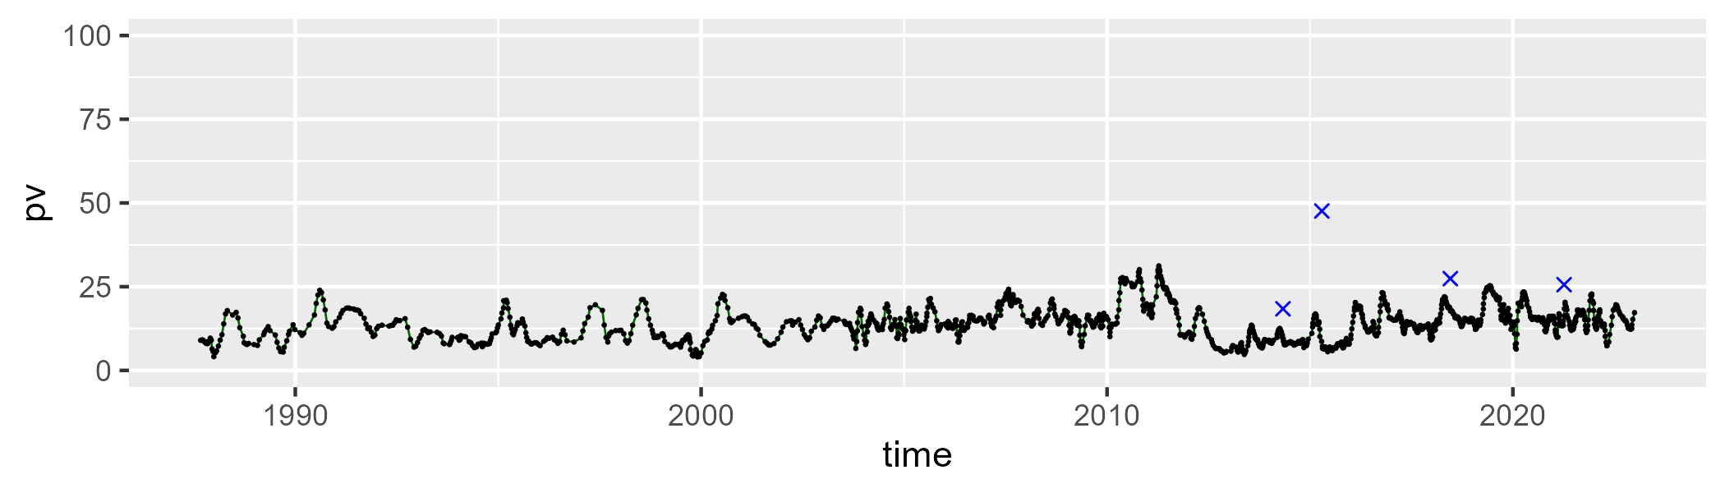

| Min. | 1st Qu. | Median | Mean | 3rd Qu. | Max. |
| --- | --- | --- | --- | --- | --- |
| 0 | 11.30435 | 19.54131 | 20.96874 | 30.3691 | 49.29376 |

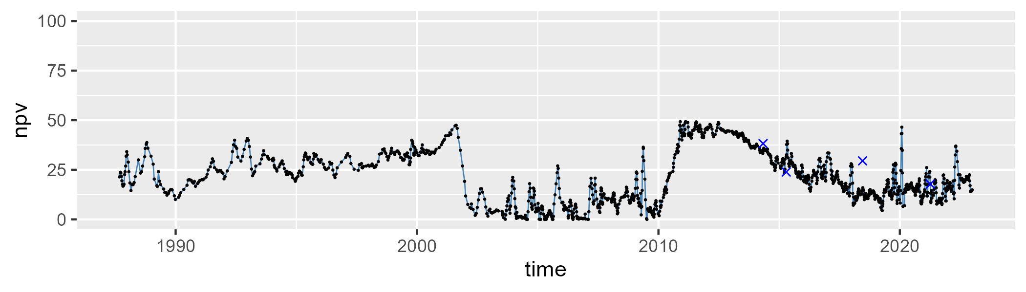

| Min. | 1st Qu. | Median | Mean | 3rd Qu. | Max. |
| --- | --- | --- | --- | --- | --- |
| 25.20287 | 56.49697 | 64.47225 | 63.52917 | 71.76376 | 86.9894 |

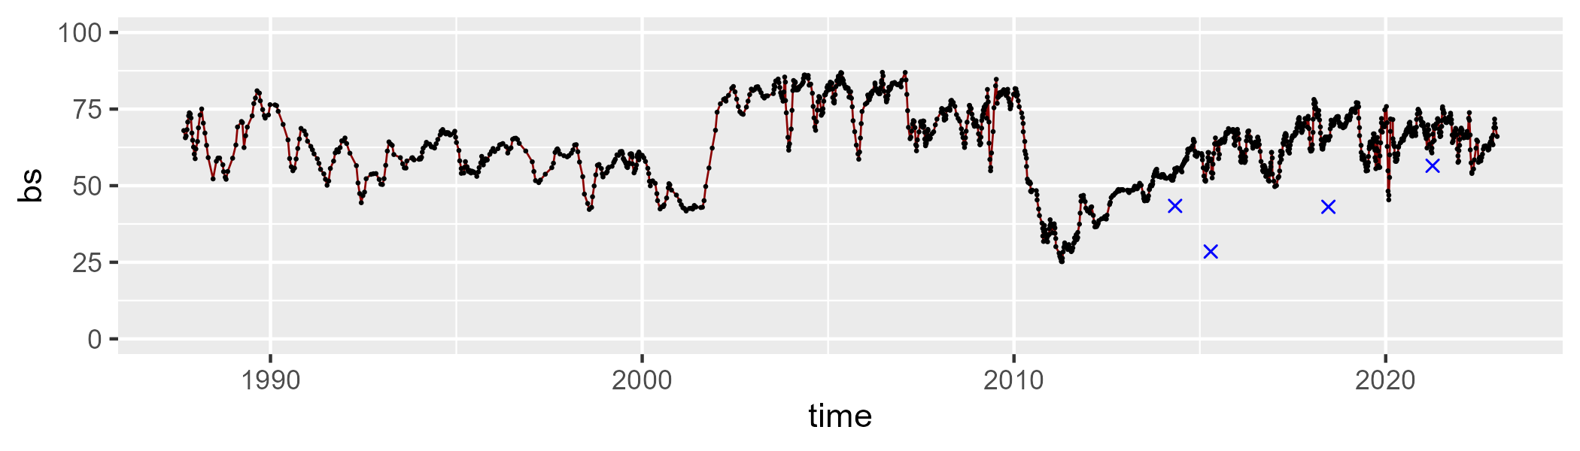

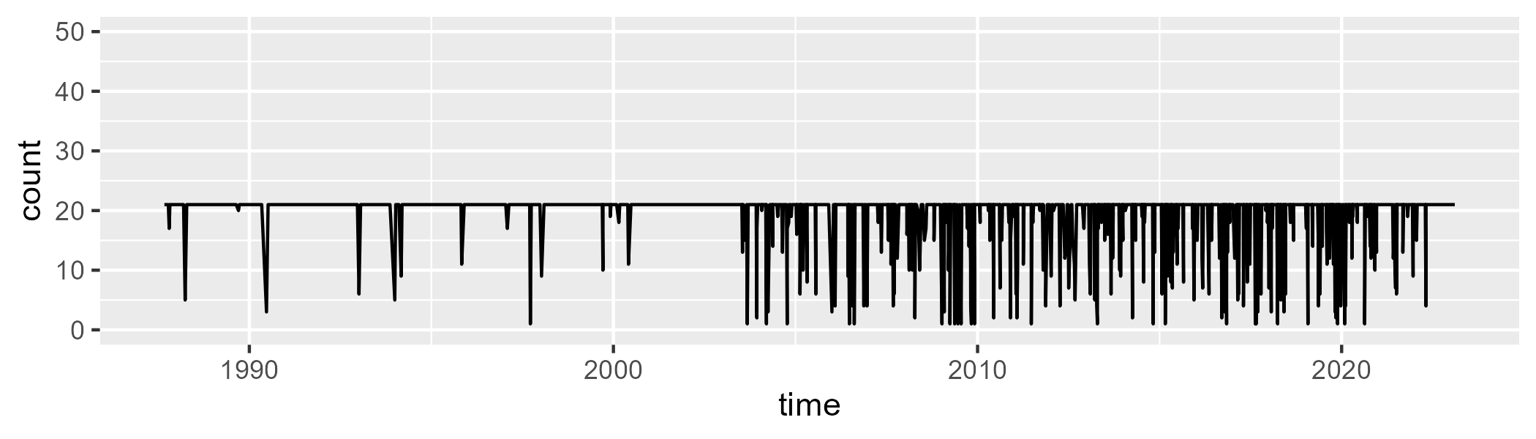

Min. : 1.00 1st Qu.:21.00 Median :21.00 Mean :19.38 3rd Qu.:21.00 Max. :21.00

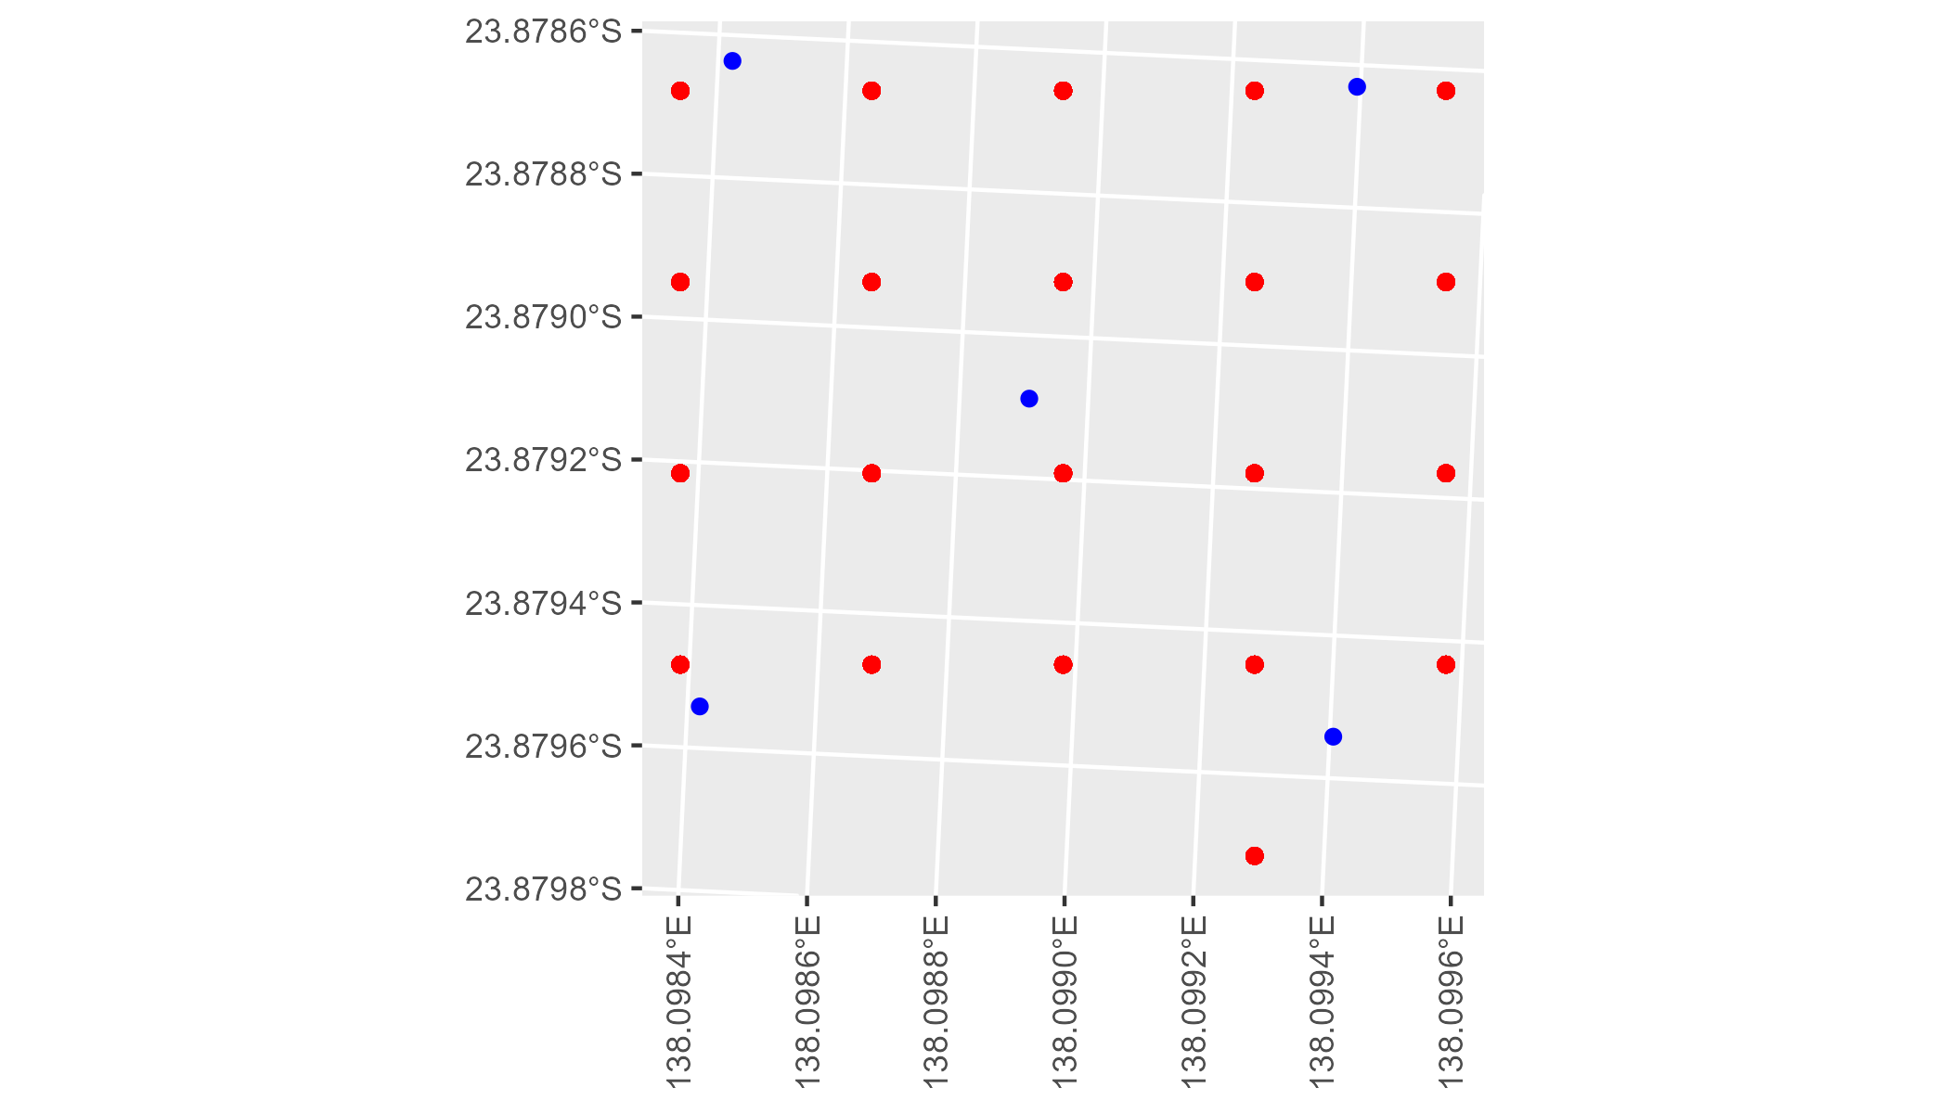

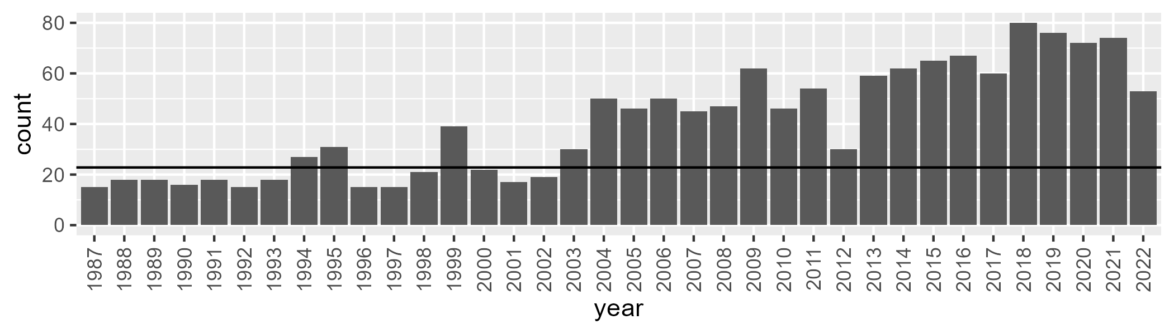

Number of samples: 1452

# QDASSD0007

| Min. | 1st Qu. | Median | Mean | 3rd Qu. | Max. |
| --- | --- | --- | --- | --- | --- |
| 4.572555 | 12.99559 | 16.14444 | 16.80365 | 20.04019 | 33.99211 |

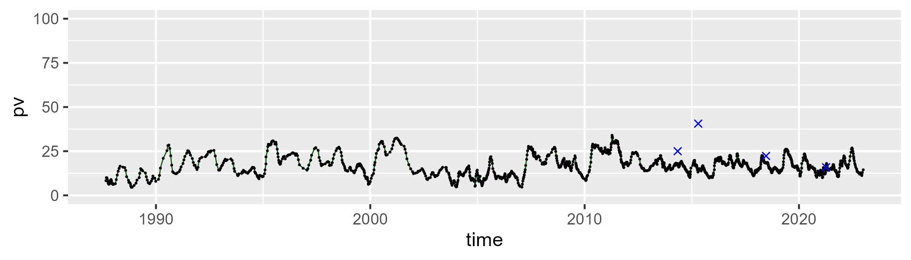

| Min. | 1st Qu. | Median | Mean | 3rd Qu. | Max. |
| --- | --- | --- | --- | --- | --- |
| 20.78007 | 34.15986 | 38.35417 | 38.34013 | 42.41343 | 55.14645 |

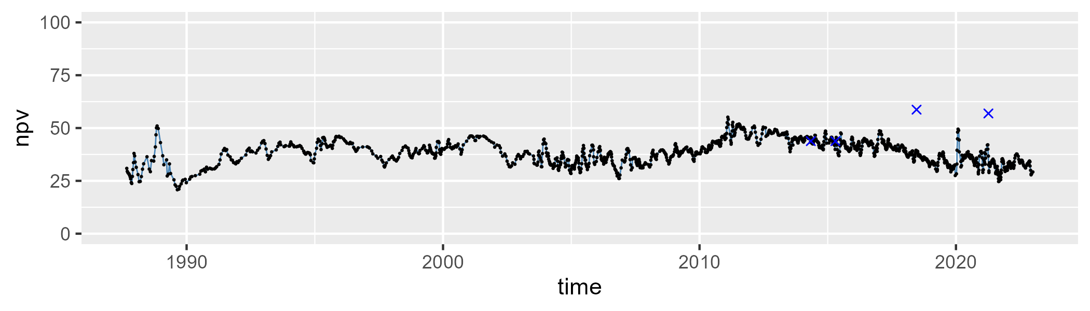

| Min. | 1st Qu. | Median | Mean | 3rd Qu. | Max. |
| --- | --- | --- | --- | --- | --- |
| 13.29812 | 37.40737 | 43.80605 | 43.43648 | 49.90911 | 70.90686 |

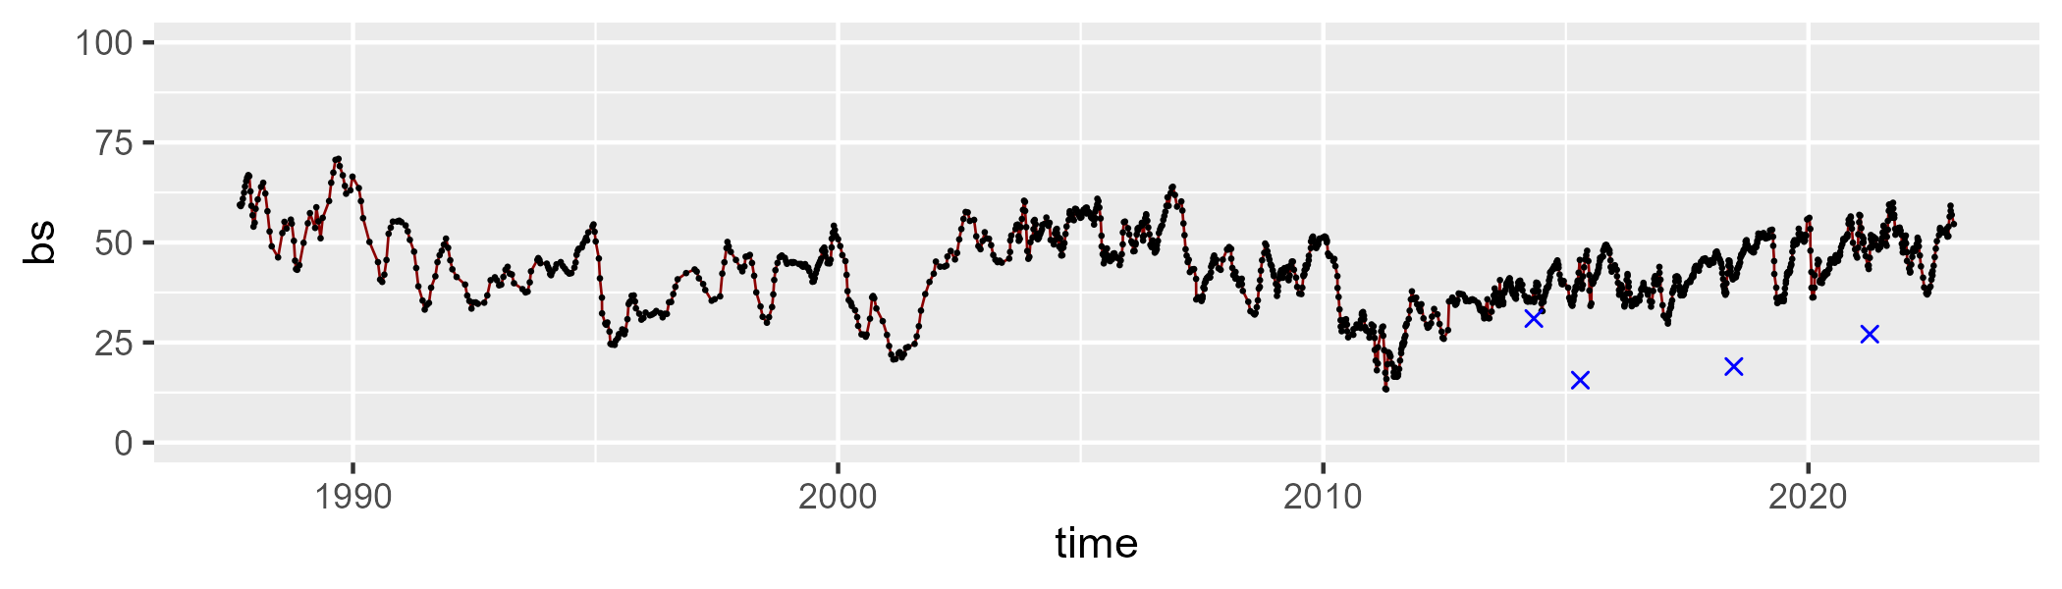

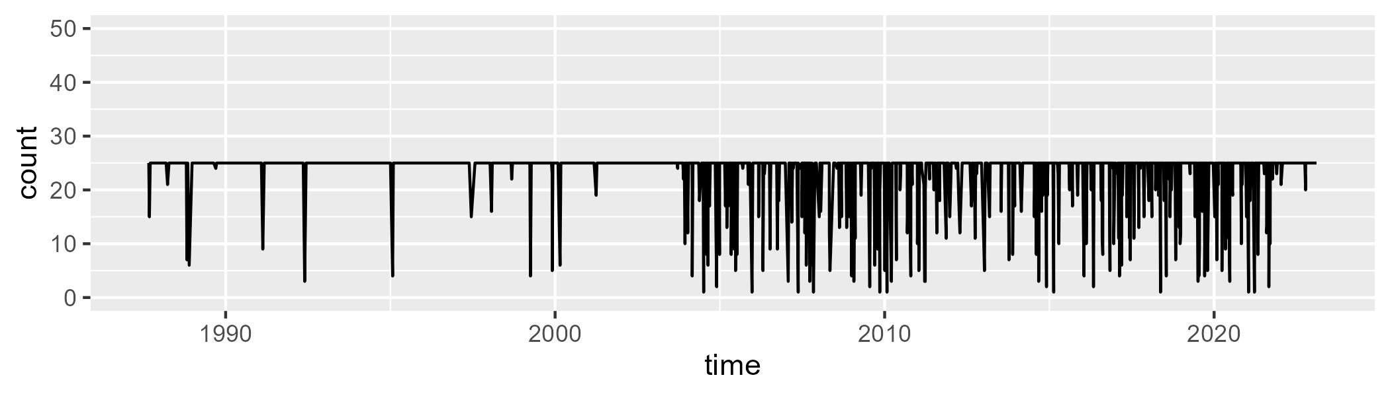

Min. : 1.00 1st Qu.:25.00 Median :25.00 Mean :23.19 3rd Qu.:25.00 Max. :25.00

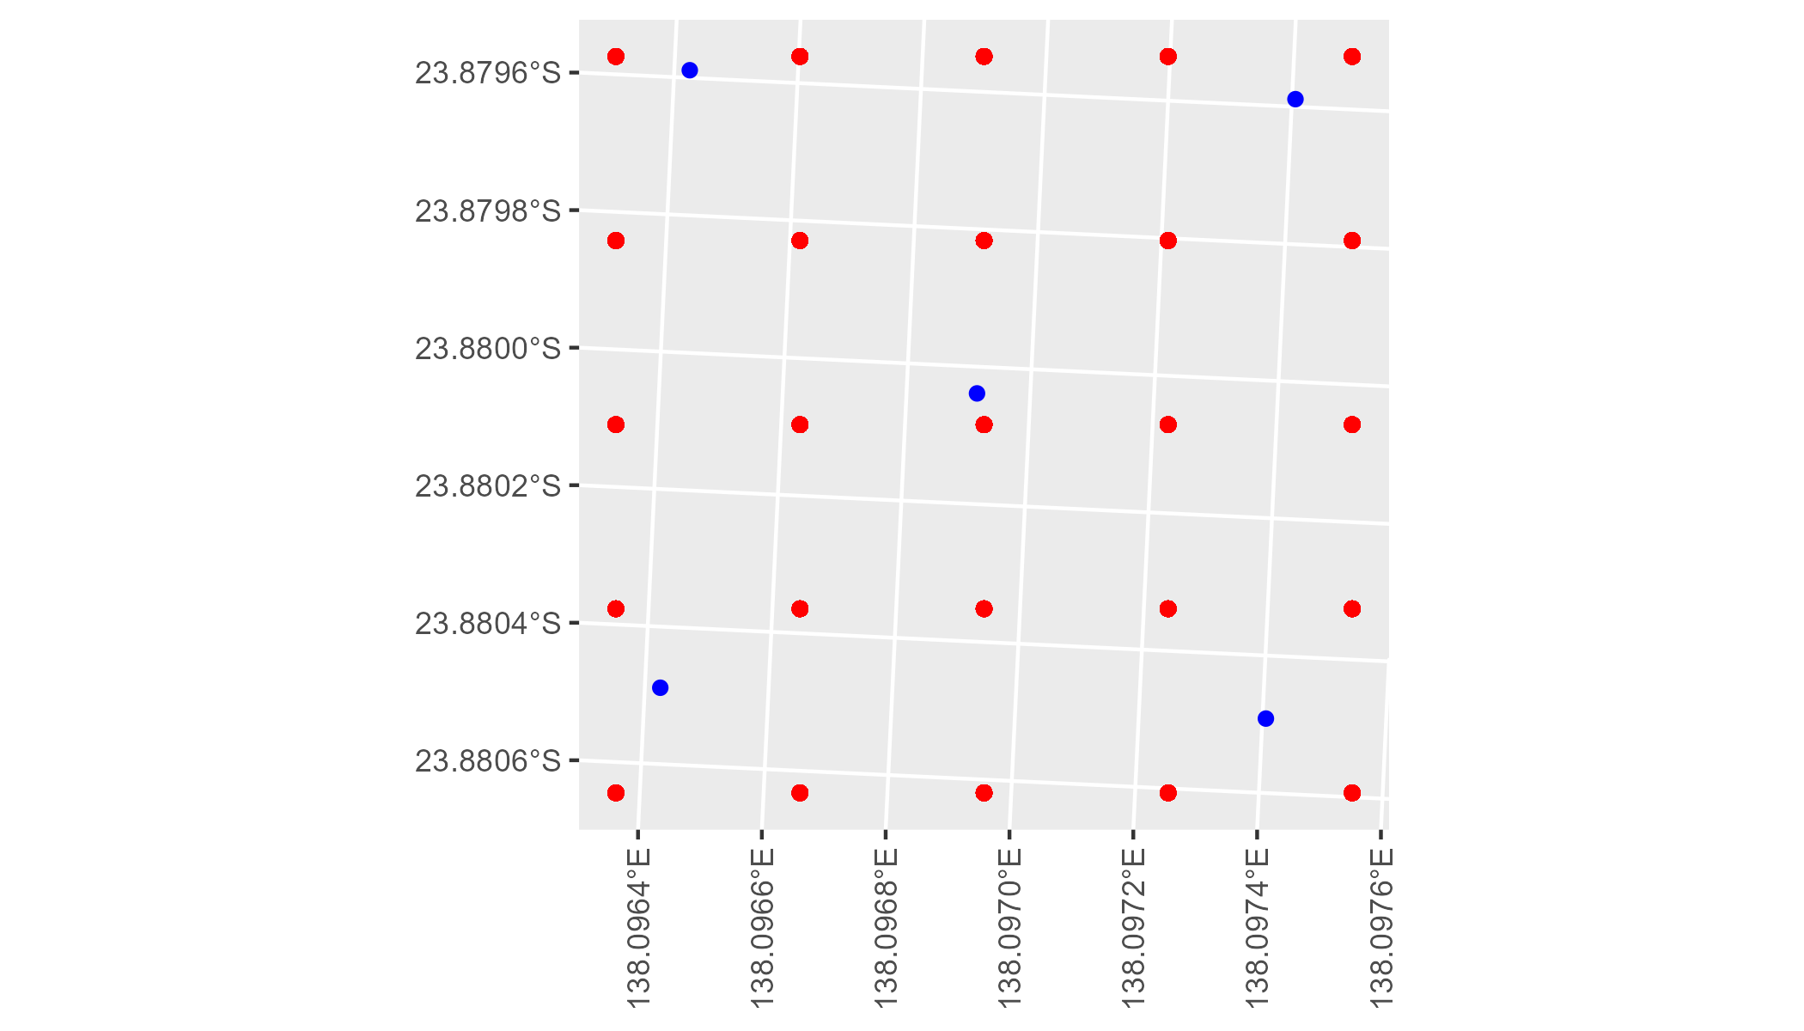

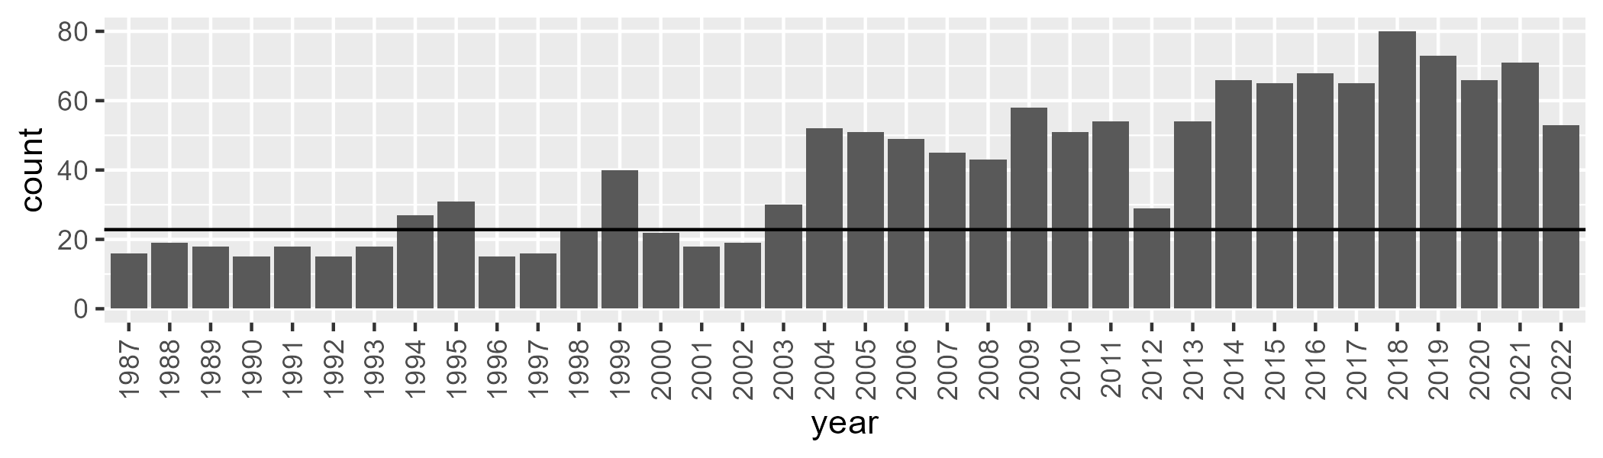

Number of samples: 1453

# QDASSD0008

| Min. | 1st Qu. | Median | Mean | 3rd Qu. | Max. |
| --- | --- | --- | --- | --- | --- |
| 1.314439 | 7.127075 | 9.830354 | 10.14214 | 12.7944 | 22.84057 |

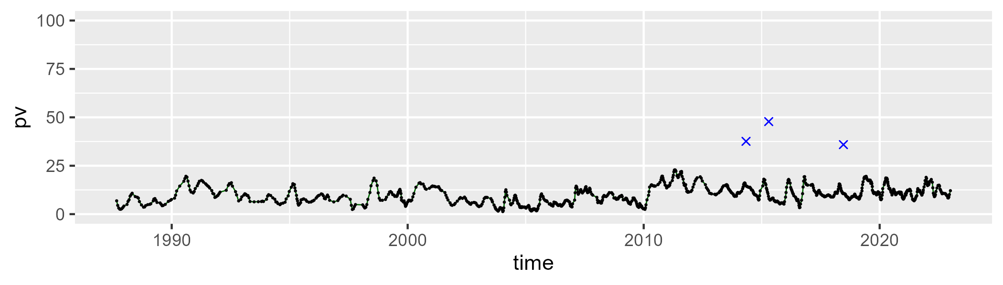

| Min. | 1st Qu. | Median | Mean | 3rd Qu. | Max. |
| --- | --- | --- | --- | --- | --- |
| 16.19019 | 27.90254 | 33.92248 | 33.78938 | 39.25744 | 55.4137 |

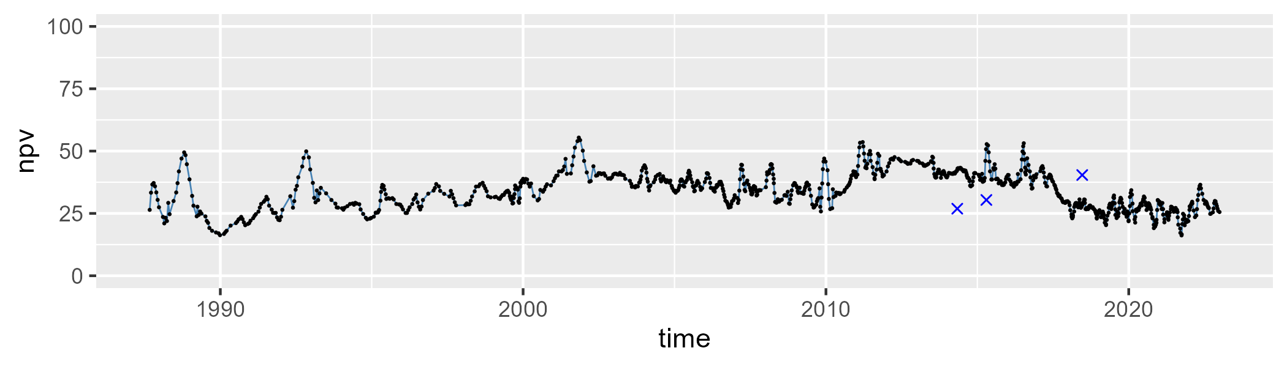

| Min. | 1st Qu. | Median | Mean | 3rd Qu. | Max. |
| --- | --- | --- | --- | --- | --- |
| 27.85327 | 49.67485 | 55.86257 | 54.60155 | 60.53519 | 75.48443 |

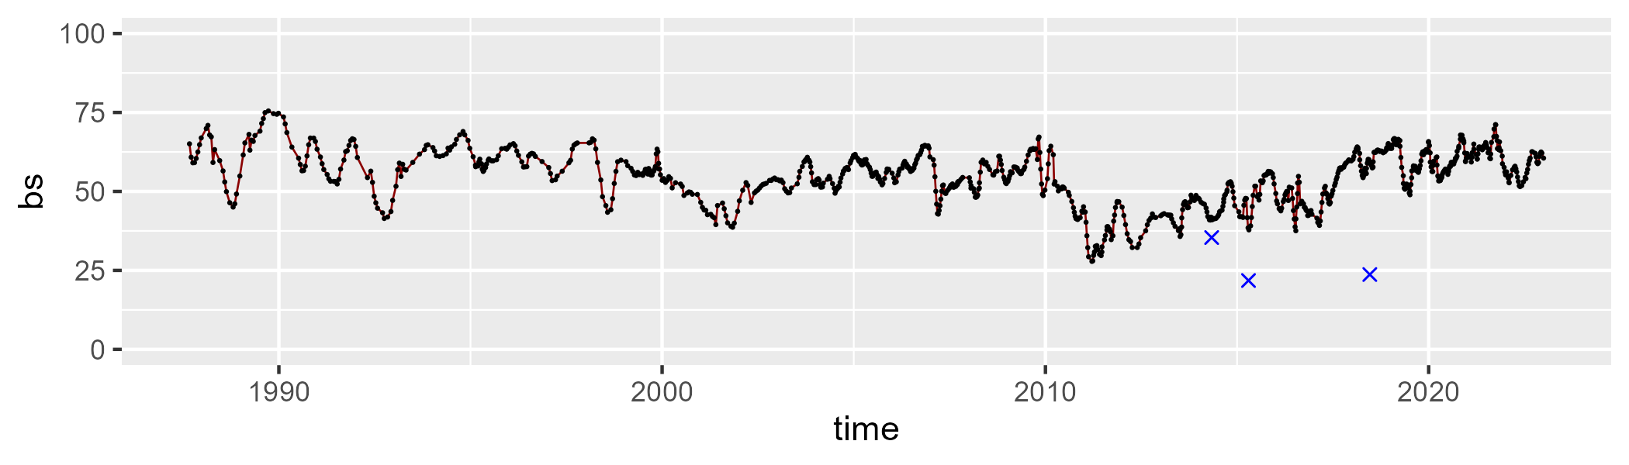

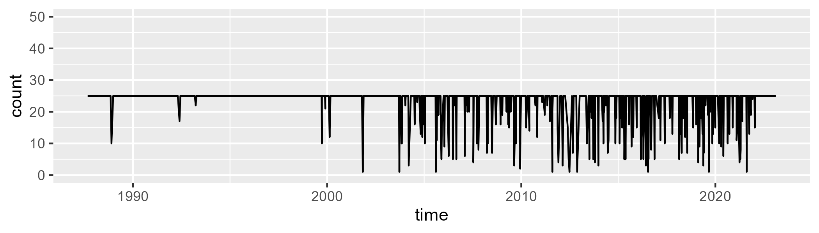

Min. : 1.00 1st Qu.:25.00 Median :25.00 Mean :23.03 3rd Qu.:25.00 Max. :25.00

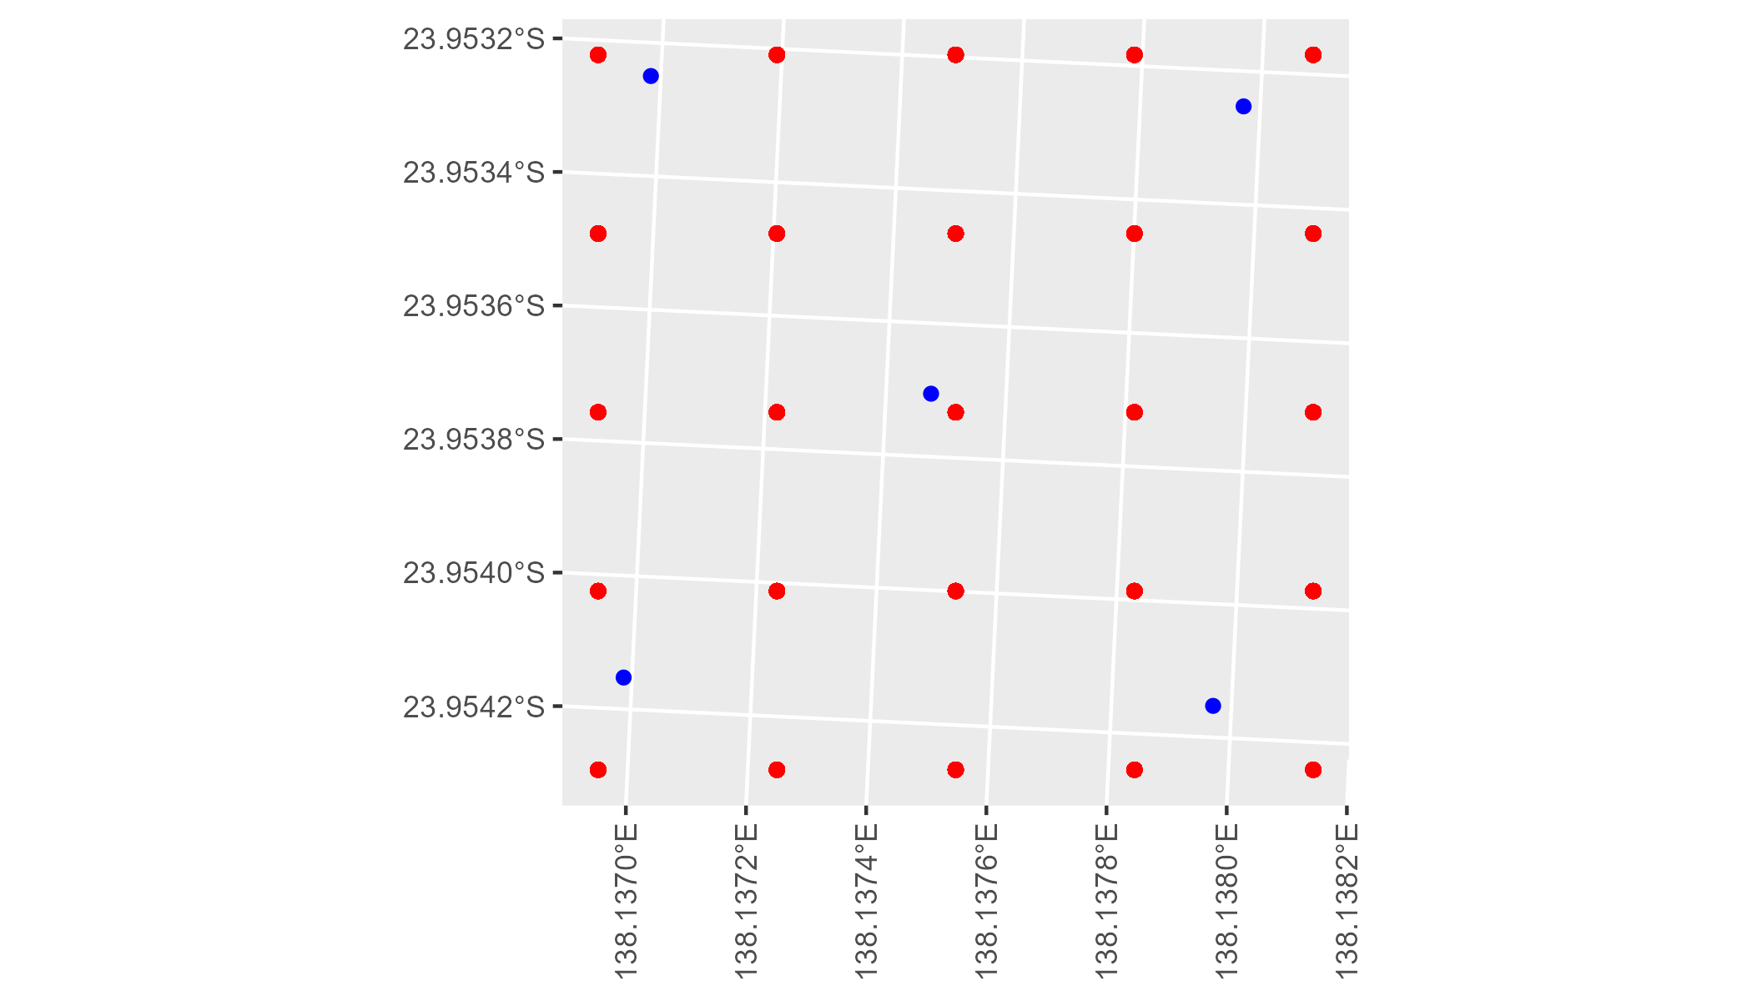

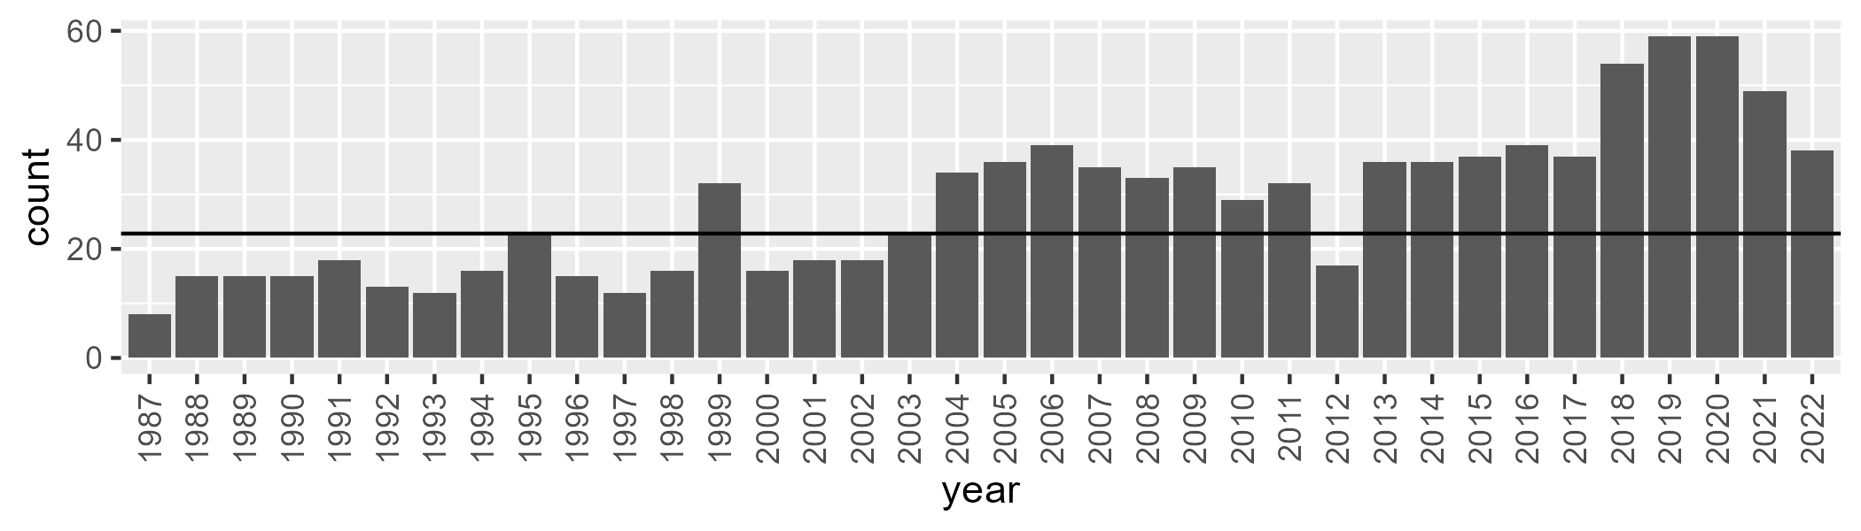

Number of samples: 1019

# QDASSD0009

| Min. | 1st Qu. | Median | Mean | 3rd Qu. | Max. |
| --- | --- | --- | --- | --- | --- |
| 0.1343924 | 14.29251 | 20.62024 | 20.99247 | 28.20499 | 50.10641 |

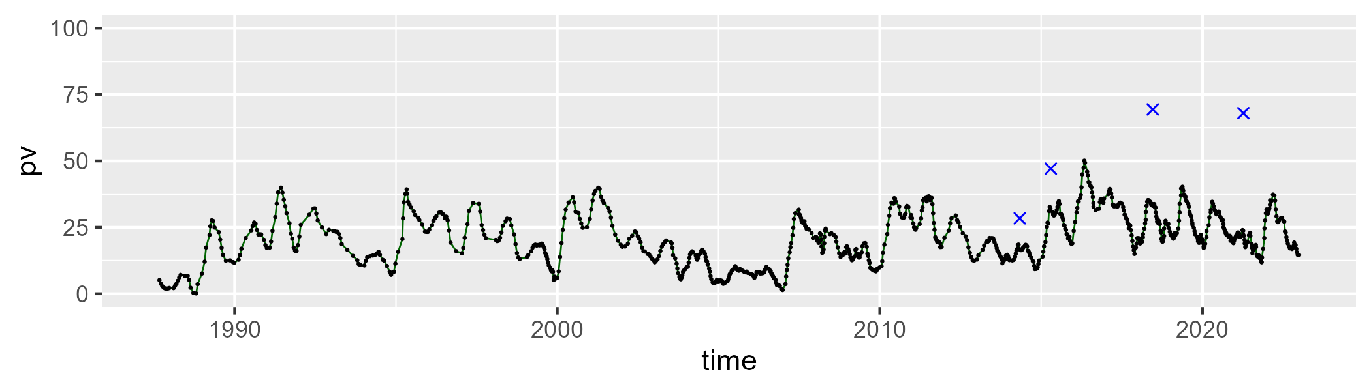

| Min. | 1st Qu. | Median | Mean | 3rd Qu. | Max. |
| --- | --- | --- | --- | --- | --- |
| 33.58999 | 45.11765 | 48.54714 | 48.67487 | 52.21859 | 65.1411 |

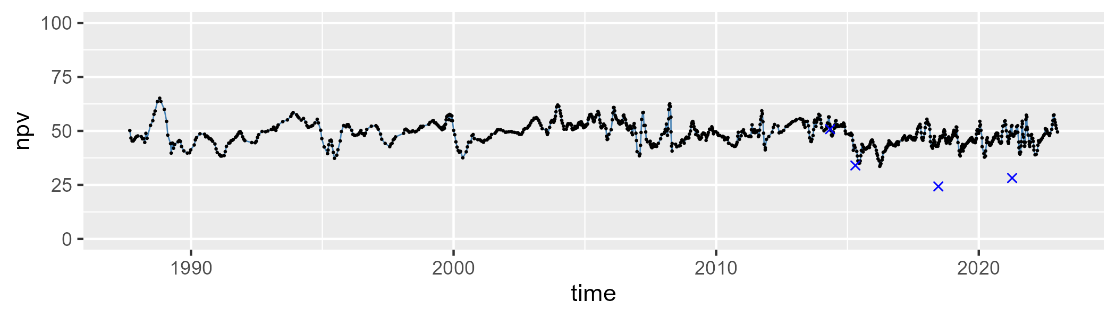

| Min. | 1st Qu. | Median | Mean | 3rd Qu. | Max. |
| --- | --- | --- | --- | --- | --- |
| 9.119706 | 23.61116 | 28.90752 | 28.96958 | 33.56208 | 56.86699 |

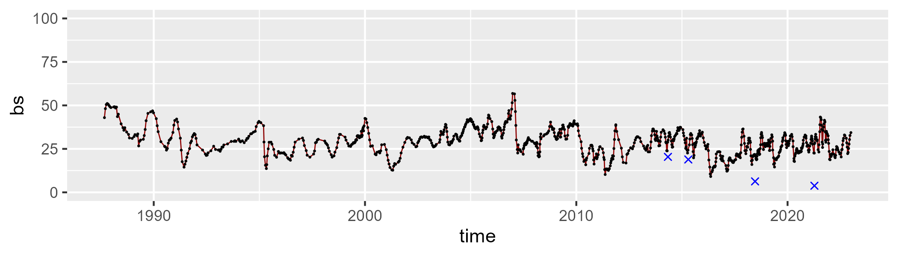

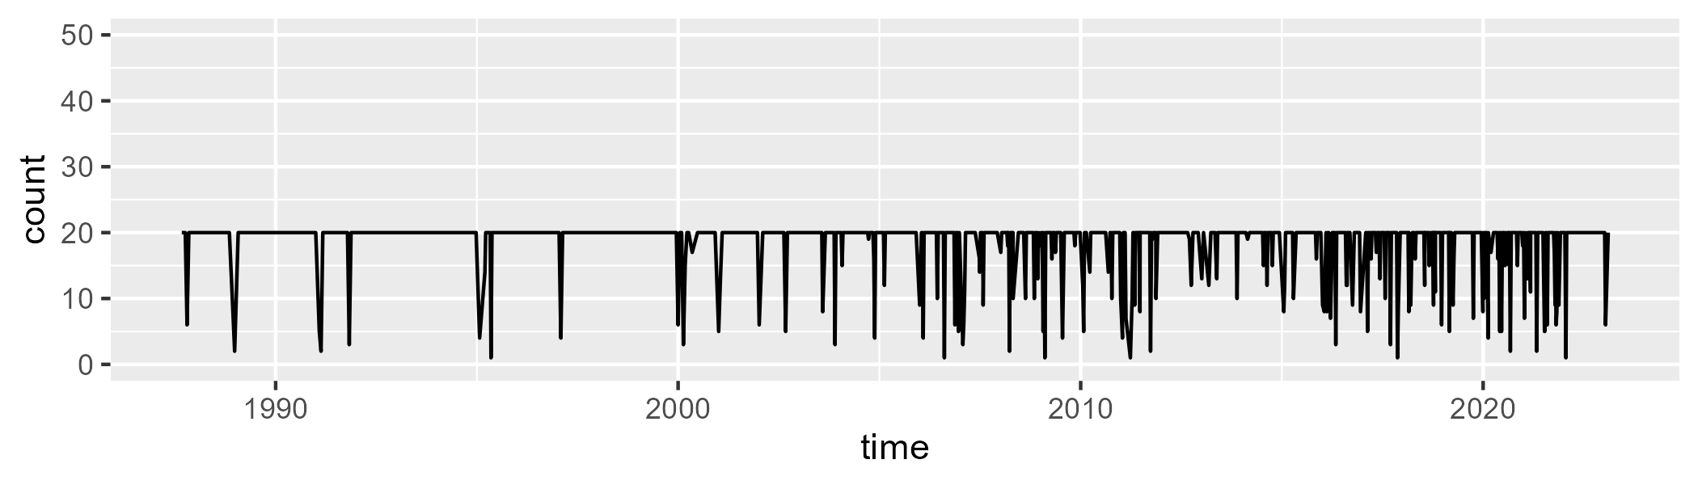

Min. : 1.0 1st Qu.:20.0 Median :20.0 Mean :18.5 3rd Qu.:20.0 Max. :20.0

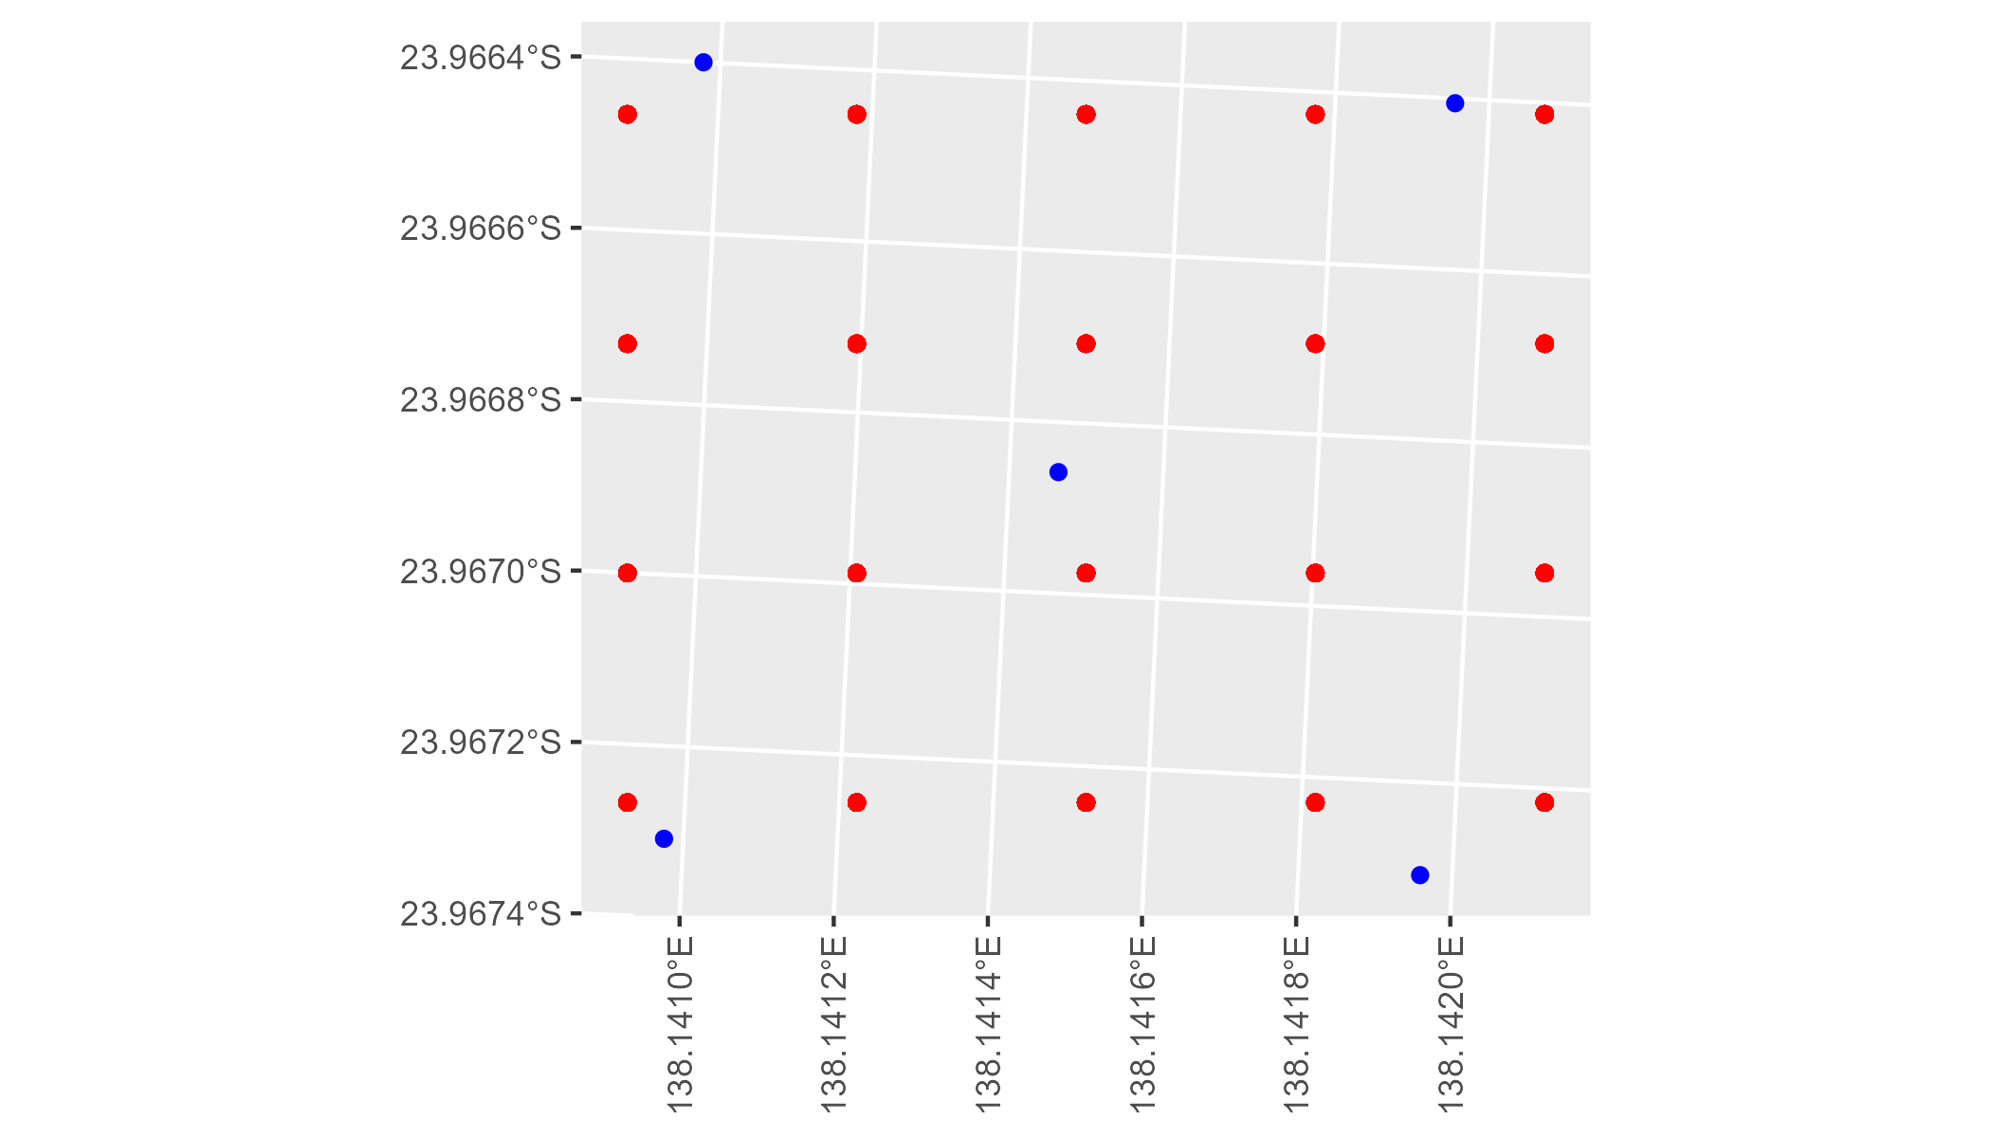

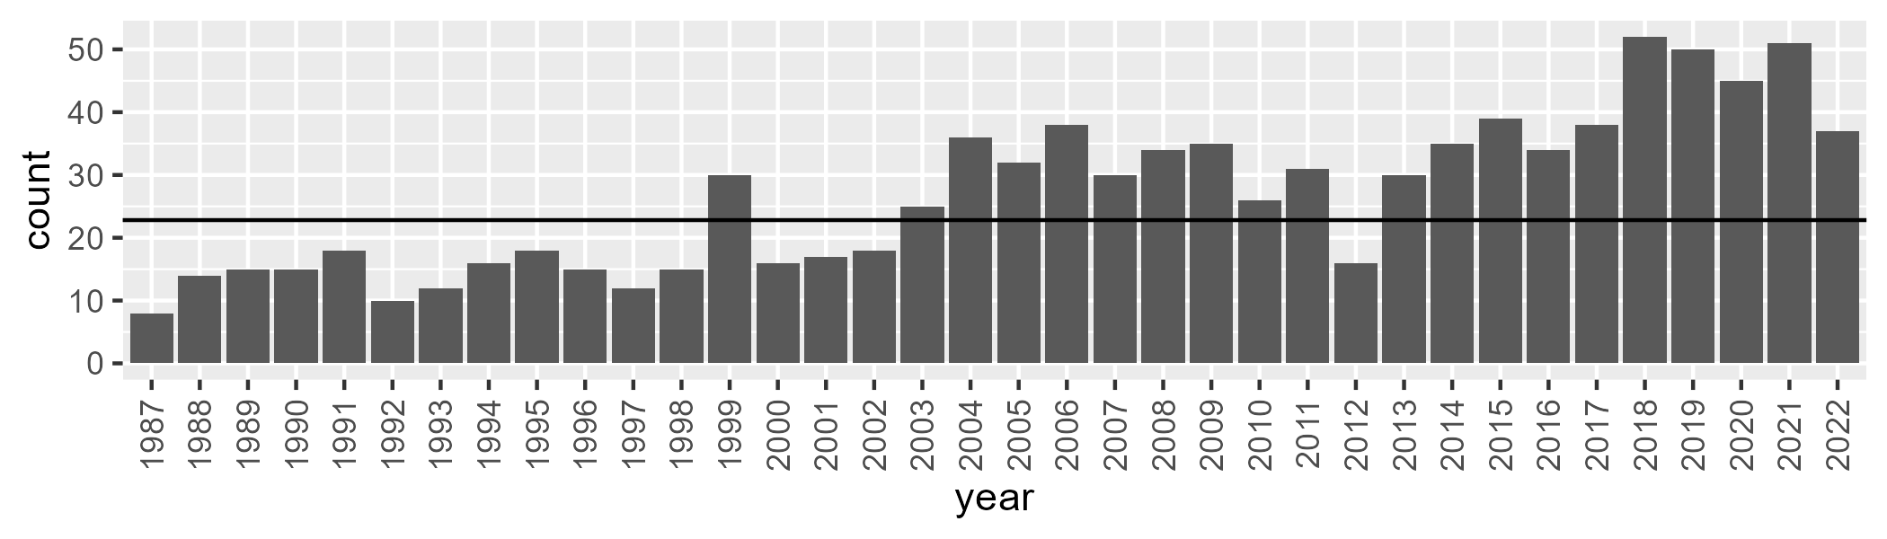

Number of samples: 963

# QDASSD0010

| Min. | 1st Qu. | Median | Mean | 3rd Qu. | Max. |
| --- | --- | --- | --- | --- | --- |
| 1.912733 | 15.2501 | 22.63837 | 23.1312 | 30.72546 | 54.64784 |

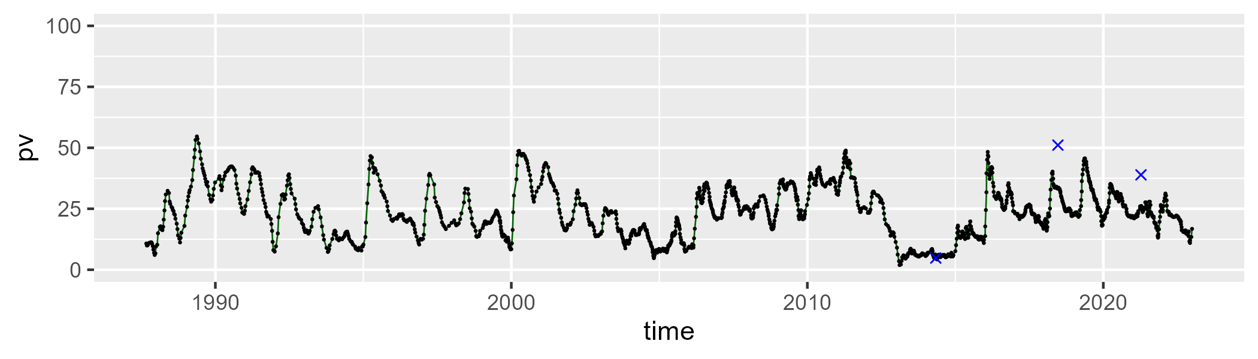

| Min. | 1st Qu. | Median | Mean | 3rd Qu. | Max. |
| --- | --- | --- | --- | --- | --- |
| 24.39127 | 41.35745 | 45.33525 | 45.8997 | 51.75724 | 66.11515 |

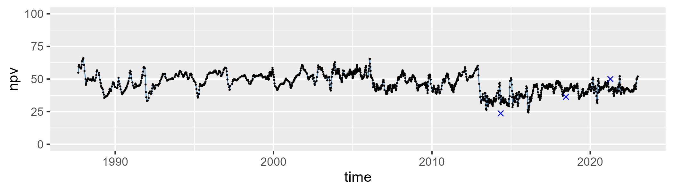

| Min. | 1st Qu. | Median | Mean | 3rd Qu. | Max. |
| --- | --- | --- | --- | --- | --- |
| 4.521439 | 22.01834 | 28.43358 | 29.55738 | 33.71259 | 64.98038 |

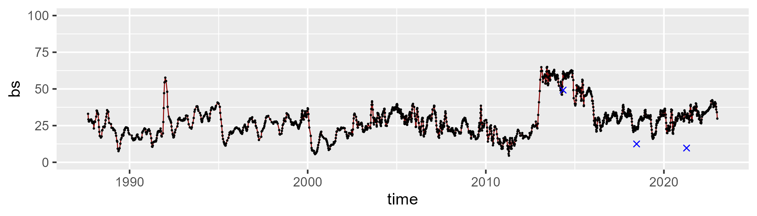

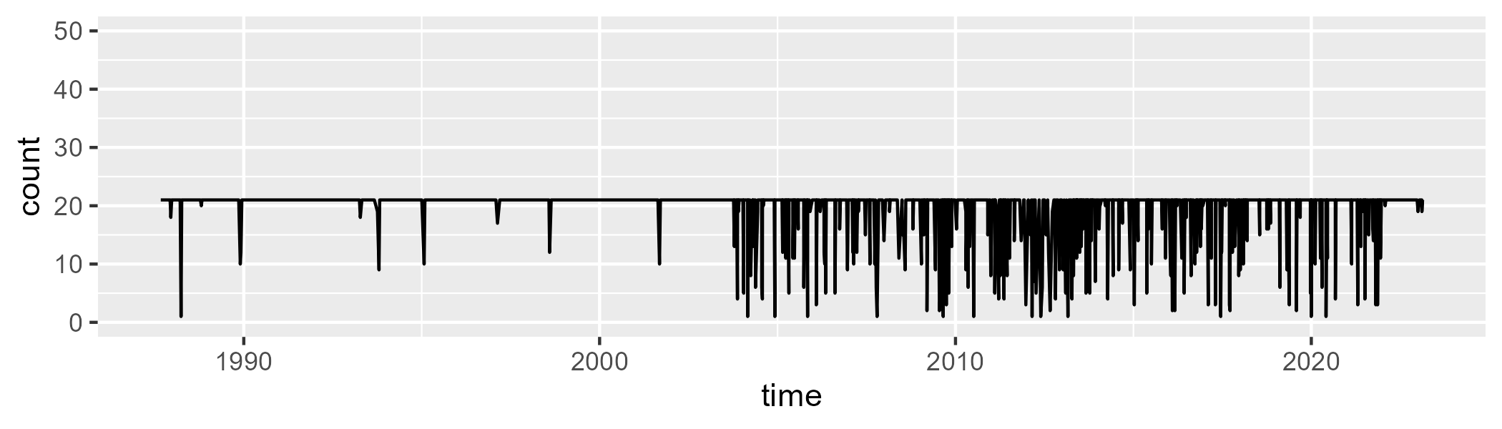

Min. : 1.00 1st Qu.:21.00 Median :21.00 Mean :19.75 3rd Qu.:21.00 Max. :21.00

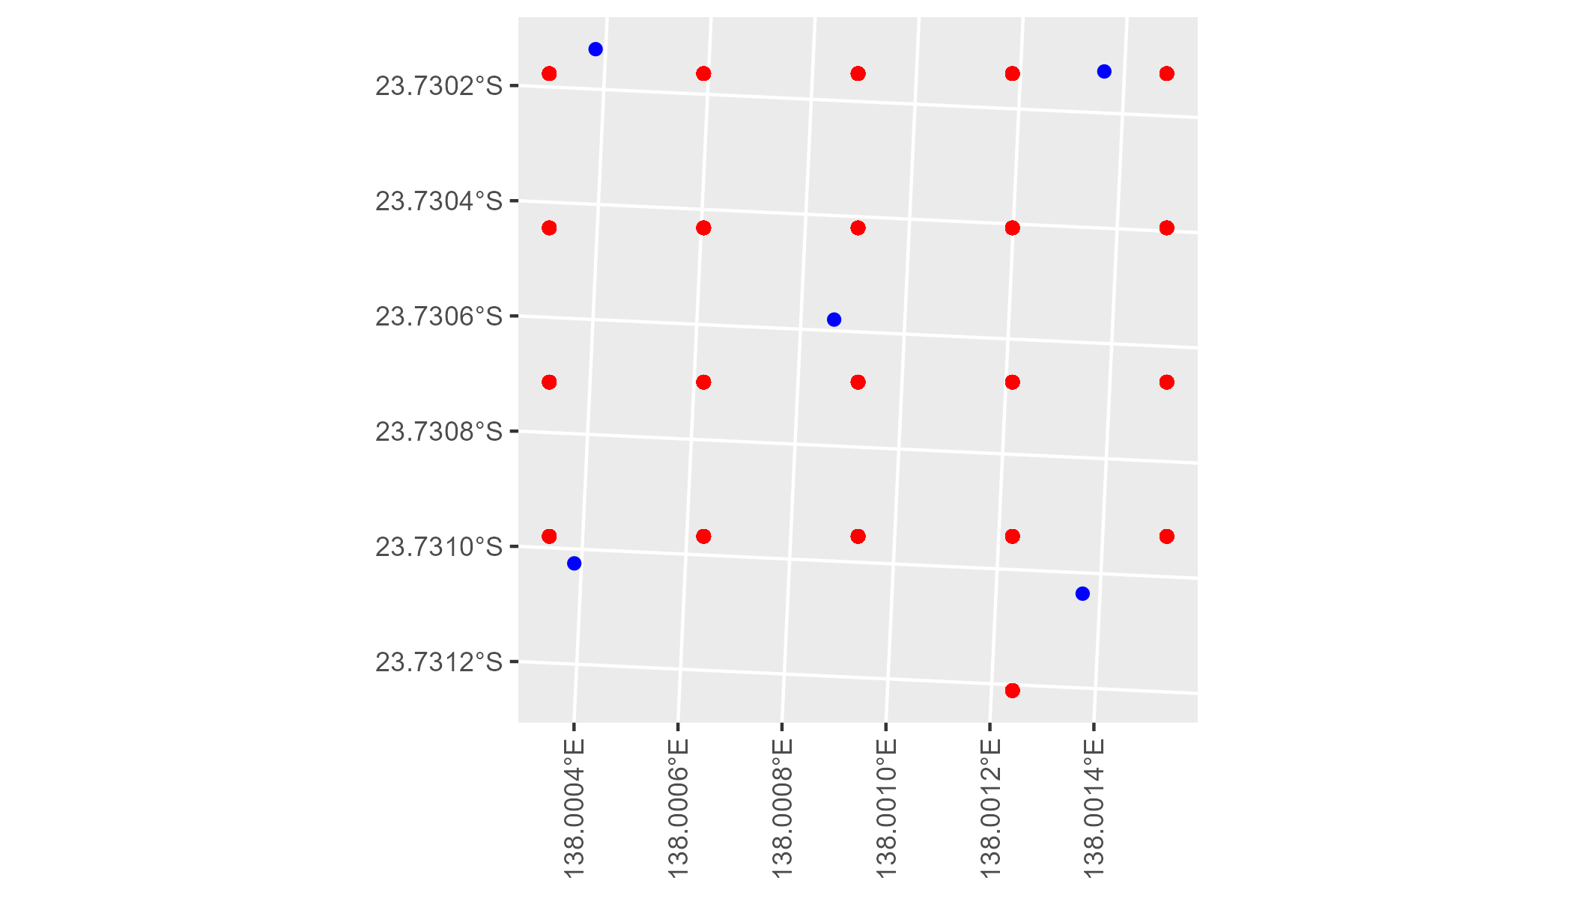

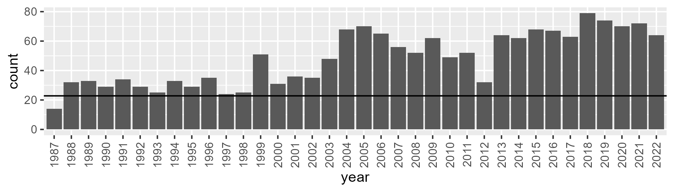

Number of samples: 1732

# QDASSD0011

| Min. | 1st Qu. | Median | Mean | 3rd Qu. | Max. |
| --- | --- | --- | --- | --- | --- |
| 3.367274 | 10.29542 | 12.1403 | 12.54566 | 14.28278 | 35.84891 |

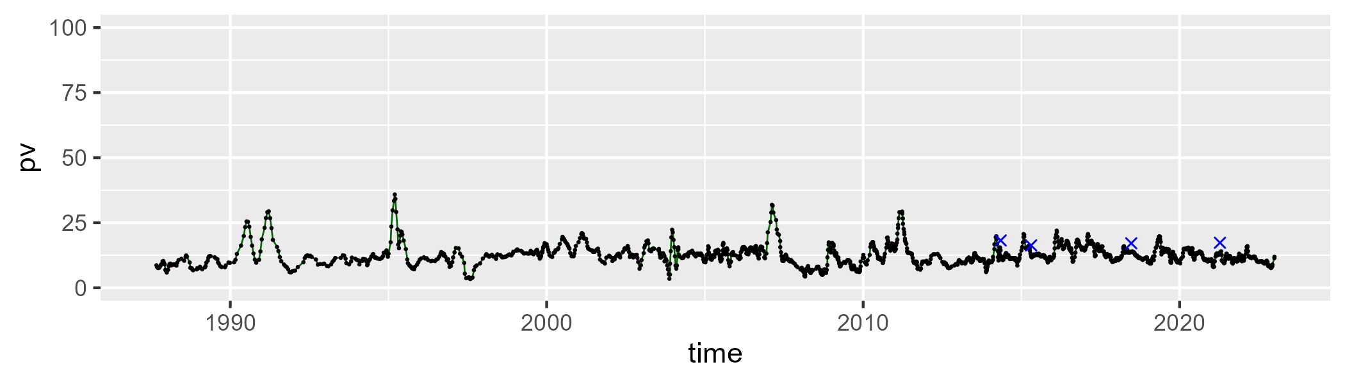

| Min. | 1st Qu. | Median | Mean | 3rd Qu. | Max. |
| --- | --- | --- | --- | --- | --- |
| 0 | 15.93297 | 21.16976 | 21.63782 | 27.70501 | 47.57959 |

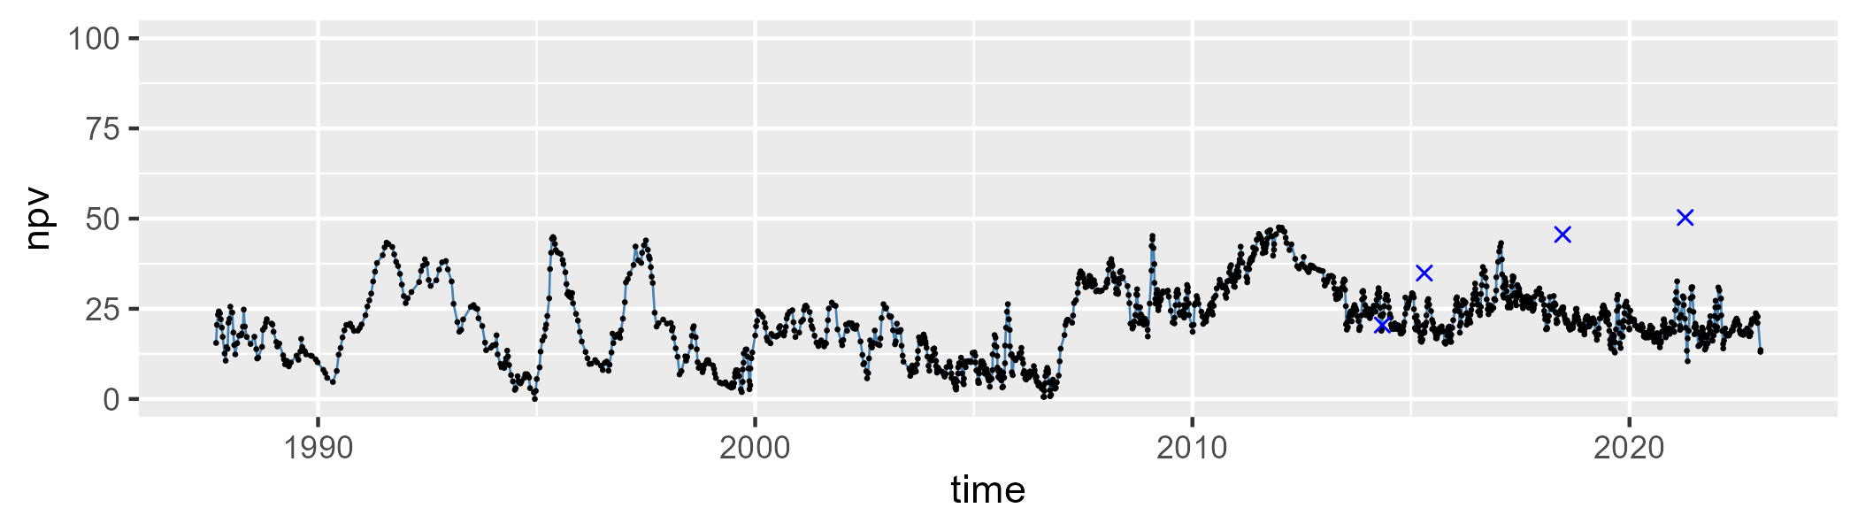

| Min. | 1st Qu. | Median | Mean | 3rd Qu. | Max. |
| --- | --- | --- | --- | --- | --- |
| 31.77008 | 58.15171 | 65.15849 | 64.26483 | 70.38428 | 86.08114 |

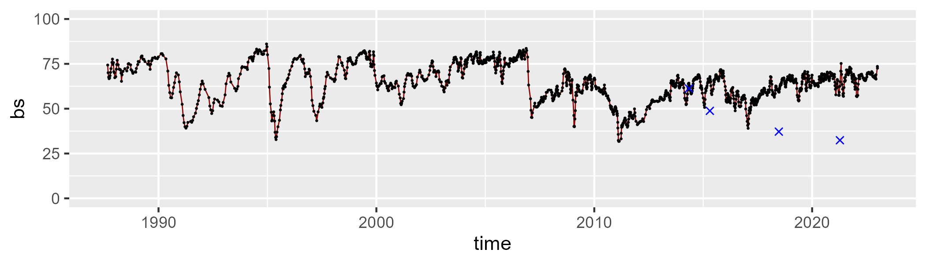

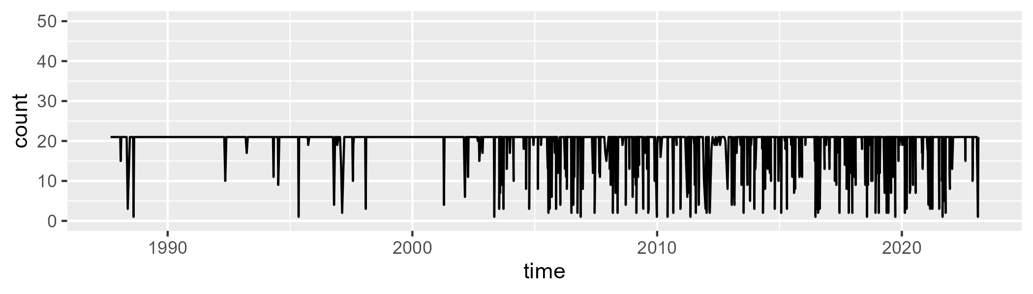

Min. : 1.00 1st Qu.:21.00 Median :21.00 Mean :19.35 3rd Qu.:21.00 Max. :21.00

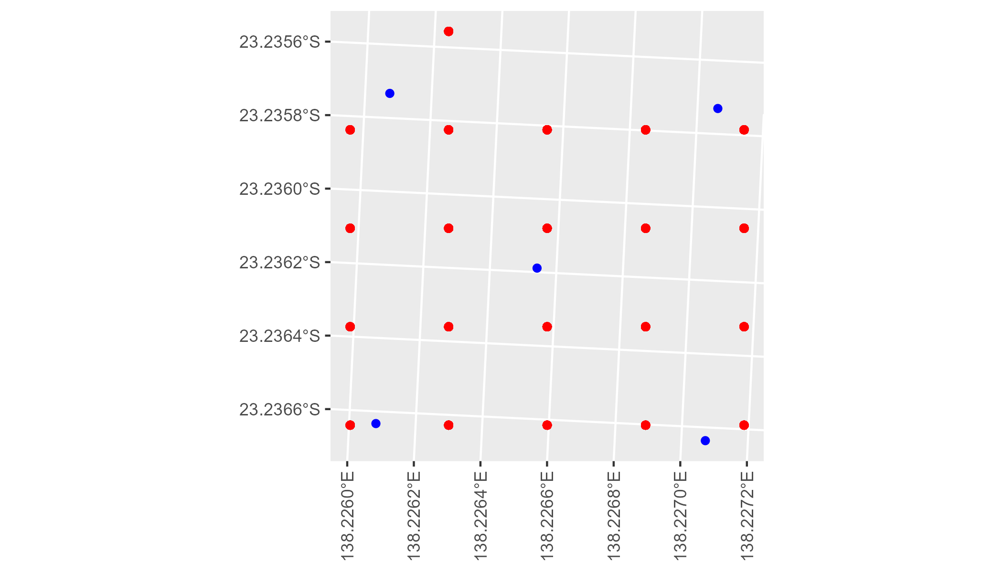

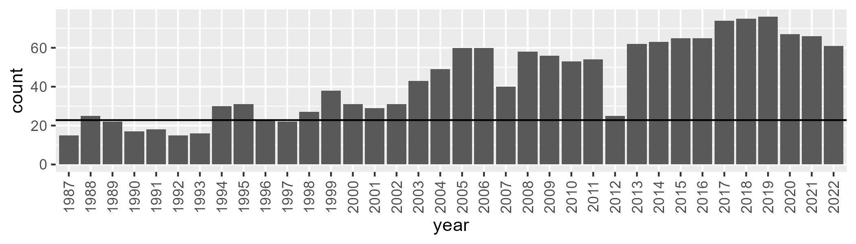

Number of samples: 1562

# QDASSD0012

| Min. | 1st Qu. | Median | Mean | 3rd Qu. | Max. |
| --- | --- | --- | --- | --- | --- |
| 0 | 1.723042 | 4.376745 | 7.934719 | 10.03756 | 55.7073 |

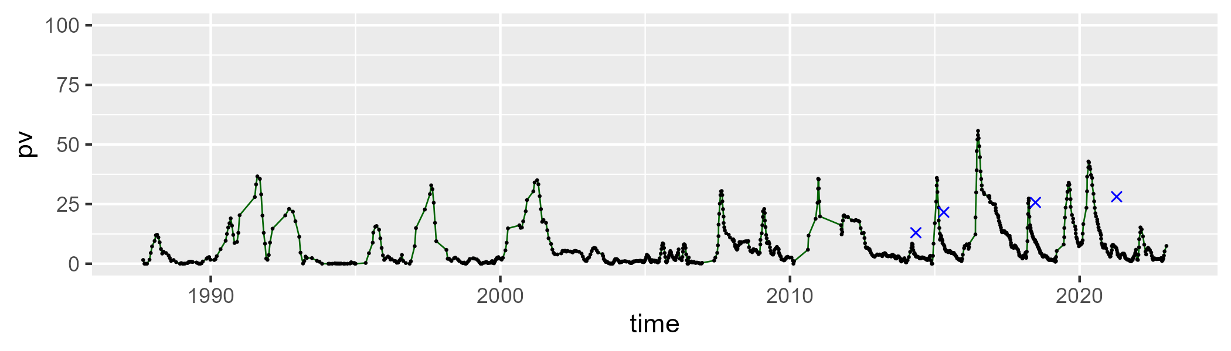

| Min. | 1st Qu. | Median | Mean | 3rd Qu. | Max. |
| --- | --- | --- | --- | --- | --- |
| 11.5105 | 31.72444 | 40.1046 | 39.4295 | 47.68658 | 74.61562 |

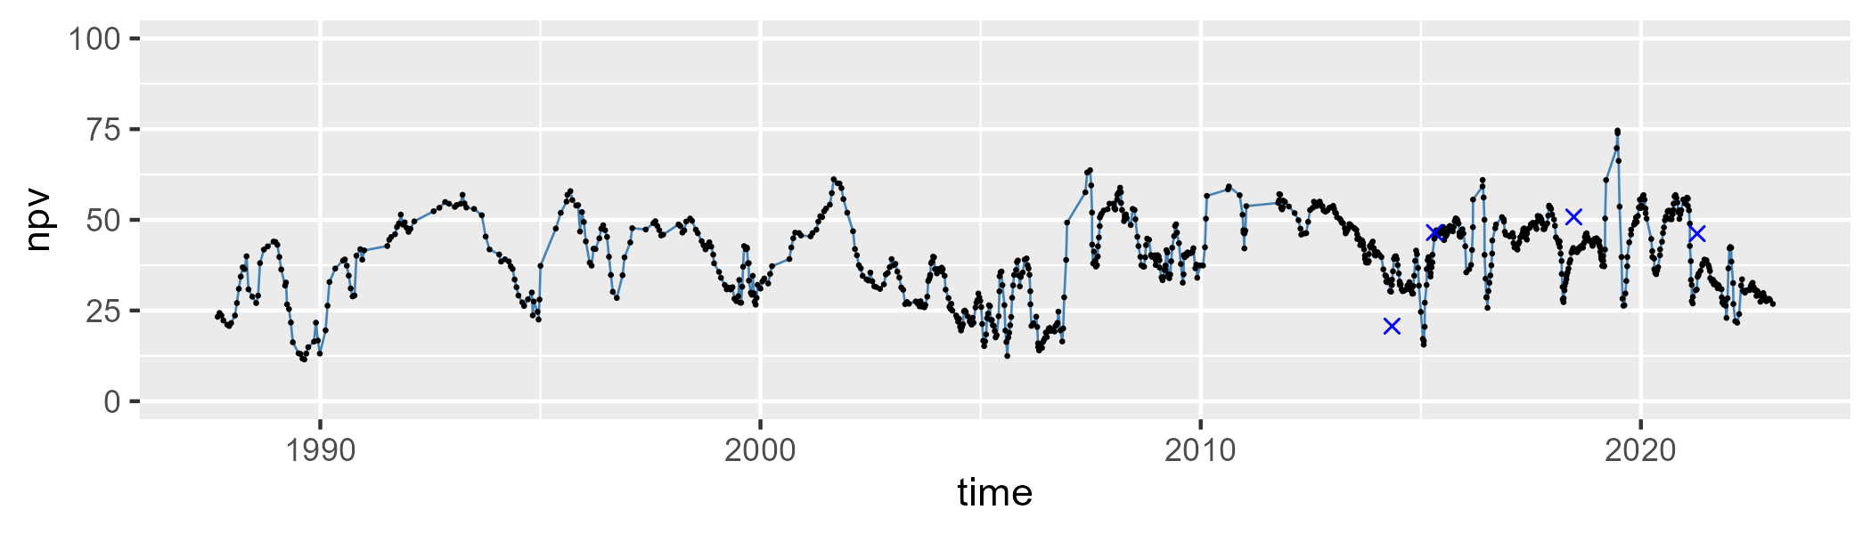

| Min. | 1st Qu. | Median | Mean | 3rd Qu. | Max. |
| --- | --- | --- | --- | --- | --- |
| 9.447466 | 39.87956 | 51.94696 | 51.19693 | 62.58316 | 88.02427 |

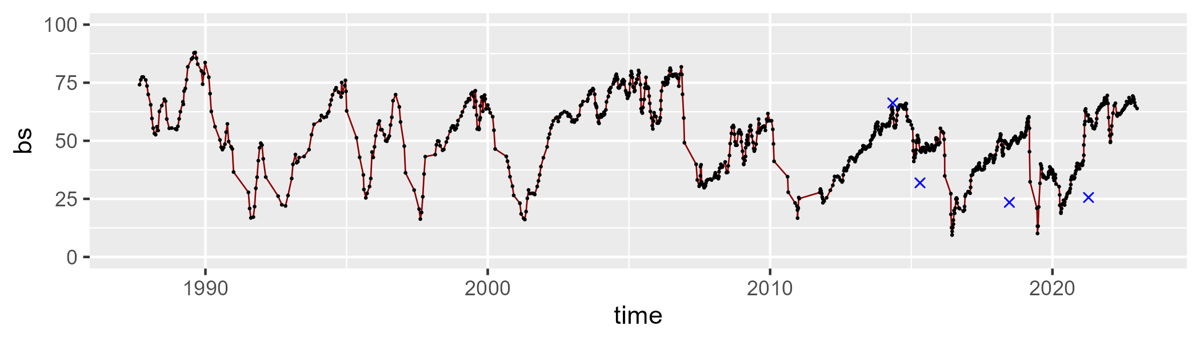

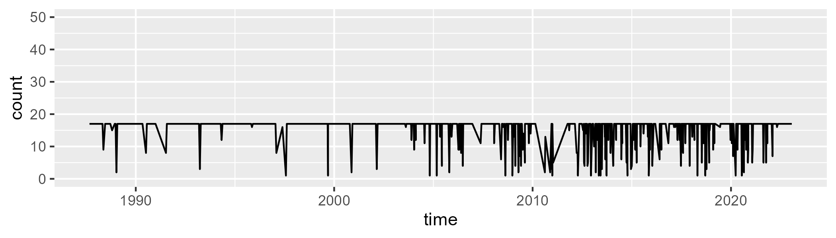

Min. : 1.00 1st Qu.:17.00 Median :17.00 Mean :15.62 3rd Qu.:17.00 Max. :17.00

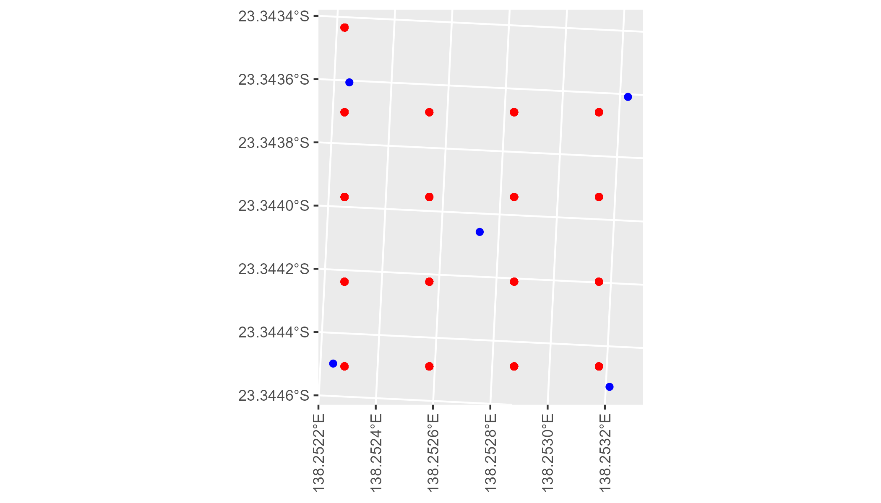

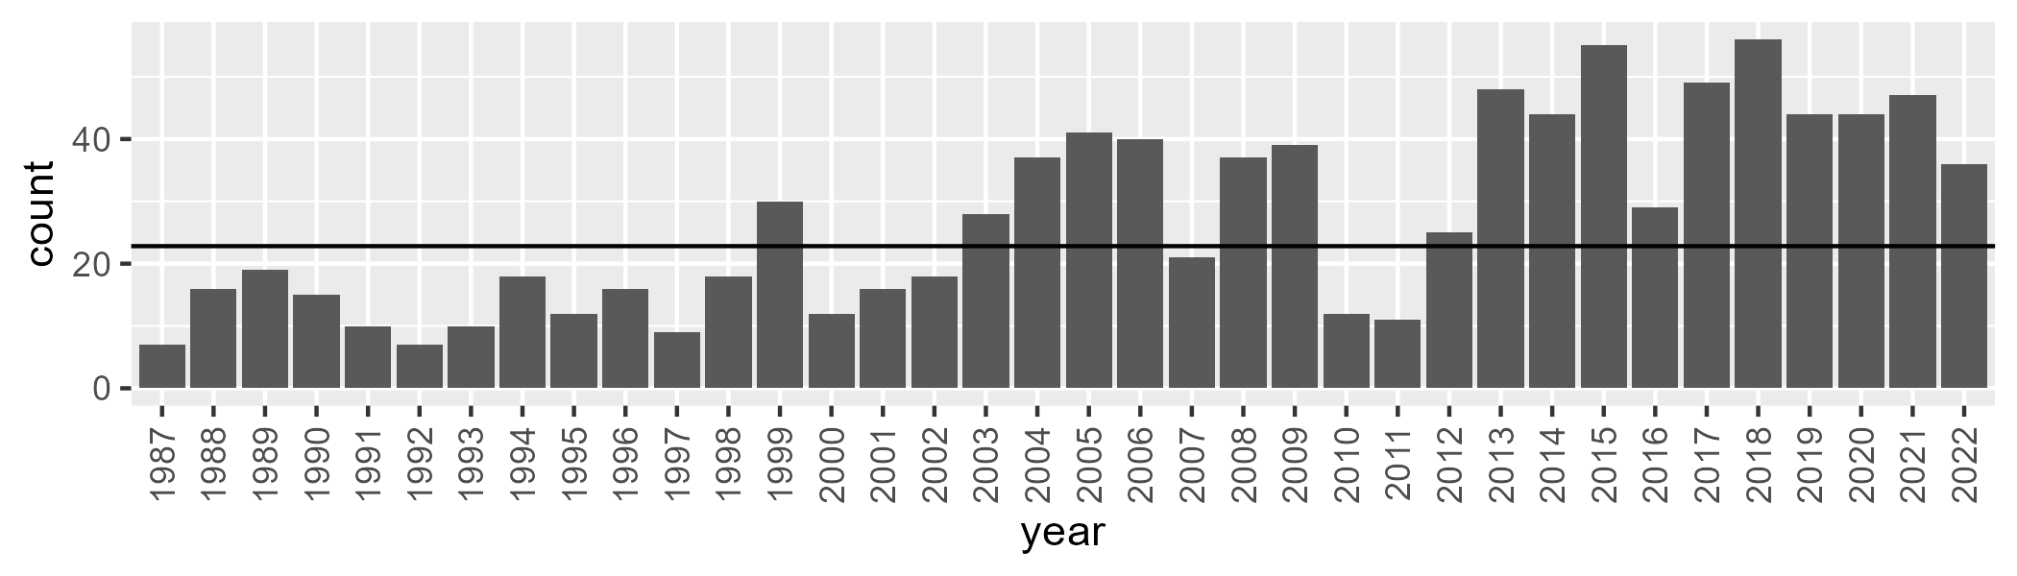

Number of samples: 976

# QDASSD0013

| Min. | 1st Qu. | Median | Mean | 3rd Qu. | Max. |
| --- | --- | --- | --- | --- | --- |
| 0.1030078 | 6.234803 | 8.64399 | 9.754368 | 11.94996 | 38.11199 |

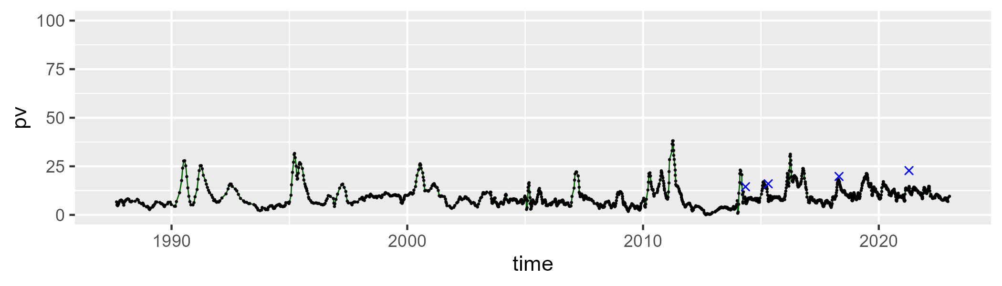

| Min. | 1st Qu. | Median | Mean | 3rd Qu. | Max. |
| --- | --- | --- | --- | --- | --- |
| 18.02492 | 28.46906 | 33.33213 | 35.99082 | 40.35898 | 80.30564 |

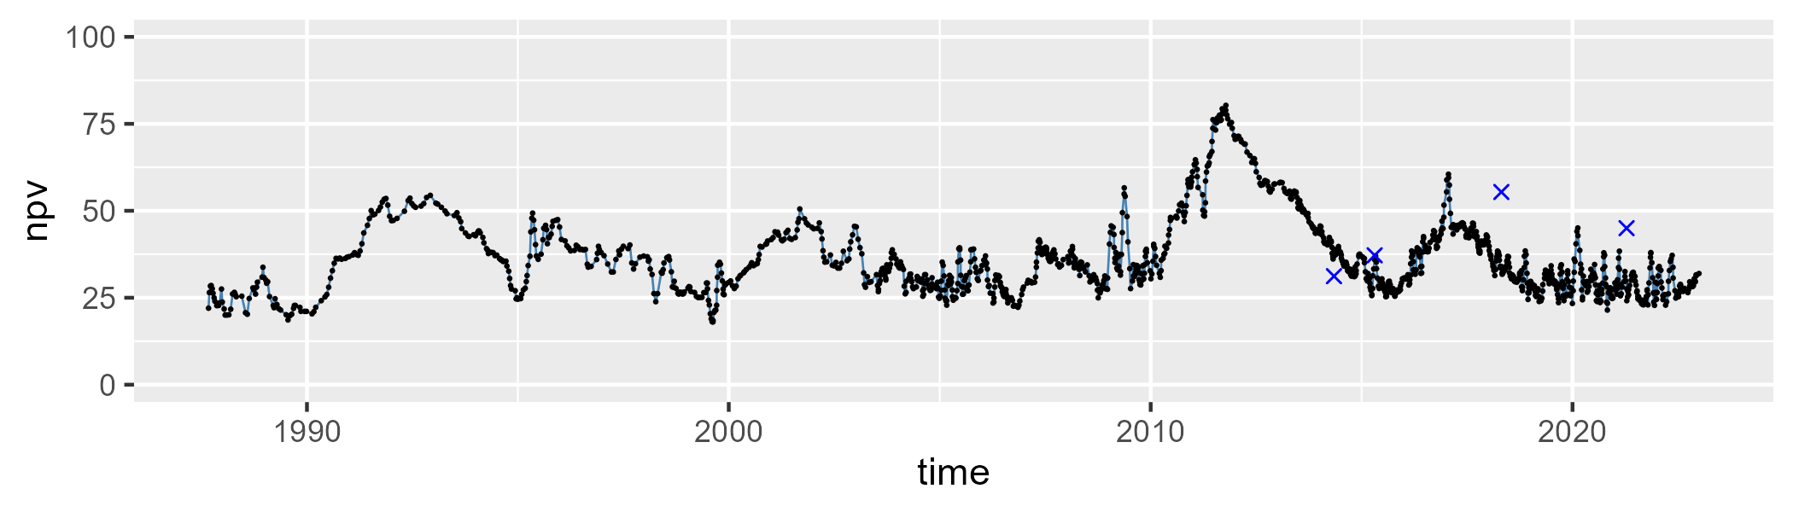

| Min. | 1st Qu. | Median | Mean | 3rd Qu. | Max. |
| --- | --- | --- | --- | --- | --- |
| 7.937303 | 47.24235 | 55.64182 | 52.80833 | 60.83433 | 74.09107 |

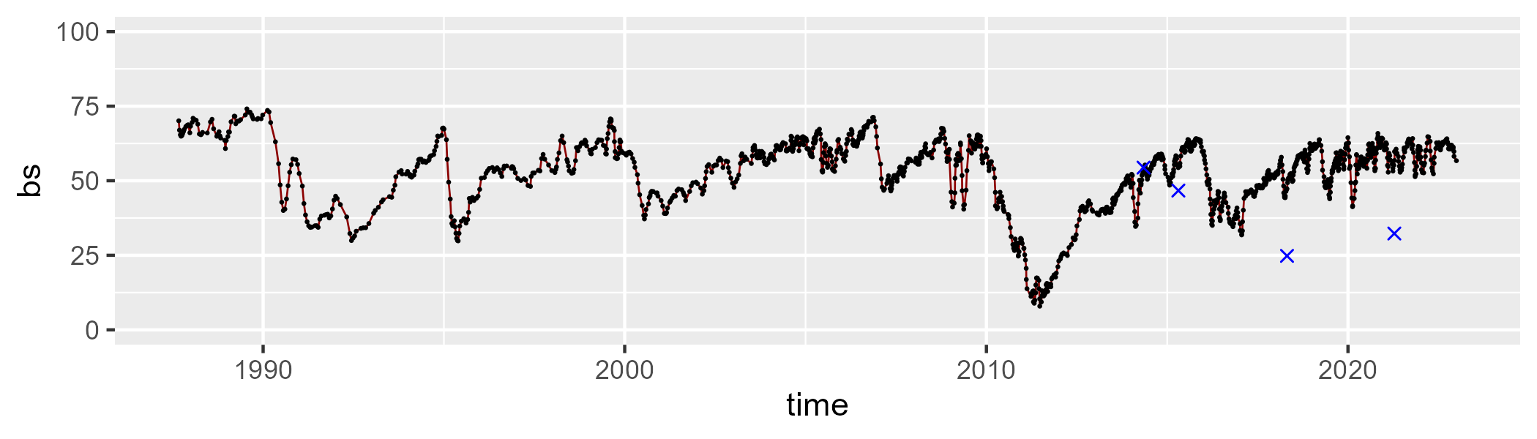

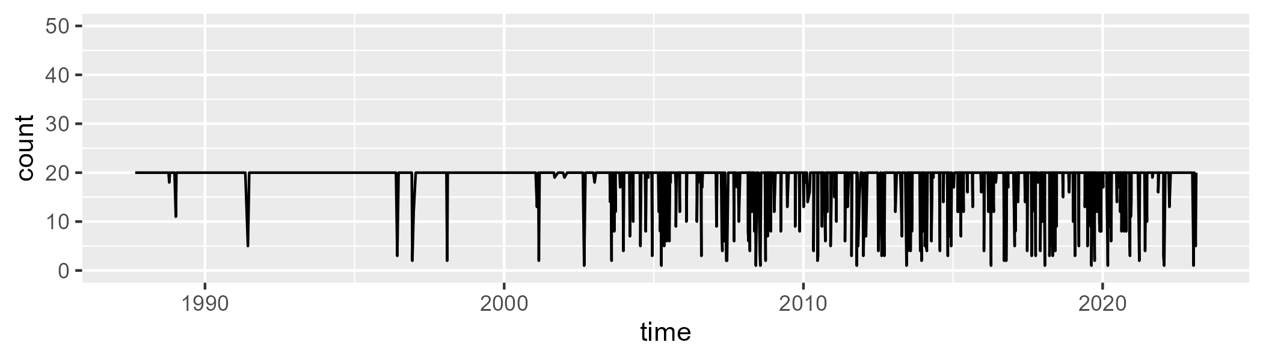

Min. : 1.00 1st Qu.:20.00 Median :20.00 Mean :18.49 3rd Qu.:20.00 Max. :20.00

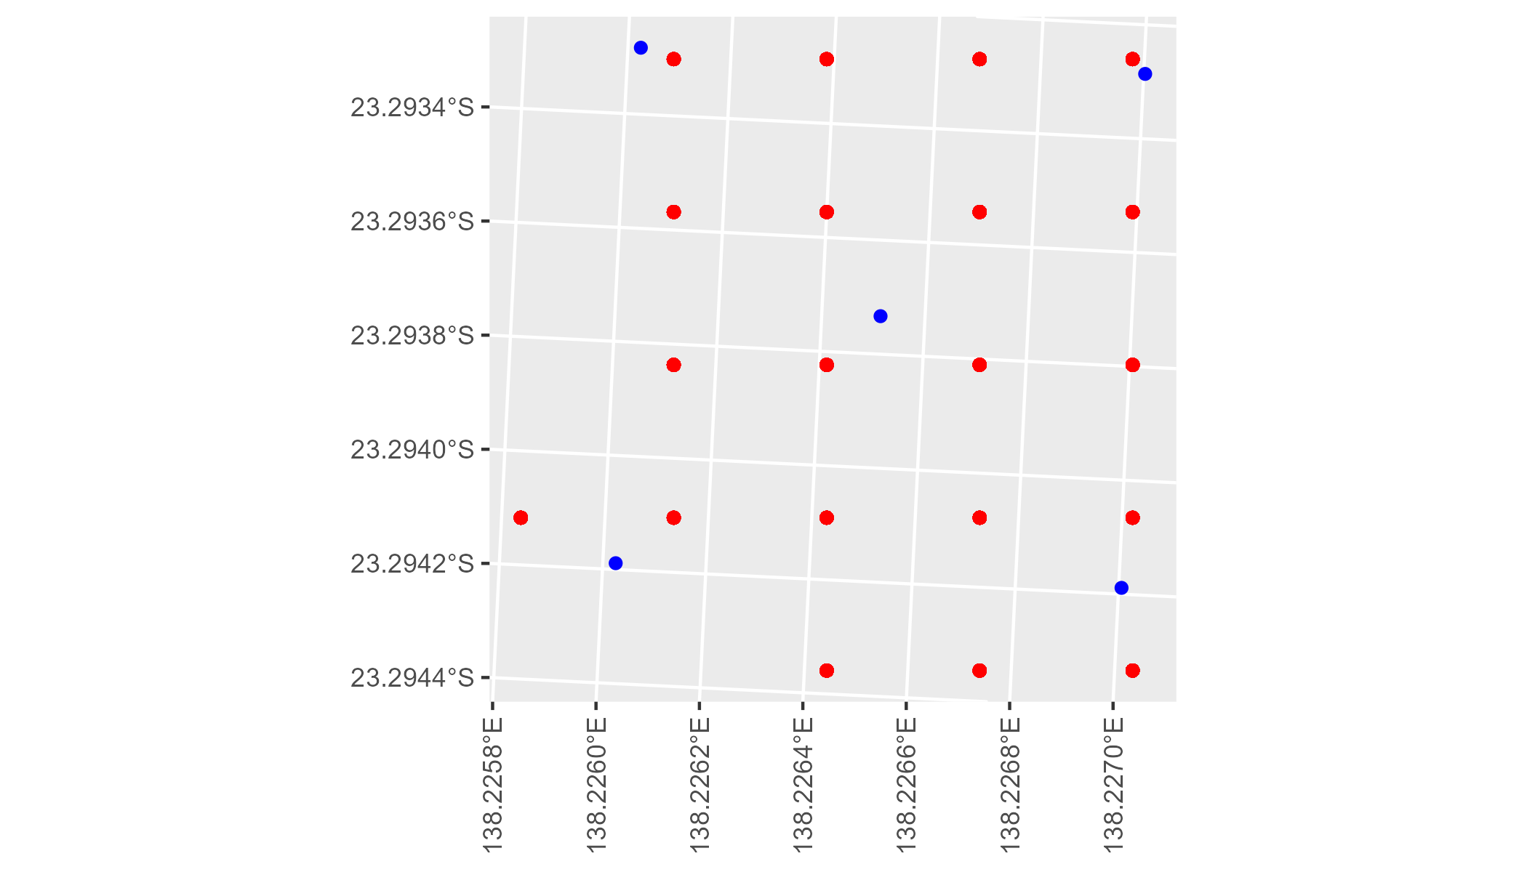

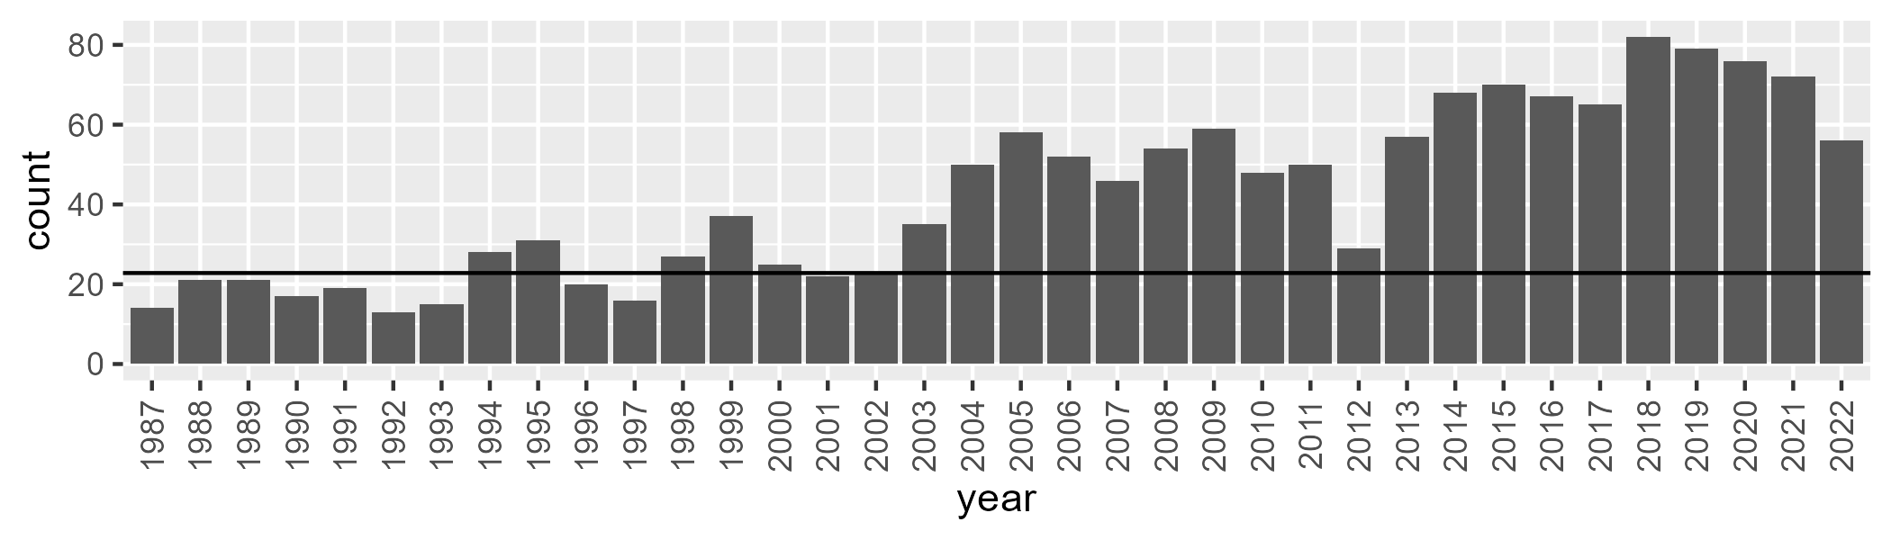

Number of samples: 1522

# QDASSD0014

| Min. | 1st Qu. | Median | Mean | 3rd Qu. | Max. |
| --- | --- | --- | --- | --- | --- |
| 0 | 3.819112 | 6.687277 | 9.750907 | 12.61516 | 55.30928 |

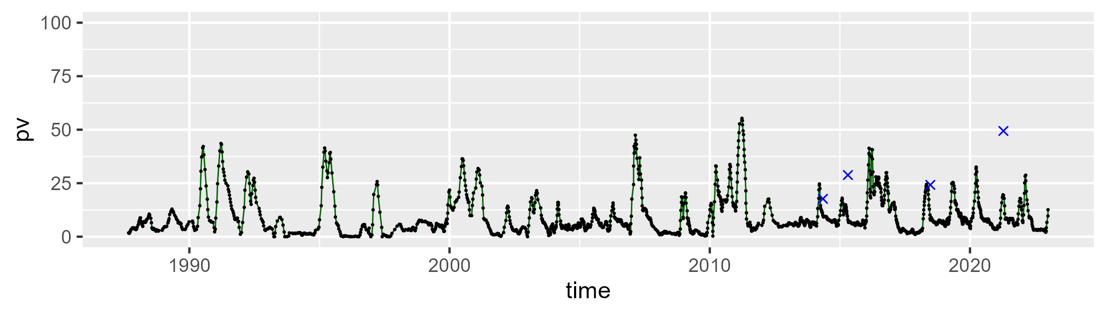

| Min. | 1st Qu. | Median | Mean | 3rd Qu. | Max. |
| --- | --- | --- | --- | --- | --- |
| 10.34418 | 24.79448 | 32.55461 | 35.11952 | 43.55591 | 74.30936 |

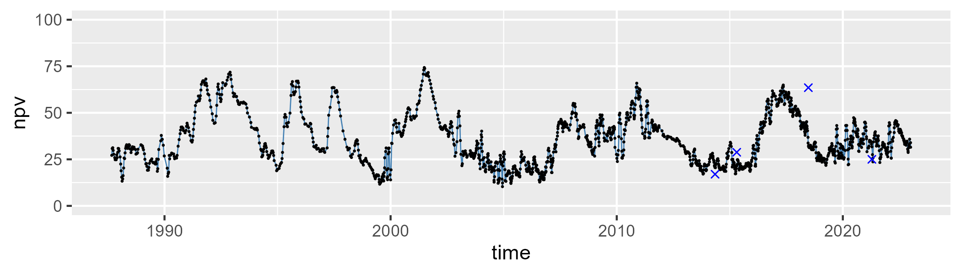

| Min. | 1st Qu. | Median | Mean | 3rd Qu. | Max. |
| --- | --- | --- | --- | --- | --- |
| 3.21934 | 42.70206 | 57.19532 | 53.63619 | 66.62706 | 81.9627 |

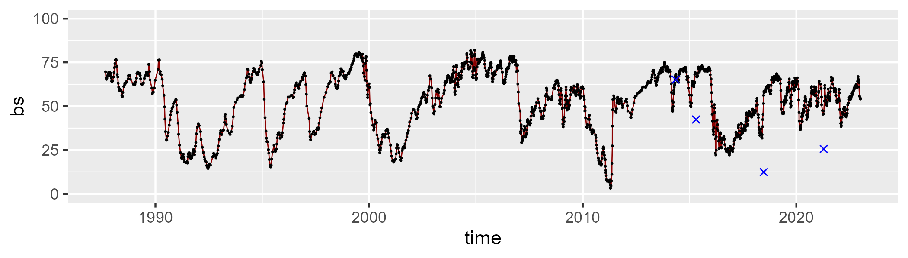

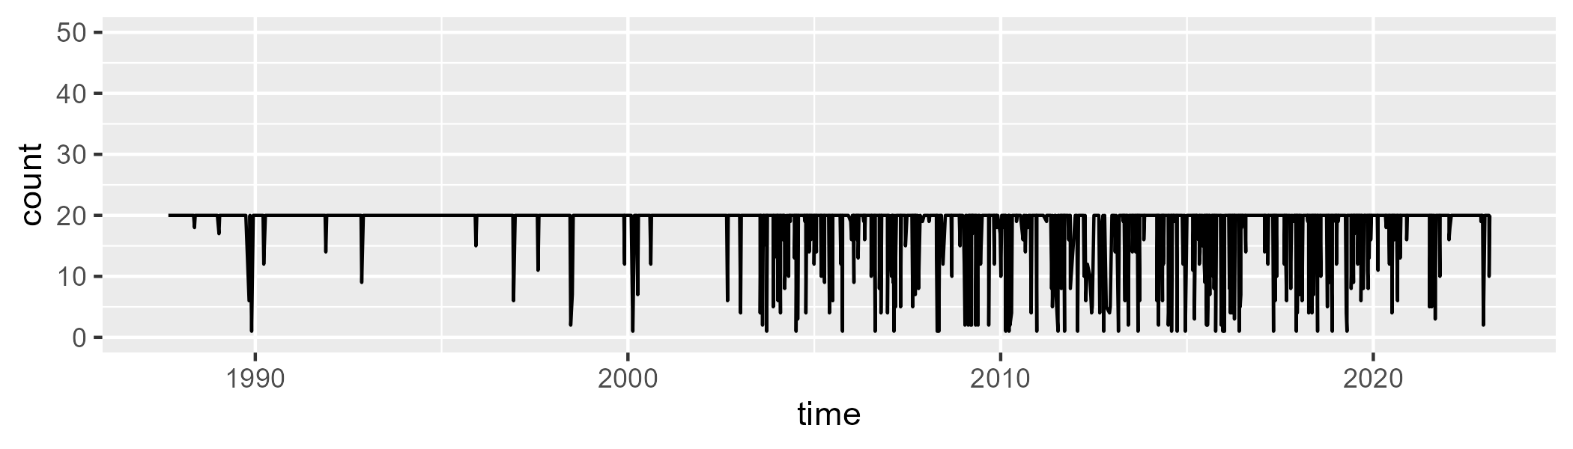

Min. : 1.00 1st Qu.:20.00 Median :20.00 Mean :18.42 3rd Qu.:20.00 Max. :20.00

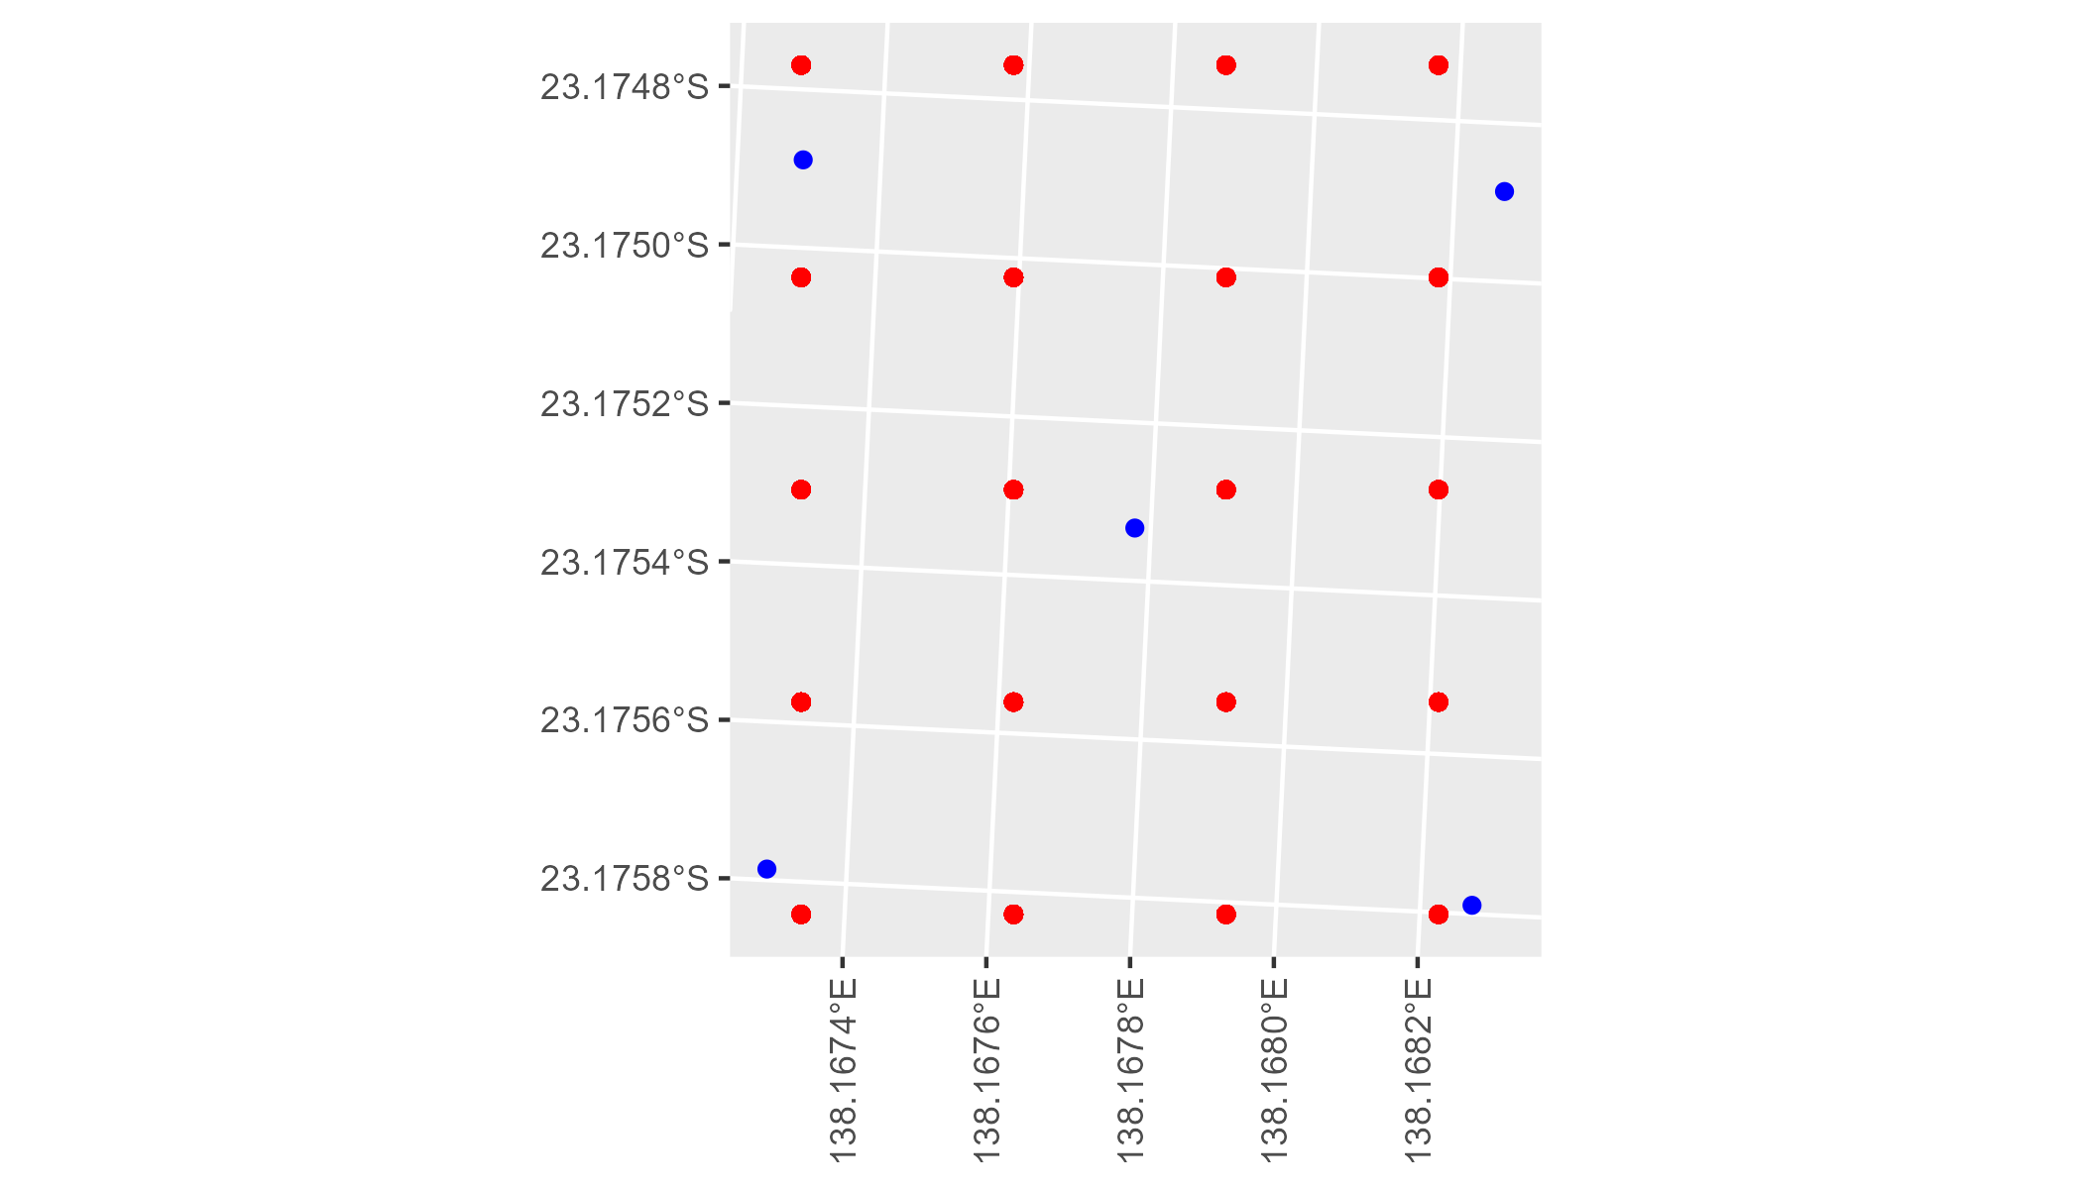

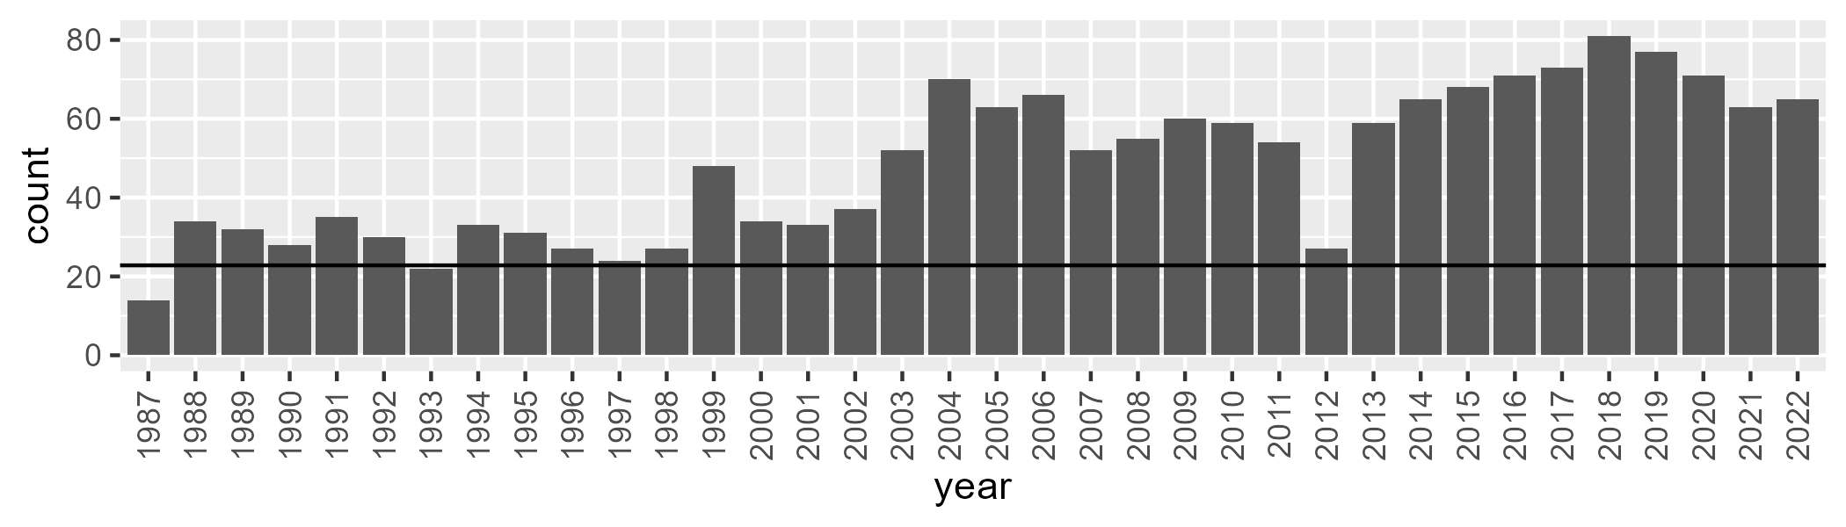

Number of samples: 1740

# QDASSD0015

| Min. | 1st Qu. | Median | Mean | 3rd Qu. | Max. |
| --- | --- | --- | --- | --- | --- |
| 0 | 5.73725 | 7.630319 | 8.681856 | 10.11511 | 37.43097 |

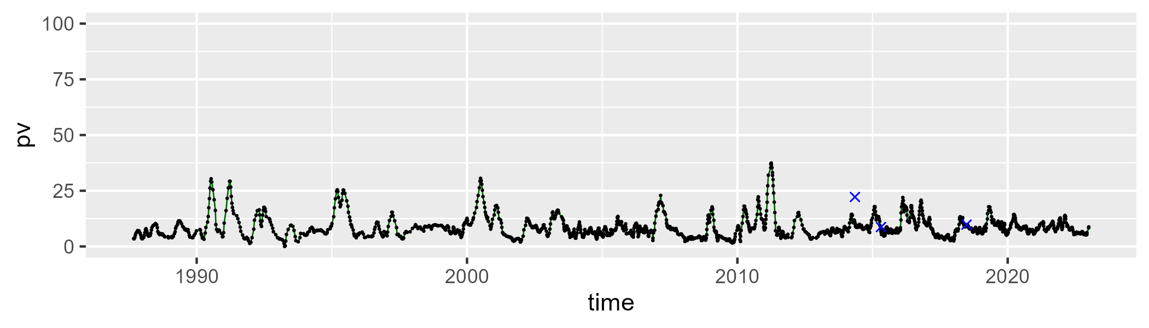

| Min. | 1st Qu. | Median | Mean | 3rd Qu. | Max. |
| --- | --- | --- | --- | --- | --- |
| 10.61231 | 22.37189 | 27.2681 | 29.54316 | 35.37892 | 65.20804 |

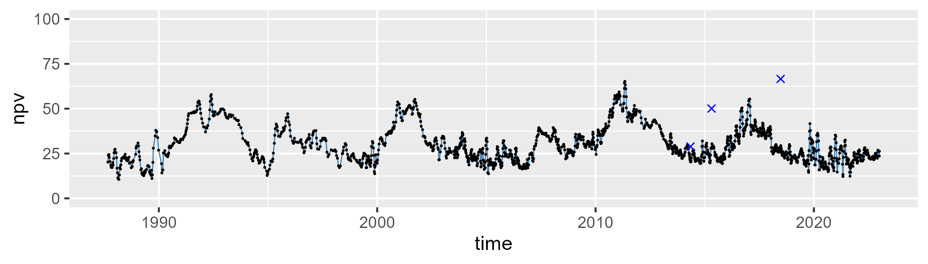

| Min. | 1st Qu. | Median | Mean | 3rd Qu. | Max. |
| --- | --- | --- | --- | --- | --- |
| 6.873198 | 54.78555 | 62.98744 | 60.2743 | 68.36241 | 81.61996 |

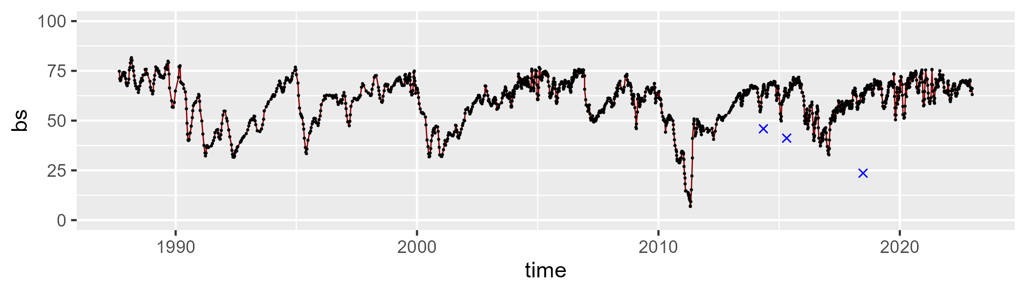

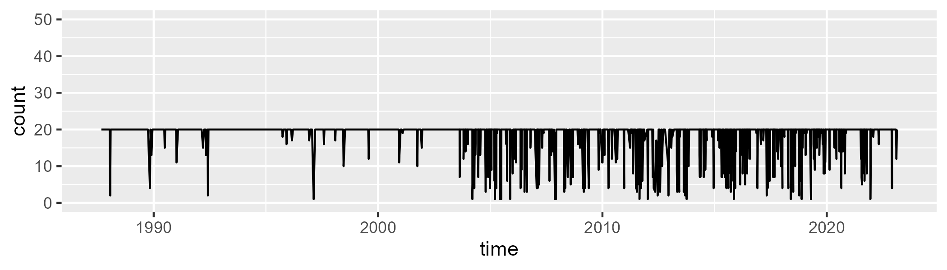

Min. : 1.00 1st Qu.:20.00 Median :20.00 Mean :18.56 3rd Qu.:20.00 Max. :20.00

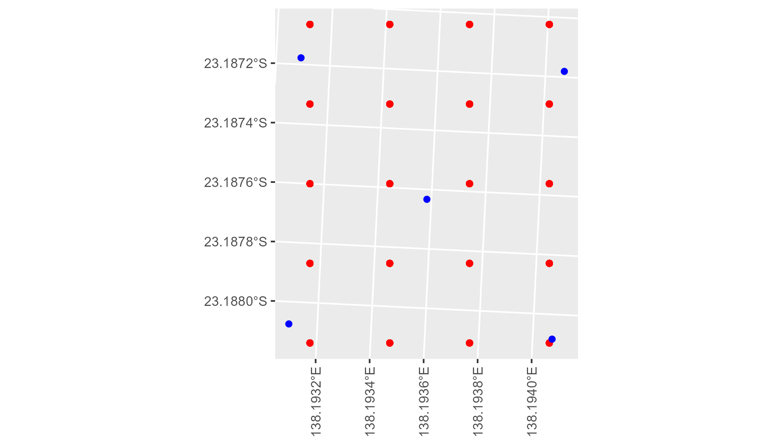

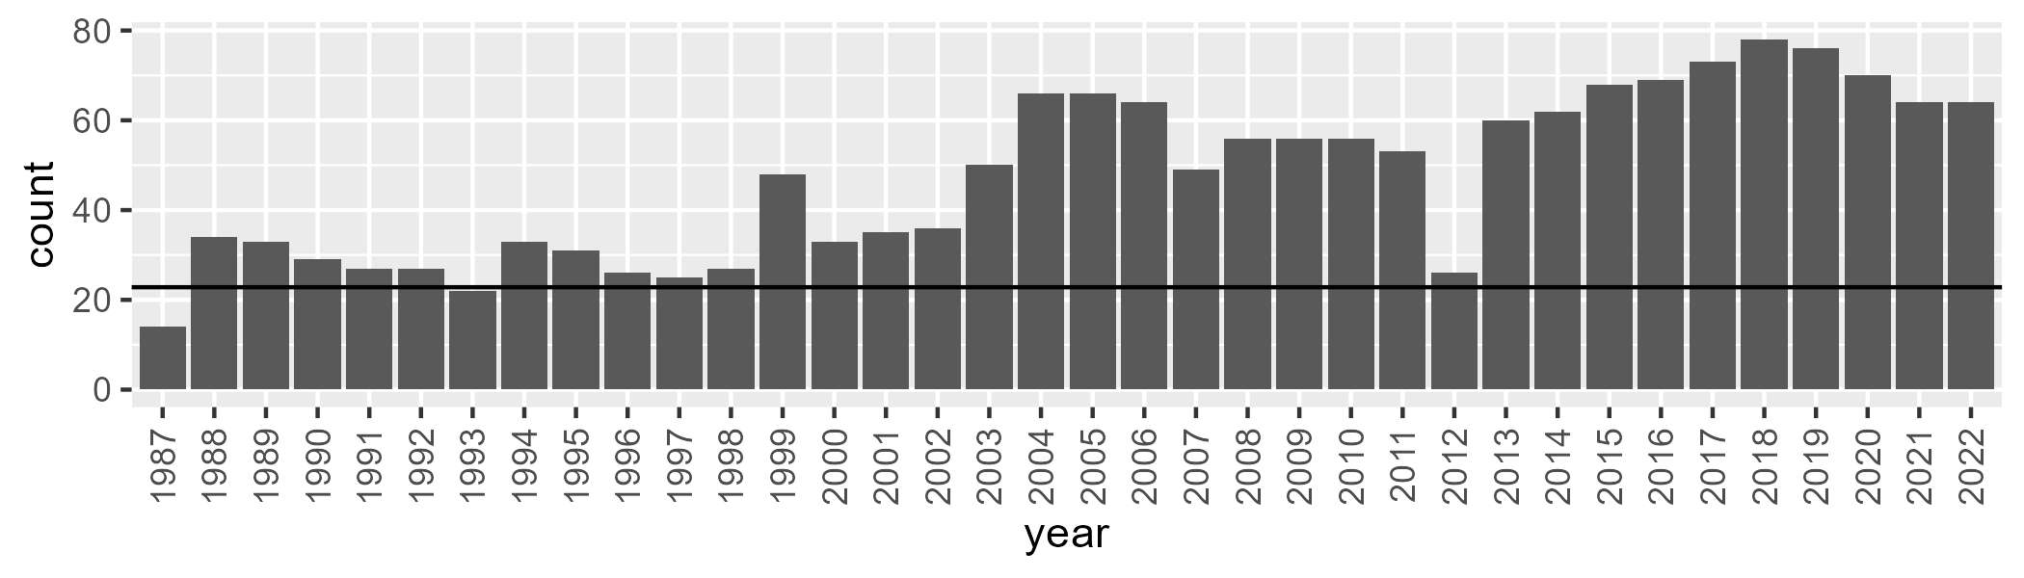

Number of samples: 1706